Improving Synthetic AEC Training Data
How eight defects were found and fixed while generating an LLM and VLM dataset from 1,963 Korean construction PDFs and 93 IFC models
Pipeline: gen_aec_syn_data · Backbone: qwen3:30b-a3b + qwen3-vl:30b via Ollama · ComfyUI SD 1.5 + depth ControlNet · NVIDIA GB10 (128 GB unified)

1. The dataset that came out
58.4 hours of generation over the full corpus produced 61,022 records. Every number below is measured on that run, not estimated.
Dataset | Records | What it is
SFT | 26,093 | Instruction / answer / evidence pairs over Korean construction regulation
DAPT | 32,964 | Domain corpus for continued pre-training
VLM | 1,965 | Five vision tasks over 393 rendered BIM scenes
Images | 2,751 | 1,179 BIM renders + 1,179 depth maps + 393 synthesised site photos

Residual defects after all fixes: no category exceeds 0.2% of records. Before the work described here, one defect alone affected 31% of the corpus and another silently discarded 32% of the source documents.

2. Why the first attempt produced nothing at all
The pipeline ran to completion on its shipped defaults and wrote zero records. A four-chunk PDF consumed 20 minutes of GPU time and produced no output file. qwen3 is a reasoning model: with the default num_predict of 8192 the entire budget was spent in the thinking channel and the answer channel came back empty. Closing that channel was not enough — the model then reasoned in prose inside the answer and was truncated before it reached the JSON.
"Okay, let's tackle this query. So, I need to generate three high-quality question-answer pairs..." (6,894 characters, 0 parseable samples)
ollama_json_mode | num_predict | Time | Samples
false | 2048 | 27.2 s | 0 — truncated mid-prose
true | 2048 | 27.2 s | 0 — truncated mid-JSON
true | 4096 | 30.9 s | 3
false | 8192 | 117.1 s | 3

The chosen row is 3.8x faster than the working alternative.

3. Text fidelity: the defect that shaped the corpus

3.1 Korean PDFs carry no space characters
Korean government documents are produced by HWP, which positions every glyph individually and writes no space characters at all. PyMuPDF returns whole sentences glued together, and its word-level extractor sees one 24-character word. 31% of DAPT records contained a run of 25 or more Hangul characters with no space in it.
Before:
■녹색건축물조성지원법시행규칙[별표3] <신설2015.5.29.>
건축물에너지평가사시험과목및시험과목일부면제범위(제14조제3항관련)
1. 시험과목
구분
시험과목
주요항목
제1 차
시험
건물에너지관계법규
1. 녹색건축물조성지원법
2. 에너지이용합리화법
3. 에너지법
4. 건
After:
■ 녹색건축물 조성 지원법 시행규칙 [별표 3] <신설 2015.5.29.>
건축물에너지평가사 시험과목 및 시험과목 일부면제 범위(제14조제3항 관련)1. 시험과목
구분
시험과목
주요항목
제 1 차
시험
건물에너지 관계 법규
1. 녹색건축물 조성 지원법
2. 에너지이용 합리화법
3. 에너지법
4. 건축법
The character bounding boxes still carry the spacing: inside a word the glyph gap is near zero, often slightly negative, while a word break is a fifth of a glyph width or more. A new space_gap_ratio setting turns that geometry back into spaces.

3.2 Line wrapping split words across newlines
PDF line wrapping is a visual artefact, but it reached the corpus verbatim. 99.4% of DAPT records contained at least one split word — 11,515 in total.
Before:
국토교통부고시제2025-207호\n철도교통관제자격증명시험시행지침\n[시행2025. 4. 25.] [국토교통부고시제2025-207호, 2025. 4. 25., 일부개\n정]\n제1장\n총\n칙\n제1조(목적) 이지침은「철도안전법시행규칙」(이하"시행규칙"이라한\n다) 제38조의7에따른관제자격증명시험(이하"자격시험" 이라한다)의\n방법ㆍ절차및실기시험평가위원의선정등에관하여필요한세
After:
국토교통부고시 제2025-207호\n철도교통 관제자격증명시험 시행지침\n[시행 2025. 4. 25.] [국토교통부고시 제2025-207호, 2025. 4. 25., 일부개정]\n제1장\n총\n칙\n제1조(목적) 이 지침은 「철도안전법 시행규칙」(이하 "시행규칙"이라 한다) 제38조의7에 따른 관제자격증명시험(이하 "자격시험" 이라 한다)의방법ㆍ절차 및 실기시험 평가
Measure | Before | After
Glued runs of 25+ Hangul characters (40 PDFs) | 782 | 5
Space ratio of extracted text | 8.9% | 17.0%
Extraction time | — | 1.4x, 0.03 s per file

3.3 A third of the documents were being discarded
The chunker required at least one chunk to have been emitted before it would keep a short trailing buffer. A document whose entire body fitted in one buffer below chunk_min_size therefore produced nothing — silently. On this corpus that was 633 documents, 32% of it. These were easy to mistake for scanned PDFs: of 640 files yielding zero chunks, only 7 genuinely had no text layer.
Cause | Files
Dropped by the chunker (text was fine) | 633
No text layer — real OCR candidates | 7

3.4 OCR for the genuine scans
One of the seven is a 700-page standard specification. An EasyOCR fallback now runs only when text extraction finds nothing. Measured: 2.5 s per page on GPU, 46 s on CPU.

4. LLM dataset: making the labels mean something
The SFT prompt listed four labels and left the choice to the model, which took the first item as a default. 96.8% of samples came back "compliant", including 327 of 330 definition questions. Asking what a term means is not a compliance judgement, so the field carried no signal at all.
Label | Before | After
compliant | 4,655 (96.8%) | 50 (0.2%)
answerable | 132 (2.7%) | 25,876 (99.2%)
non_compliant | 10 | 90
unanswerable | 12 | 77

Sample SFT record from the final dataset:
instruction: 건설기계 정기검사 미이행 시 처벌 조항은 무엇인가요?
answer: 정기검사 또는 수시검사 명령에 따르지 않을 경우 「건설기계관리법」 제13조제10항에 따라 등록번호표가 영치될 수 있습니다.
label: answerable
evidence: [{"doc_id": "건설기계(정기검사, 수시검사) 명령서", "section": "제13조제10항", "answer_span": null}]
Sample DAPT record, with metadata inferred once per document:
text: ■ 기계설비법 시행규칙 [별지 제8호서식]
기계설비 사용 전 검사 확인증
신청인
(건축주)
성명(기관 또는 법인 명칭)
대표자
전화번호
주소
기계설비
시공자
상호
공사업 등록번호
대표자
전화번호
영업소 소재지
기계설비
감리업무
수행자
상호
기계설비 감리 관련 등록번호
대표자
전화번호
영업소 소재지
검사
결과
건축허가번호
검사 현장 명칭
검사 현장 주소
검사
meta: {"source_type": "시행규칙", "source_org": "특별자치시장ㆍ특별자치도지사ㆍ시장ㆍ군수ㆍ자치구구청장", "project_type": "", "domain_tags": ["구조", "토목", "건축", "안전", "설비"]}

5. VLM dataset: four defects in the image pipeline
The VLM branch rasterises IFC geometry, derives a depth map from the same z-buffer pass, and drives ComfyUI to synthesise a photograph that a vision model then captions. Each stage had a defect that survived into the training data.
The working pipeline, end to end:
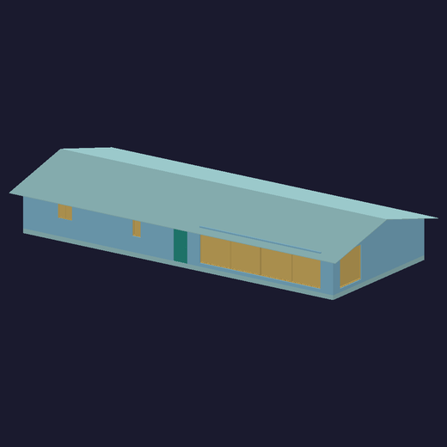 |  | 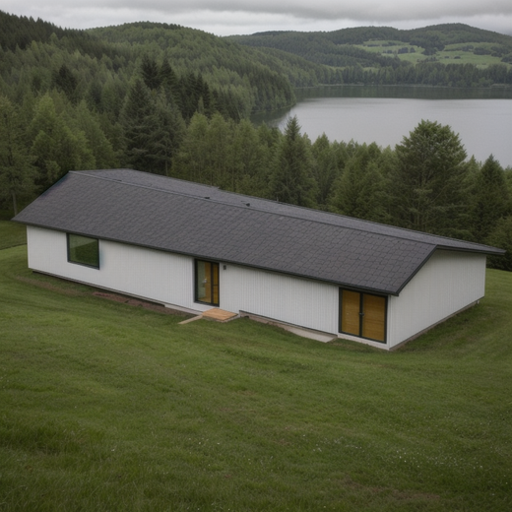
1. BIM render from IFC | 2. Depth map — ControlNet input | 3. Synthesised site photo

5.1 Only the whole model was ever rendered
Render groups were the whole model plus one per IfcSpace. IfcBuildingStorey appeared nowhere in the codebase. 63 of 94 models declared storeys and every one was ignored — 91 of 94 models rendered exactly one group, so nearly every VLM sample showed the same building from the same three angles.
 | Models
Storeys and spaces | 12
Storeys only | 51
Spaces only | 2
Neither | 29

Storey groups were added, and ifc_max_elements moved 500 to 1000 because the cap was starving space membership as well — on a 360-space model, 171 spaces matched zero elements purely because extraction stopped at 500.
Measure | Before | After
Render groups | 196 | 426
VLM records | 980 | 2,130
Distinct scenes per model | 2.1 | 4.5

5.2 The prompt asked for a building with no windows
The site-photo prompt described a structure under construction: bare concrete frame, plywood formwork, steel props, starter rebar. A structure at that stage has no windows or doors installed, so ControlNet could never place them — while the IFC models driving the render are finished buildings whose renderer colour-codes IfcWindow and IfcDoor as distinct element types.
The depth hint cannot recover this. Measured on a wall render carrying 6,659 window pixels, the depth difference between the glazing and the surrounding wall is 33.6 of 255 levels — 13%. Depth carries form, not what a surface is.
 |  | 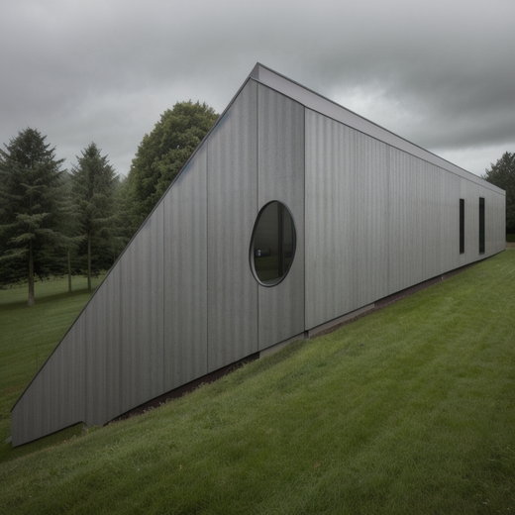
BIM render — openings present | Before: bare frame, no openings | After: glazing and doors placed

5.3 Buildings floating in a white void
Rewriting the prompt to place windows dropped every word describing the ground. Nothing replaced them, so the model had no instruction for the lower two thirds of the frame and filled it with flat white — buildings floated on a void, or on what read as snow. Two settings compounded it: "clouds" sat in the negative prompt, leaving an overcast sky as a blank white plane, and nothing excluded snow.
ControlNet strength was the other half. The depth map is empty above the model — 22 to 30% of the frame at value zero — and at strength 0.80 with end_percent 0.75 the sampler had no freedom to invent a horizon there.
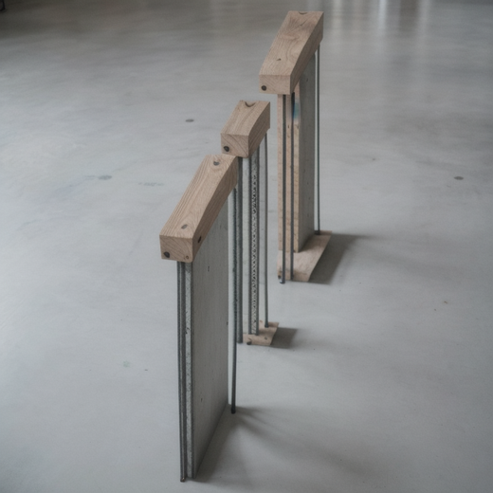 | 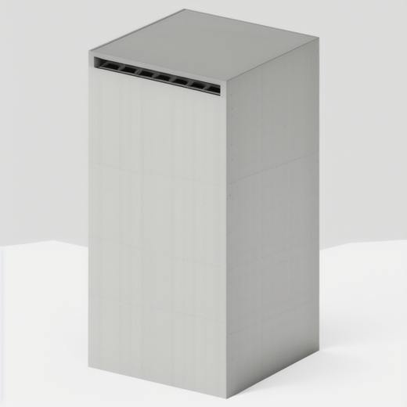 | 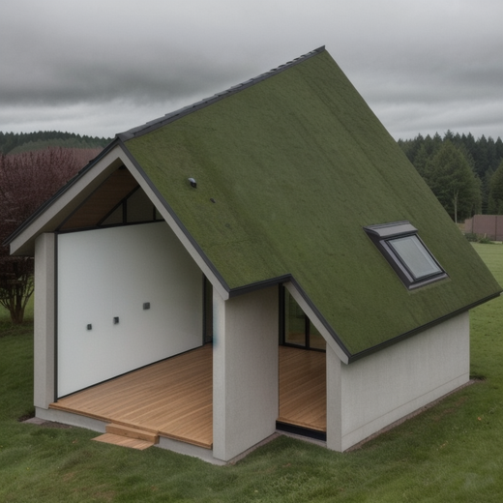
Bare frame, no ground | White void at 0.80 strength | After: ground, vegetation, cloud layer

ControlNet strength / end | Result
0.80 / 0.75 | Building held, background blank white
0.60 / 0.60 | Building held, ground and sky resolved — chosen
0.45 / 0.45 | Background good, building form lost

The prompt now names damp brown earth, grey gravel, mud with tyre ruts, small trees and rough grass, site fencing, a horizon, and a grey overcast sky with low cloud cover. Snow, frost, white ground, overexposure and high key went into the negative prompt.

5.4 Fabricated training pairs
This was the most serious defect, because it was invisible. A render group whose elements yield no triangles still went through the whole pipeline: the render came out as a flat background rectangle, no depth map was written, and the VLM stage fell back to conditioning ControlNet on that blank image. Conditioning on a blank image constrains nothing, so Stable Diffusion invented a building from the prompt alone — and the vision model captioned that invented building in confident detail.
 | 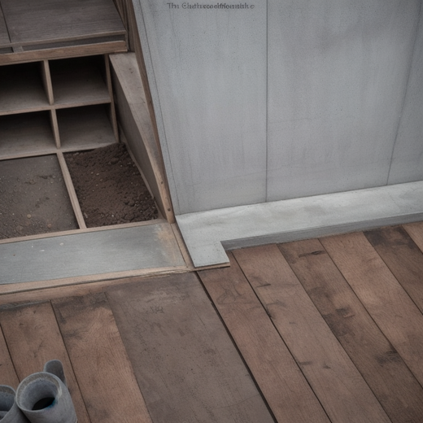
BIM render: geometry extraction produced nothing | The "site photo" generated from it — unrelated to any IFC data

On a set of conformance and proxy-only files, 18 of 18 renders were 98.5% or more background, and photos and captions were generated for all of them. The caption reads as authoritative, which is what makes the pair dangerous.
Two guards were needed: counting triangles rather than list entries, because the geometry extractor can return a non-empty list whose arrays are all empty; and refusing the fallback renderer when the failure is "no triangles", since the fallback draws a legend on the background colour and produces exactly the blank rectangle.
After the fix: zero blank renders, and 30 of 93 IFC files now produce nothing at all — reported in the log rather than silently yielding fabricated pairs.
Sample VLM records from the final dataset:
[site_description] label=clear
이 구조물은 유리 패널과 콘크리트 벽체로 구성된 높은 탑형 건축물로, 외부 표면은 깔끔하게 마무리되어 있습니다. 시공 상태는 완료됨을 보여주며, 주변에 크레인, 사다리 등 공사 중인 흔적이 없고, 구조물의 기초 부분도 정확히 시공된 상태입니다.
[element_detection] label=detected
이 현장 사진에서 보이는 구조 요소는 기둥입니다. 이 구조물은 높고 가늘며 수직 하중을 지지하는 특징을 가지고 있으며, 콘크리트와 유리로 구성된 외부 표면은 비구조적 클래딩으로 추정됩니다. 따라서 주요 구조 요소는 기둥으로 식별됩니다.
[material_identification] label=철골
이 구조물은 현대적인 고층 건축물로 보이며, 유리 외장과 함께 철골 구조를 사용한 것으로 추정됩니다. 철골 구조는 강도와 경량화를 위해 높은 곳에 설치된 구조물에서 자주 사용되며, 이 이미지의 슬림하고 고층적인 형태가 이를 지지합니다.

6. Version history
Version | Change | Effect on the dataset
#1 | think:false plus grammar-enforced JSON | 0 records to a working pipeline
#2, #5 | Output mirrors the input tree, one directory per input | 3,900 flat directories to a browsable tree
#3 | Drop samples with an empty instruction or answer | Removed 0.15% unusable records
#6 | Keep documents shorter than chunk_min_size | +633 documents, 32% of the corpus
#7 | EasyOCR fallback for scanned PDFs | +7 files including one of 700 pages
#8 | Word spacing, line unwrapping, storey groups, final_label | Glued text 31% to 0.1%; render groups 196 to 426; label collapse 96.8% to 0.2%
#9 | Site photo prompt: windows, ground, sky; ControlNet 0.60 | Windows and doors visible; buildings stand on real ground
#10 | Skip render groups with no geometry | Eliminated fabricated image/caption pairs

7. What is still open
DAPT document metadata is populated for 79.3% of records. The 21 documents that fail were investigated: their opening pages are tables of contents, so the model correctly returns empty fields. Retrying on a later slice does not help, and filename-based inference agrees with the model on only 38% of documents where both produce an answer — it would introduce wrong values rather than missing ones.
Two capabilities live in the local driver rather than the pipeline: case-insensitive file discovery, which upstream misses five .PDF files with an uppercase extension, and resume support, without which an interrupted run of this size loses a day of work.
The remaining constraint is not quality but source volume. 61,022 records at roughly 73 M tokens supports LoRA fine-tuning of a 4B to 8B model. Injecting domain knowledge into weights would need a corpus two orders of magnitude larger; retrieval remains the right home for the regulations themselves.

