Q1.

1. Early stage: 1/2500 epochs: all features are mixed up, it’s not a good feature extractor for a classifier since it’s hard to differentiate those class with it’s features.

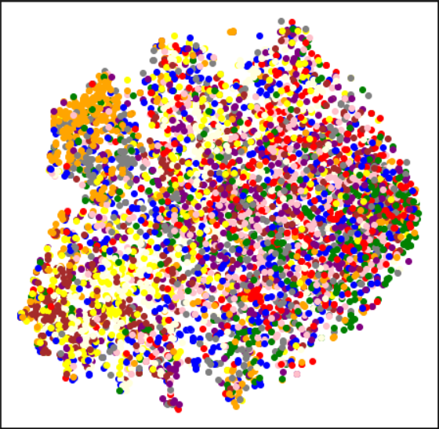

1. Middle stage: 1300/2500 epochs: it’s a decent feature extractor for a classifier because features are divided into groups based on its class for the majority of data.

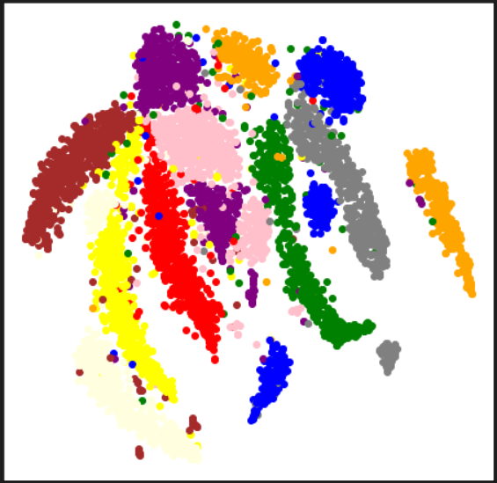

1. Final stage: 2498/2500 epochs: it’s also a good feature extractor for a classifier, however, it’s not as good as the middle stage one since features located in the right bottom part of the visualization map shows that this feature extractor is not capable of separating some data with an obvious distance between classes.

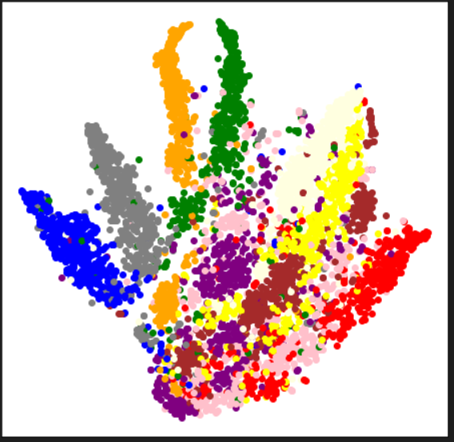

Q2:

1. Early stage: 1/2500 epochs: It’s not a good feature extractor for a domain adaption task since we can see that there are a lot of features extracted from target dataset are out of the distribution of features extracted from source dataset.

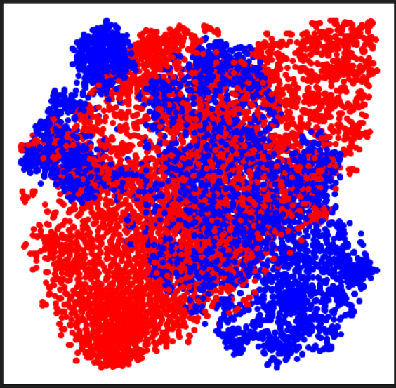

2.Middle stage: 1300/2500 epochs: although it is still not good enough for a domain adaption task, it is slightly better than the early stage one as we can see that there are more features extracted from target dataset located closer to features extracted from source dataset

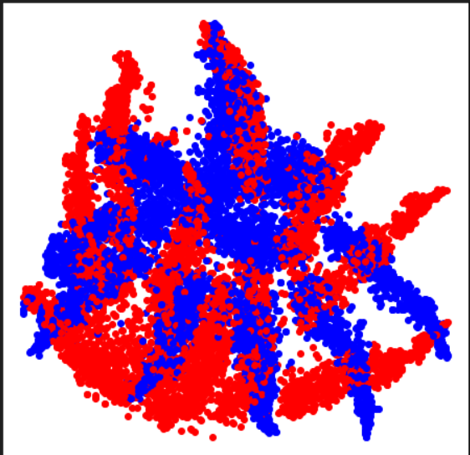

3.Final stage: 2498/2500 epochs: Although it still not aligns features extracted from source and target together, it’s the best one among three stages because we can see the distributions of two sets look similar.

