VERSION RELEASE TRACKER
Local Video Feed App
Development Iteration History · v0.1 – v0.5

Prepared for Adarsh
Compiled June 7, 2026

Table of Contents

(If entries are blank, right-click the table and choose “Update Field”.)

How to Read This Tracker
This document records how the Local Video Feed App evolved across the chats and feedback you (Adarsh) provided over time. Rather than logging every small tweak, related improvements have been clubbed into five meaningful releases, v0.1 through v0.5.
Each release is described in two layers so it is useful to both a non-technical reader and an engineer:
- “What I Asked For” — a plain-language account of the change you requested and why it mattered to you.
- “Requirement Set” — the same change expressed as formal, testable requirements, grouped into the same buckets used in the App Documentation.
Release v0.1 establishes the complete requirement database (every requirement defined and bucketed). Every release after that lists only what changed, using a colour code:
ADDED new requirement introduced REMOVED requirement retired MODIFIED existing requirement changed
Requirement IDs are stable: FR = Functional, NFR = Non-Functional, TR = Technical. When a later release modifies a requirement it refers back to the same ID; new requirements continue the numbering.
Snapshots show the app frames each release affects. v0.1 shows the whole app; later releases show only the views that changed.

Release Index
Ver. | Release | Focus & net requirement change
v0.1 | Foundational Build (Baseline) | Complete app defined — 86 requirements across all buckets.
v0.2 | Settings, Layout & Appearance Stabilization | Settings window made stable and tidy. +1 / 2 modified / −1.
v0.3 | Design & Motion System Overhaul | Premium feel + accessibility. +9 / 1 modified / −2.
v0.4 | Thumbnail Pipeline Rebuild | Fast grid, no laptop heat. +5 / 3 modified / −2.
v0.5 | Backend Performance & Runtime Hardening | Efficient, reliable runtime. +3 / 3 modified / −4.

Release v0.1 — Foundational Build (Baseline)
Status: Baseline — defines the complete requirement database.

What I Asked For
I wanted a private app for my own computer to watch the short motivational and spiritual videos I had collected — like a personal feed, but built only from my own files and working completely offline. I am not a developer (a little Python a year ago), so I described what I wanted in plain English and we built it piece by piece.
The core idea: the app should learn what I like. As I watch, I can mark videos I like or softly dislike, and the feed should lean toward my favourites while still mixing in fresh, unrated clips and the occasional one I had snoozed. I wanted to be able to snooze (cool down) content I was tired of so it comes back later on its own.
I also wanted to stay organised: tag videos into my own categories, keep a special “To Be Deleted” bucket, and safely delete junk files in bulk from inside the app. On top of that I wanted control over the experience — how many new versus favourite videos appear, playback speed, what happens when a video ends, the grid size, and the overall look — and a clean, premium, Apple-style dark interface. Finally it had to launch with a simple double-click, with all my ratings and settings saved automatically.

Requirement Set — Baseline
The full requirement database as first built, grouped into the buckets carried forward in every later release.

Functional · Feed Algorithm & Video Discovery
ID | Requirement | Detail
FR-01 | Three-bucket weighted feed | Feed composed from three pools — Ranked (interacted, no active cooldown), Fresh (never interacted), and Cooldown (snoozed) — each with a configurable weight.
FR-02 | Weighted random sampling | Videos drawn without replacement; each appears at most once, with selection probability proportional to its normalized weight within its bucket.
FR-03 | Ranked score weighting | Within Ranked, weight = (score − min_score + 0.1), normalized so the bucket total equals the ranked ratio.
FR-04 | Fresh/Cooldown equal weighting | Within Fresh and Cooldown pools all videos receive equal weight (bucket weight ÷ count).
FR-05 | Configurable ratio | Defaults ranked 5.0 / fresh 3.0 / cooldown 2.0; UI sliders auto-balance so the total is always 10.
FR-06 | Cooldown auto-expiry | A cooldown ends when elapsed time ≥ weeks × 7 days OR views since it started ≥ cooldown_views.
FR-07 | Feed persists expiry | /api/feed writes auto-expired cooldowns back to data.json in the same request.
FR-08 | Folder auto-scan | On start and refresh, scan the video folder for supported extensions and register any new files with default values.
FR-09 | First-seen timestamp | Each video records a first_seen Unix timestamp when first discovered.

Functional · Video Playback
ID | Requirement | Detail
FR-10 | HTTP range support | /video/<file> honours the Range header (206 Partial Content) so the browser can seek natively.
FR-11 | Start from beginning | On open, currentTime is set to 0 regardless of any stored position.
FR-12 | View after 3 seconds | After 3s of watching, the video's and the global total_views increment by one.
FR-13 | Save position on back | Navigating back stores the current playback position.
FR-14 | Auto-hide controls | Progress bar and nav arrows appear on mouse move and hide 2.5s after it stops; stay visible while paused.
FR-15 | Configurable speed | Applies the saved playback speed on open; a three-position snap slider sets it.
FR-16 | On-complete behaviour | When a video ends: pause, loop, or advance to the next video in the filtered feed.
FR-17 | Prev/Next navigation | Arrow buttons and keyboard arrows move within the filtered feed; disabled at the ends.
FR-18 | Controls flush to video | Controls sit at the rendered video edge, accounting for pillarboxing on portrait clips.

Functional · User Interaction System
ID | Requirement | Detail
FR-19 | Like toggle | Like: score +1.0 and interaction +1; unlike reverses both.
FR-20 | Soft dislike toggle | Soft dislike: score −0.5 and interaction +1; reverses both.
FR-21 | Cooldown toggle | Sets a cooldown {started_at, views_at_start}; un-cooldown clears it.
FR-22 | Interaction clamp | interaction_count never drops below zero.
FR-23 | In-session state | Button active states are tracked per session and not persisted — only scores and cooldowns are saved.
FR-24 | Tag button state | The tag button highlights when the current video has at least one category.

Functional · Category Management
ID | Requirement | Detail
FR-25 | ID-based categories | Categories are {id, name}; IDs are 12-char hex; videos store arrays of category IDs.
FR-26 | System “To Be Deleted” | A built-in category (id __tbd__) always exists, always sits last, and cannot be renamed, deleted, or reordered.
FR-27 | TBD exclusivity | Assigning TBD removes all other categories and vice-versa; enforced on both server and client.
FR-28 | Create category | Adds a new category before TBD; duplicate names ignored; 40-char max.
FR-29 | Delete category | Removes the category and strips its ID from every video.
FR-30 | Rename category | Updates the name; TBD cannot be renamed.
FR-31 | Reorder categories | Sets a new order; TBD is always re-appended last.
FR-32 | Legacy migration | Plain-string categories are migrated to the {id, name} form.

Functional · Filtering & Delete Mode
ID | Requirement | Detail
FR-33 | Category chip filter | Click a chip to filter; click again to clear; Cmd/Ctrl-click adds to the filter.
FR-34 | TBD activates Delete Mode | Filtering by TBD shows checkbox overlays on cards and a delete toolbar.
FR-35 | Delete toolbar | Shows “N of M selected”, Select/Deselect All, and a Delete Files button (disabled at zero).
FR-36 | Bulk delete + confirm | A confirmation modal precedes deletion; each selected file and its data entry are removed.
FR-37 | Uncategorized filter | A JS filter (no chip) shows videos with no category assignments.

Functional · Thumbnail Generation
ID | Requirement | Detail
FR-38 | Lazy generation | Thumbnails created only for cards near the viewport (IntersectionObserver, 200px margin).
FR-39 | Sequential with gap | One thumbnail at a time, 120 ms apart.
FR-40 | Capture point | Captured min(1, duration × 0.08) seconds in, to avoid black frames.
FR-41 | Size & quality | Canvas scaled to ≤ 320px wide and saved as JPEG at quality 0.7.
FR-42 | localStorage cache | Cached per file (vf_thumb_[file]) and checked before regenerating.
FR-43 | Cache migration | On boot, old thumbnail keys are cleared once via a version flag.
FR-44 | Generation timeout | If a thumbnail is not produced within 8s, generation aborts and a placeholder remains.

Functional · Statistics & Session Tracking
ID | Requirement | Detail
FR-45 | Session views | Counter increments when a video opens; shown in the top bar.
FR-46 | Session timer | Elapsed session time is shown and refreshed every 15s.
FR-47 | Historical averages | On unload, qualifying sessions append {views, duration}; last 50 kept.
FR-48 | Category stats | /api/stats returns totals plus per-category name, count, average score, and interactions.
FR-49 | Category cloud sizing | Chip height and font scale by the square root of the category's count.
FR-50 | Bin-packing auto-scale | Chips lay out in shelf rows; if they overflow, scale by 0.85 and retry (max 8 passes).
FR-51 | Category colour blending | Chips lerp toward the liked or disliked colour based on average score.

Functional · Settings & Customization
ID | Requirement | Detail
FR-52 | Persistent settings | Stored in data.json; saving performs a deep merge of nested values.
FR-53 | Default settings | Cooldown 3 weeks / 50 views, ratio 5/3/2, grid 5×2, tag colours, background, on-complete = pause, speed 1.0, folder ../videos.
FR-54 | Zoom persisted | Column count saved on slider change (range 2–10).
FR-55 | Background picker | Triangular White/Black/Red canvas; barycentric blend stored as {x, y}.
FR-56 | Tag colour palette | 21 fixed swatches across three targets (liked / disliked / unreviewed); applied on Save.
FR-57 | Configurable folder | Video folder is a relative path from app/ (default ../videos).
FR-58 | Open on General tab | The Settings modal always opens on the General tab.

Non-Functional · User Experience & Design
ID | Requirement | Detail
NFR-01 | Apple dark visual language | Black background with a defined surface/text/accent palette delivered via CSS custom properties.
NFR-02 | System font stack | -apple-system / SF Pro / Segoe UI; SF Mono for monospace.
NFR-03 | Smooth micro-animations | 180 ms cubic-bezier transitions on interactive elements; card hover scale; button-press scale.
NFR-04 | 9:16 cards | Portrait aspect ratio maintained at any column count.
NFR-05 | Score badge font clamp | Badge font size scales responsively with column width.
NFR-06 | Zero frontend dependencies | A single self-contained HTML file — no frameworks, CDN, or build step.
NFR-07 | Thin scrollbar | 4px translucent custom scrollbar.
NFR-08 | GPU containment | Grid uses contain:strict and cards contain layout/style/paint to avoid full-grid repaints.
NFR-09 | Tag popover placement | Sits left of the tag button, clamped within the video wrapper, arrow pointing right.
NFR-10 | TBD always red | The TBD chip always uses the dislike colour, never score blending.

Non-Functional · Performance & Compatibility
ID | Requirement | Detail
NFR-11 | Lazy thumbnails | Generated only near the viewport, one at a time, with an 8s hard timeout.
NFR-12 | Debounced resize | Control repositioning is debounced 80 ms on window resize.
NFR-13 | Range streaming | Videos stream with range support so browsers seek without a full download.
NFR-14 | macOS launcher | A double-clickable .command installs Flask, starts the server, and opens the browser.
NFR-15 | Windows launcher | start.bat installs Flask if missing and launches server + browser.
NFR-16 | Browser compatibility | Works in Safari, Chrome, Firefox, and Edge with no polyfills.
NFR-17 | Offline operation | Fully functional offline once Flask is installed — no CDN or external APIs.

Technical · Backend Architecture & Data
ID | Requirement | Detail
TR-01 | Python 3 + Flask ≥ 3.0 | Only dependency is flask>=3.0.0 — no ORM or extra packages.
TR-02 | Server config | host 127.0.0.1, port 8080, debug off.
TR-03 | API surface | feed, refresh, interact, save_position, record_view, full categories CRUD, tag, video delete, settings, stats.
TR-04 | Streaming endpoint | /video/<file> reads the configured folder and supports the Range header.
TR-05 | Static serving | GET / serves index.html.
TR-06 | BASE_DIR | All paths resolve relative to the server file's directory.
TR-07 | Mac launcher script | Installs Flask, starts the server, and opens localhost:8080.
TR-08 | Windows launcher script | Installs Flask, opens the browser (localhost:5000), and runs the server.
TR-09 | Category ID generation | make_cat_id() = uuid4().hex[:12].
TR-10 | localStorage keys | vf_thumb_*, vf_session_history, vf_thumb_cache_v2.
TR-11 | Settings deep merge | POST /api/settings recursively merges nested dicts; scalars replaced.
Data schema (data.json): a videos map keyed by filename (score, last_position, total_views, interaction_count, cooldown, categories, first_seen), a categories list ending in __tbd__, a global total_views counter, and the settings object.

Snapshots — Whole App
v0.1 affects the entire application, so all primary frames are shown.
Feed view — top bar, session stats, category chips, and the scored video grid
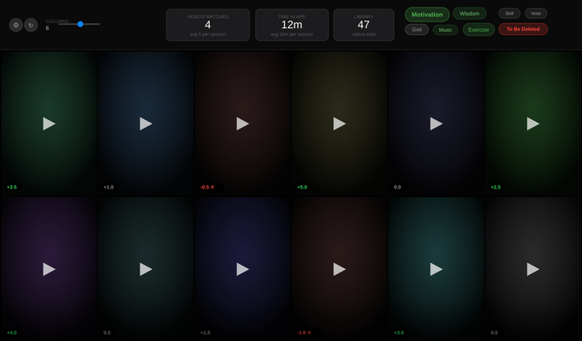
The Feed: settings gear and zoom slider (left), session stats (centre), category chips (right), and a grid of cards with score badges.
Playback view — player with the right-side rating panel
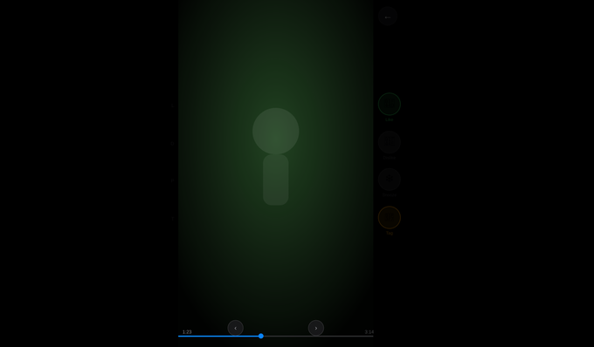
A video open in playback with like / soft-dislike / cooldown / tag controls and prev-next navigation.
Tagging — category popover
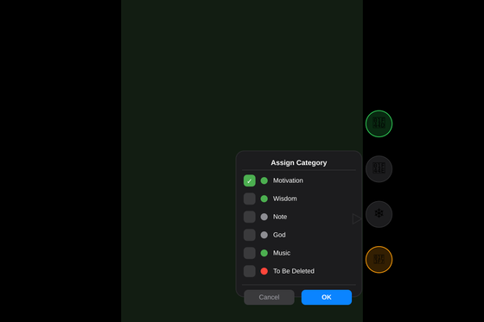
Assigning categories to a video via the tag popover.
Category management
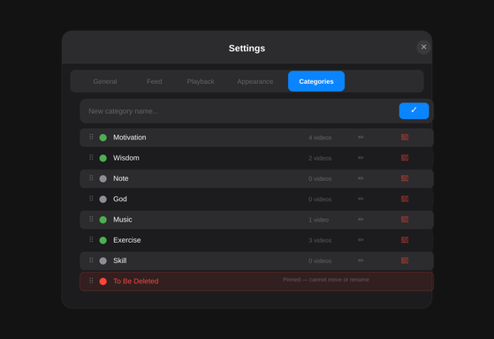
Creating, renaming, reordering, and deleting categories.
Delete mode — bulk file deletion
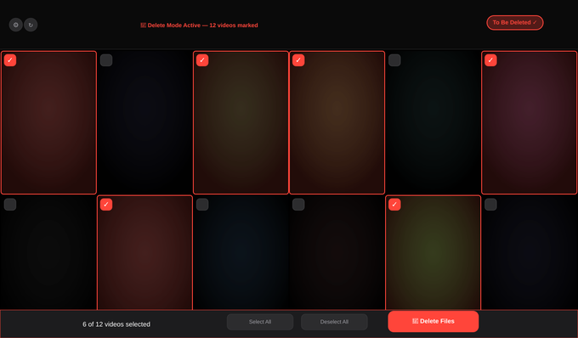
Filtering by “To Be Deleted” reveals checkboxes and the delete toolbar.
Settings — General, Feed, Playback, and Appearance tabs
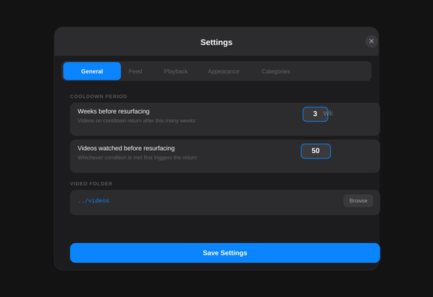
General tab — video folder and basics.
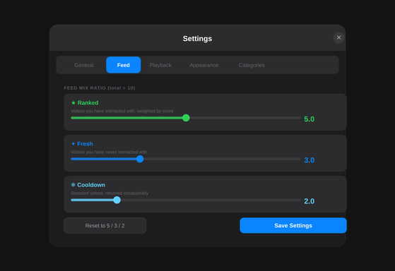
Feed tab — ranked / fresh / cooldown ratio.
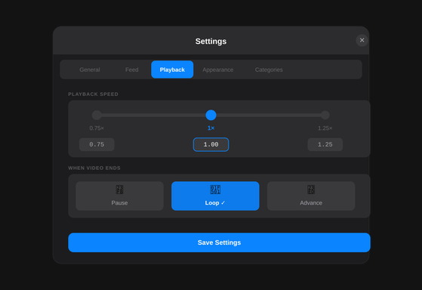
Playback tab — speed and on-complete behaviour.
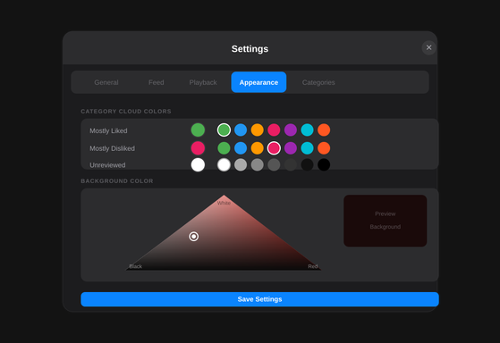
Appearance tab — grid, tag colours, and the triangular background picker.

Release v0.2 — Settings, Layout & Appearance Stabilization
Theme: Make the Settings window calm, stable, and tidy.

What I Asked For
The Settings panel was working but felt jittery. When I clicked between the five tabs the whole window kept jumping to a different size, and the Appearance tab was so tall I had to scroll to reach the background picker. I asked for the Settings window to stay one fixed, comfortable size no matter which tab is open, with anything extra scrolling neatly inside instead of stretching the window.

Requirement Set — Changes
ADDED new requirement introduced REMOVED requirement retired MODIFIED existing requirement changed
- ADDED — FR-59 — Fixed Settings modal geometry: the Settings window has a fixed size (≈ 520 × 460) with hidden overflow, and each tab pane scrolls internally so the window never resizes between tabs.
- MODIFIED — FR-55 — Background picker canvas reduced in height so the Appearance tab fits without scrolling the whole modal.
- MODIFIED — NFR-01 — Settings surface refined for a steadier, tidier layout across all five tabs.
- REMOVED — Inline min-width / max-width sizing on the modal box, which had let the window grow and shrink per tab, was removed in favour of the fixed geometry above.

Snapshots — Affected Views
Settings · General tab (now fixed size)

The Settings window now holds a single stable size as you move between tabs.
Settings · Appearance tab (fits without scrolling the window)

The background picker is reachable without resizing; overflow scrolls inside the pane.

Release v0.3 — Design & Motion System Overhaul
Theme: Make it feel premium, polished, and accessible.

What I Asked For
The app did everything I needed, but I wanted it to feel high-end — the kind of small, tactile details that make an Apple app feel expensive. I asked for smoother, more purposeful animation throughout (not one generic effect on everything), gentle motion when things open and close, and the little touches: cards and buttons that respond to a tap, thumbnails that fade in cleanly instead of popping, and tidy loading states.
I also wanted it to be considerate — usable with a keyboard, with clear focus highlights, and respectful of the system “reduce motion” setting for anyone who prefers less animation.

Requirement Set — Changes
ADDED new requirement introduced REMOVED requirement retired MODIFIED existing requirement changed
- ADDED — NFR-18 — Role-based motion system: distinct easing curves for entering (decelerate), leaving (accelerate), in-place change (standard), and taps (spring), with short 120–320 ms durations.
- ADDED — NFR-19 — Honour the OS “Reduce Motion” preference, minimising animation when it is enabled.
- ADDED — NFR-20 — Visible keyboard focus rings via :focus-visible across interactive elements.
- ADDED — NFR-21 — Polished loading states: thumbnails fade in and empty cards show a calm loading sheen rather than popping in.
- ADDED — NFR-22 — Score badge legibility: badges sit on an eased scrim with a legibility shadow to avoid banding over bright frames.
- ADDED — NFR-23 — System-wide craft: tabular numerals on scores, brand-tinted text selection/caret, momentum scrolling with overscroll containment, a depth/shadow scale, and a defined --text-dim token for muted captions.
- ADDED — NFR-24 — Entrance motion for surfaces: modals, the tag popover, and settings tabs animate in (scrim fade, panel settle, popover spring, tab cross-fade); inputs gain a focus halo and the header floats with a soft shadow.
- ADDED — NFR-25 — Playback feel: opening a video gently zooms in; like/dislike/cooldown buttons give a tactile pop; the played portion of the progress bar has a subtle live glow.
- ADDED — FR-60 — Cards are keyboard-operable (Enter / Space activate a card).
- MODIFIED — NFR-03 — Micro-animation specification replaced: the single 180 ms curve gives way to the role-based easing and durations in NFR-18.
- REMOVED — The single generic easing curve applied uniformly to every element was retired.
- REMOVED — Blanket outline:none (which had hidden keyboard focus everywhere) was removed in favour of the focus-visible rings.

Snapshots — Affected Views
Feed view — refined card motion, loading sheen, and score-badge legibility

Grid cards fade in, respond to hover/press, and remain keyboard-operable.
Playback view — open zoom, tactile rating buttons, glowing progress

Opening a video eases in; the rating controls and progress bar gain tactile, premium feedback.

Release v0.4 — Thumbnail Pipeline Rebuild
Theme: A fast grid that doesn't cook the laptop.

What I Asked For
Every time I opened the app the grid was slow to fill and my laptop got hot and the fans spun up. It felt like the app was redoing all the thumbnail work from scratch each session for my whole library. I asked for the grid to load fast and for the thumbnail work to happen once and be remembered, instead of being repeated every time.

Requirement Set — Changes
ADDED new requirement introduced REMOVED requirement retired MODIFIED existing requirement changed
- ADDED — FR-61 — Server-side thumbnail generation: the server produces each thumbnail once with ffmpeg (~0.2s each) as a small (~14 KB) JPEG.
- ADDED — FR-62 — On-disk thumbnail cache: generated thumbnails are stored under app/thumbs/ and served as tiny static images.
- ADDED — FR-63 — Background pre-warmer: after launch the server gently pre-generates any missing thumbnails for the whole library.
- ADDED — TR-12 — ffmpeg is an optional system dependency; if absent the app still works via a throttled browser fallback.
- ADDED — TR-13 — New endpoint serving the cached thumbnail image for a given video.
- MODIFIED — FR-38 to FR-41 — Thumbnail approach changes from in-browser video decode + canvas capture to loading a pre-made server JPEG; the browser path becomes a fallback that now persists each result to disk (a one-time cost, not per session).
- MODIFIED — FR-42 — localStorage thumbnail cache demoted from the primary store to a fallback-only cache.
- REMOVED — The mandatory per-session client-side video decode of every clip (the main cause of the heat and slow grid) was removed.
- REMOVED — FR-43 — The localStorage cache-v2 migration became obsolete once thumbnails live on disk.

Snapshots — Affected Views
Feed view — grid now backed by cached server thumbnails

The grid fills quickly from pre-made disk thumbnails; the browser no longer decodes every clip on each visit.

Release v0.5 — Backend Performance & Runtime Hardening
Theme: Efficient, responsive, and reliable under the hood.

What I Asked For
Even with faster thumbnails, the app still felt heavier than it should — scrubbing and seeking within a video weren't as smooth as I expected, and a couple of background animations kept running constantly. I also noticed the launcher sometimes opened the wrong page. I asked for the whole thing to be made efficient and dependable so it stays light and just works every time.

Requirement Set — Changes
ADDED new requirement introduced REMOVED requirement retired MODIFIED existing requirement changed
- ADDED — TR-14 — In-memory data cache: data.json is parsed once and held in memory, re-read only when the file actually changes (by modification time).
- ADDED — TR-15 — Threaded server: the Flask server runs threaded so streaming a video no longer blocks other requests.
- ADDED — TR-16 — Atomic saves: writes to data.json are atomic (write-temp-then-rename) to prevent corruption.
- MODIFIED — FR-07 / data access — The server no longer re-reads and re-parses data.json on every request (including every video seek chunk); it uses the in-memory cache from TR-14.
- MODIFIED — NFR-03 — Continuously running visual effects were trimmed: the infinite placeholder shimmer became a static sheen and the per-card staggered entrance was removed (cards still fade in cheaply).
- MODIFIED — TR-02 — Server configuration updated to run threaded.
- REMOVED — Re-reading and re-parsing data.json on every request and every range chunk was eliminated.
- REMOVED — The infinite shimmer animation that ran on every placeholder card simultaneously was removed.
- REMOVED — The per-card staggered entrance animation that replayed on every filter/zoom was removed.
- REMOVED — TR-08 — The launcher port mismatch was fixed: start scripts opened localhost:5000 while the server runs on 8080; now aligned to 8080.

Snapshots — Affected Views
Runtime data flow — in-memory cache, threaded streaming, atomic saves
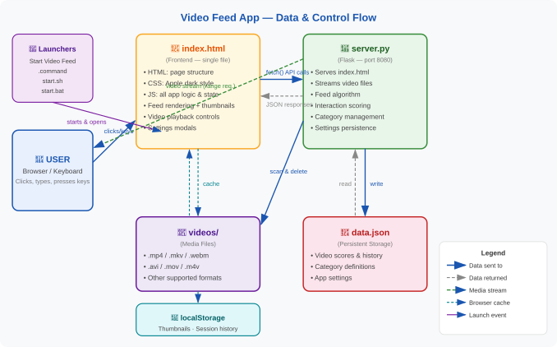
Component data flow: the server now serves from an in-memory copy of data.json and streams video on its own thread.
Feed view — lighter, with continuous animations removed

The grid stays responsive; the constant shimmer and staggered entrance effects are gone.

Appendix — Conventions & Notes
Clubbing: many small chat-by-chat tweaks were grouped into the release whose theme they served, so each release represents a body of significant, related improvement rather than a single edit.
Requirement IDs: FR/NFR/TR numbers are stable. v0.1 defines FR-01–58, NFR-01–17, TR-01–11; later releases reuse those IDs when modifying and continue the numbering (FR-59+, NFR-18+, TR-12+) when adding.
Snapshots: images are reused from the App Documentation and mapped to the frames each release affects. Where a change is purely under-the-hood, the most representative frame (e.g., the data-flow diagram) is shown.
Colour key — ADDED (green), REMOVED (red), MODIFIED (blue) — applies to every release after v0.1.

