SPREE user help

How to register?
Registration consists of three parts:
1. Standard user information section.
2. Profile generation where you specify your expert profile by entering websites (your homepage or links related to your knowledge domains) and keywords that explain your competences.
3. Profile refinement where you customize your expert categories. You can add additional fields, delete the ones automatically filtered and set up the level of expertise for each category by clicking on scale bar .
After filling in the forms you will receive a confirmation e-mail. Open the link inside of this e-mail in your browser to activate your Spree account.

How to ask an expert?
is the core functionality of the Spree system and your starting option after the login. You can always reach it via the "Ask expert" tab.
Enter your question in the "Question" field and click on . In order to get correct answer from the expert provide as many details as you can when writing your questions. Please provide your question in English!
After clicking on your question goes through the process of automatic classification. If you are not happy with the categorization you can reformulate your question and click or you can click and manually categorize your question. Here you can erase wrong categorization fields from the Question classification on the right side and add new ones from the Category tree on the left side. The main categories listed in a tree can be expanded by clicking on the plus sign on the left side of each category.

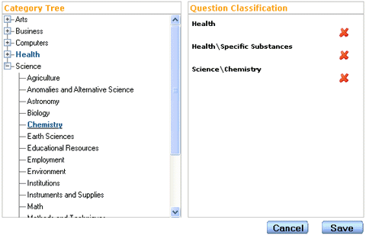
Now you are ready to contact the experts. Click . The system is going to present you detailed information about the ongoing expert contacting process. Spree also informs you about the note entries which are most related to your question and may already provide some answer.
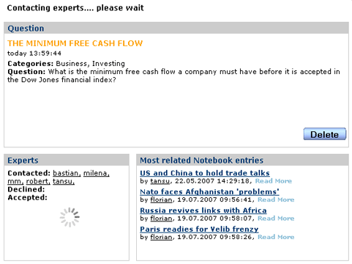

Spree users are allowed to have five ongoing questions/chats. The "My Questions" box monitors the status of your questions/chats on the left side of your screen. Clicking on one of the questions/chats will get you detailed information about it. Icons associated with questions/chats provide you with quick status information.
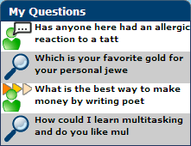
After an expert has accepted your question you can join him in a chat room where the expert will answer your question. Upon finishing the chat you will be prompted by a window to rate the chat based on the answer's quality. You can rate the chat immediately or you can postpone it for later. Direct chats are not rated.
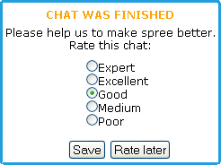

How to answer a question?
You can monitor the questions addressed to you in the "Incoming Questions" box on the left side of the screen.
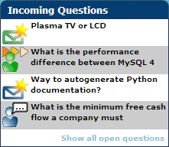
If you click on one of the questions you will get its detailed overview. You can get as much as five questions at a time.
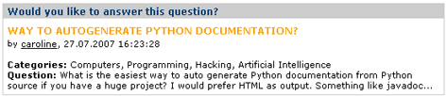
The title bar of your window will blink every time you get a new question (even when your browser is minimized). If you select that option, you can also receive your new incoming questions through e-mail.
If you want to answer a question you just need to click on . This will bring you to chat room with the user who asked the question. Upon finishing the chat you are offered the possibility to create a note based upon your conversation.
If you don't know the answer of a question click on and the question will disappear from your "Incoming Questions" box.
"Show all open questions" positioned in the bottom of the "Incoming Questions" box allows you to see a list of all unanswered questions currently in the system. Please feel free to answer these questions too.

All about chatting
The tab offers you two main options: direct chat with a selected user/expert and an overview of your finished chats.
Direct chat (follow link "Users") allows you to pick an expert from a list of all experts in the system and contact him avoiding the regular procedure of posting your question to the system. Here you can also find an overview of the users currently online.

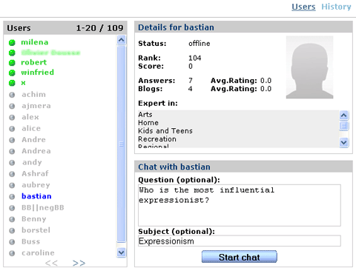
You can contact an expert by sending this expert a request for direct conversation. Selecting an expert shows the user details. Just below the details you will find the fields related to the setup of a direct chat. Here you can optionally fill in a description and a subject of your question. Direct questions are marked by the word "direct" so you can distinguish them from the regular ones.
To get an overview of your chats follow the "History" link which will take you to your chat history. Click on a chat to get the full conversation.
You can repeat the question you have posted if you are not satisfied with the answer you got by clicking . Spree will then try to find another expert for your question.
After the chat the expert can create a note related to the question by clicking . This might save an expert's future time as users with similar questions might refer to the note instead of contacting the expert.

All about notes
To go to your notes click on . You will get the list of your note entries.
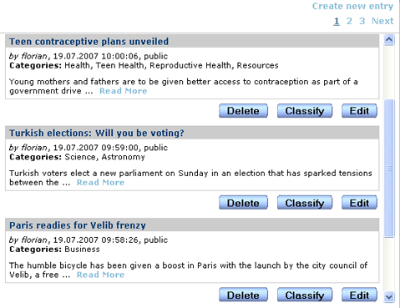
The notebook is at your disposal whenever you would like to create private notes or to share your knowledge with other users. Follow the "Create new entry" link to create a note. If you mark your note as "private" it will not be shown to other users.
After saving your note you might want to change its automatic classification. The process of manual classification follows the same steps as question classification.
Reading the notes others have written is possible upon posting a question, when the system is going to present you the notes which are most related to your question.
You can rate notes of other users directly influencing their score. You are allowed to give one rating per note.

Changing your user settings
You can change your user settings in the tab.
The "Personal" section lets you modify some of your user data such as your password or email.
The "Settings" section lets you choose whether you want to be informed about new incoming questions by email. Here you can also decide whether you want to subscribe to the Spree newsletter.
The "Profile" section allows you to change your expert profile the same way as during the registration phase.
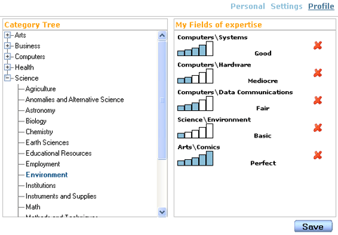
A short summary of other users profiles is obtainable by positioning the cursor over a users' name whenever the name appears underlined (e.g. in the "Score" box or in chats).
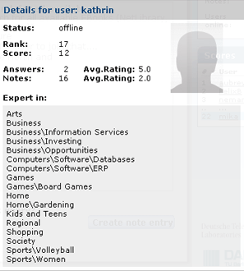

Getting your feed
If you prefer not to be logged into Spree the whole time and you still like to be informed about incoming questions or starting chats you can subscribe to the Spree feed. This comes in two flavors: as standard RSS feed and as Google gadget.
Clicking on will give you the opportunity to subscribe to the Spree feed. You can use any RSS reader you like but be aware that the refreshing period is set by the reader not by Spree! The RSS feed is personalized if your user name is provided in the url (the line where RSS is specified for your client application should look like http://www.askspree.de/feed/rss2.0?user_name=robert). Without your user_name specification RSS will not be personalized and you will get all newly asked questions.
Google gadget is obtainable for your iGoogle account and for Google desktop as well. For most browsers clicking on will automatically add the google gadget to your account. If you would like to use the gadget in your Google desktop you need to: click on "Add gadgets" (plus sign in the upper right corner of Google desktop window), fill in http://www.askspree.de/static/gadget/new.xml in the search field in the right upper corner, click on search. The Spree feed icon will appear in the window. You can then position on it and click on the "Add" button that appeared. The gadget will spring up.
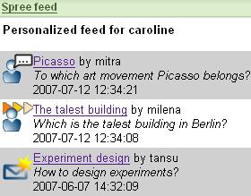
After that you can change the options of the gadget according to your taste. The gadget can also be personalized when you enter your Spree user name. The google gadget constantly refreshes its contents and keeps you up to date about the status of your Spree inbox.

