***“Zoo-Keeper App”***

***Design Patterns***

**CS 442 – Spring 2015**

**Group 2 - Amber Moore, Bresia Prudente, Leela Sai Krishna Bollineni, Anusha Daggubati**

 

1 The Purpose of the Project 5

1a The User Business or Background of the Project 5

1b Goals of the Project 5

2 The Stakeholders 6

2a The Client 6

2b The Customer 6

2c All Stakeholders 7

2d Hands-On Users of the Project 8

2e Personas 8

2f Priorities Assigned to Users 9

2g User Participation 9

2h Maintenance Users and Service Technicians 10

3 Mandated Constraints 10

3a Solution Constraints 10

3b Implementation Environment of the Current System 10

3c Partner or Collaborative Application 11

3d Off-the-Shelf Software 11

3e Anticipated Workspace Environment 11

3f Schedule Constraints 11

4 Naming Conventions and Terminology 11

4a Glossary of All Terms, Including Acronyms, Used by Stakeholders Involved in the Project 11

5 Relevant Facts and Assumptions 12

5a Relevant Facts 12

5b Business Rules 12

5c Assumptions 12

6 The Scope of the Work 12

6a The Current Situation 12

6b The Context of the Work 13

6c Work Partitioning 13

6d Specifying a Business Use Case 14

7 Business Data Model & Data Dictionary 17

7a Business Data Model 17

7b Data Dictionary 17

8 The Scope of the Product 19

8a Product Boundary 19

8b Product Use Case Tables 20

8c Individual Product Use Cases 20

9 Functional Requirements 25

9a Functional Requirements 25

10 Design Patterns 32

10a Design Goals 33

(1) Façade 33

(2) Observer 33

(3) Mediator 33

10b Key Requirements 34

(1) Façade 34

(2) Observer 34

(3) Mediator 34

## The Purpose of the Project

### The User Business or Background of the Project

The project proposed is the "Zoo-Keeper App". This application will be one of the few interfaces for the Image-Based Ecological Information System (IBEIS). According to IBEIS.org, "IBEIS is a large autonomous computational system that starts from image collections and progresses all the way to answering ecological and conservation queries, such as population sizes, species interactions, and movement patterns". It can detect various species of animals through images of those animals and identify individual animals of most striped, spotted, wrinkled or notched species. Field scientists, tourists, incidental photographers, and others take the images. The information is stored into a database and is made available for those who want to study the animal and its behavior. The "Zoo-Keeper App" is a phone application for zoo visitors and it allows them to take a picture of any animal at a zoo and instantly get information about that animal directly to their phone. For example, a student is interested in a zebra he spotted at Brookfield Zoo. After snapping a few pictures he learns that it is Kathy, a 3-year-old female Grevy’s Zebra. He learns where she has been and whom she has been with. This information is compiled from pictures of the animal that were taken over the last day, month, and year.

The purpose of this project is for tourist visits to the zoo be transitioned into a digital era. When a tourist is at a zoo, he reads a placard to learn about the animals located in the habitat. This information can be outdated or simply too much to read. The "Zoo-Keeper App" will provide updated information about the animals as well as recent photos and a more exciting zoo experience. The project will also allow animal researchers to get a better understanding of animals and their behaviors.

### Goals of the Project

**Purpose:** The purpose of us investing in this project is to create a tool that would make it easier for zoo visitors to learn about the animals they care about.

**Advantage:** The benefit of completing this project will be for the IBEIS program to have users who will bring in more information that could help expand the research.

**Measurement:** We will calculate the number of application users, if there is a large amount (at least 1,000), and the amount of new data that is collected via the IBEIS program to determine if the benefit has been achieved.

## The Stakeholders

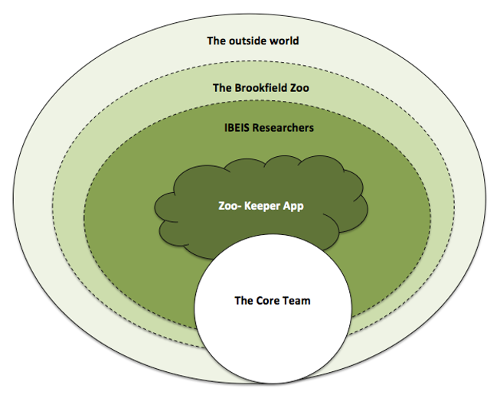

Figure 1: The Stakeholder Map

### The Client

The client for this project is Professor Tanya Berger-Wolf (Director of Computational Population Biology Lab at the University of Illinois in Chicago (UIC)) and her graduate assistant, Alessandro Oddone. Berger-Wolf plans to test the app at Brookfield Zoo and for other research projects. (See Table 1 for details)

### The Customer

The customers of this product are zoo visitors, safari tourist, animal researchers, and anyone with an affinity for animals. They shall download the application. (See Table 1 for details.)

### All Stakeholders

Table 1: Stakeholders List

|  |  |  |  |
| --- | --- | --- | --- |
| **Stakeholder Identification** | **Category**  **(See figure 1)** | **Knowledge** | **Degree of Involvement** |
| **The Client(s) (Section 2a)** | IBEIS Research | IBEIS Research and Database | High |
| **The Customers**   * **Zoo visitors** * **Safari tourist** * **Animal lovers** | Outside world | Using a mobile app | High |
| **Brookfield Zoo Director** | Brookfield Zoo | Brookfield Zoo whereabouts such as:  -Number of animals  -Different types of animals | Medium |
| **Developers** | Core Team | Programming/App Developing | High |
| **Maintenance Users and Service Technicians** | Core Team | App maintenance | High |

### Hands-On Users of the Project

Table 2: The Hands-On Users of the Project

|  |  |  |  |
| --- | --- | --- | --- |
| Stakeholder Identification | Category (See figure 1) | Degree of Influence | Decisions |
| The Client(s) (Section 2a) | IBEIS Research | High | Go/No Go |
| **The Customers**   * **Zoo visitors** * **Safari tourist** * **Animal lovers** | Outside world | High | Purchase |
| Brookfield Zoo Director | Brookfield Zoo | Medium | Location for testing App |
| Developers | Core Team | High | Design Patterns |
| **Maintenance Users and Service Technicians** | Core Team | High | Bug Fixes |

### Personas

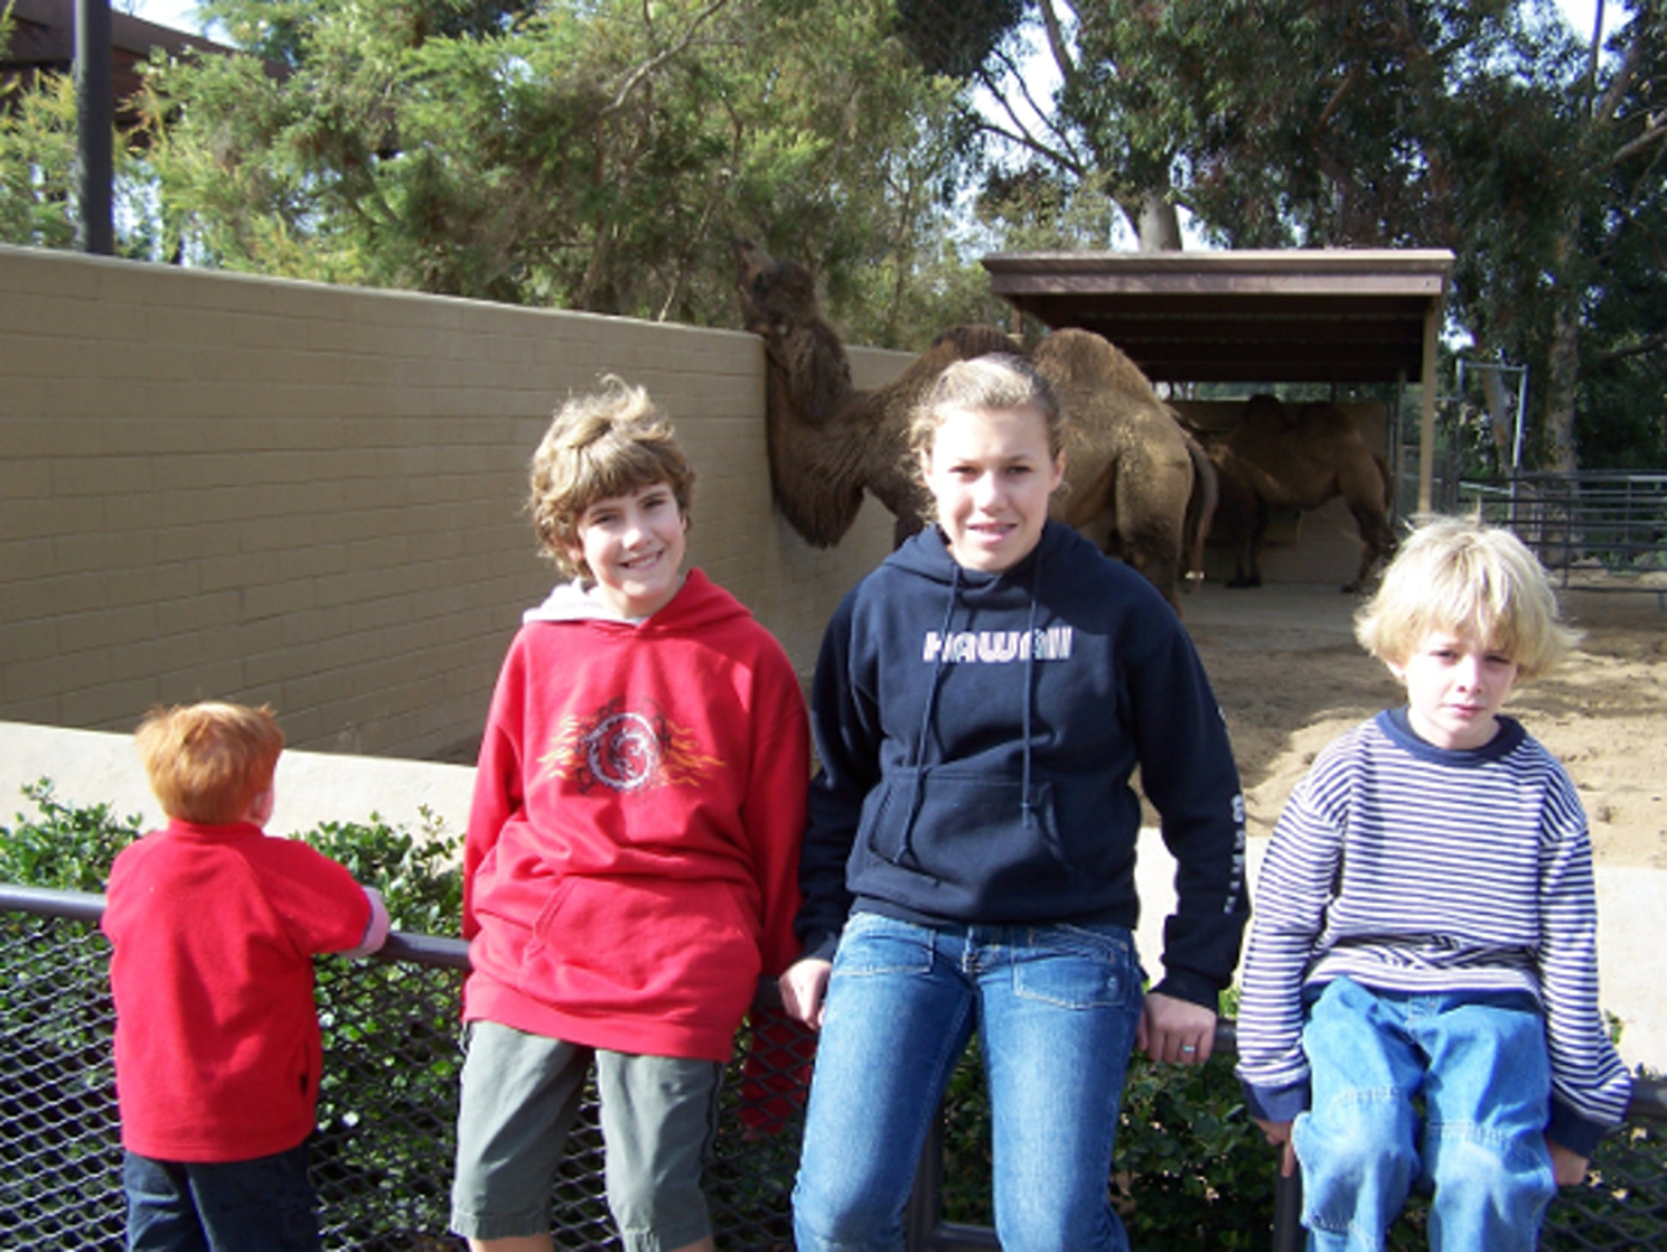

Figure 2- Emily and her three younger brothers

Emily is 13 years old. She is the oldest child and has three younger brothers. She is an eighth grader who attends Lakewood Elementary. Her favorite food is spaghetti and she loves camels. Her teacher gave her class a project to write about the things they love the most, so she decides to write about camels. Her dad planned a trip for her and her brothers to visit the Brookfield Zoo so that Emily can learn more about the camels. She saw a baby camel that she instantly fell in love with and wants to write more about it. Unfortunately, there was no placard about it, so her dad downloaded the "Zoo-Keeper App". He told Emily to use it to find more information about that camel where she learns that the camel's name is Camille and it was 4 months old. It had recently been transferred from Northern Africa with its mother. She then uses all of the information retrieved, as well as the pictures she took, to write her a paper. She was very much excited to hand the assignment in because she knew she had done a great job.

### Priorities Assigned to Users

Table 3: Priorities Assigned to Users

|  |  |
| --- | --- |
| **User Name/Category** | **Priorities** |
| **The Client(s) (Section 2a)/ IBEIS Research** | Overseers of project, Key Users |
| **The Customers /Outside world**   * **Zoo visitors** * **Safari tourist**   **Animal lovers** | Using App, Secondary and Unimportant Users |
| **Brookfield Zoo Director/ Brookfield Zoo** | Keeping location open, Unimportant User |
| **Developers/ Core Team** | Developing App, Key User |
| **Maintenance Users and Service Technicians/ Core Team** | Bug Fixing, Key User |

### User Participation

Table 4: User Participation

|  |  |
| --- | --- |
| **User Name/Category** | **Participation** |
| **The Client(s) (Section 2a)/ IBEIS Research** | Specifying requirements |
| **The Customers /Outside world**   * **Zoo visitors** * **Safari tourist**   **Animal lovers** | Testing App |
| **Brookfield Zoo Director/ Brookfield Zoo** | Allowing location to be used for testing |
| **Developers/ Core Team** | Developing |
| **Maintenance Users and Service Technicians/ Core Team** | Maintaining |

### Maintenance Users and Service Technicians

* See sections 2d-2g

## Mandated Constraints

### Solution Constraints

**Description:** The product shall use a GPS to communicate with the database.

**Rationale:** The client wishes to receive information about an animal he took a picture of.

**Fit Criterion:** Default setting for devices with GPS capability shall be set to "enabled".

**Description:** The product shall use a camera.

**Rationale:** The client wishes to take a photo of an animal to save for later or to receive further information on.

**Fit Criterion:** The device must have a built-in camera.

**Description:** The product shall operate on multiple mobile platforms.

**Rationale:** The product is to be readily available for different mobile users.

**Fit Criterion:** The product shall be cross-platform to be able to run on several mobile software platforms.

**Description:** The product shall be easy to use for the client.

**Rationale:** The client wants to be able to navigate the home screen with ease, take a picture of an animal, view their gallery, view the animal's information, or change their settings.

**Fit Criterion:** A small testing group will be used to test the number of clicks it takes to perform a desired action. 90% must be able to take a picture of an animal and view its page in fewer than 5 clicks.

**Description:** The product shall allow the user to enable or disable GPS.

**Rationale:** The client wishes to save battery or has chosen to disable the GPS during their first time setup.

**Fit Criterion:** The option shall be available in the settings page.

**Description:** The product shall show the user all available animals in a local area.

**Rationale:** The client wishes to look at information for other animals.

**Fit Criterion:** GPS must be enabled for the user to receive information from the database and view the animals within the local area.

### Implementation Environment of the Current System

The application will be installed onto the user's handheld device. Regardless of whether the user wishes to use the application for work or personal reasons, it should work the same. For best results, the user should enable GPS to enjoy the full capability of the application.

### Partner or Collaborative Application

IBEIS will be one of the collaborative operations.

### Off-the-Shelf Software

The application uses the mobile platform's built-in store in order for the user to download the app.

### Anticipated Workspace Environment

The user can run the application anytime as long as it is installed into the device. Once installed, the user should enable the GPS to be able to fully use the application. However, if the user wishes to disable the GPS, he will be unable to send pictures of the animal to the database.

### Schedule Constraints

The product development and its testing should meet the planned deadlines determined by the client and developers.

## Naming Conventions and Terminology

### Glossary of All Terms, Including Acronyms, Used by Stakeholders Involved in the Project

* **IBEIS:**  Image-Based Ecological Information System
* **GPS:** Global Positioning System
* **Key users:** They are critical to the continued success of the product. They also give greater importance to the requirements generated by this category of users. (Volere)
* **Secondary users:** They will use the product, but their opinion of it has no effect on its long-term success. Key users take precedence when there is a conflict between secondary users’ requirements and those of key users. (Volere)
* **Unimportant users:** This category of user is given the lowest priority. It includes infrequent, unauthorized, and unskilled users, as well as people who misuse the product. (Volere)
* **SDLC:** Software Development Life Cycle
* **SDM:** Spiral Method
* **GUI:** Graphical User Interface

## Relevant Facts and Assumptions

### Relevant Facts

* The existing application does not keep the medical records of the animals.
* There are 400 species of animals in Brookfield Zoo
* The zoo is spread over 60 acres of land and water containing about 2,000 animals
* There are zoo police patrols to keep track of any runaway or stolen animals.

### Business Rules

* Animal information is checked biweekly for updates.
* The application should be updated every month with new photos and details of new animals

### Assumptions

* The product is primarily English.
* The product will be obtained for free.
* The product should be running on any operating system platform.
* The product size is expected to be less than 50 megabytes.
* The product gives details of all animals in the zoo (alive or deceased).
* The United States government is planning to use the product in all zoos.

## The Scope of the Work

### The Current Situation

Currently, there is no product in place of "Zoo-Keeper App". This application will be one of the few interfaces for IBEIS. It will also have no effect on the system, but it does access the database, which grows as it continuously receives new data.

### The Context of the Work

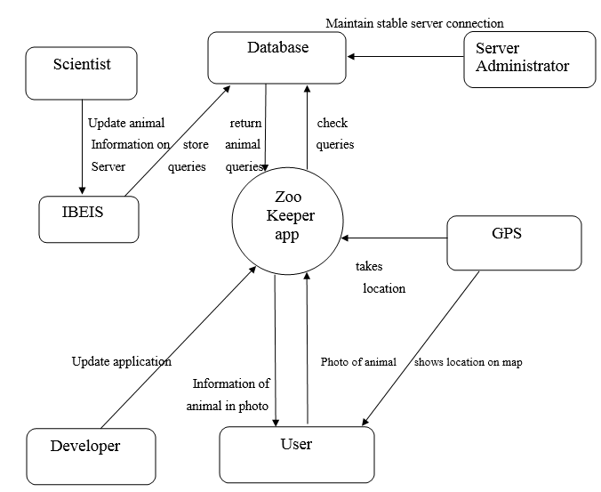

Figure 3 - The Context of the Work

### Work Partitioning

Table 5 - Work Partitioning

|  |  |  |
| --- | --- | --- |
| **Event Name** | **Input and Output** | **Summary of BUC** |
| 1. User clicks on photo of the animal | Camera click input | User clicks on the image of the animal whose information is required. |
| 1. User will be displayed a photo | Images (out) | Record the photo and display the image. |
| 1. Check database for specified animal | Animal (out) | Record the photo and check if the animal information exists in the database. |
| 1. Return animal information | Animal (in) | Recorded photo information will be displayed to the user from the database |
| 1. Store queries | Queries (out) | Record the queries |
| 1. Update animal information | Queries (out) | Any changes to the animal information will be updated. |
| 1. Update application | Code (in) | Record the application and it will be updated for better performance and usability. |
| 1. Retrieve the user location | Location (out) | Record the user location. |
| 1. Display the user location | Maps (out) | Recorded location will be displayed to the user. |

### Specifying a Business Use Case

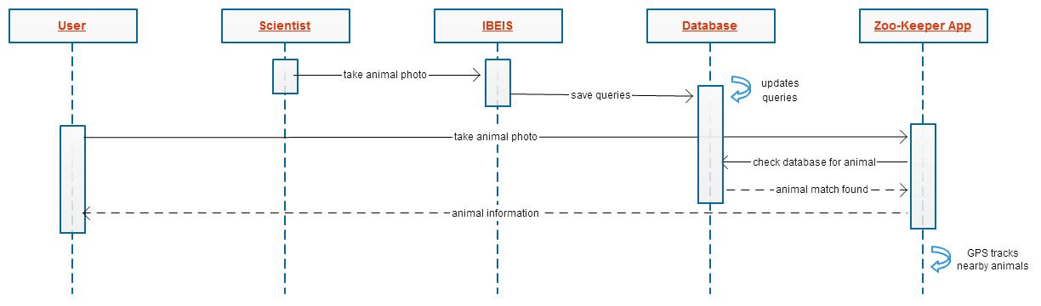

Figure 4 - Business Use Case Flow Diagram

For all scenarios, we will be using Bob and Joe as users of the product.

**Scenario 1:** User and Homepage

**Scenario 2:** First time setup with GPS disabled

**Scenario 3:** Camera Screen with GPS disabled

**Scenario 4:** User and Camera Screen

**Scenario 5:** User and Image Gallery

Table 6 - User Scenarios

|  |  |  |
| --- | --- | --- |
| **Scenario #** | **Individual User Scenarios** | **Descriptions** |
| **1** | User and Homepage | Joe opens up "Zoo-Keeper App" for the first time and is given a brief description of the application and the option to disable or enable the GPS. Joe does not want to enable the GPS on his phone and opts to disable it. He is then shown the home page and several button options, but the map does not show any available animals nearby. |
| **2** | First time setup with GPS disabled | Bob selects "take a photo" from the home screen and is taken to the camera screen page. Here, he sees the compass direction and is able to take a picture of the zebra he had been looking at. Bob then positions his camera to take a landscape photograph of the zebra and takes a picture. After snapping the photograph, Bob is taken to the "animal info" page where he views the information about the zebra he just photographed. |
| **3** | User and Camera Screen | Joe wants to take a photograph of a giraffe that he is curious about. He loads up the camera screen page to take a picture of the giraffe, but is given an error that he must enable his GPS in order to get information about an animal. Joe then goes back to the home page and selects the settings option to change his GPS settings. |
| **4** | Camera Screen with GPS disabled | Joe wants to take a photograph of a giraffe that he is curious about. He loads up the camera screen page to take a picture of the giraffe, but is given an error that he must enable his GPS in order to get information about an animal. Joe then goes back to the home page and selects the settings option to change his GPS settings. |
| **5** | User and Image Gallery | Bob selects "view photos" in his home page and sees two tabs along with the animals he photographed and images of animals that he followed. When Bob selects tab #1, he sees a scrolling list of animal images, but wants to filter the list. He sees the filter tab giving him four options: name, time, latitude/longitude, and compass direction. Bob then selects tab #2 which shows a map of his current area. Much like tab #1, he sees the similar options for his filter tab and to narrow down his images accordingly. |

## Business Data Model & Data Dictionary

### Business Data Model

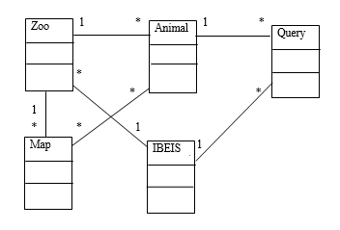

Figure 5 - Business Data Model

### Data Dictionary

Table 7 - Data Dictionary

|  |  |  |
| --- | --- | --- |
| **Name** | **Content** | **Type** |
| Zoo | Zoo Area +  Number of animals | Class |
| Animal | Image +  Information | Class |
| Map | Map area +  Coordinates | Class |
| IBEIS | Database | Class |
| Query | Query text | Class |
| Zoo Area | *Measured in square kilometers* | Attribute/element |
| Number of animals | *see database for number of animals in the zoo* | Attribute/element |
| Image | *image of the animal* | Attribute/element |
| Information | *see database for information of the animal* | Attribute/element |
| Map Area | *Area of the map displayed for the user* | Attribute/element |
| Coordinates | *Coordinates of the map displayed* | Attribute/element |
| Database | *Database associated with the IBEIS* | Attribute/element |
| Query text | *Description of the  query* | Attribute/element |

## The Scope of the Product

### Product Boundary

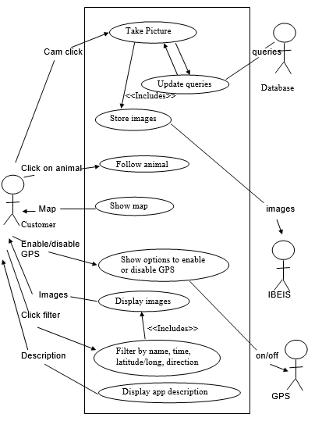

Figure 6 - Product Boundary Use Case Diagram

### Product Use Case Tables

|  |  |  |  |
| --- | --- | --- | --- |
| **PUC**  **No.** | **PUC Name** | **Actor/s** | **Input/output** |
| 1. | Take picture | Customer | Camera click |
| 2. | Update queries | Database | Queries (in) |
| 3. | Store Images | IBEIS | Images (out) |
| 4. | Follow animal | Customer | Click on photo of the animal (in) |
| 5. | Show map | Customer | Map out |
| 6. | Show option to enable/disable GPS | Customer  GPS | Enable/Disable GPS (in)  On/off (out) |
| 7. | Display Images | Customer | Images (out) |
| 8. | Filter by name, time, latitude/longitude, location | Customer | Click filter (in) |
| 9. | Display app description | Customer | Description (out) |

### Individual Product Use Cases

|  |
| --- |
| **Use case ID:** 1 **Name:** Take Picture  **Pre-conditions**: The app should be open and the user should be in the zoo with an animal in sight.  **Post conditions:** The picture is taken and sent to the IBEIS  **Initiated by:** User/customer  **Triggering event:** The user sees an animal in the zoo and wants its information. |
| **Sequence of events:**   1. User selects the camera mode    1. Application opens camera 2. User zooms and clicks on the picture of the animal.    1. The picture is stored in the phone memory and sent to the IBEIS. |
| **Alternate:** N/A  **Exception:** The phone memory is full and a picture cannot be clicked. |

|  |
| --- |
| **Use case ID:** 2 **Name:** Update queries  **Pre-conditions:** The app should be open and the picture of the animal should be taken.  **Post conditions:** The query is answered and the information displayed on the screen.  **Initiated by:** Picture taken.  **Triggering event:** User taking a picture. |
| **Sequence of events:**   1. User takes a picture    1. The picture is sent to the database and a match is found.       1. The information about that picture is displayed   3. User receives the information about the animal. |
| **Alternate:** The user can ask for more information that that is initially displayed.  **Exception:** There is no match found. The app cannot identify the animal whose picture is taken. |

|  |
| --- |
| **Use case ID:** 3 **Name:** Store Image  **Pre-conditions:** The app should be open and the picture of the animal should be taken.  **Post conditions:** The image is stored in the phone memory and in the IBEIS.  **Initiated by:** Picture taken.  **Triggering event:** User taking a picture. |
| **Sequence of events:**   1. User takes a picture    1. The picture is stored in the phone gallery.       1. A copy of the picture is also sent to the IBEIS. |
| **Alternate:** N/A  **Exception:** There is no memory on the phone to store a picture. |

|  |
| --- |
| **Use case ID:** 4 **Name:** Follow animal  **Pre-conditions:** User should be able to view the list of animals of that can be followed.  **Post conditions:** The user gets regular updates about the animal he/she followed.  **Initiated by:** User  **Triggering event:** User is interested in the information about an animal and wants to follow it. |
| **Sequence of events:**   1. User asks for list of animals.    1. The list is displayed. 2. User selects the animal he wishes to follow.    1. The available pictures and the information of that animal are copied to phone memory from the database. 3. The information and pictures are displayed.    1. Every time the information is updated the user is notified. |
| **Alternate:** The user could chose to follow any animal from the list of “My pictures”, i.e. , the pictures of animals taken by the user.  **Exception:** The database cannot be accessed. There is no memory on the phone to store pictures and data. |

|  |
| --- |
| **Use case ID:** 5 **Name:** Show map  **Pre-conditions:** User should be in the zoo and should have the GPS turned on.  **Post conditions:** The local area map is loaded.  **Initiated by:** User  **Triggering event:** User turns on the app. |
| **Sequence of events:**   1. User opens the app.    1. The GPS picks up the location of the user.    2. The map of area of 1 square kilometer around the user is retrieved from the database.    3. The map is displayed. 2. User sees the local area map displayed on the screen. |
| **Alternate:** The user can zoom in on a smaller area.  **Exception:** The database cannot be accessed. |

|  |
| --- |
| **Use case ID:** 6 **Name:** Show option to enable or disable GPS  **Pre-conditions:** User should be in the zoo.  **Post conditions:** The GPS is turned on/off according to the user’s choice.  **Initiated by:** User  **Triggering event:** User opens the app. |
| **Sequence of events:**   1. User opens the app.    1. The app checks if the GPS is on or off.    2. If it is on the system continues to load the map.    3. Else, the app suggests turning it on. 2. User decides whether to turn the GPS on or not    1. If the GPS is turned on, the map is loaded and photos can be taken    2. Else, map is unavailable and photos can’t be taken. |
| **Alternate:** N/A  **Exception:** There is no internet access to support the GPS. |

|  |
| --- |
| **Use case ID:** 7 **Name:** Display images  **Pre-conditions:** The user should have images in “My pictures” or “Animals followed” folder.  **Post conditions:** Images in the phone memory are displayed.  **Initiated by:** User  **Triggering event:** User selects the “My pictures” tab or “animals followed” tab. |
| 1. User clicks on “My pictures” folder.    1. The list of pictures are displayed as thumbnails. 2. User selects the pictures he wishes to see.    1. Selected pictured are displayed. |
| **Alternate:** User wishes to see more pictures of the animals, in which case they are copied from the database.  **Exception:** N/A |

|  |
| --- |
| **Use case ID:** 8 **Name:** Filter by name, time, latitude/longitude, location  **Pre-conditions:** The user should have images in “My pictures” or “Animals followed” folder.  **Post conditions:** Images are filtered as specified by the user.  **Initiated by:** User  **Triggering event:** User selects the Filter option. |
| **Sequence of events:**   1. User opens the gallery and clicks Filter.    1. The filter command shows a drop down menu with four options. 2. User selects the option he prefers.    1. The list is filtered accordingly. |
| **Alternate:** The user may want to filter animals found on the map.  **Exception:** N/A |

|  |
| --- |
| **Use case ID:** 9 **Name:** Display app description  **Pre-conditions:** The user should have the app installed on their phone.  **Post conditions:** The description of the app is displayed.  **Initiated by:** User  **Triggering event:** User opens the app for the first time. |
| **Sequence of events:**   1. User opens the app for the first time.    1. The description of the app is displayed. |
| **Alternate:** N/A  **Exception:** The app is not properly installed. So the description doesn’t open. |

## Functional Requirements

### Functional Requirements

|  |  |  |  |  |  |
| --- | --- | --- | --- | --- | --- |
| **Requirements #** | 1 | **PUC** | | 1,2.7 | |
| **Description** | This product shall allow users to upload images to the app after taking a picture | | | | |
| **Rationale** | To be able to retrieve information from the IBEIS database | | | | |
| **Originator** | Berger-Wolf/Oddone - Director | | | | |
| **Fit Criterion** | The picture shall be uploaded and information retrieved, including name, age, species, current location, parents, children, activities, etc., within 30 seconds for the user to save the information | | | | |
| **Customer Satisfaction** | **4** | | **Customer Dissatisfaction** | | **3** |
| **Dependencies** | All requirements regarding using IBEIS database | | | | |
| **Supporting Materials** | All work content diagrams | | | | |
| **History** | Created: February 2015 | | | | |

|  |  |  |  |  |  |
| --- | --- | --- | --- | --- | --- |
| **Requirements #** | 2 | **PUC** | | 2.7 | |
| **Description** | This product shall display detailed animal information to the user. | | | | |
| **Rationale** | To be able to learn about the animal they are interested in | | | | |
| **Originator** | Berger-Wolf/Oddone - Director | | | | |
| **Fit Criterion** | The picture shall be uploaded and information retrieved, including name, age, species, current location, parents, children, etc., within 30 seconds for the user to save the information | | | | |
| **Customer Satisfaction** | **4** | | **Customer Dissatisfaction** | | **3** |
| **Dependencies** | All requirements regarding using IBEIS database | | | | |
| **Supporting Materials** | All work content diagrams | | | | |
| **History** | Created: February 2015 | | | | |

|  |  |  |  |  |  |
| --- | --- | --- | --- | --- | --- |
| **Requirements #** | 3 | **PUC** | | 8 | |
| **Description** | This product have a search engine for user to search animals | | | | |
| **Rationale** | To be able to use the IBEIS database | | | | |
| **Originator** | Berger-Wolf/Oddone - Director | | | | |
| **Fit Criterion** | The information retrieved shall include name, age, species, current location, parents, children, etc., activity and be displayed within 30 seconds for the user to save the information | | | | |
| **Customer Satisfaction** | **4** | | **Customer Dissatisfaction** | | **3** |
| **Dependencies** | All requirements regarding using IBEIS database | | | | |
| **Supporting Materials** | All work content diagrams | | | | |
| **History** | Created: February 2015 | | | | |

|  |  |  |  |  |  |
| --- | --- | --- | --- | --- | --- |
| **Requirements #** | 4 | **PUC** | | 6 | |
| **Description** | This product shall automatic detect users current location on the map via the GPS | | | | |
| **Rationale** | To be able to locate the distance between them and the animals | | | | |
| **Originator** | Berger-Wolf/Oddone - Director | | | | |
| **Fit Criterion** | The locate between the animal and the user shall be shown on the map for the IBEIS database purposes | | | | |
| **Customer Satisfaction** | **4** | | **Customer Dissatisfaction** | | **3** |
| **Dependencies** | All requirements regarding using IBEIS database and GPS, #10 | | | | |
| **Supporting Materials** | All work content diagrams | | | | |
| **History** | Created: February 2015 | | | | |

|  |  |  |  |  |  |
| --- | --- | --- | --- | --- | --- |
| **Requirements #** | 5 | **PUC** | | 4,6 | |
| **Description** | This product shall use GPS to map highlights of nearby animals | | | | |
| **Rationale** | To be able to locate the animals home place, and zones of animals with similarities | | | | |
| **Originator** | Berger-Wolf/Oddone - Director | | | | |
| **Fit Criterion** | The locate of the animal and the user shall be shown on the map for the IBEIS database purposes | | | | |
| **Customer Satisfaction** | **4** | | **Customer Dissatisfaction** | | **3** |
| **Dependencies** | All requirements regarding using IBEIS database and GPS | | | | |
| **Supporting Materials** | All work content diagrams | | | | |
| **History** | Created: February 2015 | | | | |

|  |  |  |  |  |  |
| --- | --- | --- | --- | --- | --- |
| **Requirements #** | 6 | **PUC** | | 8 | |
| **Description** | This product shall allow users to select any animal for additional information | | | | |
| **Rationale** | To be able to retrieve more details | | | | |
| **Originator** | Berger-Wolf/Oddone - Director | | | | |
| **Fit Criterion** | The information shall be updated to date of latest picture upload | | | | |
| **Customer Satisfaction** | **4** | | **Customer Dissatisfaction** | | **3** |
| **Dependencies** | All requirements regarding using IBEIS database, #10 | | | | |
| **Supporting Materials** | All work content diagrams | | | | |
| **History** | Created: February 2015 | | | | |

|  |  |  |  |  |  |
| --- | --- | --- | --- | --- | --- |
| **Requirements #** | 7 | **PUC** | | 1,2,7,8 | |
| **Description** | This product shall notify users if uploading images to IBEIS or receiving information from IBEIS is taking longer than expected | | | | |
| **Rationale** | To be able to communicate with the user and provide feedback to user while using system | | | | |
| **Originator** | Berger-Wolf/Oddone - Director | | | | |
| **Fit Criterion** | The application should respond to user actions so that the user doesn’t become confused while using the system | | | | |
| **Customer Satisfaction** | **4** | | **Customer Dissatisfaction** | | **3** |
| **Dependencies** | All requirements regarding using IBEIS database and #1 | | | | |
| **Supporting Materials** | All work content diagrams | | | | |
| **History** | Created: February 2015 | | | | |

|  |  |  |  |  |  |
| --- | --- | --- | --- | --- | --- |
| **Requirements #** | 8 | **PUC** | | 1 | |
| **Description** | This product shall prompt users to continue taking pictures of animals | | | | |
| **Rationale** | To be able to provide updated information to be added to the IBEIS database | | | | |
| **Originator** | Berger-Wolf/Oddone - Director | | | | |
| **Fit Criterion** | All new information shall be given to users when access information for the animals of their choice with 30 seconds | | | | |
| **Customer Satisfaction** | **4** | | **Customer Dissatisfaction** | | **3** |
| **Dependencies** | All requirements regarding using IBEIS database | | | | |
| **Supporting Materials** | All work content diagrams | | | | |
| **History** | Created: February 2015 | | | | |

|  |  |  |  |  |  |
| --- | --- | --- | --- | --- | --- |
| **Requirements #** | 10 | **PUC** | | 6 | |
| **Description** | GPS settings must be enabled in user’s mobile device | | | | |
| **Rationale** | If the GPS settings are off, you cannot take a picture to send to the database | | | | |
| **Originator** | Berger-Wolf/Oddone - Director | | | | |
| **Fit Criterion** | The IBEIS database shall have twice as much data. The locating the animal is important information for the database. | | | | |
| **Customer Satisfaction** | **4** | | **Customer Dissatisfaction** | | **3** |
| **Dependencies** | All requirements regarding using IBEIS database and GPS | | | | |
| **Supporting Materials** | All work content diagrams | | | | |
| **History** | Created: February 2015 | | | | |

|  |  |  |  |  |  |
| --- | --- | --- | --- | --- | --- |
| **Requirements #** | 11 | **PUC** | | 9 | |
| **Description** | Product must provide donate option to users before exiting the application | | | | |
| **Rationale** | For IBEIS Research and Development to continue to enhance the application an all continue further research done. | | | | |
| **Originator** | Berger-Wolf/Oddone - Director | | | | |
| **Fit Criterion** | Money donated to IBEIS shall exceed current status. | | | | |
| **Customer Satisfaction** | **4** | | **Customer Dissatisfaction** | | **3** |
| **Dependencies** | All requirements regarding using IBEIS database. | | | | |
| **Supporting Materials** | All work content diagrams | | | | |
| **History** | Created: February 2015 | | | | |

## Design Patterns

This section describes the different design patterns (with diagrams) used and how they would address the design goals and key requirements of this project.

### Design Goals

### Façade

### Observer

### Mediator

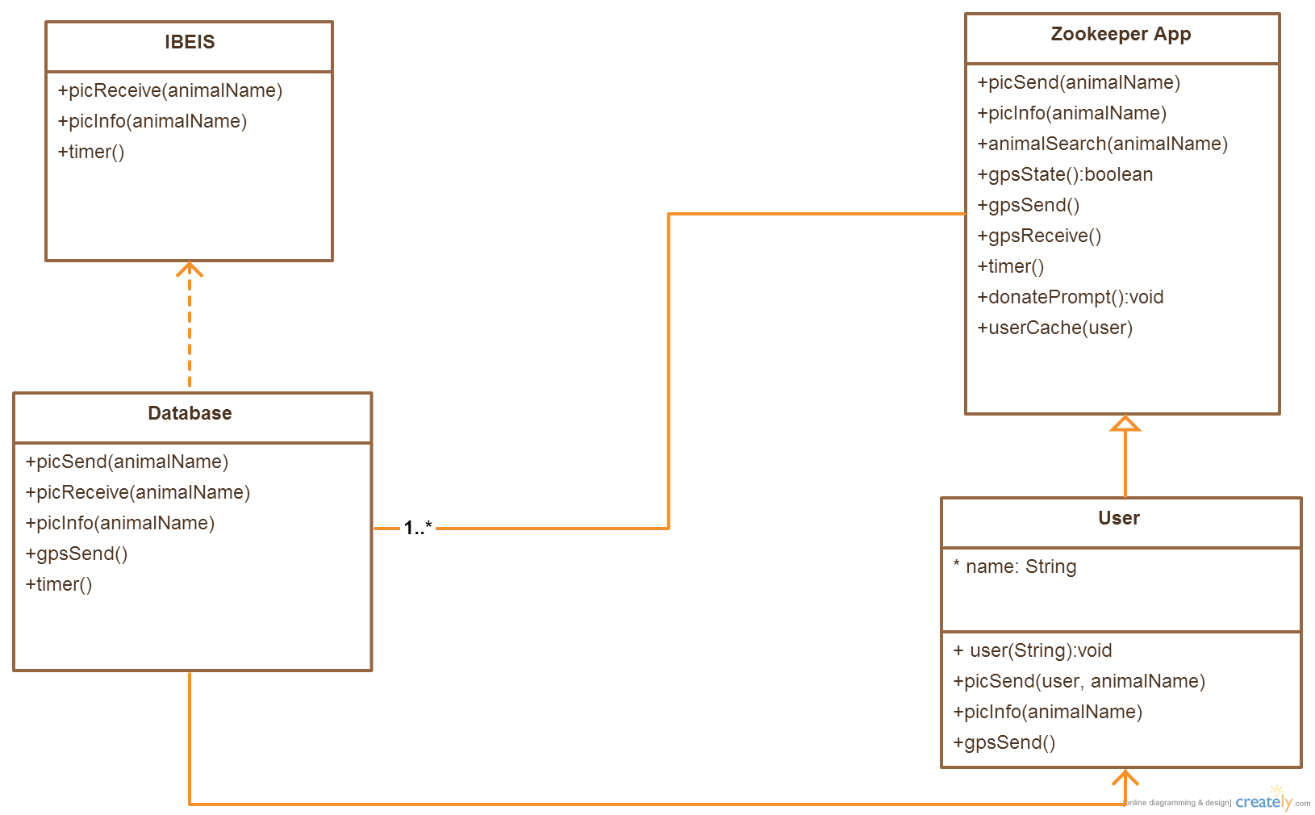

* **Manageability** - The user will be able to send pictures and receive information from the sent pictures. These are done by using picSend(animalName) and picInfo(animalName).
* **Performance** - The use of timer() checks to make sure that the application does not exceed the time required to perform a task. The donatePrompt() is also included to encourage existing users to contribute to the further success of the project.
* **Reliability** - The application will store a user cache that constantly saves the user's information so that it can reboot to the last known page before the crash occurred.
* **Scalability -** The database will be able to withstand numerous animal entries by IBEIS. This can be narrowed down by using the variable name, "animalName" which contains the animal name and species.
* **Securability** - The database will only retrieve information if the user enables GPS (specified as gpsState(), gpsSend(), and gpsReceive()) and is an existing member (username string).

### Key Requirements

### Façade

### Observer

### Mediator

All requirements must use the information gathered from the IBEIS database. Since the IBEIS database must include queries of many, if not thousands, of animal species, several classes such as picSend(animalname), picReceive(animalName), picInfo(animalName), and timer(). Both picSend() and picReceive() checks the queries on the database to update an existing animal or create a new entry. If an animal exists, the animal's information gets sent back to the application for the user to view. The timer() exists to make sure that the application does not exceed the time it takes to process the information for the user.

Additionally, the use of the GPS to upload and receive information about an animal is especially important when using the IBEIS database. The GPS is required to track the animal whereabouts and to also pinpoint the nearest location of last known recorded animal locations to the user. As a result, gpsState() is used to check if GPS is enabled or disabled. If gpsState() checks true, then the application will perform gpsSend() and gpsReceive() to display the location of any animals closest to the user.

Lastly, the application uses a donatePrompt() and userCache() to display the option to donate and to store the user's information into the device. The donatePrompt() class only shows if the user chooses to exit the application and encourages the user to donate to aid in the improvement of the application.