***“Zoo-Keeper App” Requirements Document***

**CS 442 – Spring 2015**

**Group 2 - Amber Moore, Bresia Prudente, Leela Sai Krishna Bollineni, Anusha Daggubati**

 

1 The Purpose of the Project 7

1a The User Business or Background of the Project 7

1b Goals of the Project 7

2 The Stakeholders 8

2a The Client 8

2b The Customer 8

2c All Stakeholders 9

2d Hands-On Users of the Project 10

2e Personas 10

2f Priorities Assigned to Users 11

2g User Participation 11

2h Maintenance Users and Service Technicians 12

3 Mandated Constraints 12

3a Solution Constraints 12

3b Implementation Environment of the Current System 12

3c Partner or Collaborative Application 13

3d Off-the-Shelf Software 13

3e Anticipated Workspace Environment 13

3f Schedule Constraints 13

4 Naming Conventions and Terminology 13

4a Glossary of All Terms, Including Acronyms, Used by Stakeholders Involved in the Project 13

5 Relevant Facts and Assumptions 13

5a Relevant Facts 13

5b Business Rules 14

5c Assumptions 14

6 The Scope of the Work 14

6a The Current Situation 14

6b The Context of the Work 15

6c Work Partitioning 15

6d Specifying a Business Use Case 16

7 Business Data Model & Data Dictionary 19

7a Business Data Model 19

7b Data Dictionary 19

8 The Scope of the Product 21

8a Product Boundary 21

8b Product Use Case Tables 22

8c Individual Product Use Cases 22

9 Functional Requirements 27

9a Functional Requirements 27

10 Look and Feel Requirements 35

10a Appearance Requirements 35

10b Style Requirements 35

11 Usability and Humanity Requirements 35

11a Ease of Use Requirements 35

11b Personalization and International Requirements 36

11c Learning Requirements 36

11d Understandability and Politeness Requirement 36

11e Accessibility Requirements 37

12 Performance Requirements 37

12a Speed and Latency Requirements 37

12b Safety-Critical Requirements 37

12c Precision or Accuracy Requirements 37

12d Reliability and Availability Requirements 37

12e Robustness or Fault-Tolerance Requirements 38

12f Capacity Requirements 38

12g Scalability or Extensibility Requirements 38

12h Longevity Requirements 38

13 Operational and Environmental Requirements 39

13a Excepted Physical Environment 39

13b Requirements for Interfacing with Adjacent Systems 39

13c Productization Requirements 39

13d Release Requirements 39

14 Maintainability and Support Requirements 40

14a Maintenance Requirements 40

14b Supportability Requirements 40

14c Adaptability Requirements 40

15 Security Requirements 40

15a Access Requirements 40

15b Integrity Requirements 41

15c Privacy Requirements 41

15d Audit Requirements 41

15e Immunity Requirements 41

16 Cultural Requirements 42

16a Cultural Requirements 42

17 Compliance Requirements 42

17a Legal Compliance Requirements 42

17b Standards Compliance Requirements 42

18 Open Issues 43

19 Off-the-Shelf Solutions 43

19a Ready-Made Products 43

19b Reusable Components 43

19c Products That Can Be Copied 43

20 New Problems 43

20a Effects on the Current Environment 43

20b Effects on the Installed Systems 43

20c Potential User Problems 43

20d Limitations on the Anticipated Implementation Environment That May Inhibit the New Product 43

20e Follow-Up Problems 43

21 Tasks 43

21a Project Planning 43

21b Planning of the Development Phases 43

22 Migration to the New Product 43

22a Requirements for Migration to the New Product 43

22b Data That Has to Be Modified or Translated for the New System 43

23 Risks 44

24 Costs 44

25 User Documentation and Training 44

25a User Documentation Requirements 44

25b Training Requirements 44

26 Waiting Room 44

27 Ideas for Solutions 44

## The Purpose of the Project

### The User Business or Background of the Project

The project proposed is the "Zoo-Keeper App". This application will be one of the few interfaces for the Image-Based Ecological Information System (IBEIS). According to IBEIS.org, "IBEIS is a large autonomous computational system that starts from image collections and progresses all the way to answering ecological and conservation queries, such as population sizes, species interactions, and movement patterns". It can detect various species of animals through images of those animals and identify individual animals of most striped, spotted, wrinkled or notched species. Field scientists, tourists, incidental photographers, and others take the images. The information is stored into a database and is made available for those who want to study the animal and its behavior. The "Zoo-Keeper App" is a phone application for zoo visitors and it allows them to take a picture of any animal at a zoo and instantly get information about that animal directly to their phone. For example, a student is interested in a zebra he spotted at Brookfield Zoo. After snapping a few pictures he learns that it is Kathy, a 3-year-old female Grevy’s Zebra. He learns where she has been and whom she has been with. This information is compiled from pictures of the animal that were taken over the last day, month, and year.

The purpose of this project is for tourist visits to the zoo be transitioned into a digital era. When a tourist is at a zoo, he reads a placard to learn about the animals located in the habitat. This information can be outdated or simply too much to read. The "Zoo-Keeper App" will provide updated information about the animals as well as recent photos and a more exciting zoo experience. The project will also allow animal researchers to get a better understanding of animals and their behaviors.

### Goals of the Project

**Purpose:** The purpose of us investing in this project is to create a tool that would make it easier for zoo visitors to learn about the animals they care about.

**Advantage:** The benefit of completing this project will be for the IBEIS program to have users who will bring in more information that could help expand the research.

**Measurement:** We will calculate the number of application users, if there is a large amount (at least 1,000), and the amount of new data that is collected via the IBEIS program to determine if the benefit has been achieved.

## The Stakeholders

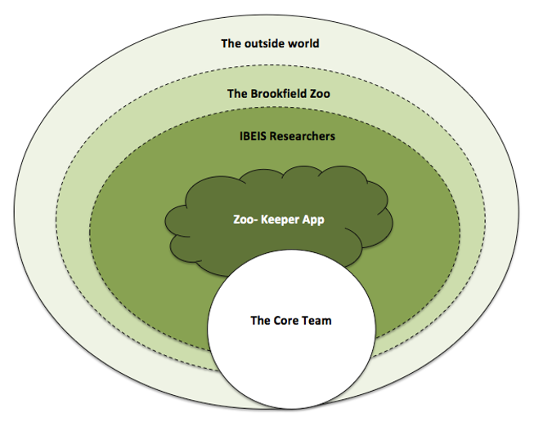

Figure 1: The Stakeholder Map

### The Client

The client for this project is Professor Tanya Berger-Wolf (Director of Computational Population Biology Lab at the University of Illinois in Chicago (UIC)) and her graduate assistant, Alessandro Oddone. Berger-Wolf plans to test the app at Brookfield Zoo and for other research projects. (See Table 1 for details)

### The Customer

The customers of this product are zoo visitors, safari tourist, animal researchers, and anyone with an affinity for animals. They shall download the application. (See Table 1 for details.)

### All Stakeholders

Table 1: Stakeholders List

|  |  |  |  |
| --- | --- | --- | --- |
| **Stakeholder Identification** | **Category**  **(See figure 1)** | **Knowledge** | **Degree of Involvement** |
| **The Client(s) (Section 2a)** | IBEIS Research | IBEIS Research and Database | High |
| **The Customers**   * **Zoo visitors** * **Safari tourist** * **Animal lovers** | Outside world | Using a mobile app | High |
| **Brookfield Zoo Director** | Brookfield Zoo | Brookfield Zoo whereabouts such as:  -Number of animals  -Different types of animals | Medium |
| **Developers** | Core Team | Programming/App Developing | High |
| **Maintenance Users and Service Technicians** | Core Team | App maintenance | High |

### Hands-On Users of the Project

Table 2: The Hands-On Users of the Project

|  |  |  |  |
| --- | --- | --- | --- |
| Stakeholder Identification | Category (See figure 1) | Degree of Influence | Decisions |
| The Client(s) (Section 2a) | IBEIS Research | High | Go/No Go |
| **The Customers**   * **Zoo visitors** * **Safari tourist** * **Animal lovers** | Outside world | High | Purchase |
| Brookfield Zoo Director | Brookfield Zoo | Medium | Location for testing App |
| Developers | Core Team | High | Design Patterns |
| **Maintenance Users and Service Technicians** | Core Team | High | Bug Fixes |

### Personas

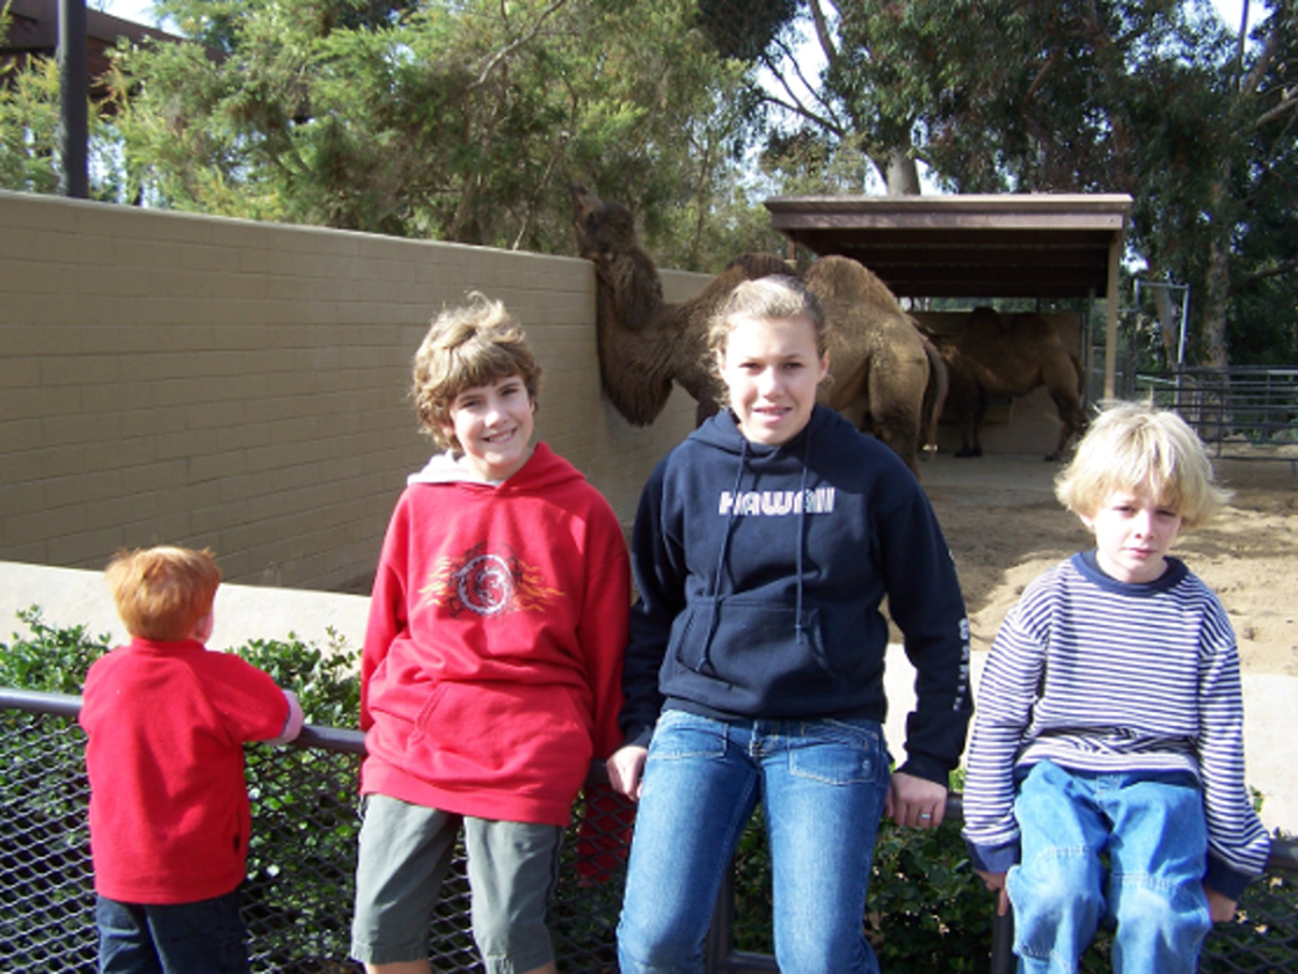

Figure 2- Emily and her three younger brothers

Emily is 13 years old. She is the oldest child and has three younger brothers. She is an eighth grader who attends Lakewood Elementary. Her favorite food is spaghetti and she loves camels. Her teacher gave her class a project to write about the things they love the most, so she decides to write about camels. Her dad planned a trip for her and her brothers to visit the Brookfield Zoo so that Emily can learn more about the camels. She saw a baby camel that she instantly fell in love with and wants to write more about it. Unfortunately, there was no placard about it, so her dad downloaded the "Zoo-Keeper App". He told Emily to use it to find more information about that camel where she learns that the camel's name is Camille and it was 4 months old. It had recently been transferred from Northern Africa with its mother. She then uses all of the information retrieved, as well as the pictures she took, to write her a paper. She was very much excited to hand the assignment in because she knew she had done a great job.

### Priorities Assigned to Users

Table 3: Priorities Assigned to Users

|  |  |
| --- | --- |
| **User Name/Category** | **Priorities** |
| **The Client(s) (Section 2a)/ IBEIS Research** | Overseers of project, Key Users |
| **The Customers /Outside world**   * **Zoo visitors** * **Safari tourist**   **Animal lovers** | Using App, Secondary and Unimportant Users |
| **Brookfield Zoo Director/ Brookfield Zoo** | Keeping location open, Unimportant User |
| **Developers/ Core Team** | Developing App, Key User |
| **Maintenance Users and Service Technicians/ Core Team** | Bug Fixing, Key User |

### User Participation

Table 4: User Participation

|  |  |
| --- | --- |
| **User Name/Category** | **Participation** |
| **The Client(s) (Section 2a)/ IBEIS Research** | Specifying requirements |
| **The Customers /Outside world**   * **Zoo visitors** * **Safari tourist**   **Animal lovers** | Testing App |
| **Brookfield Zoo Director/ Brookfield Zoo** | Allowing location to be used for testing |
| **Developers/ Core Team** | Developing |
| **Maintenance Users and Service Technicians/ Core Team** | Maintaining |

### Maintenance Users and Service Technicians

* See sections 2d-2g

## Mandated Constraints

### Solution Constraints

**Description:** The product shall use a GPS to communicate with the database.

**Rationale:** The client wishes to receive information about an animal he took a picture of.

**Fit Criterion:** Default setting for devices with GPS capability shall be set to "enabled".

**Description:** The product shall use a camera.

**Rationale:** The client wishes to take a photo of an animal to save for later or to receive further information on.

**Fit Criterion:** The device must have a built-in camera.

**Description:** The product shall operate on multiple mobile platforms.

**Rationale:** The product is to be readily available for different mobile users.

**Fit Criterion:** The product shall be cross-platform to be able to run on several mobile software platforms.

**Description:** The product shall be easy to use for the client.

**Rationale:** The client wants to be able to navigate the home screen with ease, take a picture of an animal, view their gallery, view the animal's information, or change their settings.

**Fit Criterion:** A small testing group will be used to test the number of clicks it takes to perform a desired action. 90% must be able to take a picture of an animal and view its page in fewer than 5 clicks.

**Description:** The product shall allow the user to enable or disable GPS.

**Rationale:** The client wishes to save battery or has chosen to disable the GPS during their first time setup.

**Fit Criterion:** The option shall be available in the settings page.

**Description:** The product shall show the user all available animals in a local area.

**Rationale:** The client wishes to look at information for other animals.

**Fit Criterion:** GPS must be enabled for the user to receive information from the database and view the animals within the local area.

### Implementation Environment of the Current System

The application will be installed onto the user's handheld device. Regardless of whether the user wishes to use the application for work or personal reasons, it should work the same. For best results, the user should enable GPS to enjoy the full capability of the application.

### Partner or Collaborative Application

IBEIS will be one of the collaborative operations.

### Off-the-Shelf Software

The application uses the mobile platform's built-in store in order for the user to download the app.

### Anticipated Workspace Environment

The user can run the application anytime as long as it is installed into the device. Once installed, the user should enable the GPS to be able to fully use the application. However, if the user wishes to disable the GPS, he will be unable to send pictures of the animal to the database.

### Schedule Constraints

The product development and its testing should meet the planned deadlines determined by the client and developers.

## Naming Conventions and Terminology

### Glossary of All Terms, Including Acronyms, Used by Stakeholders Involved in the Project

* **IBEIS:**  Image-Based Ecological Information System
* **GPS:** Global Positioning System
* **Key users:** They are critical to the continued success of the product. They also give greater importance to the requirements generated by this category of users. (Volere)
* **Secondary users:** They will use the product, but their opinion of it has no effect on its long-term success. Key users take precedence when there is a conflict between secondary users’ requirements and those of key users. (Volere)
* **Unimportant users:** This category of user is given the lowest priority. It includes infrequent, unauthorized, and unskilled users, as well as people who misuse the product. (Volere)
* **SDLC:** Software Development Life Cycle
* **SDM:** Spiral Method
* **GUI:** Graphical User Interface

## Relevant Facts and Assumptions

### Relevant Facts

* The existing application does not keep the medical records of the animals.
* There are 400 species of animals in Brookfield Zoo
* The zoo is spread over 60 acres of land and water containing about 2,000 animals
* There are zoo police patrols to keep track of any runaway or stolen animals.

### Business Rules

* Animal information is checked biweekly for updates.
* The application should be updated every month with new photos and details of new animals

### Assumptions

* The product is primarily English.
* The product will be obtained for free.
* The product should be running on any operating system platform.
* The product size is expected to be less than 50 megabytes.
* The product gives details of all animals in the zoo (alive or deceased).
* The United States government is planning to use the product in all zoos.

## The Scope of the Work

### The Current Situation

Currently, there is no product in place of "Zoo-Keeper App". This application will be one of the few interfaces for IBEIS. It will also have no effect on the system, but it does access the database, which grows as it continuously receives new data.

### The Context of the Work

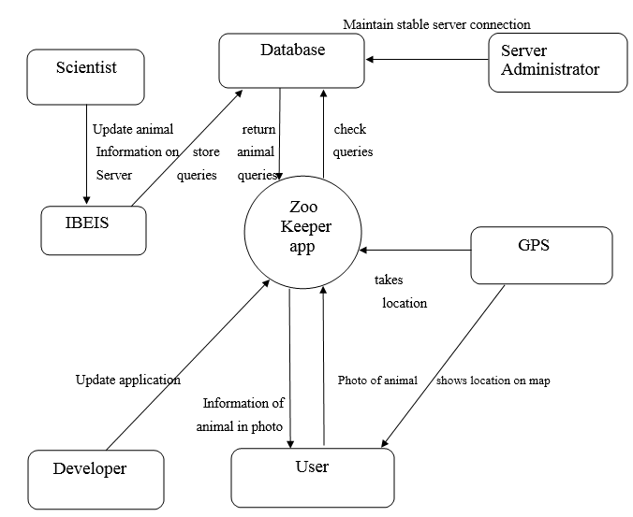

Figure 3 - The Context of the Work

### Work Partitioning

Table 5 - Work Partitioning

|  |  |  |
| --- | --- | --- |
| **Event Name** | **Input and Output** | **Summary of BUC** |
| 1. User clicks on photo of the animal | Camera click input | User clicks on the image of the animal whose information is required. |
| 1. User will be displayed a photo | Images (out) | Record the photo and display the image. |
| 1. Check database for specified animal | Animal (out) | Record the photo and check if the animal information exists in the database. |
| 1. Return animal information | Animal (in) | Recorded photo information will be displayed to the user from the database |
| 1. Store queries | Queries (out) | Record the queries |
| 1. Update animal information | Queries (out) | Any changes to the animal information will be updated. |
| 1. Update application | Code (in) | Record the application and it will be updated for better performance and usability. |
| 1. Retrieve the user location | Location (out) | Record the user location. |
| 1. Display the user location | Maps (out) | Recorded location will be displayed to the user. |

### Specifying a Business Use Case

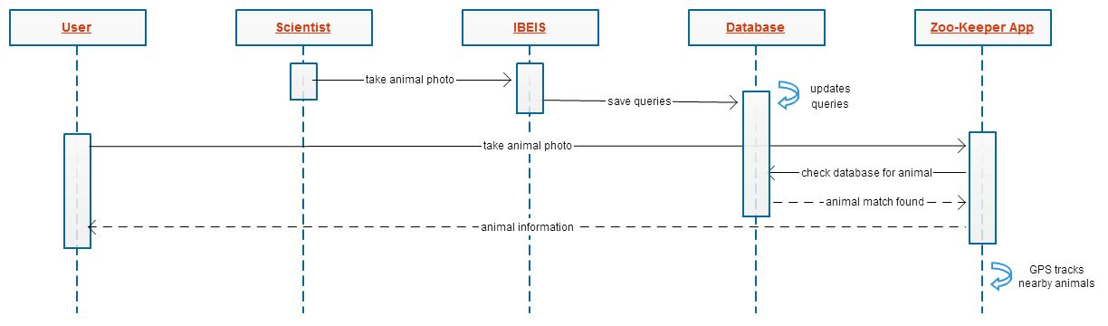

Figure 4 - Business Use Case Flow Diagram

For all scenarios, we will be using Bob and Joe as users of the product.

**Scenario 1:** User and Homepage

**Scenario 2:** First time setup with GPS disabled

**Scenario 3:** Camera Screen with GPS disabled

**Scenario 4:** User and Camera Screen

**Scenario 5:** User and Image Gallery

Table 6 - User Scenarios

|  |  |  |
| --- | --- | --- |
| **Scenario #** | **Individual User Scenarios** | **Descriptions** |
| **1** | User and Homepage | Joe opens up "Zoo-Keeper App" for the first time and is given a brief description of the application and the option to disable or enable the GPS. Joe does not want to enable the GPS on his phone and opts to disable it. He is then shown the home page and several button options, but the map does not show any available animals nearby. |
| **2** | First time setup with GPS disabled | Bob selects "take a photo" from the home screen and is taken to the camera screen page. Here, he sees the compass direction and is able to take a picture of the zebra he had been looking at. Bob then positions his camera to take a landscape photograph of the zebra and takes a picture. After snapping the photograph, Bob is taken to the "animal info" page where he views the information about the zebra he just photographed. |
| **3** | User and Camera Screen | Joe wants to take a photograph of a giraffe that he is curious about. He loads up the camera screen page to take a picture of the giraffe, but is given an error that he must enable his GPS in order to get information about an animal. Joe then goes back to the home page and selects the settings option to change his GPS settings. |
| **4** | Camera Screen with GPS disabled | Joe wants to take a photograph of a giraffe that he is curious about. He loads up the camera screen page to take a picture of the giraffe, but is given an error that he must enable his GPS in order to get information about an animal. Joe then goes back to the home page and selects the settings option to change his GPS settings. |
| **5** | User and Image Gallery | Bob selects "view photos" in his home page and sees two tabs along with the animals he photographed and images of animals that he followed. When Bob selects tab #1, he sees a scrolling list of animal images, but wants to filter the list. He sees the filter tab giving him four options: name, time, latitude/longitude, and compass direction. Bob then selects tab #2 which shows a map of his current area. Much like tab #1, he sees the similar options for his filter tab and to narrow down his images accordingly. |

## Business Data Model & Data Dictionary

### Business Data Model

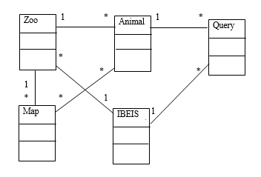

Figure 5 - Business Data Model

### Data Dictionary

Table 7 - Data Dictionary

|  |  |  |
| --- | --- | --- |
| **Name** | **Content** | **Type** |
| Zoo | Zoo Area +  Number of animals | Class |
| Animal | Image +  Information | Class |
| Map | Map area +  Coordinates | Class |
| IBEIS | Database | Class |
| Query | Query text | Class |
| Zoo Area | *Measured in square kilometers* | Attribute/element |
| Number of animals | *see database for number of animals in the zoo* | Attribute/element |
| Image | *image of the animal* | Attribute/element |
| Information | *see database for information of the animal* | Attribute/element |
| Map Area | *Area of the map displayed for the user* | Attribute/element |
| Coordinates | *Coordinates of the map displayed* | Attribute/element |
| Database | *Database associated with the IBEIS* | Attribute/element |
| Query text | *Description of the  query* | Attribute/element |

## The Scope of the Product

### Product Boundary

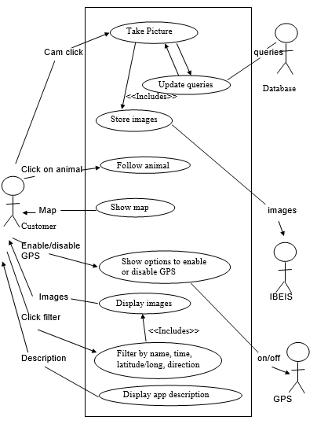

Figure 6 - Product Boundary Use Case Diagram

### Product Use Case Tables

|  |  |  |  |
| --- | --- | --- | --- |
| **PUC**  **No.** | **PUC Name** | **Actor/s** | **Input/output** |
| 1. | Take picture | Customer | Camera click |
| 2. | Update queries | Database | Queries (in) |
| 3. | Store Images | IBEIS | Images (out) |
| 4. | Follow animal | Customer | Click on photo of the animal (in) |
| 5. | Show map | Customer | Map out |
| 6. | Show option to enable/disable GPS | Customer  GPS | Enable/Disable GPS (in)  On/off (out) |
| 7. | Display Images | Customer | Images (out) |
| 8. | Filter by name, time, latitude/longitude, location | Customer | Click filter (in) |
| 9. | Display app description | Customer | Description (out) |

### Individual Product Use Cases

|  |
| --- |
| **Use case ID:** 1 **Name:** Take Picture  **Pre-conditions**: The app should be open and the user should be in the zoo with an animal in sight.  **Post conditions:** The picture is taken and sent to the IBEIS  **Initiated by:** User/customer  **Triggering event:** The user sees an animal in the zoo and wants its information. |
| **Sequence of events:**   1. User selects the camera mode    1. Application opens camera 2. User zooms and clicks on the picture of the animal.    1. The picture is stored in the phone memory and sent to the IBEIS. |
| **Alternate:** N/A  **Exception:** The phone memory is full and a picture cannot be clicked. |

|  |
| --- |
| **Use case ID:** 2 **Name:** Update queries  **Pre-conditions:** The app should be open and the picture of the animal should be taken.  **Post conditions:** The query is answered and the information displayed on the screen.  **Initiated by:** Picture taken.  **Triggering event:** User taking a picture. |
| **Sequence of events:**   1. User takes a picture    1. The picture is sent to the database and a match is found.       1. The information about that picture is displayed   3. User receives the information about the animal. |
| **Alternate:** The user can ask for more information that that is initially displayed.  **Exception:** There is no match found. The app cannot identify the animal whose picture is taken. |

|  |
| --- |
| **Use case ID:** 3 **Name:** Store Image  **Pre-conditions:** The app should be open and the picture of the animal should be taken.  **Post conditions:** The image is stored in the phone memory and in the IBEIS.  **Initiated by:** Picture taken.  **Triggering event:** User taking a picture. |
| **Sequence of events:**   1. User takes a picture    1. The picture is stored in the phone gallery.       1. A copy of the picture is also sent to the IBEIS. |
| **Alternate:** N/A  **Exception:** There is no memory on the phone to store a picture. |

|  |
| --- |
| **Use case ID:** 4 **Name:** Follow animal  **Pre-conditions:** User should be able to view the list of animals of that can be followed.  **Post conditions:** The user gets regular updates about the animal he/she followed.  **Initiated by:** User  **Triggering event:** User is interested in the information about an animal and wants to follow it. |
| **Sequence of events:**   1. User asks for list of animals.    1. The list is displayed. 2. User selects the animal he wishes to follow.    1. The available pictures and the information of that animal are copied to phone memory from the database. 3. The information and pictures are displayed.    1. Every time the information is updated the user is notified. |
| **Alternate:** The user could chose to follow any animal from the list of “My pictures”, i.e. , the pictures of animals taken by the user.  **Exception:** The database cannot be accessed. There is no memory on the phone to store pictures and data. |

|  |
| --- |
| **Use case ID:** 5 **Name:** Show map  **Pre-conditions:** User should be in the zoo and should have the GPS turned on.  **Post conditions:** The local area map is loaded.  **Initiated by:** User  **Triggering event:** User turns on the app. |
| **Sequence of events:**   1. User opens the app.    1. The GPS picks up the location of the user.    2. The map of area of 1 square kilometer around the user is retrieved from the database.    3. The map is displayed. 2. User sees the local area map displayed on the screen. |
| **Alternate:** The user can zoom in on a smaller area.  **Exception:** The database cannot be accessed. |

|  |
| --- |
| **Use case ID:** 6 **Name:** Show option to enable or disable GPS  **Pre-conditions:** User should be in the zoo.  **Post conditions:** The GPS is turned on/off according to the user’s choice.  **Initiated by:** User  **Triggering event:** User opens the app. |
| **Sequence of events:**   1. User opens the app.    1. The app checks if the GPS is on or off.    2. If it is on the system continues to load the map.    3. Else, the app suggests turning it on. 2. User decides whether to turn the GPS on or not    1. If the GPS is turned on, the map is loaded and photos can be taken    2. Else, map is unavailable and photos can’t be taken. |
| **Alternate:** N/A  **Exception:** There is no internet access to support the GPS. |

|  |
| --- |
| **Use case ID:** 7 **Name:** Display images  **Pre-conditions:** The user should have images in “My pictures” or “Animals followed” folder.  **Post conditions:** Images in the phone memory are displayed.  **Initiated by:** User  **Triggering event:** User selects the “My pictures” tab or “animals followed” tab. |
| 1. User clicks on “My pictures” folder.    1. The list of pictures are displayed as thumbnails. 2. User selects the pictures he wishes to see.    1. Selected pictured are displayed. |
| **Alternate:** User wishes to see more pictures of the animals, in which case they are copied from the database.  **Exception:** N/A |

|  |
| --- |
| **Use case ID:** 8 **Name:** Filter by name, time, latitude/longitude, location  **Pre-conditions:** The user should have images in “My pictures” or “Animals followed” folder.  **Post conditions:** Images are filtered as specified by the user.  **Initiated by:** User  **Triggering event:** User selects the Filter option. |
| **Sequence of events:**   1. User opens the gallery and clicks Filter.    1. The filter command shows a drop down menu with four options. 2. User selects the option he prefers.    1. The list is filtered accordingly. |
| **Alternate:** The user may want to filter animals found on the map.  **Exception:** N/A |

|  |
| --- |
| **Use case ID:** 9 **Name:** Display app description  **Pre-conditions:** The user should have the app installed on their phone.  **Post conditions:** The description of the app is displayed.  **Initiated by:** User  **Triggering event:** User opens the app for the first time. |
| **Sequence of events:**   1. User opens the app for the first time.    1. The description of the app is displayed. |
| **Alternate:** N/A  **Exception:** The app is not properly installed. So the description doesn’t open. |

## Functional Requirements

### Functional Requirements

|  |  |  |  |  |  |
| --- | --- | --- | --- | --- | --- |
| **Requirements #** | 1 | **PUC** | | 1,2.7 | |
| **Description** | This product shall allow users to upload images to the app after taking a picture | | | | |
| **Rationale** | To be able to retrieve information from the IBEIS database | | | | |
| **Originator** | Berger-Wolf/Oddone - Director | | | | |
| **Fit Criterion** | The picture shall be uploaded and information retrieved, including name, age, species, current location, parents, children, activities, etc., within 30 seconds for the user to save the information | | | | |
| **Customer Satisfaction** | **4** | | **Customer Dissatisfaction** | | **3** |
| **Dependencies** | All requirements regarding using IBEIS database | | | | |
| **Supporting Materials** | All work content diagrams | | | | |
| **History** | Created: February 2015 | | | | |

|  |  |  |  |  |  |
| --- | --- | --- | --- | --- | --- |
| **Requirements #** | 2 | **PUC** | | 2.7 | |
| **Description** | This product shall display detailed animal information to the user. | | | | |
| **Rationale** | To be able to learn about the animal they are interested in | | | | |
| **Originator** | Berger-Wolf/Oddone - Director | | | | |
| **Fit Criterion** | The picture shall be uploaded and information retrieved, including name, age, species, current location, parents, children, etc., within 30 seconds for the user to save the information | | | | |
| **Customer Satisfaction** | **4** | | **Customer Dissatisfaction** | | **3** |
| **Dependencies** | All requirements regarding using IBEIS database | | | | |
| **Supporting Materials** | All work content diagrams | | | | |
| **History** | Created: February 2015 | | | | |

|  |  |  |  |  |  |
| --- | --- | --- | --- | --- | --- |
| **Requirements #** | 3 | **PUC** | | 8 | |
| **Description** | This product have a search engine for user to search animals | | | | |
| **Rationale** | To be able to use the IBEIS database | | | | |
| **Originator** | Berger-Wolf/Oddone - Director | | | | |
| **Fit Criterion** | The information retrieved shall included name, age, species, current location, parents, children, etc., activity and be displayed within 30 seconds for the user to save the information | | | | |
| **Customer Satisfaction** | **4** | | **Customer Dissatisfaction** | | **3** |
| **Dependencies** | All requirements regarding using IBEIS database | | | | |
| **Supporting Materials** | All work content diagrams | | | | |
| **History** | Created: February 2015 | | | | |

|  |  |  |  |  |  |
| --- | --- | --- | --- | --- | --- |
| **Requirements #** | 4 | **PUC** | | 6 | |
| **Description** | This product shall automatic detect users current location on the map via the GPS | | | | |
| **Rationale** | To be able to locate the distance between them and the animals | | | | |
| **Originator** | Berger-Wolf/Oddone - Director | | | | |
| **Fit Criterion** | The locate between the animal and the user shall be shown on the map for the IBEIS database purposes | | | | |
| **Customer Satisfaction** | **4** | | **Customer Dissatisfaction** | | **3** |
| **Dependencies** | All requirements regarding using IBEIS database and GPS, #10 | | | | |
| **Supporting Materials** | All work content diagrams | | | | |
| **History** | Created: February 2015 | | | | |

|  |  |  |  |  |  |
| --- | --- | --- | --- | --- | --- |
| **Requirements #** | 5 | **PUC** | | 4,6 | |
| **Description** | This product shall use GPS to map highlights of nearby animals | | | | |
| **Rationale** | To be able to locate the animals home place, and zones of animals with similarities | | | | |
| **Originator** | Berger-Wolf/Oddone - Director | | | | |
| **Fit Criterion** | The locate of the animal and the user shall be shown on the map for the IBEIS database purposes | | | | |
| **Customer Satisfaction** | **4** | | **Customer Dissatisfaction** | | **3** |
| **Dependencies** | All requirements regarding using IBEIS database and GPS | | | | |
| **Supporting Materials** | All work content diagrams | | | | |
| **History** | Created: February 2015 | | | | |

|  |  |  |  |  |  |
| --- | --- | --- | --- | --- | --- |
| **Requirements #** | 6 | **PUC** | | 8 | |
| **Description** | This product shall allow users to select any animal for additional information | | | | |
| **Rationale** | To be able to retrieve more details | | | | |
| **Originator** | Berger-Wolf/Oddone - Director | | | | |
| **Fit Criterion** | The information shall be updated to date of latest picture upload | | | | |
| **Customer Satisfaction** | **4** | | **Customer Dissatisfaction** | | **3** |
| **Dependencies** | All requirements regarding using IBEIS database, #10 | | | | |
| **Supporting Materials** | All work content diagrams | | | | |
| **History** | Created: February 2015 | | | | |

|  |  |  |  |  |  |
| --- | --- | --- | --- | --- | --- |
| **Requirements #** | 7 | **PUC** | | 1,2,7,8 | |
| **Description** | This product shall notify users if uploading images to IBEIS or receiving information from IBEIS is taking longer than expected | | | | |
| **Rationale** | To be able to communicate with the user and provide feedback to user while using system | | | | |
| **Originator** | Berger-Wolf/Oddone - Director | | | | |
| **Fit Criterion** | The application should respond to user actions so that the user doesn’t become confused while using the system | | | | |
| **Customer Satisfaction** | **4** | | **Customer Dissatisfaction** | | **3** |
| **Dependencies** | All requirements regarding using IBEIS database and #1 | | | | |
| **Supporting Materials** | All work content diagrams | | | | |
| **History** | Created: February 2015 | | | | |

|  |  |  |  |  |  |
| --- | --- | --- | --- | --- | --- |
| **Requirements #** | 8 | **PUC** | | 1 | |
| **Description** | This product shall prompt users to continue taking pictures of animals | | | | |
| **Rationale** | To be able to provide updated information to be added to the IBEIS database | | | | |
| **Originator** | Berger-Wolf/Oddone - Director | | | | |
| **Fit Criterion** | All new information shall be given to users when access information for the animals of their choice with 30 seconds | | | | |
| **Customer Satisfaction** | **4** | | **Customer Dissatisfaction** | | **3** |
| **Dependencies** | All requirements regarding using IBEIS database | | | | |
| **Supporting Materials** | All work content diagrams | | | | |
| **History** | Created: February 2015 | | | | |

|  |  |  |  |  |  |
| --- | --- | --- | --- | --- | --- |
| **Requirements #** | 10 | **PUC** | | 6 | |
| **Description** | GPS settings must be enabled in user’s mobile device | | | | |
| **Rationale** | If the GPS settings are off, you cannot take a picture to send to the database | | | | |
| **Originator** | Berger-Wolf/Oddone - Director | | | | |
| **Fit Criterion** | The IBEIS database shall have twice as much data. The locating the animal is important information for the database. | | | | |
| **Customer Satisfaction** | **4** | | **Customer Dissatisfaction** | | **3** |
| **Dependencies** | All requirements regarding using IBEIS database and GPS | | | | |
| **Supporting Materials** | All work content diagrams | | | | |
| **History** | Created: February 2015 | | | | |

|  |  |  |  |  |  |
| --- | --- | --- | --- | --- | --- |
| **Requirements #** | 11 | **PUC** | | 9 | |
| **Description** | Product must provide donate option to users before exiting the application | | | | |
| **Rationale** | For IBEIS Research and Development to continue to enhance the application an all continue further research done. | | | | |
| **Originator** | Berger-Wolf/Oddone - Director | | | | |
| **Fit Criterion** | Money donated to IBEIS shall exceed current status. | | | | |
| **Customer Satisfaction** | **4** | | **Customer Dissatisfaction** | | **3** |
| **Dependencies** | All requirements regarding using IBEIS database. | | | | |
| **Supporting Materials** | All work content diagrams | | | | |
| **History** | Created: February 2015 | | | | |

## Look and Feel Requirements

### Appearance Requirements

**Requirement:** This product shall be attractive to user ages 7 and older.

**Rationale:** For the app to be likeable for kids who are the majority of visitors of the zoo.

**Fit Criterion:** A sampling of representative children ages 7-15, 16-21, and 21 and older, which will given the application and within 5 minutes begin using it

**Requirements:** The product must have non-distractive, bright, and attractive colors on all screens of the app that follow use of color rules.

**Rationale:** To keep the user engaged while using the app.

**Fit Criterion:** Survey a group of users to determine how they felt after using the app.

### Style Requirements

**Requirements:** This product shall appear trustworthy.

**Rationale:** For users to be willing to give access to photos for the database

**Fit Criterion:** Our goal is that 80 percent of the users trust the app. We will users of all ages.

**Requirements:** This product shall appear interactive

**Rationale:** For users to be encourage to use the app often.

**Fit Criterion:** The amount of new data added to the IBEIS database will determine the number of users and how often they use the app.

## Usability and Humanity Requirements

### Ease of Use Requirements

**Requirement:** The application shall be easy for anyone over 10 years of age.

**Fit Criterion:** 90% of the 10 year olds shall be able to successfully perform the following tasks in less than 10 minutes

* Take a picture of the animal
* Enable GPS to send animal pictures to the database or view available animals on the local map
* Find the animal's information page

**Requirement:** The application shall require the user to have no prior training.

**Fit Criterion:** Users who use the product for the first time shall be able to perform the tasks in less than 10 minutes.

**Requirement:** The application shall help the user avoid making mistakes.

**Fit Criterion:** Using the application for a week shall yield a total error rate of less than 1 percent.

**Requirement:** The application shall be used constantly.

**Fit Criterion:** An anonymous survey shall show that the application used by 65% of the intended users have used the product after the becoming familiar with it for a week.

### Personalization and International Requirements

* The application shall retain the user's settings, such as enabling or disabling GPS.
* The application shall allow the user to follow and view animals that he either took pictures of or are in the local area.

### Learning Requirements

**Requirement:** The application shall be easy for any individual who know Basic English.

**Fit Criterion:** 98% of users shall be able to navigate the application without asking to clarify.

**Requirement:** Users do not need to have any prior knowledge of how to use the application.

**Fit Criterion:** 95% of the users shall be able to successfully perform the following tasks in 5 minutes.

* Taking pictures of the animal
* Change their settings
* Enable the GPS after being given an error message

### Understandability and Politeness Requirement

* The application uses words and symbols that are naturally understandable by the community.
* The application does not offend any religion or political parties.

### Accessibility Requirements

* This application shall be accessible for colorblind individuals.
* The application shall conform to the Disabilities Act.

## Performance Requirements

### Speed and Latency Requirements

* The application must not take more than 15 seconds to boot up.
* The application must not take more than 1 second to respond to the user's input.
* When the user takes a picture of the animal, it must not take more than 10 seconds to retrieve the information from the database.
* When the user sends the photograph of an animal to the database, it must not take longer than 10 seconds.

### Safety-Critical Requirements

**Requirement:** The application must not consume too many Random Access Memory (RAM) on any given handheld device.

**Fit Criterion:** The application should make sure that it does not consume too much RAM on the handheld device. Should this ever occur, the application or handheld device shall display a warning to the user indicating a RAM error?

**Requirement:** The application must not cause any mobile processors to overheat substantially.

**Fit Criterion:** The application should immediately exit if the mobile processor exceeds 85 degrees Fahrenheit.

### Precision or Accuracy Requirements

* All animal names and information must be accurate and use proper spelling and grammar.
* The application must be able to respond to the user's input at least once.

### Reliability and Availability Requirements

* The application will be available for the user 24 hours every day.
* If the application has any available updates, the user must be able to have those updates installed into their handheld device.
* In the case of failure, the application must be able to save the last known animal information the user was viewing.
* If the application fails while the player sends the animal to the database, they will be able to retry.
* The application should be able to run every time the user starts it. For every 100-application startup by the same user, it should not fail more than 5% of the time.

### Robustness or Fault-Tolerance Requirements

* If the application freezes or crashes, the user must be able to view the last page he was viewing.
* If the user's handheld device loses power while using the application, he will be able to view the last page he was on.
* If the application is unable to enable GPS in 30 seconds, it will continue to attempt a connection for 5 minutes. If it cannot detect a GPS, it will notify the user and then switch the GPS to disabled.

### Capacity Requirements

* Updates for the game should be kept under a limited memory for all handheld devices.
* The file should not exceed the capacity based on the policy of the mobile platform's built-in stores.

### Scalability or Extensibility Requirements

* The database will be able to handle a substantial amount of queries for thousands of animals. This number is expected to increase as users upload more photographs of these animals.

### Longevity Requirements

* The application will be tested intensively for bugs and issues before being released to the market.
* The application will be expected to operate for a minimum of 4 years.

## Operational and Environmental Requirements

### Excepted Physical Environment

* The product shall be used in the specified zoo.
* The product will also work in dim light provided there is a flash to the mobile.
* The product can be used where there is internet availability within the zoo.
* Any mobile user in any conditions like cold, windy, rainy, shall use the product**.**

### Requirements for Interfacing with Adjacent Systems

**Requirement:** The product must be in interface with the camera of the mobile.

**Rationale:** For the user to easily capture image of animal

**Fit criterion:** The app must connect with the mobile camera within 1 sec

**Requirement:** The product must work in any version of Android or IOS in case it is updated.

**Rationale:** As the mobiles keep updating it is better to make app run in all versions.

**Fit Criterion:** The app must check the version and accordingly show the required update for the app within 2 sec.

**Requirement:** The new data that is added must sync with the previous information from the database.

**Rationale:** There should not be any ambiguity for the same information

**Fit criterion:** The new information must over write the older information with 100% efficiency

### Productization Requirements

* The installation process of the product must be easily understandable so that even the first time users should not face any difficulties.
* The colors, fonts, pictures that are used in the product must be attractive and clear so that they are easily saleable.
* The product must be of small size in memory.

### Release Requirements

**Requirement:** The product will be updated and released once in 6months with new modifications.

**Rationale:** So as to deliver new attachments and better the performance

**Fit Criterion:** The new update must be updated in 5sec.

**Requirement:** Each new release must not cause any data loss from the old version.

**Rationale:** All the information will be the same as of the previous version.

**Fit Criterion:** The data lost from old version due to installation of new release must be less than 0.01%.

## Maintainability and Support Requirements

### Maintenance Requirements

**Requirement:** The product can be maintained and updated by the user as well at any time.

**Rationale:** So as to easily access and update any new data

**Fit criterion:** More than 95% of the users are updating the information of the app.

### Supportability Requirements

**Requirement:** The information that is updated by the users should be very quick

**Rationale:** Users does not like to waste time

**Fit Criterion:** 95% of the users must update information in less than 2 sec

**Requirement:** The help option in the product must give entire description how the app works

**Rationale:** Makes the work easy for the user.

**Fit Criterion:** More than 90% of the people must be satisfied with the help option

### Adaptability Requirements

* The product must run under any operating systems like IOS, Android etc.
* The product can be used worldwide as it can support any language

## Security Requirements

### Access Requirements

* The zoo staff cannot directly change the information of any animal. They can only suggest changes if any. Only the IBEIS can actually change it.
* Only the user can see his location on the map. The exact position of the user is unavailable to the database and the IBEIS

### Integrity Requirements

* The database shall protect the data it transmits and receives from unsophisticated attack involving unauthorized addition, modification or deletion.
* The database must log any attempt by the administrator to authorize any user to bypass the administrator-configured data integrity controls

### Privacy Requirements

* The product shall inform the user of any information that is being used i.e., the location of the user or the animals the user follows.
* The product shall notify the users if the information policy is changed

### Audit Requirements

**Requirement:** The product shall maintain a log of the dates on which it is updated.

**Rationale:** To keep track of updated date and information

**Requirement:** The product shall maintain list of all authorized people who can make changes to the database.

**Rationale:** So that only authorize people can access data.

**Fit criterion:** Only 60% of the users can access data.

### Immunity Requirements

**Requirement:** The application shall scan all entered or downloaded data and pictures against the published definitions of known viruses, worms, malware, spyware and other undesirable interference.

**Rationale:** To keep the product free from malware

**Fit criterion:** 95% of the users must run the product smoothly.

**Requirement:** The application shall delete the infected file if found.

**Rationale:** To make product run fast and efficiently.

**Fit criterion:** All the infected files must be removed within 1min after being infected

**Requirement:** The application shall daily update its list of published definitions of known harmful programs.

**Rationale:** To check the details of infected files and their reason for infection

**Fit criterion:** More than 98% of harmful programs are defined daily.

## Cultural Requirements

### Cultural Requirements

**Requirement:** The application shall be able to display and take information in American English, British English, French and Spanish.

**Rationale:** So that it can be used all over the world

**Fit criterion:** More than 65% people all over the world can use this product

**Requirement:** The application shall not be offensive to any religious or ethnic group.

**Rationale:** So that it can be used by all kinds of people irrespective of religion

**Fit criterion:** Not even a single case has been registered against the product based on ethnic issues

## Compliance Requirements

### Legal Compliance Requirements

**Requirement:** This product shall abide by all Animal Protection laws of the U.S.

**Rationale:** For animals to not be abused by users of the app

**Fit Criterion:** No complaints filed by Brookfield or other Zoos where app is tested.

**Requirements:** This product shall abide by Copyright laws of IBEIS.

**Rationale:** To allow IBEIS research to enhance

**Fit Criterion:** IBEIS Research has improved since release of product

**Requirements:** This product shall abide by all laws of Brookfield Zoo.

**Rationale:** For IBIES Research to utilize the location for testing

**Fit Criterion:** There shall be a monthly testing prior to release of product.

**Requirement:** Personal information shall be implemented so as to comply with the Data Protection Act.

**Fit Criterion:** Users don’t deactivate their account due to distrust of app.

### Standards Compliance Requirements

**Requirement:** This product shall abide by all application developing standards.

**Rationale:** For users to be familiar with app

**Fit Criterion:** Users continue to use app often.

**Requirement:** This product shall abide by all research facilities standards.

**Rationale:** For IBEIS to continue research worldwide

**Fit Criterion:** Twice as many research institutions will recognize IBEIS.

## Open Issues

|  |  |  |  |  |  |
| --- | --- | --- | --- | --- | --- |
| **Issue Number** | **Cross reference to affected requirements** | **Summary of the issue** | **Stakeholders involved** | **Action** | **Resolution** |
| 1 | Section 3c, solution constraints | This product shall be available on multiple platform, but developers are only testing on Android devices. | Developer, Core Team | Develop app on Android | Develop later version on more platforms |

## Off-the-Shelf Solutions

### Ready-Made Products

The “Zoo-Keeper” Application will be the first of its kind. No current mobile device application are used for the purpose of this product. The closet solution is the IBEIS Online Database System used by professionals which is currently being developed.

### Reusable Components

Current the IBEIS Database will be reuse for the application along with other IBEIS systems. This shall take weeks to implement into a mobile platform.

### Products That Can Be Copied

The Graphical User Interface (GUI) for the application will be remodel after the online version of the system. This shall take a week or two to implement onto the mobile platform.

## New Problems

### Effects on the Current Environment

* Information being displayed electronically will affect zoos that constantly update or use placards.

### Effects on the Installed Systems

There will be no effect on the system since there will be no system installed within the application.

### Potential User Problems

* Users who are not comfortable or familiar with the use of an electronic device will find some difficulty using the application.

### Limitations on the Anticipated Implementation Environment That May Inhibit the New Product

* IBEIS is not powerful enough to cope with the projected queries.
* The server is not powerful enough to cope with the growth of the projected queries.
* The application will not be able to run on all mobile platforms.

### Follow-Up Problems

* The server loses all of the queries, resulting in the users unable to look up information for a particular animal.
* IBEIS should be able to handle a large number of information and the server should be able to handle the growth of the queries.

## Tasks

### Project Planning

The "Zoo-Keeper" application is intended to be used by all types of users, regardless of whether the product will be used for personal or work purposes. This means that the application will have to undergo an extensive amount of testing prior to its release to the general public to ensure that the users of the product will not encounter any bugs or technical issues. Additionally, as the product is part of a large project that includes the contributions by many researchers, it also requires a substantial amount of time and money to be invested. As a result, using the Spiral Method (SDM) of the Software Development Life Cycle (SDLC) models would be the best approach for this project.

### Planning of the Development Phases

|  |  |
| --- | --- |
| **Phase** | **Description** |
| Planning | Functional and non-functional requirements are gathered by means of trawling, interviews, and brainstorming. |
| Risk Analysis | Requirements are thoroughly analyzed to identify potential risks. Any risks found during the analysis encourages alternate solutions to be implemented. Once all of the risks are identified, a prototype is produced at the end of the phase. |
| Engineering | Develop the software using the prototype created during the risk analysis phase. Product also undergoes testing to ensure that it works as expected and meets the requirements from the planning phase. It is important that the product must be able to communicate with IBEIS and the server properly. |
| Evaluation | Customers use the product at a zoo for evaluation and provide feedback. |

## Migration to the New Product

### Requirements for Migration to the New Product

### Data That Has to Be Modified or Translated for the New System

## Risks

## Costs

## User Documentation and Training

### User Documentation Requirements

### Training Requirements

## Waiting Room

All requirements must be fulfilled upon release.

## Ideas for Solutions