## The Scope of the Work

### The Current Situation

"Zoo-Keeper App" incorporates the Image-Based Ecological Information System (IBEIS) to use the most updated information for any given animal. The user will be able to make use of a more updated information for that animal instead of an outdated or wordy placard. Additionally, users performing field work will be able to differentiate animals instead of relying on written information.

### The Context of the Work

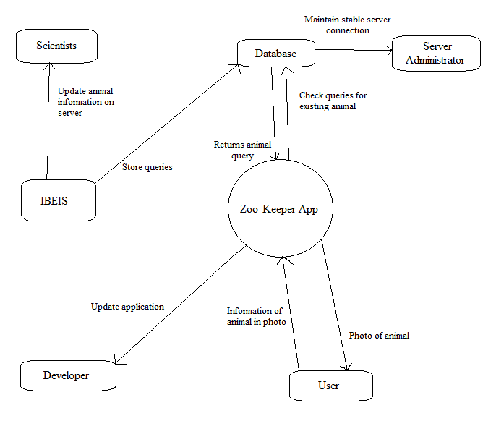

## The Scope of the Product

### Scenario Diagram(s)

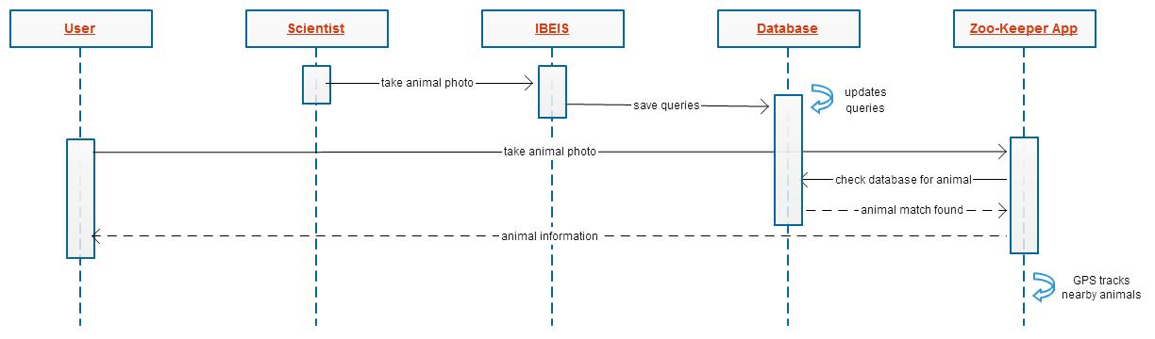

### Product Scenario List

**Scenario 1:** User and Home Page

**Scenario 1a:** First time setup with GPS disabled

**Scenario 2:** User and Camera Screen

**Scenario 2a:** Camera Screen with GPS disabled

**Scenario 3:** User and Image Gallery

### Individual Product Scenarios

For all product scenarios, we will be using Bob and Joe as a users of the product.

**Scenario 1:** User and Home Page

Bob opens up "Zoo-Keeper App" for the first time and is given a brief description of the application as well as the option to disable or enable GPS. He leaves the GPS enabled as it suggests that leaving it is highly recommended. Afterwards, he sees the home page giving him several buttons: take a photo, view photos, and settings. He also sees a small, local map displaying all available animals nearby.

**Scenario 1a:** First time setup with GPS disabled

Joe opens up "Zoo-Keeper App" for the first time and is given a brief description of the application and the option to disable or enable the GPS. Joe does not want to enable the GPS on his phone and opts to disable it. He is then shown the home page and several button options, but the map does not show any available animals nearby.

**Scenario 2:** User and Camera Screen

Bob selects "take a photo" from the home screen and is taken to the camera screen page. Here, he sees the compass direction and is able to take a picture of the zebra he had been looking at. Bob then positions his camera to take a landscape photograph of the zebra and takes a picture. After snapping the photograph, Bob is taken to the "animal info" page where he views the information about the zebra he just photographed.

**Scenario 2a:** Camera Screen with GPS disabled

Joe wants to take a photograph of a giraffe that he is curious about. He loads up the camera screen page to take a picture of the giraffe, but is given an error that he must enable his GPS in order to get information about an animal. Joe then goes back to the home page and selects the settings option to change his GPS settings.

**Scenario 3:** User and Image Gallery

Bob selects "view photos" in his home page and sees two tabs along with the animals he photographed and images of animals that he followed. When Bob selects tab #1, he sees a scrolling list of animal images, but wants to filter the list. He sees the filter tab giving him four options: name, time, latitude/longitude, and compass direction. Bob then selects tab #2 which shows a map of his current area. Much like tab #1, he sees the similar options for his filter tab and to narrow down his images accordingly.