**“Zoo-Keeper App”**

**Requirements Document Summary**

**Group 2 - Amber Moore, Bresia Prudente, Leela Sai Krishna Bollineni, Anusha Daggubati**

**Project Description, Purpose, and Context of the Work**

The project proposed is the "Zoo-Keeper App". This application will be one of the few interfaces for the Image-Based Ecological Information System (IBEIS). The app will be able to detect various species of animals through images of those animals and identify individual animals of most striped, spotted, wrinkled or notched. Those images will be stored into the IBEIS database and is made available for those who want to study the animal and its behavior via the user’s phone. This app is to be used mainly by zoo-visitors, by eventually be used by safari tourist, field scientists, incidental photographers, and etc.

The purpose of this project is to bring the way tourists visit the zoo into the digital era. Currently when at a zoo, the “visitor” is forced to read a placard to find out information on the animals located in the habitat. This information can be outdated or simply too much to read. The "Zoo-Keeper App" will give updated information of the animals as well as recent photos and a more exciting zoo experience. The project will also allow researchers, who study animals, to get a better understand of animals and their behaviors.

**Context of the Work Diagram**

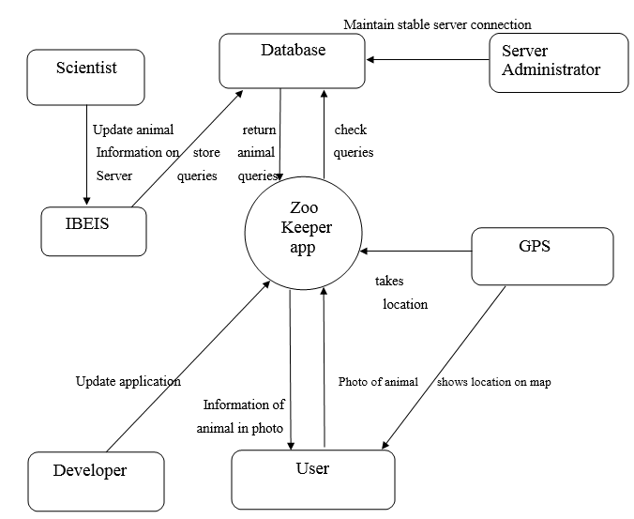

**Design Patterns**

**Facade**

**Observer**

**Mediator**

We focus primarily on performance and scalability due to the tremendous amount of queries that the IBEIS database needs to store and sort. Also, all of the key requirements rely on the queries of the IBEIS database, which is not only complex and contains a vast amount of animal queries, but also needs to be able to quickly pinpoint the animal that the user would look like to view information on. Lastly, in the diagram, we use the "Zookeeper App" as the mediator, the User as the concrete colleague, the database as the mediator interface, and IBEIS as the concrete mediator.

**Conclusion**

The “Zoo-Keeper App” borrows information taken from the database, which retrieves queries from IBEIS, for the purpose of educating the public about a particular zoo animal.