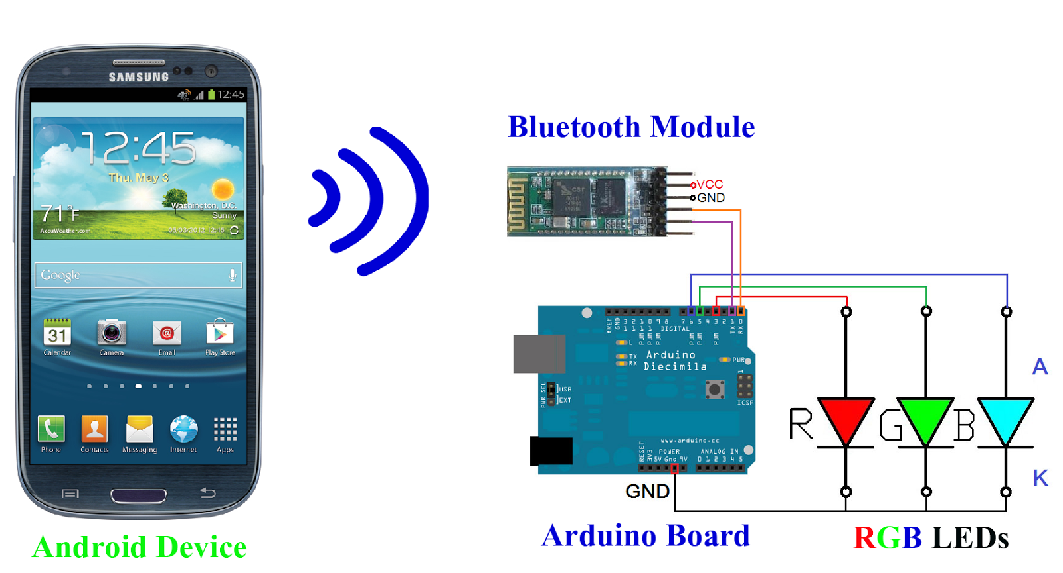
Figure 6
Using a Bluetooth, Arduino, breadboard, and an RGB led (or several), the Fancy Scooter can allow the user to customize the color of the scooter lights. This is controlled through an Android phone application which will give the user the ability to configure the color of the lights. The user can choose from a variety of different colors by selecting from a particular shade on the color wheel and this will send a value to RGB led via the Bluetooth (Figure 6). If the user decides to turn off the led, a button can be pressed to turn the led on and off.

A similar project can be found here:
http://www.instructables.com/id/Controlling-an-RGB-Led-with-Arduino-and-Processing/?ALLSTEPS
A video of this project at work can be viewed here:
https://www.youtube.com/watch?v=i8iETqm7k_I

