INVENTORY MANAGEMENT SYSTEM WITH POINT OF SALE (POS) FOR 5AR AGRIVET

BAM 285 Final Course Work

Presented to the Faculty of the
College Information Technology Education
Phinma University of Iloilo
Rizal, Iloilo City

In Partial Fulfillment
of the Requirements for the Degree
Bachelor of Science in Information Technology

by

Macapayag, Ryan
Bautista, John Reuben
Tano, Joshua
Genandoy, Jhon Paulo
Amualla, Jaspher
Manzo, Derek Angelo
Calubihan, Angelo

October 2026

INVENTORY MANAGEMENT SYSTEM WITH POINT OF SALE (POS) FOR 5AR AGRIVET

BAM 285 Final Course Work
Bachelor of Science in Information Technology

By
Ryan Macapayag
John Reuben Bautista
Joshua Tano

________________________  Marlo Kyn B. Bunda  (Panel) | ________________________  Kristine Anne Laguna  (Panel)
________________________  Jenny Rose Montillie  (Panel) | ________________________  Jireh A. Flavio  (Adviser)

Concurred:
________________________  Marlo Kyn B. Bunda  BAM 285, Project Lead | ________________________  Seth D. Nono, MSCS  Dean

October 2026

ABSTRACT
ABSTRACT
5AR Agrivet is a business in the agrivet sector, selling chicken feeds and other agrivet supplies. Its owner, Fritz Basco, writes down each sale on paper with a pen. As a result, keeping track of sales and monitoring inventories is time-consuming. Mr. Basco also has a job as a seaman, and he is away from the store for considerable stretches of time. He wants to be able to monitor the sales and stock levels of 5AR Agrivet even when he is not there.
Handwritting sales and stock is time consuming and prone to errors. Research in retail stores has found that the recorded stock does not necessarily match the actual stock on the shelves [1, 2] and that small retail stores with manual stock management have difficulty in producing a sales report [3, 4].
The system to be designed is Web-based Inventory Management System along with Point of Sale (POS). It centralizes products, categories, suppliers, stock movements, sales, receipts and reports. The POS at the counter totals up every sale, logs the transaction, displays the receipt on the screen and removes items from inventory when they are sold. The inventory side manages the product inventory and a history of all the stock-in and stock-out movements. The dashboard and reports provide the owner with information about what was sold and what products require attention. It has administrator and staff accounts, and maintains an activity log of significant actions. It is created in PHP, MySQL, HTML, CSS, JavaScript and Bootstrap and deployed online on the InfinityFree platform, allowing it to be accessed via web browser and internet connection. The records are kept in an online database, which means that the owner can log in from his administrator account and check the dashboard, sales history, sales reports and inventory reports, even if he is not in the store.
Systems analysis and design techniques were adopted in the project, including: Stakeholder analysis, SIPOC analysis, Current-state and Future-state process analysis, Root-cause analysis, and Requirements engineering. The system is designed to save time in sales recording, reduce errors, provide the owner with organised and up to date records and allow the owner to view them from a distance. A test plan consisting of 62 test cases was developed, with six of these for the owner's remote monitoring, and a questionnaire for the user evaluation. This paper does not assert a complete validation of the system, since the results of the formal testing, the remote-access tests and the user evaluation are not yet complete.

ACKNOWLEDGEMENTS
The researchers would like to thank everyone who helped make this project possible.
First, to our adviser, Jireh A. Flavio, for his guidance, advice, and patience throughout the development of this project. To the panel members, Marlo Kyn B. Bunda, Kristine Anne Laguna, Jenny Rose Montillie, and Jireh A. Flavio, for their comments and suggestions that helped improve the system and this paper. And to the faculty of the College of Information Technology Education of Phinma University of Iloilo for the knowledge and support they gave us.
To Fritz Basco, owner of 5AR Agrivet, for giving his time and for explaining how the business records its sales and manages its stock. His situation is the reason this project exists.
To our families, for their love, understanding, and encouragement, and to our groupmates, for the effort, patience, and teamwork that helped us finish this work.

TABLE OF CONTENTS
ABSTRACT i
ACKNOWLEDGEMENTS iii
TABLE OF CONTENTS iv
LIST OF TABLES viii
LIST OF FIGURES x
CHAPTER 1 INTRODUCTION 1
1.1 Background of the Project 1
1.2 Statement of the Problem 3
1.2.1 General Problem 3
1.2.2 Specific Problems 3
1.3 Objectives of the Project 4
1.3.1 General Objective 4
1.3.2 Specific Objectives 5
1.4 Significance of the Project 6
1.5 Purpose and Description 7
1.6 Scope and Limitation 8
CHAPTER 2 REVIEW OF RELATED LITERATURE AND SYSTEMS 12
2.1 Related Literature 12
2.2 Related Systems 14
2.3 Synthesis 16
CHAPTER 3 METHODOLOGY, RESULTS AND DISCUSSION 18
3.1 Requirements Analysis 18
3.1.1 Stakeholder Analysis 18
3.1.2 SIPOC Analysis 21
3.1.3 Current-State Process 25
3.1.4 Problems Identified 26
3.1.5 Root-Cause Analysis 29
3.1.6 Requirements Engineering 30
3.2 Framework of the Project 40
3.2.1 Conceptual Framework 40
3.2.2 Proposed Future-State Process 41
3.2.3 Before-and-After Process Comparison 42
3.2.4 Proposed System Modules 46
3.2.5 Business Logic and Automation Rules 48
CHAPTER 4 SYSTEM IMPLEMENTATION, TESTING, AND EVALUATION 51
4.1 Introduction 51
4.2 Development Tools and Technologies 51
4.3 System Architecture and Deployment 53
4.3.1 System Architecture 53
4.3.2 Online Deployment 54
4.3.3 Remote Monitoring by the Owner 55
4.4 System Modules and Features 57
4.4.1 Use Cases 57
4.4.2 Data Flow Diagrams 62
4.4.3 Process Flowcharts 64
4.4.4 Implemented Modules and Features 67
4.5 Database Design and Structure 70
4.6 User Interface and System Screenshots 86
4.7 System Testing and Results 98
4.7.1 Testing Approach 98
4.7.2 Preliminary Run During Development 98
4.7.3 Test Plan Summary 101
4.7.4 Test Results 102
4.8 Evaluation and Discussion 102
4.8.1 Evaluation Status 102
4.8.2 Discussion 103
4.8.3 Limitations and Observations 106
4.9 Chapter Summary 107
CHAPTER 5 CONCLUSION AND RECOMMENDATIONS 109
5.1 Introduction 109
5.2 Summary of the Proposed Study Design and Implementation 109
5.3 Summary of Findings 110
5.4 Conclusion 115
5.5 Recommendations 116
REFERENCES 122
APPENDIX A Test Cases 125
APPENDIX B User Guide 173
B.1 Opening the System 173
B.2 Logging In and Out 173
B.3 Using the Dashboard 173
B.4 Making a Sale (POS) 174
B.5 Viewing Receipts and Sales History 174
B.6 Managing Products 175
B.7 Managing Categories and Suppliers 175
B.8 Recording Stock In and Stock Out 175
B.9 Viewing Reports 176
B.10 Managing Users and Viewing the Activity Log (Administrator Only) 176
B.11 Monitoring the Business Remotely (Owner) 177
APPENDIX C User Evaluation Questionnaire 179
C.1 Purpose and Respondents 179
C.2 The Questionnaire 179
C.3 Computing and Reporting the Results 186

LIST OF TABLES
Table 3.1 Stakeholder Analysis 19
Table 3.2 SIPOC Analysis Framework 22
Table 3.3 Problems and Root Causes 27
Table 3.4 Functional Requirements Catalog 31
Table 3.5 Non-Functional Requirements Specification 37
Table 3.6 Before-and-After Process Comparison 43
Table 3.7 User Roles and Access Rights 47
Table 3.8 Business Logic and Automation Rules 48
Table 4.1 Development Tools and Technologies 52
Table 4.2 Use Case Descriptions 59
Table 4.3 Implemented Modules and Features 68
Table 4.4 Database Tables 70
Table 4.5 Foreign Key Relationships 73
Table 4.6 Data Dictionary: users 74
Table 4.7 Data Dictionary: categories 75
Table 4.8 Data Dictionary: suppliers 76
Table 4.9 Data Dictionary: products 76
Table 4.10 Data Dictionary: product_units 79
Table 4.11 Data Dictionary: stock_transactions 80
Table 4.12 Data Dictionary: sales 81
Table 4.13 Data Dictionary: sale_items 83
Table 4.14 Data Dictionary: activity_logs 84
Table 4.15 Main Screens of the System 86
Table 4.16 Records in the Development Database Export 99
Table 4.17 Test Plan Summary 101
Table 4.18 Problems, System Features, and Available Evidence 104
Table 5.1 Expected Benefits and Available Evidence 112
Table A.1 Test Cases for the Inventory Management System with POS 126
Table C.1 User Evaluation Questionnaire (Parts B to F) 180
Table C.2 Interpretation of Mean Ratings 187
Table C.3 Summary of Evaluation Results (to be completed after data collection) 188

LIST OF FIGURES
Figure 3.1 Current State of the Process 26
Figure 3.2 Conceptual Framework of the System 41
Figure 3.3 Proposed Future-State Process 42
Figure 3.4 Proposed System Modules 47
Figure 4.1 System Architecture and Online Deployment 54
Figure 4.2 Use-Case Diagram 58
Figure 4.3 Context-Level Data Flow Diagram 63
Figure 4.4 Level 1 Data Flow Diagram 64
Figure 4.5 Flowchart of the POS Checkout 65
Figure 4.6 Flowchart of Recording Stock In and Stock Out 66
Figure 4.7 Flowchart of Cancelling a Sale 67
Figure 4.8 Entity-Relationship Diagram 72
Figure 4.9 Login Page 89
Figure 4.10 Dashboard 90
Figure 4.11 Point of Sale 91
Figure 4.12 On-Screen Receipt 91
Figure 4.13 Sales History 92
Figure 4.14 Sales Reports 93
Figure 4.15 Product List 94
Figure 4.16 Product Form with Selling Units 95
Figure 4.17 Stock In Form 96
Figure 4.18 Stock History 96
Figure 4.19 Inventory Report 97
Figure 4.20 Activity Log 97

CHAPTER 1
INTRODUCTION

Background of the Project
Technology is the way of the business world for recording transactions and managing their products and services and it is no different with small stores. Even in a small shop, it is necessary to monitor stocks, orders for new products and what has been sold. If such records are correct and readily available, the owner will be better equipped to make decisions. If not, issues become apparent soon.
One of these issues is the discrepancy between the quantity that a store thinks it has and the actual amount that it does. A study of almost 370,000 inventory data from 37 stores of one retailer found that 65% of the data was wrong [1]. Inaccurate inventory records were identified as one of the key reasons for stockout in retail stores in a subsequent study [2]. If a store is unable to know what is actually on its shelves, it can order a product that it is out of stock of or order a product that is already on hand.
There are also small stores that have not taken to a system where all products are stored on the shelf. The stock was entered by hand in one stationery store and a daily sales report was not possible as sales were also handwritten [3]. A research on small retail stores in Thailand showed that some products were not counted and others were over counted, and that product counting, sales monitoring and sales data were still not documented electronically, but rather counted by hand or on paper [4]. Local studies have developed inventory and POS systems for small stores in the Philippines to keep track of their stock-in and stock-out, and to create daily, monthly, and yearly sales reports [5]. Another report mentioned a web-based PHP/MySQL inventory system for small businesses that provided real-time visibility of inventory levels and was platform independent [6].
5AR Agrivet has chicken feeds and other agrivet supplies. Fritz Basco, its owner, records the details on paper using a pen for each sale. Each sale is done by hand, so the total sales for a day or a period of time, as well as checking the quantity of stock remaining, requires additional time and effort.
This is difficult because of the owner's situation. Fritz Basco is also a seaman, meaning he may not be in the business for extended periods. He doesn't look at paper records when he is away and the sales and stock of 5AR Agrivet is not easily available for him to look at unless someone informs him of the figures. He requires an easy to use solution to review sales history, sales summaries and stock levels from a distance.
To overcome this, the researchers created an Inventory Management System with a Point of Sale (POS) for 5AR Agrivet. Product, category and supplier records are maintained, all stock-in/stock-outs are tracked, counter sales are processed and an on-screen receipt is generated for every sale, with sales and inventory reports generated. It is also possible to sell a product in more than one unit (e.g. by sack or by kilo) while the stock is still counted in one unit (e.g. kilo). The system was developed using PHP, MySQL, HTML, CSS, JavaScript and Bootstrap. It is deployed online on InfinityFree, thus the owner/authorized staff can open it using a web browser with an internet connection. The records are stored in an internet database, which means Fritz Basco can log in from his administrator account and open the dashboard, sales history, sales reports and inventory reports via a web browser, even while he is not at the store, provided he has an internet connection. This is a significant part of the motivation for going online and is the reason the system is deployed remotely. It has been deployed, but not yet tested with the owner's account outside of the store (Appendix A, TC-57 to TC-62).

1.2 Statement of the Problem

1.2.1 General Problem
What can be done to make the sales recording and stock monitoring for 5AR Agrivet more effective using a web-based management system that can be integrated with products, stock, sales, receipts and reports, and that allows the owner to access sales and stock information from his/her location?
1.2.2 Specific Problems
In particular, the following problems are tackled in the study:
Paper writing is used with a pen, and the total amount of each sale and the record of the sale requires manual writing and computation.
There is no system of product, category and supplier information.
The quantity of each product is not maintained up to date by tracking stock-in and stock-out.
4. Business is unable to readily identify products with low stocks or products that are out of stock.
5. Sales history and sales reports cannot be produced without going through handwritten records.
Records are not accessible via Web browser and access to records is not restricted by user role and is not tracked by activity log.
Fritz Basco is the owner and is unlikely to be at the business, so he won't be able to check on sales and the inventory of 5AR Agrivet as easily while on vacation.
The project will aim to achieve the following objectives:
1.3.1 General Objective
The overall aim of this study is to design and develop a web-based Inventory Management System (WIS) with a Point of Sale (POS) to enable 5AR Agrivet to manage its inventory, products, sales, receipts and reports in a single system and enable the owner to access the sales and inventory information remotely via a web browser.
1.3.2 Specific Objectives
To specifically achieve this, the study seeks to:
Create a POS module that enables the staff to choose their products, automatically calculates the total of every sale, logs cash or GCash payments, and provides an on-screen receipt.
2. Create product, category and supplier management modules which maintain a single database of the business, including the number of units sold of products sold in more than one unit.
Create stock-in and stock-out functions which will log all movements of stock and maintain a history of stock that cannot be edited.
4. Automatically display low stock and out of stock products on dashboard and product list.
5. Sales history, sales reports (today, this week, this month, best selling products, profit by product), and inventory reports which can be exported as CSV.
7. Maintain an activity log of critical actions, and assign administrator and staff user accounts.
8. Move the system online to InfinityFree where it can be accessed via a web browser.
8. Give the owner (Fritz Basco) an administrator account and let him review the dashboard, sales history, sales reports, inventory reports in a web browser from outside the store, if there is an internet connection available and give him a chance to test it (Appendix A, TC-57 to TC-62).
1.4 SIGNIFICANCE OF THE PROJECT
This project's findings could benefit the following:
The owner, Fritz Basco: The owner will have access to sales and stock information in one system rather than having to go through handwritten pages. The reports and the dashboard assist the owner to understand what's selling, what's running out of stock and how many units were sold during a certain period. Since the system is online, records can be accessed via web browser. The online system allows Fritz Basco to log in and check the sales and stock of 5AR Agrivet from anywhere he has an internet connection, and may not be at the store.
The Staff/Cashiers: Staff will no longer have to do the calculations and write all sale totals by hand. The POS calculates the total and the change and displays the receipt on the screen, so that it is quicker and easier to do at the counter. Their entries in the POS and the stock forms are also what the owner is looking at remotely, so if they record each sale and delivery on time, the owner will have a full view.
The Customers: Customers receive a better organized transaction and products are not sold when out of stock.
The Students: The project provides hands-on experience to the students in analyzing a real business problem and designing, developing and deploying a working information system.
Future Researchers: This paper and the system could be used as a reference for students who would like to create or enhance an inventory and POS system for a small business.

1.5 Purpose and Description
Purpose
The project aims to provide 5AR Agrivet with an easy-to-use, dependable solution to record sales and track inventory. The system is designed to eliminate the need to use a pen and paper to make sales and record stock, decrease the amount of time needed to record and calculate on a paper system, minimise the risk of inaccuracies, and ensure sales and stock records are maintained and easily accessible for future reference. It also seeks to allow the owner (a seaman) to access the sales and inventory records from afar, while away from the business.
Description
The Inventory Management System with POS is a web application. It is installed on the web and opened by the Web browser. On the server side, it is written in PHP, and on the database side, it is written in MySQL. On the user interface, it is written in HTML, CSS, JavaScript, and Bootstrap. The charts are created using Chart.js. Local development environment: XAMPP. No separate remote module was developed because the owner uses his admin account to open the dashboard, sales history, sales reports and inventory reports via a browser. These pages are the same from inside and out the store.
The system consists of the following main components: a logon page for the administrator and staff; a dashboard to view product counts, low-stock/out-of-stock items, stock movements etc. recently; product management, category management and supplier management; stock-in, stock-out and history; a point of sale system with on-screen receipts, sales history and sales cancellation; sales and
Limitations
The system must be connected to the Internet. It doesn't work without an internet connection and it relies on the hosting service (InfinityFree).
The web pages used for remote monitoring are the same as the store. There is no mobile app for the system, and no SMS or email alerts, so the owner needs to log in to view the records.
The information the owner can view is only as complete and up-to-date as the sales and stock movements entered by staff in the store.
Remote access has been implemented, but not yet tested using the owner's account from a mobile phone and an internet connection not the same as the store. It is a designed capability until the tests in Appendix A (TC-57 to TC-62) have been performed.
Receipts displayed as electronic transaction records. The printing of receipts on a physical printer is not a part of the project and the system was not tested with a printer.
No barcode scanning, online ordering or online payment gateways are supported. The cashier records the payments manually on the basis of the reference number provided in GCash.
Only cash and GCash payments are accepted. Credit sales or installment payments are not recorded.
It's designed to use with one store and one database. Does not allow multiple branches.
Changes in stock may only be made via stock transactions. Opposite transactions are used to correct mistakes, not edit the history.
The unique key on the sale items table ensures that a product can be included in a sale only once. It is not acceptable to sell the same product in two different units in one transaction.
Purchase orders and reordering products are not automatically generated.
The testing and evaluation presented in Chapter 4 is in test plan format. If the test results are not yet performed, the button will be marked as pending.

CHAPTER 2
REVIEW OF RELATED LITERATURE AND SYSTEMS

2.1 Related Literature
This chapter presents studies and systems that are related to inventory management, sales recording, and point of sale systems for small stores. The resources listed are those that the researchers could locate and verify.
One of the most researched problems in retail operations is inventory record accuracy. DeHoratius and Raman analyzed almost 370,000 inventory records from 37 stores of one retailer and discovered that 65 percent of records were incorrect, thus the recorded inventory was different from the inventory in the store [1]. They also discovered that sometimes practices like inventory auditing reduced the problem, and a more complex store environment exacerbated the problem [1]. Their research reveals that how stock is recorded and checked is as important as whether or not there is a record.
Best and colleagues investigated the same issue in a different way. With the help of retailers, they created a simulation of a retail store containing several processes that can go wrong and observed the differences between the recorded stock and the actual stock as a result of the operational errors. They emphasized the need for accurate inventory records as one of the most significant factors leading to retail stockouts, and noted that much of the previous research has focused on when the system indicates more stock than is available on the shelf, whereas when the store has more stock than is reflected in the system, the cases were less well studied [2]. The studies were carried out on retail chains, but these are also applicable to small stores: if the stock changes are not entered correctly, the stock records are not kept up to date with the actual stock.
The manual method is the typical beginning for small stores. Hassan et al. reported a stationary shop with the records still being entered manually from the stored record files, and a daily sales report was not possible because of manually recorded sales. Once the shop implemented inventory management software, keeping inventory data and creating the required reports was quicker [3]. This is similar to 5AR Agrivet where sales are still on paper and this delays the tracking of sales and inventory.
Limpianchob conducted a survey on the issues faced by small retail businesses and found that the businesses did not have any inventory management systems and that product counting, sales monitoring and sales data collection were manual or paper-based. This resulted in ineffective inventory management and some products were stored in abundance while some products were not in sufficient quantity [4]. The researcher then designed an internetless, easy-to-use, and a simple point of sale program that would record expenses and monitor the sales of each product. An average satisfaction rating of 82.95 per cent has been given to the program in a trial [4].
One of a program's limitations is that it can only be run at the store. Web based systems overcome this restriction. In the same manner, Lim et al developed a web based inventory management system named EzStock for small businesses using HTML, CSS, JavaScript, PHP and MySQL database which are the same types of tools that are used in this project. The system provides real-time inventory level visibility, works across platforms, and is reported to have high user satisfaction in the evaluation by the authors [6]. Any device with a browser and Internet connection can access a system that runs on a server. This is the property that is important to an owner who isn't at the store. The reliance on the internet also renders the system unusable if it goes down or the server is down.
2.2 RELATED SYSTEMS
The most popular Stationery Inventory Management Software. The following system has been developed to assist the inventory operator of a stationery shop to manage the inventory in a systematic manner instead of manually recording the stock of stationery. The problem was identified in an interview, and the system can facilitate the recording of inventory information and generate reports quickly [3]. Like

CHAPTER 3
METHODOLOGY, RESULTS AND DISCUSSION

3.1 Requirements Analysis
This section outlines the analysis carried out in the project. It determines who is involved, how the process is currently operating, what are the issues, and what the process needs to do. The current process involves manually recording sales transactions with a pen and paper by the client (Fritz Basco) at 5AR Agrivet. The related studies in chapter 2 and the features of the implemented system are also used in the analysis. The situation of the client is also taken into account, as he is a seaman and required to keep an eye on the business remotely.
3.1.1 Stakeholder Analysis
The table of people and groups involved in the project and their expectations of the system is presented in Table 3.1.
Table 3.1 Stakeholder Analysis
Stakeholder | Role in the System | Interest / Expectation
Business Owner / Administrator (Fritz Basco) | Owns 5AR Agrivet and decides on purchases and prices. Uses the system to view reports and the dashboard, manage products, categories, suppliers, and users, and cancel sales when needed. Works as a seaman, so he may log in from outside the store to review sales and inventory. | Wants accurate sales and stock records and less time spent on writing and tracking sales by hand. Also wants to review sales and inventory remotely while he is away from the store.
Staff / Cashier | Processes sales at the counter and records stock movements. Uses the POS, product list, and stock functions. | Wants a fast and simple way to record sales and compute totals. Their entries are also what the owner reviews remotely, so they need to be complete and on time.
Customers | Buy feeds and supplies. Their purchases are recorded through the POS. | Want quick service and products that are available.
Suppliers | Deliver products to the business. Their information is stored and linked to products and stock-in records. | Need clear records of what was delivered. (Indirect user; does not use the system.)
Researchers / Developers | Analyze the problem, then design, build, deploy, and document the system. | Want a working system that meets the client's needs and the course requirements.
Adviser and Panel | Guide and evaluate the project. | Expect a complete, well- documented, and workable system.

3.1.2 SIPOC Analysis
The SIPOC (Suppliers, Inputs, Process, Outputs, Customers) analysis in Table 3.2 gives a high-level view of the sales and inventory process that the system supports.

Table 3.2 SIPOC Analysis Framework
Suppliers | Inputs | Process | Outputs | Customers
Suppliers (product deliveries) | Product, category, and supplier details | 1. Staff or owner logs in through the web browser | On-screen receipt | Customers (receipts)
Customers (purchase and payment) | Stock delivered by suppliers | 2. Product and stock records are maintained | Sales history | Business owner (reports, dashboard, remote review)
Business owner (product details and prices) | Items and quantities selected by the customer | 3. Customer chooses products; staff adds them to the POS cart | Updated stock quantities and stock history | Staff (updated stock and sales records)
 | Payment (cash or GCash reference) | 4. System checks stock and computes the total | Sales reports and inventory reports (CSV export)
 | User login details | 5. Payment is entered; system computes change | Dashboard figures and activity log
 |  | 6. System saves the sale, deducts stock, and shows the receipt on screen
 |  | 7. Reports and dashboard are generated and can be opened by the owner through a web browser, including from outside the store

3.1.3 Current-State Process
At present, Fritz Basco records the sales of 5AR Agrivet manually by writing the transaction details on paper using a pen. The sale record is separate from the stock, so the quantity left for each product is not updated by the sale itself and has to be checked separately. Knowing the sales for a day or a period means going through the written pages one by one. Figure 3.1 shows this process. The paper records stay at the store, so the owner can learn the sales and the stock only when he is there or when someone reports them to him. This is a difficulty because Fritz Basco works as a seaman and may be far from the business.
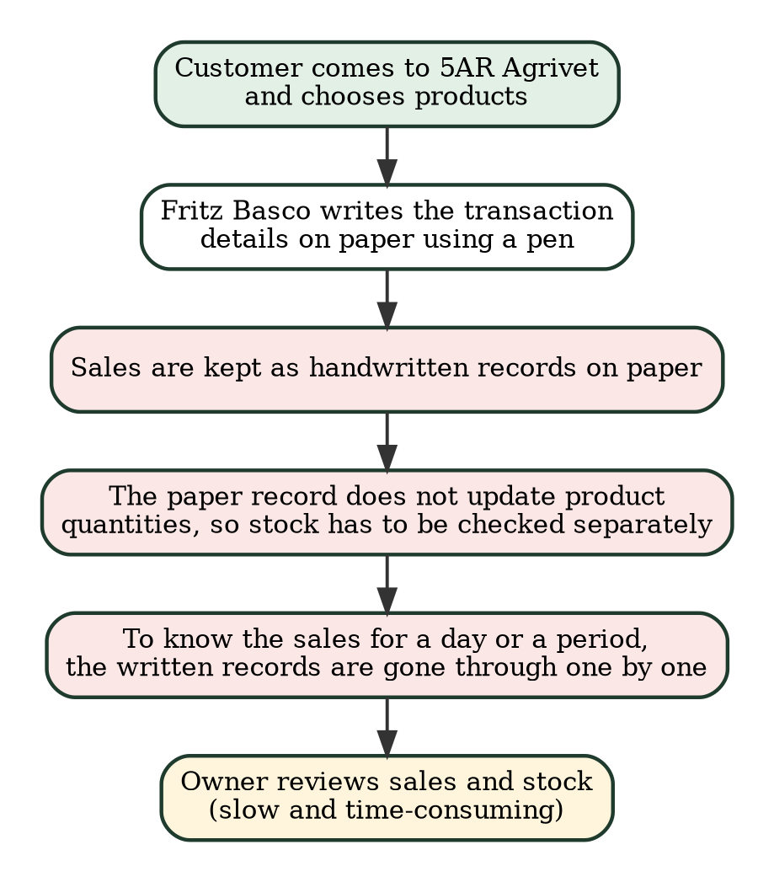
Figure 3.1 Current State of the Process

3.1.4 Problems Identified
Based on the current process, the problems in Table 3.3 were identified.
Table 3.3 Problems and Root Causes
No. | Problem | Effect | Root Cause
P1 | Tracking sales is time- consuming because sales are written on paper with a pen. | Sales have to be written down one by one and later gone through to get totals for a day or a period. | No digital record of sales; no automatic totals.
P2 | Monitoring inventory is time-consuming. | Stock has to be checked by hand to know what is available or running low. | Stock is not updated automatically when a sale is made.
P3 | Handwritten recording can lead to mistakes in recording and computing. | A wrong entry, a missed sale, or a wrong total can make the records unreliable [1], [3]. | Totals and entries depend on doing them by hand each time.
P4 | Sales, product, supplier, and stock information is not kept in one system. | The owner has to rely on paper records and on memory to find information. | No single system for products, suppliers, stock, and sales.
P5 | Sales and inventory reports are hard to prepare. | The owner cannot easily see best-selling products, sales for a given period, or products that need restocking [3], [4]. | Data is not organized in a way that can be summarized automatically.
P6 | The owner cannot monitor sales and inventory remotely. | Fritz Basco, who works as a seaman, cannot review the sales or the stock when he is away from the store. | Records are on paper and are kept at the store; there is no online system.

3.1.5 Root-Cause Analysis
The problems were grouped into four areas: People, Process, Platform / Technology, and Paperwork / Information.
People
Recording and computing are done by hand, so the accuracy of the records depends on the person doing the work. When the work is repeated many times a day, the chance of a missed or wrong entry goes up [3].
Process
The sale, the stock check, and the sales summary are separate manual steps. Stock is not updated at the moment of the sale, so the business has to check or count it separately. Preparing a sales summary means going back through the written records.
Platform / Technology
The business does not have a system that connects its sales and its inventory. Without it, there is nothing that computes totals, updates stock, or produces reports automatically, and the records cannot be opened through a web browser.
Paperwork / Information
Sales information is kept on paper. This makes it harder to search, to summarize by date, and to find out which products sell best or are running low [4]. Because the paper is kept at the store, the owner cannot read it while he is away.
Core Diagnostic Finding
The main cause of the problems is that sales and inventory are recorded and checked by hand, without a system that links them. Because of this, every sale needs extra manual work to compute, record, and reflect in the stock, and the owner has no quick way to get summaries. A system that records sales and stock movements together and produces reports automatically addresses this cause directly. For an owner who works as a seaman, paper records also cannot be reviewed from a distance.

3.1.6 Requirements Engineering
The requirements below describe what the system does (functional) and how well it should do it (non-functional). They are based on the features implemented in the system.
A. Functional Requirements
Table 3.4 lists the functional requirements of the system.
Table 3.4 Functional Requirements Catalog
ID | Module | Requirement
FR-01 | Login | Users log in with a username and password. Passwords are stored as hashes, and disabled accounts are blocked.
FR-02 | User Roles | The system has administrator and staff roles. Deleting products, categories, and suppliers, cancelling sales, managing users, and viewing the activity log are for administrators only.
FR-03 | Products | Add, view, edit, and delete products with SKU (unique), name, category, supplier, description, cost price, selling price, minimum stock, base unit, and an optional image (JPG, PNG, or WEBP). Products that already have transaction history cannot be deleted.
FR-04 | Product Search | Search products by name or code and filter by category and stock status, with pagination.
FR-05 | Selling Units | Each product has a base unit in which stock is counted. A product can have other selling units with a conversion quantity and a selling price, and can allow decimal quantities.
FR-06 | Categories | Add, edit, and delete categories. Duplicate names are rejected, and a category in use cannot be deleted.
FR-07 | Suppliers | Add, edit, and delete suppliers. A supplier linked to products or deliveries cannot be deleted.
FR-08 | Stock In | Record stock received, with date, supplier, reference number, and remarks. The product quantity is updated automatically.
FR-09 | Stock Out | Record stock removed, with a reason and remarks. The system does not allow stock to go below zero.
FR-10 | Stock History | Show a read-only history of all stock transactions with search and filters by product, type, and date.
FR-11 | Stock Status | Mark a product as low stock when its quantity is above zero but not more than its minimum stock, and as out of stock when the quantity is zero.
FR-12 | Point of Sale | Search and select products, choose the unit and quantity, and show the cart with the running total. The system prevents adding more than the available stock.
FR-13 | Payment | Record payment by cash or GCash. For cash, compute the change. For GCash, require the reference number.
FR-14 | Complete Sale | Save the sale and its items, assign a receipt number, and deduct the stock in a single database transaction. Protect against duplicate submission of the same sale.
FR-15 | Receipt | Show an on-screen receipt for each sale with the receipt number, items, total, payment, and change. The receipt can be opened again from the sales history.
FR-16 | Sales History | List recorded sales with receipt number, date, products sold, payment method, total, amount paid, change, status, and cashier. Search and filter by payment method, status, and date.
FR-17 | Cancel Sale | The administrator can cancel a completed sale by giving a reason. The items are returned to stock through a stock-in record, and the sale stays in the history as cancelled.
FR-18 | Sales Reports | Show sales totals for today, this week, and this month; sales in a chosen date range with a daily chart, number of transactions, items sold, and average sale; best-selling products; profit by product; and a monthly summary of the last 12 months.
FR-19 | Inventory Reports | Generate an inventory report (current stock) and a stock transactions report with filters and CSV export.
FR-20 | Dashboard | Show total products, total units, low-stock and out-of-stock counts, categories, stock status, products needing attention, recent stock movements, and a stock-by-category chart.
FR-21 | User Management | The administrator can add and edit users, assign roles, and disable accounts.
FR-22 | Activity Log | Record important actions such as logins, changes, stock movements, sales, and exports, and let the administrator view the log.
FR-23 | Remote Access | Authorized users, including the owner's administrator account, can log in through a web browser over the internet and open the dashboard, sales history, sales reports, and inventory reports from outside the store. Access still requires login, and administrator-only functions stay restricted by role. This is provided by the online deployment of the existing modules and not by a separate module.

B. Non-Functional Requirements
Table 3.5 lists the non-functional requirements of the system.
Table 3.5 Non-Functional Requirements Specification
ID | Category | Requirement
NFR-01 | Security | Passwords are hashed. All database queries with user input use prepared statements. Output is escaped, and every form uses a CSRF token. Role checks are done on the server.
NFR-02 | Session Control | Sessions expire after 30 minutes of inactivity. After 5 failed login attempts, login is locked for 1 minute. Disabled users are blocked on their next request.
NFR-03 | Data Integrity | Stock changes and sale records are saved inside database transactions. Prices use a fixed-decimal type. Stock cannot go below zero. Stock history rows are only added, never edited or deleted.
NFR-04 | Usability | The interface uses a sidebar menu, forms with validation messages, search, filters, and pagination. It uses Bootstrap 5 so the layout adjusts to different screen sizes.
NFR-05 | Accuracy | Totals, change, stock status, and report figures are computed by the system from the database, not typed in by the user.
NFR-06 | Compatibility | The system is built with PHP 8 and MySQL and is accessed through a web browser. It is deployed on InfinityFree. XAMPP is used only as a local development environment. Currency is shown in pesos and the time zone is set to Asia/Manila.
NFR-07 | Maintainability | The code is plain procedural PHP with shared helper files for authentication, layout, and functions, and with separate CSS and JavaScript files.
NFR-08 | Availability and Connectivity | The system is hosted online, so an internet connection is needed to use it. It does not work offline, and its availability depends on the hosting service. Bootstrap and Chart.js are loaded from the internet.
NFR-09 | Auditability | Logins, changes, stock movements, sales, cancellations, and exports are written to the activity log.
NFR-10 | Accessibility of Access | Authorized users, including the owner while he is away from the store, can open the system from a computer or other device that has a web browser and an internet connection. The pages use the responsive Bootstrap layout, which is intended to fit a phone screen. This is to be confirmed in TC-02 and TC-57 to TC-62.

3.2 Framework of the Project

3.2.1 Conceptual Framework
Figure 3.2 shows the conceptual framework of the system using the input-process-output model. Product and stock information, sale details, and user accounts go into the system. The system processes them and produces updated stock, receipts, reports, and dashboard figures. All of these are saved in the MySQL database.
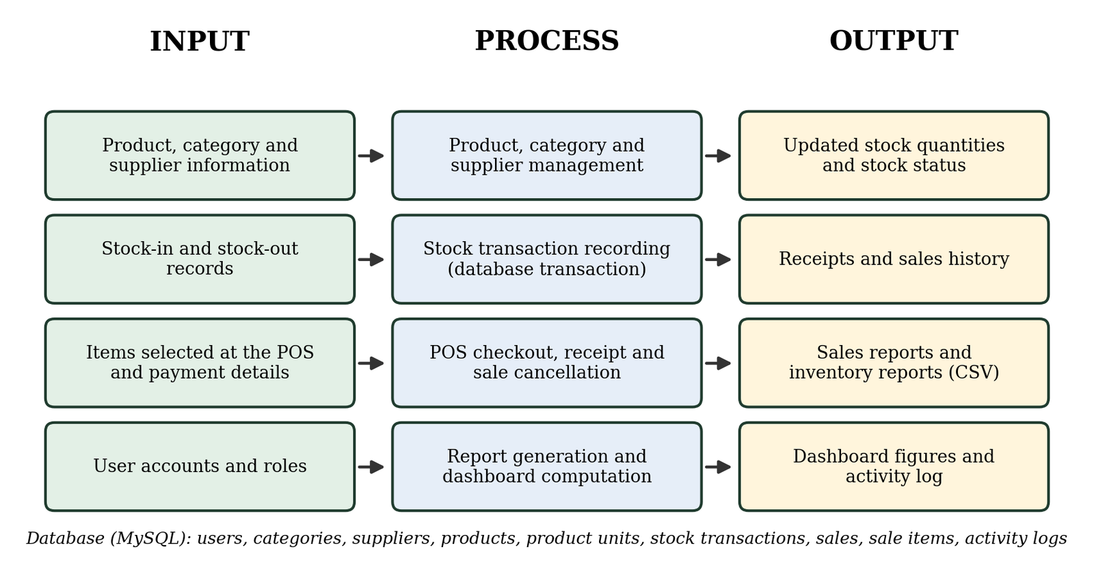
Figure 3.2 Conceptual Framework of the System

3.2.2 Proposed Future-State Process
With the proposed system, the process begins when staff log in through a web browser and add the customer's items to the POS. The system computes the total and checks the stock. If there is not enough stock, it shows a message and the quantity is adjusted. After the payment is entered, the system saves the sale, deducts the stock, and shows the receipt on screen. The sales and stock history are updated automatically, and the owner can view the dashboard and reports through the online system whenever he has an internet connection, including when he is away from the store. Figure 3.3 shows this process.
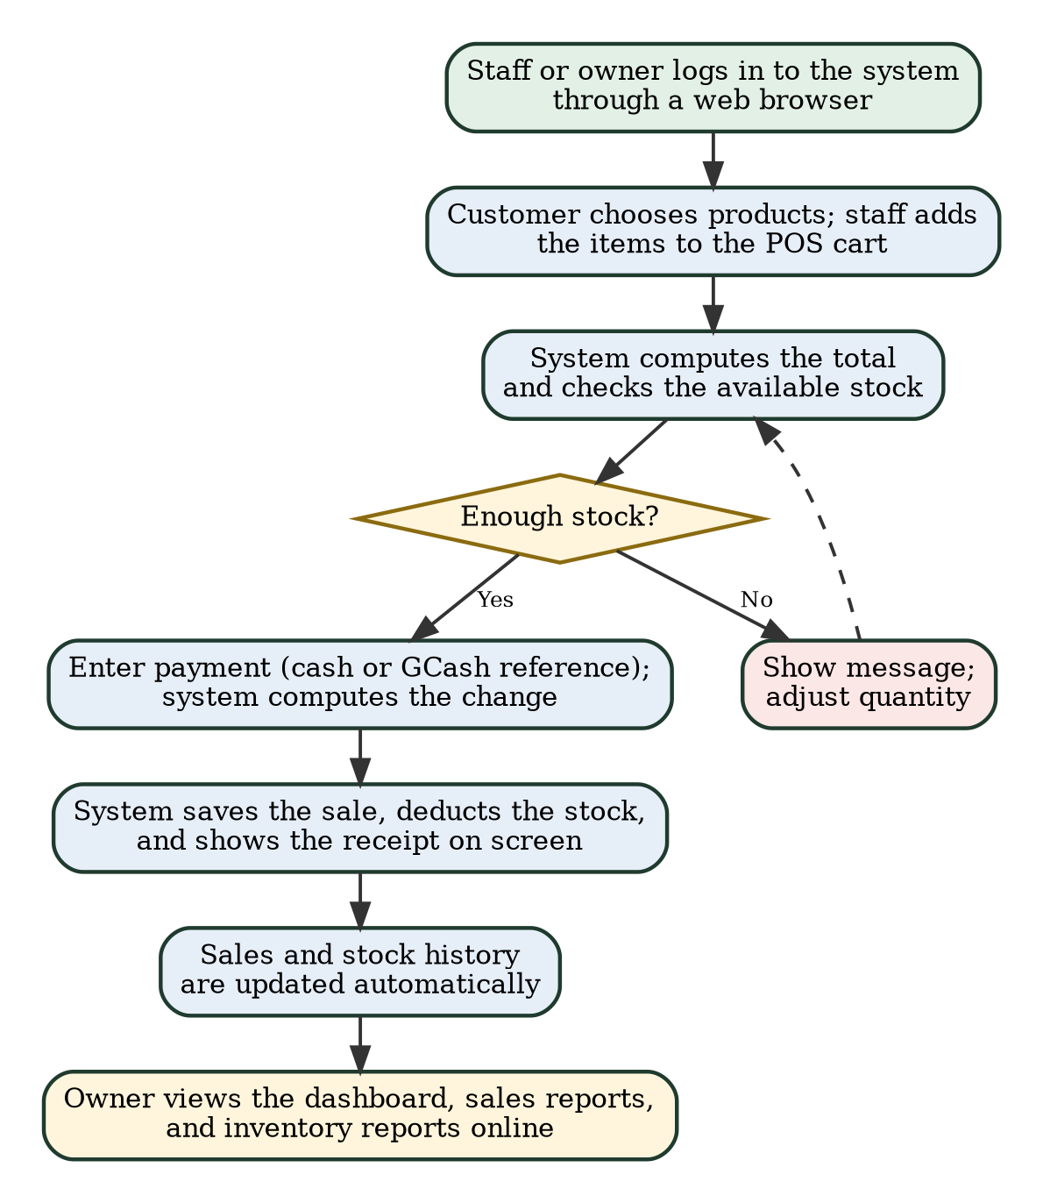
Figure 3.3 Proposed Future-State Process

3.2.3 Before-and-After Process Comparison
Table 3.6 compares the process before and after using the system.
Table 3.6 Before-and-After Process Comparison
Activity | Before (Paper and Pen) | After (With the System)
Recording a sale | Written on paper using a pen. | Items are selected at the POS and the sale is saved automatically.
Computing the total | Computed manually. | Computed automatically, including the change for cash payments.
Sale record or receipt | Sale details are written on paper. | An on-screen receipt (digital transaction record) is created for every sale.
Updating stock after a sale | The written record does not update stock; stock is checked separately. | Stock is deducted automatically when the sale is completed.
Receiving new stock | No digital record of deliveries. | Recorded as a stock-in with supplier, date, and reference number.
Knowing what is low or out of stock | Requires checking the stock by hand. | Shown automatically on the dashboard and in the product list.
Finding past sales | Requires going through the handwritten pages. | Searchable sales history with filters by date, payment method, and status.
Preparing sales reports | Time-consuming and done by hand. | Generated automatically for a chosen date range, with charts and best-selling products.
Preparing inventory reports | Done by counting stock manually. | Generated from current records and exportable as CSV.
Correcting mistakes | Not tracked in a system. | Sales are cancelled by the administrator with a reason, and stock is returned. Stock errors are fixed by an opposite transaction.
Tracking who did what | No system record of who made an entry. | Cashier on each sale and an activity log of key actions.
Accessing records | Records are on paper and can only be read where the paper is kept. | Records can be opened through a web browser over the internet by the owner and authorized staff, including from outside the store.
Monitoring the business from far away | Not possible unless someone reports the figures to the owner. | The owner logs in with his administrator account and views the dashboard and reports through a web browser. An internet connection is needed.

3.2.4 Proposed System Modules
Figure 3.4 shows the modules of the system. All users log in first. The menu is grouped into Sales, Inventory, Stock, Reports, and Administration. The dashboard gives a summary of the current stock. Only the administrator can see the Administration group.
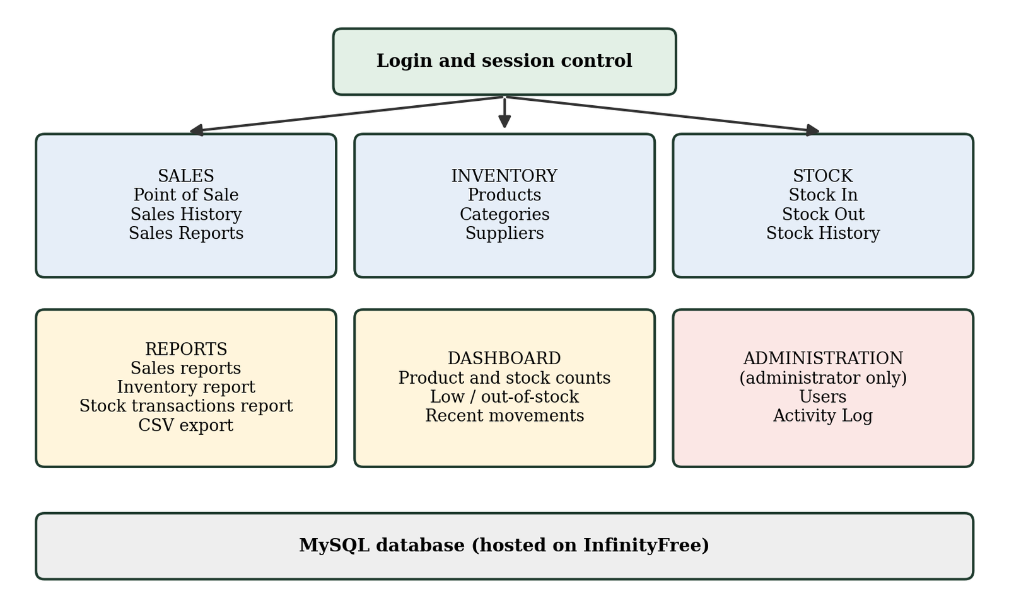
Figure 3.4 Proposed System Modules
Table 3.7 shows what each type of user can do in the system.
Table 3.7 User Roles and Access Rights
Action | Staff | Administrator
Log in, view dashboard | Yes | Yes
Open the system remotely through a web browser (needs an internet connection) | Yes | Yes
Use the POS, view sales history and receipts, view sales reports | Yes | Yes
View, add, and edit products, categories, and suppliers | Yes | Yes
Record stock in and stock out, view stock history | Yes | Yes
Generate and export inventory reports | Yes | Yes
Delete products, categories, and suppliers | No | Yes
Cancel a completed sale | No | Yes
Manage user accounts and view the activity log | No | Yes

The owner is expected to use the administrator account for remote monitoring. Staff accounts can also view sales and inventory records, as shown in Table 3.7, so the owner should give accounts only to the people who need them. Any account can log in from anywhere with an internet connection, because the system does not limit access by location.

3.2.5 Business Logic and Automation Rules
The system follows the rules in Table 3.8. These rules are checked by the program, so the user does not have to remember them.
Table 3.8 Business Logic and Automation Rules
No. | Rule | Description
R1 | Low stock | A product is low stock when its quantity is greater than zero and not more than its minimum stock.
R2 | Out of stock | A product is out of stock when its quantity is zero.
R3 | No negative stock | A stock-out or a sale cannot be saved if it would make the quantity less than zero.
R4 | One transaction | A sale, its items, the stock deduction, and the stock history entries are saved together. If any part fails, nothing is saved.
R5 | Duplicate protection | Each checkout carries a token, so pressing the button twice does not record the same sale twice.
R6 | Payment check | Payment must be cash or GCash. GCash needs a reference number, and the same reference cannot be used twice.
R7 | Sale cancellation | Only an administrator can cancel a completed sale, and a reason is required. The items go back to stock as a stock-in record.
R8 | Protected history | Stock transactions are only added. Products with history and suppliers in use cannot be deleted, and users are disabled instead of deleted.
R9 | Unique SKU | Every product must have a unique SKU, which is saved in capital letters.
R10 | Login protection | Five failed login attempts lock login for one minute, and sessions end after 30 minutes without activity.

CHAPTER 4
SYSTEM IMPLEMENTATION, TESTING, AND EVALUATION

4.1 Introduction
This chapter describes the Inventory Management System with POS as it was implemented for 5AR Agrivet. It covers the tools used, the architecture and online deployment, the modules and features, the database, the user interface, and the testing and evaluation of the system. The description is based on the source code and the database export of the system. Test records and evaluation results that have not been collected are marked as pending, and no results are reported for tests that have not been performed.

4.2 Development Tools and Technologies
Table 4.1 lists the tools and technologies used. The versions of Bootstrap, Bootstrap Icons, and Chart.js come from the files that the pages load. The PHP and database versions are those of the local development computer, as shown in the database export. The deployed system runs on the PHP and MySQL services provided by InfinityFree.
Table 4.1 Development Tools and Technologies
Tool / Technology | Version or Detail | Use in the Project
PHP [7] | PHP 8 (8.2.12 on the development computer); procedural style with MySQLi and prepared statements | Server-side processing: login, sales, stock, reports, and user management.
MySQL [8] | MySQL-compatible database; MariaDB 10.4.32 on the development computer | Stores users, products, stock transactions, sales, and the activity log.
HTML and CSS | HTML5 and CSS3 | Page structure and styling.
JavaScript | Plain JavaScript (script.js, pos.js, sales-reports.js) | Cart and payment screen of the POS, form behavior, and charts.
Bootstrap [9] | 5.3.3 (loaded from a CDN) | Responsive layout and interface components.
Bootstrap Icons | 1.11.3 (loaded from a CDN) | Icons in the menu and buttons.
Chart.js [10] | 4.4.3 (loaded from a CDN) | Dashboard and sales report charts.
InfinityFree [11] | Web hosting service | Hosts the deployed PHP application and its MySQL database.
XAMPP [12] | Apache, MariaDB 10.4.32, phpMyAdmin 5.2.1 (as shown in the export) | Local development and testing environment only.
Web browser | Any modern browser | Used by the owner and staff to open the system.

4.3 System Architecture and Deployment

4.3.1 System Architecture
The system follows a simple client-server design, shown in Figure 4.1. The user opens the system in a web browser. The browser sends requests to the PHP application on the web host. The PHP scripts check the user's login and role, read or write the MySQL database using prepared statements, and send back an HTML page. Product images are saved in the uploads folder on the host. The Bootstrap, Bootstrap Icons, and Chart.js files are loaded by the browser from a content delivery network.
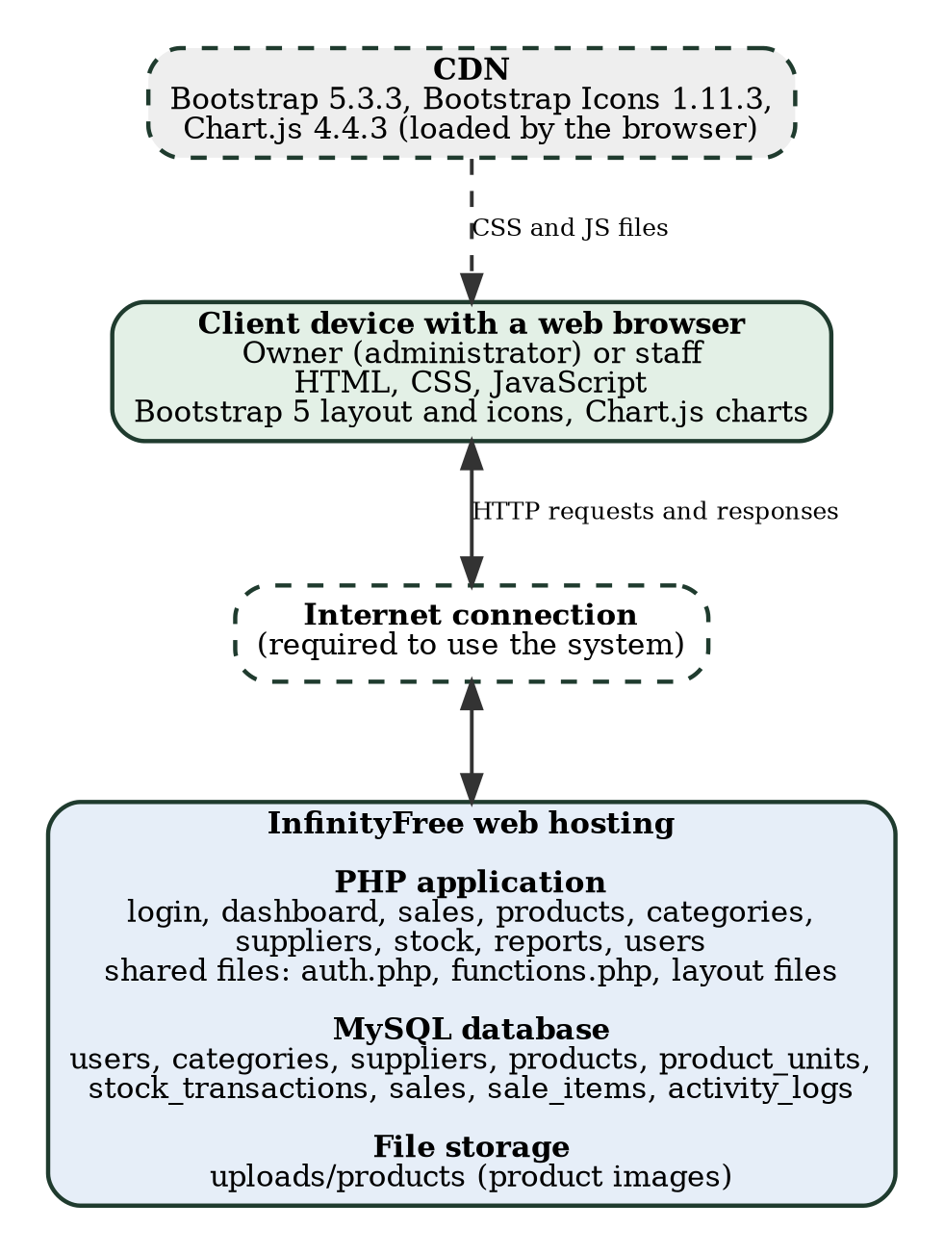
Figure 4.1 System Architecture and Online Deployment

4.3.2 Online Deployment
The system is deployed online on InfinityFree. The PHP files and the product image folder are hosted there, and the data is stored in the MySQL database that the hosting service provides. Fritz Basco and authorized staff can open the system through a web browser by entering its web address, https://5ar-agri-sup-inventory-system.infinityfreeapp.com/login.php, and logging in with their accounts. The system was developed and tried on a local XAMPP environment, as shown by the database export, which was generated on a local server. XAMPP is not needed on the client's computer to use the deployed system.
Because the system is online, an internet connection is required for normal use and for all database operations. It does not work offline. If the internet connection or the hosting service is not available, the system cannot be opened. Access to the data is controlled by the login page, the administrator and staff roles, and the other security measures described in Table 3.5.

4.3.3 Remote Monitoring by the Owner
Fritz Basco works as a seaman and may be far from 5AR Agrivet. The system is intended to let him monitor the business through the deployed website. To do this, he opens the web address of the system in the browser of a computer or a mobile phone, logs in with his administrator account, and opens the pages he needs. The Dashboard shows the stock counts, the low-stock and out-of-stock products, and the recent stock movements. Sales History lists each sale with its receipt number, payment method, status, and cashier. Sales Reports shows the totals for today, this week, and this month, the sales in a chosen date range, the best-selling products, the profit by product, and the monthly summary. The Reports menu gives the inventory report and the stock transactions report with CSV export. These are the same pages that the staff use at the store, so remote monitoring needed no separate module (use case UC-15 in Table 4.2).
The owner sees only what has been entered in the system. Sales and stock movements are entered by the staff at the store through the POS and the stock forms, so the information he sees is only as complete and as current as those entries. The system also needs an internet connection on the owner's device and on the host. It has no offline mode and sends no automatic alerts.
What this paper can state at this time is limited. The system has been deployed on InfinityFree, and Figures 4.9 to 4.20 are screenshots taken from the deployed address on October 20, 2026, as shown by the web address and the date in the images. They were taken in a computer browser. Access with the owner's own account from a mobile phone and from an internet connection different from the store's has not yet been recorded. Test cases TC-57 to TC-62 in Appendix A were prepared for this purpose, together with TC-02 (opening the system on a phone) and TC-10 to TC-12 (access rights of staff accounts). Until they are performed, remote monitoring is a designed and deployed capability and not a confirmed one.
The availability of remote monitoring also depends on the hosting service. InfinityFree's support forum states a limit of 50,000 hits per day for the free plan, and an account that reaches the limit is taken offline for 24 hours [13]. A reply in another forum thread states that no uptime guarantee is given for the free hosting [14]. These statements come from forum posts and should be checked against InfinityFree's current terms. How close the system comes to this limit has not been measured. Access is protected by the login page, the administrator and staff roles, the session timeout of 30 minutes, the temporary login lock, and the activity log, which records the IP address of each action.

4.4 System Modules and Features

4.4.1 Use Cases
Figure 4.2 shows the use-case diagram. There are two types of users. The staff or cashier can use the sales, inventory, stock, and reporting functions. The administrator can do everything the staff can do, and can also delete records, cancel sales, manage users, and view the activity log. Table 4.2 describes the use cases. The owner uses the administrator account to monitor the business remotely (UC-15 in Table 4.2). This is not drawn as a separate use case in Figure 4.2, because it reuses the dashboard, sales history, sales report, and inventory report use cases over an online connection.
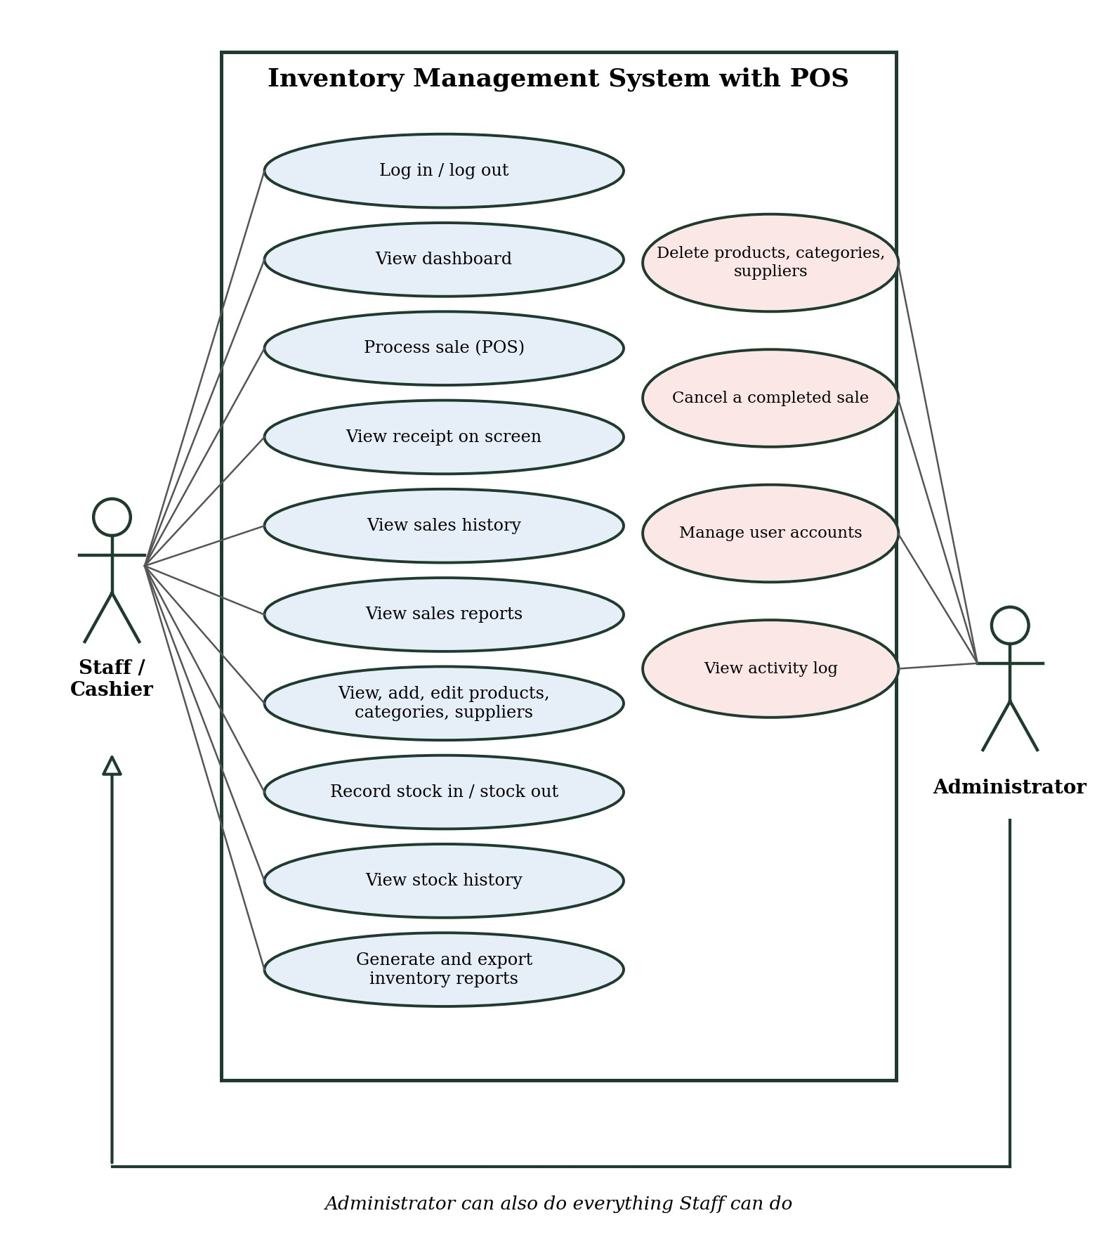
Figure 4.2 Use-Case Diagram
Table 4.2 Use Case Descriptions
ID | Use Case | Actor | Description
UC-01 | Log in and log out | Staff, Administrator | The user enters a username and password. The session ends on logout or after 30 minutes without activity.
UC-02 | View dashboard | Staff, Administrator | Shows product counts, stock status, products needing attention, recent movements, and a chart.
UC-03 | Process sale (POS) | Staff, Administrator | Adds products to a cart, records cash or GCash payment, and saves the sale.
UC-04 | View receipt on screen | Staff, Administrator | Shows the receipt of a sale and lets the user open it again from the sales history.
UC-05 | View sales history | Staff, Administrator | Lists sales with filters by receipt number, payment method, status, and date.
UC-06 | View sales reports | Staff, Administrator | Shows sales totals, best-selling products, profit by product, and monthly summary.
UC-07 | Manage products, categories, suppliers | Staff, Administrator | View, add, and edit records, including selling units and product image.
UC-08 | Record stock in and stock out | Staff, Administrator | Adds a stock transaction and updates the product quantity.
UC-09 | View stock history | Staff, Administrator | Shows the read-only list of stock transactions.
UC-10 | Generate and export inventory reports | Staff, Administrator | Shows the inventory and stock transactions reports and exports them as CSV.
UC-11 | Delete products, categories, suppliers | Administrator | Deletes records that are not in use or have no history.
UC-12 | Cancel a completed sale | Administrator | Cancels a sale with a reason and returns the items to stock.
UC-13 | Manage user accounts | Administrator | Adds and edits users, sets roles, and disables accounts.
UC-14 | View activity log | Administrator | Shows the record of important actions.
UC-15 | View sales and inventory remotely | Administrator (owner) | The owner opens the system in a web browser from outside the store, logs in, and uses the dashboard (UC-02), sales history (UC-05), sales reports (UC-06), and inventory reports (UC-10). It needs an internet connection. Remote access is to be verified by TC-57 to TC-62.

4.4.2 Data Flow Diagrams
Figure 4.3 is the context diagram. It shows the system as one process with the staff, the administrator, the customer, and the supplier around it. The customer and the supplier do not use the system directly. Their information is entered by staff. Figure 4.4 breaks the system into seven processes and seven data stores. Processes 1.0 to 6.0 write entries to the activity log (D7).
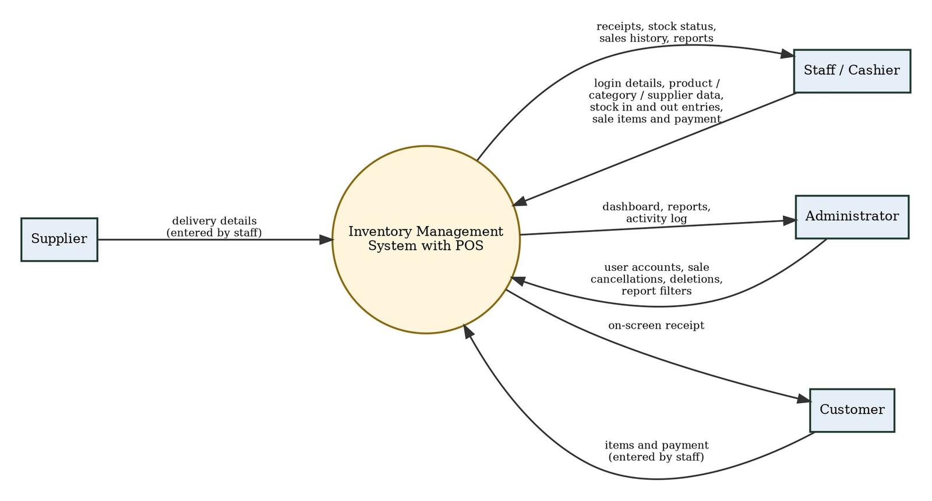
Figure 4.3 Context-Level Data Flow Diagram
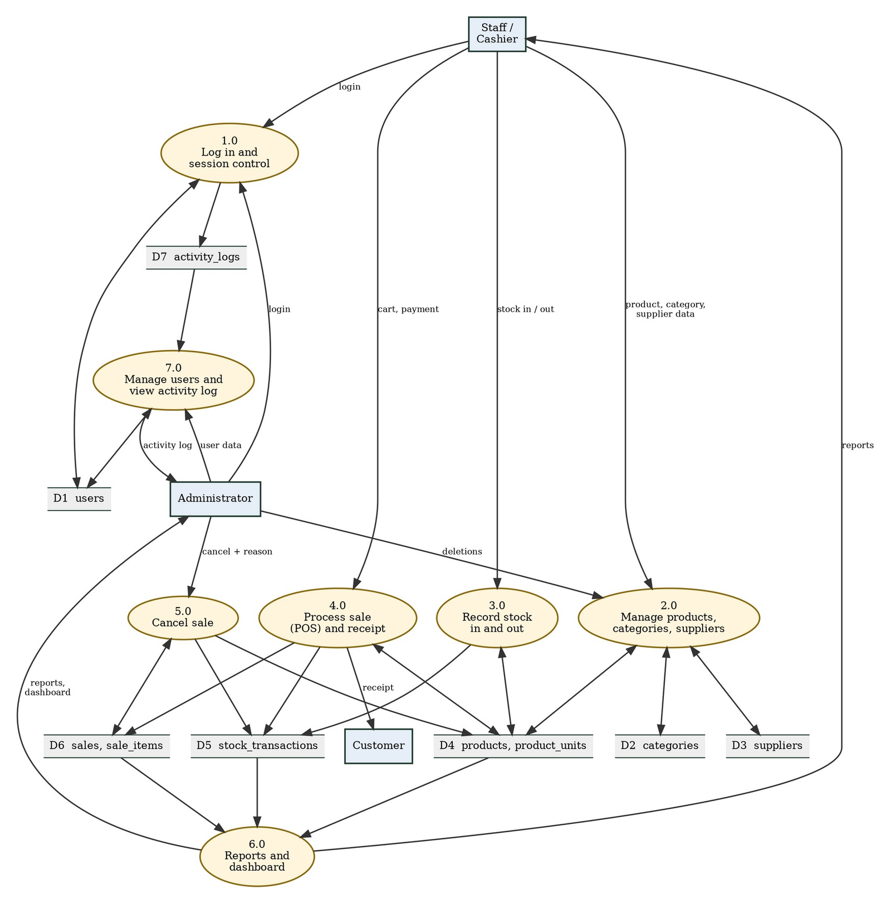
Figure 4.4 Level 1 Data Flow Diagram

4.4.3 Process Flowcharts
Figure 4.5 shows how a sale is completed in the POS. The cashier builds the cart, chooses cash or GCash, and completes the sale. The server then checks the request again and saves everything in one database transaction. If any check fails, nothing is saved. A token on each checkout prevents the same sale from being saved twice.
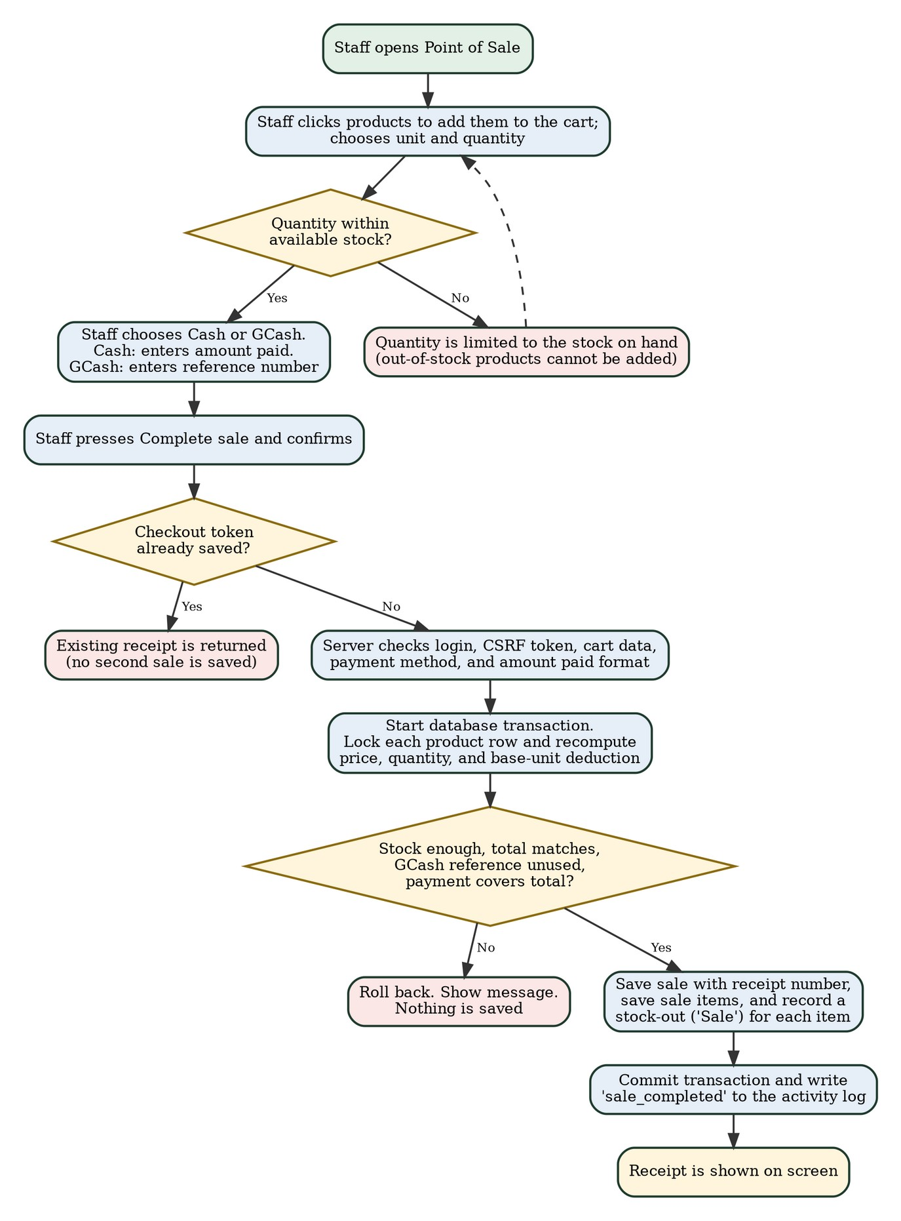
Figure 4.5 Flowchart of the POS Checkout
Figure 4.6 shows how a stock-in or stock-out is recorded. The product row is locked during the update so the quantity and the history row stay consistent, and a stock-out that would make the stock negative is rejected.
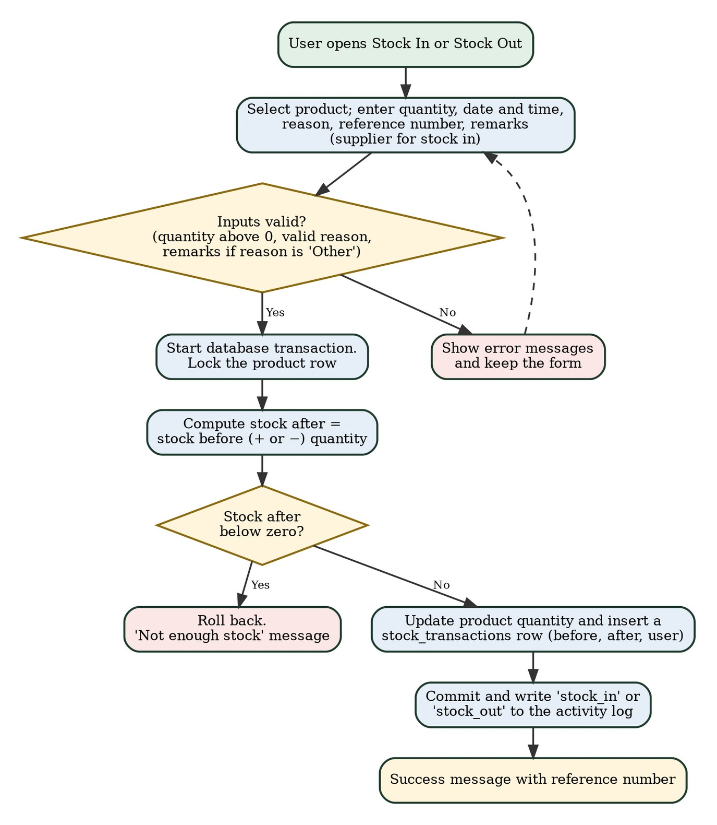
Figure 4.6 Flowchart of Recording Stock In and Stock Out
Figure 4.7 shows how the administrator cancels a sale. The sale is marked as cancelled, and each item is returned to stock through a stock-in record, so the stock history still shows what happened.
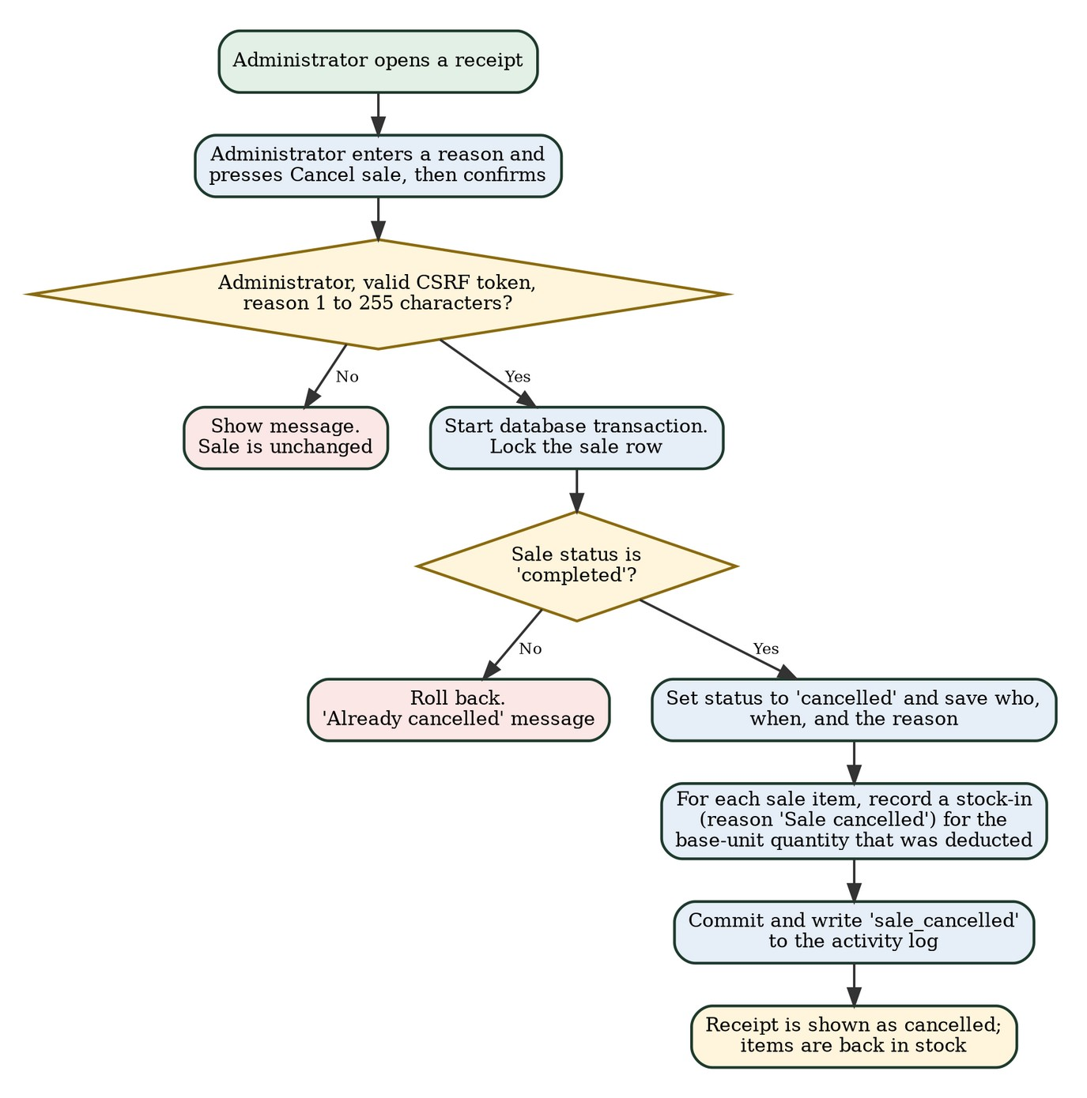
Figure 4.7 Flowchart of Cancelling a Sale

4.4.4 Implemented Modules and Features
Table 4.3 summarizes the modules and the features found in the source code. These match the functional requirements in Table 3.4.
Table 4.3 Implemented Modules and Features
Module | Implemented Features
Login and Security | Username and password login with hashed passwords; administrator and staff roles; session timeout of 30 minutes; temporary lock after 5 failed attempts; CSRF token on forms; prepared statements.
Dashboard | Total products, total units, low-stock and out-of-stock counts, categories, products needing attention, recent stock movements, and a stock-by-category chart.
Products | Add, edit, view, and delete products with SKU, category, supplier, prices, minimum stock, image, and base unit; extra selling units with conversion quantity and price; search, filters, and pagination.
Categories and Suppliers | Add, edit, and delete with duplicate-name checks and delete protection when the record is in use.
Stock | Stock-in and stock-out with reason, reference number, and remarks; opening stock recorded as a stock-in; read-only stock history with filters; automatic low-stock and out-of-stock status.
Point of Sale and Sales | Product search, cart, unit and quantity selection, stock check, cash or GCash payment, change computation, receipt numbers, on- screen receipt, sales history, and administrator-only sale cancellation.
Reports | Sales reports (today, this week, this month, date range, best sellers, profit by product, monthly summary); inventory report and stock transactions report with CSV export.
Administration | User accounts with roles and enable/disable; activity log of logins, changes, stock movements, sales, cancellations, and exports.
Online Access | Deployed on InfinityFree and opened through a web browser with an internet connection. The owner can use the administrator account to view the dashboard, sales, and reports from outside the store (to be confirmed by TC-57 to TC-62).

The receipt, sales report, and inventory report pages also have a Print button that opens the browser's print dialog. The group does not have a physical printer, so this button was not tested and printing is not part of the project requirements.

4.5 Database Design and Structure
The database is named inventory_system and has nine tables, listed in Table 4.4. The structure below comes from the database export of the development copy, which was generated on October 12, 2026. Money values use fixed-decimal columns, and stock quantities use three decimal places so that products sold by weight can be handled.
Table 4.4 Database Tables
Table | Purpose
users | Accounts of the administrator and staff.
categories | Product categories.
suppliers | Supplier records.
products | Product records with prices, current stock, minimum stock, base unit, and image.
product_units | Additional selling units of a product with conversion quantity and price.
stock_transactions | Every stock-in and stock-out, with stock before and after.
sales | One row per sale with receipt number, payment, status, and cancellation details.
sale_items | The products in each sale, with the quantity in base units and in the unit sold.
activity_logs | Record of important actions by users.

Figure 4.8 is the entity-relationship diagram. A category and a supplier can have many products. A product can have many selling units, stock transactions, and sale items. A sale has many sale items. A user can create many stock transactions, sales, and log entries, and a user can also be recorded as the one who cancelled a sale. Table 4.5 lists the foreign keys defined in the database.
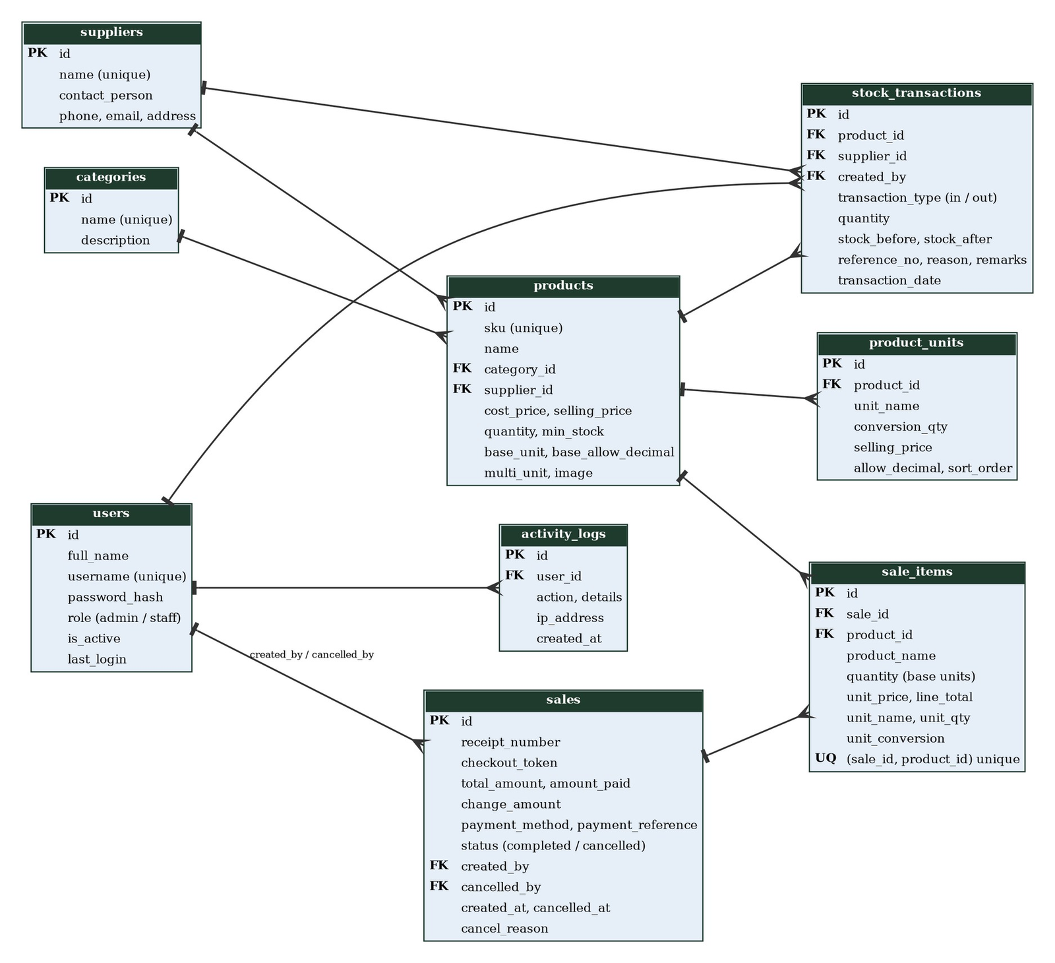
Figure 4.8 Entity-Relationship Diagram

Table 4.5 Foreign Key Relationships
Constraint | Child Column | Parent Column | Rule
fk_products_category | products.category_id | categories.id | On update cascade; delete restricted
fk_products_supplier | products.supplier_id | suppliers.id | On update cascade; delete restricted
fk_pu_product | product_units.product_id | products.id | On update cascade; on delete cascade
fk_tx_product | stock_transactions.product_id | products.id | On update cascade; delete restricted
fk_tx_supplier | stock_transactions.supplier_id | suppliers.id | On update cascade; delete restricted
fk_tx_user | stock_transactions.created_by | users.id | On update cascade; delete restricted
fk_sales_user | sales.created_by | users.id | On update cascade; delete restricted
fk_sales_cancelled | sales.cancelled_by | users.id | On update cascade; delete restricted
fk_sale_items_sale | sale_items.sale_id | sales.id | On update cascade; delete restricted
fk_sale_items_product | sale_items.product_id | products.id | On update cascade; delete restricted
fk_logs_user | activity_logs.user_id | users.id | On update cascade; on delete set null

The data dictionary of each table follows (Tables 4.6 to 4.14). The sales table has unique keys on the receipt number, the checkout token, and the payment reference. The sale_items table has a unique key on the sale and product together.
Table 4.6 Data Dictionary: users
Column | Type | Null | Key / Default | Description
id | int(10) unsigned | No | Primary key, auto increment | User number.
full_name | varchar(100) | No |  | Full name of the user.
username | varchar(30) | No | Unique | Login name.
password_hash | varchar(255) | No |  | Hashed password.
role | enum('admin','staff') | No | Default 'staff' | Access level.
is_active | tinyint(1) | No | Default 1 | 1 = active, 0 = disabled.
last_login | datetime | Yes | Null | Time of the last login.
created_at | datetime | No | Current timestamp | Date the account was created.

Table 4.7 Data Dictionary: categories
Column | Type | Null | Key / Default | Description
id | int(10) unsigned | No | Primary key, auto increment | Category number.
name | varchar(100) | No | Unique | Category name.
description | varchar(255) | Yes | Null | Short description.
created_at | datetime | No | Current timestamp | Date created.

Table 4.8 Data Dictionary: suppliers
Column | Type | Null | Key / Default | Description
id | int(10) unsigned | No | Primary key, auto increment | Supplier number.
name | varchar(120) | No | Unique | Supplier name.
contact_person | varchar(100) | Yes | Null | Contact person.
phone | varchar(30) | Yes | Null | Phone number.
email | varchar(120) | Yes | Null | Email address.
address | varchar(255) | Yes | Null | Address.
created_at | datetime | No | Current timestamp | Date created.

Table 4.9 Data Dictionary: products
Column | Type | Null | Key / Default | Description
id | int(10) unsigned | No | Primary key, auto increment | Product number.
sku | varchar(50) | No | Unique | Product code, saved in capital letters.
name | varchar(150) | No | Indexed | Product name.
category_id | int(10) unsigned | No | Foreign key to categories | Category of the product.
supplier_id | int(10) unsigned | Yes | Foreign key to suppliers | Usual supplier.
description | text | Yes | Null | Notes about the product.
image | varchar(255) | Yes | Null | File name of the product image.
cost_price | decimal(10,2) | No | Default 0.00 | Cost of one base unit.
selling_price | decimal(10,2) | No | Default 0.00 | Selling price of one base unit.
quantity | decimal(12,3) | No | Default 0.000 | Current stock in base units. Changed only through stock transactions.
min_stock | int(11) | No | Default 10 | Minimum stock level for the low-stock status.
created_at / updated_at | datetime | No | Current timestamp | Date created and last updated.
base_unit | varchar(30) | No | Default 'pc' | Unit in which stock is counted.
base_allow_decimal | tinyint(1) | No | Default 0 | Whether the base unit allows decimal quantities.
multi_unit | tinyint(1) | No | Default 0 | Whether the product has other selling units.

Table 4.10 Data Dictionary: product_units
Column | Type | Null | Key / Default | Description
id | int(10) unsigned | No | Primary key, auto increment | Unit number.
product_id | int(10) unsigned | No | Foreign key to products | Product that owns the unit.
unit_name | varchar(30) | No |  | Name of the unit, such as sack.
conversion_qty | decimal(14,4) | No |  | Number of base units in one of this unit.
selling_price | decimal(10,2) | No | Default 0.00 | Selling price of one of this unit.
allow_decimal | tinyint(1) | No | Default 0 | Whether decimal quantities are allowed.
sort_order | int(11) | No | Default 0 | Display order.

Table 4.11 Data Dictionary: stock_transactions
Column | Type | Null | Key / Default | Description
id | int(10) unsigned | No | Primary key, auto increment | Transaction number.
product_id | int(10) unsigned | No | Foreign key to products | Product affected.
transaction_type | enum('in','out') | No |  | Stock in or stock out.
quantity | decimal(12,3) | No |  | Quantity moved, in base units.
stock_before / stock_after | decimal(12,3) | No |  | Stock before and after the transaction.
reference_no | varchar(50) | No | Indexed | Reference number, such as a receipt or delivery number.
supplier_id | int(10) unsigned | Yes | Foreign key to suppliers | Supplier, for deliveries.
reason | varchar(50) | No |  | Reason, such as Sale or Delivery.
remarks | varchar(500) | Yes | Null | Extra notes.
transaction_date | datetime | No | Indexed | Date and time of the movement.
created_by | int(10) unsigned | Yes | Foreign key to users | User who recorded it.
created_at | datetime | No | Current timestamp | Time the row was saved.

Table 4.12 Data Dictionary: sales
Column | Type | Null | Key / Default | Description
id | int(10) unsigned | No | Primary key, auto increment | Sale number.
receipt_number | varchar(30) | No | Unique | Receipt number, such as RCP-YYYYMMDD-#####.
checkout_token | char(32) | No | Unique | Token that prevents saving the same sale twice.
total_amount | decimal(12,2) | No |  | Total of the sale.
amount_paid | decimal(12,2) | No |  | Amount paid by the customer.
payment_method | varchar(10) | No | Default 'cash' | Cash or GCash.
payment_reference | varchar(50) | Yes | Unique | GCash reference number.
change_amount | decimal(12,2) | No | Default 0.00 | Change given.
status | enum('completed','cancelled') | No | Default 'completed' | Status of the sale.
created_by | int(10) unsigned | Yes | Foreign key to users | Cashier.
created_at | datetime | No | Current timestamp | Date and time of the sale.
cancelled_by / cancelled_at | int / datetime | Yes | Null | Who cancelled the sale and when.
cancel_reason | varchar(255) | Yes | Null | Reason for cancellation.

Table 4.13 Data Dictionary: sale_items
Column | Type | Null | Key / Default | Description
id | int(10) unsigned | No | Primary key, auto increment | Row number.
sale_id | int(10) unsigned | No | Foreign key to sales; unique with product_id | Sale that owns the item.
product_id | int(10) unsigned | No | Foreign key to products | Product sold.
product_name | varchar(150) | No |  | Product name at the time of sale.
quantity | decimal(12,3) | No |  | Quantity deducted, in base units.
unit_price | decimal(10,2) | No |  | Price of the unit sold.
line_total | decimal(12,2) | No |  | Total of the line.
unit_name | varchar(30) | Yes | Null | Unit sold, such as sack.
unit_qty | decimal(12,3) | Yes | Null | Quantity in the unit sold.
unit_conversion | decimal(14,4) | Yes | Null | Base units in one of the unit sold.

Table 4.14 Data Dictionary: activity_logs
Column | Type | Null | Key / Default | Description
id | int(10) unsigned | No | Primary key, auto increment | Log number.
user_id | int(10) unsigned | Yes | Foreign key to users | User who did the action.
action | varchar(50) | No |  | Type of action, such as login or sale_completed.
details | varchar(500) | No | Default '' | Details of the action.
ip_address | varchar(45) | Yes | Null | IP address of the user.
created_at | datetime | No | Indexed | Date and time of the action.

4.6 User Interface and System Screenshots
Table 4.15 lists the main screens of the system and who can use them. The screens are shown in Figures 4.9 to 4.20. The figures are screenshots of the deployed system. The web address in the browser and the date shown in the images (October 20, 2026) show that they were taken from the deployed copy. They were taken in a computer browser and show sample records created during development, not the real records of 5AR Agrivet. Screenshots from a mobile phone browser are still to be added after TC-02 and TC-57 to TC-62 are performed. The group has not included mock-up or edited images as evidence. Remote monitoring by the owner uses these same screens.
Table 4.15 Main Screens of the System
Screen | Menu Group | Users | Description
Login | None | Everyone | Username and password form with messages for invalid or locked logins.
Dashboard | Dashboard | Staff, Administrator | Stock counts, status, products needing attention, recent movements, and chart.
Point of Sale | Sales | Staff, Administrator | Product search, cart, unit and quantity, payment method, change, and Complete sale button.
Receipt | Sales | Staff, Administrator | On-screen receipt of a sale; the administrator also sees the Cancel sale option.
Sales History | Sales | Staff, Administrator | List of sales with search and filters.
Sales Reports | Sales | Staff, Administrator | Sales totals, chart, best sellers, profit by product, and monthly summary.
Products | Inventory | Staff, Administrator | Product list and the add or edit form with selling units and image.
Categories and Suppliers | Inventory | Staff, Administrator | Lists and forms for categories and suppliers.
Stock In and Stock Out | Stock | Staff, Administrator | Forms for recording stock movements.
Stock History | Stock | Staff, Administrator | Read-only list of stock transactions.
Reports | Reports | Staff, Administrator | Inventory and stock transactions reports with CSV export.
Users and Activity Log | Administration | Administrator | User accounts and the log of actions.

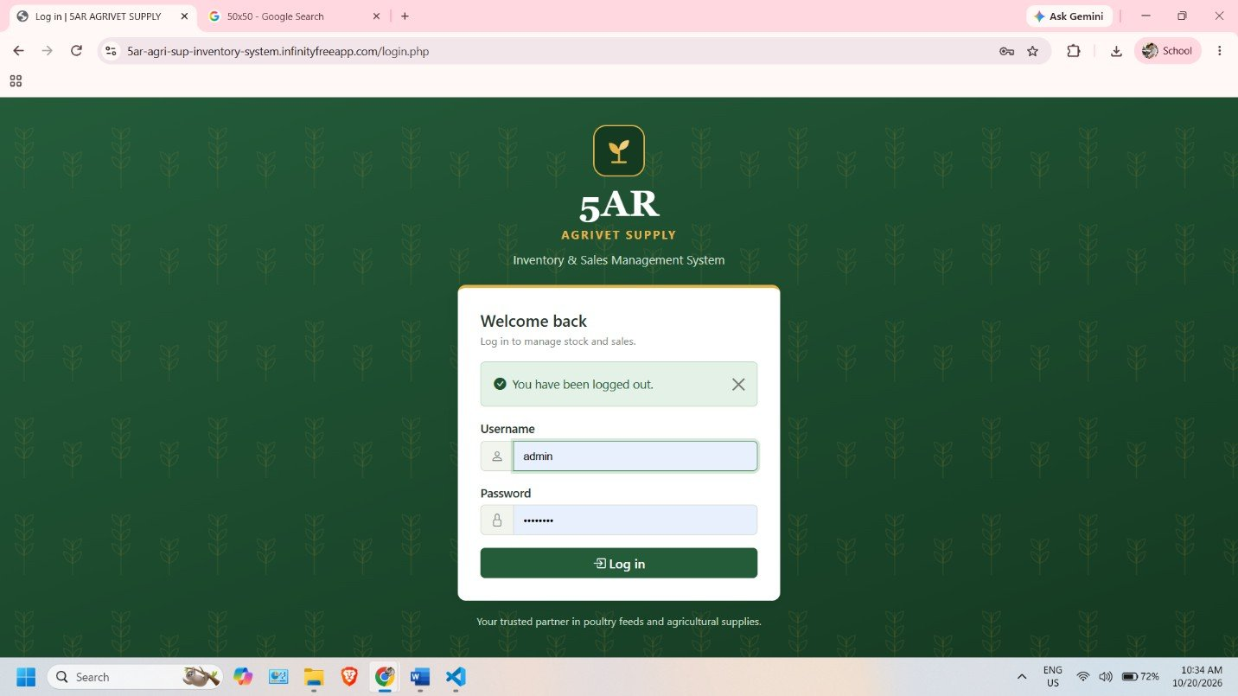
Figure 4.9 Login Page
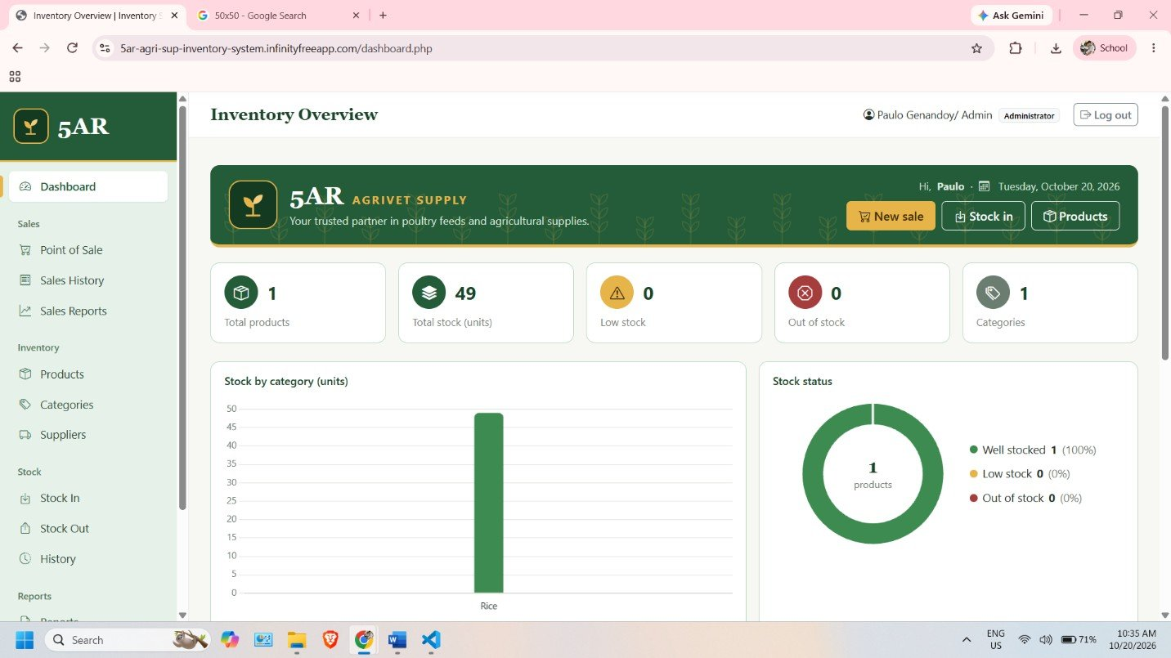
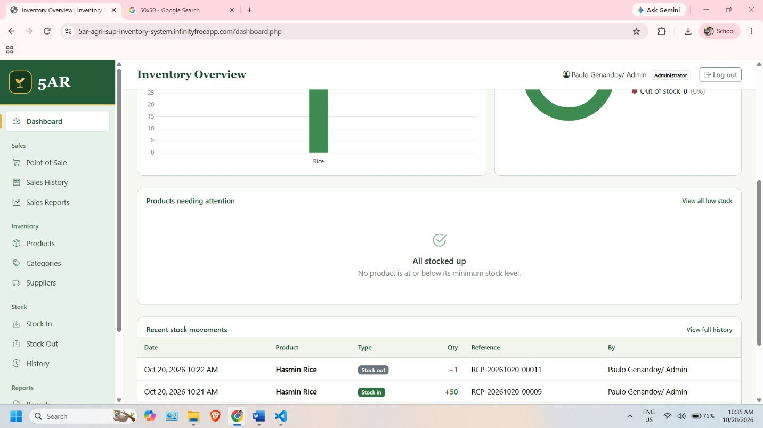
Figure 4.10 Dashboard
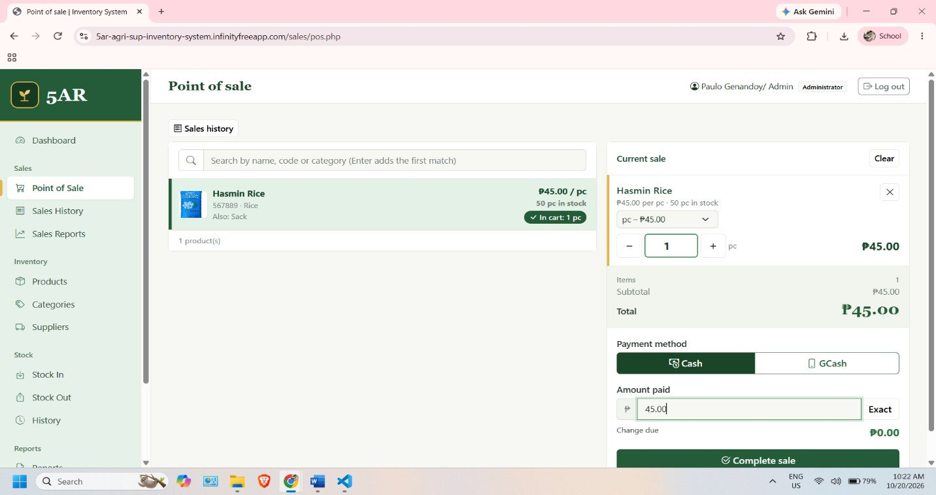
Figure 4.11 Point of Sale
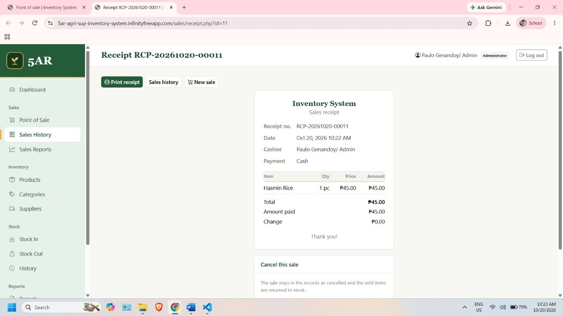
Figure 4.12 On-Screen Receipt
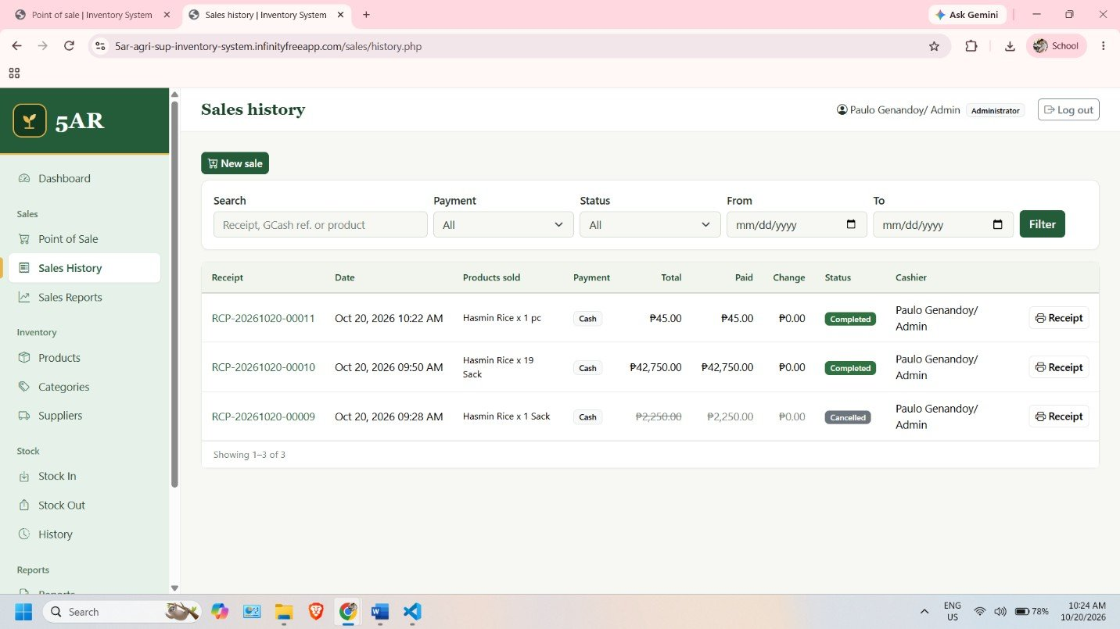
Figure 4.13 Sales History
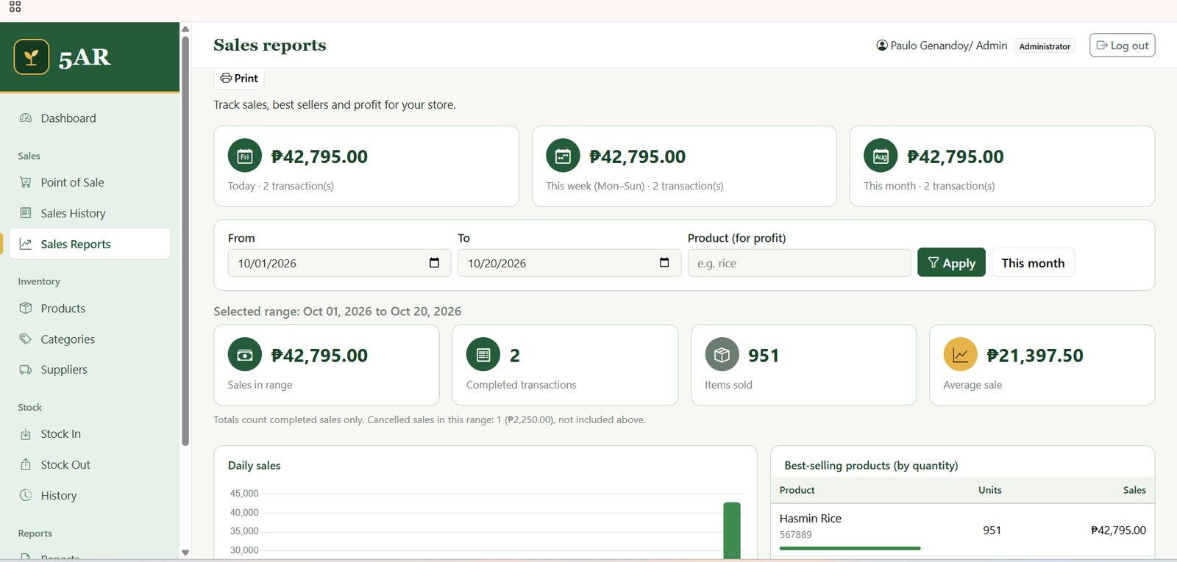
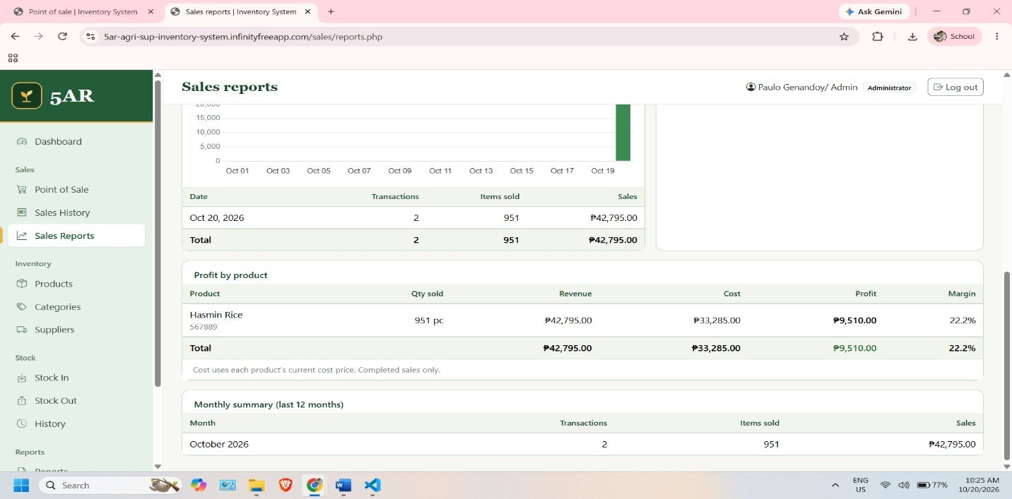
Figure 4.14 Sales Reports
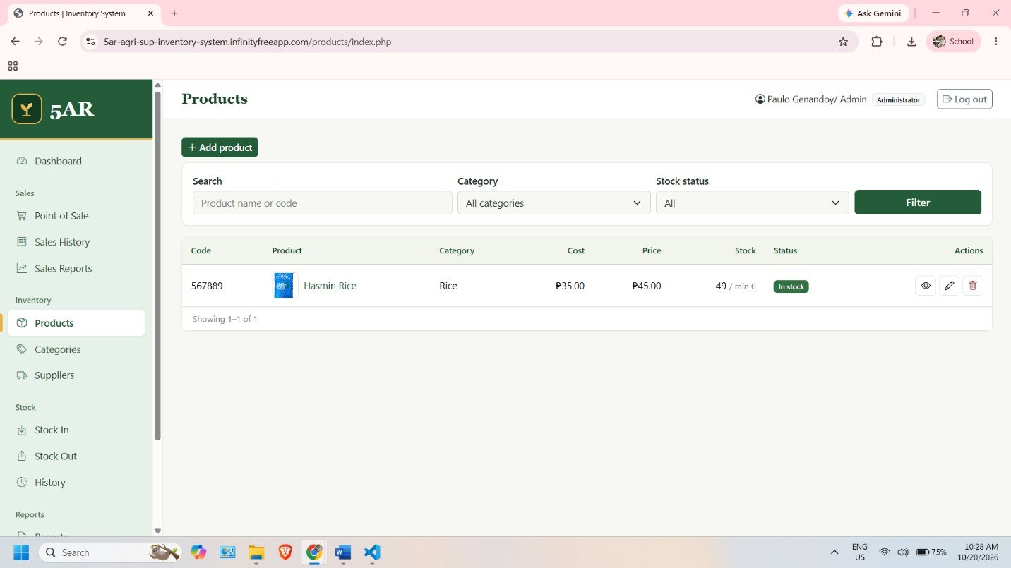
Figure 4.15 Product List
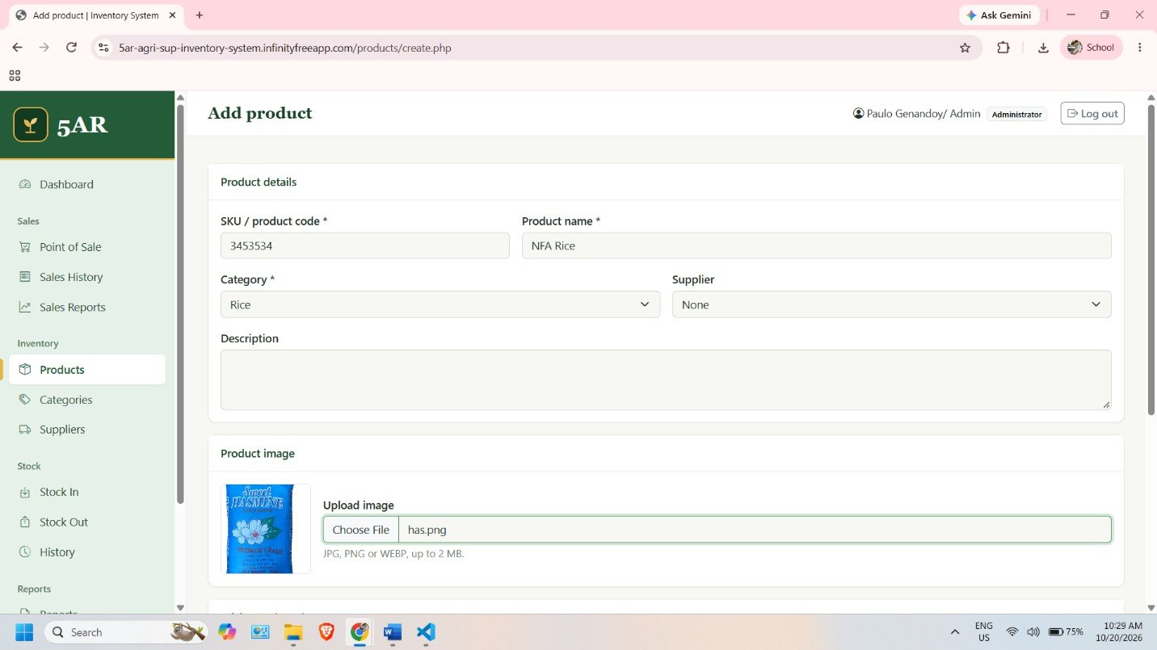
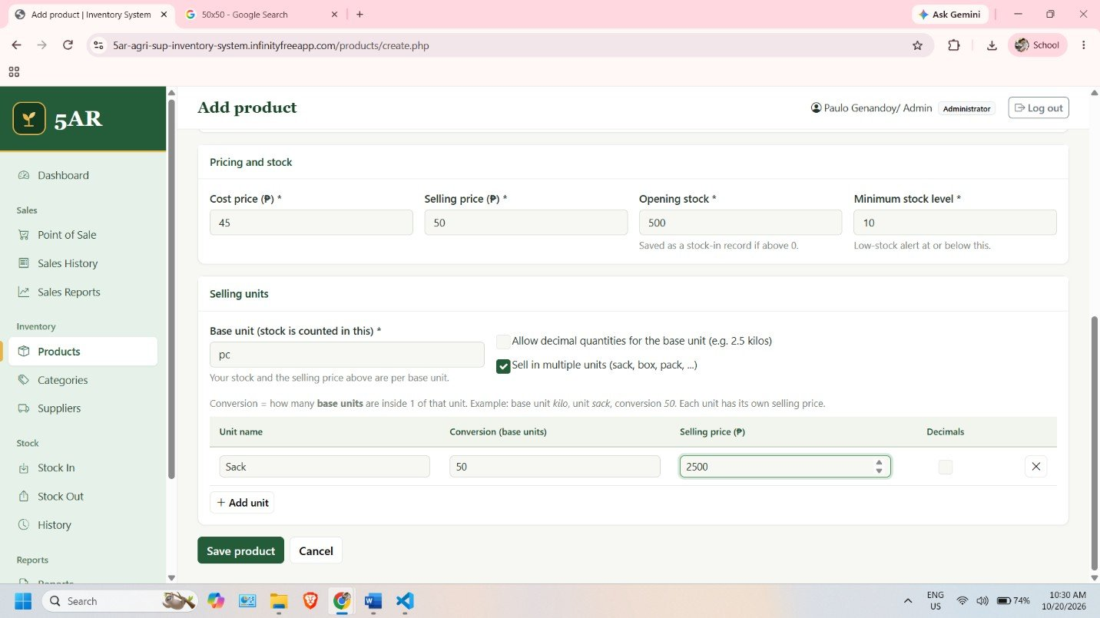
Figure 4.16 Product Form with Selling Units
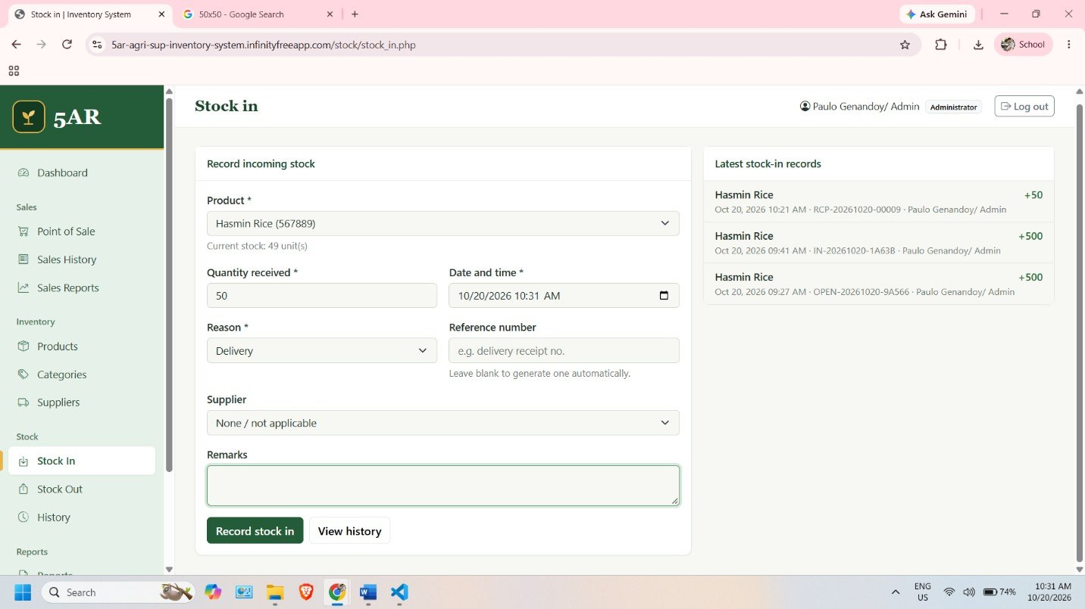
Figure 4.17 Stock In Form
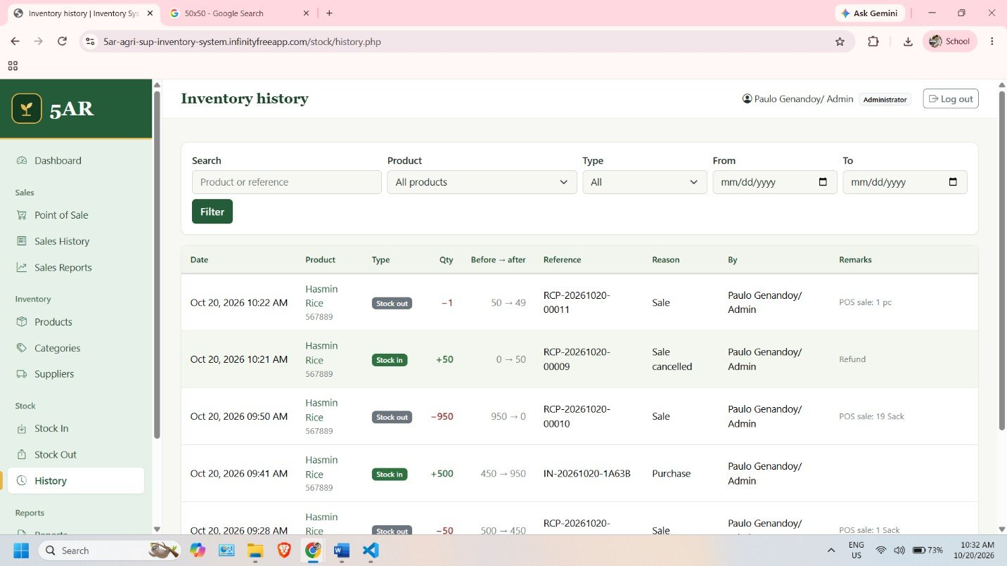
Figure 4.18 Stock History
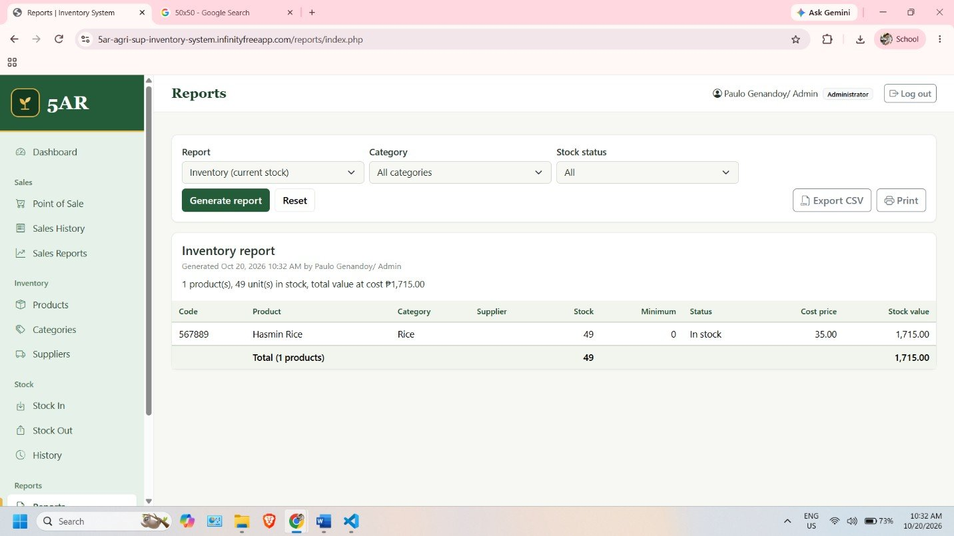
Figure 4.19 Inventory Report
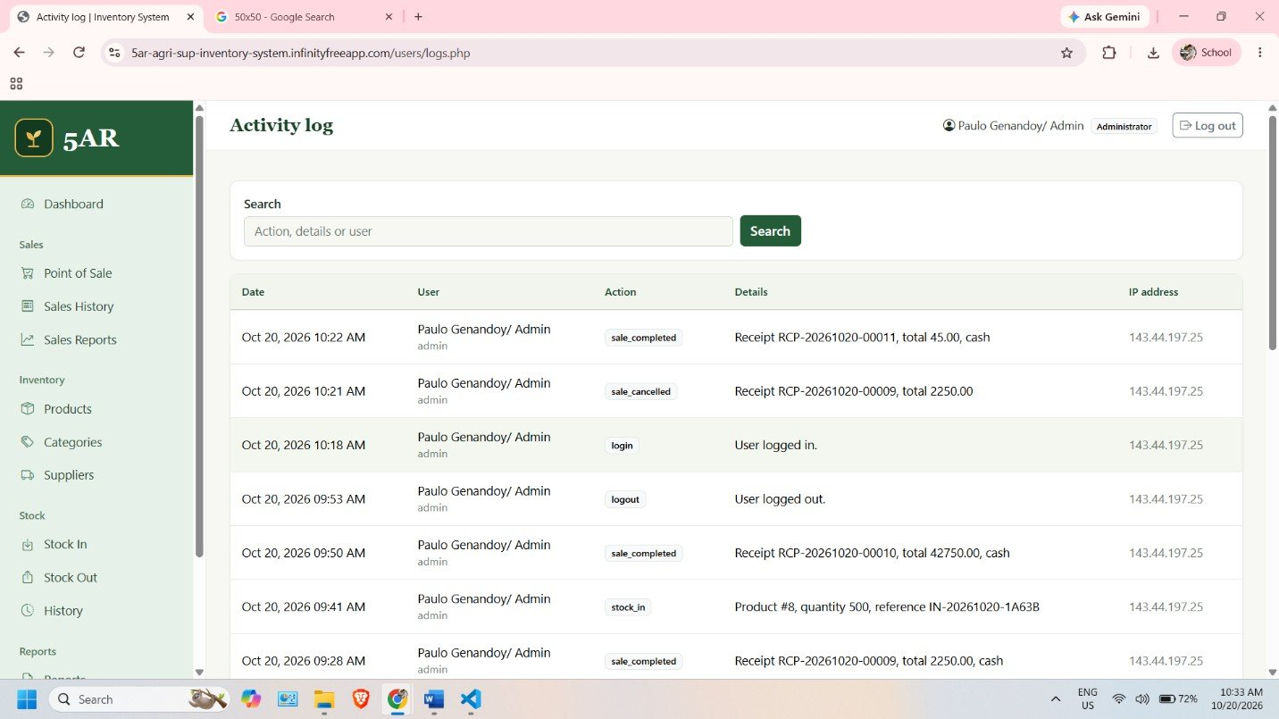
Figure 4.20 Activity Log

4.7 System Testing and Results

4.7.1 Testing Approach
Black-box functional testing is used to test the functions of the system. Each function gets followed by a Tester and the results are compared to the desired output and the actual result and status is recorded. The test cases were developed from the business rules, the functional requirements and the source code. They include deployment, login and session, access control, products, categories and suppliers, stock, POS, receipts and sales history, sale cancellation, reports and dashboard, users and activity log, security and remote monitoring by the owner. 62 test cases were prepared, with the first 56 being prepared before the remote-monitoring requirement was added, and the remaining seven test cases (TC-57 to TC-62) added to meet the requirement. The complete list is given in Appendix A.
4.7.2: Preliminary Run (Dev)
Sample records exist that demonstrate that some functions have been used during development in the database export of the development copy. Table 4.16 lists them. The following records are based on sample data and do not represent the actual data of 5AR Agrivet and are not a formal test result. No records of a cancelled sale, GCash sale, or a low stock product are included in the export.
Table 4.16 Records in the Development Database Export
Function | Record Found | What It Shows
Login | A failed login for the username admin, followed by a successful login of the administrator account. | Login check and activity logging.
User management | A staff account was created by the administrator. | Administrator can add users with a role.
Master records | A sample category, supplier, and product were created. The product was created with an opening stock of 500. | Master records work. Opening stock is saved as a stock-in with its own reference number.
Selling units | The sample product has a unit named Sack with a conversion of 50 and a price of 2,250.00. | Selling units with conversion are stored.
Sale | Receipt RCP-20261012-00008, cash, total 2,250.00, status completed. One sack was sold, which deducted 50 from stock (500 to 450). | POS sale, receipt number, unit conversion, and automatic stock deduction.
Stock in | A delivery of 500 was recorded with reference IN-20261012-AF923 (450 to 950). | Stock-in updates the quantity and the history.

Black-box functional testing is used to test the functions of the system. Each function gets followed by a Tester and the results are compared to the desired output and the actual result and status is recorded. The test cases were generated based on the business rules, functional requirements and the source code. They encompass the following: deployment, login and session, access control, products, categories and suppliers, stock, POS, receipts and sales history, sale cancellation, reports and dashboard, users and activity log, security and remote monitoring by the owner. 62 test cases were prepared, with the first 56 being prepared before the remote-monitoring requirement was added, and the remaining seven test cases (TC-57 to TC-62) added to meet the requirement. The complete list is given in Appendix A.
4.7.2: Preliminary Run (Dev)
There are sample records which illustrate that some functions have been used in the development copy during the database export. Table 4.16 lists them. The data shown below are taken from sample data and are not a formal test result and do not represent the actual test data of 5AR Agrivet. Cancelled sale, GCash sale, and a low stock product are not included in the export.
activity log and sales report are created for the deployed copy. They are similar to Table 4.16, but from screenshots of sample data. They were not tested by any of the testers who recorded the steps, the expected result, and the status for them, so they are not formal test results, and the test cases in Appendix A are still pending.
4.7.3 Test Plan Summary
The number of test cases for each module is indicated in Table 4.17. All test cases are yet to be marked.
Table 4.17 Test Plan Summary
Module | Test Cases | Number | Result
Deployment | TC-01 to TC-03 | 3 | Pending
Login and Session | TC-04 to TC-09 | 6 | Pending
Access Control | TC-10 to TC-12 | 3 | Pending
Products | TC-13 to TC-19 | 7 | Pending
Categories and Suppliers | TC-20 to TC-23 | 4 | Pending
Stock | TC-24 to TC-29 | 6 | Pending
Point of Sale | TC-30 to TC-41 | 12 | Pending
Receipt and Sales History | TC-42 to TC-43 | 2 | Pending
Sale Cancellation | TC-44 to TC-46 | 3 | Pending
Reports and Dashboard | TC-47 to TC-51 | 5 | Pending
Users and Activity Log | TC-52 to TC-54 | 3 | Pending
Security | TC-55 to TC-56 | 2 | Pending
Remote Monitoring | TC-57 to TC-62 | 6 | Pending
Total | TC-01 to TC-62 | 62 | Pending

4.7.4 Test Results
Formal testing of the deployed system has not been recorded yet. For this reason, the Actual Result and Status columns in Appendix A are left as pending, and this paper does not claim that any test passed or failed. Table A.1 now also has columns for the date tested and for the evidence, so each test can be recorded as it is performed. Before submission, the group should run each test case on the deployed system, record what actually happened, and attach screenshots as evidence. The remote-monitoring tests (TC-57 to TC-62) must be run with the owner's authorized account on a mobile phone and on an internet connection different from the store's. The access-rights tests (TC-10 to TC-12 and TC-61) must confirm that a staff account cannot open administrator-only functions. Test cases that fail should be noted together with the correction made.

4.8 Evaluation and Discussion

4.8.1 Evaluation Status
A user evaluation of the system by Fritz Basco, the staff, or other respondents has not been conducted or recorded. A questionnaire has been prepared in Appendix C. Its items follow the quality characteristics of ISO/IEC 25010 [15], namely functional suitability, usability, reliability, security, and performance efficiency, with an added section on remote monitoring by the owner, and it uses a five-point agreement scale [16]. Reference [5] also used the ISO 25010 standard to evaluate its system. No questionnaire responses have been collected, so no respondent counts, ratings, or percentages are reported in this paper. After the responses are collected, the results must be computed as shown in Appendix C and reported in this section based on the real responses.

4.8.2 Discussion
Table 4.18 relates each problem in Table 3.3 to the features of the system. The second column shows what the system was designed to do, based on the source code. The third column states what evidence is available. A feature that exists in the code is not yet proof that it works well for the business, so the improvements in daily use are still expected benefits until testing and use by the client confirm them.
Table 4.18 Problems, System Features, and Available Evidence
Problem | System Feature | Evidence Available
P1: Tracking sales on paper is time-consuming | POS with automatic totals, change, saved sales, and sales history with filters. | Implemented. A sample sale was saved during development (Table 4.16). Formal testing and client use pending.
P2: Monitoring inventory is time- consuming | Automatic stock deduction at sale; stock-in and stock-out; low-stock and out-of-stock status; dashboard. | Implemented. Sample stock movements recorded (Table 4.16). Low-stock display not yet shown by test records.
P3: Handwritten recording leads to mistakes | Computation by the system, stock checks, database transactions, duplicate-sale protection, read- only history. | Implemented in the code. Not yet verified by recorded tests.
P4: Information is not in one system | One database for products, categories, suppliers, stock, sales, and users, accessible online. | Implemented. Online access depends on the deployment.
P5: Reports are hard to prepare | Sales reports, inventory and stock transaction reports, CSV export, and dashboard. | Implemented. Report outputs not yet verified with recorded tests.
P6: The owner cannot monitor sales and inventory remotely | Online deployment; administrator account for the owner; dashboard, sales history, sales reports, and inventory reports opened through a web browser. | Deployed. Figures 4.9 to 4.20 show the pages at the deployed address, taken from a computer. Access from outside the store with the owner's account is not yet tested (TC-57 to TC-62 pending).

Remote monitoring (P6) depends on three conditions that testing and actual use must still confirm. First, the owner's account must open the dashboard and the reports from outside the store, on a phone and on another internet connection. Second, the staff must enter every sale and stock movement at the store, because the owner can only see what is recorded. Third, the hosting service and the internet connections on both sides must be available when the owner needs the records. Because the benefits of remote monitoring have not been tested or measured, this paper treats them as expected benefits.

4.8.3 Limitations and Observations
- The system needs an internet connection and depends on the InfinityFree hosting service.
- The database design allows only one line per product in a sale, so the same product cannot be sold in two different units in one transaction. This is recorded as a limitation and as a test case (Appendix A).
- The sample data in the development database are not the real products of 5AR Agrivet. The real products, categories, and suppliers must be entered before the system is used in the business.
- The system was not tested with a printer, and printing is not part of the project.
- Remote access with the owner's account has not yet been tested from a mobile phone and from an internet connection different from the store's. The screenshots were taken in a computer browser.
- The owner's remote view is only as current as the entries made by the staff. The system has no automatic alerts, so the owner has to log in to check.
- The free plan of InfinityFree has usage limits and no uptime guarantee [13], [14]. If the host is not available, the owner cannot view the records.

4.9 Chapter Summary
This chapter described the implemented Inventory Management System with POS. The system uses PHP, MySQL, HTML, CSS, JavaScript, and Bootstrap, and is deployed online on InfinityFree so that it can be opened through a web browser. It has modules for login and roles, the dashboard, products with selling units, categories, suppliers, stock movements, the POS with on-screen receipts and sale cancellation, reports, user management, and an activity log. The owner is intended to use these same pages remotely through his administrator account, because he works as a seaman. The database has nine tables, and the diagrams and data dictionary describe its actual structure. The screenshots were taken from the deployed system. A test plan with 62 test cases was prepared (56 general test cases and 6 test cases for remote monitoring), together with a user-evaluation questionnaire. The test results, the remote-access tests, and the user evaluation are still to be completed and are not reported as done.

CHAPTER 5
CONCLUSION AND RECOMMENDATIONS

5.1 Introduction
This chapter presents the overall conclusion and the recommendations for the Inventory Management System with POS developed for 5AR Agrivet. It first summarizes the study design and implementation, then the findings, and then gives the conclusion and the recommendations for the continued use and improvement of the system.

5.2 Summary of the Proposed Study Design and Implementation
The study addressed the problem of 5AR Agrivet, a business that sells chicken feeds and other agrivet supplies. Its owner, Fritz Basco, records sales manually by writing the transaction details on paper using a pen. This makes it time-consuming to find the sales for a day or a period, to check how much stock is left, and to prepare reports. Because the owner works as a seaman and may be far from the business, the study also addressed his need to monitor the sales and the inventory remotely.
The project used systems analysis and design techniques. The researchers analyzed the stakeholders, the SIPOC of the sales and inventory process, the current-state process, the problems, and their root causes, and they listed the functional and non-functional requirements. They then built the system with PHP for the server-side processing, MySQL for the database, and HTML, CSS, JavaScript, and Bootstrap for the interface. The system is deployed online on InfinityFree, so the owner and authorized staff can open it through a web browser with an internet connection.
The main implemented modules are login with administrator and staff roles, a dashboard, product management with selling units, category and supplier management, stock-in, stock-out, and stock history, a point of sale with cash and GCash payment, on-screen receipts, sales history and sale cancellation, sales reports, inventory and stock transaction reports with CSV export, user management, and an activity log. The system replaces the paper-and-pen recording of sales with digital records that are saved in one database, and it updates the stock together with every sale. Because the system is online, the same dashboard, sales, and report pages can be opened by the owner through a web browser from outside the store.

5.3 Summary of Findings
The findings below are separated into what the requirements analysis showed, what the implementation shows, and what has not yet been demonstrated.
Findings from the requirements analysis
The analysis showed that the current practice is to write each sale on paper with a pen. Because of this, the business has no digital sales record, no automatic total, and no stock update at the time of the sale. Six problems were identified (Table 3.3): tracking sales takes a lot of time, monitoring inventory takes a lot of time, handwritten records can contain mistakes, information is not kept in one system, reports are hard to prepare, and the owner, who works as a seaman, cannot monitor sales and inventory remotely. The related studies in Chapter 2 reported similar problems in other small stores that record sales and stock manually [3], [4]. They did not deal with an owner who is away from the business.
Findings from the implementation
The implemented system has the features listed in the functional requirements (Table 3.4). It computes the total and the change of each sale, saves the sale and the stock deduction together in one database transaction, assigns a receipt number, shows an on-screen receipt, and keeps a stock history that cannot be edited. It shows low-stock and out-of-stock products, and gives sales and inventory reports. The database has nine tables with defined relationships. The development database export contains sample records that show a login, the creation of a user, a category, a supplier, and a product, a sale of one sack that deducted 50 base units from the stock, and a stock-in that raised the quantity again (Table 4.16). These records are sample data created during development and are not formal test results. The system is deployed online, and the screenshots in Figures 4.9 to 4.20 were taken from the deployed address on October 20, 2026. They also show a cancelled sale whose items were returned to stock in the stock history, and an activity log that records the actions (Section 4.7.2). These are observations of sample data and not formal test results.
Expected benefits and what has been demonstrated
Table 5.1 separates the improvements that the system is designed to provide from the evidence that is available at this time.
Table 5.1 Expected Benefits and Available Evidence
Expected Benefit | Feature Designed for It | Evidence Available
Organized sales records | Sales and sale items saved in the database; sales history with filters. | Demonstrated in the development data (one sample sale). Use by the client not yet recorded.
Automatic total computation | POS computes the total and the change. | Implemented. The sample sale shows a saved total. Formal test pending.
Inventory tracking | Stock is deducted at each sale; stock-in and stock-out are recorded with stock before and after. | Demonstrated in the development data (stock 500 to 450 to 950).
Low-stock awareness | Low-stock and out-of-stock status on the dashboard and product list. | Implemented. Not yet shown by recorded tests.
Report generation | Sales reports, inventory report, stock transactions report, CSV export. | Implemented. Report outputs not yet verified by recorded tests.
Faster recording and less time spent | Fewer manual steps at the counter and no need to go through written pages. | Not measured. No time comparison was done, so no figure is reported.
Access through a browser | Online deployment on InfinityFree. | Screenshots (Figures 4.9 to 4.20) show the system open at its deployed address in a computer browser. Deployment test cases TC-01 to TC-03 are pending.
Remote monitoring by the owner | Online deployment; administrator account; dashboard, sales history, sales reports, and inventory reports in the browser. | Deployed, but not yet confirmed from outside the store with the owner's account. TC-57 to TC-62 are pending.

No quantitative findings, such as time saved, error rates, or user satisfaction scores, are reported because they were not measured. The formal testing and the user evaluation are still to be done (Sections 4.7 and 4.8).

5.4 Conclusion
The developed Inventory Management System with POS addresses the identified problem of 5AR Agrivet by replacing the paper-and-pen recording of sales with a web-based system. The system lets the staff record a sale at the POS, computes the total and the change, saves the sale, and deducts the stock in the same step. Because sales, products, suppliers, stock movements, and users are kept in one database, the owner can review sales history, current stock, low-stock products, and reports without going through handwritten pages. The online deployment lets the owner and authorized staff open the system through a web browser, as long as there is an internet connection.
The system also responds to the situation of the owner, who works as a seaman. Because the records are kept in an online database, the dashboard, sales history, sales reports, and inventory reports can be opened through a web browser with the owner's administrator account, so the owner does not have to be at the store to review them. This capability is deployed, but it has not yet been confirmed from outside the store with the owner's account on a mobile phone and on another internet connection. Its usefulness also depends on the staff entering every sale and stock movement on time, on the owner's internet connection, and on the availability and security of the hosting service. For these reasons, remote monitoring should be described as an implemented and deployed capability whose benefit still has to be confirmed through testing and actual use.
Based on the requirements analysis and the implemented features, the system is useful for recording sales, managing products and stock, and reviewing business information, and the objectives of the project were met in terms of the features that were built and deployed. The objective on remote access (Objective 8 in Section 1.3.2) was met in terms of design and deployment, but its use from outside the store is still to be verified. The sample records in the development database support that the sale and stock functions work. However, the formal testing and the evaluation by the client and staff are not yet recorded, so the benefits in daily use remain expected benefits and should be confirmed after the system is tested and used in the business.

5.5 Recommendations
Based on the study, the researchers recommend the following.
Continued use by Fritz Basco and authorized staff
- Enter the real products, categories, suppliers, prices, and starting stock of 5AR Agrivet, and remove the sample records from the development data.
- Give each staff member a separate account with a strong password, keep the administrator account for the owner only, and disable accounts of people who no longer work for the business.
- Use the activity log and the stock history to review changes regularly.
Remote monitoring by the owner
- Perform TC-57 to TC-62 with the owner's authorized account, using a mobile phone and an internet connection different from the store's, and keep screenshots as evidence before relying on remote monitoring.
- Record each sale and each stock movement at the time it happens, so that what the owner sees remotely matches what is happening in the store.
- Agree on how the owner will review the records, for example which pages to check and how often, and on how the staff will report problems to him.
- Review the activity log from time to time. It records the IP address of each action, so the owner can look for logins or actions that he does not recognize.
System security and account permissions
- Use a strong password for the administrator account, do not share it with staff, and avoid an obvious username such as admin.
- Confirm that staff accounts cannot open administrator-only functions (TC-10 to TC-12 and TC-61). Broken access control is the first category in the OWASP Top 10 list of web application security risks [17].
- Staff accounts can also view sales and inventory reports. Give accounts only to people who need them, and disable the account of anyone who leaves the business.
- Check that the browser shows a secure (HTTPS) connection on the login page, because passwords travel over the internet (TC-62).
Internet availability and hosting
- Make sure that the store and the owner each have a reliable internet connection. Agree on a temporary procedure for internet or hosting downtime, such as writing sales on paper and encoding them afterward, so that the records the owner sees stay complete.
- Check the limits and terms of the InfinityFree plan, including the daily hit limit and the absence of an uptime guarantee [13], [14]. If the owner depends on remote monitoring, consider a paid hosting plan with a stated uptime and backups.
Database backups and data protection
- Export the database regularly through the database tool of the hosting service (such as phpMyAdmin, if available), and keep copies outside the hosting account. Do not assume that the hosting service keeps backups for the business. Confirm what the hosting plan provides.
- Keep a copy of the product images folder and of the system files.
- Access the system only on trusted devices, log out after use, and use a secure (HTTPS) connection if the hosting provides it.
User training and proper recording of stock
- Train the owner and staff to use the POS, the stock-in and stock-out forms, and the reports before regular use.
- Record every delivery as a stock-in and every other stock removal as a stock-out with the correct reason, so that the stock quantities stay accurate.
- Correct stock mistakes by recording an opposite transaction, and cancel wrong sales through the administrator instead of leaving them in the records.
Monitoring after deployment and correction of issues
- Complete the test cases in Appendix A on the deployed system, record the actual results, and fix the problems found.
- Collect feedback from the owner and staff after a period of use, and keep a list of issues to be corrected.
Maintenance
- Name a person who will maintain the system after the project, and keep a list of reported problems and of the changes made to the system.
- Test again after every change, especially login, user roles, the POS, and the reports.
- Bootstrap, Bootstrap Icons, and Chart.js are loaded from the internet (Table 4.1). Check from time to time that the pages still display correctly.
- Log in to the hosting account regularly and check the provider's rules on inactive accounts. Keep the hosting account details in a secure place, and do not write them in this paper.
Future improvements
- Allow the same product to be sold in more than one unit in a single sale, which the current database design does not support.
- Add barcode scanning to speed up product selection at the POS.
- Improve the reports, for example by adding CSV export to the sales reports and more charts and filters.
- Add purchase orders or reorder reminders based on the minimum stock level.
- Add a summary view or alerts, such as SMS or email, for daily sales and low-stock products, so that the owner does not have to log in to check. These are not implemented.
- Add extra protection for the administrator account, such as two-step verification.
- Add other features that the business may need, such as customer records or credit sales, after confirming the need with the client.

REFERENCES
[1] N. DeHoratius and A. Raman, "Inventory record inaccuracy: An empirical analysis," Management Science, vol. 54, no. 4, pp. 627–641, 2008, doi: 10.1287/mnsc.1070.0789.
[2] J. Best, C. H. Glock, E. H. Grosse, Y. Rekik, and A. Syntetos, "On the causes of positive inventory discrepancies in retail stores," International Journal of Physical Distribution & Logistics Management, vol. 52, no. 5/6, pp. 414–430, 2022, doi: 10.1108/IJPDLM-07-2021-0291.
[3] U. K. Hassan et al., "Most Stationery Inventory Management System," Acta Electronica Malaysia (AEM), vol. 2, no. 2, pp. 10–13, 2018, doi: 10.26480/aem.02.2018.10.13.
[4] C. Limpianchob, "Point of sale system programming for small retail business," Modern Management Journal, vol. 21, no. 1, 2023. [Online]. Available: https://so04.tci-thaijo.org/index.php/stou-sms-pr/article/view/254202
[5] J. M. D. Valencia, M. U. F. Balusa, and J. F. De Pedro, "Inventory system of 909 Drug Store in Jamindan, Capiz," Undergraduate thesis, Mambusao Satellite College, Capiz State University, Capiz, Philippines, 2023. [Online]. Available: https://repository.capsu.edu.ph/handle/123456789/241
[6] H. Q. Lim, A. R. Rahmat, and S. Suban@Ani, "An inventory management system for small businesses," Journal of Digital System Development, vol. 3, no. 1, pp. 29–44, 2025, doi: 10.32890/jdsd2025.3.1.3.
[7] The PHP Group, "PHP Manual." [Online]. Available: https://www.php.net/manual/en/
[8] Oracle Corporation, "MySQL Documentation." [Online]. Available: https://dev.mysql.com/doc/
[9] Bootstrap, "Bootstrap Documentation." [Online]. Available: https://getbootstrap.com/
[10] Chart.js Contributors, "Chart.js Documentation." [Online]. Available: https://www.chartjs.org/
[11] InfinityFree, "InfinityFree Free Web Hosting." [Online]. Available: https://www.infinityfree.com/
[12] Apache Friends, "XAMPP." [Online]. Available: https://www.apachefriends.org/
[13] InfinityFree Support Forum, "InfinityFree hits." [Online]. Available: https://forum.infinityfree.net/t/infinityfree-hits/70654
[14] InfinityFree Community Forum, "Request for details regarding your free hosting plan." [Online]. Available: https://forum.infinityfree.com/t/request-for-details-regarding-your-free-hosting-plan/119773
[15] International Organization for Standardization, "ISO/IEC 25010:2023, Systems and software engineering — Systems and software Quality Requirements and Evaluation (SQuaRE) — Product quality model," ISO/IEC, 2023.
[16] R. Likert, "A technique for the measurement of attitudes," Archives of Psychology, vol. 22, no. 140, pp. 1–55, 1932.
[17] OWASP Foundation, "OWASP Top 10:2021." [Online]. Available: https://owasp.org/Top10/

APPENDIX A
Test Cases
The Actual Result, Date Tested, and Evidence columns are left blank, and the Status column is marked Pending, because the tests have not yet been performed and recorded on the deployed system. For each test, the tester records the date, the device and the connection used (for example, a computer on the store's Wi-Fi or a phone on mobile data), what actually happened, and the file name or figure number of a screenshot as evidence. Status stays Pending until the test is run, and then becomes Passed or Failed. A test that fails is repeated after the correction is made, and both results are noted. TC-01 to TC-56 were prepared earlier and are unchanged. TC-57 to TC-62 were added to cover the requirement that the owner can monitor sales and inventory remotely.
Table A.1 Test Cases for the Inventory Management System with POS
ID | Module | Test Objective | Steps | Expected Result | Actual Result | Status | Date Tested | Evidence (file or figure no.)
TC-01 | Deployment | Open the deployed system in a browser | Enter the system's web address on a computer browser with internet. | The login page loads. |  | Pending
TC-02 | Deployment | Open the system on a phone browser | Open the same web address on a mobile browser and log in. | Pages load and the layout adjusts to the screen size. |  | Pending
TC-03 | Deployment | Use the system without internet | Turn off the internet connection and reload the page. | The page cannot load. The system does not work offline. |  | Pending
TC-04 | Login and Session | Valid login | Enter a correct username and password. | User is taken to the dashboard; last login is updated; a login entry appears in the activity log. |  | Pending
TC-05 | Login and Session | Invalid password | Enter a correct username and a wrong password. | An "invalid username or password" message appears; a failed login is logged. |  | Pending
TC-06 | Login and Session | Login lock | Enter wrong credentials 5 times, then try again within 1 minute. | Login is temporarily blocked with a message. |  | Pending
TC-07 | Login and Session | Disabled account | Disable a user, then try to log in with that account. | Login is refused. |  | Pending
TC-08 | Login and Session | Session timeout | Log in, stay idle for more than 30 minutes, then click any menu. | User is returned to the login page. |  | Pending
TC-09 | Login and Session | Logout | Click the logout button. | Session ends and the login page is shown. |  | Pending
TC-10 | Access Control | Staff cannot open Users page | Log in as staff and open the Users page address. | Access is refused and the user is redirected. |  | Pending
TC-11 | Access Control | Staff cannot delete a product | Log in as staff and try to delete a product. | The system rejects the action with a message. |  | Pending
TC-12 | Access Control | Administration menu | Log in as staff, then as administrator, and compare the sidebar. | The Administration group appears only for the administrator. |  | Pending
TC-13 | Products | Add a product | Fill in all required fields with valid data and save. | Product is saved; the SKU is stored in capital letters; opening stock is recorded as a stock- in entry. |  | Pending
TC-14 | Products | Duplicate SKU | Add a product with an SKU that already exists. | The system rejects it with a message. |  | Pending
TC-15 | Products | Invalid price | Enter a negative selling price and save. | The system rejects it and shows an error. |  | Pending
TC-16 | Products | Product image upload | Upload a JPG, PNG, or WEBP image within the size limit; then upload a file of another type. | Valid image is saved and shown; invalid file is rejected. |  | Pending
TC-17 | Products | Add selling units | Add a unit (for example, sack) with a conversion quantity and price; then add the same unit name again. | First unit is saved; duplicate unit name is rejected. |  | Pending
TC-18 | Products | Search and filter products | Search by name or code and filter by category and stock status. | The list shows only matching products. |  | Pending
TC-19 | Products | Delete a product | As administrator, delete a product with no history, then one with stock history. | Product without history is deleted; product with history is blocked. |  | Pending
TC-20 | Categories and Suppliers | Add a category | Add a new category, then add the same name again. | First is saved; duplicate is rejected. |  | Pending
TC-21 | Categories and Suppliers | Delete a category in use | As administrator, delete a category that has products. | Deletion is blocked with a message. |  | Pending
TC-22 | Categories and Suppliers | Add and edit a supplier | Add a supplier, edit its contact details, then add the same name again. | Supplier is saved and updated; duplicate name is rejected. |  | Pending
TC-23 | Categories and Suppliers | Delete a supplier in use | As administrator, delete a supplier linked to a product or delivery. | Deletion is blocked with a message. |  | Pending
TC-24 | Stock | Stock in | Record a stock-in for a product with supplier, reference, and date. | Quantity increases; a history row shows stock before and after. |  | Pending
TC-25 | Stock | Stock out | Record a stock-out with a valid reason. | Quantity decreases; a history row is added. |  | Pending
TC-26 | Stock | Stock out above available | Record a stock-out larger than the quantity on hand. | The system rejects it and the quantity does not change. |  | Pending
TC-27 | Stock | Reason "Other" needs remarks | Record a stock transaction with reason "Other" and no remarks. | The system asks for remarks. |  | Pending
TC-28 | Stock | Stock history is read-only | Open the stock history and filter by product, type, and date. | Filters work; there are no edit or delete controls. |  | Pending
TC-29 | Stock | Low and out- of-stock status | Set quantities to equal the minimum stock, and to zero. | The product shows Low stock at the minimum level and Out of stock at zero. |  | Pending
TC-30 | Point of Sale | Add items to the cart | Click products and set quantities. | Cart lines and the running total update. |  | Pending
TC-31 | Point of Sale | Quantity limit | Try to add more than the available stock. | Quantity is limited to the stock on hand. |  | Pending
TC-32 | Point of Sale | Out-of-stock product | Try to add a product with zero stock. | The product cannot be added. |  | Pending
TC-33 | Point of Sale | Cash payment | Select Cash and enter an amount higher than the total; then enter an amount lower than the total. | Change is computed for the higher amount; the lower amount is rejected. |  | Pending
TC-34 | Point of Sale | Complete a cash sale | Complete a sale with cash. | Sale is saved with a receipt number; stock is deducted; a "Sale" entry appears in stock history; the on-screen receipt opens. |  | Pending
TC-35 | Point of Sale | GCash reference required | Select GCash and leave the reference blank or invalid. | The system requires a valid reference number. |  | Pending
TC-36 | Point of Sale | Duplicate GCash reference | Complete a GCash sale, then use the same reference in another sale. | The second sale is rejected. |  | Pending
TC-37 | Point of Sale | Double submission | Press Complete sale twice quickly. | Only one sale is recorded. |  | Pending
TC-38 | Point of Sale | Selling in another unit | Sell one product by a larger unit (for example, sack) that has a conversion quantity. | Stock is reduced by the converted base-unit quantity. |  | Pending
TC-39 | Point of Sale | Decimal quantity | Enter a decimal quantity for a unit that allows it, then for one that does not. | Allowed unit accepts it; the other rejects it. |  | Pending
TC-40 | Point of Sale | Price changed during checkout | Change a price in another browser while a cart is open, then complete the sale. | The sale is stopped and the user is told to review the cart. |  | Pending
TC-41 | Point of Sale | Same product in two units | Add the same product in two different units in one cart and complete the sale. | Observe and record the result. The database allows one line per product per sale, so this case may be rejected. |  | Pending
TC-42 | Receipt and Sales History | On-screen receipt | Open the receipt after a sale. | The receipt shows the receipt number, items, total, payment, and change. |  | Pending
TC-43 | Receipt and Sales History | Sales history filters | Search by receipt number and filter by payment method, status, and date. | The list shows only matching sales and links to each receipt. |  | Pending
TC-44 | Sale Cancellation | Cancel a sale | As administrator, cancel a completed sale and enter a reason. | Status becomes cancelled; items return to stock through a stock-in entry. |  | Pending
TC-45 | Sale Cancellation | Staff cannot cancel | Log in as staff and open a receipt. | No cancel option is available. |  | Pending
TC-46 | Sale Cancellation | Cancel twice | Try to cancel an already cancelled sale, and cancel without a reason. | Both attempts are rejected. |  | Pending
TC-47 | Reports and Dashboard | Sales report totals | Open Sales Reports and compare totals with the sales history. | Totals match and cancelled sales are not counted. |  | Pending
TC-48 | Reports and Dashboard | Sales report range | Choose a date range. | Daily chart, transaction count, items sold, average sale, best sellers, profit by product, and monthly summary are shown. |  | Pending
TC-49 | Reports and Dashboard | Inventory report and CSV export | Open the inventory report, apply filters, and export CSV. | The report matches the filters and the CSV file opens in a spreadsheet. |  | Pending
TC-50 | Reports and Dashboard | Stock transactions CSV | Open the stock transactions report and export CSV. | The CSV matches the filtered list; the export is logged. |  | Pending
TC-51 | Reports and Dashboard | Dashboard figures | Compare the dashboard counts with the product list. | Total products, low- stock, out-of-stock, and category counts match. |  | Pending
TC-52 | Users and Activity Log | Create a user | As administrator, add a user with a short password, then with a valid password. | Short password is rejected; valid one is saved. |  | Pending
TC-53 | Users and Activity Log | Own account protection | As administrator, try to disable your own account or change your own role. | The system does not allow it. |  | Pending
TC-54 | Users and Activity Log | Activity log entries | Perform a login, sale, and stock-in, then open the activity log. | Each action appears with user, time, and details. |  | Pending
TC-55 | Security | CSRF token | Submit a form with a missing or wrong token. | The request is rejected. |  | Pending
TC-56 | Security | Protected folders | Open the config and includes folder addresses directly in the browser. | Access is denied. |  | Pending
TC-57 | Remote Monitoring | Owner logs in from outside the store | On a mobile phone that uses mobile data (not the store's Wi-Fi), open the web address of the system and log in with the owner's administrator account. | The login page loads, the owner reaches the dashboard, and the last login time is updated. |  | Pending
TC-58 | Remote Monitoring | Dashboard viewed remotely | While logged in remotely, open the dashboard and compare its totals, low-stock and out-of-stock counts, and recent movements with the Products page. | The figures match the product list, recent stock movements are shown, and the layout fits the phone screen. |  | Pending
TC-59 | Remote Monitoring | Sales data is current | Ask the staff to complete a sale in the POS at the store. On the remote device, reload Sales History and Sales Reports. | The new sale appears in Sales History with its receipt number, and today's total in Sales Reports increases by the sale total. |  | Pending
TC-60 | Remote Monitoring | Inventory report viewed remotely | On the remote device, open Reports, generate the inventory report with a filter, and export the CSV. | The report shows the current stock with low- stock and out-of-stock status, and the CSV file downloads and matches the report. |  | Pending
TC-61 | Remote Monitoring | Staff limits when logging in remotely | On a remote device, log in with a staff account, check the sidebar, and open the Users and Activity Log addresses directly. | The Administration menu is not shown, and direct access to administrator- only pages is refused (same result as TC-10 to TC-12). |  | Pending
TC-62 | Remote Monitoring | Remote access is secure and traceable | Check that the browser shows a secure (HTTPS) connection on the login page. Log in remotely, then log out. Leave another remote session idle for more than 30 minutes. Then open the Activity Log as administrator. | The connection is secure, the idle session ends, and the remote login appears in the activity log with the time and an IP address different from the store's connection. |  | Pending

APPENDIX B
User Guide
This guide explains the main tasks in the deployed Inventory Management System with POS. The steps follow the screens and buttons in the source code. Names of some menu items may differ slightly on the screen.

B.1 Opening the System
- Connect the computer or device to the internet.
- Open a web browser and enter the web address of the system https://5ar-agri-sup-inventory-system.infinityfreeapp.com/login.php
- The login page appears. If the page does not load, check the internet connection. The system cannot be used offline.

B.2 Logging In and Out
- Type the username and password given to you, then click the login button.
- After five wrong attempts, login is locked for one minute. Wait, then try again.
- Use the logout button when you are finished. The system also logs you out after 30 minutes without activity.

B.3 Using the Dashboard
- After login, the dashboard shows the total products, total units, low-stock and out-of-stock counts, products needing attention, recent stock movements, and a chart.
- Use it to see which products need to be restocked.

B.4 Making a Sale (POS)
- Open Point of Sale from the Sales menu.
- Search for a product and click it to add it to the cart. Choose the unit (for example, sack or kilo) and the quantity. The system does not allow a quantity higher than the stock on hand.
- Check the cart and the total.
- Choose Cash and type the amount paid, or choose GCash and type the reference number. For cash, the system shows the change.
- Click Complete sale and confirm. The system saves the sale, deducts the stock, and opens the on-screen receipt.
- Add each product only once per sale. Selling the same product in two different units in one sale is not supported.

B.5 Viewing Receipts and Sales History
- Open Sales History from the Sales menu.
- Use the search box and filters (payment method, status, date) to find a sale, then click its receipt number to open the receipt.
- Administrators only: to cancel a wrong sale, open its receipt, type the reason, and click Cancel sale. The items are returned to stock and the sale stays in the history as cancelled.

B.6 Managing Products
- Open Products from the Inventory menu. Use the search box and filters to find a product.
- Click the add button to create a product. Fill in the SKU, name, category, supplier, prices, minimum stock, base unit, and optional image (JPG, PNG, or WEBP). The opening stock is recorded as a stock-in.
- To sell a product in another unit, add a selling unit with its name, how many base units it contains, and its price.
- Click edit to change a product. Only administrators can delete products, and a product with stock history cannot be deleted.

B.7 Managing Categories and Suppliers
- Open Categories or Suppliers from the Inventory menu.
- Add or edit the record and save. Duplicate names are not accepted.
- Only administrators can delete records, and records that are in use cannot be deleted.

B.8 Recording Stock In and Stock Out
- Open Stock In (for deliveries) or Stock Out (for other removals) from the Stock menu.
- Select the product, enter the quantity, date and time, reason, reference number, and remarks. For stock in, select the supplier.
- Save. The product quantity is updated. A stock out larger than the stock on hand is rejected.
- Open Stock History to see all movements. The history cannot be edited or deleted.

B.9 Viewing Reports
- Open Sales Reports from the Sales menu to see totals for today, this week, and this month, sales for a chosen date range, best-selling products, profit by product, and the monthly summary.
- Open Reports from the Reports menu to see the inventory report and the stock transactions report. Apply the filters, then use the CSV export button to download the report as a file that opens in a spreadsheet.

B.10 Managing Users and Viewing the Activity Log (Administrator Only)
- Open Users from the Administration menu.
- Add a user with a full name, username, password of at least 8 characters, and role. To stop a person from using the system, disable the account instead of deleting it.
- Open Activity Log to review logins, changes, stock movements, sales, cancellations, and exports.

B.11 Monitoring the Business Remotely (Owner)
- Connect your phone or computer to the internet. The system cannot be used offline.
- Open a web browser and enter the web address of the system (see B.1).
- Log in with the owner's administrator account. Do not share the password, and do not log in on a public or shared computer.
- Open the Dashboard to see the stock counts, the low-stock and out-of-stock products, and the recent stock movements.
- Open Sales History to see each sale with its receipt number, payment method, status, and cashier. Open Sales Reports to see the totals for today, this week, and this month, the best-selling products, and the profit by product.
- Open Reports from the Reports menu to see the inventory report. Use the CSV export button if you want to save a copy.
- Log out when you are finished. The system also logs you out after 30 minutes without activity.
- Remember that the screens show only the sales and stock movements that the staff have already entered. If the page does not open, check your internet connection and try again later, because the hosting service may be temporarily unavailable.

APPENDIX C
User Evaluation Questionnaire

C.1 Purpose and Respondents
This questionnaire is for collecting the opinions of the people who use the Inventory Management System with POS for 5AR Agrivet. Its statements follow the product quality characteristics of ISO/IEC 25010 [15] and add a section on remote monitoring for the owner. It has not been answered yet, and this paper reports no responses. The respondents should be people who actually used the deployed system, for example Fritz Basco as the owner and the staff or cashiers who used the POS. The number of respondents is to be decided with the adviser. The answers of the owner and of the staff should be tabulated separately, because they use the system differently. Part F (remote monitoring) is answered only by the owner, or by anyone who tested the remote access.

C.2 The Questionnaire
Part A. Respondent profile
Name (optional): ________________ Date answered: ___________
Role: ☐ Owner ☐ Staff / Cashier ☐ Other: ________
Device used: ☐ Computer ☐ Mobile phone ☐ Both
Internet connection used: ☐ Store connection ☐ Mobile data ☐ Other: ________
Rating scale: 5 = Strongly Agree, 4 = Agree, 3 = Neutral, 2 = Disagree, 1 = Strongly Disagree. Mark one box for each statement. If a statement does not apply to you, leave it blank and write N/A beside it.
Table C.1 User Evaluation Questionnaire (Parts B to F)
No. | Statement | 5 | 4 | 3 | 2 | 1
A. Functional Suitability
FS1 | The system lets me record a sale with cash or GCash payment, and it shows the total and the change correctly.
FS2 | The stock of a product goes down automatically after a sale is completed.
FS3 | I can record stock-in and stock-out, and the stock history shows each movement.
FS4 | The system shows which products are low in stock or out of stock.
FS5 | The sales history, sales reports, and inventory reports give the information I need about the business.
FS6 | The functions of the system, including cancelling a sale by the administrator, are enough for the daily recording of sales and stock of 5AR Agrivet.
B. Usability (called Interaction Capability in ISO/IEC 25010:2023)
US1 | The screens and menus are easy to understand.
US2 | It is easy to learn how to use the POS and the stock forms.
US3 | The error and warning messages, for example for not enough stock or a wrong payment, are clear.
US4 | The system can be used comfortably on the device that I used (computer or phone).
US5 | I can find the reports and records that I need without help.
C. Reliability
RL1 | The system worked without errors or unexpected results while I used it.
RL2 | The records (stock, sales, and totals) stayed correct and consistent.
RL3 | The system was available whenever I needed to use it.
D. Security
SC1 | I need a username and password to enter the system.
SC2 | Staff accounts can only use the functions that they are allowed to use.
SC3 | I feel that the records of the business are protected from people who should not see or change them.
SC4 | The activity log and the stock history make it possible to see who did what.
E. Performance Efficiency
PE1 | The pages opened quickly.
PE2 | Completing a sale in the POS was faster than writing it on paper.
PE3 | The dashboard and the reports loaded in a reasonable time.
F. Remote Monitoring (owner only)
RM1 | I was able to open the system from outside the store using a web browser and my administrator account.
RM2 | The dashboard, sales history, sales reports, and inventory reports were easy to read on my phone or other device when I was away from the store.
RM3 | The information I saw remotely matched what was recorded at the store.
RM4 | Being able to check sales and inventory remotely helps me monitor the business while I am away.

Part G. Comments
1. What did you like most about the system?
__________________________________________
2. What problems or errors did you meet?
__________________________________________
3. What should be improved or added?
__________________________________________

C.3 Computing and Reporting the Results
Follow these steps after the real responses have been collected.
- Count the answers. For each statement, count how many respondents chose each rating from 5 to 1.
- Compute the mean of each statement: mean = (5 × n5 + 4 × n4 + 3 × n3 + 2 × n2 + 1 × n1) ÷ N, where n5 to n1 are the numbers of respondents who chose each rating and N is the number of respondents who answered that statement.
- Compute the mean of each criterion (A to F) by adding the means of its statements and dividing by the number of statements in that criterion.
- Compute the overall mean for the five quality characteristics (A to E) by averaging their criterion means. Report Part F (remote monitoring) separately, because only the owner, or whoever tested the remote access, answers it.
- Interpret each mean using Table C.2.
- If it is useful, report the percentage of agreement for each statement: (number of respondents who chose 4 or 5 ÷ N) × 100.
- Report the results by respondent group (owner and staff), state N for each group, and place the real counts and means in Table C.3 and in Section 4.8. Report only real responses. If N is small, say so and describe the results without generalizing them.
Table C.2 Interpretation of Mean Ratings
Mean range | Description | Interpretation
4.21 – 5.00 | Strongly Agree | The characteristic is very well met.
3.41 – 4.20 | Agree | The characteristic is well met.
2.61 – 3.40 | Neutral | The characteristic is moderately met.
1.81 – 2.60 | Disagree | The characteristic is poorly met.
1.00 – 1.80 | Strongly Disagree | The characteristic is not met.

The five-point agreement scale follows the method of Likert [16]. The mean ranges in Table C.2 divide the scale into five equal intervals.
Table C.3 Summary of Evaluation Results (to be completed after data collection)
Criterion | No. of statements | Mean | Interpretation
A. Functional Suitability | 6
B. Usability | 5
C. Reliability | 3
D. Security | 4
E. Performance Efficiency | 3
Overall (A to E) | 21
F. Remote Monitoring (owner only) | 4

Table C.3 is blank on purpose. It must be filled in only with the results of real responses, and no value may be entered before the evaluation is carried out.

