Final Project - I want to be a Billionaire

# DATA LOADING, DATA STRUCTURE

'install.packages("tidyverse")  
install.packages("countrycode")  
install.packages("moderndive")'

## [1] "install.packages(\"tidyverse\")\ninstall.packages(\"countrycode\")\ninstall.packages(\"moderndive\")"

library(dplyr)  
library(ggplot2)  
library(countrycode)  
library(moderndive)  
  
baires <- read.csv("Forbes Billionaires.csv")  
baires$continent <- countrycode(sourcevar = baires[, "Country"],  
 origin = "country.name",  
 destination = "continent")  
  
str(baires)

## 'data.frame': 2600 obs. of 8 variables:  
## $ Rank : int 1 2 3 4 5 6 7 8 9 10 ...  
## $ Name : chr "Elon Musk " "Jeff Bezos " "Bernard Arnault & family " "Bill Gates " ...  
## $ Networth : num 219 171 158 129 118 111 107 106 91.4 90.7 ...  
## $ Age : int 50 58 73 66 91 49 48 77 66 64 ...  
## $ Country : chr "United States" "United States" "France" "United States" ...  
## $ Source : chr "Tesla, SpaceX" "Amazon" "LVMH" "Microsoft" ...  
## $ Industry : chr "Automotive " "Technology " "Fashion & Retail " "Technology " ...  
## $ continent: chr "Americas" "Americas" "Europe" "Americas" ...

# BUBBLE CHART ANALYSIS

## Net Worth X Number X Industry

by_indstry <- baires %>%  
 group_by(Industry) %>%  
 summarize(sum_nw = sum(Networth), avg_nw = mean(Networth), n = n()) %>%  
 arrange(sum_nw)  
  
ggplot(by_indstry, aes(sum_nw, n, size = avg_nw, color = Industry)) +  
 geom_jitter() +  
 labs(title = "Billionaires by industry, net worth, and count",  
 x = "Number of billionaires",  
 y = "Total net worth (log scale)"  
 ) +  
 scale_y_log10() +  
 geom_text(aes(label=Industry, size = 4), vjust=-1)

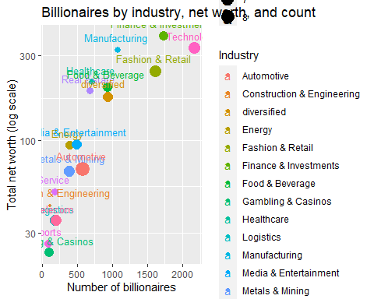

## Net Worth X Number X Country X Continent

by_cntry <- baires %>%  
 group_by(Country) %>%  
 summarize(sum_nw = sum(Networth), avg_nw = mean(Networth), n = n(), continent = unique(continent)) %>%  
 arrange(sum_nw)  
  
ggplot(by_cntry, aes(sum_nw, avg_nw, size = n, color = continent)) +  
 geom_point() +  
 labs(title = "Average vs Total net worth by country and number of billionaires",  
 x = "Total net worth (log scale)",  
 y = "Average net worth"  
 ) +  
 scale_x_log10() +  
 geom_text(aes(label=Country, size = 100, vjust=-1.25))

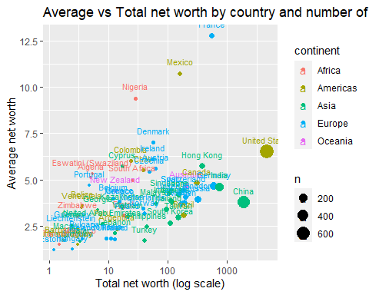

## Rank X Age X Net Worth X Industry

baires %>%  
 filter(Rank <= 200) %>%  
 ggplot(aes(Rank, Age, size = Networth, color = continent )) +  
 geom_jitter() +  
 labs(title = "Top 200 billionaires by rank, age, net worth, and continent",  
 x = "Rank",  
 )

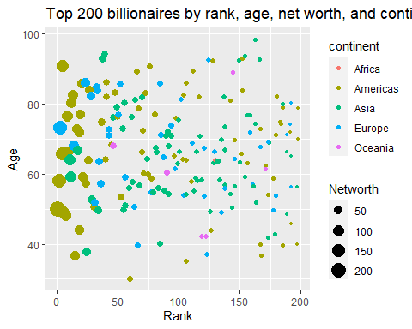

## Rank X Age X Net Worth X Industry X Continent

baires %>%  
 filter(Rank <= 200) %>%  
 ggplot(aes(Rank, Age, size = Networth, color = Industry )) +  
 geom_jitter() +  
 facet_wrap(~continent) +  
 labs(title = "Top 200 billionaires by rank, age, net worth, and industry",  
 x = "Rank",  
 )

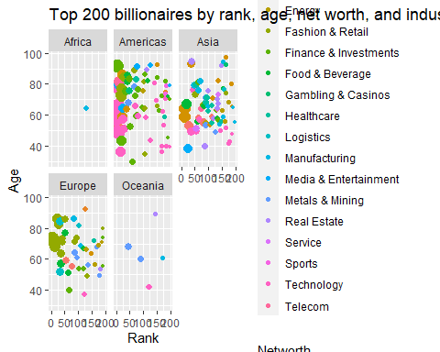

# COUNTRY ANALYSIS

## Column: Number of billionaires by country

num_by_cntry <- baires %>%  
 group_by(Country) %>%  
 summarize(n = n()) %>%  
 arrange(desc(n))  
  
total_baires <- nrow(baires)  
  
per_by_cntry <- num_by_cntry %>%  
 mutate(percentage = num_by_cntry$n/total_baires*100)  
  
top10_per_by_cntry <- head(per_by_cntry, n = 10)  
  
ggplot(top10_per_by_cntry, aes(reorder(Country, -n), n, fill = Country)) +  
 geom_col() +  
 theme(legend.position = "none",  
 axis.title.x=element_blank()) +  
 labs(title = "Number of billionaires by country",  
 subtitle = "US and China has the largest number of billionaires globally",  
 y = "Number of billionaires"  
 ) +  
 geom_text(aes(label=round(n,1)), vjust=-0.25)

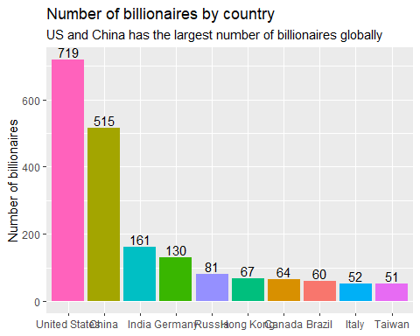

## Net Worth by Country x Industry

top10c <- top10_per_by_cntry$Country  
  
nw_by_cntry_x_indstry <- baires %>%  
 filter(Country == top10c) %>%  
 group_by(Country, Industry) %>%  
 summarize(sum_nw = sum(Networth))

## `summarise()` has grouped output by 'Country'. You can override using the  
## `.groups` argument.

ggplot(nw_by_cntry_x_indstry, aes(Country, sum_nw, fill = Industry)) +  
 geom_col() +  
 theme(axis.title.x=element_blank()) +  
 labs(title = "Net worth by country and industry",  
 y = "$ billion"  
 ) +  
 theme(axis.text.x = element_text(angle = 45, vjust=0.75))

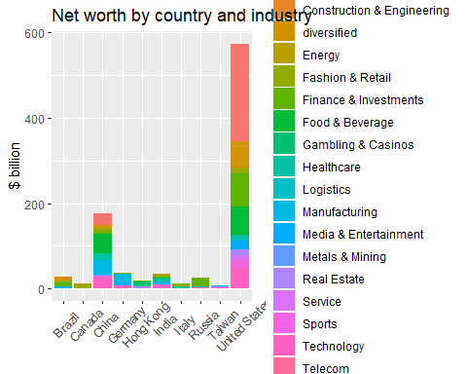

## Histogram: Number of billionaires by country

ggplot(num_by_cntry, aes(n)) +  
 geom_histogram() +  
 theme(legend.position = "none") +  
 labs(title = "Histogram of number of billionaires by country",  
 subtitle = "Most countries in this list only have 1 billionaire",  
 x = "Number of billionaires"  
 ) +  
 scale_x_log10()

## `stat_bin()` using `bins = 30`. Pick better value with `binwidth`.

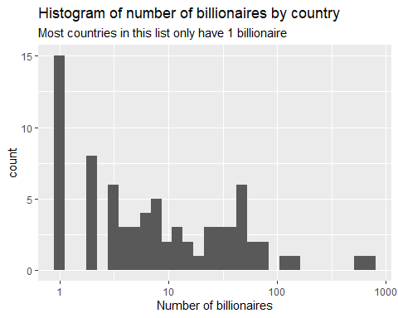

## Column: Net worth by country

nw_by_cntry <- baires %>%  
 group_by(Country) %>%  
 summarize(sum_nw = sum(Networth)) %>%  
 arrange(desc(sum_nw))  
  
total_nw <- sum(baires$Networth)  
  
pernw_by_cntry <- nw_by_cntry %>%  
 mutate(percentage = nw_by_cntry$sum_nw/total_nw*100)  
  
top10_pernw_by_cntry <- head(pernw_by_cntry, n = 10)  
  
ggplot(top10_pernw_by_cntry, aes(reorder(Country, -sum_nw), sum_nw, fill = Country)) +  
 geom_col() +  
 theme(legend.position = "none",  
 axis.title.x=element_blank()) +  
 labs(title = "Total net worth of billionaires by country",  
 subtitle = "Net worth of US billionaires are substantially larger than the rest",  
 y = "$ billion"  
 ) +  
 geom_text(aes(label=round(sum_nw,1)), vjust=-0.25)

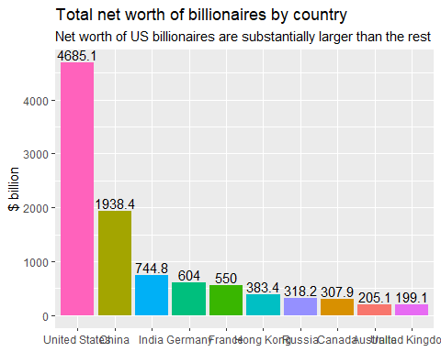

## Histogram: Net worth of billionaires by country

ggplot(nw_by_cntry, aes(sum_nw)) +  
 geom_histogram() +  
 theme(legend.position = "none") +  
 labs(title = "Histogram of net worth of billionaires by country",  
 x = "$ billion"  
 ) +  
 scale_x_log10()

## `stat_bin()` using `bins = 30`. Pick better value with `binwidth`.

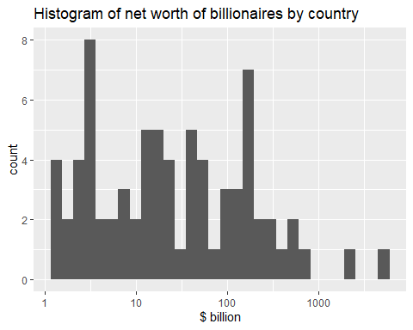

# INDUSTRY ANALYSIS

## Column: Number of billionaires by industry

no_by_indstry <- baires %>%  
 group_by(Industry) %>%  
 summarize(n = n()) %>%  
 arrange(desc(n))  
  
perno_by_indstry <- no_by_indstry %>%  
 mutate(percentage = no_by_indstry$n/total_baires*100)  
  
top10_perno_by_indstry <- head(perno_by_indstry, n = 10)  
  
ggplot(top10_perno_by_indstry, aes(reorder(Industry, -n), n, fill = Industry)) +  
 geom_col() +  
 theme(legend.position = "none",  
 axis.text.x = element_text(angle = 45, vjust=0.75)) +  
 labs(title = "Share of billionaires' net worth by industry",  
 x = "Industry",  
 y = "Number of billionaires"  
 ) +  
 geom_text(aes(label=round(n,1)), vjust=-0.15)

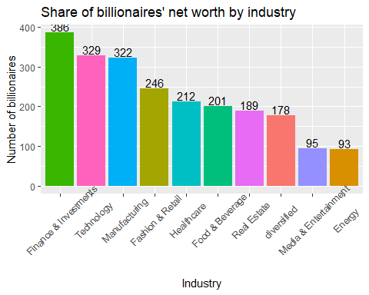

## Column: Net worth by industry

nw_by_indstry <- baires %>%  
 group_by(Industry) %>%  
 summarize(sum_nw = sum(Networth)) %>%  
 arrange(desc(sum_nw))  
  
total_nw <- sum(baires$Networth)  
  
pernw_by_indstry <- nw_by_indstry %>%  
 mutate(percentage = nw_by_indstry$sum_nw/total_nw*100)  
  
top10_pernw_by_indstry <- head(pernw_by_indstry, n = 10)  
  
ggplot(top10_pernw_by_indstry, aes(reorder(Industry, -sum_nw), sum_nw, fill = Industry)) +  
 geom_col() +  
 theme(legend.position = "none",  
 axis.text.x = element_text(angle = 45, vjust=0.75),  
 axis.title.x=element_blank()) +  
 labs(title = "Share of billionaires' net worth by industry",  
 y = "$ billion"  
 ) +  
 geom_text(aes(label=round(sum_nw,1)), vjust=-0.5)

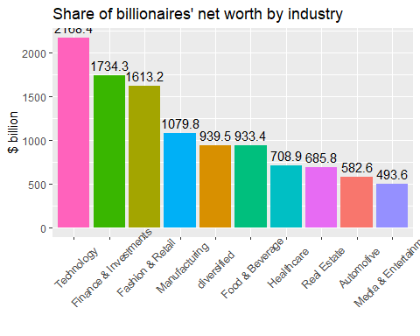

## Column: Number of billionaires by industry and continent

num_by_indstry_x_continent <- baires %>%  
 group_by(Industry, continent) %>%  
 summarize(n = n())

## `summarise()` has grouped output by 'Industry'. You can override using the  
## `.groups` argument.

ggplot(num_by_indstry_x_continent, aes(Industry, n, fill = continent)) +  
 geom_col() +  
 theme(axis.title.x=element_blank()) +  
 labs(title = "Number of billionaires by industry and continent",  
 y = "Count"  
 ) +  
 theme(axis.text.x = element_text(angle = 90, vjust=0.5))

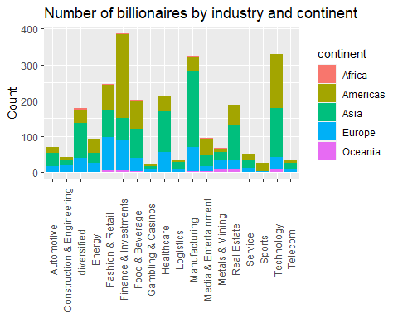

## Column: Net worth by industry and continent

nw_by_indstry_x_continent <- baires %>%  
 group_by(Industry, continent) %>%  
 summarize(sum_nw = sum(Networth))

## `summarise()` has grouped output by 'Industry'. You can override using the  
## `.groups` argument.

ggplot(nw_by_indstry_x_continent, aes(Industry, sum_nw, fill = continent)) +  
 geom_col() +  
 theme(axis.title.x=element_blank()) +  
 labs(title = "Net worth of billionaires by industry and continent",  
 y = "$ billion"  
 ) +  
 theme(axis.text.x = element_text(angle = 90, vjust=0.5))

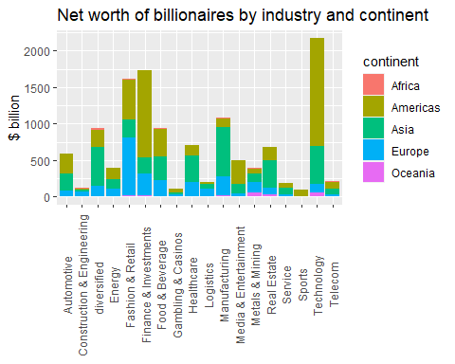

# AGE ANALYSIS

## Histogram

ggplot(baires, aes(Networth)) +  
 geom_histogram() +  
 theme(legend.position = "none") +  
 labs(title = "Histogram of net worth of billionaires by country",  
 subtitle = "Most billionaies have around $1 - $2 billion",  
 x = "Number of billionaires (log scale)",  
 y = "count (log scale)"  
 ) +  
 scale_x_log10() +  
 scale_y_log10()

## `stat_bin()` using `bins = 30`. Pick better value with `binwidth`.

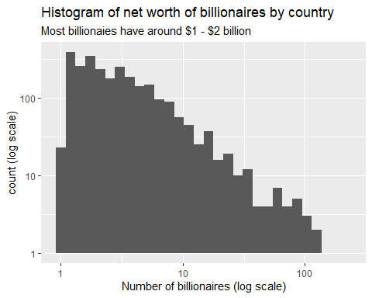

ggplot(baires, aes(Age)) +   
 geom_histogram(binwidth = 10) +  
 labs(title = "Histogram of age of billionaires by country",  
 subtitle = "Median age of 64 years old",  
 x = "Age"  
 )

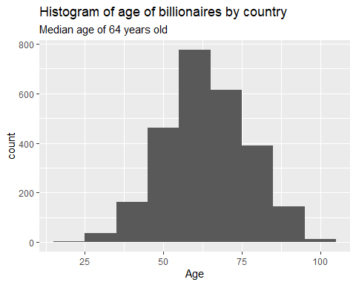

## Age by Continent

ggplot(baires, aes(Age, fill = continent)) +  
 geom_histogram(binwidth = 10) +  
 facet_grid(~continent) +  
 theme(legend.position = "none") +  
 scale_y_log10() +  
 labs(title = "Histogram of billionaires' age by continent",  
 x = "Age",  
 y = "Count (log scale)"  
 )

## Warning: Transformation introduced infinite values in continuous y-axis

## Warning: Removed 6 rows containing missing values (geom_bar).

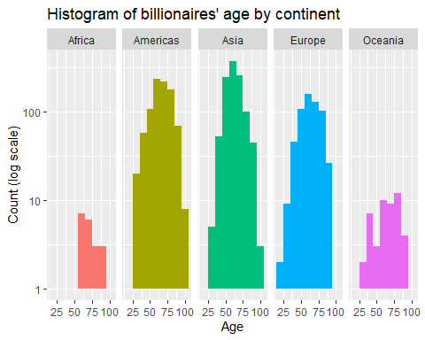

ggplot(baires, aes(continent, Age)) +  
 geom_boxplot() +  
 theme(legend.position = "none",  
 axis.title.x = element_blank()) +  
 scale_y_log10() +  
 labs(title = "Boxplot of billionaires' age by continent",  
 subtitle = "Median age of billionaires in Asia younger than others",  
 y = "Age"  
 )

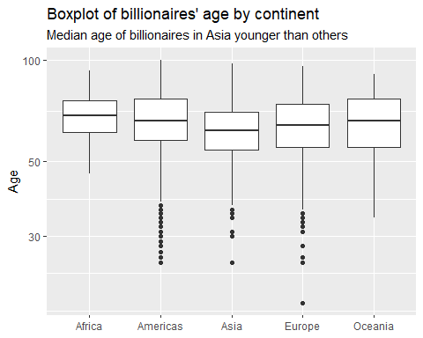

##Age by Industry

top10i <- top10_pernw_by_indstry$Industry  
  
baires %>%  
 filter(Industry == top10i) %>%  
 ggplot(aes(Industry, Age)) +  
 geom_boxplot() +  
 labs(title = "Boxplot of billionaire by industry and age",  
 x = "Industry",  
 y = "Age"  
 ) +   
 theme(axis.text.x = element_text(angle = 10, vjust=0.75),  
 axis.title.x = element_blank())

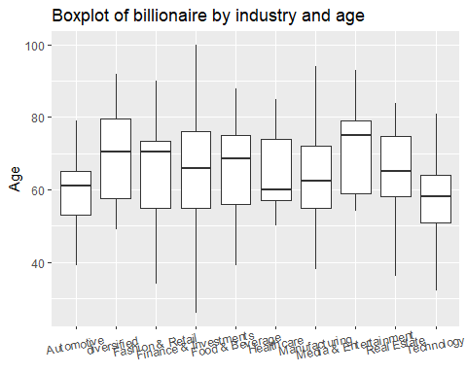

# REGRESSION

## Regression

baires$continent <- factor(baires$continent, ordered = FALSE)  
  
baires$continent <- relevel(baires$continent, ref = "Asia")  
  
model <- lm(log10(Networth) ~ Age + continent, data = baires)  
get_regression_table(model)

## # A tibble: 6 × 7  
## term estimate std_error statistic p_value lower_ci upper_ci  
## <chr> <dbl> <dbl> <dbl> <dbl> <dbl> <dbl>  
## 1 intercept 0.253 0.035 7.29 0 0.185 0.321  
## 2 Age 0.002 0.001 4.70 0 0.001 0.004  
## 3 continent: Africa 0.11 0.08 1.39 0.166 -0.046 0.266  
## 4 continent: Americas 0.103 0.016 6.40 0 0.072 0.135  
## 5 continent: Europe 0.056 0.018 3.05 0.002 0.02 0.091  
## 6 continent: Oceania 0.075 0.053 1.42 0.155 -0.028 0.178

## Regression - Coefficients

regtab <- get_regression_table(model)  
  
regtab %>%  
 filter(p_value <=0.1) %>%  
 ggplot(aes(term, 10^(estimate), fill = term)) +  
 geom_col() +  
 labs(title = "Coefficients of variables with p_value <= 0.05",  
 x = "Variable",  
 y = "Coefficient ($ billion)"  
 ) +  
 geom_text(aes(label=round(10^estimate,4), vjust=-.5))

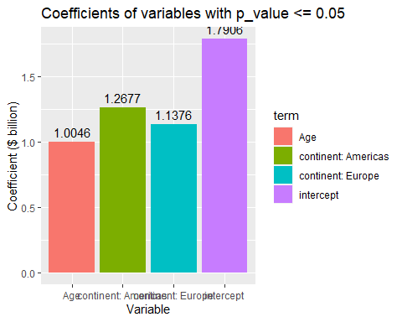 # QUICK FACTS

## NETWORK RANGE OF BILLIONAIRES - MAX, MIN, MEAN

nw_descriptive_stats <- c(nrow(baires), max(baires$Networth), min(baires$Networth), mean(baires$Networth), median(baires$Networth))  
names(nw_descriptive_stats) <- c("Number of billionaires", "Highest net worth", "Lowest net worth", "Average net worth", "Median net worth")  
nw_descriptive_stats

## Number of billionaires Highest net worth Lowest net worth   
## 2600.00000 219.00000 1.00000   
## Average net worth Median net worth   
## 4.86075 2.40000

## RICHEST, YOUNGEST, OLDEST, MALAYSIAN BILLIONAIRES

richest_baires <- baires %>%  
 arrange(desc(Networth)) %>%  
 head(n = 10L)  
  
youngest_baires <- baires %>%  
 arrange(Age) %>%  
 head(n = 10L)  
  
oldest_baires <- baires %>%  
 arrange(desc(Age)) %>%  
 head(n = 10L)  
  
MY_baires <- baires %>%  
 filter(Country == "Malaysia") %>%  
 arrange(desc(Networth))  
   
  
richest_baires

## Rank Name Networth Age Country Source  
## 1 1 Elon Musk 219.0 50 United States Tesla, SpaceX  
## 2 2 Jeff Bezos 171.0 58 United States Amazon  
## 3 3 Bernard Arnault & family 158.0 73 France LVMH  
## 4 4 Bill Gates 129.0 66 United States Microsoft  
## 5 5 Warren Buffett 118.0 91 United States Berkshire Hathaway  
## 6 6 Larry Page 111.0 49 United States Google  
## 7 7 Sergey Brin 107.0 48 United States Google  
## 8 8 Larry Ellison 106.0 77 United States software  
## 9 9 Steve Ballmer 91.4 66 United States Microsoft  
## 10 10 Mukesh Ambani 90.7 64 India diversified   
## Industry continent  
## 1 Automotive Americas  
## 2 Technology Americas  
## 3 Fashion & Retail Europe  
## 4 Technology Americas  
## 5 Finance & Investments Americas  
## 6 Technology Americas  
## 7 Technology Americas  
## 8 Technology Americas  
## 9 Technology Americas  
## 10 diversified Asia

youngest_baires

## Rank Name Networth Age Country  
## 1 1292 Kevin David Lehmann 2.4 19 Germany  
## 2 1929 Pedro Franceschi 1.5 25 Brazil  
## 3 1929 Wang Zelong 1.5 25 China  
## 4 2190 Alexandra Andresen 1.3 25 Norway  
## 5 1929 Henrique Dubugras 1.5 26 Brazil  
## 6 2190 Katharina Andresen 1.3 26 Norway  
## 7 1513 Ryan Breslow 2.0 27 United States  
## 8 1818 Austin Russell 1.6 27 United States  
## 9 431 Gary Wang 5.9 28 United States  
## 10 637 Gustav Magnar Witzoe 4.5 28 Norway  
## Source Industry continent  
## 1 drugstores Fashion & Retail Europe  
## 2 fintech Finance & Investments Americas  
## 3 chemicals Metals & Mining Asia  
## 4 investments diversified Europe  
## 5 fintech Finance & Investments Americas  
## 6 investments diversified Europe  
## 7 e-commerce software Technology Americas  
## 8 sensors★ Automotive Americas  
## 9 cryptocurrency exchange Finance & Investments Americas  
## 10 fish farming Food & Beverage Europe

oldest_baires

## Rank Name Networth Age Country  
## 1 1645 George Joseph 1.8 100 United States  
## 2 163 Robert Kuok 11.7 98 Malaysia  
## 3 1238 Charles Munger 2.5 98 United States  
## 4 1341 David Murdock 2.3 98 United States  
## 5 622 Masatoshi Ito 4.6 97 Japan  
## 6 1513 S. Daniel Abraham 2.0 97 United States  
## 7 1929 Ana Maria Brescia Cafferata 1.5 97 Peru  
## 8 637 Ted Lerner & family 4.5 96 United States  
## 9 1645 Stephen Jarislowsky 1.8 96 Canada  
## 10 1929 John Farber 1.5 96 United States  
## Source Industry continent  
## 1 insurance Finance & Investments Americas  
## 2 palm oil, shipping, property diversified Asia  
## 3 Berkshire Hathaway Finance & Investments Americas  
## 4 Dole, real estate Food & Beverage Americas  
## 5 retail Fashion & Retail Asia  
## 6 Slim-Fast Food & Beverage Americas  
## 7 mining, banking diversified Americas  
## 8 real estate Real Estate Americas  
## 9 money management Finance & Investments Americas  
## 10 chemicals Manufacturing Americas

MY_baires

## Rank Name Networth Age Country  
## 1 163 Robert Kuok 11.7 98 Malaysia  
## 2 185 Quek Leng Chan 10.6 80 Malaysia  
## 3 431 Teh Hong Piow 5.9 92 Malaysia  
## 4 460 Ananda Krishnan 5.7 84 Malaysia  
## 5 523 Koon Poh Keong 5.2 60 Malaysia  
## 6 586 Yeow Chor & Yeow Seng Lee 4.8 64 Malaysia  
## 7 1196 Chen Lip Keong 2.6 74 Malaysia  
## 8 1445 Lau Cho Kun 2.1 86 Malaysia  
## 9 1513 Kuan Kam Hon & family 2.0 74 Malaysia  
## 10 1513 Lim Kok Thay 2.0 70 Malaysia  
## 11 1729 G. Gnanalingam 1.7 77 Malaysia  
## 12 1818 Lim Wee Chai 1.6 64 Malaysia  
## 13 1818 Tan Yu Yeh 1.6 51 Malaysia  
## 14 1818 Kie Chie Wong 1.6 74 Malaysia  
## 15 2076 Syed Mokhtar AlBukhary 1.4 70 Malaysia  
## 16 2190 Jeffrey Cheah 1.3 77 Malaysia  
## 17 2190 Koon Poh Ming 1.3 65 Malaysia  
## Source Industry continent  
## 1 palm oil, shipping, property diversified Asia  
## 2 banking, property diversified Asia  
## 3 banking Finance & Investments Asia  
## 4 telecoms, media, oil-services Telecom Asia  
## 5 aluminum Manufacturing Asia  
## 6 palm oil, property Food & Beverage Asia  
## 7 casinos, property, energy Gambling & Casinos Asia  
## 8 palm oil, property diversified Asia  
## 9 rubber gloves Manufacturing Asia  
## 10 casinos Gambling & Casinos Asia  
## 11 ports Logistics Asia  
## 12 rubber gloves Manufacturing Asia  
## 13 retail Fashion & Retail Asia  
## 14 investments Metals & Mining Asia  
## 15 engineering, automotive Construction & Engineering Asia  
## 16 property, healthcare Real Estate Asia  
## 17 aluminum Metals & Mining Asia

## AGE RANGE OF BILLIONAIRES - OLDEST, YOUNGEST, AVERAGE AGE

age_descriptive_stats <- c(max(baires$Age), min(baires$Age), mean(baires$Age), median(baires$Age))  
names(age_descriptive_stats) <- c("Oldest", "Youngest", "Average age", "Median age")  
age_descriptive_stats

## Oldest Youngest Average age Median age   
## 100.00000 19.00000 64.27192 64.00000

## THE TEN OLDEST AND YOUNGEST BILLIONAIRES IN THE WORLD

oldest_baires <- baires %>%  
 arrange(desc(Age)) %>%  
 head(n = 10L)  
  
youngest_baires <- baires %>%  
 arrange(Age) %>%  
 head(n = 10L)  
  
oldest_baires

## Rank Name Networth Age Country  
## 1 1645 George Joseph 1.8 100 United States  
## 2 163 Robert Kuok 11.7 98 Malaysia  
## 3 1238 Charles Munger 2.5 98 United States  
## 4 1341 David Murdock 2.3 98 United States  
## 5 622 Masatoshi Ito 4.6 97 Japan  
## 6 1513 S. Daniel Abraham 2.0 97 United States  
## 7 1929 Ana Maria Brescia Cafferata 1.5 97 Peru  
## 8 637 Ted Lerner & family 4.5 96 United States  
## 9 1645 Stephen Jarislowsky 1.8 96 Canada  
## 10 1929 John Farber 1.5 96 United States  
## Source Industry continent  
## 1 insurance Finance & Investments Americas  
## 2 palm oil, shipping, property diversified Asia  
## 3 Berkshire Hathaway Finance & Investments Americas  
## 4 Dole, real estate Food & Beverage Americas  
## 5 retail Fashion & Retail Asia  
## 6 Slim-Fast Food & Beverage Americas  
## 7 mining, banking diversified Americas  
## 8 real estate Real Estate Americas  
## 9 money management Finance & Investments Americas  
## 10 chemicals Manufacturing Americas

youngest_baires

## Rank Name Networth Age Country  
## 1 1292 Kevin David Lehmann 2.4 19 Germany  
## 2 1929 Pedro Franceschi 1.5 25 Brazil  
## 3 1929 Wang Zelong 1.5 25 China  
## 4 2190 Alexandra Andresen 1.3 25 Norway  
## 5 1929 Henrique Dubugras 1.5 26 Brazil  
## 6 2190 Katharina Andresen 1.3 26 Norway  
## 7 1513 Ryan Breslow 2.0 27 United States  
## 8 1818 Austin Russell 1.6 27 United States  
## 9 431 Gary Wang 5.9 28 United States  
## 10 637 Gustav Magnar Witzoe 4.5 28 Norway  
## Source Industry continent  
## 1 drugstores Fashion & Retail Europe  
## 2 fintech Finance & Investments Americas  
## 3 chemicals Metals & Mining Asia  
## 4 investments diversified Europe  
## 5 fintech Finance & Investments Americas  
## 6 investments diversified Europe  
## 7 e-commerce software Technology Americas  
## 8 sensors★ Automotive Americas  
## 9 cryptocurrency exchange Finance & Investments Americas  
## 10 fish farming Food & Beverage Europe

## SOURCE OF WEALTH

baires %>%  
 group_by(Source) %>%  
 summarize(sum_nw = sum(Networth)) %>%  
 arrange(desc(sum_nw))

## # A tibble: 895 × 2  
## Source sum_nw  
## <chr> <dbl>  
## 1 "real estate" 574.  
## 2 "diversified " 382   
## 3 "investments" 358.  
## 4 "software" 290.  
## 5 "pharmaceuticals" 284.  
## 6 "hedge funds" 272.  
## 7 "Google" 261.  
## 8 "Walmart" 238   
## 9 "Microsoft" 232.  
## 10 "Tesla, SpaceX" 219   
## # … with 885 more rows