**Advisory Committee:**

A B C

Multiple accounts suggest that online targeting advertising has substantial impacts on electoral outcomes. I study the effects of targeted campaigns by Oxford Analytica and find no evidence that their campaigns affected electoral outcomes in any district. Qualitative investigations suggest that the ads were either not seen or ignored by targetted voters.

See formatting hints here: <https://achale.gitlab.io/tutorialmarkdownthesis/>

# Introduction

Motivation

Relevant literatures

Overview of findings

I describe the design in section and results in section

# Design

## Inferential Strategy

Text

## Measurement strategy

Data, descriptive statistics

## Cases

Motivation, case selection

# Results

## Main results

See Figure .

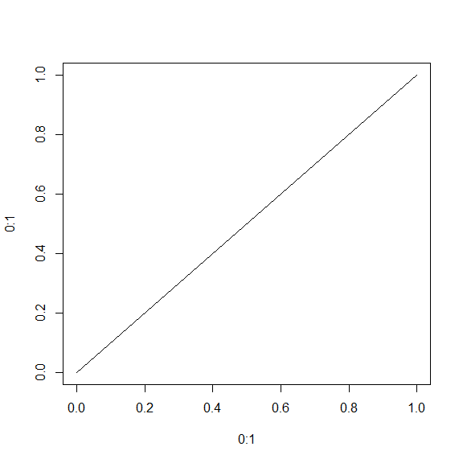

A figure with a detailed note

See Table

A caption describing this table

|  |  |
| --- | --- |
| name | value |
| A | 1 |
| B | 2 |

Regression results:

## Intepretations

Text

## Robustness Extensions

# Conclusion

Putnam (2000) said some great stuff

Putnam said some great stuff (Putnam 2000)

Putnam (2000, 7) said some great stuff

Putnam said some great stuff (Putnam 2000, 7)

See also New York Times Editorial Board (2021).

# References

New York Times Editorial Board. 2021. “Hong Kong Crackdown Is an Early Test for Biden.” 2021. <https://www.nytimes.com/2021/01/24/opinion/hong-kong-arrests.html>.

Putnam, Robert D. 2000. “Bowling Alone: America’s Declining Social Capital.” In *Culture and Politics*, 223–34. Springer.

# Appendix

## Model details

## Robustness results