export table to Word

Macartan

3/12/2021

This Word document is made by compiling an .Rmd document to Word. The key thing to show here is that you can take your model output and generate nicely formatted tables in word quickly.

# Analysis

We make some models like this:

data <- data.frame(Y = rnorm(10), X = runif(10))  
  
model_1 <- lm(Y~1, data = data)  
model_2 <- lm(Y~X, data = data)

# Table Results

We then export like this:

my_table <- export_summs(model_1, model_2)  
  
my_table

|  |  |  |
| --- | --- | --- |
|  | Model 1 | Model 2 |
| (Intercept) | 0.10 | -0.92 |
|  | (0.38) | (0.79) |
| X |  | 1.77 |
|  |  | (1.23) |
| N | 10 | 10 |
| R2 | 0.00 | 0.21 |
| *** p < 0.001; ** p < 0.01; * p < 0.05. | | |

The functions used to make the table has various options to let you customize the table.

# A figure

Similarly we can export our figures to Word

with(data, plot(X, Y))

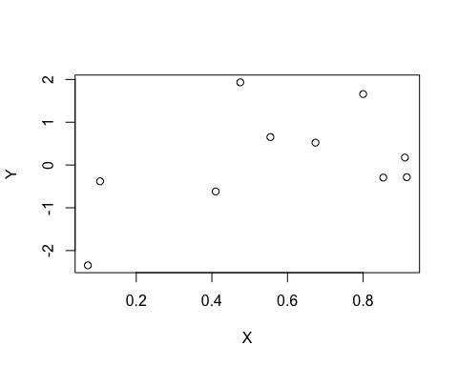

A nice figure