PROG101: Principles of Programming Logic and Design
Designing Logical Solutions for Sierra Leone Community Challenges
Freetown Community Flood Early Alert System (FCFEAS)
Table of Contents

1. Rationale

1.1 Problem Description
Freetown floods every rainy season, but the warning that reaches a family in a flood-prone settlement is often late, unclear or absent. The community problem addressed here is therefore the lack of a timely, ward-specific and easily understood flood alert that connects weather and water data to community action.
Who is affected. Residents of low-lying coastal and riverside settlements such as Kroo Bay, Portee and Rokupa, and of hillside areas such as Regent, are most exposed. Informal-settlement households, women, children, older people and people with disabilities suffer most (ACAPS, 2017; GFDRR, 2017a). Schools, clinics, the National Disaster Management Agency (NDMA), the Sierra Leone Meteorological Agency (SLMet) and the Sierra Leone Red Cross Society also bear the consequences.
Why the problem exists. First, Freetown’s population has grown roughly tenfold since independence (ACAPS, 2017) and more than 68 areas are classed as slums or informal settlements (Cambridge Prisms: Coastal Futures, 2023), pushing households onto floodplains, coasts and steep slopes. Second, the warning chain is fragmented: gaps remain in observation networks, real-time data integration, forecasting accuracy and last-mile dissemination (CREWS, 2026a). Third, advisories rely mainly on radio, television and social media (Kanu, 2025), while literacy was only 36% for women and 52% for men in 2013 (ACAPS, 2017), so text-heavy or internet-based messages exclude many people.
How the proposed solution addresses it. FCFEAS automates the path from data to action. It collects rainfall, water-level and community readings, classifies every ward into one of four alert levels using clear decision rules, sends short SMS alerts in English and Krio, activates volunteers and radio for serious alerts, and escalates automatically if nobody acknowledges.

1.2 Background
On 14 August 2017, after three days of intense rain, a hillside at Regent collapsed and, with flash floods, affected about 6,000 people; 1,141 were declared dead or missing (GFDRR, 2017a) and more than 3,000 people lost their homes (PreventionWeb, n.d.a). Damage and loss was estimated at about US$31.65 million (GFDRR, 2017b). Four major floods in 15 years had affected more than 220,000 people by 2018 (Africanews, 2018). The danger continues: between 31 August and 5 September 2025, flash floods hit 17 communities in seven districts and affected 11,080 people, following earlier major floods in 2019, 2021 and 2024 (IFRC, 2025).
Policy is moving in the same direction. The UN Early Warnings for All initiative aims to protect everyone through early warning systems by the end of 2027, built on four pillars: risk knowledge, detection and forecasting, warning dissemination, and preparedness and response (WMO, n.d.). In Sierra Leone, CREWS has piloted a rainfall-based flood forecasting model and a multi-agency Flood Task Force, and its next phase targets last-mile channels such as SMS, IVR, radio and sirens (CREWS, 2026a; 2026b). The IFRC (2025) notes that early action protocols now use rainfall thresholds, river levels and community reports as triggers. FCFEAS designs the logic that links such triggers to community alerts.

1.3 Community Impact
Problem solved: delayed, unclear and non-targeted flood warnings. Expected impact: households can move children, documents and stock to higher ground earlier; fewer deaths, injuries and losses; fewer post-flood disease outbreaks, since cholera is endemic in Sierra Leone (ACAPS, 2017); and faster coordination between NDMA, SLMet, volunteers and the district committees. Beneficiaries: primarily residents of high-risk wards (about 10% of Freetown’s population live in high-risk climate areas; Green Climate Fund, n.d.), and secondarily schools, clinics, markets, response agencies and researchers. Long-term sustainability: the design uses SMS, which works on basic phones; mobile internet penetration in Sub-Saharan Africa is only about 27% (GSMA, 2024), so internet-only tools would exclude many users. Open-source licensing removes licence fees, local institutions and trained volunteers operate it, and thresholds are reviewed each rainy season with SLMet data.

1.4 Proposed Solution
FCFEAS is a logical design (no source code) of a monitoring cycle that repeats every 15 minutes. Inputs: 24-hour rainfall, hourly rainfall intensity, water level as a percentage of channel capacity, and SMS flood reports from residents. Processing: validation, risk classification per ward, message creation and escalation rules. Outputs: SMS alerts, radio and volunteer notifications, sirens for the highest level, and a log. Table 1 gives the four alert levels.
Table 1: FCFEAS alert levels (thresholds are illustrative and must be calibrated with SLMet and NDMA)
Level | Trigger (any one condition) | Public action
GREEN | Below all thresholds below | No alert. “All clear” is sent when returning from a higher level.
YELLOW | rain24 ≥ 50 mm, or water level ≥ 60% | Be alert: clear drains, secure belongings, listen to radio.
ORANGE | rain24 ≥ 100 mm, or water ≥ 80%, or (rain24 ≥ 50 mm and confirmed reports) | Prepare to move: gather children, documents, medicine. Volunteers activated.
RED | rain24 ≥ 150 mm, or water ≥ 100%, or (rainfall ≥ 30 mm/h and confirmed reports) | Move to higher ground now. Siren and door-to-door alert.
Rainfall thresholds are multiplied by 0.8 in high-risk wards. “Confirmed” means at least 3 community reports in the cycle. The 100 to 150 mm range echoes the heavy-rainfall advisory issued by NDMA and SLMet in August 2025 (Kanu, 2025).

1.5 Computational Thinking Process
The problem was analysed using the four techniques of computational thinking (Wing, 2006), summarised in Table 2.
Table 2: Computational thinking applied to FCFEAS
Technique | Application
Decomposition | The system is split into seven modules: data collection, subscriber management, risk analysis, message building, dissemination, escalation, and logging.
Pattern recognition | The same wards flood repeatedly and in the same sequence: heavy rain, rising water, resident reports, damage (IFRC, 2025). This justifies thresholds, a high-risk ward list and report confirmation.
Abstraction | Soil type, drain design and terrain are ignored. Each ward is reduced to four numbers: rain24, rainHr, waterPct and reportCount.
Algorithm design | An ordered cycle of input, validation, decision cascade, loops over wards and subscribers, and escalation (Sections 2 to 4).

1.6 Algorithm Design
The algorithm is a WHILE loop that runs every 15 minutes. Inside it, a FOR EACH loop visits every ward, a decision cascade (RED, then ORANGE, then YELLOW, otherwise GREEN) assigns the level, and alerts are sent only when the level changes. A second loop sends SMS to each subscriber, and a selection chooses English or Krio. Each task is a function, grouped into modules. Sections 2 to 5 give the full algorithm, pseudocode, flowcharts and modules.

1.7 SDG Alignment
FCFEAS mainly supports SDG 11 (Sustainable Cities and Communities) and SDG 13 (Climate Action), and also supports SDG 1 and SDG 9 (Table 3). Target wording is from PreventionWeb (n.d.b).
Table 3: SDG alignment
SDG and target | Contribution of FCFEAS
SDG 11, Target 11.5: reduce deaths, people affected and economic losses from disasters, including water-related disasters, protecting the poor | Earlier, targeted warnings to informal settlements reduce deaths, injuries and losses.
SDG 13, Target 13.1: strengthen resilience to climate-related hazards; Target 13.3: improve capacity on early warning | Provides a repeatable early-warning logic and builds local capacity among volunteers and agencies.
SDG 1, Target 1.5: build resilience of the poor to climate-related extreme events | Protects households with the least capacity to recover from flood shocks.
SDG 9, Target 9.c: increase access to information and communications technology | Uses basic mobile phones and SMS, so no smartphone or data plan is required.

1.8 Open Source Justification
Why open source: a public-safety service should not depend on one vendor, and its rules must be open to inspection by SLMet, NDMA, universities and communities so that thresholds can be trusted and improved. Benefits for Sierra Leone: no licence fees; no vendor lock-in; local developers and students gain skills; the same design can be reused in other flood-affected districts (the 2025 floods reached seven districts; IFRC, 2025); and existing open tools can be reused. Potential community contributions: Krio, Mende and Temne message translations; threshold calibration by hydrologists; ward and risk data; low-cost sensor integrations; testing, documentation and bug fixes. An OSI-approved licence such as AGPL-3.0 would keep improvements public.

1.9 Digital Public Goods Justification
Digital public goods are open-source software, open data, open standards, open AI systems and open content that follow privacy and other applicable laws, do no harm and help attain the SDGs (DPGA, n.d.a). The DPG Standard sets nine indicators, including an approved open licence, SDG relevance, platform independence, documentation, privacy compliance and do-no-harm by design (DPGA, n.d.b). FCFEAS could meet them by: (1) targeting SDGs 11 and 13; (2) using an OSI-approved licence; (3) publishing anonymised alert logs and ward risk data as open data; (4) using open standards such as REST/JSON and the Common Alerting Protocol; (5) collecting minimal personal data with consent (JOIN and STOP commands); and (6) preventing harm through data validation, audit logs and escalation to humans. RapidPro, UNICEF’s SMS platform under AGPL-3.0, is already a verified DPG (DPGA, 2025), showing a realistic deployment route.
Accessibility, openness and public benefit: the system works on basic phones without internet, supports Krio, is free to citizens, and its code, rules and open data are public. Formal DPG status requires nomination and review by the Digital Public Goods Alliance.

2. Algorithm

2.1 Constants, Variables, Data Types and Boolean Logic
Constants hold fixed thresholds so they can be changed in one place. Values are illustrative.
Table 4: Constants
Constant | Value | Data type | Meaning
CYCLE_MINUTES | 15 | Integer | Time between monitoring cycles
RAIN_YELLOW, RAIN_ORANGE, RAIN_RED | 50, 100, 150 | Real (mm) | 24-hour rainfall thresholds
INTENSITY_RED | 30 | Real (mm/h) | Hourly rainfall for RED when confirmed
WATER_YELLOW, WATER_ORANGE, WATER_RED | 60, 80, 100 | Real (%) | Water level as % of channel capacity
CONFIRM_COUNT | 3 | Integer | Reports needed to confirm flooding
HIGH_RISK_FACTOR | 0.8 | Real | Lowers rainfall thresholds in high-risk wards
ACK_WAIT_MINUTES | 10 | Integer | Wait for acknowledgement before escalation
MAX_RETRIES | 3 | Integer | SMS retry attempts
RAIN24_MAX, RAINHR_MAX, WATER_MAX | 500, 200, 300 | Real | Sanity limits for data validation

Table 5: Main variables
Variable | Data type | Purpose
ward (code, displayName, highRisk) | Record: String, String, Boolean | A monitored ward
rain24, rainHr, waterPct | Real | Rainfall (24 h, hourly) and water level
reportCount | Integer | Number of resident flood reports in the cycle
level, previousLevel | String (GREEN, YELLOW, ORANGE, RED) | Current and last alert level
confirmed, acknowledged, systemRunning | Boolean | Report confirmation, acknowledgement and loop control
factor | Real | 0.8 for high-risk wards, otherwise 1.0
phone, language | String | Subscriber details (language is EN or KR)
sentCount, failCount, attempts | Integer | SMS delivery counters
wards, subscribers, retryQueue | Array / List | Collections processed by loops

Table 6: Boolean logic used
Expression | Result when TRUE
confirmed = (reportCount >= CONFIRM_COUNT) | Community reports support the sensor data
rain24 >= RAIN_RED * factor OR waterPct >= WATER_RED OR (rainHr >= INTENSITY_RED AND confirmed) | Level is RED
rain24 >= RAIN_ORANGE factor OR waterPct >= WATER_ORANGE OR (rain24 >= RAIN_YELLOW factor AND confirmed) | Level is ORANGE
rain24 >= RAIN_YELLOW * factor OR waterPct >= WATER_YELLOW | Level is YELLOW
level <> previousLevel | An alert message must be sent
level = "ORANGE" OR level = "RED" | Notify radio and volunteers, and check escalation
NOT acknowledged | Escalate to district committee and NDMA duty officer

2.2 Step-by-Step Algorithm
- START the system.
- Load constants, the ward list (with high-risk flag) and the subscriber list.
- For every ward, set previousLevel to GREEN. Set systemRunning to TRUE.
- WHILE systemRunning is TRUE, repeat steps 5 to 19.
- INPUT: collect rain24 and rainHr (gauges or volunteers), waterPct (volunteer staff gauges) and incoming SMS. Count FLOOD reports per ward as reportCount.
- Validate all readings against the sanity limits. If any value is invalid, log the error, flag the duty officer and go to step 19.
- FOR EACH ward in the ward list, repeat steps 8 to 17.
- Decision: if the ward is high-risk, set factor to 0.8; otherwise set factor to 1.0.
- Set confirmed to TRUE if reportCount is at least 3.
- Decision cascade: if the RED condition is met, level is RED; else if the ORANGE condition is met, level is ORANGE; else if the YELLOW condition is met, level is YELLOW; otherwise level is GREEN.
- If level equals previousLevel, go to step 17 (no new alert).
- Build the alert message in English and Krio for the new level (GREEN produces an “all clear”).
- Loop: for every subscriber in the ward, choose the language, send the SMS, count successes, and queue failures. Retry queued messages up to 3 times.
- If level is ORANGE or RED, notify community radio, ward volunteers and the NDMA focal point. If RED, also trigger the siren and door-to-door alert.
- If level is ORANGE or RED, wait 10 minutes for acknowledgement. If none arrives, escalate to the District Disaster Management Committee and the NDMA duty officer.
- Set previousLevel to level.
- Move to the next ward (end of FOR EACH loop).
- Save the cycle results to the log and update the dashboard.
- WAIT 15 minutes. If a stop signal was received, set systemRunning to FALSE.
- When the loop ends, save the final report and END.

3. Pseudocode
Keywords are in bold, comments are in italics. Each function is a separate module component (Section 5).

3.1 Main program
PROGRAM FreetownFloodAlertSystem
// ----- Constants -----
CONSTANT CYCLE_MINUTES = 15
CONSTANT RAIN_YELLOW = 50, RAIN_ORANGE = 100, RAIN_RED = 150 // mm in 24 hours
CONSTANT INTENSITY_RED = 30 // mm per hour
CONSTANT WATER_YELLOW = 60, WATER_ORANGE = 80, WATER_RED = 100 // % of channel
CONSTANT CONFIRM_COUNT = 3
CONSTANT HIGH_RISK_FACTOR = 0.8
CONSTANT ACK_WAIT_MINUTES = 10, MAX_RETRIES = 3
CONSTANT RAIN24_MAX = 500, RAINHR_MAX = 200, WATER_MAX = 300
// ----- Variables -----
DECLARE wards AS ARRAY OF Ward
DECLARE data AS ARRAY OF WardData
DECLARE previousLevel AS ARRAY OF STRING
DECLARE level AS STRING
DECLARE pair AS MessagePair // pair.english and pair.krio
DECLARE systemRunning AS BOOLEAN

CALL loadWards(wards)
FOR EACH ward IN wards DO
SET previousLevel[ward.code] = "GREEN"
END FOR
SET systemRunning = TRUE

WHILE systemRunning = TRUE DO
SET data = collectData(wards)
IF isValidData(data) = FALSE THEN
CALL logEvent("INVALID DATA", "Duty officer review needed")
ELSE
FOR EACH ward IN wards DO
SET level = calculateRiskLevel(ward, data[ward.code])
IF level <> previousLevel[ward.code] THEN
SET pair = buildMessage(ward, level)
CALL sendAlerts(ward, level, pair)
CALL checkEscalation(ward, level)
SET previousLevel[ward.code] = level
END IF
END FOR
CALL logEvent("CYCLE COMPLETE", previousLevel)
END IF
WAIT CYCLE_MINUTES minutes
IF stopSignalReceived() = TRUE THEN SET systemRunning = FALSE
END WHILE
CALL saveFinalReport()
END PROGRAM

3.2 Module 1: Data collection
FUNCTION collectData(wards) RETURNS ARRAY OF WardData
DECLARE result AS ARRAY OF WardData
DECLARE incoming AS LIST OF STRING
FOR EACH ward IN wards DO
SET result[ward.code].rain24 = readRainfall24h(ward) // INPUT: gauge or volunteer
SET result[ward.code].rainHr = readRainfallHourly(ward)
SET result[ward.code].waterPct = readWaterLevelPercent(ward)
SET result[ward.code].reportCount = 0
END FOR
SET incoming = fetchIncomingSMS()
FOR EACH sms IN incoming DO
CALL receiveSMSReport(sms, result)
END FOR
RETURN result
END FUNCTION

FUNCTION receiveSMSReport(sms, result)
DECLARE command, wardCode AS STRING
DECLARE severity AS INTEGER // 1 = street, 2 = doorstep, 3 = inside home
SET command = firstWord(sms.text)
IF command = "FLOOD" THEN
SET wardCode = secondWord(sms.text)
SET severity = toNumber(thirdWord(sms.text))
IF wardExists(wardCode) = TRUE AND severity >= 1 AND severity <= 3 THEN
SET result[wardCode].reportCount = result[wardCode].reportCount + 1
OUTPUT sendSMS(sms.phone, "Thank you. Your flood report was received.")
ELSE
OUTPUT sendSMS(sms.phone, "Wrong format. Send: FLOOD WARDCODE 1-3")
END IF
ELSE IF command = "JOIN" THEN
CALL registerSubscriber(sms.phone, secondWord(sms.text), thirdWord(sms.text))
ELSE IF command = "STOP" THEN
CALL removeSubscriber(sms.phone)
END IF
END FUNCTION

FUNCTION isValidData(data) RETURNS BOOLEAN
FOR EACH entry IN data DO
IF entry.rain24 < 0 OR entry.rain24 > RAIN24_MAX THEN RETURN FALSE
IF entry.rainHr < 0 OR entry.rainHr > RAINHR_MAX THEN RETURN FALSE
IF entry.waterPct < 0 OR entry.waterPct > WATER_MAX THEN RETURN FALSE
END FOR
RETURN TRUE
END FUNCTION

3.3 Module 2: Subscriber management
FUNCTION registerSubscriber(phone, wardCode, languageCode) RETURNS BOOLEAN
IF isValidPhone(phone) = FALSE OR wardExists(wardCode) = FALSE THEN
OUTPUT sendSMS(phone, "Could not join. Send: JOIN WARDCODE EN or KR")
RETURN FALSE
END IF
IF languageCode <> "KR" THEN SET languageCode = "EN"
IF subscriberExists(phone) = TRUE THEN
CALL updateSubscriber(phone, wardCode, languageCode)
ELSE
CALL addSubscriber(phone, wardCode, languageCode)
END IF
OUTPUT sendSMS(phone, "You will receive flood alerts for " + wardCode + ". Send STOP to leave.")
RETURN TRUE
END FUNCTION

FUNCTION removeSubscriber(phone)
IF subscriberExists(phone) = TRUE THEN CALL deleteSubscriber(phone)
OUTPUT sendSMS(phone, "You have been removed from flood alerts.")
END FUNCTION

3.4 Module 3: Risk analysis
FUNCTION calculateRiskLevel(ward, entry) RETURNS STRING
DECLARE factor AS REAL
DECLARE confirmed AS BOOLEAN
IF isHighRiskWard(ward) = TRUE THEN
SET factor = HIGH_RISK_FACTOR
ELSE
SET factor = 1.0
END IF
SET confirmed = (entry.reportCount >= CONFIRM_COUNT)
IF entry.rain24 >= RAIN_RED * factor OR entry.waterPct >= WATER_RED OR (entry.rainHr >= INTENSITY_RED AND confirmed) THEN
RETURN "RED"
ELSE IF entry.rain24 >= RAIN_ORANGE * factor OR entry.waterPct >= WATER_ORANGE OR (entry.rain24 >= RAIN_YELLOW * factor AND confirmed) THEN
RETURN "ORANGE"
ELSE IF entry.rain24 >= RAIN_YELLOW * factor OR entry.waterPct >= WATER_YELLOW THEN
RETURN "YELLOW"
ELSE
RETURN "GREEN"
END IF
END FUNCTION

FUNCTION isHighRiskWard(ward) RETURNS BOOLEAN
RETURN ward.highRisk = TRUE
END FUNCTION

3.5 Module 4: Message builder
FUNCTION buildMessage(ward, level) RETURNS MessagePair
DECLARE pair AS MessagePair
SET pair.english = TEMPLATE_EN[level] + " " + ward.displayName
SET pair.krio = TEMPLATE_KRIO[level] + " " + ward.displayName // community-approved translation
SET pair.english = pair.english + " Report: FLOOD " + ward.code + " 1-3"
SET pair.krio = pair.krio + " Report: FLOOD " + ward.code + " 1-3"
RETURN pair
END FUNCTION

3.6 Module 5: Alert dissemination
FUNCTION sendAlerts(ward, level, pair)
DECLARE sentCount, failCount, attempts AS INTEGER
DECLARE subscribers, retryQueue AS LIST OF Subscriber
DECLARE text AS STRING
SET subscribers = getSubscribers(ward.code)
SET sentCount = 0
SET failCount = 0
FOR EACH sub IN subscribers DO
IF sub.language = "KR" THEN
SET text = pair.krio
ELSE
SET text = pair.english
END IF
IF sendSMS(sub.phone, text) = TRUE THEN // OUTPUT
SET sentCount = sentCount + 1
ELSE
SET failCount = failCount + 1
APPEND sub TO retryQueue
END IF
END FOR
SET attempts = 1
WHILE retryQueue is not empty AND attempts < MAX_RETRIES DO
FOR EACH sub IN retryQueue DO
IF sendSMS(sub.phone, chooseText(sub, pair)) = TRUE THEN
SET sentCount = sentCount + 1
SET failCount = failCount - 1
REMOVE sub FROM retryQueue
END IF
END FOR
SET attempts = attempts + 1
END WHILE
IF level = "ORANGE" OR level = "RED" THEN
CALL notifyRadioAndVolunteers(ward, pair.english)
CALL notifyNDMAFocalPoint(ward, level)
END IF
IF level = "RED" THEN CALL triggerSiren(ward)
CALL logEvent("ALERT SENT", ward.code + " " + level + " sent=" + sentCount + " failed=" + failCount)
END FUNCTION

3.7 Module 6: Escalation
FUNCTION checkEscalation(ward, level)
DECLARE acknowledged AS BOOLEAN
IF level = "ORANGE" OR level = "RED" THEN
WAIT ACK_WAIT_MINUTES minutes // run as a timer so other wards are not delayed
SET acknowledged = hasAcknowledged(ward)
IF acknowledged = FALSE THEN
CALL callDistrictCommittee(ward, level)
CALL callNDMADutyOfficer(ward, level)
CALL logEvent("ESCALATED", ward.code)
ELSE
CALL logEvent("ACKNOWLEDGED", ward.code)
END IF
END IF
END FUNCTION

3.8 Module 7: Logging and reporting
FUNCTION logEvent(eventType, details)
DECLARE entry AS LogEntry
SET entry.timestamp = currentDateTime()
SET entry.type = eventType
SET entry.details = details
APPEND entry TO logFile
END FUNCTION

FUNCTION saveFinalReport()
SET totalAlerts = countEntries(logFile, "ALERT SENT")
SET totalEscalations = countEntries(logFile, "ESCALATED")
OUTPUT "Alerts sent: " + totalAlerts + ", escalations: " + totalEscalations
END FUNCTION

4. Flowcharts
The flowcharts were drawn with Mermaid and use standard symbols: ovals for start and end, rectangles for processes, parallelograms for input and output, diamonds for decisions, and double-sided rectangles for sub-processes that have their own flowchart. The Mermaid source files (.mmd) are stored in the GitHub repository.
Table 7: Flowchart index
Flowchart | Shows | Key structure
Flowchart 1 | Main system loop | Repetition (WHILE), validation decision
Flowchart 2 | Ward processing loop | Repetition (FOR EACH), decision on level change
Flowchart 3 | Risk classification function | Nested decisions and Boolean logic
Flowchart 4 | Sending SMS alerts | Loop over subscribers, language selection, retry
Flowchart 5 | Notification and escalation | Decisions on level and acknowledgement
Flowchart 6 | Module structure | Modular design and problem decomposition

4.1 Flowchart 1
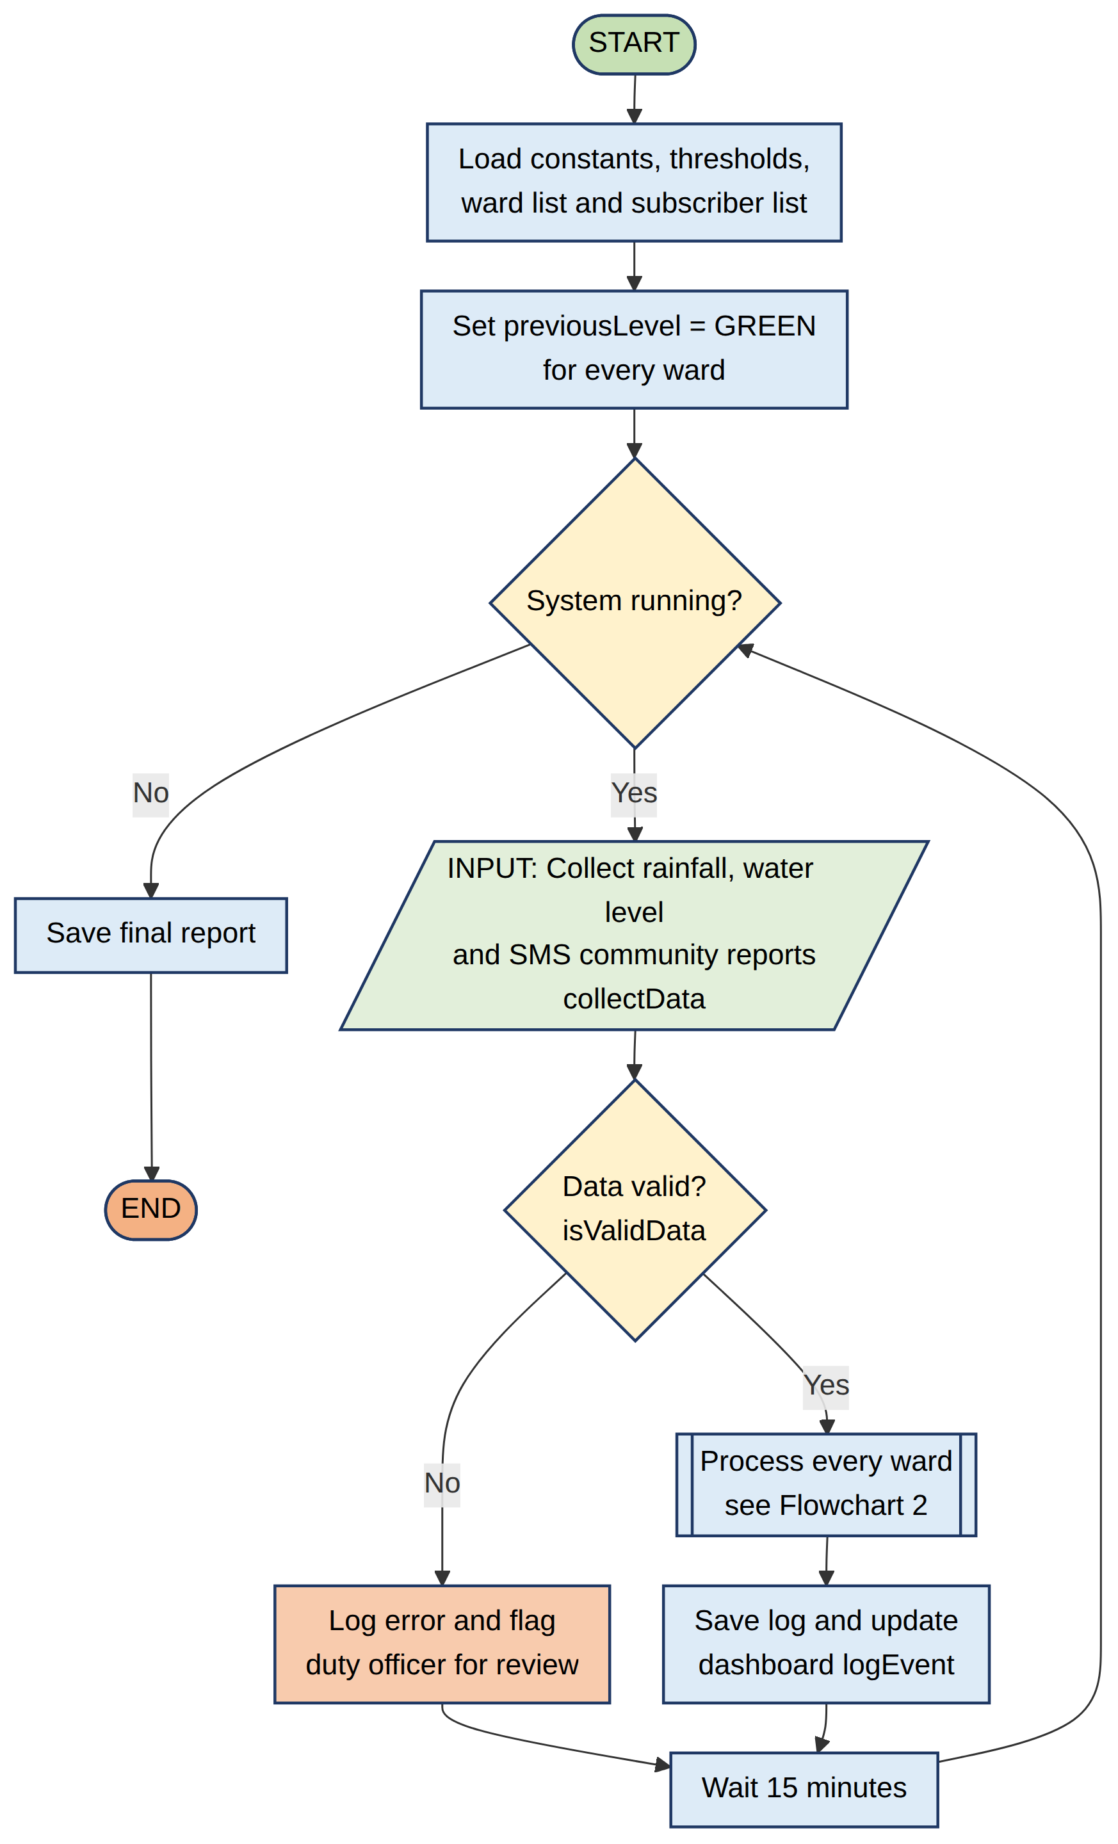
Flowchart 1: Main system loop

4.2 Flowchart 2
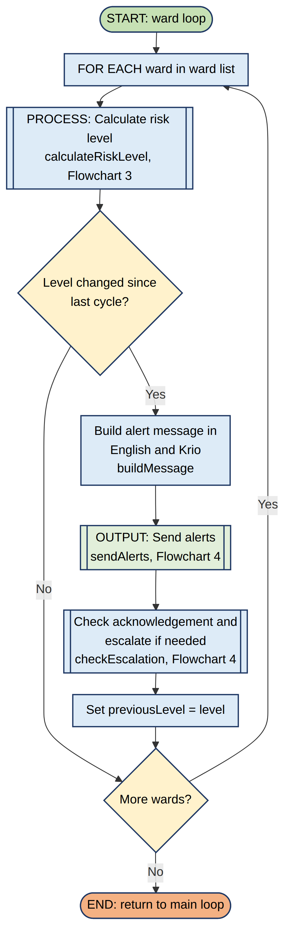
Flowchart 2: Ward processing loop

4.3 Flowchart 3
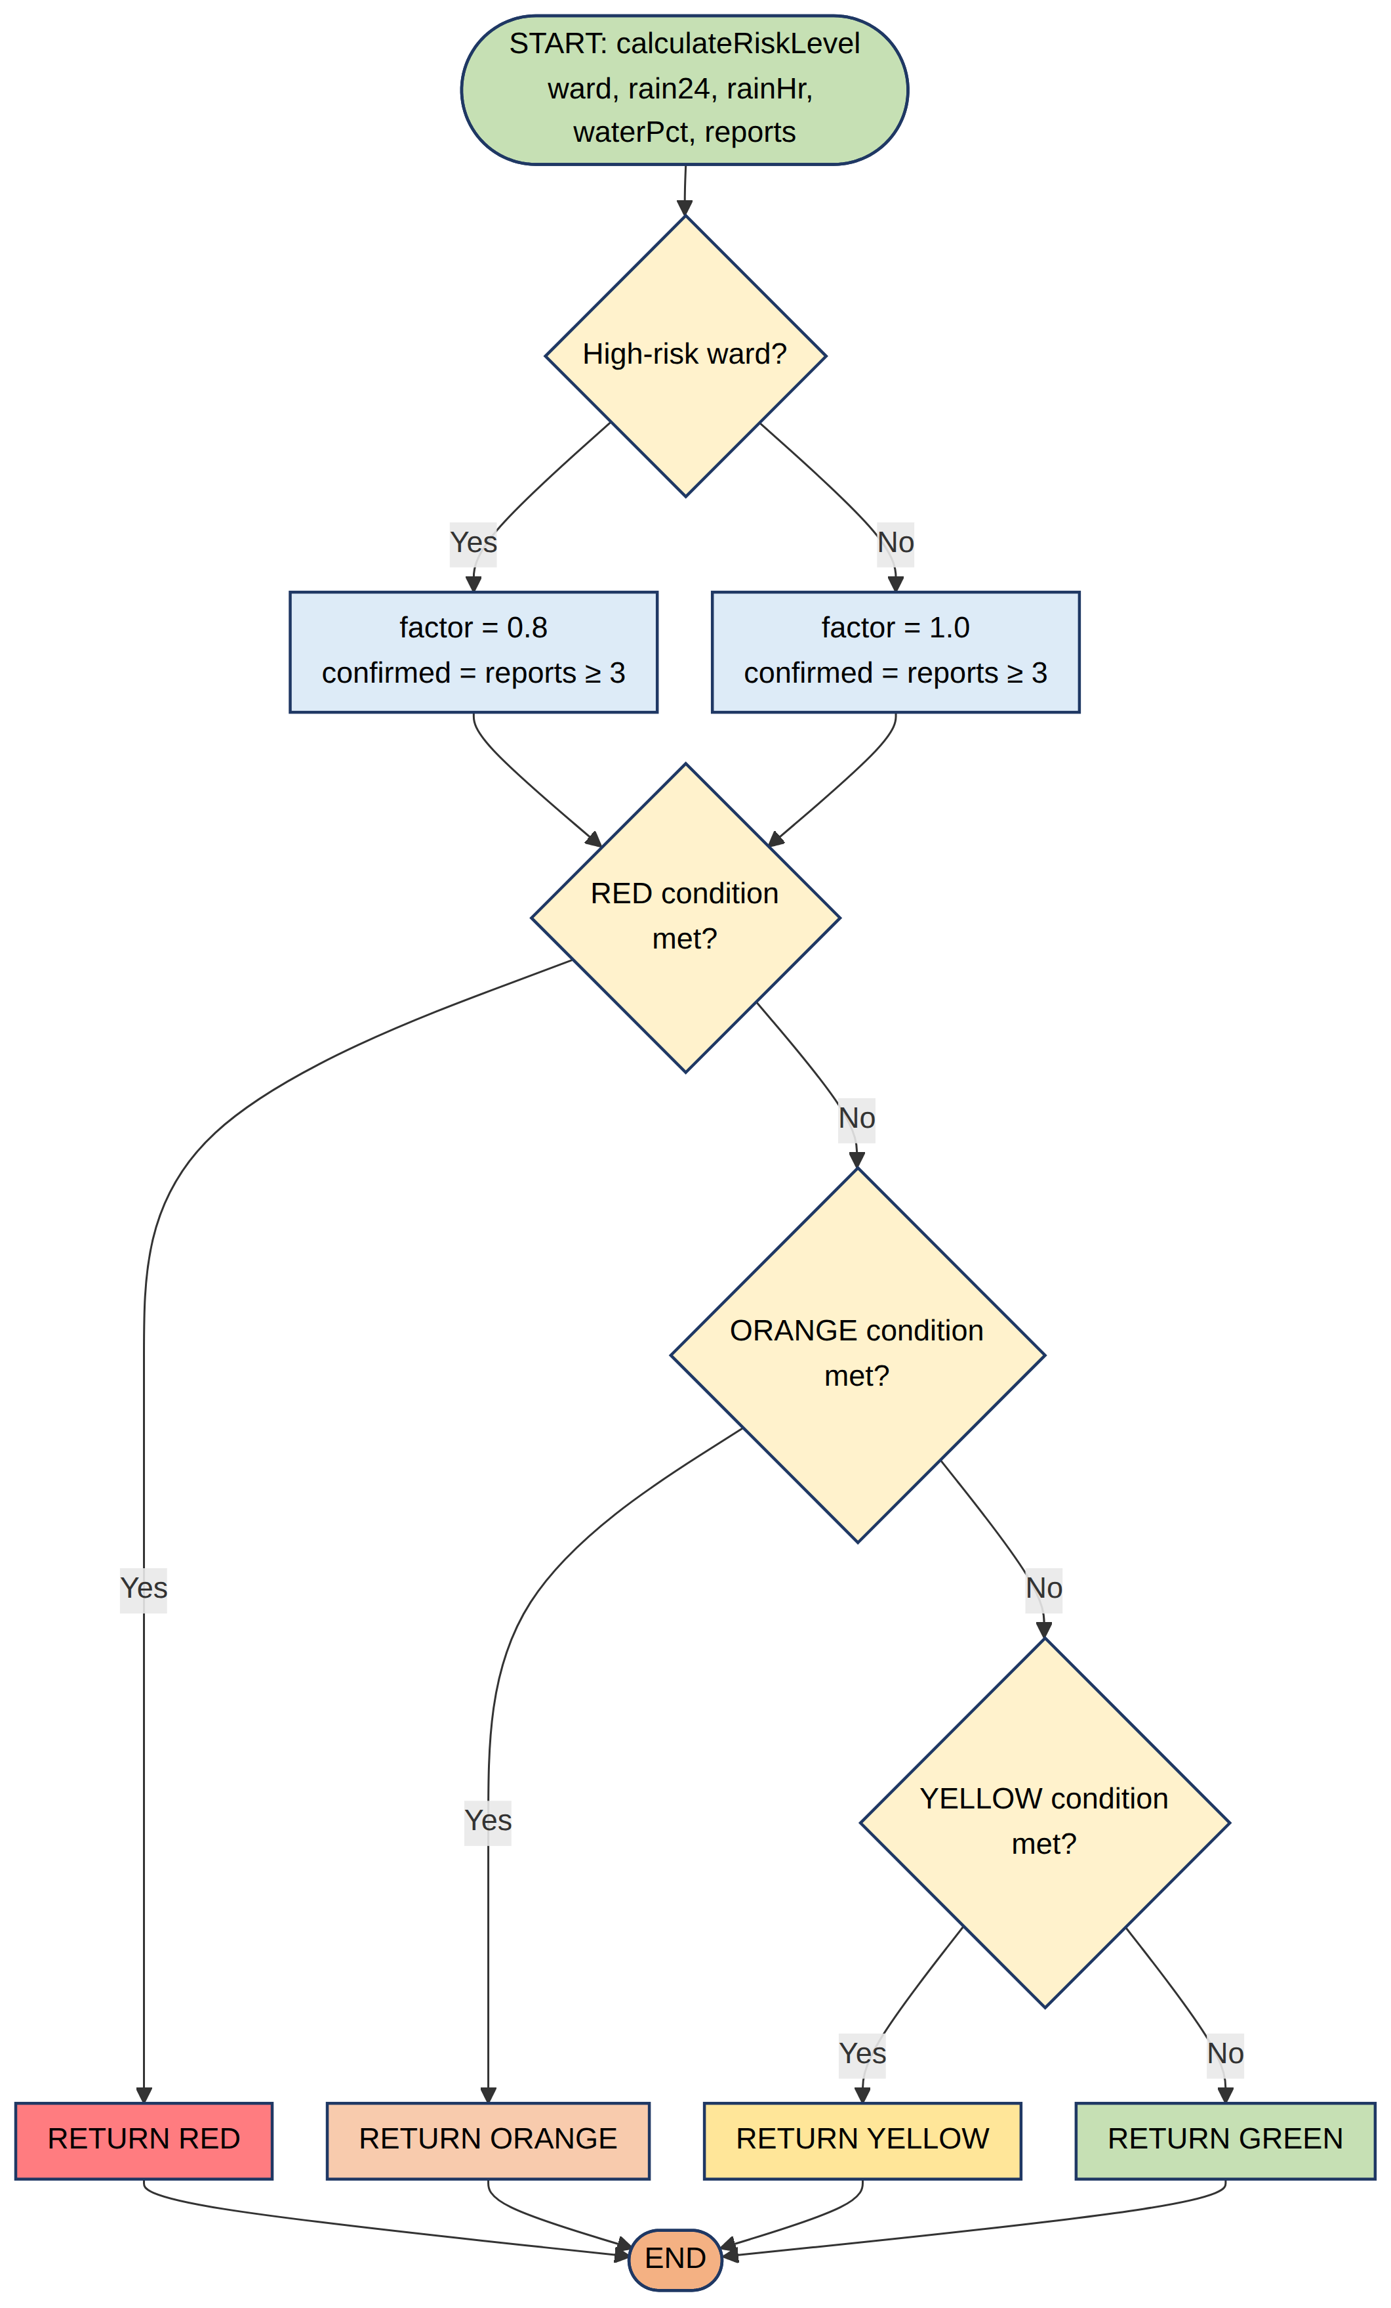
Flowchart 3: calculateRiskLevel function (conditions are defined in Table 1 and Table 6)

4.4 Flowchart 4
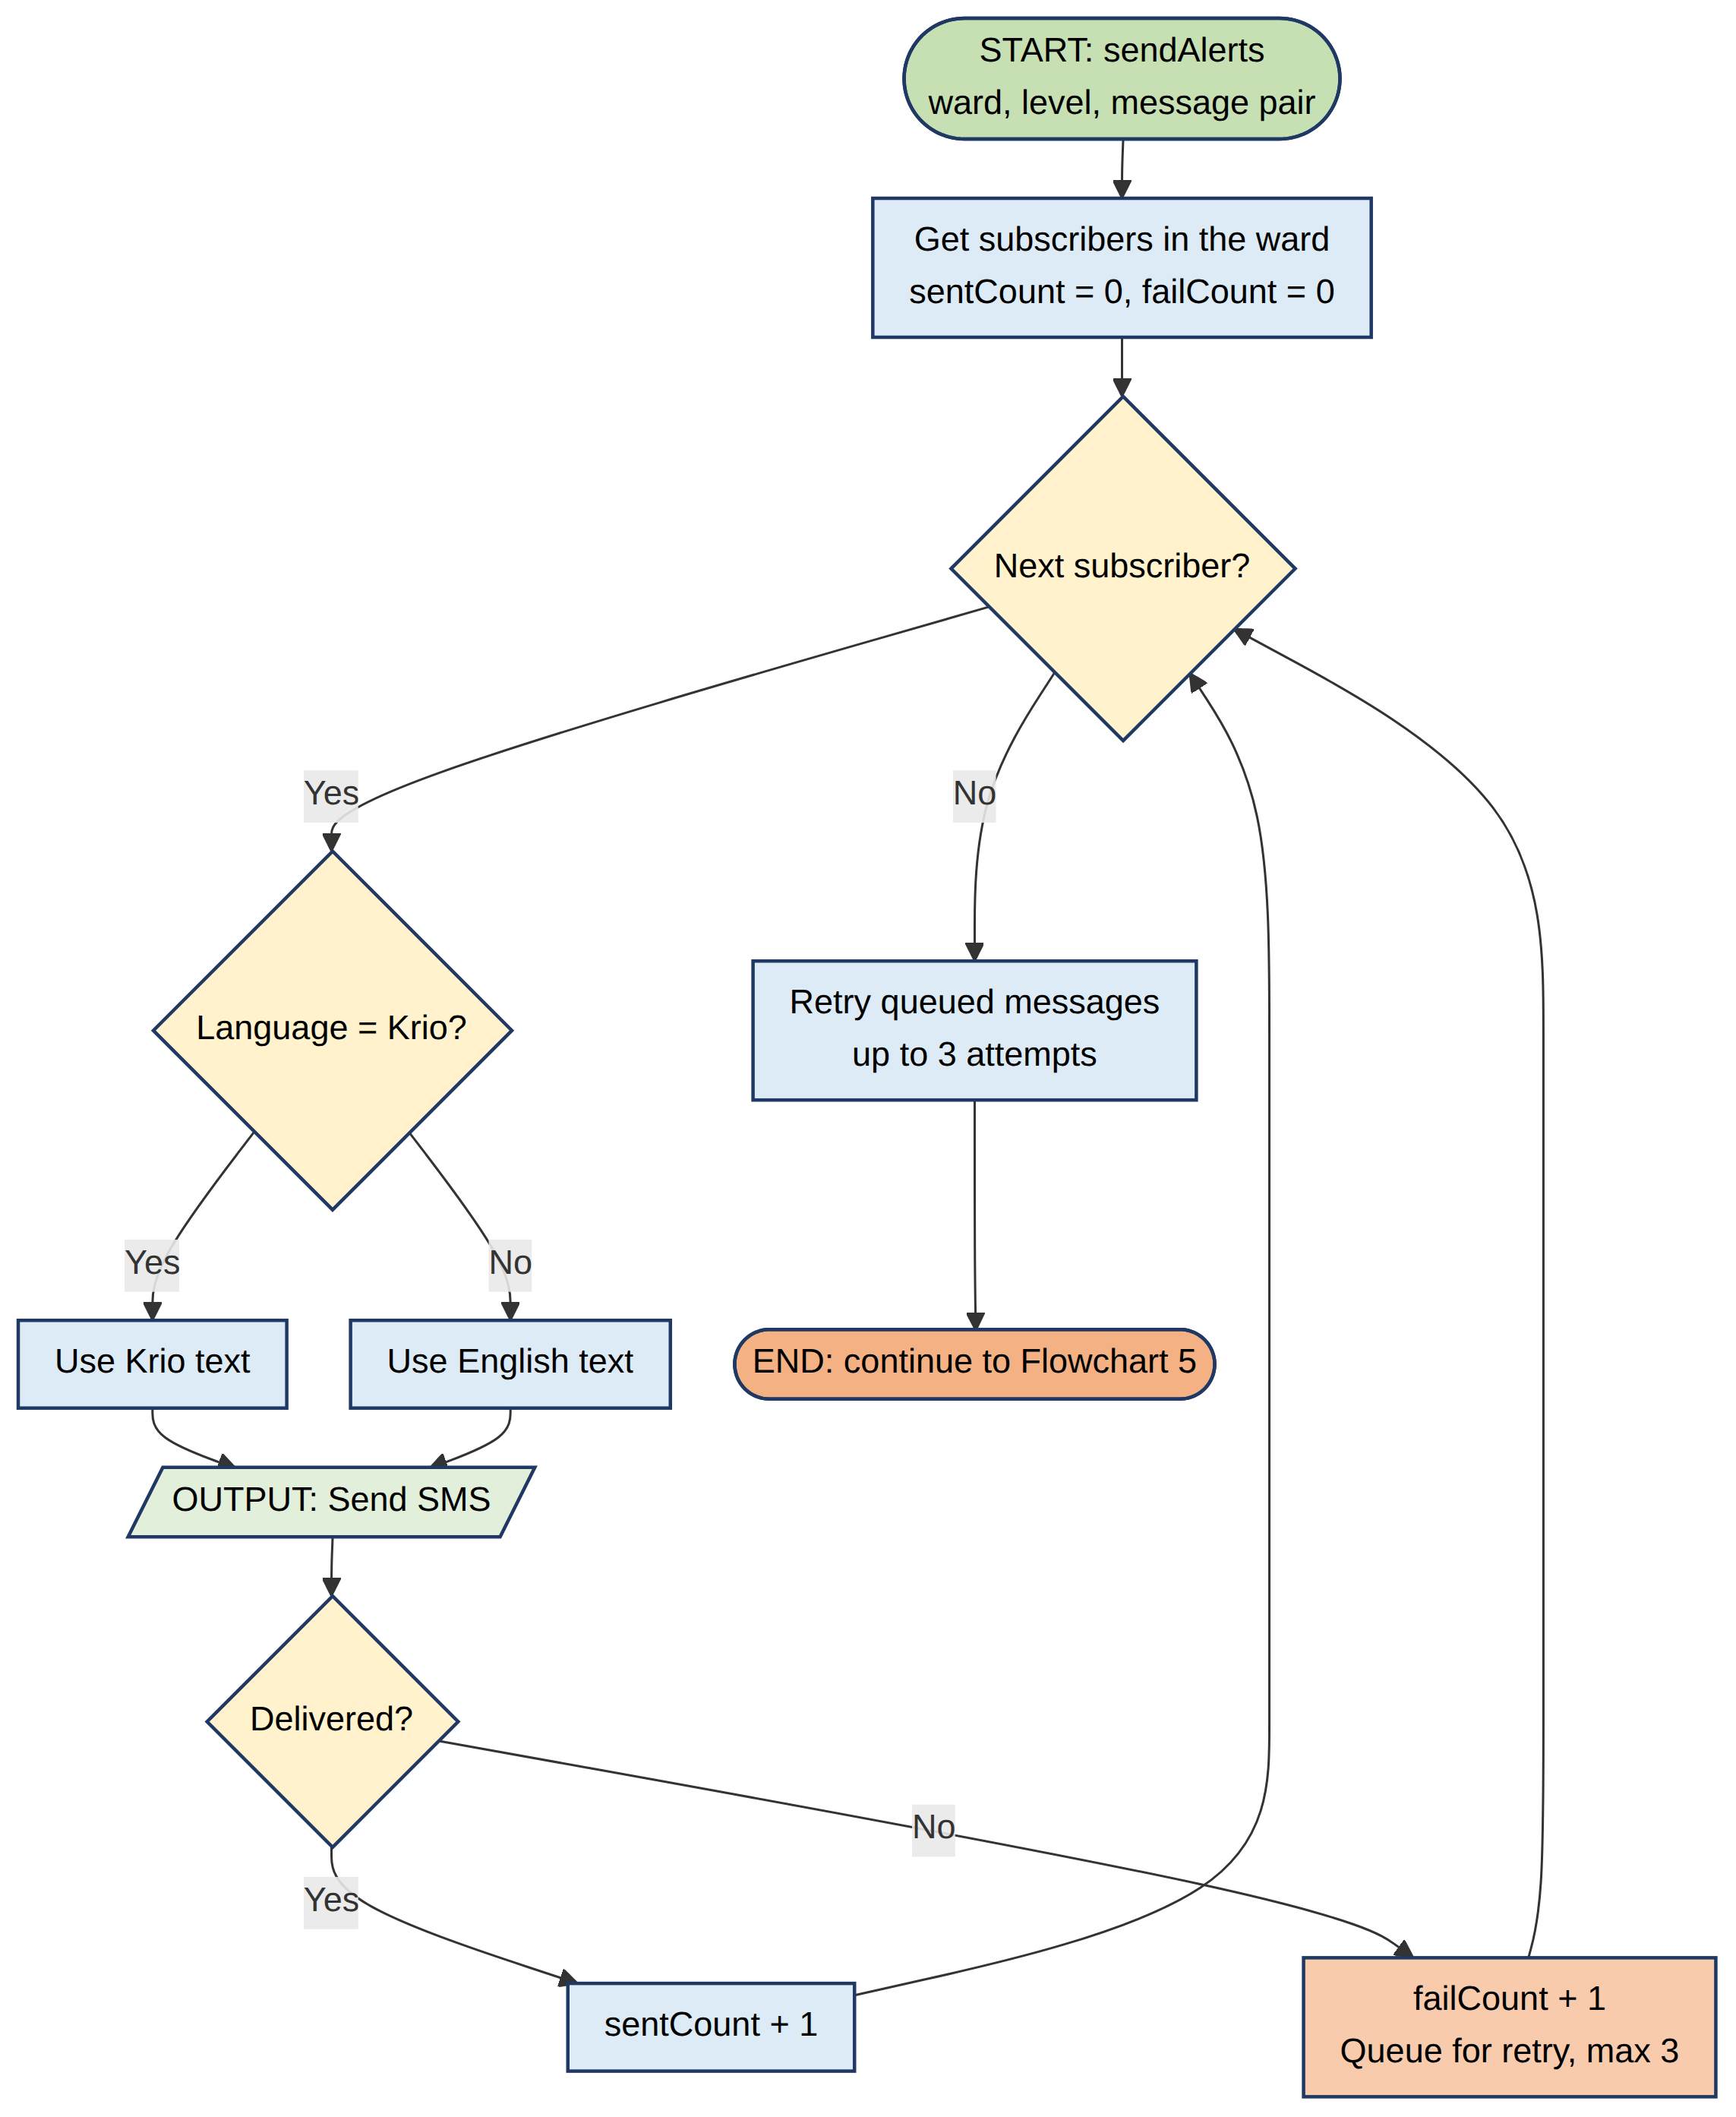
Flowchart 4: sendAlerts function (SMS loop)

4.5 Flowchart 5
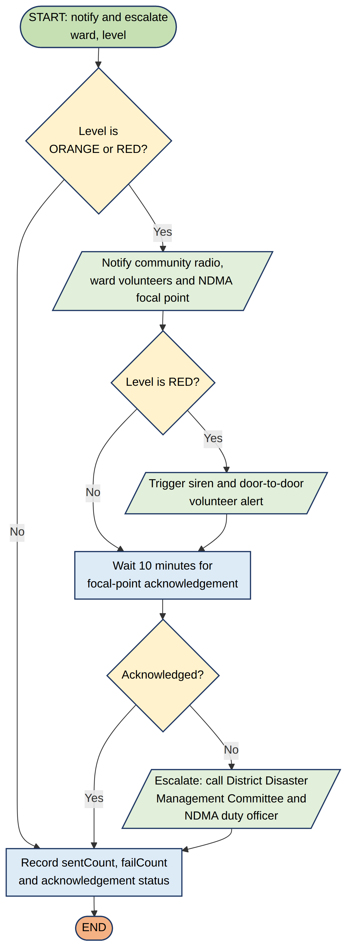
Flowchart 5: Notification and escalation (rest of sendAlerts and checkEscalation)

5. Functional Modules
Problem decomposition produced seven modules and a main controller. Each module has one clear responsibility, which makes the system easier to design, test, share between team members and improve through open-source contributions.
Table 8: Functional modules
Module | Purpose | Input → Output | Functions
M1 Data Collection | Gather and validate readings and SMS reports | Gauges, volunteers, SMS → validated ward data | collectData, receiveSMSReport, isValidData
M2 Subscriber Management | Register and remove residents | JOIN and STOP SMS → subscriber list | registerSubscriber, removeSubscriber, getSubscribers
M3 Risk Analysis | Classify each ward | Ward data → GREEN, YELLOW, ORANGE or RED | calculateRiskLevel, isHighRiskWard
M4 Message Builder | Create short alert text | Ward, level → English and Krio text | buildMessage
M5 Alert Dissemination | Deliver alerts on all channels | Message pair → SMS, radio, volunteers, siren | sendAlerts, notifyRadioAndVolunteers, triggerSiren
M6 Escalation | Make sure serious alerts are acted on | Level, acknowledgement → escalation calls | checkEscalation
M7 Logging and Reporting | Keep an audit trail and reports | Events → log and final report | logEvent, saveFinalReport

Input, processing and output summary. Input: rainfall, water level, resident SMS and registrations. Processing: validation, risk classification, message creation, retries and escalation. Output: SMS, radio and volunteer notifications, sirens, acknowledgements and logs.

5.1 Module structure chart
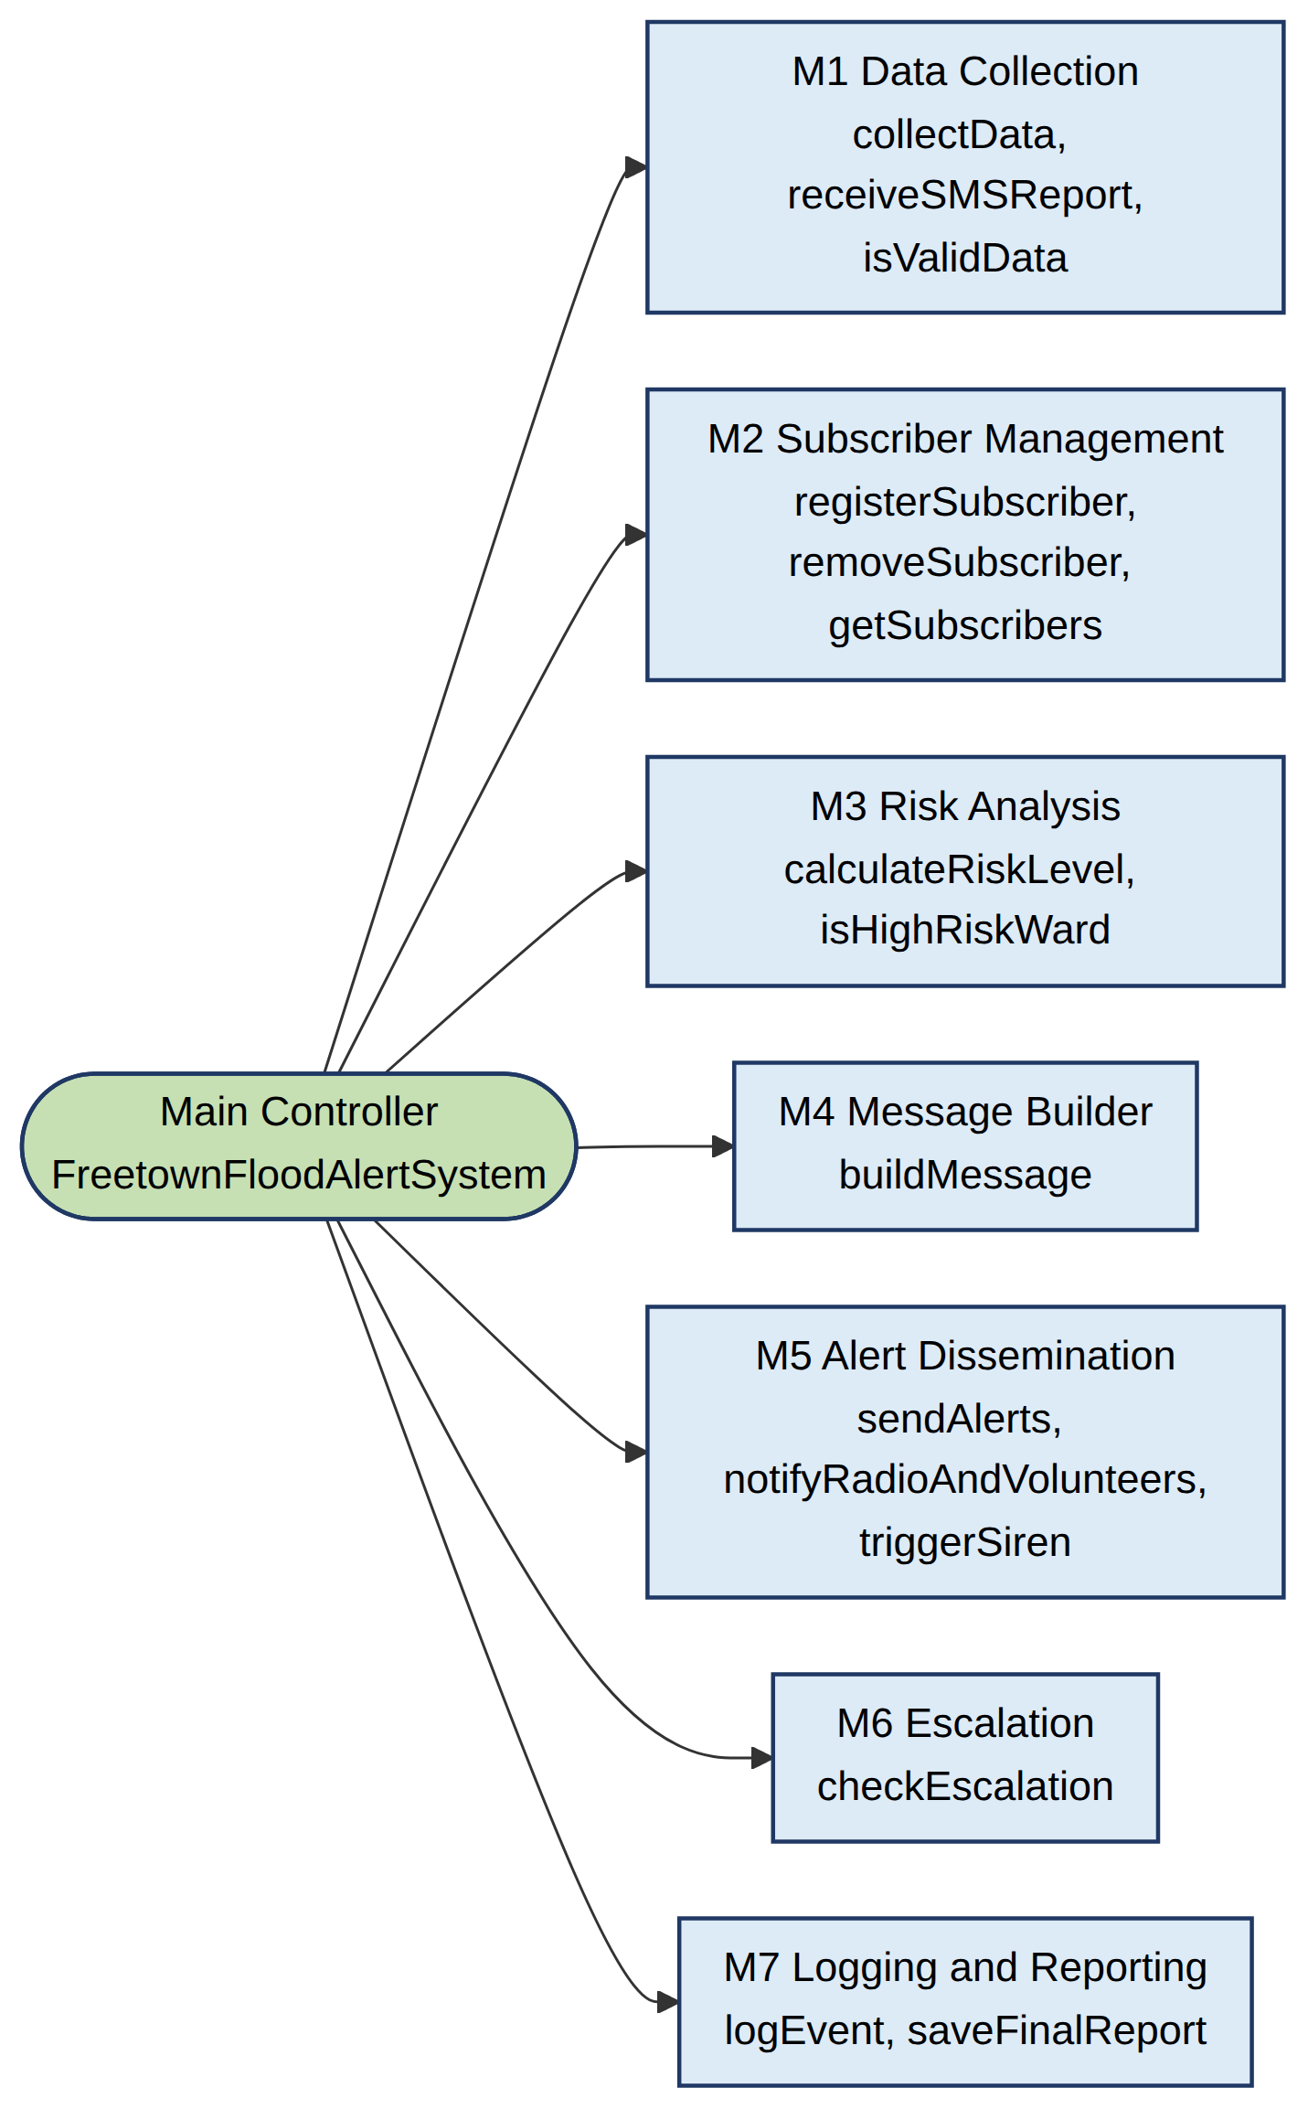
Flowchart 6: Module structure of FCFEAS

6. Expected Outputs
The sample scenarios below use the constants in Table 4. KROO, PORTEE, CULVERT and REGENT are treated as high-risk wards (factor 0.8) and HILLST (Hill Station) as a standard ward (factor 1.0); this classification is illustrative and must be set by NDMA and Freetown City Council. Units are mm for rain24, mm/h for rainHr and % for waterPct.
Table 9: Sample scenarios
# | Inputs | Decision path | Expected output
1 | KROO: rain24 12, rainHr 2, waterPct 25, reports 0 | No RED, ORANGE or YELLOW test is met → GREEN. Same as previous level. | No SMS. Log: KROO GREEN.
2 | KROO: rain24 45, rainHr 8, waterPct 40, reports 0 | YELLOW test: 45 ≥ 50 × 0.8 = 40 → YELLOW (changed from GREEN). | SMS to KROO subscribers: “YELLOW ALERT Kroo Bay. Heavy rain. Stay alert, clear drains, listen to radio.” No escalation.
3 | HILLST: rain24 45, same other values | Factor 1.0: 45 < 50 → GREEN. | No SMS. Shows how the high-risk factor changes the result compared with scenario 2.
4 | PORTEE: rain24 85, rainHr 10, waterPct 70, reports 4 (previous YELLOW) | RED test fails (85 < 120). ORANGE test: 85 ≥ 100 × 0.8 = 80 → ORANGE. | SMS to PORTEE subscribers, radio, volunteers and NDMA focal point notified. 10-minute acknowledgement timer starts. No siren.
5 | CULVERT: rain24 55, rainHr 32, waterPct 70, reports 4 (confirmed) | RED test: rainHr 32 ≥ 30 AND confirmed → RED. | SMS, radio, volunteers, siren and door-to-door alert. If no acknowledgement after 10 minutes: District Disaster Management Committee and NDMA duty officer are called. Log: ESCALATED.
6 | REGENT: rain24 130, rainHr 20, waterPct 105, reports 0 | RED test: waterPct 105 ≥ 100 → RED. | RED SMS: “RED ALERT Regent. Flood danger. Move to higher ground NOW.” Siren and escalation rules apply.
7 | PORTEE: rain24 20, rainHr 0, waterPct 30, reports 0 (previous RED) | All tests fail → GREEN (changed from RED). | “ALL CLEAR Portee-Rokupa. Flood risk is now low.” sent to subscribers.
8 | KROO: rain24 −5 (faulty gauge) | isValidData returns FALSE. | No alerts this cycle. Log: INVALID DATA. Duty officer reviews; previous levels stay in force; next cycle in 15 minutes.
9 | SMS “JOIN KROO KR” from a new number | Valid ward, language KR → subscriber added. | Confirmation SMS: “You will receive flood alerts for KROO. Send STOP to leave.”
10 | SMS “FLOOD KROO” (missing severity) | Severity is not 1 to 3 → invalid format. | Reply: “Wrong format. Send: FLOOD WARDCODE 1-3”. Report is not counted.

Sample log line (illustrative): 2026-09-02 06:15 | ALERT SENT | KROO ORANGE | sent=248 | failed=2 | acknowledged=YES.
Krio message templates must be written and approved by community translators before use, so only English text is shown here.

7. GitHub Evidence
Complete this section after the repository is created, following the repository steps given separately. Replace each placeholder with the real item.
Evidence | Details to insert
Repository name | PROG101_Assignment1_StudentName_StudentID
Repository URL | [Paste the full https://github.com/… link]
Git commit history | [Insert screenshot of the commit list, showing regular commits with dates]
README.md | [Insert screenshot of the README.md as displayed on GitHub]
Repository screenshot | [Insert screenshot of the repository main page showing all uploaded files]

Repository contents: report (PDF and Word), the Flowcharts folder (PNG and Mermaid .mmd files), Pseudocode folder, and README.md.

8. References
ACAPS (2017) Briefing note: Sierra Leone – Mudslides and floods. Available at: https://www.acaps.org/sites/acaps/files/products/files/20170816_acaps_start_briefing_note_sierra_leone_mudslides_and_floods.pdf (Accessed: 28 October 2026).
Africanews (2018) ‘Sierra Leone remembers victims of the deadly 2017 mudslide and floods’, Africanews, 15 August. Available at: https://www.africanews.com/amp/2018/08/15/sierra-leone-remembers-victims-of-the-deadly-2017-mudslide-and-floods/ (Accessed: 28 October 2026).
Cambridge Prisms: Coastal Futures (2023) ‘Impact statement’. Available at: https://doi.org/10.1017/cft.2023.29.pr3 (Accessed: 28 October 2026).
CREWS (2026a) Sierra Leone 2.0. Climate Risk and Early Warning Systems initiative. Available at: https://crews-initiative.org/project/sierra-leone-2-0/ (Accessed: 28 October 2026).
CREWS (2026b) CREWS ASW Sierra Leone 2.0 project document. Available at: https://crews-initiative.org/wp-content/uploads/2026/04/CREWS-ASW-Sierra-Leone-2.0-Project-Document.pdf (Accessed: 28 October 2026).
Digital Public Goods Alliance (DPGA) (n.d.a) Digital public goods. Available at: https://digitalpublicgoods.net/digital-public-goods (Accessed: 28 October 2026).
Digital Public Goods Alliance (DPGA) (n.d.b) Setting a standard for digital public goods. Available at: https://www.digitalpublicgoods.net/blog/setting-a-standard-for-digital-public-goods (Accessed: 28 October 2026).
Digital Public Goods Alliance (DPGA) (2025) RapidPro. DPG Registry. Available at: https://digitalpublicgoods.net/r/rapidpro (Accessed: 28 October 2026).
GFDRR (2017a) Sierra Leone: Rapid damage and loss assessment of August 14th, 2017 – landslides and floods in the Western Area. Global Facility for Disaster Reduction and Recovery. Available at: https://www.gfdrr.org/en/sierra-leone-rapid-damage-and-loss-assessment-august-2017-landslides-and-floods (Accessed: 28 October 2026).
GFDRR (2017b) Sierra Leone: Rapid damage and loss assessment. Global Facility for Disaster Reduction and Recovery. Available at: https://www.gfdrr.org/en/publication/sierra-leone-rapid-damage-and-loss-assessment (Accessed: 28 October 2026).
Green Climate Fund (n.d.) SAP033: Enhancing climate information systems for resilient development in Sierra Leone. Available at: https://www.greenclimate.fund/project/sap033 (Accessed: 28 October 2026).
GSMA (2024) The Mobile Economy Sub-Saharan Africa 2024. Available at: https://www.gsma.com/solutions-and-impact/connectivity-for-good/mobile-economy/sub-saharan-africa-2024/ (Accessed: 28 October 2026).
International Federation of Red Cross and Red Crescent Societies (IFRC) (2025) DREF operation: Sierra Leone – Floods 2025 (MDRSL019). Available at: https://go-api.ifrc.org/api/downloadfile/92455/MDRSL019do (Accessed: 28 October 2026).
Kanu, S.S. (2025) ‘S/Leone braces for heavy rainfall: NDMA and SLMet issue warning’, Premier Media, 7 August. Available at: https://www.premiermedia-sl.com/?p=24670 (Accessed: 28 October 2026).
PreventionWeb (n.d.a) Sierra Leone – Rapid damage and loss assessment of August 14th, 2017 – landslides and floods in the Western Area. Available at: https://www.preventionweb.net/quick/69723 (Accessed: 28 October 2026).
PreventionWeb (n.d.b) SDGs with targets related to disaster risk. Available at: https://preventionweb.net/quick/66335 (Accessed: 28 October 2026).
Wing, J.M. (2006) ‘Computational thinking’, Communications of the ACM, 49(3), pp. 33–35.
World Meteorological Organization (WMO) (n.d.) WMO and the Early Warnings for All initiative. Available at: https://wmo.int/activities/early-warnings-all/wmo-and-early-warnings-all-initiative (Accessed: 28 October 2026).

