Udemy Machine Learning

Steps for a daya scientist
- Formulate Question
  - Movie example is not how much will my movie make but the movie revenue
- Gather data
- Clean data (errors, missing, incomplete)
- Explore & Visualize
- Train Algorithm
- Evaluate

Linear Regression

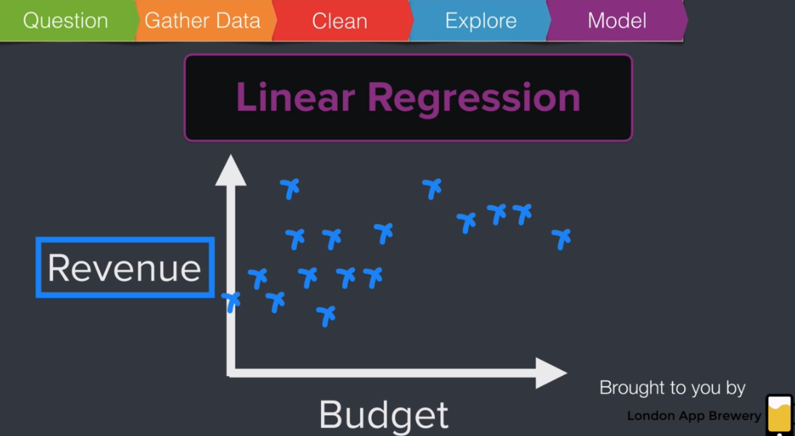
What the linear regression will do is try and represent the relationship between the budget and the revenue as a straight line.
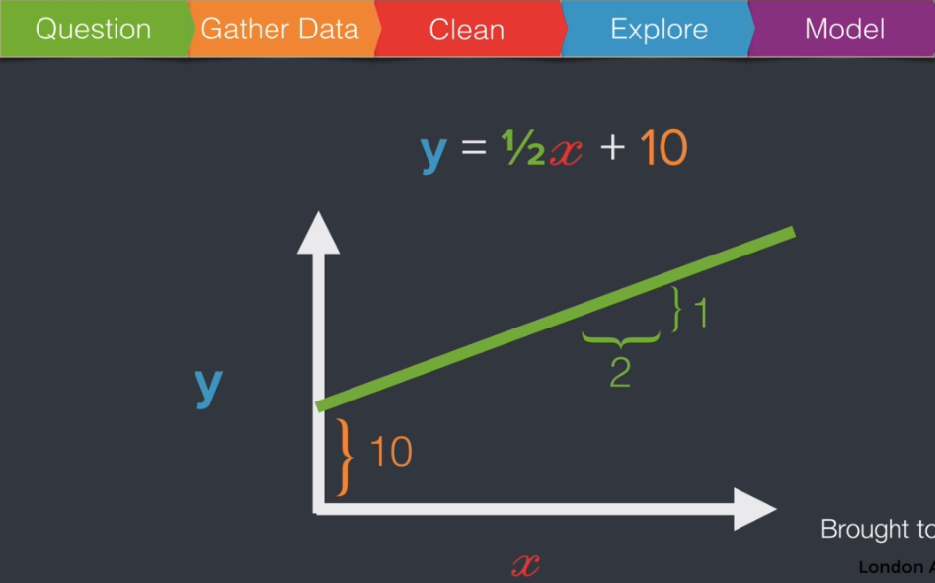
We know that we can plot y as a function of X and that's a line. And if we cut the y axis at 10 then we say that our line has an intercept of 10 and if every time X increased by 2 and it made y increase by 1 then we say that the line has a slope that is equal to one half. It would be Y is equal to m x plus C where m is the slope and sees the constant.

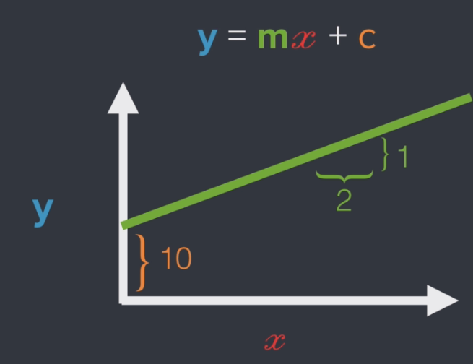
Generic equation y = mx + c where:
- m + 1 / 2
- c = 10
- y = ½x + 10

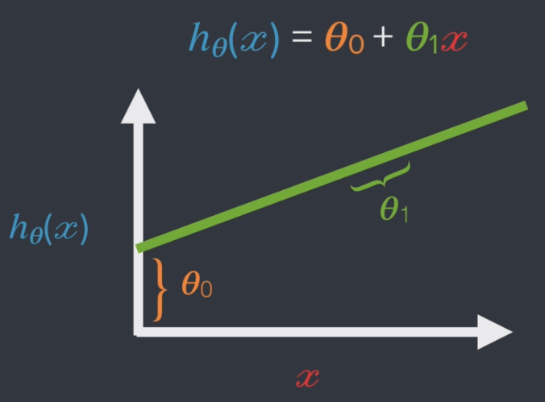
replace the C for the constant with theta 0 and the slope coefficient will be written as theta 1 and also will change the order in this equation so we'll have the constant first and then the slope, and instead of writing y you'll also often see is h theta x where H stands for hypothesis. This is the preferred notation for ML

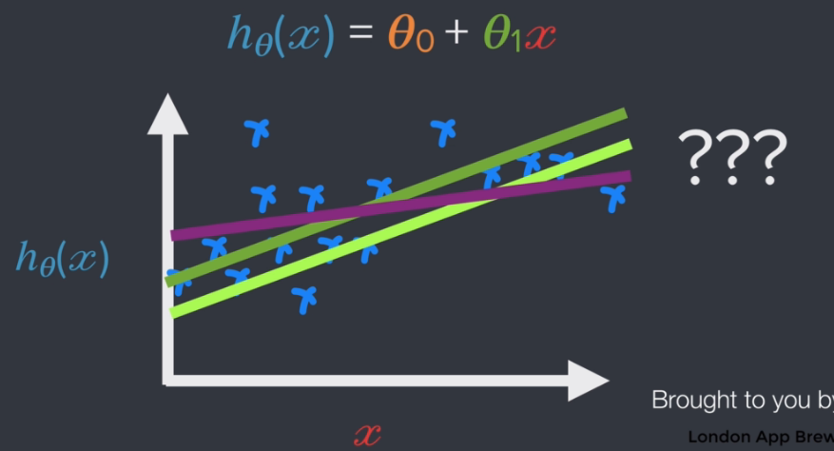
So which line is best??

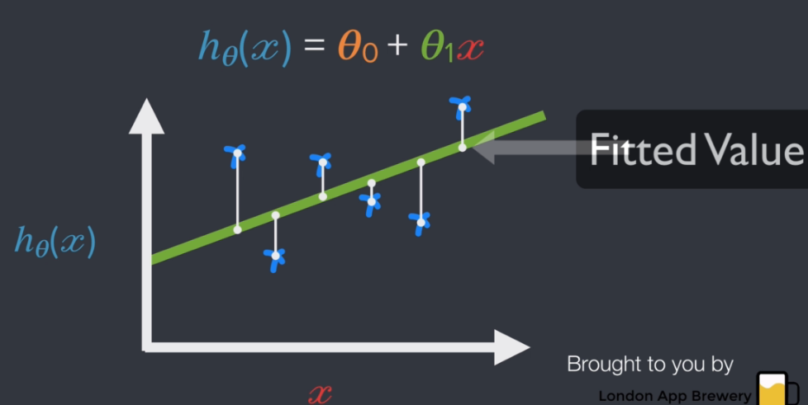
would be a difference between the actual data point and the point on the line. The point on the line here is called the fitted value or the predicted value.

it's these gaps that will help us choose the best possible. The intercept and the best possible slope for our line. These white lines are actually called residuals.
Now why will the residuals help us choose the best possible line for our data.
we have a measure by which to compare the different lines that we can draw through the data.
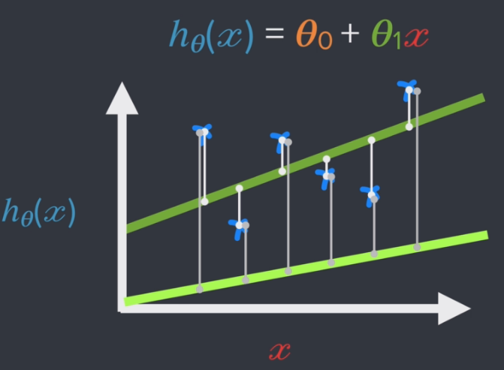
All we have to do is look at the size of the residuals and choose the line with the smallest residuals and that's great because now our algorithm has a very clear objective.

Calculate the line
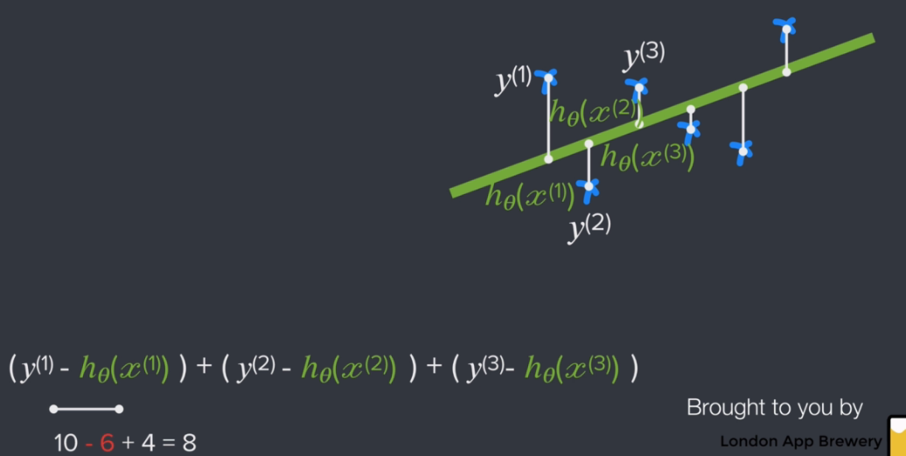

The goal of our linear regression is going to be to calculate the line that minimizes these residuals.
The first residual that first residual is going to be the difference between the actual value the Y 1 and the predicted value which is the one on the line and that second residual would also be just the difference between the actual value in white here and the fitted value in green and the same is true for that third data point. Now suppose we actually have calculated the values for these residuals and these residuals have the values 10 negative 6 and 4. In this case what we can't do is just add them up and find the lowest sum because that second data point is below the line.

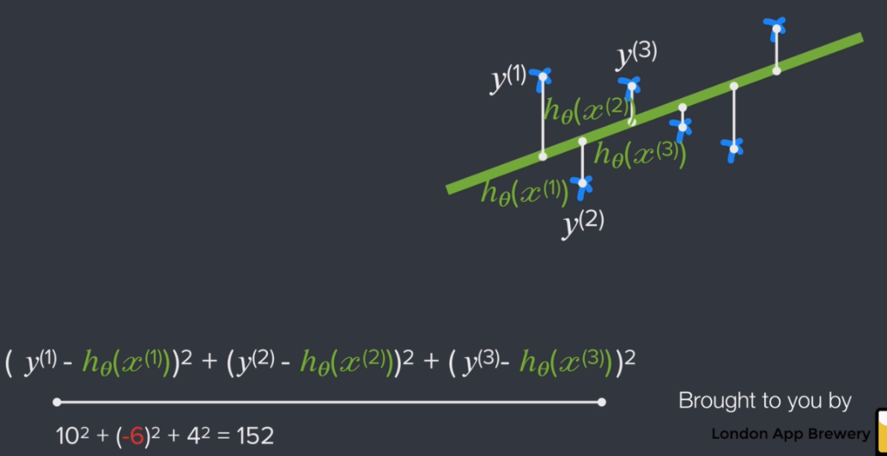
have to turn all of these numbers positive and the way we can do that is by squaring the residuals.
Now what we've got is a single number the sum of the squared residuals. This is the number that the linear regression will try to minimize in order to choose the best parameters for the line. In other words to find the best possible fit for our regression what we need to do is we need to choose an intercept the theta zero and we need to choose the slope theta one that minimizes the sum of the squared residuals and you'll see this number also being referred to as the residual sum of squares or RSS.
RSS - the sum of the squared residuals also referred to as the residual sum of squares
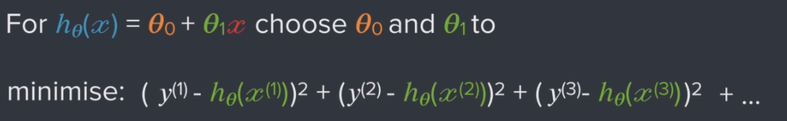

Section 3 - Intro to Optimization and the Gradient Descent Algorithm

how a machine learns

Predict -> Calculate Error -> Learn -> repeat

defines an algorithm as a set of mathematical instructions or rules that especially if given to a computer will help calculate an answer to a problem.

Back to linear regression
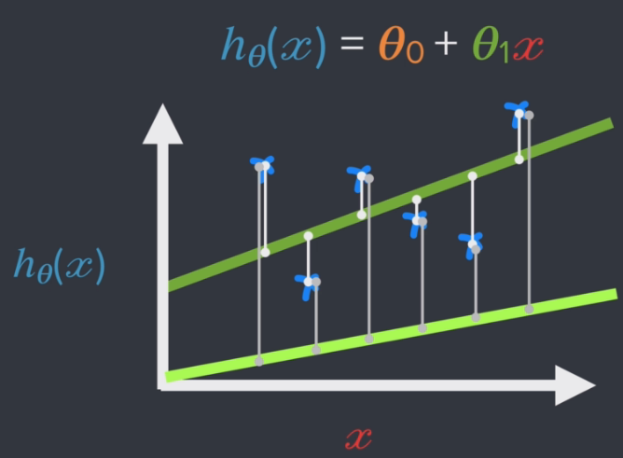
So our algorithm somehow had to rank what the best values were for theta zero and theta one. So by best what we actually mean is the line that minimizes the distance between the data points and the line.
So by best what we actually mean is the line that minimizes the distance between the data points and the line for example this dark green line here is clearly better than this light green line below. Why. Well because it's got a shorter distance between the line and the data points.
Rack to RSS
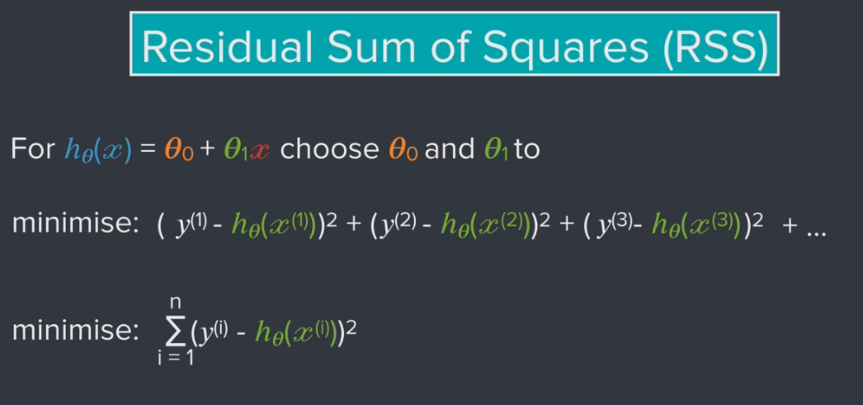
So we're going to square all these differences and then add them up and now we've got a single number.
And we've also got a goal right. So we've got this single number that has a name. It's called the residual sum of squares and this residual sum of squares gives us a single metric on how good our estimates for theta 1 and theta zero are. So with this in mind we know that we can find the best possible values for theta zero and theta one by minimizing this residual sum of squares.. We can think about this number as measuring the size of our error and expressing how good or badly we did.

Cost Functions - or how it's also called the sum of squared residuals and a very big part of the machine learning process is optimizing for solution that has the lowest cost. Also called:
- Loss functions
- Error functions
- objective function

Chap 32 – Notebook stuff but LaTex formatting

Chap 33
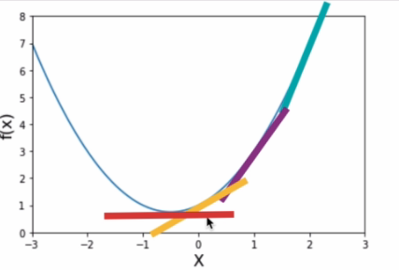
So if X was equal to two if we were here on the graph then the cost would be decreasing a lot as we're moving down. But when X is equal to 1 then that costs still decreasing but by not as much because the line just isn't as steep. By the same token when X is equal to zero. That line is like flattening out even more. At this point the cost is only decreasing very very slightly. Then we'd reach our minimum and then the cost starts increasing again as we move up the curve. So in other words the slope or the steepness of this function. It's telling us when we've reached our minimum cost because that slope is the rate of change.
Slope calculated by Power Rule
- d/dx of X^n = n * x(n-1)
- x^5th = 5 * x(5 – 1) = 5x^4th
- [x^3rd + 5x^2 +7] = 3x^2 + 10x

Lot of stuff on matplotlib

Chap 34 – Loops and the Gradient Descent Algorithm
Still more matplotlib
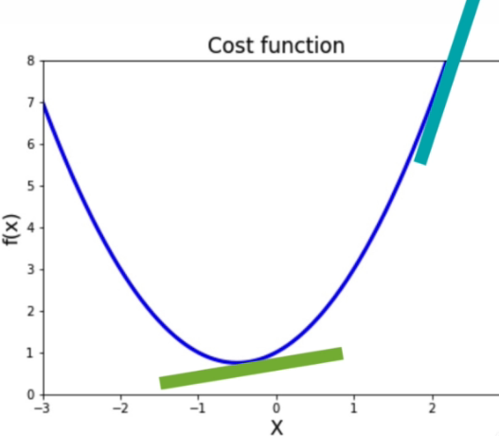
So if the slope is very very steep then it's indicative of being very very far away from where we want to be. A steep slope means that we've got a high error. If the slope is zero or close to it then our error is small.

Chapter 35 - Advanced Functions and the Pitfalls of Optimization
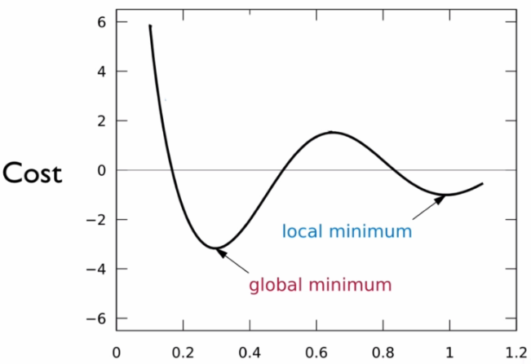
if our cost function look something like this then we would have to minima one of which has a much lower cost than the other one. One of these is a global minimum and the other one is a local minimum. The local minimum actually has a higher cost than the global minimum. But our gradient descent would not discover the global minimum if the initial starting point was on the right hand side of that local maximum of that small hump right there in the middle of the chart.
What's the solution.
Well the easiest thing to do would be to simply try out multiple different starting values and see if
they end up in the same place. Think of this as like injecting a little bit of randomness into our gradient descent so we could do this by choosing a whole host of like random starting values and then running our gradient descent over and over again to see where it ends up.

An approach you could take if you actually don't know what the cost function looks like right. If you don't know where the minimum is. This might be something that you want to try.

this particular version of gradient descent isn't our only option. Similar to how we can try a bunch of different random starting points other algorithms have randomness baked into them. One of the versions of gradient descent that has more randomness baked in is called Stochastic gradient descent. And this is in contrast what we're currently doing which is called Batch gradient descent but the thingto note about any of these approaches is that none of them are perfect. You'll find that no matter which approach you choose it has certain strengths and it has certain weaknesses and it's important to understand what the pros and cons are of of each approach.

Chapter 36 - Tuples and the Pitfalls of Optimization (Part 2)
tuples are often used when the data they contain is heterogeneous. tuples often contain a mix of data and contrast to lists i.e. different data types
They are immutable

Chapter 37 - Understanding the Learning Rate
So far we've changed up the initial guesses and analyzed the impact that this had on the algorithm in
different situations on different cost functions. But we've not really messed with the multiplier and this is what we're gonna do now.
If we look at our update step namely this line right here we can see that our learning rate which I've
called multiplier is multiplied with the gradient the gradient is the value of the slope of the cost
function and the multiplier.
It's just a constant but together they determine how big of a step we take.
So if you remember with the gradient when the slope was steep then the gradient was a large number.
And similarly if the multiplier is launch we also take a big step.

how do we know what the right learning rate actually is? If we pick a very large learning rate then our algorithm doesn't converge. And if we pick a very very small learning rate then our algorithm might actually take forever.
See the “Effect of the learning rate” section
We've run our gradient descent three separate times with different learning rates and now we can see how the cost decreases with each iteration of the loop and what we're seeing here is that the highest learning rate the one in hot pink converges the fastest. In other words the higher the multiplier the faster the convergence. And in contrast we've got the really low multiplier converging very very slowly to the minimum. Now if we've picked an even lower multiplier then it would reach the minimum even more slowly but as we've shown before the higher multiplier is only better up to a point right.
So I think that illustrates the problem really nicely when the algorithm is bouncing around with no clear direction and I think a takeaway from this exercise is that picking the right learning rate is both a bit of an art and a science and so it shouldn't come really as a surprise that there isn't really one perfect solution for picking a good learning rate either. So even if you go to the literature on machine learning you'll find that there are different approaches for picking a good learning rate.
one of the really really big advantages of gradient descent is that it is incredibly simple is an incredibly simple algorithm and is also quite fast so it's quite a fast thing to run to train your machine learning model and that's an advantage that not every other competing algorithm can claim for themselves.
The bold driver and it works like this. If your error rate was reduced since the last iteration. Then you can try increasing the learning rate by 5 percent. And if your error rate was in fact increased meaning that you skipped over the optimal point then you should reset the values of your parameters to the values of the previous iteration and decrease the learning rate by 50 percent so you can see with this kind of rule how the learning rate would change increased by 5 percent. If you had a reduction in your error rate and go back one step and decrease the learning rate by 50 percent. If you had an increase in your cost.

Chapter 38 - How to Create 3-Dimensional Charts
3D color map reference - https://matplotlib.org/3.1.1/tutorials/colors/colormaps.html
Very useful as a 3D intro, not much in ML

Chapter 39. Understanding Partial Derivatives and How to use SymPy
importing two things, one of them is the symbols functionality which will help us write mathematical notation and the other is diff which allows us to differentiate a mathematical function.

40 - Implementing Batch Gradient Descent with SymPy – See notebook, mainly SymPy stuff and dictionaries
41 - Loops and Performance Considerations –

Batch Gradient Descent with SymPy
Shows how SymPy is resource intensive
Python is actually doing a lot of extra work in this case every single time this loop runs it has to differentiate our cost function and then evaluate that cost function and these instructions actually are a little bit more resource intensive than if it already knew from the get go what the partial derivative was. And this is one of the drawbacks of why you might not want to use simple high in your loop if you're running an optimization algorithm many many many times.
42 - Reshaping and Slicing N-Dimensional Arrays
Graphing 3D Gradient Descent & Adv Numpy Arrays
Learn more about numpy and dimensional arrays because these things are incredibly powerful.
43. Concatenating Numpy Arrays – Just Python code

44 - Introduction to the Mean Squared Error (MSE) - Some good Latex formatting but that is about it
Example 5 - Working with Data & a Real Cost Function
MSE is a real cost function, not an example.
RSS is a good cost function but MSE is better with one small modification and that modification is dividing the whole thing by the number of data points then the residual sum of squares gets a new name.
45. Transposing and Reshaping Arrays

Working with Data & a Real Cost Function

This is the best fit line and the data the plots that we've been running previously have been the cost functions and we're going to be plotting the mean square error shortly. Now the cost functions plot the relationship between the parameters that we're trying to estimate and how far off we were from the actual data. So the cost functions don't plot the actual data itself.

46. Implementing a MSE Cost Function – continuation of chap 45

47. Understanding Nested Loops and Plotting the MSE Function (Part 1)

3D Plot for the MSE Cost Function

48. Plotting the Mean Squared Error (MSE) on a Surface (Part 2)

49. Running Gradient Descent with a MSE Cost Function

Partial Derivatives of MSE w.r.t. 𝜃0 and 𝜃1
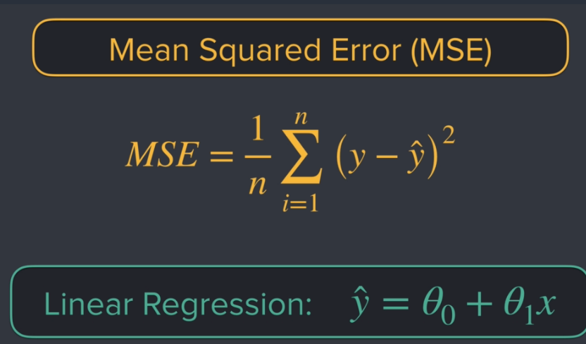

50. Visualising the Optimisation on a 3D Surface
Just plot what we did in Chap 49

