Section 5: Predict House Prices with Multivariable Linear Regression
The first step in data science and machine learning is always defining the problem that you want to solve and making sure that you're asking the right questions.
Problem - Our real estate agents need a software tool that helps them value homes in the Boston area. At the push of a button this tool needs to output a benchmark price based on the characteristics of the home and by characteristics.
- how many rooms
- crime rate
- good schools
- which factors are less important in determining the house price
- the valuation tool needs to be tractable.
53. Gathering the Boston House Price Data
some Python modules actually come with sample datasets that we can use, like scikitlearn
https://scikit-learn.org/stable/index.html
https://scikit-learn.org/stable/datasets/index.html
54. Clean and Explore the Data (Part 1): Understand the Nature of the Dataset
Follow the steps
- We've formulated our question.
- We've gathered our data.
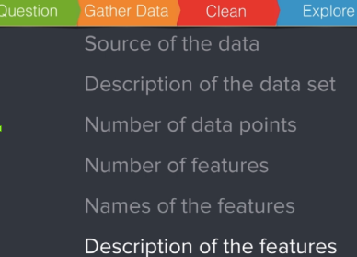
Oftentimes we're going to be exploring visualizing and cleaning this data more or less at the same time simply because the problems that the data has only becomes apparent after you start digging into

Questions - The reason these questions are very crucial is because we need to understand what the dataset is actually measuring.
- Where does the data come from, what's the source of the data.
- Can I find some sort of short description of what's in the data set. This is important for understanding the all important context under which the data was collected and also how the data was collected.
- How big is the data set actually, important from a practical point because working with a dataset with 10 million data points will require very different techniques than working with a data set of say 10 data points.
  - How many individual data points are there in the data set.
  - Am I dealing with an enormous data set or a small one.
- the fourth question is how many features are there in the dataset.
  - how many aspects were measured
  - how many entries are there for each row in the table
  - how many columns
  - The number of features will tell us how much information we have
  - will help us figure out how many characteristics we're going to be basing our prediction
- what are the names of the features
- what are the descriptions of each feature.
After the dataset load… (this is not applicable to all datasets
boston_datset = load_boston()
dir(boston_datset)
- returns attributes one of which is DESCR which if you print it tells the following:
- Number of data points
- Number of attributes
- Attribute info
55. Clean and Explore the Data (Part 2): Find Missing Values
attribute is going to be used in a different context in machine learning the features of a data set are typically represented as the columns in a table and these columns you'll often see refer to as the attributes of a data set. In other words when using this word attribute and the machine learning context we will refer to a feature or an independent variable.
The boston_dataset is a bunch object. a bunch of object in the notebook is all very well and good but one of the most common types of objects that you're actually going to be encountering in your work as a machine learning expert or as a data scientist is the pandas. Data from the pandas data frame is gonna be our main workhorse.
ML jargon you'll often hear the number of data points or rows being referred to as the number of instances. So here we've got and 506 instances. This is how this would instance is used in the context of machine learning and the important thing to note here is that this word instance means something completely different to a programmer to a python

56. Visualising Data (Part 1): Historams, Distributions & Outliers
Data visualizations help us make sense of our data at the exploration stage. There's two things that we want to get a sense for right now. The first is the distribution of the data and the second are outliers in our data. Histograms are great for this.
57. Visualising Data (Part 2): Seaborn and Probability Density Functions
Seaborn is a more powerful version of matplotlib

58. Working with Index Data, Pandas Series, and Dummy Variables
Lot of graphing and some Python

59. Understanding Descriptive Statistics: the Mean vs the Median
A key part of data exploration that you want to do in conjunction with data visualization is looking at some descriptive statistics of the data that you're working with.
So in this lesson I'm going to show you how you can pull up various different statistics on a data frame which you could have a look at in conjunction with your data visualizations
mean is another word for average
median is calculated by arranging all the data from lowest to highest and then picking the one in the middle.
So in contrast to the mean the median is not affected so much by big outliers this whole discussion
data.describe() well bring up a whole bunch of summary statistics from the data frame all at the same time.
the median this 50 percent row.
Boston housing data has an outlier in the number of rooms category that might be worth investigating. It's an outlier is because the average number of rooms and the median number of rooms is around six. You can also see that most of the properties have between five point nine and six point six rooms. So this property here with almost nine rooms is gigantic and also quite far from the norm.

60. Introduction to Correlation: Understanding Strength & Direction
Correlation is the degree to which things move together and I think you can see this best through some pics
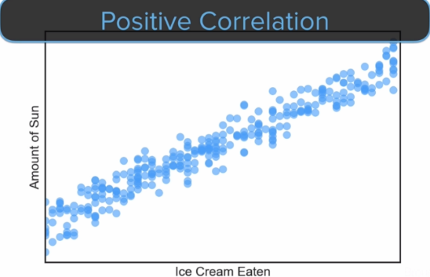
Positive correlation
- if one of these values is high then the other value tends to be high too.
- If one of them is low then the other one tends to be low as well.

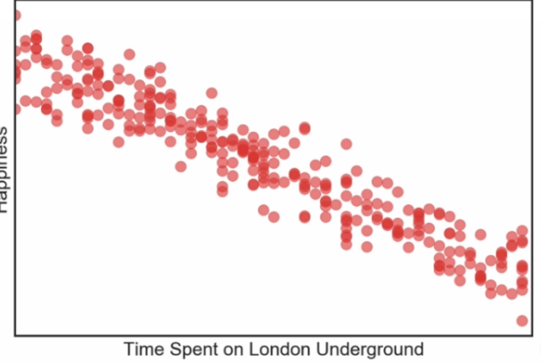
Negative coorelation
- resulting graph will be downward sloping.
- If one of these variables has a high value than the other one tends to have a low value.
- The variables tend to move in opposite directions.

correlations have a like a strength to them magnitude correlations can be strong or they can
be weak if the value of x is high then the value of Y can be low but it doesn't have to be.
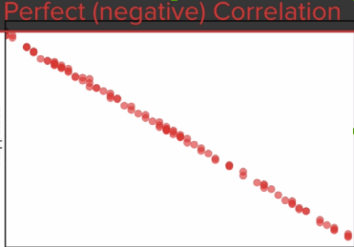

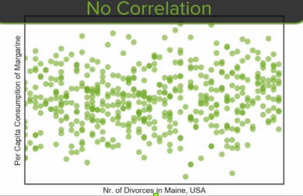
If there is no correlation then we get a plot that looks somewhat like this.

Math representation uses Greek letter rho
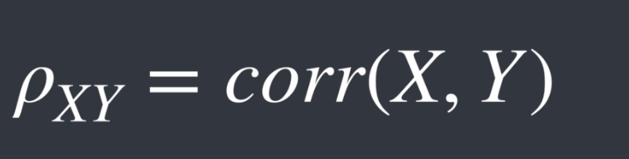
correlation is actually calculated as a single number between minus one and positive one minus one is a perfect negative correlation and positive one is a perfect positive correlation and a correlation of zero means that there's no correlation at all the variables are uncorrelated.

correlation is a statistical measure of a linear relationship between two variables. Why should we look at the correlations of our features during the data exploration stage.
The answer is is that we primarily care about two things.
- the strength of the correlation. strength is important because it tells us how much correlation there actually is.
- direction since it tells us if the moves are in the same or in the opposite direction.

61. Calculating Correlations and the Problem posed by Multicollinearity
Multicollinearity - when two or more predictors in a regression are highly related to one another. So for this example it was body fat and weight which are very highly related. Each of these do not provide unique and independent information to the regression. means that the estimates start becoming unreliable and your findings stop making sense. Put simply the models starts getting confused. But the thing to remember is that high correlations don't automatically mean that you have this problem
high correlations can be an early warning sign that there is some sort of problem high correlations between your features

62. Visualising Correlations with a Heatmap
the correlation matrix has its pros and cons. Just like every other tool regarding the pros we've learned something about our data. We've learned that the amount of tax and the amount of industry are correlated and we've added something to our to do list for later namely that we should investigate if we really need the DHS feature in our model or not.
Another pro is that we've learned that certain features with high correlations are possible sources of multicore linearity. Now I emphasize the word possible. High correlations don't necessarily imply this problem of multicore linearity but we will revisit this issue during the regression analysis stage by running a formal test for this problem.
correlation does not imply causation. Just because two things move together doesn't mean that one thing causes another. In other words everybody who drank water in 1850 is now dead. But this doesn't mean that drinking water will kill you.
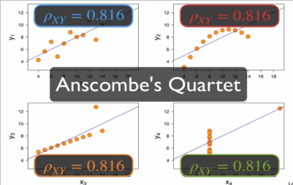
Another limitation of correlations is that they only check for linear relationships and it turns out just because there's a low Pearson correlation coefficient does not mean that there is no relatioship between two variables. Graph below has same correlation but is different. it's important to look at these correlations and these descriptive statistics in conjunction with some charts

63. Techniques to Style Scatter Plots
Lots od stuff on scatter plots
IMPORTANT for seaborn, sns.set() resets Seaborn style
By default it uses the last style used

65. Working with Seaborn Pairplots & Jupyter Microbenchmarking Techniques
using some micro-benchmarking code (%%time) for Jupyter. However, this may cause problems and the issue is being worked on by the team behind Jupyter. The solution is to simply omit this line of code.

Not so useful due to outliers
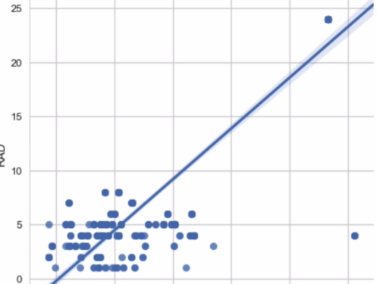

sns.lmplot is an simple way to plot scatters
sns.pairplot(data) ploys all the dif columns against each other
But the power of our analysis isn't gonna come from looking at our aggressions against that target in isolation. The power comes from combining all our explanatory variables and running a multi variable regression.

The point I'm trying to make is that we're going to combine all the explanatory power in our features to estimate our property prices in Boston and our model of choice is called multi variable regression

66. Understanding Multivariable Regression - time to train our model.
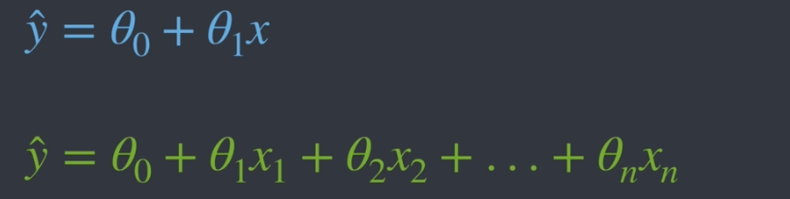
Top is theta0 and theta1
Multivariable is the bottom
For Boston homes it would be this
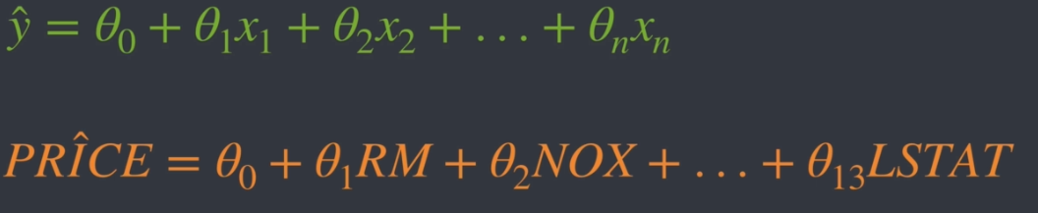
Python will give us the theta values Θ0, Θ1RM + Θ2NOX + ….
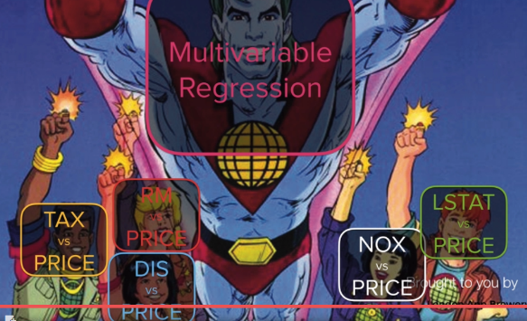

67. How to Shuffle and Split Training & Testing Data
One of the habits that I want us to get into when training our algorithms is to split up our dataset into two parts. We're going to shuffle all our data and divide our data set into a training data set and a testing dataset set because we want our algorithm to learn those theta parameters based only on the training data set. And this means that we can use the other part of our dataset that hasn't been used for testing because with the testing data set we can see how our algorithm performs out of sample how it performs on a data set that it hasn't seen yet.
68. Running a Multivariable Regression
make some predictions on what we expect to see making these predictions is a very important step because it provides a sense check on what the computer is kind of spit out to us we should never blindly trust the numbers that we get back that's out silly city mistakes are made.
The coef code shows the numbers that fill out the equation:
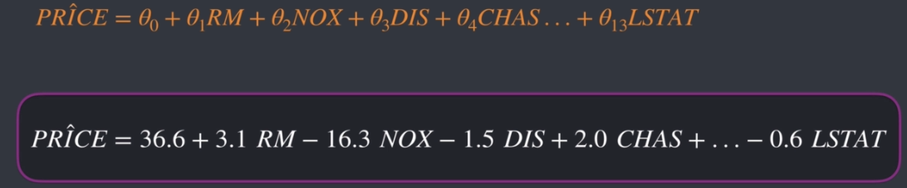

69. How to Calculate the Model Fit with R-Squared - For our training data we get an R squared of zero point seven five and for our test data set we get an r squared of zero point six seven. Now these values are actually both quite high. But we've been able to explain approximately 75 percent of the variance in our house prices with just 13 features 13 things and we can explain a lot of what's going on in the real world how a question that

70. Introduction to Model Evaluation
We've trained our algorithm and now we're getting to the point where we can evaluate our results refine our model look for problems look for improvements and deploy our model.
So what kind of things do we do at this stage. We're going to start by asking a series of questions about our model and about our results, look at various stats to make a diagnosis.
R-squared
p-values
VIF - variance inflation factor
BIC - Bayesian information

71. Improving the Model by Transforming the Data
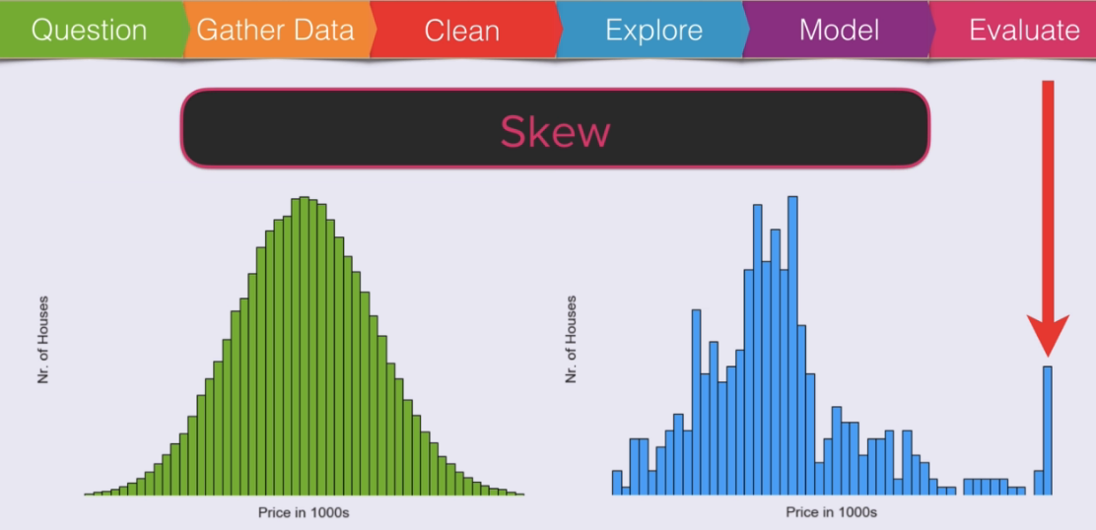
a bunch of properties in the right tail of this distribution compared to a normal distribution. Having more data points in one of the tails is called a skew. The distribution of house prices is skewed
to the right.
We can actually put a number to the skew, we can measure the skew of our target values.
Well a normal distribution is completely symmetrical, the right tail and the left tail are exactly the same size. So the skew of a normal distribution is equal to zero
A transformation would be applying some sort of calculation to all the prices in the dataset.
I want to do something that will affect our large house prices in the tail more than the rest. And to accomplish this I will use a log transformation on our property prices.

with the log transformation achieves is you get a small change of around five in the small price of seven but you get a large change of around forty six for the large values in the dataset.

Doing this because we want a linear model and the tail is messing that up

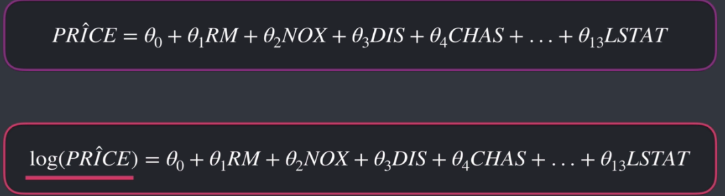
old equation vs new, improved equation

72. How to Interpret Coefficients using p-Values and Statistical Significance – Look at thetas in more detail
if we're looking to predict house prices we're not just going to be interested in the sign and the size of our coefficients.
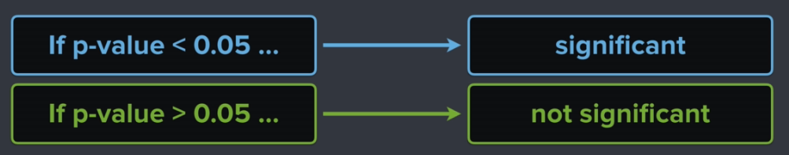

most academic research papers that you come across analyze the significance of their findings using p values
this metric of p values. If the p value is less than a certain threshold that threshold being zero point zero five then the result is deemed statistically significant and when the p value is greater than zero point zero five then this result is considered to be not statistically significant.
73. Understanding VIF & Testing for Multicollinearity
Now put simply multicollinearity is when two or more predictor variables in a regression are highlyrelated to one another. In that case they do not provide unique or independent information to the model
The consequences of multicollinearity are as follows.
- There is a loss of reliability in the estimates of the effects for the individual features. a high variability in the coefficient estimates for small changes in the model, for example adding or removing a feature can have dramatic effects.
- The estimates of our theta values in our model become unstable and can even switch signs from positive to negative and vice versa.
- findings are strange or misleading or don't make sense.
formal check how you can look at a metric to tell you whether you have this problem or not. The formal check that we will do is by looking at a statistic called the variance inflation factor or VIF
74. Model Simiplication & Baysian Information Criterion
how can we simplify our model? The industry factor This has a p value of around 0.44 meaning it is not statistically significant. The threshold for p values if you recall was zero point zero five. So now the question is should we try removing the industry factor from the model?
it is really really tempting to remove insignificant predictors. But even dropping statistically insignificant features is not something people do lightly because even a feature with a low p value can add value to the model as a whole by providing some kind of information that the other features do not provide.
Actually deciding on what to keep and what to throw away from a machine learning model is a bit of an art and it gets into this whole topic of feature selection which is a very very big topic indeed
The goal of this lesson is to introduce you to this topic a feature selection in the context of a regression
looking at a metric that you can use to help you make your decisions. That metric is called Bayesian information criterion or BIC, it is a way you can measure complexity. It's basically a number that allows you to compare two different models. So what you end up doing is you run a regression with model number one and then you run a regression with Model Number two now model number one might have a big value of 148 and model number 2 might have a big value of 154 for the actual number doesn't by itself mean very much. What matters is which one is lower because all else equal a lower big number is better so this measure can help you pick between two or more models.

75. How to Analyse and Plot Regression Residuals
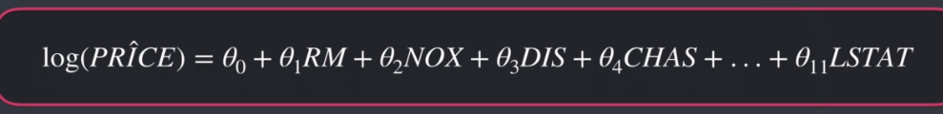
Model has dropped 2 features, AGE and INDUST so down to this.
Same but with Y-hat
What we're looking at here is the equation to predict a property price given some information about that property in our notation Y-hat is that properties predicted to value the predicted value is calculated from all the theta parameters and all the values of the individual features.
Y = Target Value
Y-hat = predicted value
r = residual value, difference b/w the target and predicted value
so….
R = Y – Y-hat
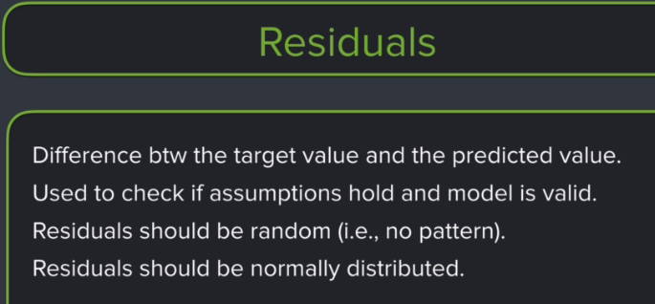
For starters we like to think that our model can more or less explain what's actually going on in the real world. I mean after all we have a high R squared and our eleven features together explain about 75 percent of the variance in property prices. So this means that what's left unexplained. The residuals the difference between our predictions and the actual values should be random.The part that we're missing from our model shouldn't have a clear pattern.
If there's a pattern in the residuals then there's also some predictive information in the residuals. And if there's predictive information in the residuals then that predictive information is missing from our model.
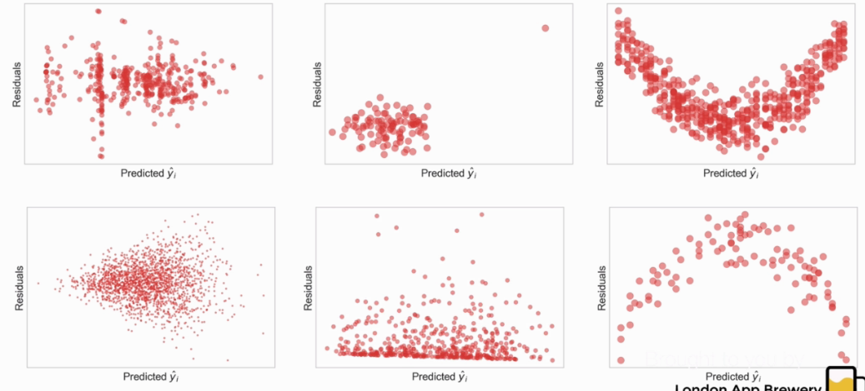
any non-random pattern in the residualsndicates that there is an issue
These are all not what we want to see

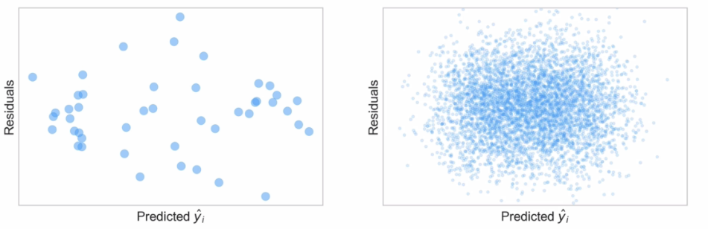
data points but they're kind of scattered about in a pretty random fashion. This is what you would kind of expect to see. You'll want to see kind of like a cloud shape where most of the residuals are centered around zero and the cloud is more or less symmetric.
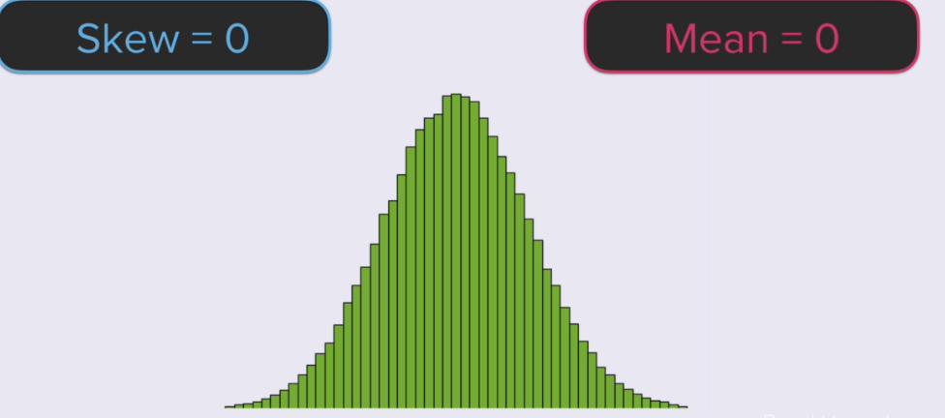
This is what we want

76. Residual Analysis (Part 1): Predicted vs Actual Values
mainly graphng but shows how to use Latex notation in a graph
plt.title(f'Actual vs Predicted log prices: $y _i$ vs $\hat y_i$ (Corr {corr})',
anything b/w $ and $ is treated as Laytex

77. Residual Analysis (Part 2): Graphing and Comparing Regression Residuals
Continuation of the above

78. Making Predictions (Part 1): MSE & R-Squared
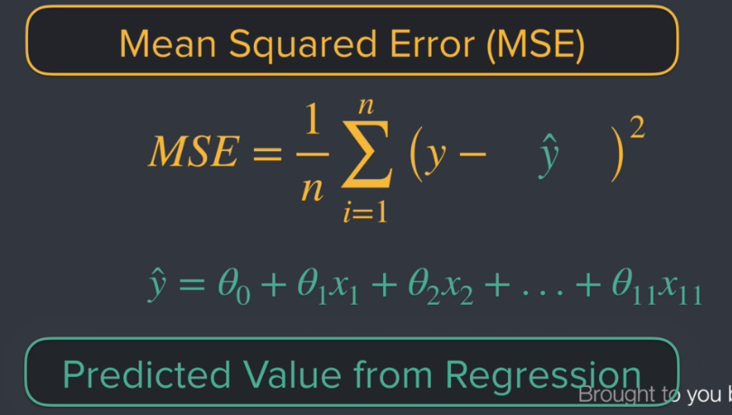
We've talked extensively about cost functions and the role of the means squared error cost function in machine learning.the mean square error is just the residuals squared and then summed up and then divided by the number of observations
the mean square error weighs the large differences more heavily and thus it punishes large residuals the effect of this is is that it makes the means quite a very sensitive to outliers.
We've also covered how an algorithm that finds the best fit line minimizes this particular equation. And we've also talked a lot about metrics like r squared and we touched on how to compare different models.
79. Making Predictions (Part 2): Standard Deviation, RMSE, and Prediction Intervals
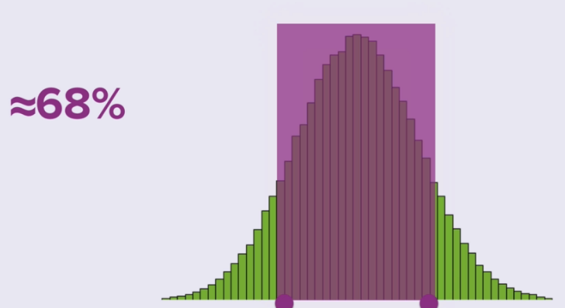
The range will actually depend on the shape of the distribution that you're working with. If we know the distribution we can estimate the range very accurately. Our go to distribution is usually the normal distribution because the very very nice thing about the normal distribution is that we know its shape. We know that for a normal distribution 68 percent of the observations are between these two points.
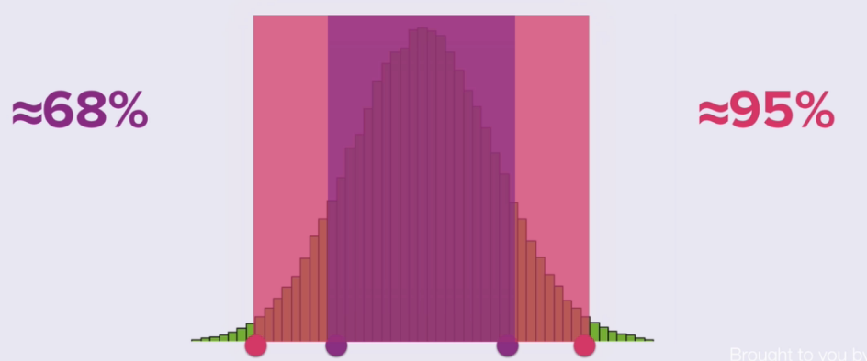
Ninety five percent of the observations fall within this pink range that I've highlighted right here.
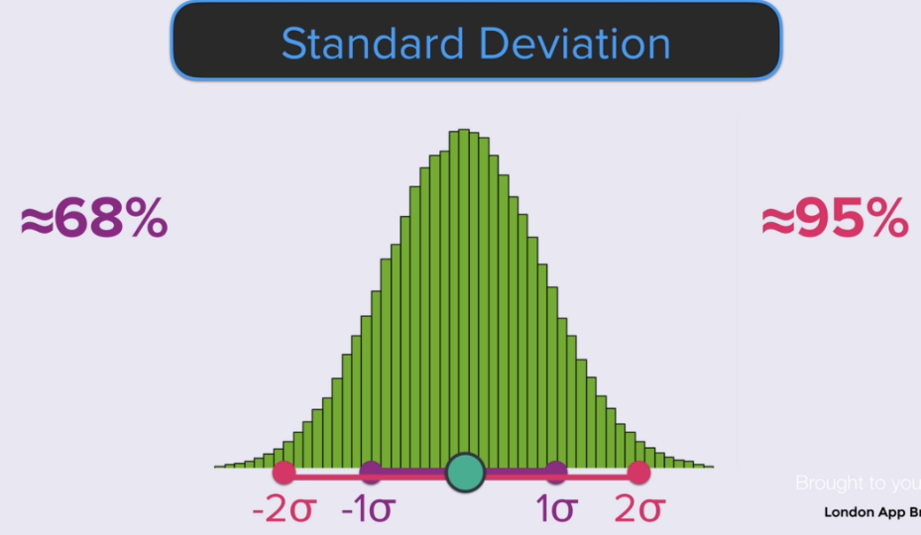
The point quantify the points around the mean. The mean is right here in the middle of the distribution and the distance from the mean to that bright purple point is called one standard deviation for a normal distribution. You'll usually see the Greek letter sigma used to denote the standard deviation.The left purple point is at minus one standard deviation and for normal distribution as we said before around 68 percent of all the observations lie between minus and plus one standard deviation. The right pink point is that two standard deviations and the left pink point is at minus two standard deviations. Approximately ninety five percent of observations lie between plus two and minus two standard deviation is for a normal distribution.
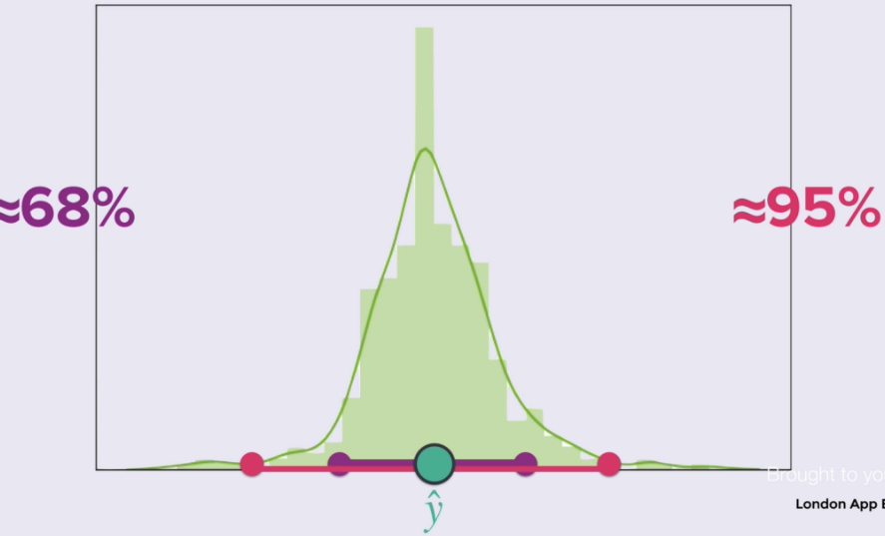
If this green point here right in the middle is our estimate for the property price from our model are y hat What is the distribution that we're gonna be looking at here? Any guess once the distribution that tells us something about the variance in our price estimates ? It's actually the distribution of the residuals from our regression. This is the reason why we care so much about whether the distribution is a normal distribution or not.
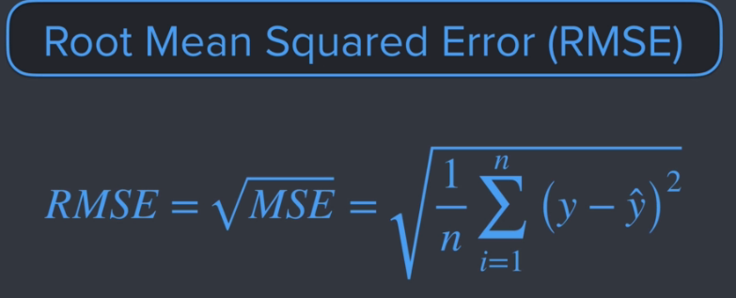
How do we get our range? We can make one small modification to the mean square error and get something very very handy for calculating the range and making predictions. By taking the square root of this thing by taking the square root of the mean square error ee get another metric and this one is called the root mean square error or our MSE and it's this metric the RNC that has a really really nice interpretation because the root mean square error represents one standard deviation of the differences between our actual and our predicted values.
The root mean square error represents one standard deviation of the differences between our actual and our predicted values. The root mean square error is one standard deviation in the distribution of our residuals.

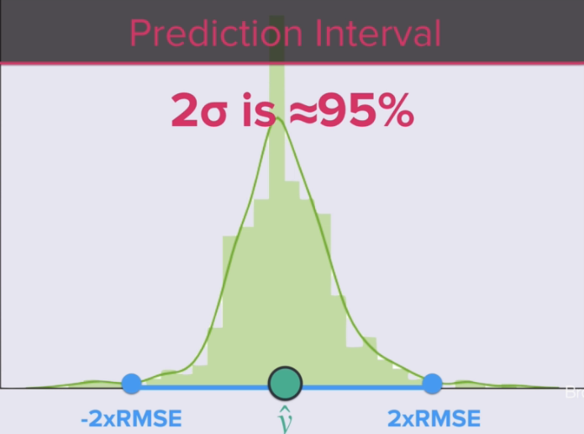
The first thing we choose is how wide we want that interval to be say we want to cover around 95 percent of the observations. Then we would use two standard deviations either side. And this means taking our prediction and adding two times the brute mean square error to it for the upper bound and subtracting two times the root mean square error for our lower bound on our prediction. And that's how we get the range in our Jupiter notebook.
the root mean square is a very good measure of how accurately the model predicts the target because we can determine a range the width of this range is a very important criterion. If the main purpose of the model is prediction and this is a big contrast to something like r squared because r squared says absolutely nothing about the predictive power of the model or the prediction error.
80. Build a Valuation Tool (Part 1): Working with Pandas Series & Numpy ndarrays
see the notebook

