Exploratory Data Analysis of Student Lifestyle Factors and Academic Performance
Mini Project — Exploratory Data Analysis (EDA)
Submitted by: [Your Name] | Roll No.: [Your ID] | Course: [Course Name] | Date: October 2026

1. Introduction
Exploratory Data Analysis (EDA) is the process of examining, cleaning, summarising and visualising data to discover patterns, relationships and unusual observations. This project applies EDA to a dataset of 2,000 students containing daily lifestyle hours, a stress category and Grade Point Average (GPA).

2. Objective
The objective is to understand the structure and quality of the student dataset and to investigate how study habits, sleep, social activity, physical activity, extracurricular activity and stress are associated with academic performance.

3. Research Questions
- How are the main lifestyle variables and GPA distributed?
- Is study time associated with GPA?
- Is sleep associated with GPA?
- Which lifestyle variable has the strongest relationship with GPA?
- Do different stress levels show differences in GPA?
- Do different study-time groups show differences in average GPA?

4. Dataset Description
The dataset contains 2,000 students and 8 variables. It had 0 duplicate rows and 0 missing values. One additional variable, Study_Group, was derived during the analysis from Study_Hours_Per_Day.
Variable | Type | Description
Student_ID | Integer | Unique student identifier
Study_Hours_Per_Day | Numeric | Daily study time (hours)
Extracurricular_Hours_Per_Day | Numeric | Daily extracurricular activity (hours)
Sleep_Hours_Per_Day | Numeric | Daily sleep (hours)
Social_Hours_Per_Day | Numeric | Daily social activity (hours)
Physical_Activity_Hours_Per_Day | Numeric | Daily physical activity (hours)
GPA | Numeric | Academic performance (grade point average)
Stress_Level | Categorical | Stress category: Low, Moderate, High
Study_Group (derived) | Categorical | Study-time band: Low (<6.5h), Moderate (6.5–8.5h), High (>8.5h)

Data note: for every student, the five hour variables (study, extracurricular, sleep, social, physical activity) add up to exactly 24 hours. The variables are therefore not independent: more time in one activity necessarily means less in others. This affects how the negative correlations in Section 7 should be read.

5. Data Cleaning
Column names were checked and standardised, numeric fields were confirmed as numeric types, stress categories were normalised (trimmed and capitalised) and ordered Low < Moderate < High, and the data were checked for duplicate rows and missing values. None were found, so no records were removed and all 2,000 students were retained. One potential outlier was noted: physical activity reaches 13 hours per day (25 students exceed 10 hours). These values were kept because they are consistent with the 24-hour structure of the data, but they should be treated with caution.

6. Descriptive Statistics
The mean GPA is 3.116 and the median GPA is 3.110, indicating a roughly symmetric distribution. GPA ranges from 2.240 to 4.000. Study hours and sleep hours both range from 5 to 10 hours per day.
Variable | Mean | Median | Std. Dev. | Min | Max
Study Hours Per Day | 7.476 | 7.400 | 1.424 | 5.0 | 10.0
Extracurricular Hours Per Day | 1.990 | 2.000 | 1.156 | 0.0 | 4.0
Sleep Hours Per Day | 7.501 | 7.500 | 1.461 | 5.0 | 10.0
Social Hours Per Day | 2.705 | 2.600 | 1.689 | 0.0 | 6.0
Physical Activity Hours Per Day | 4.328 | 4.100 | 2.514 | 0.0 | 13.0
GPA | 3.116 | 3.110 | 0.299 | 2.24 | 4.00

7. Correlation Findings
Pearson correlations between each lifestyle variable and GPA are shown below.
Variable | r with GPA | p-value | Interpretation
Study Hours Per Day | +0.734 | < 0.001 | Strong positive
Physical Activity Hours Per Day | −0.341 | < 0.001 | Moderate negative
Social Hours Per Day | −0.086 | < 0.001 | Very weak negative
Extracurricular Hours Per Day | −0.032 | 0.150 | No meaningful relationship
Sleep Hours Per Day | −0.004 | 0.848 | No relationship

The strongest relationship with GPA is Study Hours Per Day (r = 0.734). Sleep (r = −0.004) and extracurricular hours (r = −0.032) show essentially no linear relationship with GPA and are not statistically significant. The negative correlation for physical activity should be interpreted carefully: because daily hours sum to 24, students who study more necessarily have less time for other activities, so part of this negative association is a time-trade-off effect. All findings are associations and should not be interpreted as proof of causation.

8. Stress-Level Findings
Stress level | Students | Mean GPA | Median GPA | Std. Dev.
Low | 297 | 2.817 | 2.820 | 0.215
Moderate | 674 | 3.025 | 3.020 | 0.221
High | 1029 | 3.262 | 3.270 | 0.275

Mean GPA rises with stress level, and the differences are statistically significant (one-way ANOVA, F = 434.9, p < 0.001). This does not mean stress improves grades. Average study time also rises with stress (5.5 hours for Low, 7.0 for Moderate, 8.4 for High), so higher-stress students are also the heaviest studiers. Stress and GPA are both linked to study effort, which is a likely confounder.

9. Study-Time Group Findings
Students were grouped by daily study time. The originally planned bands (<3h, 3–5h, >5h) could not be used because the minimum study time in the data is 5 hours, which left the Low group empty and 99% of students in a single group. Bands of <6.5h, 6.5–8.5h and >8.5h were used instead, giving reasonably balanced groups.
Study-time group | Students | Mean GPA | Median GPA | Std. Dev.
Low (<6.5h) | 622 | 2.856 | 2.855 | 0.212
Moderate (6.5–8.5h) | 810 | 3.120 | 3.120 | 0.220
High (>8.5h) | 568 | 3.394 | 3.400 | 0.211

Average GPA increases steadily with study time, from 2.856 in the Low group to 3.394 in the High group (one-way ANOVA, F = 930.0, p < 0.001), consistent with the strong correlation found in Section 7.

10. Visualisations

10.1 GPA Distribution
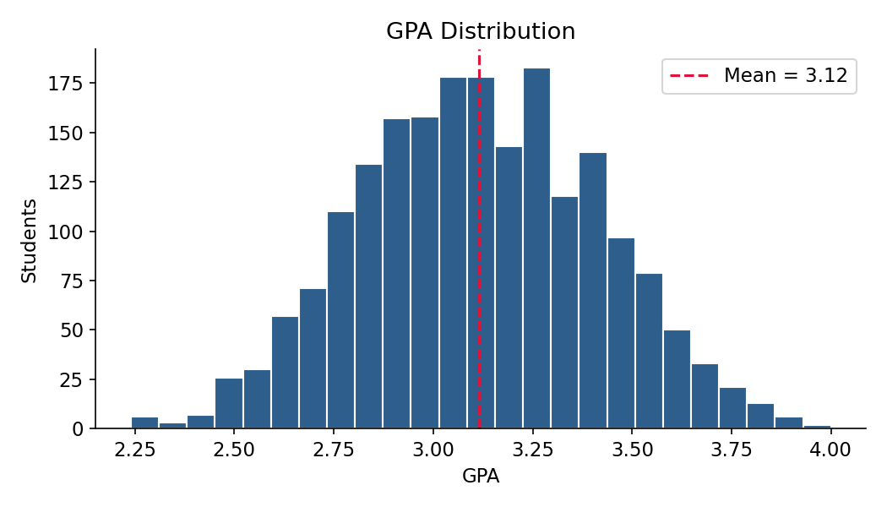
Figure 1: GPA distribution with mean marked

10.2 Study Hours vs GPA
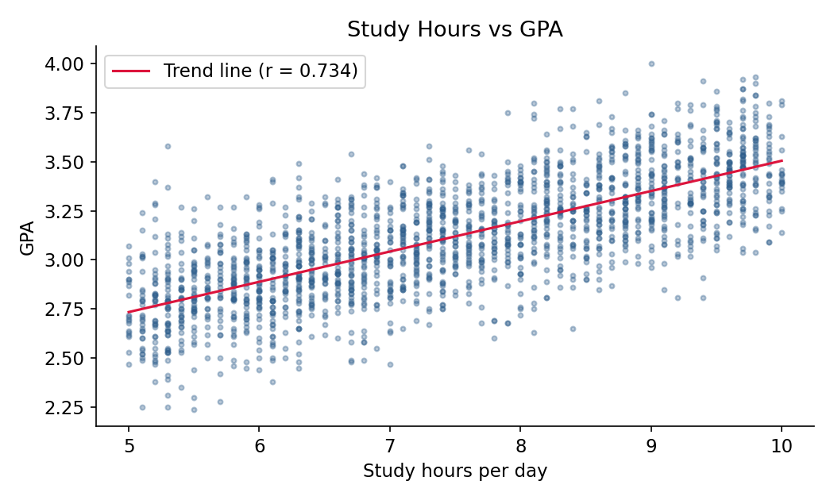
Figure 2: Study hours versus GPA with trend line

10.3 GPA by Stress Level
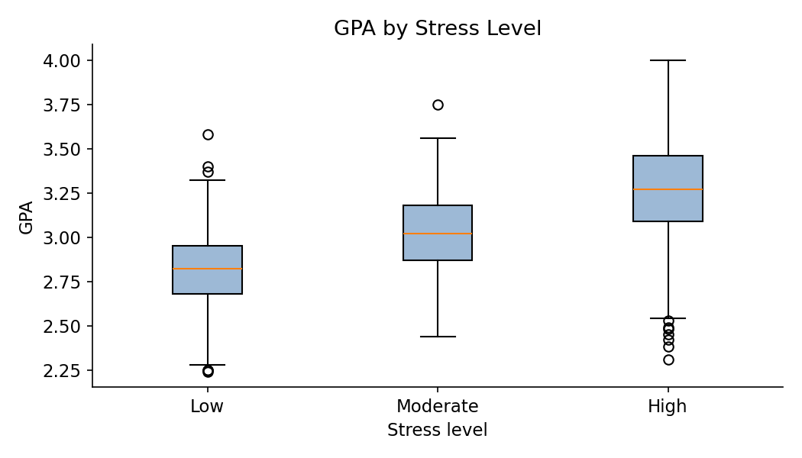
Figure 3: GPA by stress level

10.4 Correlation Matrix
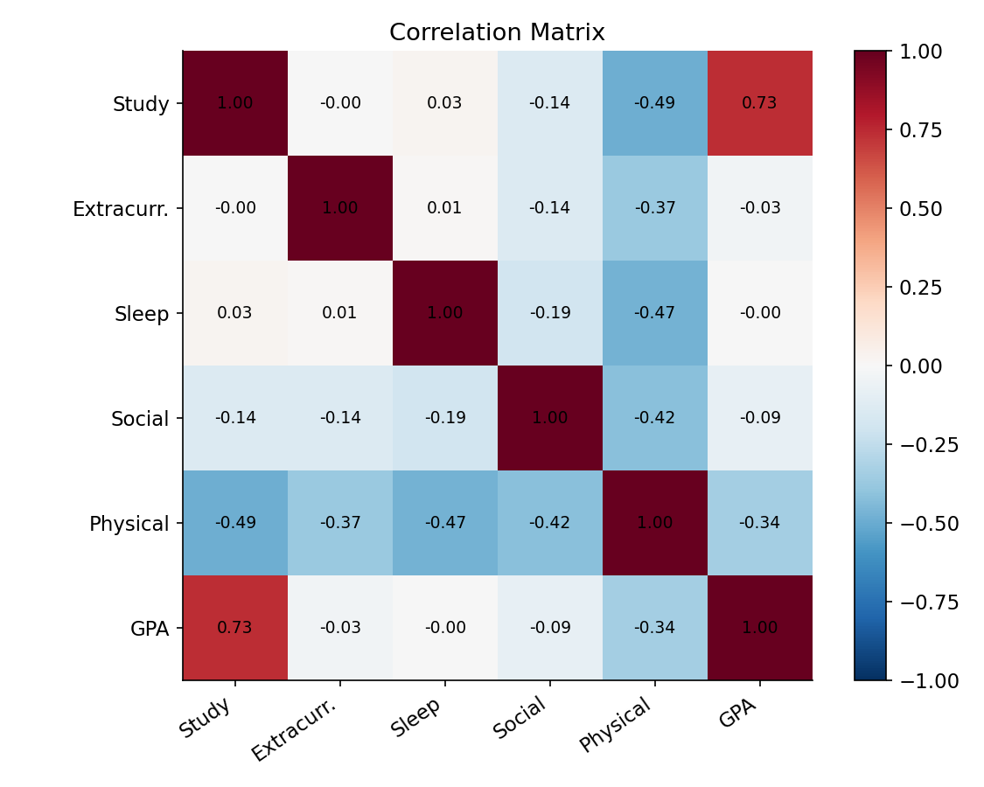
Figure 4: Correlation matrix of numeric variables

10.5 Average GPA by Study-Time Group
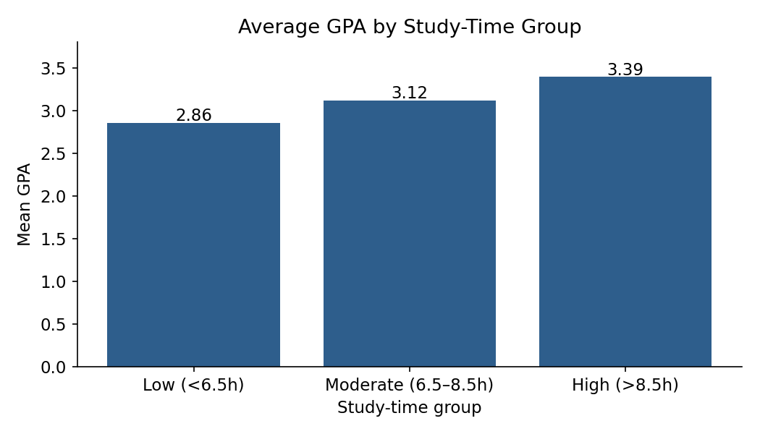
Figure 5: Mean GPA by study-time group

11. Conclusion
The dataset is clean (no missing values or duplicates). Study time is by far the strongest correlate of GPA (r = 0.734), and GPA rises consistently across study-time groups. Physical activity shows a moderate negative association, partly reflecting the fixed 24-hour budget, while sleep, extracurricular and social hours show little or no relationship with GPA. Higher-stress students have higher average GPA, but this is likely explained by their greater study time rather than any benefit of stress. Because the data are observational and the hour variables are mutually constrained, the results describe associations, not causal effects.

12. Recommendations
- Students should maintain consistent study routines while balancing sleep, physical activity and social commitments.
- Academic support programmes can use lifestyle information to identify students who may benefit from additional guidance.
- Future studies should collect longitudinal data and include factors such as prior GPA, course workload and socioeconomic variables.
- Future research should use validated survey instruments, measure stress independently of workload, and include broader student populations.

13. Tools Used
Python, Pandas, NumPy, SciPy, Matplotlib, and Google Colab / Jupyter Notebook.

