**COT 5405: Programming Assignment 2**

**Description**

This program simulates the addition and removal of nodes from a random graph process. A node is added to the graph with a probability of *p*. The node on the other end of the edge of the new node is selected based on a linear preferential attachment rule which is:



Where:

* dt(u) is the degree of a given node in graph Gt
* mt is the total number of edges in graph Gt

A node is removed from a graph with a probability of *q* (where *q = 1-p*). The node selected to delete is chosen based on a probability distribution that favors small degree nodes. When a node is deleted, all edges associated with that node will be removed as well. The probability is determined based on the following formula:



Where:

* dt(u) is the degree of a given node in graph Gt
* nt is the total number of nodes in graph Gt
* mt is the total number of edges in graph Gt

In this script, the behavior of Gt is analyzed with p = 0.6. 0.75, 0.8 and 0.9. The output will display the following graphs (using matplotlib):

* Number of Nodes vs. Time
* Number of Edges vs. Time
* Degree Distribution of Nodes

**Requirements**

This script is written for Python 3 and requires the following modules in order to run properly:

* matplotlib
* numpy
* networkx
* tkinter

To install in Windows:

pip3 install --upgrade matplotlib numpy networkx

To install in macOS:

sudo -H pip3 install --upgrade matplotlib numpy networkx

To install in Ubuntu (debian linux):

sudo -H pip3 install --upgrade matplotlib numpy networkx

sudo apt-get install python3-tk

**Usage**

To run the simulation type the following command into the command prompt: In Windows:

py -3 generate_random_graph_final.py

In macOS and Ubuntu (debian linux):

python3 generate_random_graph_final.py

Output will look like the following:

**Figure 1:**

[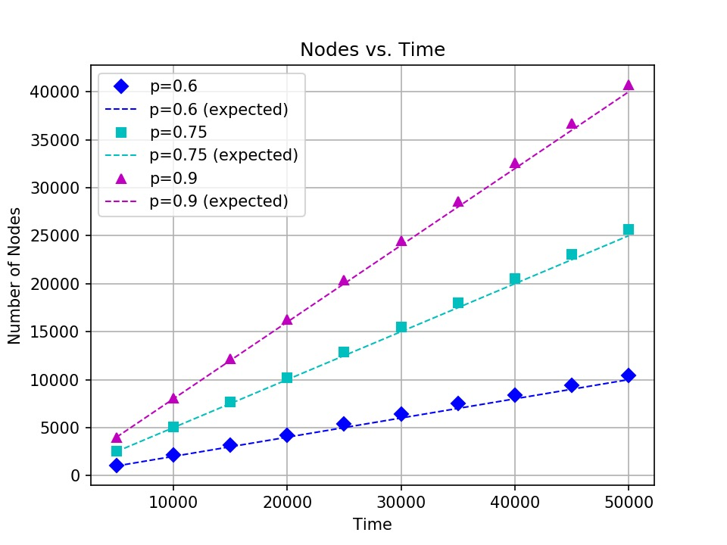](https://raw.githubusercontent.com/monicabernard/COT-5405/master/project2/figure1_nodes_v_time_mbernard.jpeg)

[continued on text page]

**Figure 2:**

[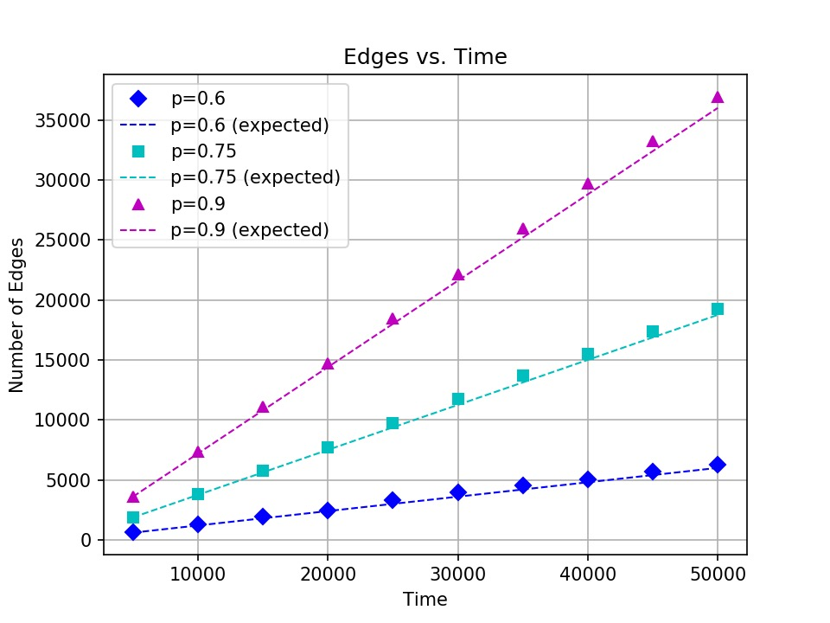](https://github.com/monicabernard/COT-5405/blob/master/project2/figure2_edges_v_time_mbernard.jpeg?raw=true)

**Figure 3:**

[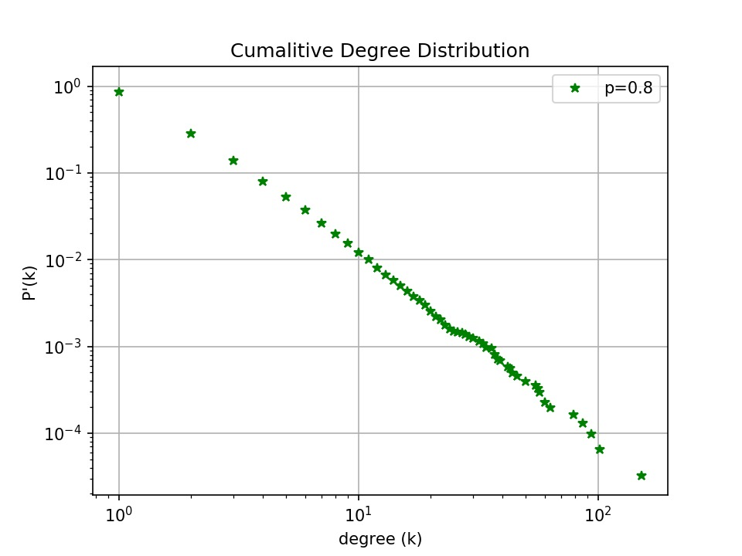](https://github.com/monicabernard/COT-5405/blob/master/project2/figure3_degrees_dist_mbernard.jpeg?raw=true)