**Introduction**

We are looking at opening a restaurant but where could we open it? Hence, we explore the different restaurants distribution in two different cities, New York City and Toronto.

**Business Problem**

We will need locality information in New York City and Toronto in order to explore opening of a restaurant. We have to ensure good human traffic and there is not many competitors around the area. Hence, we need to analyse different scenarios to increase the success of the restaurants, and to avoid similar restaurants in the same area. The area we should look at are:

* different district school information
* restaurant information

For this project, we are mainly focused on the areas in these two cities to set up a restaurant and ensure maximum profitability for new business.

**Data and Required Libraries**

To choose the restaurant, we will need to access following data:

* Neighbourhoods in New York And Toronto
* From the table above, we will use the data to build our analysis. We will use FourSquare APIs for the coordinates data(latitude, longitude) in New York City and Toronto.

From FourSquare, we will need following venues data:

* the school information
* different restaurant information

These data will be used to analysed to determine which location is the best suited to set up the restaurant.

* pandas and numpy for handling data.
* request module for using FourSquare API.
* geopy to get co-ordinates of City of New York.
* folium to visualize the results on a map

**Approach**

* Collect the new york city data from <https://cocl.us/new_york_dataset>
* Using FourSquare API we will find all venues for each neighborhood.
* Filter out all venues that are Indian Resturants.
* Find rating , tips and like count for each Indian Resturants using FourSquare API.
* Using rating for each resturant , we will sort that data.
* Visualize the Ranking of neighborhoods using folium library(python)

**Queries that can be answered using above dataset**

* What is best location in New York City for Indian Cuisine ?
* Which areas have potential Indian Resturant Market ?
* Which all areas lack Indian Resturants ?
* Which is the best place to stay if I prefer Indian Cuisine ?

**Observations**

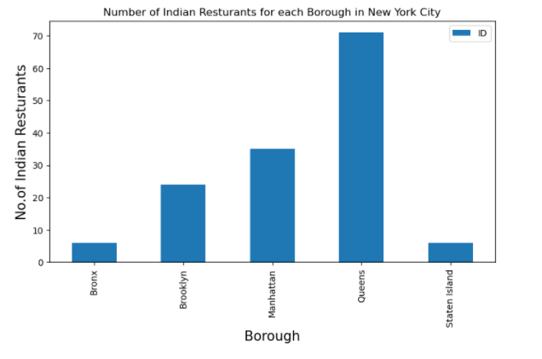

From the above table generated, Queens has the most number of Restaurants

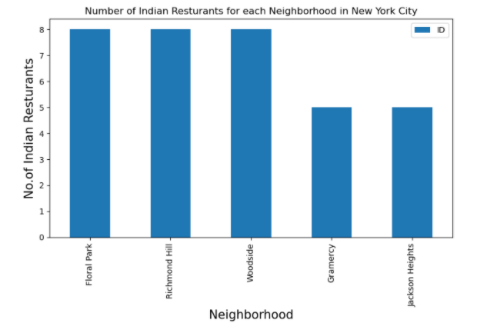

Floral Park, Richmond Hill & Woodside have the most number of Indian Restaurants

**Conclusion**

* Best neighbourhoods for Indian cuisine: Astoria(Queens), Blissville (Queens), Civic Center (Manhattan)
* Potential market for Indian restaurant: Manhatten
* Lowest rating for Indian Restaurants: Staten Island
* Best place to stay for Indian Cuisine: Manhatten
* Limitation: Information limited to accuracy of data provided by FourSquare