Philip Garcia

pgar@unm.edu

CS251

03/07/2021

**Problem Description:**

Given two integer matricesA and B, you are requested to compose a program to perform matrix addition (A + B). Both matrices have N rows and M columns; N > 1, M > 1; You need to divide both (A and B) into four equal (or close to equal) size of submatrices(A0,0, A0,1, A1,0, A1,1 and B0,0, B0,1, B1.0, B1.1) and each submatrix has dimension close to (N/2) x (M/2). You need to create four Java threads. Eachthreadperforms a subset of addition on one pair of the submatrices. For example, thread0 performs addition on A0,0 and B0,0, thread 1 performs addition on A0,1 and B0,1, . . . etc. The final result should store in the matrix C of size N by M. (Taken from problem statement document)

**Additional Program Notes:**

This program minimizes processor cycles and memory usage by enabling multi-threading. Multi-threading breaks a single complex task into smaller chunks, also known as ‘threads’, and allows multiple threads to be run concurrently across multiple processor cores. If processor resources are limited, the processor will queue threads, then allow them to be run as resources become available. In the case of blocked threads, for example waiting for user input, the processor can begin background processing of tasks while waiting for the blocked process to complete (not utilized in this program). It’s important to note, multi-threaded processes share memory. Therefore, memory utilization is also minimized.

**UML Diagram:**

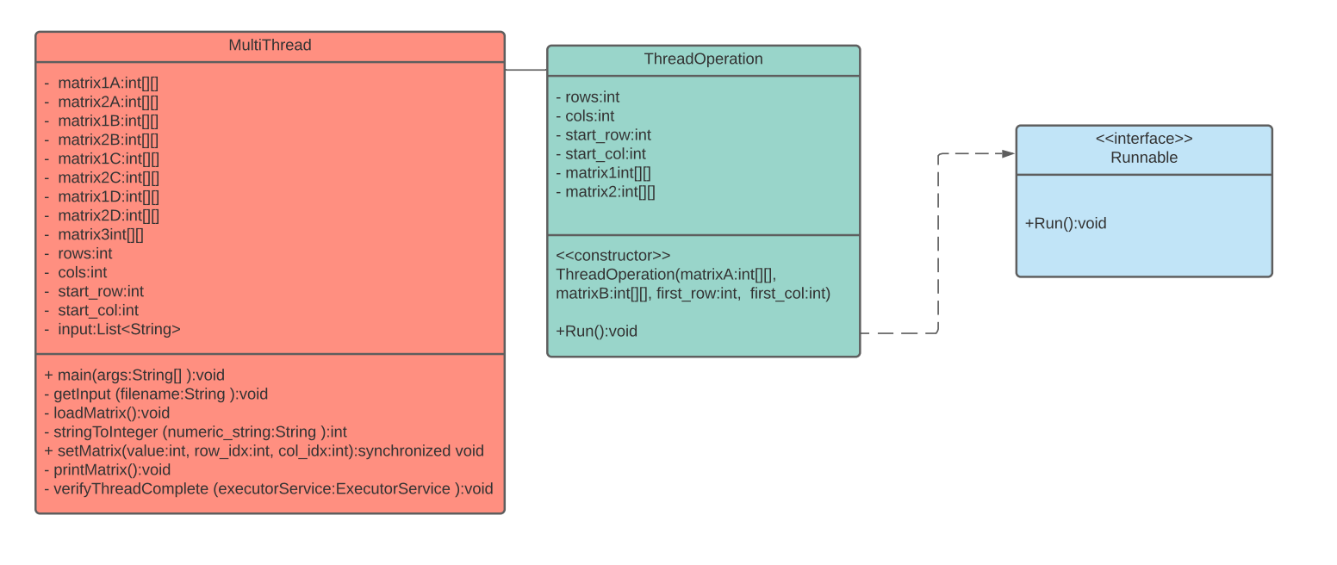

**Control Flow (Flow Chart):**

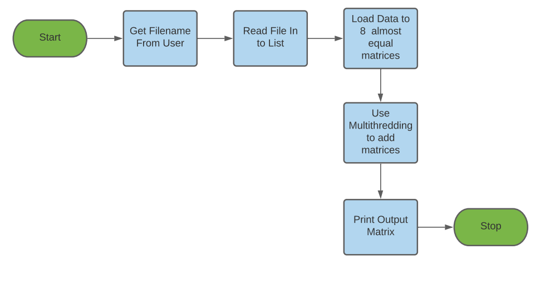

**User Execution:**

Opens a text file, using the file name from the command line (file format as described below), and input the two matrices A and B.

**File Format:**

1) the first line has two numbers, N and M (N rows, M columns), the size of both matricesA and B

2) the next Nlines each has M elements for one of the rows of A

3) the next N lines each has M elements for one of the rows of B

Example:

4 6

2 3 1 2 5 1

3 1 2 2 2 4

1 2 3 2 7 2

3 6 1 5 1 3

6 5 4 1 4 3

3 3 2 2 1 1

7 5 4 3 2 5

2 1 8 4 8 4(Taken from problem statement document)