Philip Garcia

Philip.a.garcia@gmail.com

CS2251 Spring 2021

02/09/2021

Problem Description

Create a class TicTacToe that will enable you to write a program to play Tic-Tac-Toe. The class contains a **private** 3-by-3 two-dimensional array (nine cells). Use an enum type to represent the status of the game after a move, WIN, DRAW, CONTINUE. The value in each cell of the array should be named X, O, and EMPTY (for a position that does not contain an X or an O). The constructor should initialize the board elements to EMPTY. Allow two human players. Whenever the first player moves, place an X in the specific square, and place an O wherever the second player moves. Each move must be to an empty square. After each move, determine whether the game has been won, is a draw, or the players should continue.

Major Program Components (Classes, Objects, and Methods) (From Program01 Instructions doc)

UML Diagram

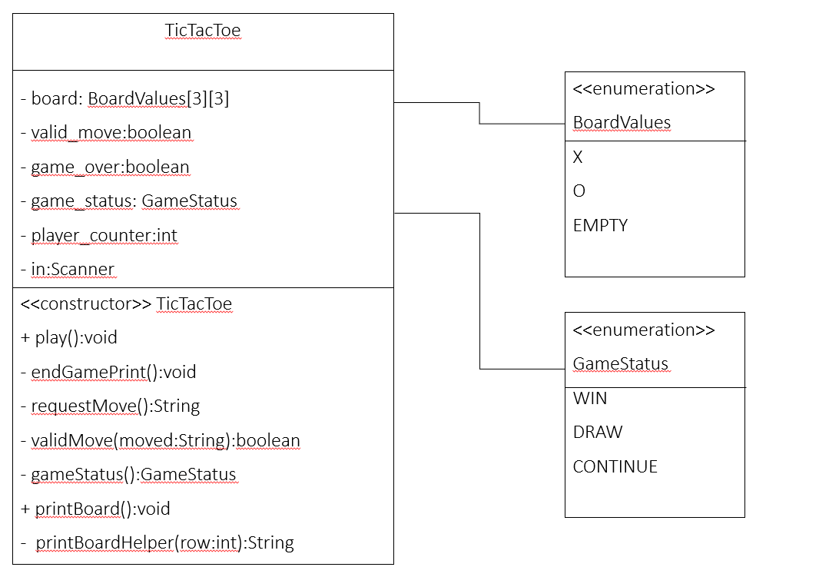

Control Flow (Flow Chart)

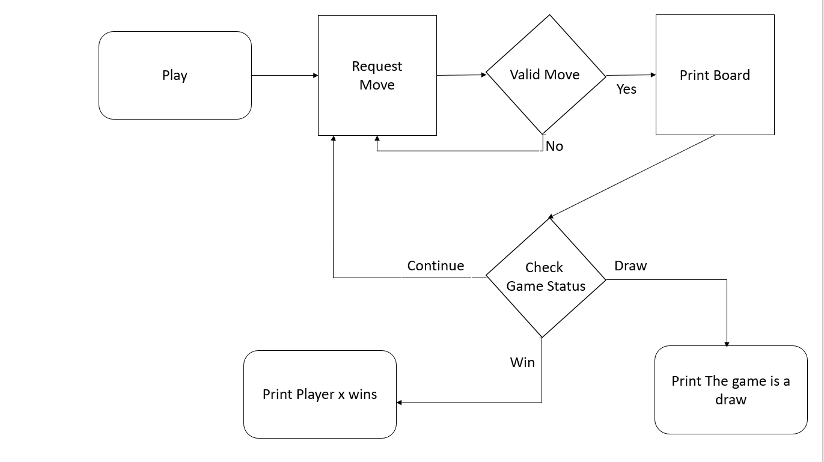

User Execution

User begins execution by invoking the .play method.

Note: Program has been designed to work with this test harness:

Create another class TicTacToeTest containing the main() method, instantiating the object TicTacToe, and invoking the methods of TicTacToe (printBoard(), play()) to play the game.