Philip Garcia

pgar@unm.edu

CS251

03/07/2021

**Problem Description:**

Given two integer matricesA and B, you are requested to compose a program to perform matrix addition (A + B). Both matrices have N rows and M columns; N > 1, M > 1; You need to divide both (A and B) into four equal (or close to equal) size of submatrices(A0,0, A0,1, A1,0, A1,1 and B0,0, B0,1, B1.0, B1.1) and each submatrix has dimension close to (N/2) x (M/2). You need to create four Java threads. Eachthreadperforms a subset of addition on one pair of the submatrices. For example, thread0 performs addition on A0,0 and B0,0, thread 1 performs addition on A0,1 and B0,1, . . . etc. The final result should store in the matrix C of size N by M. (Taken from problem statement document)

**Additional Program Notes:**

This program utilizes a client server model in which the server opens a socket and listens for clients trying to connect. Both the server and client launch JFrame GUI windows in their constructors.

**UML Diagram:**

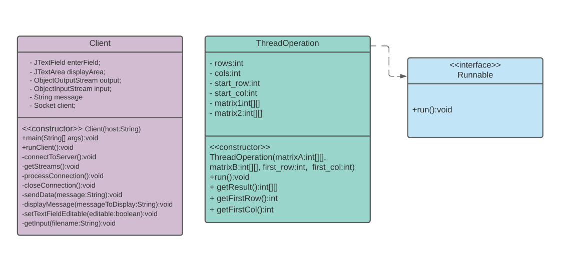

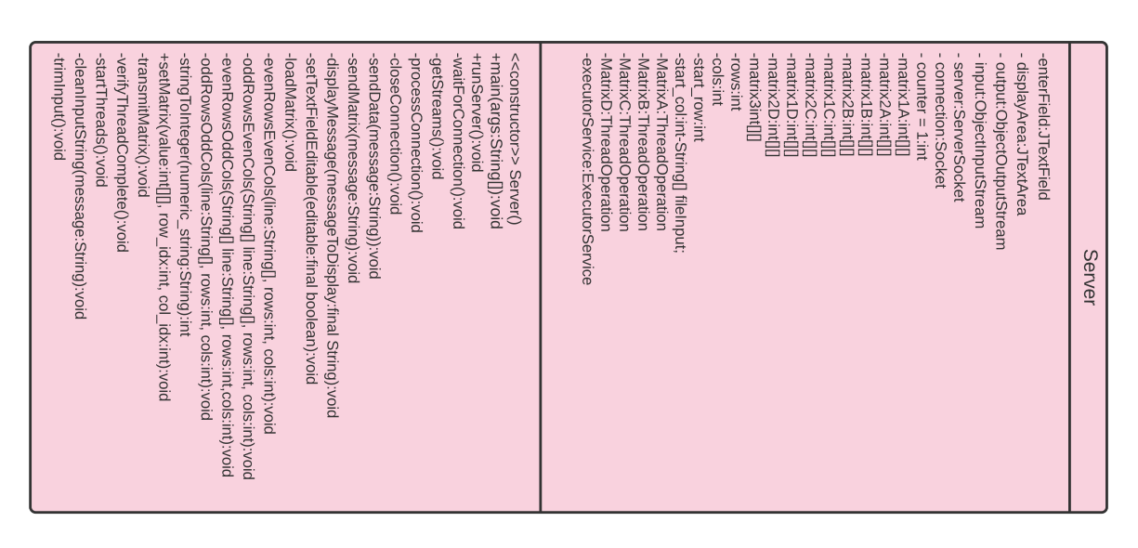

**Control Flow (Flow Chart):**

Server: Client:

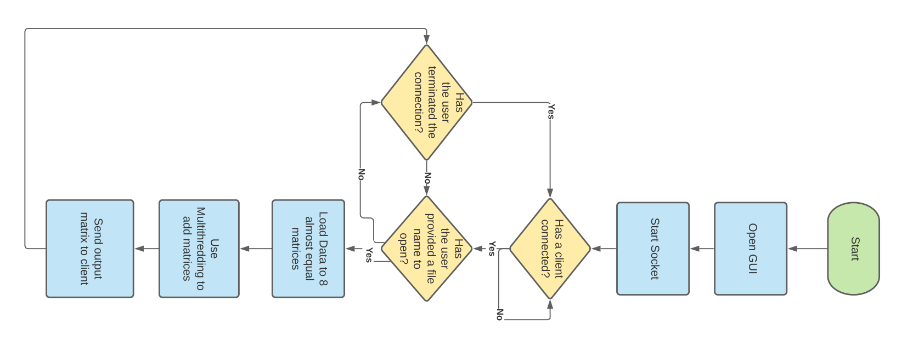 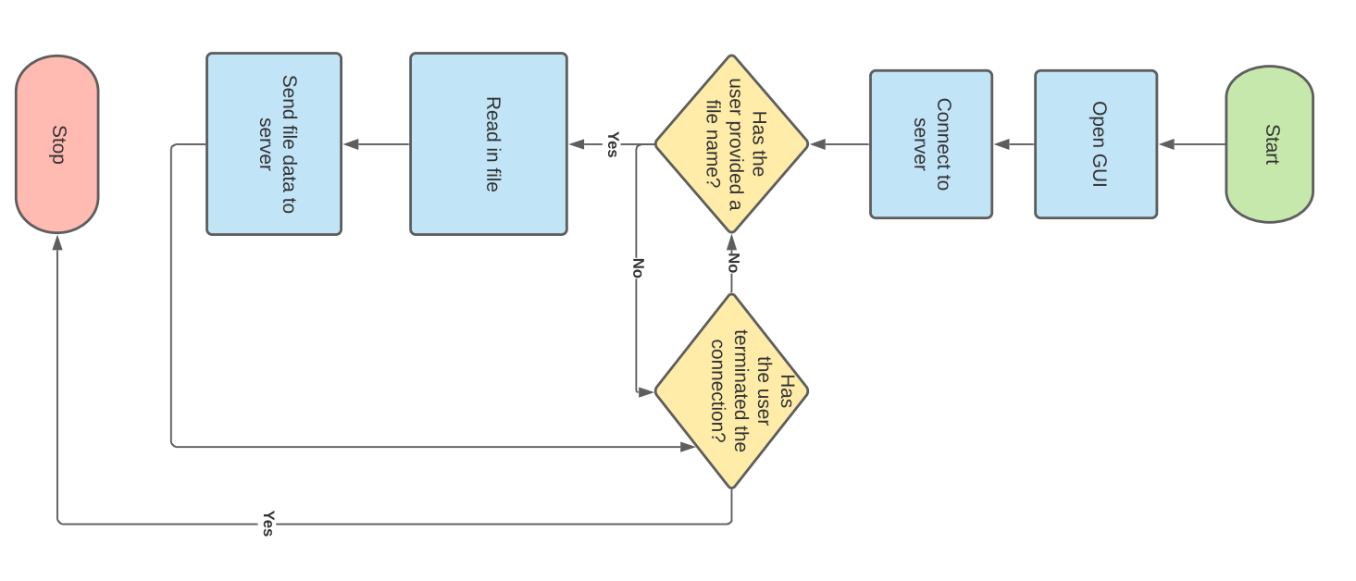

**User Execution:**

The client window has a text box in which the user can enter a file name. Both the client and server windows have a big red terminate button that will terminate connection between the server and client. The terminate connection button on the client side will also close the GUI window.

**File Format:**

1) the first line has two numbers, N and M (N rows, M columns), the size of both matricesA and B

2) the next Nlines each has M elements for one of the rows of A

3) the next N lines each has M elements for one of the rows of B

Example:

4 6

2 3 1 2 5 1

3 1 2 2 2 4

1 2 3 2 7 2

3 6 1 5 1 3

6 5 4 1 4 3

3 3 2 2 1 1

7 5 4 3 2 5

2 1 8 4 8 4(Taken from problem statement document)