Philip Garcia

Philip.a.garcia@gmail.com

CS2251 Spring 2021

02/06/2021

**Problem Description**

A real estate investor in Albuquerque, New Mexico started their residential rental business since 2016. Their business expanded from a few single-family houses to a couple of dozens of single-family houses plus a few of apartment complexes. The information about their rental properties are listed in a database file, rentalDB, which include monthly rent. The monthly rent varies from $600.00 to $1,400.00 based on the rental unit configurations, such as property type and number of bedrooms.

Due to the increase of business tax and other expenses, the company decided to increase the rent of single-family house by 4% and the rent of apartment unit by 8%. You are requested to write a program to compute the rent for their rentals, update the database file and output the new monthly rent summary on the screen. In your program, you need to have at least the followings:

1. An interface, Payment, to calculate the rent of the two rental types.
2. A super class, RentalProperty, for the two different rental properties. It **implements** the interface Payment.
3. Two subclasses: SingleFaimlyRental and ApartmentRental for the two different rental properties. They should **extends** the RentalProperty.
4. Apply polymorphism (such as RentalProperty[] rentals = mew RentalProperty[numProperty]) to update the database file, rentalDB via the method UpdateRent(). The updated database file should retain its original record format as well as sequence of the records. It also output the new monthly rent summary on the screen.

Hint: identify how many rental properties (how many records), numProperty, in the database file first.

You need to open the database file (plain text file), rentalDB, and get the current rental information for your program. In the database file, a line represents a data record, six fields per records, all fields are right justified. The format of rentalDB as follows:

Field 1 (6 characters): Unique sequence number.

Field 2 (4 characters): rental type – S means single-family rental, A means apartment rental

Field 3 (10 characters): rental ID – a 7 characters rental property identification (first letter is the rental type, next three letters is the rental location, next three digits is the rental ID of the location)

Field 4 (3 characters): number of bedrooms – it means how many bedrooms of the rental.

Field 5 (10 characters): monthly rent

**UML Diagram**

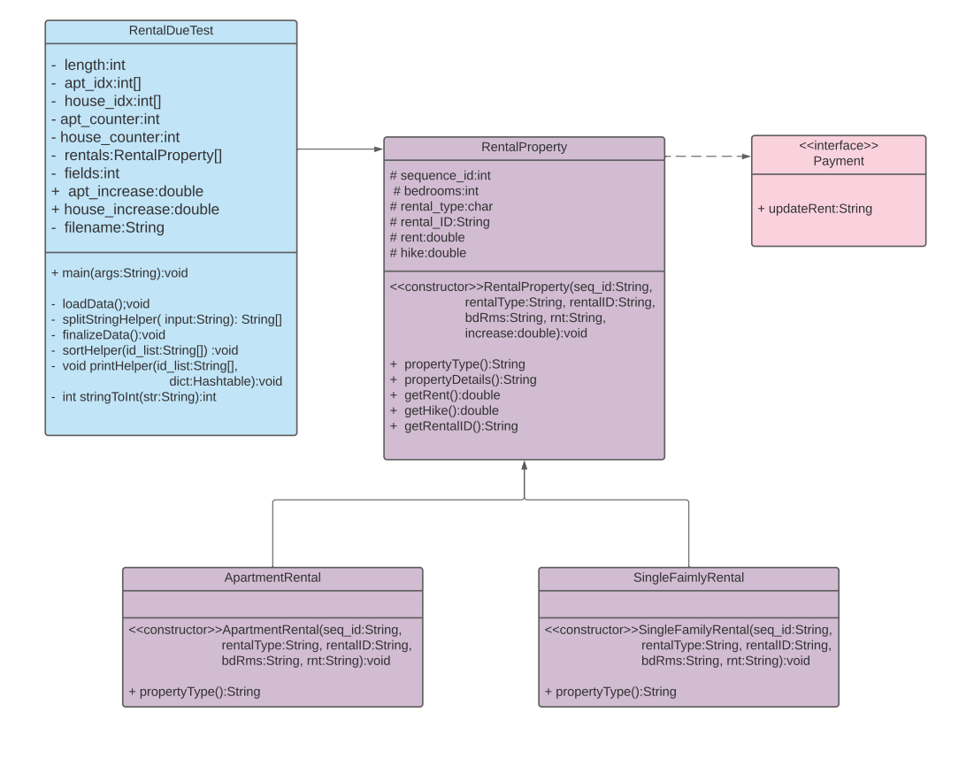

**Control Flow (Flow Chart)**

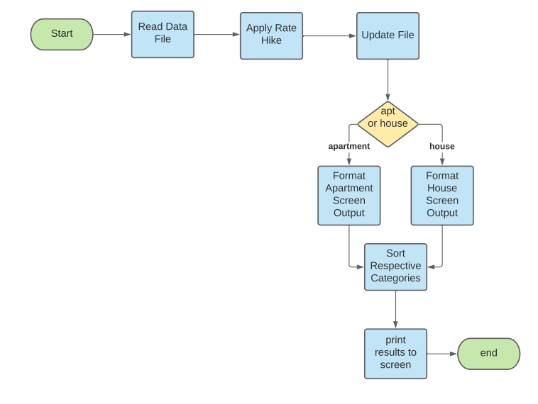

**User Execution**

User loads file named rentalDB.txt in the root folder of the java program, runs the program, the file will be overwritten with the updated data and the screen will display results.