D.TEC | LA 2028 OLYMPIC GAMES

DESIGN CONFIRMATION DOCUMENT
Media Registration Portal
Expression of Interest — Application & Review System

March 2026 | For Stakeholder Review | Prepared by D.TEC

Executive Summary
The Media Registration Portal (MRP) is a purpose-built platform that manages the Expression of Interest process for press accreditation at the LA 2028 Olympic Games. It serves as the first formal step for media organizations worldwide to register their interest in covering the Games.
The portal connects three groups: media organizations submitting applications, National Olympic Committees (NOCs) and selected International Federations (IFs) reviewing and approving applicants within their quota allocations, and IOC OIS providing global oversight. Once a media organization is approved, their record enters the organization master data workflow and the accreditation system, where individual credentialing is managed separately.
This document presents the current design for stakeholder review. We have made significant progress across architecture, user experience, and system design. Our focus now is on delivering a fully functional prototype demonstrating the complete end-to-end process, followed by a transition to a production-grade deployment as features are prioritized and confirmed with stakeholders.
ABOUT THIS DOCUMENT
How to read the callout boxes
DECISION NEEDED — An open question where we need your guidance before we can finalize the design.

PROVISIONAL DECISION — A design choice we have made to keep development moving. We would welcome your confirmation or correction.

DESIGN NOTE — Context on a specific design choice and why we made it.

Who Uses the System
The portal is designed for four distinct user groups. The applicant flow is public-facing; all other access is role-controlled.
APPLICANT  Media Organization  Submits an Expression of Interest through a public-facing form. Sees only their own submission and status, plus the contact for their NOC or IF. | REVIEWER  NOC / IF Administrator  Reviews and approves applications from their territory within their IOC-allocated quota. Sees only their own territory's applications.
OVERSIGHT  IOC OIS  Read-only global view across all NOCs and IFs. Approves Press by Number submissions. Reviews anomalies. Does not manage individual applications. | ADMINISTRATION  OCOG ACR Staff  Codes approved organizations, manages the Common Codes workflow, and oversees the handoff to the accreditation system. Full access.

DECISION
Access control — applicants see only their own data
The public URL is accessible to anyone to submit an Expression of Interest. Once submitted, applicants can return to check their status using their reference number and email. They see only their own record — no list views, no other organizations' data, no quota information.
• Applicants may also see the name and contact email for the NOC or IF responsible for their territory.
• Please confirm: should any additional information be visible to applicants after submission?

The Application Journey
Step 1 — Email Verification
A media organization begins by entering their contact email address. The portal sends a verification link to confirm the address before allowing them to proceed to the form. This prevents spam submissions and ensures all applications are contactable.
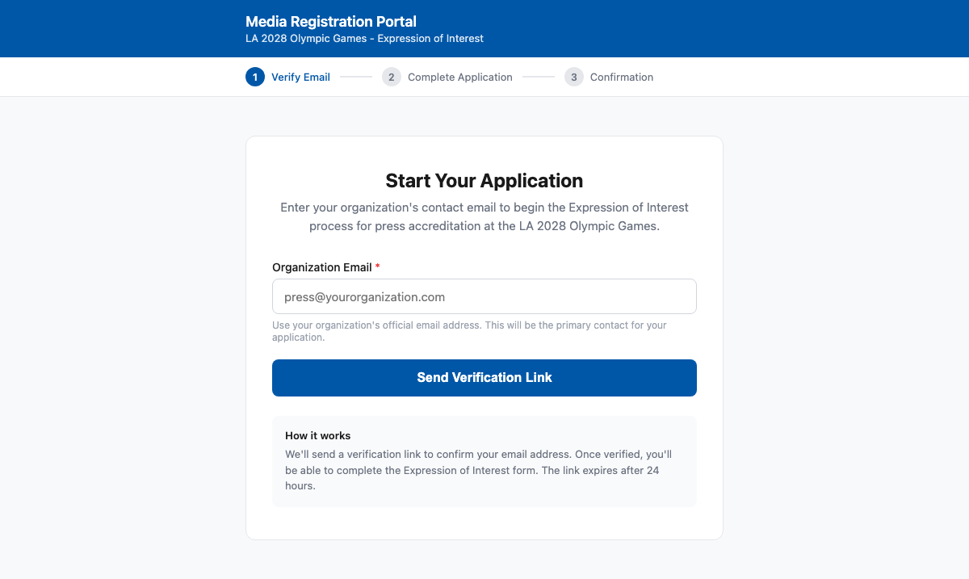
Screen 1 — Email Verification: applicant enters their email to receive a verification link
PROVISIONAL
Verification links expire after 24 hours
An applicant who misses the window can re-enter their email to receive a new link. Please confirm this window is appropriate, or advise if a longer period would better suit applicants across time zones.

Step 2 — Expression of Interest Form
Once their email is verified, the applicant completes the Expression of Interest form. The form captures the organization's details, primary contact, and the type of accreditation being sought. The form is designed to be completed in a single session of under ten minutes.
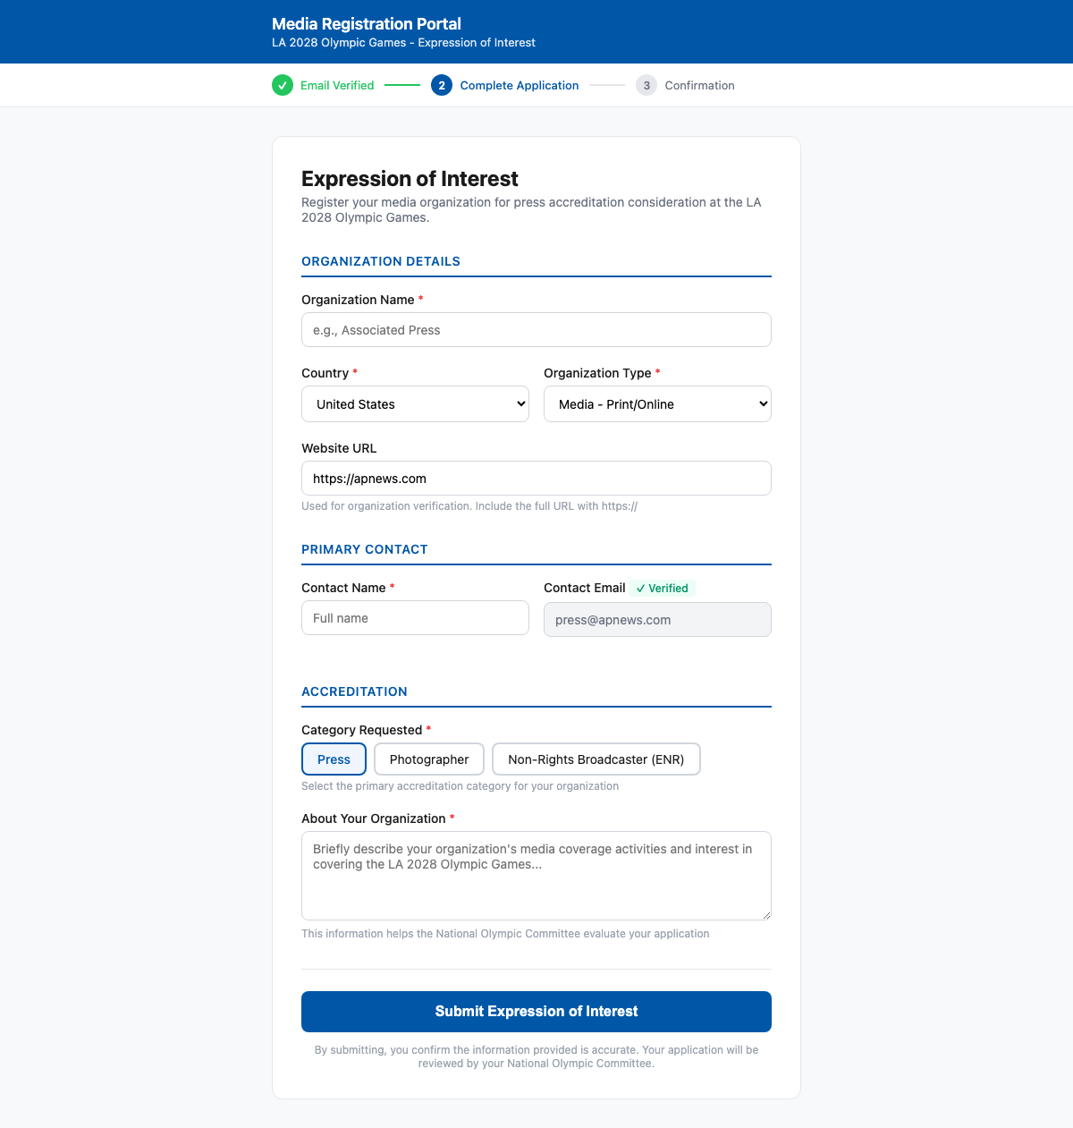
Screen 2 — EoI Form: contact email pre-filled from verification step; applicant selects accreditation category
DECISION
Final list of form fields — and accreditation categories
The fields shown reflect the Milan Cortina 2026 process as a starting point. IOC OIS will provide the definitive field list for LA 2028.
• The MICO26 Press by Number form uses categories E (Journalist), EP (Photographer), ET (Technical), EC, and NOC E. The EoI form categories should align with these, as NOCs have requested alignment between the portal and the Press by Number form to ease their workflow.
• Please confirm the correct accreditation categories for the EoI stage.

Step 3 — Submission Confirmation
After submitting, the applicant receives a confirmation with a unique application reference number, a summary, and a plain-language explanation of what happens next — including review timeline and how they will be notified.
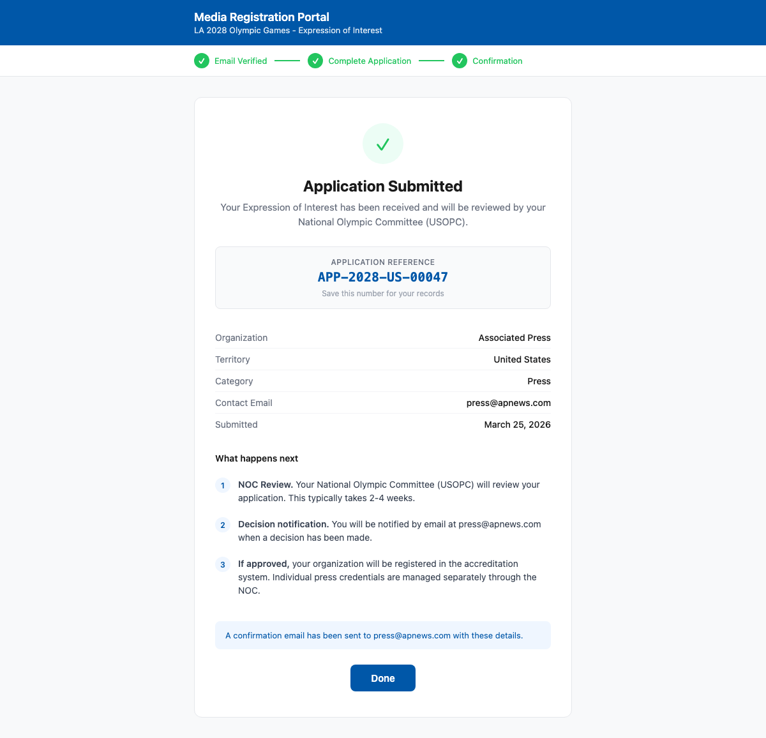
Screen 3 — Confirmation: reference number, summary, and next steps
DECISION
What review timeline should we communicate to applicants?
The confirmation screen currently reads "typically 2–4 weeks." The IOC allocates quotas to NOCs in July, with the portal opening end of August.
• What is the realistic NOC review window for the EoI phase?
• Should this vary by territory, or is a single global estimate appropriate?

NOC & IF Review — Managing Your Territory
Each National Olympic Committee and selected International Federation has access to a dashboard showing all applications from their territory. The administrator can search, filter, and sort applications, then open each one to review in detail. NOCs and IFs operate identically within the system — both are quota-holding responsible organizations.
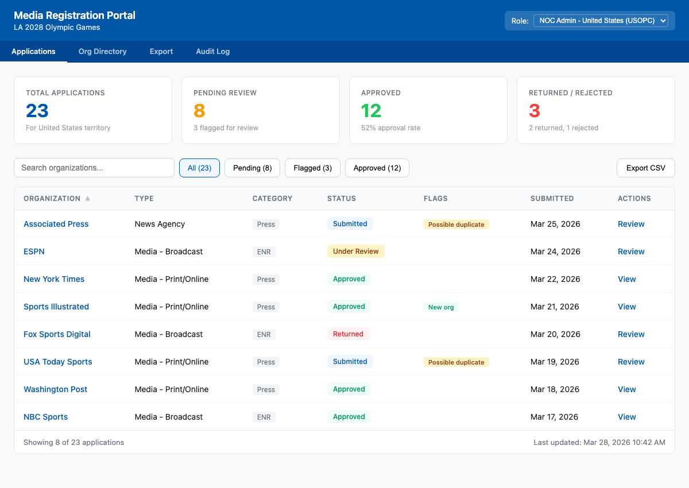
Screen 4 — NOC/IF Dashboard: application list with status filters, multi-territory flags, and at-a-glance statistics
Application Review
When a reviewer opens an application, they see the full organization details alongside any flags raised. The review screen also displays the organization's history from previous Games editions to inform the decision.
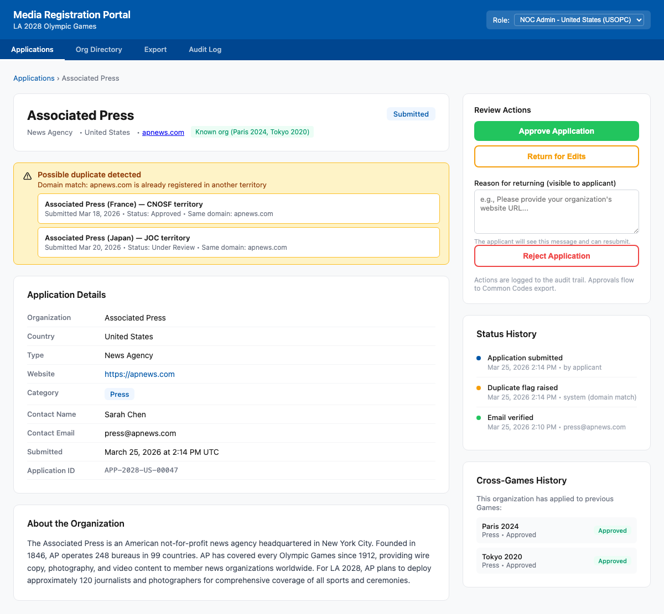
Screen 5 — Application Detail: org record, multi-territory flags with matched organizations, approve/return/reject actions, cross-Games history
PROVISIONAL
Organizations in different territories are treated as separate entities
AP-Japan (applying through JOC) and AP-US (applying through USOPC) are treated as separate organizations in the system — each managed independently by their NOC, each receiving their own quota allocation, and each coded separately in the Common Codes system.
When the same domain appears across multiple NOC territories, the system raises a "multi-territory" flag for IOC awareness — but does NOT block either submission as a duplicate.
A true duplicate (same domain + same NOC) is blocked.
• Please confirm: is this the correct interpretation of how multi-territory organizations should be handled?

DECISION
Who has authority to resolve multi-territory flags?
Our current design allows the NOC administrator to resolve flags independently ("legitimate multi-territory org" or "confirm as duplicate"). IOC OIS would have a filtered view to see all resolved flags.
• Should NOC administrators be empowered to resolve these independently?
• Or should cross-territory flags be escalated to IOC OIS for final determination?

PROVISIONAL
Returning an application notifies the applicant
When an application is returned for corrections, the applicant receives an email with the reviewer's written reason and a link to resubmit. Please confirm, and advise whether the reviewer should also be notified when the applicant resubmits.

PROVISIONAL
Returned applications expire after 30 days without resubmission
If not resubmitted within 30 days, the application moves to an expired state. Please advise if a different window is appropriate.

IOC Oversight — Global View
IOC OIS has access to a global dashboard aggregating activity across all 206 NOCs and selected IFs. The view is organized by responsible organization — NOC or IF — allowing the team to quickly identify which territories are active, which are lagging, and where anomalies have been detected.
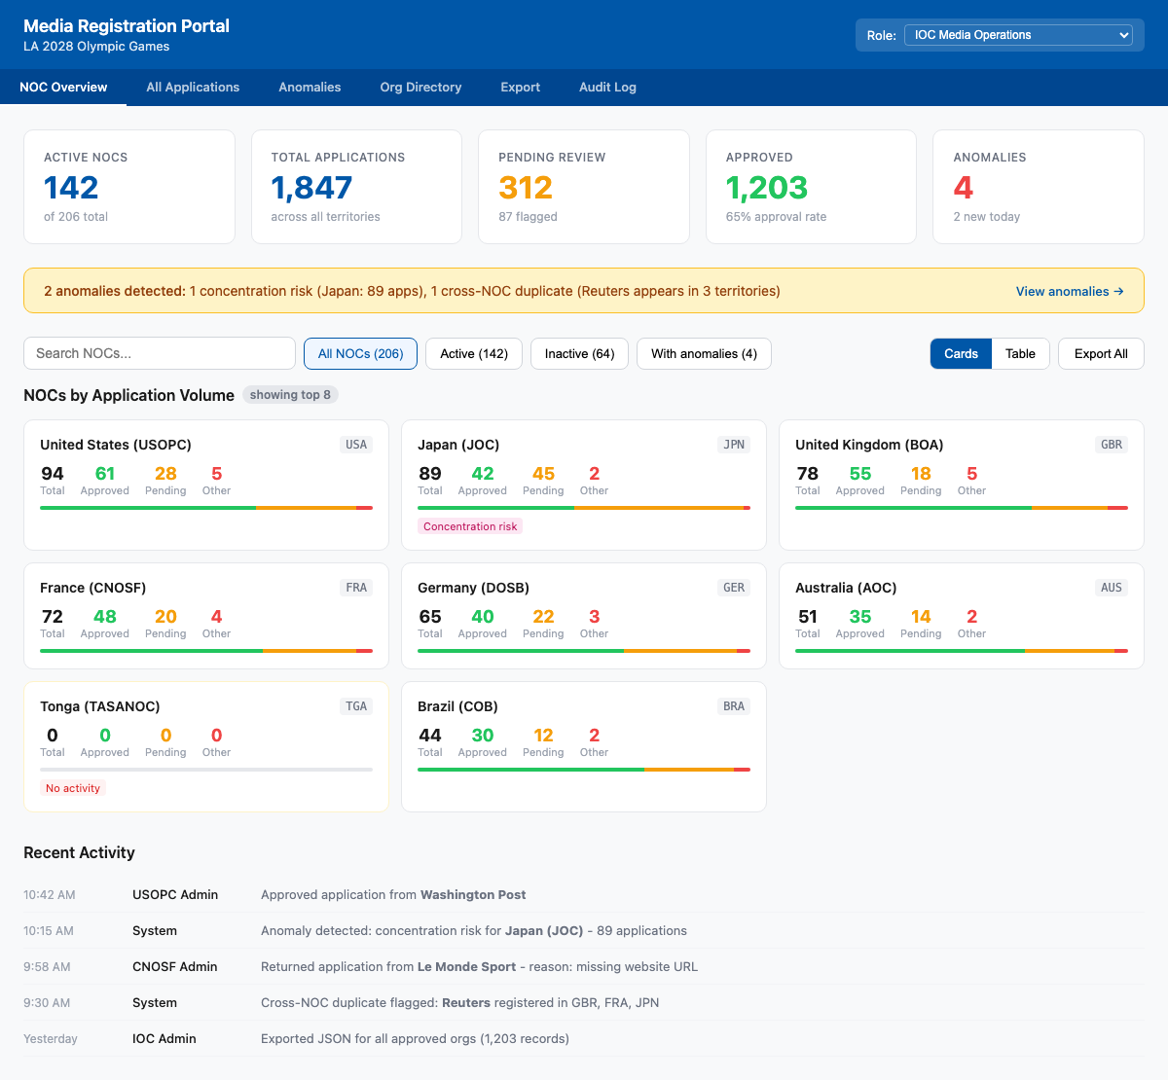
Screen 6 — IOC Global Dashboard: each NOC/IF with application status breakdown; anomaly banner surfaces concentration risk and cross-territory flags
DECISION
How does IOC decide and set the quota for each NOC and IF?
The IOC allocates press accreditation quotas to NOCs and selected IFs. The MICO26 process used Excel templates pre-populated with IOC-allocated numbers. For LA 2028, the portal could include a quota management screen where IOC OIS enters and confirms allocations — replacing the Excel process.
• Is there a front-end workflow to support quota allocation, or is this still managed externally and loaded into the system?
• Quota allocations are expected to be confirmed in July 2026 before the portal opens. How should late quota changes be handled?
• Should NOCs/IFs be able to request quota amendments through the system?

PROVISIONAL
Anomaly: concentration risk triggered above 80 applications per NOC
This threshold is a provisional starting point.
• Does this vary by territory size?
• Should larger territories (USA, Japan, Germany) have a higher threshold?

DECISION
What action should IOC take when an anomaly is detected?
• Who at IOC OIS is responsible for reviewing and resolving anomalies?
• Is a dashboard notification sufficient, or should anomalies trigger an email alert?

Feature Summary
The table below summarises all planned features. The initial prototype covers the complete end-to-end EoI and review process. Subsequent phases introduce additional capabilities as features are prioritized.
Feature | Description | Phase
EoI Application Form | Public-facing form for media organizations to submit an Expression of Interest | Prototype
Email Verification | Confirms applicant email before submission is permitted | Prototype
Applicant Status Page | Applicant can check their own application status with reference number + email | Prototype
NOC & IF Review Dashboard | Territory-scoped view for NOC and IF administrators to review, approve, return, and reject applications | Prototype
IOC Global Dashboard | Aggregate view across all NOCs and IFs with anomaly detection | Prototype
Organization Deduplication | Blocks true duplicates (same org, same NOC). Flags multi-territory orgs (same domain, different NOC) for IOC awareness. | Prototype
Organization Directory | Searchable directory of all registered organizations, persisted across Games editions | Prototype
Audit Trail | Complete record of all actions on every application | Prototype
Common Codes & ACR Handoff | Approved org records trigger Common Codes coding workflow; quota data passed to the accreditation system | Prototype
Press by Number | NOC/IF-managed quota allocation with IOC approval workflow | Next phase
IF Dashboard | Sports-specialist accreditation for selected IFs (~6 total) — same workflow as NOC | Next phase
Quota Management (IOC) | IOC OIS interface to set, confirm, and amend NOC/IF quota allocations | Next phase
ENR Undertaking | In-system undertaking agreement for Non-Rights Broadcasters | Next phase
French/Spanish Localisation | Full localisation per Olympic Charter requirements | Next phase
DGP SSO Integration | Full single sign-on integration with the Digital Games Platform | Next phase
Paralympic Cross-linking | Linking Olympic org records to Paralympic accreditation records | Future

Open Questions for Your Review
The following questions are consolidated here for your convenience. We have noted our provisional position where applicable. Your guidance allows us to finalize the system with confidence.
1. What is the final list of fields for the EoI application form — and what are the correct accreditation categories?
MICO26 used E, EP, ET, EC, NOC E. NOCs have requested alignment between EoI fields and the Press by Number form. Blocking for schema design.
2. How does IOC decide and communicate quota allocations to NOCs and IFs — and should the portal include a quota management interface for IOC?
Quotas are expected in July 2026. Currently managed via Excel. A portal interface would replace this process but requires IOC OIS input on workflow.
3. What review timeline should we communicate to applicants on the confirmation screen?
Portal opens end of August. Quotas confirmed in July. What is the realistic NOC review window?
4. Are AP-Japan and AP-US treated as separate organizations with independent quota allocations — or as the same entity managed across territories?
Our provisional model treats them as separate (flat model). Please confirm this reflects how OCOG ACR codes them in Common Codes.
5. Who has authority to resolve multi-territory flags — NOC/IF administrators independently, or IOC OIS?
Provisional: NOC resolves, IOC has visibility. Should cross-territory flags require IOC sign-off?
6. How should IOC respond to anomalies — dashboard notification only, or automated alerts?
Who at IOC OIS owns the response workflow?
7. Should concentration risk thresholds vary by territory size?
Currently a uniform threshold of 80 applications.
8. After the Press by Number phase, does the NOC/IF workflow transition entirely into the accreditation system for Press by Name — or does MRP collect any individual-level data?
The IOC document states Stage 2 is submitted through the OCOG accreditation system. We believe MRP's scope ends at PbN. Please confirm.
9. Can NOC/IF teams have more than one administrator?
Currently one login per responsible organization. Some may require multiple reviewers.

Next Steps
Development is underway. Our immediate focus is delivering a fully functional prototype demonstrating the complete end-to-end process — from a media organization's first interaction through to NOC/IF review and IOC oversight. This prototype will be available for your review and testing in April.
Following the prototype, our roadmap moves into a productionalization phase targeting an end-of-August launch. Features will be prioritized in close collaboration with stakeholders. The Press by Number phase, IF quota management, and IOC quota allocation interface are the primary next-phase priorities given the July quota allocation timeline.
We do not require responses to the open questions before development begins. For the form field list and accreditation categories in particular, earlier input is more valuable as it affects the database design, but we have provisional designs in place and can begin immediately.
CONTACT
Questions or feedback
Please direct any questions or feedback to the D.TEC team. We look forward to demonstrating the working prototype in April.

