Project: Implementation

Requirements: 1

Regarding the application: database has been created; named: bluehunterapp, after installing Python Flask server & client mysql db. At this time, the bluehunterapp db. Host 2 tables; pharamcies and users. See below screenshots for details:

I) Backend: MySQL database:

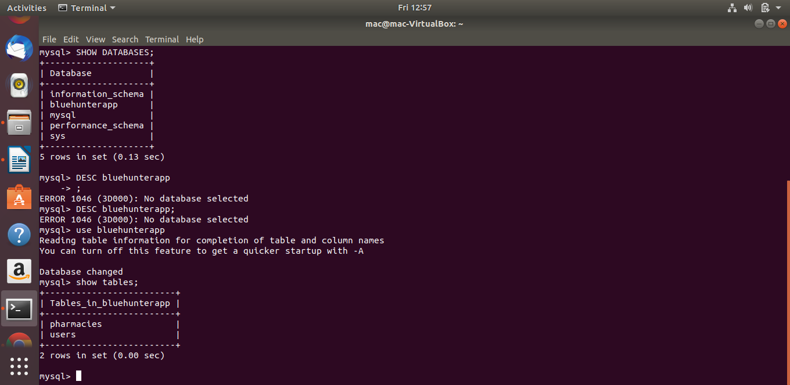
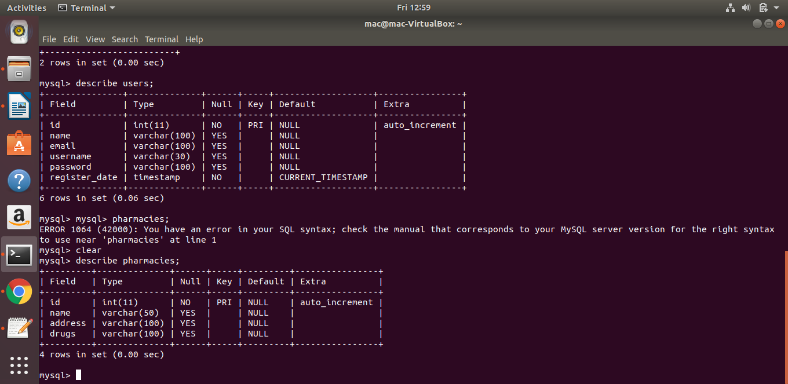

II) Front-End:
The user authentication system allows user to sign up/register, validate user inputs, submits them (user’s data) to the db. Redirect to login page for first time login. Validate user’s login information, if valid & active user, allowed to his/her dashboard, and his name displayed on the top.
