With document containing multiple features in the tree, selecting edges in a feature implies there is a selection object for each feature. If more than one edge in a feature is selected, then the selection object for that feature will contain a reference to each edges selected.
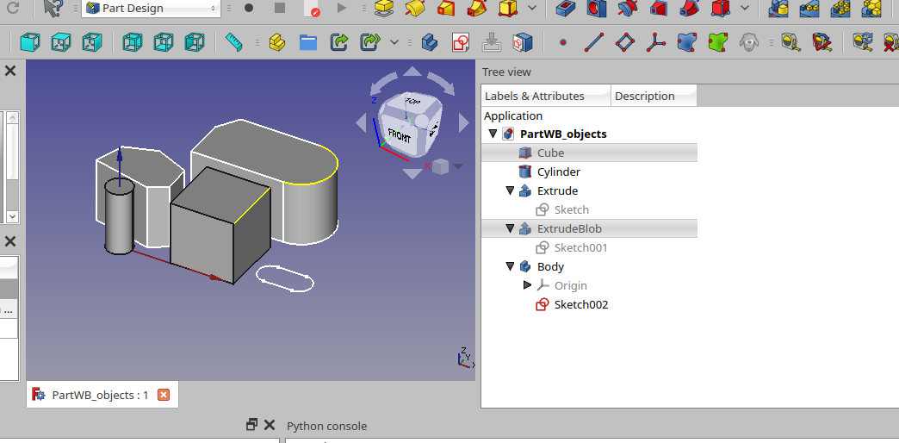Figure 1-1

In Figure 1-1 shows a drawing with multiple features. An edge in feature Cube and an edge in feature ExtrudeBlob are selected.

If we enter the following in the FreeCAD Python console:

>>> Gui.Selection.getSelectionEx()

The output is:

[<SelectionObject>, <SelectionObject>]

Note: This is a python list containing two selection objects.

This implies we can iterate through the list and get information about the selected items.

>>> print(Gui.Selection.getSelectionEx()[0].SubElementNames)
('Edge7',)
>>> print(Gui.Selection.getSelectionEx()[1].SubElementNames)
('Edge6',)

This displays the names of the edges that are selected in each feature.

This is great, but, we don’t have any idea which feature contains these edges.

The following script provides a bit more information:

The output in the Report view shows:
Example 1

#!/usr/bin/env python
# -*- coding: utf-8 -*-

for sel in FreeCADGui.Selection.getSelectionEx():
print('---------------------------------------')
print('Container type: ', sel.Object) #identifies the object/container type
print('Container object: ', sel.ObjectName) #the internal name of the container
print('Container user label: ', sel.Object.Label) #the label applied by the user
SelNams = sel.SubElementNames #returns a tuple with names of selected items
print('Selected edges in container: ', SelNams) #print the names of the selected edges

---------------------------------------
Container type: <Part::PartFeature>
Container object: Extrude001
Container user label: ExtrudeBlob
Selected edges in container: ('Edge10',)
---------------------------------------
Container type: <Part::PartFeature>
Container object: Box
Container user label: Cube
Selected edges in container: ('Edge6',)

Now we know the feature in the tree called ExtrudeBlob contains Edge10 and the feature called Cube contains Edge6.

Better but what we really want are details of these selected edges.

Some additional code will get some more detail.

Example 2

#!/usr/bin/env python
# -*- coding: utf-8 -*-
import re
import math
import itertools

for sel in FreeCADGui.Selection.getSelectionEx():
print('---------------------------------------')
print('Container type: ', sel.Object) #identifies the object/container type
print('Container object: ', sel.ObjectName) #the internal name of the container
print('Container user label: ', sel.Object.Label) #the label applied by the user
SelNams = sel.SubElementNames #returns a tuple with names of selected items
print('Selected edges in container: ', SelNams) #print the names of the selected edges
for selectededges, simplename in zip(sel.SubObjects, SelNams):
print('---------------------------------------')
print('Processing: ', simplename)
print('Selected edge type: ', selectededges.Curve.TypeId)
if selectededges.Curve.TypeId == 'Part::GeomCircle':
print('Arc length: ', selectededges.Length)
arcang = selectededges.Length/(2*math.pi*selectededges.Curve.Radius)*360
print('Arc angle: ', arcang)
else:
print('Length: ', selectededges.Length)
print('Edge verts: ', selectededges.Vertexes)
for vert in selectededges.Vertexes:
print('Vert X ',vert.X, ' Y: ', vert.Y, ' Z: ', vert.Z)

The output of Example 2:

---------------------------------------
Container type: <Part::PartFeature>
Container object: Extrude001
Container user label: ExtrudeBlob
Selected edges in container: ('Edge10',)
---------------------------------------
Processing: Edge10
Selected edge type: Part::GeomCircle
Arc length: 15.707963267948966
Arc angle: 180.0
Edge verts: [<Vertex object at 0x5595844e0250>, <Vertex object at 0x559585e546e0>]
Vert X 18.834149299461068 Y: 12.105376823277663 Z: 10.0
Vert X 18.834149299461068 Y: 22.105376823277663 Z: 10.0
---------------------------------------
Container type: <Part::PartFeature>
Container object: Box
Container user label: Cube
Selected edges in container: ('Edge6',)
---------------------------------------
Processing: Edge6
Selected edge type: Part::GeomLine
Length: 10.0
Edge verts: [<Vertex object at 0x5595855ba650>, <Vertex object at 0x559583cdc9d0>]
Vert X 18.0 Y: 10.0 Z: 10.0
Vert X 18.0 Y: 0.0 Z: 10.0

Some notes:

- This line in the code print('Selected edge type: ', selectededges.Curve.TypeId)
shows the type of the edge is retained in the Curve.TypeId.
- The python zip iterator was used to iterate through two lists simultaneously.
  - I’ve not found how to access the “simplename” (for example ‘Edge6’)

