Julie Brisbane, Hali Hanley, Casey Owen, Madison Maloney

LT Quarry

Software Engineering

29 March 2022

**Project Description**

**Overview**

Cadet mail, specifically package retrieval is an on-going problem that leads to wasted productivity for both CGA mailroom staff and cadets. This is an ongoing need because mail is not always ready to be picked up the day it is delivered. This leaves cadets going to check for their mail constantly until it is ready or asking the mail room staff who cannot help them at that time. On the other hand, cadets may forget to get their mail or not know if they received a package or letter from someone else if they never check. This project seeks to outline the process of designing a fully digital workflow management system. The final step is the project will be proposed as a software engineering project normally is before implementation. Our specific project idea for CGA will be a mailing system for cadets to utilize to see when their packages have arrived and been sorted in the mailroom.

Currently, the mail process at the Academy begins with a cadet ordering mail or someone sending a cadet mail. Then, from Monday through Friday from 930 am to 4 pm the mail room receives mail delivered. The staff sorts the mail and places smaller items into P.O. boxes and note cards in the boxes if there are larger items. This way when a cadet opens their box and sees a note card they know they have a larger package and present the card to the desk. One issue that arises from this process is that sometimes the mail room can be very behind on sorting. This causes cadets to be unsure of when their package will be ready for pick up. Furthermore, if cadets do not pick up their mail frequently, the mail room may become overcrowded with mail making it difficult for the staff.

The new process would be a phone application where the mail room staff would input when mail is ready to be picked up for a specific cadet. The cadet then logs in with their own credentials that connect with their box number. They will be able to check if their mail is ready and receive notifications. The cadet will then take their “virtual notecard” to the mail desk and be able to pick up their package. This will eliminate the note card process that the staff goes through to place them in the correct boxes every time they sort a piece of mail. This will also eliminate cadets constantly checking for a package and bothering the mail room staff by asking. Additionally, it allows cadets to see if an unexpected package arrived so that they know to pick it up.

**Stakeholders**

The stakeholders involved would be cadets and mail room staff members. The cadets’ role in the process is to download the app and check for mail as well as ensuring they are picking up their mail. The mail room staff’s role is to input the sorted mail to the app for the cadet to be notified. The staff will also check off the mail on the app once it has been picked up.

**System Scope**

The scope of our system is a system that cadets and mail room staff will use. The mail room staff will scan a package with their scanners, and it will connect to the cadet account on the network. The cadet will then receive a notification on their phone saying that their package is ready for pickup. The system will not include C-Division or academic departments. The system will only represent when a package has been sorted and is ready to be picked up. It does not notify when a package is delivered because delivery systems already do that for customers. The phone notification will create a virtual notecard that will be used at pickup to collect the package. The system will have access to the cadet database to match the .edu account and have additional information of their box number. Figure S.1 is a context diagram to better understand the basics of the system.

Figure S.1

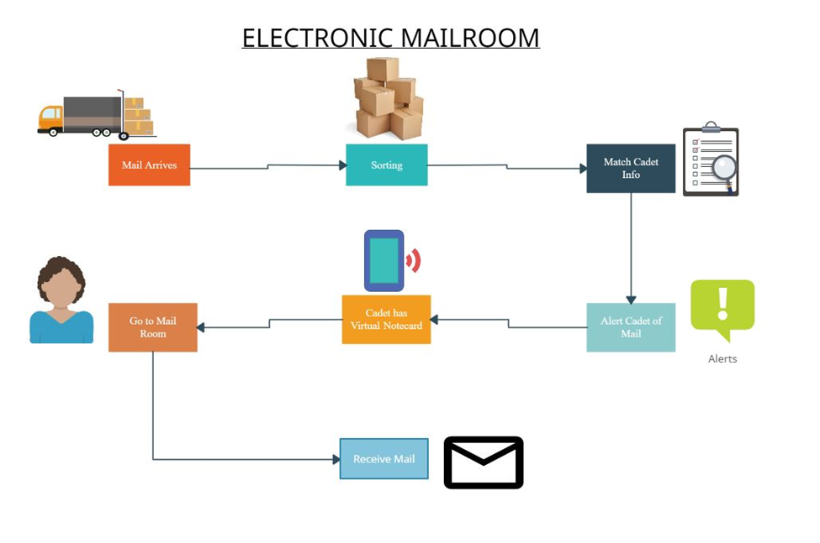

**User Requirements**

**1. Functionality**

|  |  |  |  |
| --- | --- | --- | --- |
| Req. # | Requirement | Stakeholder | Type |
| 1.1 | The system shall allow mail room staff to scan package with scanners when it has been sorted | Mail room staff | Functional |
| 1.2 | The system shall determine the owner of the package based on the scan | Mail room staff/ cadet users | Functional |
| 1.3 | The system shall connect scan from scanner to the software to notify the cadet when a package that belongs to them has been sorted and is ready for pick up | Cadet users | Functional |
| 1.4 | The system shall allow the cadet’s virtual notecard to be scanned at pick up | Mail room staff/ Cadet users | Functional |
| 1.5 | The system shall clear the package from the cadet’s inbox after being scanned at pickup | Cadet users | Functional |

**2. Security**

|  |  |  |  |
| --- | --- | --- | --- |
| 2.1 | The system should only allow package scanning by verified USCGA mail room scanners | Mail room staff | Non-Functional |
| 2.2 | The system should require correct username and password to log in to account | Cadet users | Non-Functional |
| 2.3 | The system should only allow Cadets to make accounts and not outsiders | Cadet Users/ Mail room staff security | Non-Functional |

**3. Environment Compatibility and Availability**

|  |  |  |  |
| --- | --- | --- | --- |
| 3.1 | The system should be compatible with different mobile devices including iPhone and Androids | Cadet Users | Non-Functional |
| 3.2 | The system should be available on the AppStore and Google Play Store | Cadet Users | Non-Functional |

**Use Case Diagram**

Figure U.1

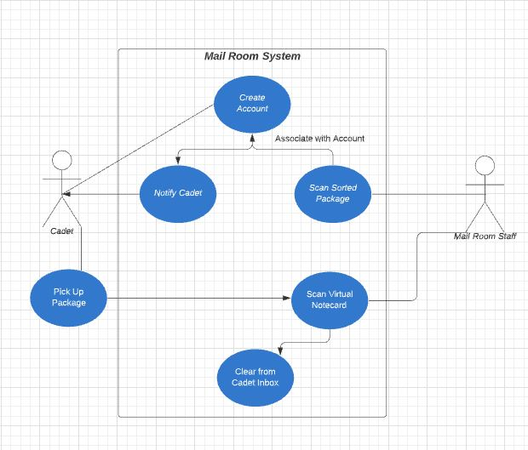

**Architecture**

**Layered Architecture**

The Layered Architecture pattern allows for separation and independence in the architectural design process, which is vital when changes are going to have to be made while the application is being developed. The layered approach is supportive of incremental development, which is when a system is developed in stages and supports the process of altering different components when we have already moved past that stage. This design pattern also makes it so that the architecture is changeable and moveable, which allows for extended functionality when new layers need to replace existing layers.

**Architecture Diagrams**

Figure A.1

|  |
| --- |
| **USER INTERFACE**  Application user interface: USCGA iMail app |
| **CONFIGURATION SERVICES**  Group management  Application management  Identity management |
| **APPLICATION SERVICES**  Notification System  Scanning capability  History archive  Messaging |
| **UTILITY SERVICES**  Authentication  Databases of Cadet Codes to Cadet Mailbox #s  Application Storage  Interfacing  User Storage  Logging and Monitoring |

Figure A.2

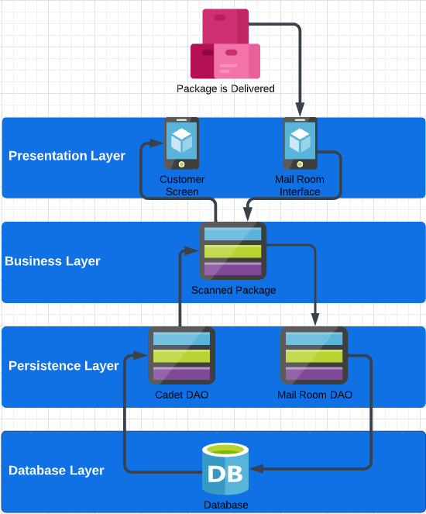

**Architecture Description**

Figure A.1 is a broad description of a four layered architecture. The lowest layer consists of system support software such as databases and operating systems. In this layer, we have the interface and application needs. Authentication is needed to connect the cadet’s mailbox number to their cadet code, which they use to log-in for the app. The connection between the box numbers and the cadet codes will be kept in a database that the app accesses. The next layer being the application layer, this provides the components concerned with the way the app functions. This layer includes the notification system that will notify cadets when they have a package waiting for them. The scanning ability for the mailroom staff is also in this layer. The app needs to be able to receive scanning information from the mailroom and transcribe it to a cadet’s mailbox number, which then will be passed through the database to retrieve the cadet code. The third layer is regarding the user interface management and providing the user authentication and authorization to access their accounts and be able to see if there is a scanned package waiting for them to pick-up. The top layer is the user interface facilities, which is essentially the interface and design of it.

Figure A.2 is a physical depiction of how the system will work. The arrows going down to the database are the services on the mailroom side of the application. It portrays when the package is delivered the mailroom has their interface of the application up, they scan the package, the scanned information is transcribed to the cadet’s mailbox number, which is then called from the Mail Rooms DAO (data access object), then the cadet’s mailbox number is sent to the database which then returns the cadet’s code. From this point the process makes its way back upwards. It connects the cadet code to the correct server that connects to the cadet’s application. Then the cadet is notified that they have a package waiting for them in the mailroom, which is done through the interface of the app.