
USCGA Mail Room Notification System

2/c Julie Brisbane  USCGA Cyber Systems Major |  | 2/c Hali Hanley  USCGA Cyber Systems Major
2/c Casey Owen  USCGA Cyber Systems Major |  | 2/c Madison Maloney  USCGA Cyber Systems Major

Project Overview

Problem statement and Motivation
Cadet mail, specifically package retrieval, is an on-going problem that leads to wasted productivity for both CGA mailroom staff and cadets. This is an ongoing need because mail is not always ready to be picked up the day it is delivered. This leaves cadets going to check for their mail constantly until it is ready or asking the mail room staff who cannot help them at that time. On the other hand, cadets may forget to get their mail or not know if they received a package or letter from someone else if they never check. This project seeks to outline the process of designing a fully digital workflow management system. The final step is the project will be proposed as a software engineering project normally is before implementation. Our specific project idea for CGA will be a mailing system for cadets to be notified when their packages have been sorted in the mailroom.
Currently, the mail process at the Academy begins with a cadet ordering mail or someone sending a cadet mail. Then, from Monday through Friday from 9:30am to 4pm the mail room receives delivered mail. The staff sorts the mail and places smaller items into P.O. boxes and note cards in the boxes if there are larger packages. This way when a cadet opens their box and sees a note card, they know they have a larger package and present the card to the desk. One issue that arises from this process is that sometimes the mail room can be very behind on sorting. This causes cadets to be unsure of when their package will be ready for pick up. Furthermore, if cadets do not pick up their mail frequently, the mail room may become overcrowded with mail making it difficult for the staff.

Proposal
The new mail room process would be an email notification system where the mail room staff would input when mail is ready to be picked up for a specific cadet. The cadet then receives an email to their EDU account that their package is ready for pick up. This will eliminate cadets constantly checking for a package and bothering the mail room staff by asking. Additionally, it allows cadets to see if an unexpected package arrived so that they know to pick it up. They mail room staff will be able to enter additional information in the automated email if necessary such as if the package is perishable. The mail room staff will be able to search the cadets’ names or P.O. box number in the system to connect with the correct email. This allows for ease on the mailroom staff when a box may be missing part of/all of a name or box number.

Stakeholders
The stakeholders involved would be cadets, mail room staff members, and the IT department. The cadets’ role in the process is to check their email for package notifications as well as ensuring they are picking up their mail. The mail room staff’s role is to input the sorted mail into the automatic system for the cadet to be notified. The IT department requires that the system be compatible with Microsoft 365 in order to connect to the USCGA EDU domain easier and maintain current security.

Scope
The scope of our system is a system that cadets and mail room staff will use. The mail room staff will sort a package and be able to enter the cadet’s name or information to the system. The mailroom system will connect to the cadet account on the EDU network. The cadet will then receive an EDU email saying that their package is ready for pickup. The system will not include C-Division or academic departments. The system will only represent when a package has been sorted and is ready to be picked up. It does not notify when a package is delivered because delivery systems already do that for customers. The system will have access to the cadet database to match the EDU account and have additional information of their box number. Figure S.1 is a context diagram to better understand the basics of the system.

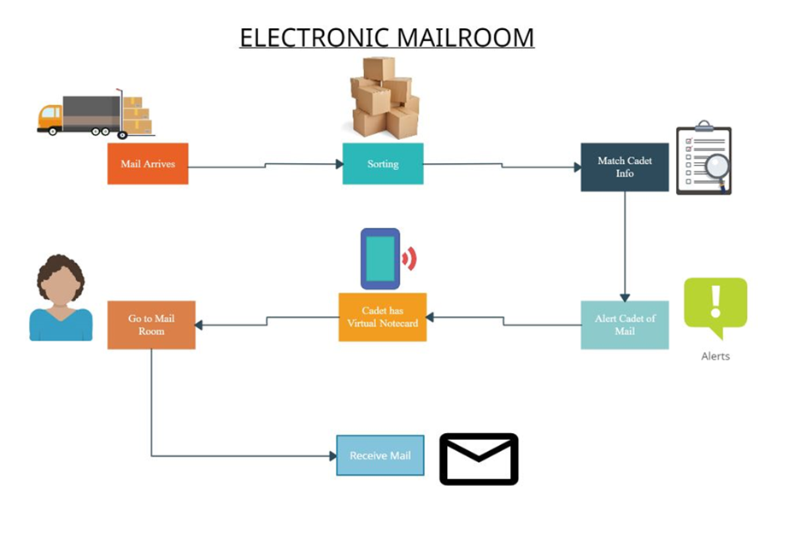
Figure 1. Context Diagram

Requirements Analysis
Requirements are decided on early in the process when a smaller understanding of the project is known. These requirements are constantly updated as the preliminary steps occur. This constitutes agile development since requirements were not finalized and constantly changing as we made new discoveries. Interviews, surveys, and constraints contribute to the finalized requirements needed to finalize the design.

Interview Summaries
We interviewed the key stakeholders for the project including the mail room staff, IT department, and the Corps of Cadets through a survey. This allowed us to edit and add requirements for our system as well as conduct a cost/benefit analysis.

Mail Room Interview
We asked the mailroom four major questions that were focused on getting information on how the mailroom currently operates and how our project would positively/negatively affect their workflow. The first question was if an electronic notification system would benefit the mailroom, the answer was an enthusiastic yes. The second question was how difficult it would be to integrate an application to scan packages for a database after sorting. The mailroom staff said it would be about the same process they already have in place. It would just change the process in how they do it. Our last two questions focused on ease of use for the mailroom staff. They said that it would make the sorting process faster since it would not take as long to scan the packages in and look up the name/box number. Lastly, a few things that the mailroom staff would need access to is the database that holds the cadets name, email, and box number so they can look it up quickly and write in on the box. They currently have a binder with all cadet names and box numbers that takes more time to look through before writing the number on the box. An online database that can query names would speed up this process. They also emphasized the issue with packages being sorted slowly and cadets constantly asking if their package has arrived. They currently have a sign telling cadets not to ask about their package if they do not have a notecard in their box. However, the mailroom admitted that the sign does not defer cadets from continuing to ask.

Cadet Survey
The survey was sent out to the corps of cadets. The survey asked 4 simple questions to inquire about the cadet's interactions with the mailroom. The survey was filled out by 172 cadets. Of those only two did not have a smartphone. Most of the respondents, 160 of the 172, said that they have experienced timing issues when picking up a package. Finally, 148 of the 172 said that they would download an app while the others would not. This information was expected, we knew that the cadets would want a different system than there was and many of them had smartphones and would download an app. The final question was a free response for anything the thought would be useful. This provided some tips that were very helpful. The majority of the responses in this section focused on two things, notifications, and no additional work for the mailroom. Multiple cadets asked for a notification system of sorts, either a text or email. There was a large response rate to the amount of work that would be done by the mailroom staff and cadets suggesting that the system should not create extra work for the mail room.

IT Department Interview
The scope of our project was changed drastically after interviewing the IT department. Some constraints were placed on our project if it were to be pursued at the Academy. For instance, the IT department suggested that a brand-new application constructed from scratch would be complicated compared to other options. The easiest option would be to use the existing EDU database and Microsoft 365 systems at the Academy. They also suggested finding an existing application to assist in our system rather than a brand new one. This would be something similar to the external desire2learn system that is connected to our EDU database and can send automated emails. This led us to decide on finding an application that could access and manage the EDU database as well as send automated emails when a package has been sorted.
The next important aspect of the interview with IT was dealing with the mailroom scanners. Currently, the scanners only scan the barcode which does not have information on the name of the person it is delivered to. They stated that the mailroom would still need to input something about the cadet such as their name into the system in order for them to be notified. We have determined that it may be possible for the mailroom to continue using their scanners only for delivery and pickup but after sorting use a different device. This could be a laptop where they simply enter the name on the box, and this triggers the database to send the email notification to the cadet. This still makes the process easier for the mailroom and follows constraints set by the IT department.
When asked about the time it would take for the project to be completed, the IT department explained that it always depends. There are factors such as human resources and priorities. It also depends on the type of development used such as agile. They also explained that adding people to the workload does not always assist in completing the project and can even make it more difficult or complex.

Cost Benefit Analysis
The monetary cost of our project would be close to zero due to using a free application and an existing database. Furthermore, there would not be new technology implemented as far as scanners. There may need to be laptops distributed to the mailroom staff although there may be options of existing EDU laptops that IT has and can provide.
There may be some cost as far as time taken to implement. This includes time to present the project to stakeholders, get approved, and make updates so that it is perfected for use. Additionally, larger testing will be required, and this adds time. However, there should not be a need for too many humans to work on the project because we use an existing application and have most of it determined. This is also due to simplified logic and minimal coding. There are also limited physical resources needed. As mentioned before, a few laptops will be required for the mailroom but that would be all that is physically necessary. Additionally, there would be time and resources taken to train the mailroom on the use of the system. They are not used to a modern system and may have different technological skill levels. However, the system is simple to use and would be easy to learn. Training would require a few humans from either the project group or IT department.
The benefits of the project would include an easier process for the mailroom, less exhaust of cadets checking for packages, and a more technologically updated system rather than an outdated one. The mail room would not need to look up box numbers manually in a binder or be badgered by cadets asking about their packages. They would also not need to write box numbers on notecards, search for the box on the wall, or place it in. The cadet would only need to bring their email notification as their new notecard. Cadets would not waste time checking over and over for packages. The benefits of the system far outweigh the low costs and this outdated system needs to be updated as the world today is surpassing previous methods with new technology.

System Requirements
Table 1. Functional Requirements
Req. # | Requirement | Stakeholder | Type
1.1 | The system shall leverage the USCGA EDU domain and be compatible with Office 365 | IT Department | Functional
1.3 | The system shall send automated email to notify cadets of their package being ready for pickup | Mail room staff/Cadet users | Functional
1.4 | The system shall allow the mail room staff to write additional information in the automated emails | Mail room staff | Functional
1.5 | The system shall include Cadets’ full name in the database corresponding to their email address | Mail room staff | Functional
1.6 | The system shall include Cadets’ P.O. box number in the database corresponding to their email address | Mail room staff | Functional
1.7 | The system shall allow mail room staff to search for Cadet email by Cadets’ first names. | Mail room staff | Functional
1.8 | The system shall allow mail room staff to search for Cadet email by Cadets’ last names. | Mail room staff | Functional
1.9 | The system shall allow mail room staff to search for Cadet email by Cadets’ P.O. box number | Mail room staff | Functional
1.9 | The system shall allow mail room staff to manually input cadet email if necessary. | Mail room staff | Functional

Table 2. Non-Functional Requirements
2.1 | The system should only give automatic email sending access to the mailroom staff. | IT department | Non-Functional
2.2 | The system should require correct username and password to log in | IT department | Non-Functional

Use Case
The Use Case diagram in Figure 2 is a depiction of how the users interact with the system. The mailroom is on one end of the system sorting packages and entering cadet information to the internet application. The system is doing its job of finding the cadet information in the database and sending the automated email. The cadet users are receiving notification of their package and going to pick up their package.

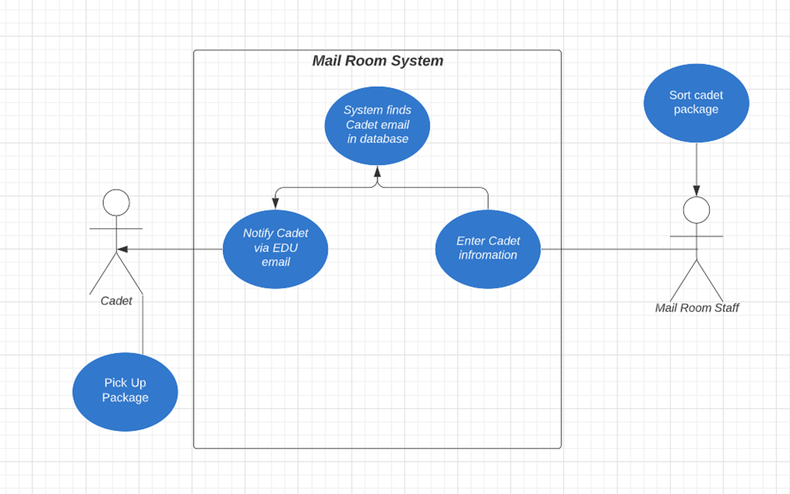
Figure 2 – Use Case Diagram

Design
The design part of the lifecycle includes deciding on architecture and workflows. It also contains preliminary testing of the system demonstration thus far. It does not include further in depth testing that would take place if the project were accepted for implementation. Here is where the existing application is decided on for use in our system.

Layered Architecture
For this software engineering project, we decided that the best architecture pattern to follow is the Layered Architecture pattern. The Layered Architecture pattern allows for separation and independence in the architectural design process, which is vital when changes are going to have to be made while the application is being developed. The layered approach is supportive of incremental development, which is when a system is developed in stages and supports the process of altering different components when we have already moved past that stage. This design pattern also makes it so that the architecture is changeable and moveable, which allows for extended functionality when new layers need to replace existing layers.

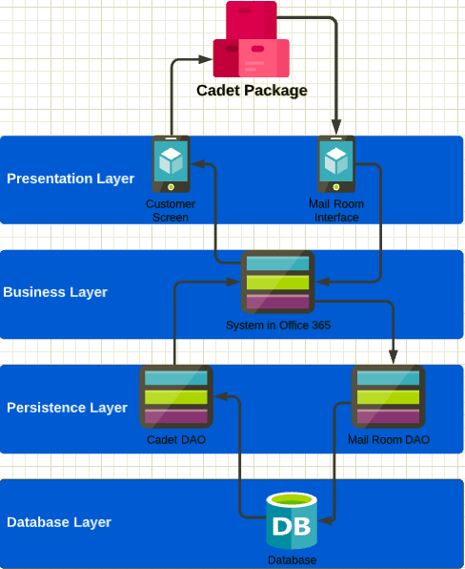
Figure 3. Physical Workflow of Layered Architecture

Architecture Description
The Layered Architecture system that we developed is a 4-layered process that divides each major part of the Mailroom notification system into its own section. Each of the four sections have individual responsibilities and requirements that are associated with them. Figure 3 depicts the flow of the architecture and a broad overview of how the system works with each different component. The four layers (presentation, business, persistence, and database) are specifically designed to organize the process for both the users, mailroom staff and cadets.

Presentation Layer
The presentation layer is the interface that either the mailroom staff or the cadets visually see and interact with. For the mailroom staff, this interface looks like a simple screen that populates a fill box to enter the cadet’s name or box number from the scanned package. The mailroom staff will have to manually enter this information based on the scanned information. For the cadet’s interface, this will be the outlook 365 application that every cadet is already familiar with. This layer is also responsible for the notification system that notifies a cadet that their package is waiting for pick-up. Another aspect of this layer is the ability for the mail room to manually look-up and enter a cadet’s box number or last name. For example, if the scanned package does not have the correct information or the scanner is unable to read the information, the mailroom staff will be able to manually look up a cadet’s name by searching the box number or vice versus and then manually push the notification to the cadet’s inbox.

Business Layer
Within the business layer we associated the bulk of the process and operations of this project. This layer is responsible for identity management. This is the process of using a singular input to then search and populate the information (name, email, and box number) of the cadet that the package belongs to. In Figure 3 this layer is depicted as the “systems in Office 365”, the system being utilized in this layer is dependent on the user. The mailroom staff will be utilizing the Power Automate application within the Office 365 system. This application is essentially what runs this entire project. The Power Automate application is what allows the mailroom to search for cadets by either box number or name, it also allows for the automated email to be sent to the correct individual based on the input the mailroom staff enter. On the cadet side of the system, the Outlook application within Office 365 will be utilized. The cadets will receive their notification of a package in their name through the cadet’s specific email address.

Persistence Layer
The Persistence Layer is what connects the database to the Office 365 applications. This layer is responsible for the way the entire project runs and that with everyone iteration the system will run the same. This layer is also responsible for updating the database and committing the changes that occur annually. The changes that will occur annually are the deletion of the graduating classes information in the database and the input of the new freshman class. The Mailroom DAO (data access object) is the process that will receive the information from power automate, i.e., cadets name or box number, and then send to the database to pull the cadets email that is associated with the entered information. Then the database will return the cadets email to the Cadet DAO which will then connect the email to the Outlook 365 application and send the notification to the Cadet’s inbox.

Database Layer
This layer is what holds all the information of the Corps of Cadets. Within this layer there is a form that has three boxes related to each Cadet. These three boxes are the Cadet’s name, Cadet’s mailbox number, and the Cadet’s EDU email. The database will allow a query to call any of the three boxes and will return all three boxes of information. This layer is what relates all three aspects and assigns them to one individual Cadet. The process is that the layer receives the information from the Mailroom DAO, which comes from the Power Automate query, and finds the cadet’s email. Once the cadet’s email is found, it is then sent to the Cadet DAO which queries a message that is sent to the Outlook application.

Workflows

Workflow Diagrams

Workflow Descriptions

Component Proposal

Preliminary Testing

Process
The overall process describes how we worked as a team to complete this project proposal and come up with a fully workable system. It includes our split of tasks, complexity velocity, results, reflection, and further work to be done.

Team Assessment
Our team focused on a “divide and conquer” ideology for this project. We began by splitting our project into smaller tasks to be completed weekly in “sprints”. We then decided on how complex each task would be and who would complete each task. We would get together during lab periods and see what we had to do for that week's sprint. We would take that information and branch it out for each person to get some amount of work to complete during that sprint. Then at the end of the sprint we would bring all our work together and create a combined document or bring our data together to create a full set of data. With each week broken up into a sprint of work and each sprint broken up to each member, it allowed us to have more time on each part. This allowed for maximum work done within a short amount of time. At times we would get ahead on work and would be able to work on future sprints. Thus, allowing for more time on more complicated items. The challenge we faced with this process was the lack of change management for our project idea. Since each of us was busy with our own challenges, at times there was a lack of updates from each other on changes that we had made on the project idea overall. Another challenge we faced was communication since we would meet one to two times a week in person we would need to communicate via teams, email, or other messaging systems. This would mean there might be a delay with replies.
Julie, Madison, and Hali split the interviews into three parts that one person took responsibility for and wrote summaries of. Madison took responsibilities of team manager and outlined tasks on our project board as well as assigned complexity. Hali also worked on the architecture and Julie on the Requirements portion. Casey found the Office 365 application and completed testing, design, and logic of the proposed system. We had many meeting periods where the system needed to be reconfigured with discussion and problem solving between team members. These discussions were very successful and allowed smoother progress. Overall, this process, although it had some challenges, turned out to be a major success. It created less pressure, more communal work, and better teamwork.

Assessment of Complexity Velocity
Each sprint was evaluated with a complexity value from 1 to 6 with a value of 1 being least complex and 6 being most complex. Each task was also evaluated in our project board which averaged to the sprint values.

Sprint 1:

Complexity Value = 3
This sprint was the start of our project. We set up a description of what we were planning on doing, the problem we were facing, and creating the project outline. The outline included the requirements we were seeking as well as the initial architecture we had in mind. This would be on the more complex side of the task scoring. This is because at the start of the project we did not fully understand the direction we were heading. We set up our project board with tasks for each sprint. This week was more of setting up the map for our future weeks.

Sprint 2:
Complexity Value = 2
In this sprint, we acted upon our initial ideas of who was at stake within our project. We decided on the stakeholders being the mailroom staff, the IT Department, and the Corps of Cadets. We went out and interviewed each of these stakeholders. This process was not as demanding as other weeks and gave us a better understanding of the direction we were heading.

Sprint 3:
Complexity Value = 2
The middle week was one of the less complex weeks. It required a summary of the work done over the last two weeks. We followed up on the previous week and continued to finalize the details from there. We summarized each of the interviews as well as wrote a basic architecture.

Sprint 4:
Complexity Value = 4
This week was a complex week. It was also when our project switched a little bit. We went from an app that was just an idea to using an existing application through Office 365. We found the application Power Automate and this was the decided component. This caused additional complexity as we updated our project requirements, adjusted our workflow, and updated the architecture. This caused for a change in everyone's parts and a change to how we would go about the rest of the project.

Sprint 5:
Complexity Value = 4
This week was when we started to finish up the rest of the required material for our final document and presentation. It is also the week where we completed the power automate functionality and got it to a working form. This was complex because we had new requirements and would come across more and more issues that had to be solved.

Sprint 6:
Complexity Value = 3
This is the last sprint. This is where we finalize all documents and test all functional pieces to make sure everything works. This was not as complex as the previous parts but still required a good amount of work to finish. This ensured that our presentation is ready, the demonstration is ready, and all required documents are up to date and prepared for submission.

Summary and Results
(add how project could be updated with scanner capabilities in the future)

Demonstration

