VANTARE VANTAGE SUIT

Milestone Report
Functional Verification of App Pairing, BLE Communication, Movement Tracking, and Session Retrieval
Date: 11 September 2026

Overview
This report provides a status update on the Vantare Vantage Suit program. The functional milestones covered below — application pairing, BLE communication, movement tracking, session retrieval, and integrated system operation — have been implemented and verified on the current prototype: the Master hub together with the sensor nodes in use. Progress against the full project requirements is summarized in the status table, and the working functionality is demonstrated in the accompanying video walkthrough.

Milestone Status
Functionality | Completion | Demonstrated in Video
App Pairing | Complete | Yes
BLE Communication | Complete | Yes
Movement Tracking | Complete | Yes
Session Retrieval | 80–85% | Yes
Integrated System | 50–60% | Yes
Completion percentages reflect progress against the full project requirements.

1. App Pairing Functionality
Pairing between the suit and the host software is implemented and verified on the current prototype.
• The live web session connects to the Master using the suit’s BLE interface. The mobile application will use the same interface and connection parameters, so it connects on the same basis as the verified web session.
• Mobile application development is progressing in parallel, and the majority of its core functionality has already been completed.

2. BLE Communication Functioning
Wireless communication is implemented and working across the full data path:
• Node to Master: the Master connects to the sensor nodes and exchanges live data and recording transfers with them.
• Master to host: the Master streams live sensor data to the host application over BLE.
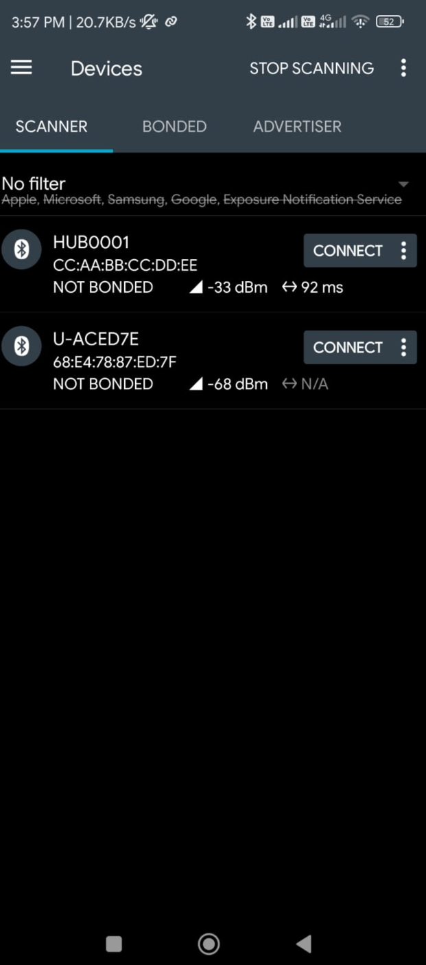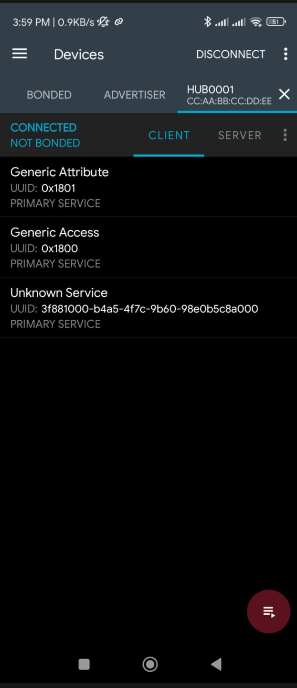
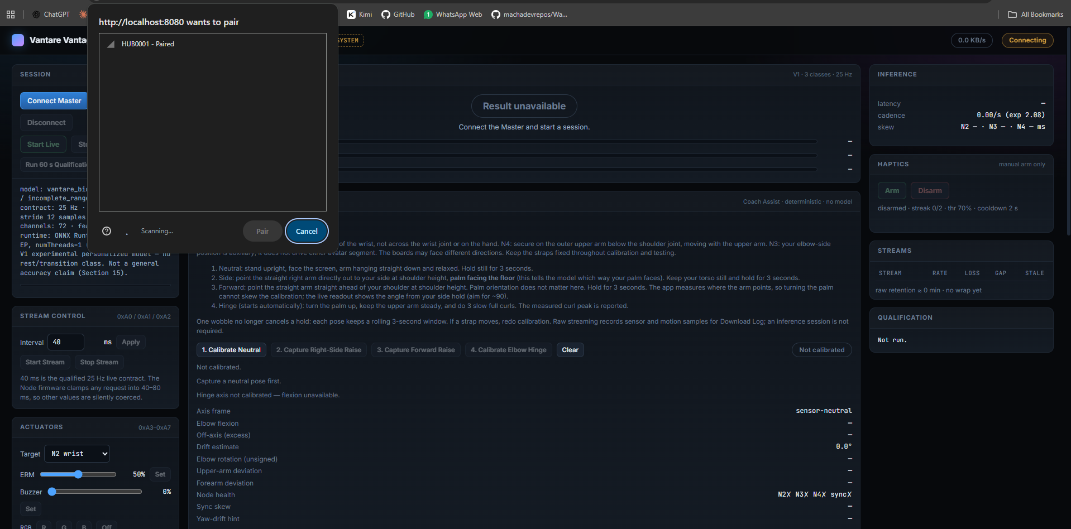
We can connect to the master its Bluetooth identity is named as HUB0001 and we can connect to it via both the desktop webpage and phone application as well the phone screenshots are for nrf connect app which is used to test the Bluetooth working for projects that use BLE.
The same parameters are configured in the application side and the app will be able to communicate with the system easily.
The links are configured for MTU 247, data length 251, and 2M PHY. The Master-to-host link uses the same BLE interface for both the web tool and the mobile application, so the verified web connection confirms the communication path the mobile application relies on.

3. Movement Tracking Functioning
Movement tracking is implemented and working. Using the three sensor nodes in use on the current prototype, arm movement was instrumented, mapped, and tracked in real time. During a session, motion data flows from the nodes through the Master to the application, where it is visualized and processed. The complete tracking pipeline is operational and demonstrated in the accompanying video.
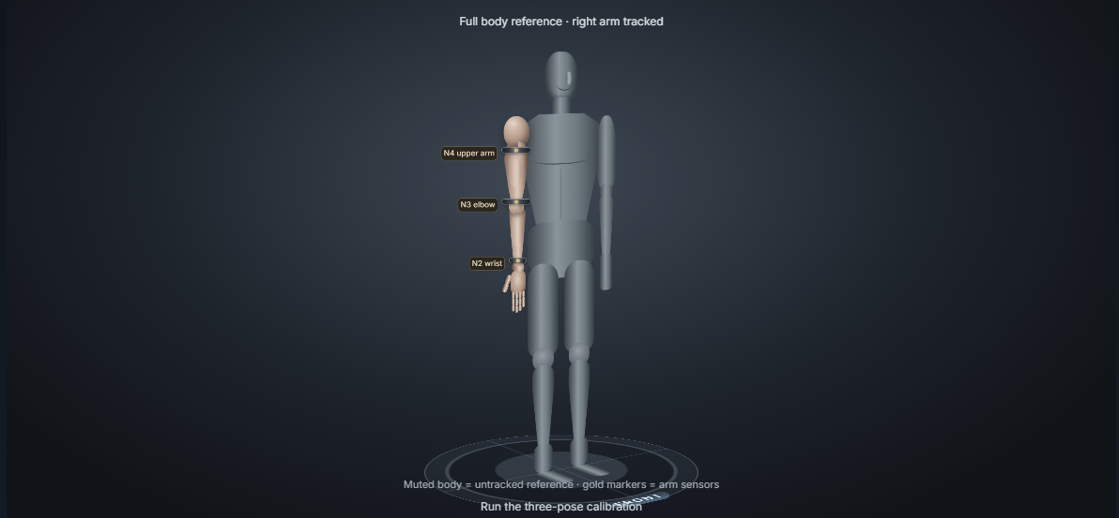

4. Session Retrieval Functioning
Session recording and retrieval are implemented as follows:
• During a live session, each node records its data locally to its on-board flash memory.
• When the recording completes, the node transfers the session to the Master, which validates the data and stores it on the on-board SD card.
• Completed sessions remain on the SD card indefinitely — they are never deleted automatically, so any completed session can be retrieved at any time by removing the SD card from the Master and reading it on a computer.
• Only complete sessions are stored. If a recording is interrupted before it completes — for example, if power is lost during capture — the partial data is discarded and the session is reset on the next boot rather than retrieved, since an incomplete capture may be corrupted and unsuitable for analysis.
Core retrieval of completed sessions is implemented and in use, representing approximately 80–85% of the full retrieval scope. Recovery of interrupted sessions is not included in the current implementation; if this capability is required, it can be added as a future enhancement.

5. Integrated System Demonstration
The functions described above are implemented and operating together on the current prototype — the Master hub and the sensor nodes in use. In a live session, the nodes connect and communicate with the Master, movement data is streamed to the application, and sessions are recorded and stored on the SD card for retrieval. This end-to-end operation is demonstrated in the accompanying video.
Against the complete project requirements, integrated system completion is currently estimated at 50–60%. The remaining scope covers full-suit scale-up and end-to-end validation across the complete suit configuration.

Demonstration Video
A walkthrough video demonstrating the functionality described in this report is available at the link below.
Video link: https://drive.google.com/file/d/1sRf4wm2eMPCnjv2l-a5dvuPhXvoQJqXe/view?usp=drive_link

