Michael Chang (machang), Mitchell Lee (mklee1)

18-441

Project 2 Design Document

Packet Format:

Below, we have included our own packet format. It is similar to TCP, but is more of a barebones version. It includes less information, but we have chosen to retain some of it. For example, we chose to retain the source port and destination port for sending purposes. We also include the checksum for error correction. Lastly, we include the sequence and acknowledgement numbers to aid in setting up the connection. In order to maintain the format, we include 16 bits of padding after the checksum before sending the actual packet information.

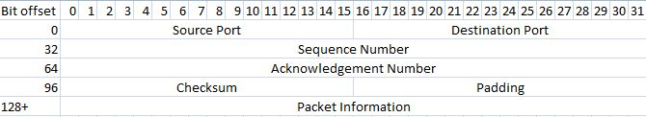

State Transition Diagram:

Last_Ack

Receive

Wait

TCP-lite Handshake Connection

Failed

Closed

Ack Received

Ack sent

Syn Sent

Established!

Syn Received