ATL Housing: Households Served

Manual workshop attendee workbook
Build it yourself in Microsoft Fabric | Browser-first | Two-day lab
Edition 1.1, November 11, 2026 UTC. Based on the supplied ATL Housing execution
guide, draft v0.4. Screenshots are from the actual ATLhousing reference environment;
they are not mockups. Fabric menus can change; identify controls by their labels.
What you will build: original Excel landing, metadata-driven SQL ingestion,
typed Warehouse staging, dimensional transformations, an explicit Direct Lake
model, the HT1-HT10 report, Spark DQ and a monitored master pipeline. The requested
AI extension adds a source-grounded business ontology and a published data agent,
with manual setup and 15 sample question/answer exercises in M15-M16.
This is a manual build, not an automation quick start. You will click the
Fabric controls, create each item, enter settings and paste the supplied SQL,
Power Query, DAX and notebook cells yourself. Do not run deploy*.py, the data
generator or the source loader.
Protect the reference build. Build only in the participant workspace assigned
by the instructor. The shared ATLhousing workspace shown in screenshots already
contains the reference solution. If you have not been assigned a separate build
workspace, use the inspection track: open items, compare settings and run
read-only checks, but do not save changes, reload tables or start pipelines.

Module index
How to use this workbook
M1. Sign in, inspect the kit and confirm access
M2. Create the Warehouse, Lakehouse and manual Excel landing
M3. Create connections, schemas, metadata and staging tables
M4. Build the metadata-driven SQL pipeline manually
M5. Create the real Excel Dataflow Gen2
M6. Build production dimensions and facts
M7. Assemble the base master pipeline and failure handling
M8. Create DimDate, with a supported Copilot fallback
M9. Create and configure the explicit Direct Lake model
M10. Author the HT1-HT10 report manually
M11. Optional presenter lab: mirroring versus shortcuts
M12. Governance and DevOps, administrator/presenter-gated
M13. Spark DQ, reconciliation and the final master acceptance run
M14. Conditional presenter lab: Azure Databricks Unity Catalog
M15. Build the ATL Housing business ontology
M16. Build, test and publish the housing data agent
Final attendee sign-off
Troubleshooting at the point of failure
Asset index and repeatability notes

How to use this workbook
- Extract the companion lab ZIP before starting; do not open files inside the ZIP.
- Keep this PDF or Word document open beside Fabric. The offline HTML version has
clickable local asset links; the PDF/Word links also have private-repository
equivalents. If a link is unavailable, open the printed file path in Notepad.
- Use workshop-assets for copy-and-paste content and data\excel for the
unchanged original workbooks supplied in the distribution pack.
- Finish each module's Check / Stop / Catch-up before continuing.
- Record your own resource IDs and run IDs. Values in screenshots identify the
reference environment, not values to copy into a different participant workspace.
- Ask the instructor before changing permissions, enabling a schedule, sending an
alert, applying a label, creating workspaces or changing source configuration.
No Azure capacity purchase, source restore, SQL source reload, source-row update
or public GitHub Pages publishing is part of the attendee build.

Suggested two-day sequence
Day | Modules | Work product
1 morning | M1-M3 | Access, landing, connections, schemas and control/staging tables
1 afternoon | M4-M7 | SQL and Excel ingestion, transforms and base master pipeline
2 morning | M8-M10 | Date dimension, Direct Lake, measures, RLS configuration and report
2 afternoon | M13, return to M7 | Spark checks, final reconciliation/framing and accepted master run
Presenter/admin sessions | M11, M12, M14 | Conditional zero-copy, governance, DevOps and Databricks modules
Additional AI lab, 60-90 minutes | M15-M16, after M9/M13 | Business ontology, published data agent and grounded Q&A

M13 is deliberately completed before the final M7 acceptance run. The report's
DQ page is created in M10 and receives actual run results in M13.

Your resource worksheet
Complete the right-hand column with the instructor. Never substitute an
unrelated existing connection just because it is visible.
Setting | Reference / required value | Your assigned value
Tenant/account | Approved workshop tenant; organizational account | __________________
Build workspace | Instructor assigns an isolated participant workspace | __________________
Workspace ID | Reference only: 4d77b5c8-d96f-41df-83e1-954c582336d8 | __________________
Capacity | Existing approved capacity; reference is F8, West US 3 | __________________
SQL server | sql-atlhousing.database.windows.net | __________________
Source database | ATLHousing, schema hs | ATLHousing
Source access | Read-only for the workshop; no destructive loader | Confirmed: ______
Storage | fabridemo, container atldemo | Confirmed: ______
Lakehouse | LH_ATL_Landing in your workspace | ID: ______________
Warehouse | WH_ATL_HS in your workspace | SQL endpoint: ____
Approved Excel batch | Instructor assigns a unique folder/batch name | __________________
Semantic model | SM_HouseholdsServed in your workspace | ID: ______________
Ontology | ONT_ATL_Housing, same validated model | ID: ______________
Data agent | DA_ATL_Housing, published only after testing | ID: ______________
Viewer/program map | Approved identity and allowed program codes | Pending / ________
Fiscal calendar / label | Business-approved values only | Pending / ________
Alert / schedule | Approved destination and enablement decision | Pending / ________

Important corrections to the draft execution guide
Draft shorthand | Use in this workshop
Example source database name | The user-approved source is ATLHousing
Approximate source counts | Use the verified count table in M4, not approximate draft numbers
Unit.PropertyKey | Source Unit has PropertyID; resolve the dated property version
FamilyMember.MemberKey | Source FamilyMember uses HouseholdID; do not join it to every snapshot
Summarized supportive totals | Original roster columns are ReportMonth, HouseholdID, Program, SupportType
Global staging truncate first | Do not globally truncate; use current-run landing and transactional publication
Distinct household count | Preserve household-program-month observations, including second-program records
Hide source personal columns | Exclude unnecessary columns from the model; hiding is not security
All guide modules already accepted | Core data/report works; security, alerts, schedules and presenter modules have explicit gates

M1. Sign in, inspect the kit and confirm access
Objective: start with the correct tenant, approved existing resources and
readable original data. Prerequisite: instructor-assigned workspace and access.
- Open https://app.fabric.microsoft.com in Edge or Chrome.
- Sign in with the approved workshop organizational account. If an account picker
appears, choose the workshop tenant, not a personal or unrelated work account.
- Select Workspaces, then your assigned workspace. Confirm its name with the
instructor before creating or editing anything.
- Open Workspace settings and inspect the license/capacity assignment. Do not
start a trial, resize a capacity or create a new paid resource as a workaround.
- Confirm that you can create Fabric items and that the source SQL connection
can be used or created. Contributor/Member authoring access is not a Viewer
RLS test. On the reference F8, confirm appropriate Power BI Pro/PPU or an
approved existing trial for report authoring/Viewer consumption; the Fabric
capacity alone is not a free report-viewer license.
- In the extracted lab pack, open data\excel. Confirm 24 .xlsx files:
12 UnitAvailability_YYYYMM.xlsx and 12 SupportiveHousing_YYYYMM.xlsx,
covering January-December 2025.
- Open a sample of each workbook type in Excel. The UnitAvailability sheet is
UnitAvailability; the supportive sheet is Roster. No password should be
requested. Close without saving changes.
- Use the readable originals from the kit. The original storage excel/ blobs
in this environment were encrypted; do not overwrite them or attempt to remove
their encryption. A password prompt is a Stop, not a reason to regenerate data.
- Keep source SQL and storage read-only. CSVs are controls/bootstrap alternatives;
they are not a second feed to append on top of SQL.
Check: correct workspace, authorized source access, 24 readable originals.
Stop: missing access, an unexpected tenant, encrypted files or production data.
Catch-up: instructor supplies access and the original kit; no regeneration.
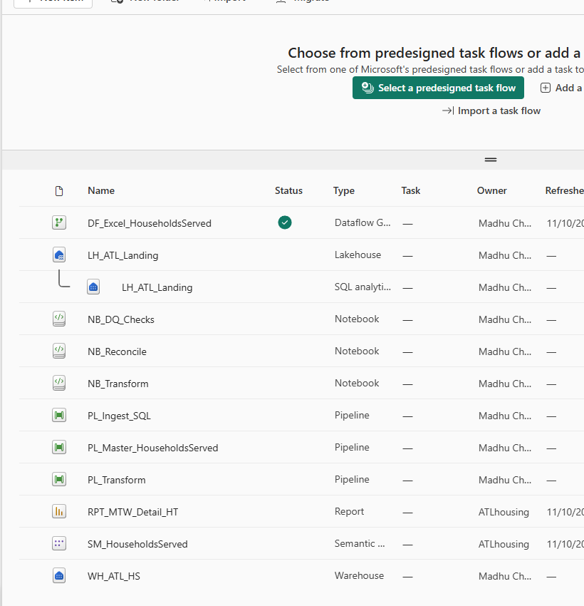
Figure 1. Reference workspace after the build. Your participant workspace starts
empty. Use New item to create each artifact in the following modules.

M2. Create the Warehouse, Lakehouse and manual Excel landing
Objective: create your destination objects without altering the source.
- In your assigned workspace, select New item. Search for Warehouse,
select it, enter WH_ATL_HS and choose Create.
- Return to the workspace. Select New item > Lakehouse, name it
LH_ATL_Landing and choose Create. Use the default supported Lakehouse
options unless your instructor has provided a different configuration.
- Open the Lakehouse. In Explorer, expand Files.
- From the Files folder menu, choose New subfolder and create landing.
Inside it create excel, then the unique approved batch folder from your worksheet.
- Open that batch folder. Use Upload > Upload files, select all 24 original
.xlsx files from data\excel, and wait for every upload to complete.
- Confirm the folder contains all 24 workbooks, with the original filenames.
Do not place a second copy in nested folders or combine previous batches.
- Record the Lakehouse ID. Open its URL or use the item details/link: the ID is
the GUID identifying the Lakehouse, not the workspace GUID.
- Record the workspace ID separately. You will use both values in M4 and M5.
- Only an authorized administrator assigns approved Entra groups through
Manage access. Do not create the draft guide's suggested groups or grant
roles to guessed identities.
Check: one Warehouse, one Lakehouse, exactly 24 originals in
Files\landing\excel\<your-approved-batch>.
Stop: the current folder is the shared reference Lakehouse or an old batch.
Catch-up: inspect the reference folder with the instructor; do not replace it.
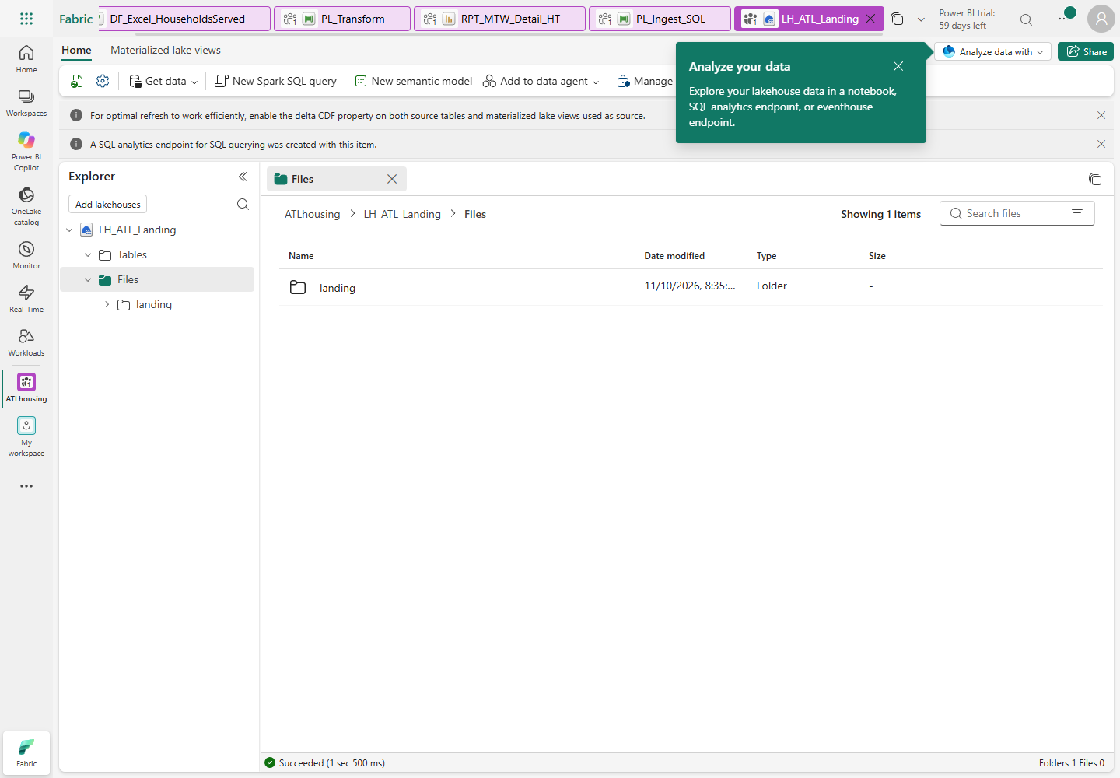
Figure 2. Start from Files and create folders before uploading; Tables is a different area.
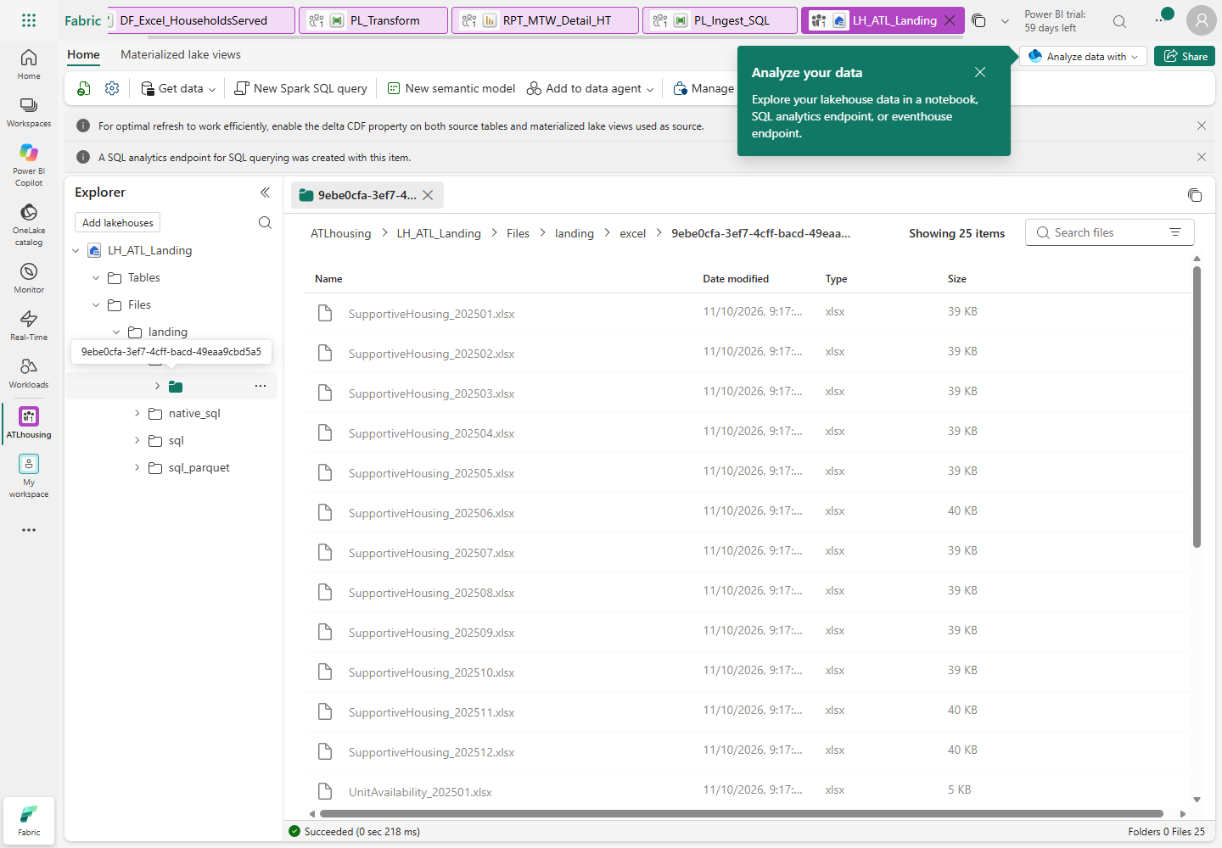
Figure 3. Reference batch of original workbooks. Use your own folder/batch ID.

M3. Create connections, schemas, metadata and staging tables
Objective: prepare the destination and an approved organizational SQL connection.

M3.1 Connect to the existing SQL source
- Open the Fabric Settings gear and Manage connections and gateways.
- If the instructor has shared the dedicated approved SQL connection, select and
test that connection. Otherwise select New > Cloud.
- Enter connection name ATL_HS_SQL_Source (or your instructor-assigned unique name).
- Choose the supported SQL Server/Azure SQL connection type offered by the dialog.
The pipeline source connector in M4 is Azure SQL Database.
- Enter server sql-atlhousing.database.windows.net and database ATLHousing.
- Choose Organizational account / Microsoft Entra ID, sign in with the approved
workshop account, and use an encrypted connection. Do not choose an unrelated
gateway or copy another person's connection credentials.
- Set privacy level Organizational where offered. Do not select Skip test
connection. Test and create the connection.
- If you lack connection-creation or sharing rights, stop for the administrator.
Do not fall back to a SQL password, storage key or SAS token.

M3.2 Execute the destination SQL manually
- Return to your workspace and open WH_ATL_HS.
- Select New SQL query. Verify that the selected database is the Fabric
Warehouse WH_ATL_HS, not the source Azure SQL database.
- Open 01_foundation.sql in Notepad. Copy its
complete contents into the Fabric SQL editor and choose Run.
- Open a new query and repeat with
02_source_staging.sql.
- Repeat with 03_transform_procedures.sql.
This creates procedures; do not execute the fact loaders before ingestion.
- If your editor does not accept GO, run the blocks between GO separators
individually, in order. Never remove validation or exception handling.
- Refresh Explorer > Schemas. Inspect stg, prd and mtd.
- Confirm the ten source staging tables plus stg.AnswerKey, the two Excel staging
tables, control tables, prd.DQ_Results and the stored procedures.
- Run the following query in the Warehouse:
SELECT SourceSchema,SourceTable,TargetTable,LoadType,WatermarkColumn,IsActive
FROM mtd.TablesToCopy ORDER BY SourceTable;
- Expect ten active Full entries. Watermarks are NULL: this workshop does full
loads, not a falsely advertised incremental Member load.
- Copy the Warehouse's SQL connection string from its settings/Home command.
Record only the server hostname as WAREHOUSE_SQL_ENDPOINT; notebook cells
must not contain a whole connection string or an Azure SQL source hostname.
Check: ten active metadata entries, correctly typed empty destination tables,
and four relevant procedures including mtd.usp_LogRun.
Stop: a SQL editor points to ATLHousing while you are about to execute DDL.
Catch-up: paste the same reviewed SQL files manually into your assigned Warehouse.
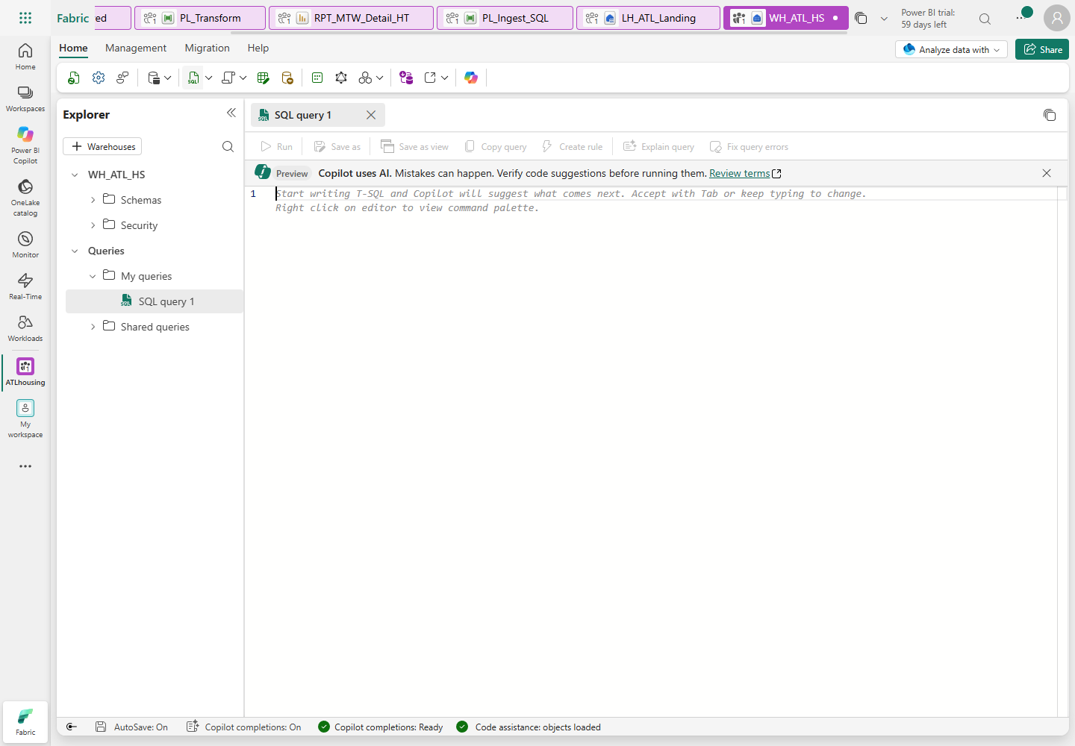
Figure 4. New SQL query is the manual execution surface. Refresh Explorer after DDL.

M4. Build the metadata-driven SQL pipeline manually
Objective: SQL SELECTs -> immutable run-scoped Parquet -> transactional staging.
This deliberately avoids the draft's global truncate-first pattern.

M4.1 Create the Lookup and ForEach
- Return to the workspace. Select New item > Pipeline, name it PL_Ingest_SQL.
- On the activity ribbon add Lookup. In General, set its name to
Lookup active full-load tables.
- Open Settings. Select your WH_ATL_HS Warehouse connection, choose Query,
and paste lookup.sql.
- Clear First row only. If you preview, expect ten rows and the three columns
SourceSchema, SourceTable and TargetTable.
- Add ForEach, named ForEach SQL table.
- Drag the Lookup's green On success connector to the ForEach.
- Select ForEach > Settings. Leave Sequential unchecked, set Batch count
to 4, and use Add dynamic content for Items:
@activity('Lookup active full-load tables').output.value
- Keep these exact activity names: later expressions refer to them literally.
- Set activity retries to 0 for this controlled lab. Do not configure overlapping runs.
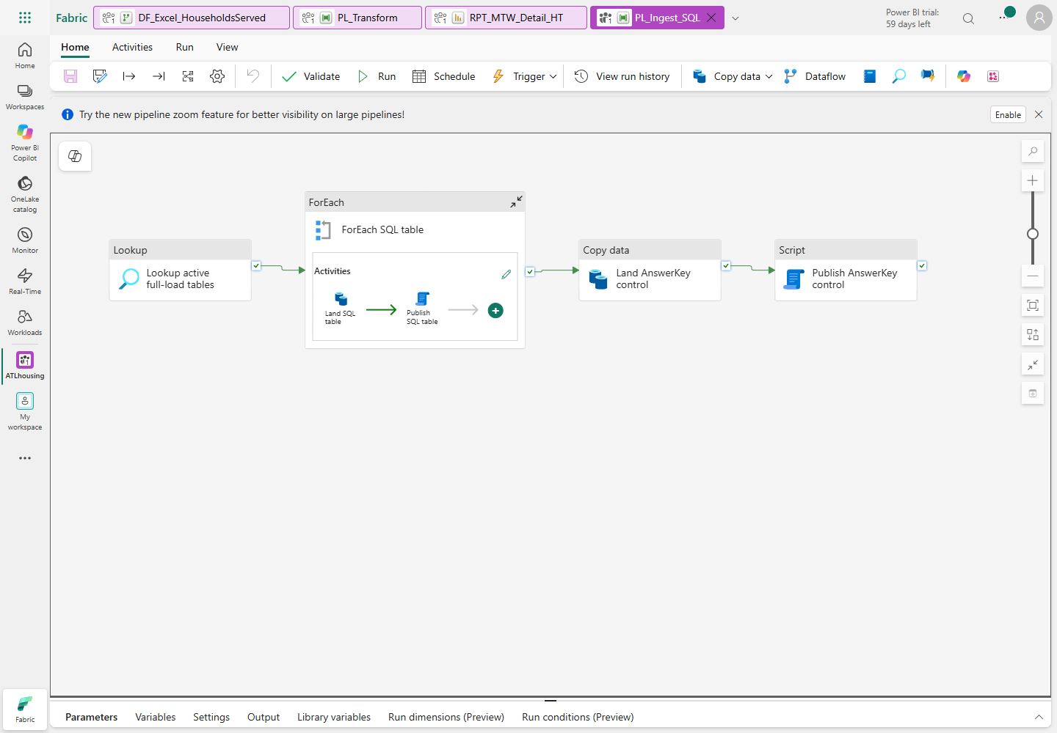
Figure 5. The control AnswerKey copy is outside the ten-table ForEach.
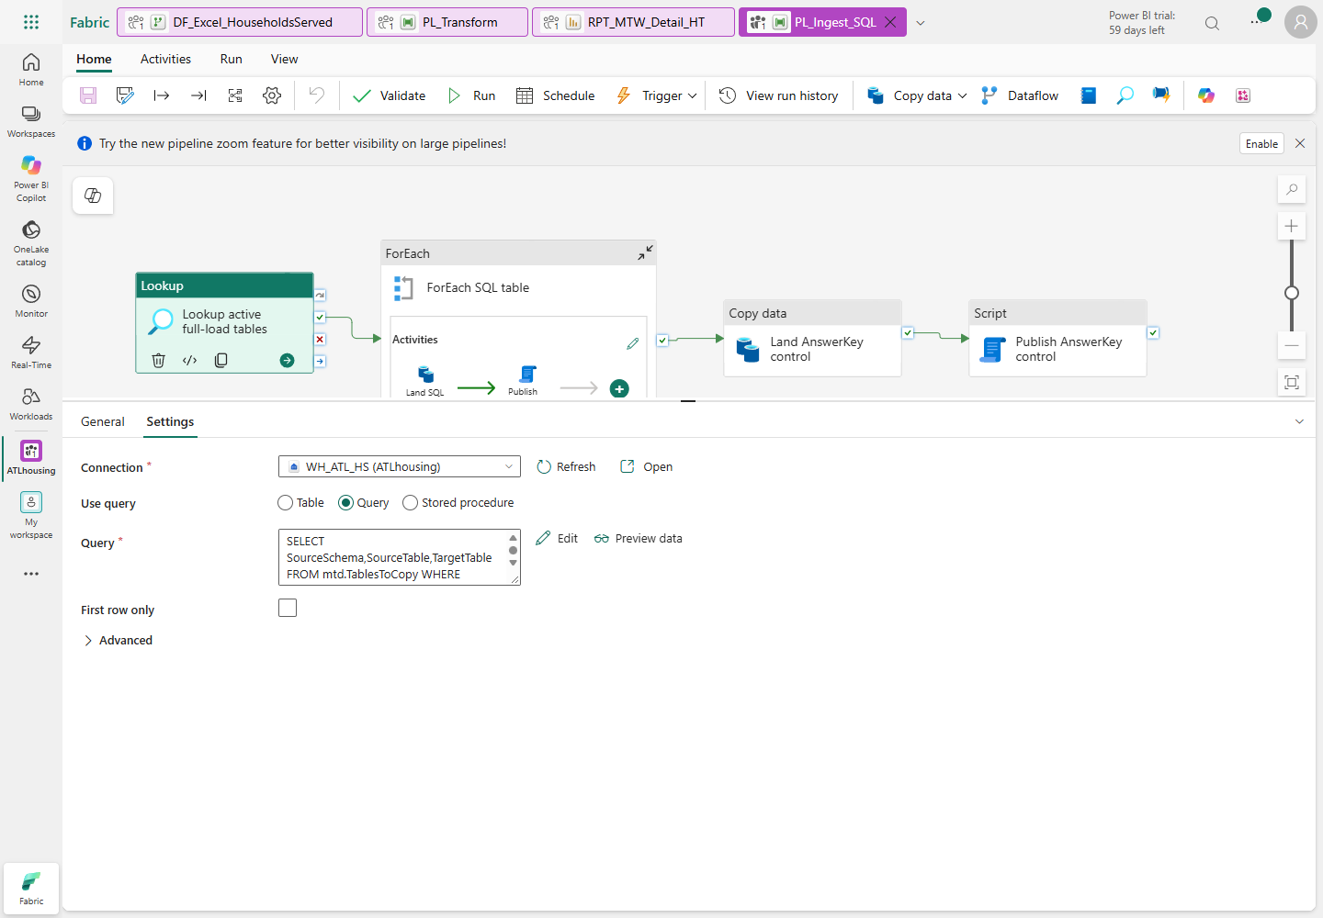
Figure 6. Select Query and clear First row only; the full query is in the asset file.
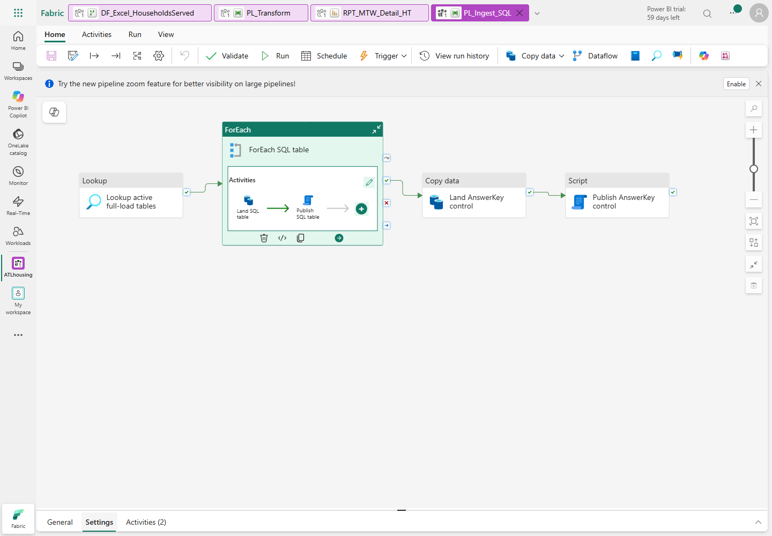
Figure 7. Items must be the Lookup output array; the batch count is 4.

M4.2 Add the two nested activities
- Select the ForEach, open its Activities tab, then choose the pencil/Edit
control. You are now editing inside the loop.
- Add Copy data, named Land SQL table.
- In Source, choose the dedicated ATL_HS_SQL_Source connection and the
Azure SQL Database source type. Select Query.
- Choose Add dynamic content, open
sql-source-query.txt, and
paste the expression, not a quoted string containing the expression.
- In Destination, choose your LH_ATL_Landing, root folder Files.
- Set folder-path dynamic content to:
@concat('landing/native_sql/',pipeline().RunId)
- Set file-name dynamic content to:
@concat(item().TargetTable,'.parquet')
- Choose file format Parquet, compression Snappy. Do not use a historical
folder wildcard or a fixed run ID.
- Keep schema-based mapping/type conversion enabled where offered. Do not allow
data truncation, and do not invent column mappings between different names.
- Add Script, named Publish SQL table, after Copy on On success.
- Select the destination WH_ATL_HS connection. Add a NonQuery script.
- Open publish-sql-table.txt
in Notepad. Replace <WORKSPACE_ID> and <LAKEHOUSE_ID> with your worksheet
GUIDs. Verify that no angle-bracket placeholder remains.
- Paste the entire expression through Add dynamic content in the script
text field. Do not paste it as literal SQL or replace pipeline().RunId with
an old value.
- The expression performs a destination transaction: DELETE the matching staging
table, COPY the exact current-run Parquet, compare count with Copy rowsRead,
COMMIT, then log success. Errors roll back and rethrow.
- Select the PL_Ingest_SQL breadcrumb to return to the parent canvas.
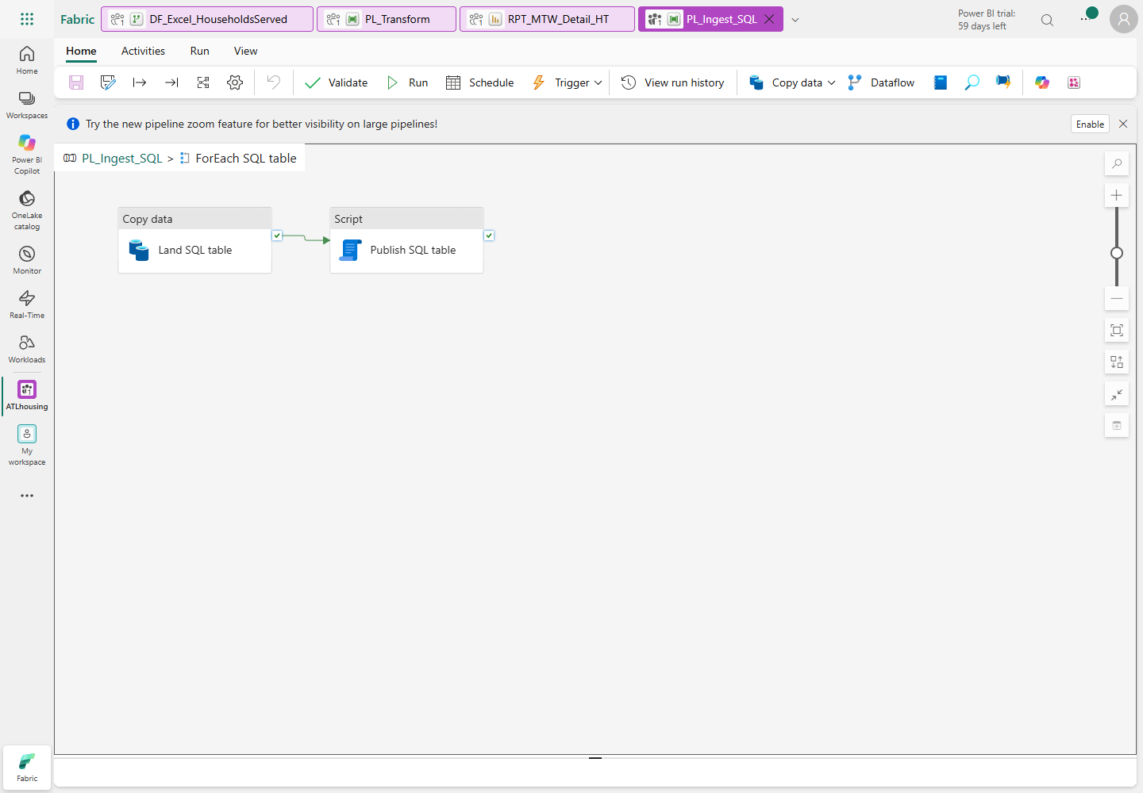
Figure 8. Copy must succeed before the current table is published.
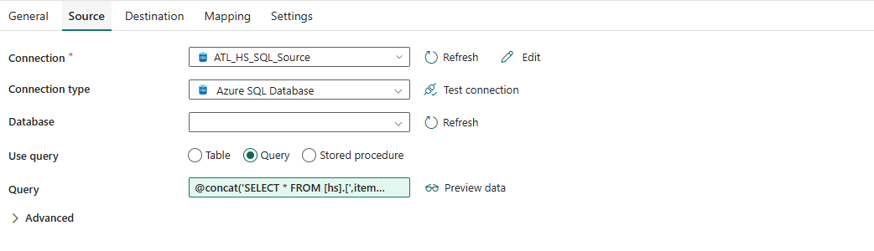
Figure 9. Use the approved source connection and an allowlisted metadata table name.
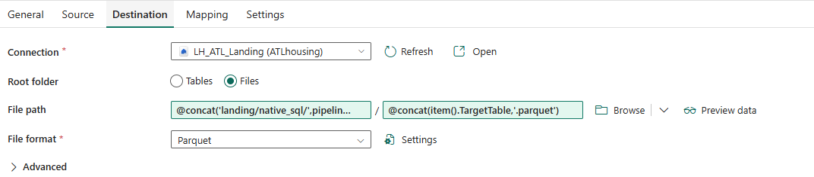
Figure 10. Run-scoped paths prevent re-ingestion of historical batches.

M4.3 Copy AnswerKey separately and test
- Outside ForEach, add Copy data, named Land AnswerKey control.
- Connect ForEach On success to this activity.
- Source: same approved SQL connection; literal query
SELECT * FROM [hs].[AnswerKey].
- Destination: same Lakehouse Files root and current-run folder expression;
file name AnswerKey.parquet, format Parquet/Snappy.
- Add Script, named Publish AnswerKey control, after it on success.
- Select WH_ATL_HS, NonQuery, and paste the reviewed expression from
publish-answer-key.txt.
Replace both workspace/Lakehouse placeholders first.
- Choose Validate, correct every error, then Save.
- Ensure no other publisher/master is running. Choose Run and open
View run history or Monitor.
- Wait for terminal Succeeded. Open the ForEach details and inspect all ten
copies/publications plus both control activities. Submission is not completion.
- In the Warehouse, run SELECT COUNT_BIG(*) FROM stg.<table> for each table.
Compare with the fixed-source counts below; counts are not business metrics.
Source/staging table | Expected rows
SourceSystem | 2
ProgramType | 9
VoucherType | 5
ActionType | 5
IncomeSource | 6
Property | 127
Unit | 25,794
UnitLocation | 25,794
Member | 240,819
FamilyMember | 48,021
AnswerKey, control only | 108

Check: every source table and AnswerKey loaded; inspect the current run's files.
Stop: partial failure, wrong target connection, any mismatched count or another active publisher.
Catch-up: correct the setting and rerun this pipeline serially; never append CSV data.

M5. Create the real Excel Dataflow Gen2
Objective: read only your approved original-file batch and replace both typed
Excel staging tables. Do not infer completion from a query preview.

M5.1 Parameters and four manual queries
- Select New item > Dataflow Gen2. Name it DF_Excel_HouseholdsServed.
Use the current supported Gen2 experience offered by your tenant.
- Open Home > Manage parameters > New parameter. Create these required Text
parameters with current values from your worksheet:
Parameter name | Current value
pWorkspaceId | Your participant workspace GUID
pLakehouseId | Your participant Lakehouse GUID
pApprovedBatch | Your exact approved batch-folder name

- Choose Get data > Blank query. Open Advanced editor, replace its contents
with WorkbookRows.pq, select
Done, and name the query WorkbookRows.
- Repeat for CurrentBatch.pq,
naming it CurrentBatch.
- When prompted for the OneLake Data Lake connection, select Organizational
account and the approved tenant account. The URL must point to your own
Files/landing/excel/<batch> path. Use Organizational privacy; no account keys.
- Repeat for UnitAvailability.pq,
naming it UnitAvailability.
- Repeat for SupportiveHousing.pq,
naming it SupportiveHousing.
- Do not add destinations to parameters, the function or CurrentBatch. Only the
final two table queries have destinations.
- Inspect availability preview: 72 rows, six columns, integer unit counts and
EffectiveDateKey; SourceFile must retain the original filename.
- Inspect supportive query schema: EffectiveDateKey integer; HouseholdID,
Program, SupportType and SourceFile text. The actual original roster has
20,752 rows; it does not contain pre-aggregated VASH/Other columns.
The function validates worksheet names, expected columns and ReportMonth against
the filename. It computes SheetName before navigating Excel.Workbook, avoiding
the Kind argument-shadowing issue encountered during the reference build.
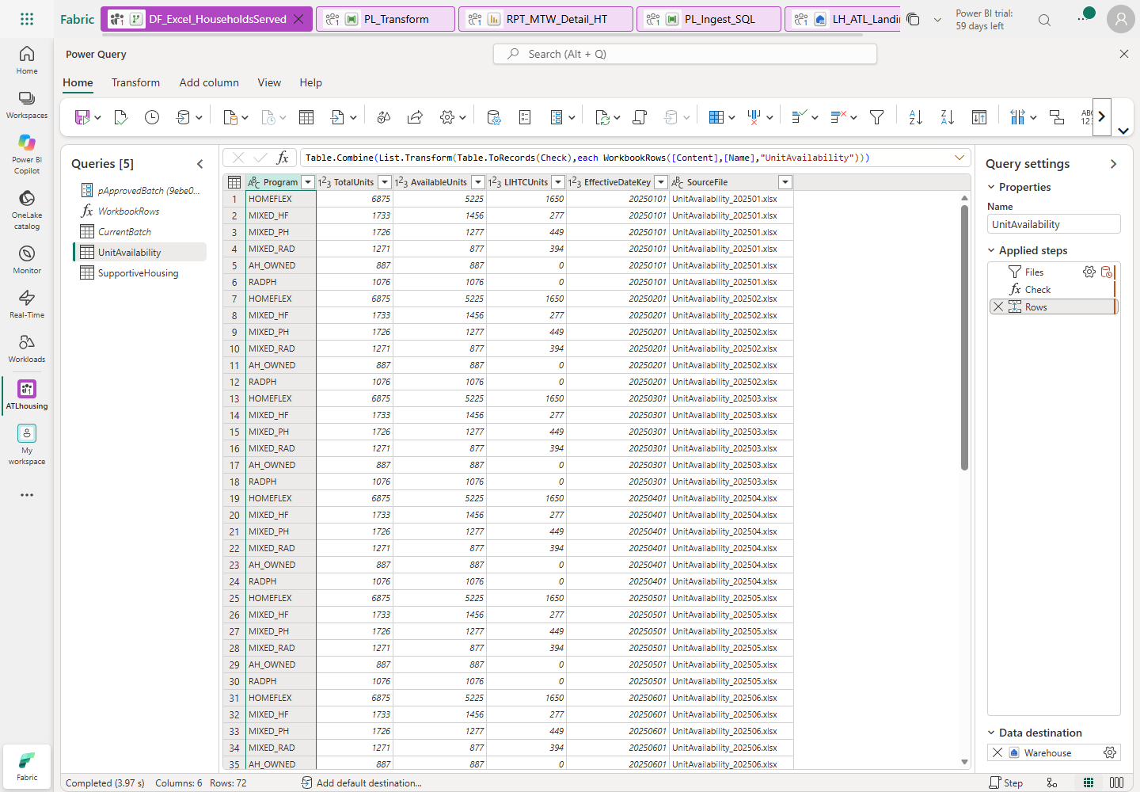
Figure 11. The reference build shows five queries because its workspace/Lakehouse
IDs were fixed. Your portable manual build adds the two ID parameters above.

M5.2 Configure both existing destinations
- Select UnitAvailability and Add data destination > Warehouse.
- Select/create the approved organizational Warehouse connection.
- Select your workspace > WH_ATL_HS > stg > UnitAvailability.
Choose the existing table, not a newly invented default table name.
- Advance to destination settings. Select update method Replace.
- Use manual column mapping; do not let the wizard recreate or alter the table:
Query column | Destination column | Type
EffectiveDateKey | EffectiveDateKey | Integer
Program | Program | Text
TotalUnits | TotalUnits | Integer
AvailableUnits | AvailableUnits | Integer
LIHTCUnits | LIHTCUnits | Integer
SourceFile | SourceFile | Text

- Confirm the destination. Select SupportiveHousing and repeat for existing
WH_ATL_HS.stg.SupportiveHousing, also Replace.
- Map EffectiveDateKey, HouseholdID, Program, SupportType and SourceFile to the
same-named destination columns. Keep HouseholdID as text.
- Choose Save & run, or Publish then Refresh if those are the labels
offered by your Gen2 version.
- Open Recent runs. Wait for the actual refresh to finish successfully for
both destinations. A successful preview is not a successful load.
- In the Warehouse run:
SELECT COUNT_BIG(*) AS AvailabilityRows FROM stg.UnitAvailability; -- 72
SELECT COUNT_BIG(*) AS SupportiveRows FROM stg.SupportiveHousing; -- 20752
SELECT EffectiveDateKey,Program,COUNT(*) AS N
FROM stg.UnitAvailability GROUP BY EffectiveDateKey,Program HAVING COUNT(*)<>1;
Check: 72 / 20,752 rows and no duplicate availability keys.
Stop: either query failed, a month/file is missing, a table was appended, or
data types changed. Do not transform a partially refreshed batch.
Catch-up: fix the connection/mapping and rerun the real Gen2 refresh.

M6. Build production dimensions and facts
Objective: preserve the actual observation grain and source history.
- In your Warehouse open a new SQL query.
- Execute these calls in order, only after M4 and M5 succeeded:
EXEC prd.usp_Load_Dimensions;
EXEC prd.usp_Load_FactHouseholdSnapshot;
EXEC prd.usp_Load_FactUnitAvailability;
- Open 05_metrics_view.sql and run it
manually in the Warehouse.
- Run 06_dq_views.sql in the same way.
- Inspect row counts: household fact 240,819; availability fact 72;
supportive fact 20,752.
- Run 07_validate_all_metrics.sql.
Inspect every result set: actual and expected each 108 keys, no duplicate
keys, and zero mismatch rows across all 17 metrics.
- Do not fix missing-unit or duplicate-program teaching defects by dropping
observations. Do not replace missing facts with AnswerKey values.
Business rule | What to verify
Grain | Household + program + month observations, not distinct household-months
Category | Elderly first, then Disabled, then Workforce
Household type | Child count > 0 means With children; source counts exclude live-in aides
Property | Resolve Unit.PropertyID to inclusive SCD2 version at snapshot date
Unit history | Do not invent source versions that do not exist
Missing units | Retain observations through unknown key -1
Supportive | Join month + household + its own program
Inventory | Available excludes LIHTC; voucher inventory/vacancy remains NULL
Negative vacancy | Preserve it; do not clamp to zero

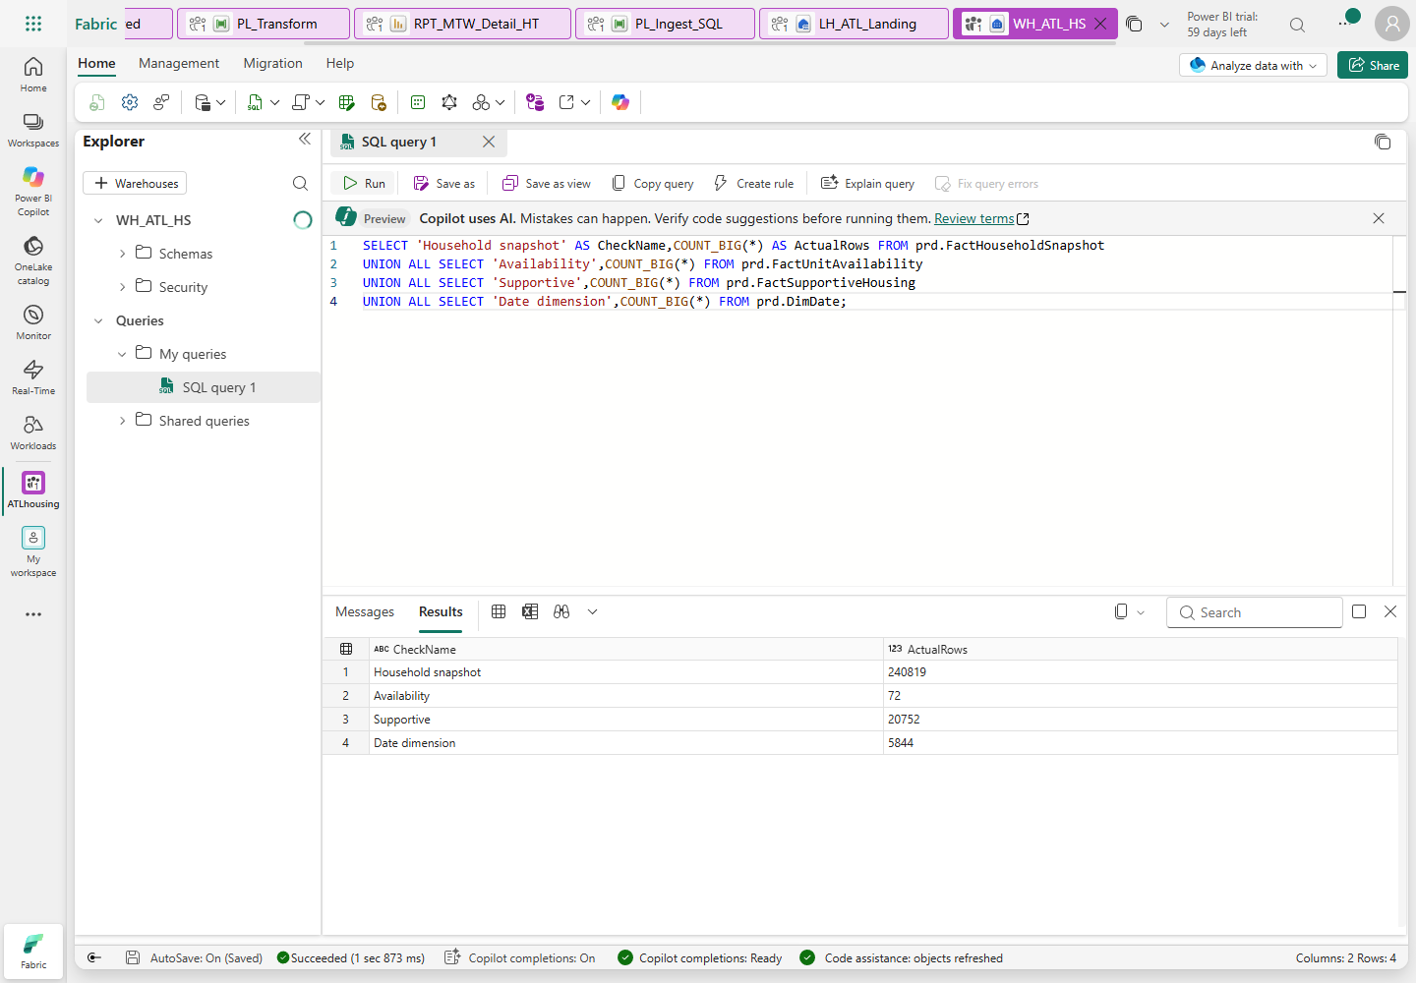
Figure 12. Counts are an initial checkpoint; the full-outer 17-metric comparison
is the accuracy check.

M6.1 Create the transformation notebook and child pipeline
- Select New item > Notebook and name it NB_Transform.
- Attach your LH_ATL_Landing as the default Lakehouse.
- In the first code cell, type
warehouse_server = "<WAREHOUSE_SQL_ENDPOINT>", replacing the placeholder with
the Warehouse hostname recorded in M3. Use Python/PySpark, not a SQL cell.
- Mark this cell as a parameter cell using its ... > Toggle parameter cell
command where available.
- Add another code cell. Paste
NB_Transform.py.
This is manual notebook authoring, not running a local deployment script.
- Save. Ensure no other publisher is running, choose Run all, and wait for
success. This intentionally repeats the destination transforms idempotently.
- Create a pipeline named PL_Transform. Add Notebook, name its activity
Transform, and select your workspace > NB_Transform.
- Set retries to 0; validate and save. Run it once serially and inspect its
linked notebook execution.
Check: three facts, all 17 metrics reconciled, notebook/child pipeline succeeded.
Stop: any SQL structural error; keep the exception and fix its cause.
Catch-up: repaste the reviewed SQL definitions/cells in your own destination,
then rerun in order; never reload the source database.

M7. Assemble the base master pipeline and failure handling
Objective: wire the manual artifacts and test genuine success/failure states.
M13 later adds DQ and model-framing acceptance to this chain.
EffectiveMonth is validated reporting/control context: this lab still reloads
all 12 supplied months. It is not an incremental SQL or Excel filter.
- Create pipeline PL_Master_HouseholdsServed.
- Click the empty canvas, open Parameters, and add EffectiveMonth,
type String, default 2025-01.
- Add a Script activity named Validate reporting month, connection
WH_ATL_HS, script type NonQuery.
- Paste validate-month.sql.
- Add these script parameters as Input, type String:
Name, without @ | Dynamic value
EffectiveMonth | @pipeline().parameters.EffectiveMonth
RunId | @pipeline().RunId

- Add Invoke pipeline, named Ingest SQL. Select your PL_Ingest_SQL and
enable Wait on completion. Connect validation On success to it.
- Add Dataflow, named Ingest approved Excel; select your real
DF_Excel_HouseholdsServed. Connect SQL On success to it.
- Add Invoke pipeline, named Transform production tables; select your
PL_Transform, wait on completion, and connect Dataflow success to it.
- Add Script, named Log master success, connection WH_ATL_HS, NonQuery.
Paste master-success.txt using
Add dynamic content. Initially connect transform success to this activity.
- For each of the four core stages, add a failure branch. Create a Script
named Log failure - <stage name> and connect the stage's red On failure
output to it.
- For the failure log, use WH_ATL_HS and NonQuery. Open
master-failure.txt, replace
<FAILED_ACTIVITY_NAME> with that exact stage name, then paste dynamically.
- After each failure log add a Fail activity, named Fail master - <stage>.
Error code: ATL_HS_STAGE_FAILED; message: the failed stage name and an
instruction to inspect its activity details and PipelineRunLog.
- A logging activity must never turn a failed pipeline into a green success.
Do not add a success path that bypasses a failed prerequisite.
- Validate, save and run the base chain once. Record the parent run ID, linked
SQL/transform child IDs, Gen2 refresh status and total duration.
- Label this checkpoint base chain, not final workshop acceptance. M13 adds
structural DQ and Warehouse/model reconciliation before success is logged.
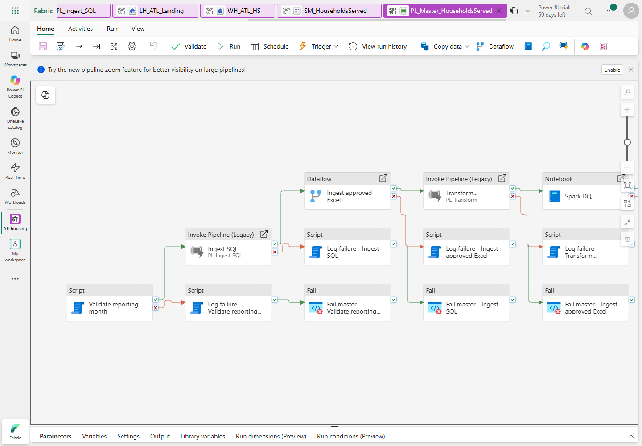
Figure 13. The reference includes the final M13 stages. Add those later as directed.

Safe forced-failure test
- Ensure no other publisher is active. Run with EffectiveMonth=2025-13.
- Confirm validation fails before SQL/Excel ingestion; inspect the error details.
- Confirm its failure log succeeds and the explicit Fail activity leaves the
whole master Failed. Downstream ingestion must not run.
- Inspect the Warehouse log:
SELECT RunId,Stage,Status,[RowCount],ErrorMessage
FROM mtd.PipelineRunLog ORDER BY StartedAt DESC;
- Restore the normal parameter to 2025-01.
Check: genuine successful base run and genuine terminal failed test with a log.
Stop: a failed prerequisite produces a green master, or copies run after an
invalid month.
Catch-up: correct connector conditions and wait-on-completion settings.

M8. Create DimDate, with a supported Copilot fallback
Objective: exactly 5,844 dates, 2015-01-01 through 2030-12-31.
- Ask the instructor whether Copilot is actually available for your account,
tenant and capacity. The existing F8 assignment alone does not establish this.
- Default supported path: in the Warehouse open a new SQL query, paste
04_dimdate.sql and run it manually.
- If Copilot is available and the instructor chooses that exercise, create
Dataflow Gen2 DF_DimDate and open Copilot. Use this prompt:
Create a date table from 2015-01-01 through 2030-12-31 inclusive.
Include Date, integer DateKey (yyyymmdd), CalendarYear, MonthNumber,
QuarterNumber, ISOWeek, MonthYear (yyyy-MM), QuarterYear,
MonthStartDate, and locale-independent IsWeekend (Yes/No).
AgencyFiscalYear must remain nullable until the agency supplies its rule.
Return 5,844 unique dates. Do not assume calendar year is the fiscal year.
- Review the generated M and types before running anything. Choose destination
WH_ATL_HS.prd.DimDate, correct types, and Replace. Do not execute both paths
concurrently or create two competing date-table feeds.
- Verify in the Warehouse:
SELECT COUNT(*) AS Dates,COUNT(DISTINCT DateKey) AS DistinctKeys,
MIN([Date]) AS FirstDate,MAX([Date]) AS LastDate
FROM prd.DimDate;
Check: 5,844 / 5,844 / 2015-01-01 / 2030-12-31.
Stop: a generated table ends in 2025 or guesses the agency fiscal year.
Catch-up: use the reviewed SQL fallback. Approved fiscal logic is a later,
explicit business decision, not a reason to invent a value.

M9. Create and configure the explicit Direct Lake model
Objective: a dimensional semantic model, not an assumed default model.

M9.1 Select tables and relationships
- In your workspace select New item > Semantic model > OneLake catalog.
Select your WH_ATL_HS Warehouse as the supported OneLake source.
This is the Direct Lake on OneLake creation route, not Get data's generic
Power Query/Import route or the SQL analytics endpoint's Direct Lake on SQL route.
- Name it SM_HouseholdsServed, choose your assigned workspace, and select
these production tables:
DimDate, DimProgramType, DimVoucherType, DimActionType, DimIncomeSource,
DimProperty, DimUnit, FactHouseholdSnapshot, FactUnitAvailability,
FactSupportiveHousing and DQ_Results.
- Include the physical mtd.ProgramScope security map as the only metadata
table. Do not include AnswerKey, source Member/FamilyMember or other staging tables.
- Choose OK to create, then check a table's Properties > Storage mode:
it must be Direct Lake. If the catalog route is not available, stop and ask
the instructor; do not silently create Import or accept DirectQuery as equivalent.
- Open the model. Select Viewing > Editing before authoring.
- Select Manage relationships > New relationship (or drag matching key fields).
Create the following active relationships. Dimension is the one side,
fact the many side; cross-filter direction is Single, dimension to fact:
Dimension key | Fact key
DimDate.DateKey | FactHouseholdSnapshot.EffectiveDateKey
DimProgramType.ProgramTypeKey | FactHouseholdSnapshot.ProgramTypeKey
DimProperty.PropertyKey | FactHouseholdSnapshot.PropertyKey
DimUnit.UnitKey | FactHouseholdSnapshot.UnitKey
DimVoucherType.VoucherTypeKey | FactHouseholdSnapshot.VoucherTypeKey
DimActionType.ActionTypeKey | FactHouseholdSnapshot.ActionTypeKey
DimIncomeSource.IncomeSourceKey | FactHouseholdSnapshot.IncomeSourceKey
DimDate.DateKey | FactUnitAvailability.EffectiveDateKey
DimProgramType.ProgramTypeKey | FactUnitAvailability.ProgramTypeKey
DimDate.DateKey | FactSupportiveHousing.EffectiveDateKey
DimProgramType.ProgramTypeKey | FactSupportiveHousing.ProgramTypeKey

- Do not relate facts to each other, connect FamilyMember directly to the snapshot,
or add an extra active DimUnit-to-DimProperty relationship.
- Select DimDate.MonthYear > Sort by column > MonthStartDate. Format Date as
a date. Right-click DimDate > Mark as date table and choose its Date column.
Set key columns to Do not summarize and hide surrogate keys.
- Use Edit tables / the source-table column selection to remove unneeded
HouseholdID, MemberKey, SourceUnitKey and PropertyManager columns from the model.
This report is aggregate-only. Do not remove required relationship keys.
- Keep names, DOB, ethnicity, citizenship, income and street addresses out of the
model. If the current web editor cannot exclude an unneeded source column,
stop for the instructor to provide an approved projection; hiding is not a
security substitute.
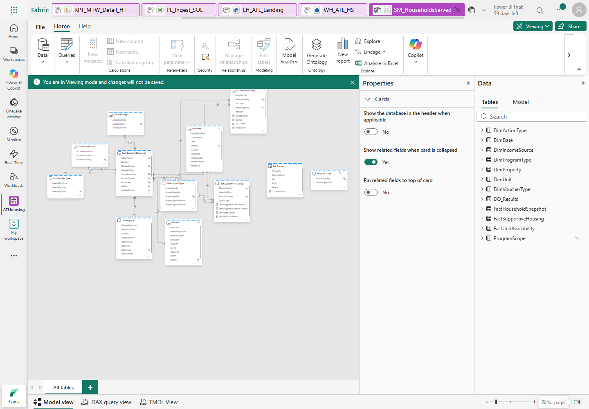
Figure 14. Use Fit to page to inspect all tables; every relationship has one-direction filtering.
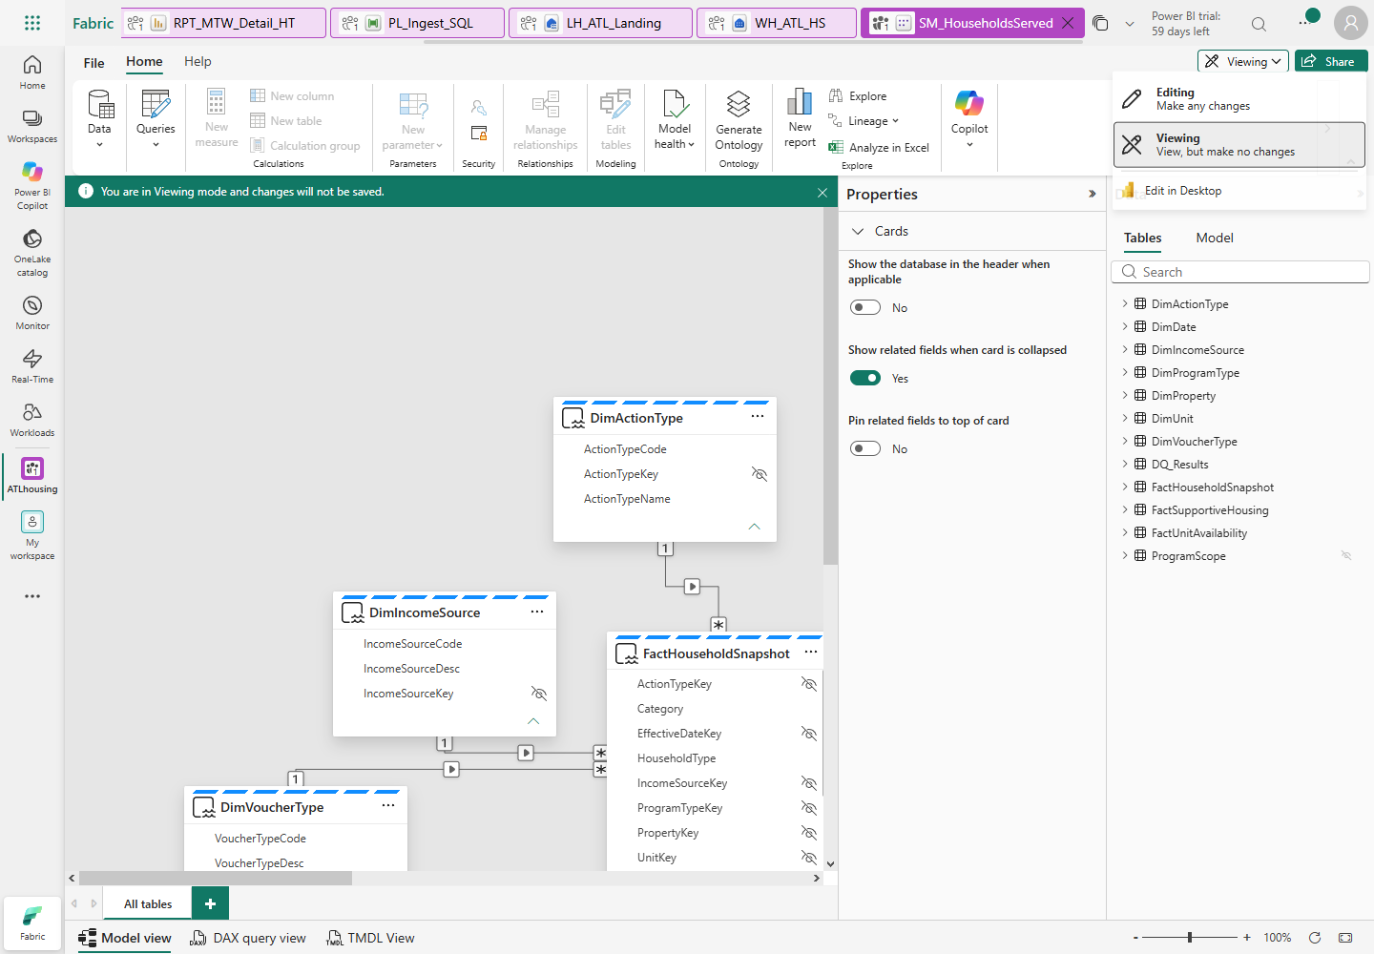
Figure 15. Switch to Editing to author relationships/measures. Merely viewing is not editing.

M9.2 Add actual model measures, one at a time
- Select the table named in the file's first comment, then New measure.
- Open each matching file under workshop-assets\dax, paste its formula into
the formula bar, and confirm with the checkmark/Enter.
- Do not paste a whole DEFINE MEASURE query into the measure formula bar.
These files are already individual, persistent measure definitions.
Owning table | Measure files to add
FactHouseholdSnapshot | Households, Households-With-Children, Households-Without-Children, Elderly-Households, Disabled-Households, Workforce-Households
FactUnitAvailability | Available-Units, LIHTC-Units, Total-Units, Unit-Based-Households, Vacant-Units, Occupancy-Percent, DQ-Flag, Vacancy-Color
FactSupportiveHousing | VASH-With-Children, VASH-Without-Children, Other-Supportive-With-Children, Other-Supportive-Without-Children
DQ_Results | DQ-Observations

- Set count/unit measures to whole-number format. Format Occupancy % as a
percentage. Vacancy Color and DQ Flag return text, not numeric sums.
- Do not replace COUNTROWS with distinct HouseholdID counting. The source's
planted second-program observations are intentional.
- Open DAX query view, paste reconcile.dax
and choose Run.
- Expect 27 program-month rows: January, July and December, nine programs each.
Compare all 17 output metrics, not just Households, with the same keys in
stg.AnswerKey / data\controls\answer_key.csv.
- A full metric/key comparison is also performed by the manually authored
NB_Reconcile in M13. Do not sign off model acceptance solely from a row count.

M9.3 Configure RLS only with an approved mapping
- Ask the instructor for the approved Viewer UPN and allowed program codes.
Do not guess identities or grants. If none are approved, record this
security acceptance as Pending and do not grant consumer access.
- In your Warehouse, open
08_approved_program_scope.sql.
Replace the two explicit placeholders with the approved Viewer UPN and program
code, run it manually, and inspect its returned grant. Repeat only for each
additional approved program. Do not commit populated identities to Git.
- Keep ProgramScope disconnected and hidden in the model.
- In model Editing mode choose Security / Manage roles, create ProgramScope.
- Select Switch to DAX editor. Set the DimProgramType filter to
ProgramScope.dax.
- Add this filter on ProgramScope itself:
LOWER(ProgramScope[UserPrincipalName]) = LOWER(USERPRINCIPALNAME())
- Save the role. An unmapped role member must see no programs.
- Have the authorized owner assign the approved user to the role and grant
appropriate model/report access. Do not make them Contributor to bypass RLS.
- Test View as, then an actual Viewer session. Verify household,
availability and supportive facts; also test an unmapped user sees no programs.
- Record the actual result. An author/Admin view or an unassigned role is not
proof of Viewer enforcement.
Check: Direct Lake partitions, 11 active single-direction relationships,
actual measures and three-month reconciliation. RLS sign-off requires a Viewer.
Stop: many-to-many, unexpected Import/DirectQuery, missing keys or unapproved grants.
Catch-up: compare the settings/table list with the reference; do not run the model deployer.

M10. Author the HT1-HT10 report manually
Objective: recreate the three matrices and DQ/definition pages from your model.

M10.1 Create the report and strict month slicer
- In your semantic model select New report. Save it as RPT_MTW_Detail_HT
in your assigned workspace.
- Add a title text box: ATL Housing | Households served.
- Add a Slicer visual; drag DimDate.MonthYear into its field well.
- In slicer formatting choose Dropdown, enable Single select and
disable Select all. Keep exactly one selected month.
- In the visual Filters pane add DimDate.CalendarYear and select 2025, so the
slicer does not offer years outside the supplied demo snapshot.
- Select 2025-01. Test Ctrl-click on a second month: the slicer must still have
exactly one selected month. If not, correct the single-select control before
relying on report totals.
- Use Edit interactions if necessary; the month must filter all three matrices.
It intentionally does not filter disconnected run-level DQ controls.

M10.2 Occupied household category matrix
- Add Matrix. Rename/title it Occupied households.
- Add Rows, in order: FactHouseholdSnapshot.HouseholdType, then Category.
- Add Columns: DimProgramType.ProgramTypeShortName.
- Add Values: Households measure, not a summed key or distinct HouseholdID.
- Select the visual's Expand all down one level in the hierarchy button
so both category levels are visible.
- Keep household-type subtotals and the grand total visible.
- Exclude a structural blank ProgramTypeShortName in a report-level filter;
do not exclude the real unknown-unit observations.
- January grand total must be 19,998; With children 7,635 and Without
children 12,363. Category precedence is Elderly > Disabled > Workforce,
regardless of the labels' alphabetical display order.

M10.3 Inventory matrix, row metrics and negative-vacancy formatting
- Add another Matrix. Columns: ProgramTypeShortName.
- Values: Available Units, LIHTC Units, Total Units, Vacant Units.
- Open Format visual > Values > Options and turn Switch values to rows
On. The four metrics should be rows, not repeated columns under each program.
- In Cell elements / Specific column, apply settings to Vacant Units.
Enable font color and select fx.
- Choose Format style: Field value, based on measure Vacancy Color.
Apply to values and totals where offered.
- Verify real rendered cells: January Mixed-Homeflex -37 and Mixed-RAD
-75 must be red. A saved color expression alone is not evidence.
- Preserve NULL voucher inventory/vacancy. Do not fill it with zero, and do not
subtract voucher households from the unit-based grand total.
- January totals: Available 10,798, LIHTC 2,770, Total 13,568,
Vacant 1,197.

M10.4 Supportive matrix
- Add a third Matrix. Columns: ProgramTypeShortName.
- Values: VASH With Children, VASH Without Children, Other Supportive With
Children, Other Supportive Without Children.
- Again turn Switch values to rows On.
- January grand totals must be 22, 120, 606, 973, in that order.
They come from the original roster, not answer-key facts.
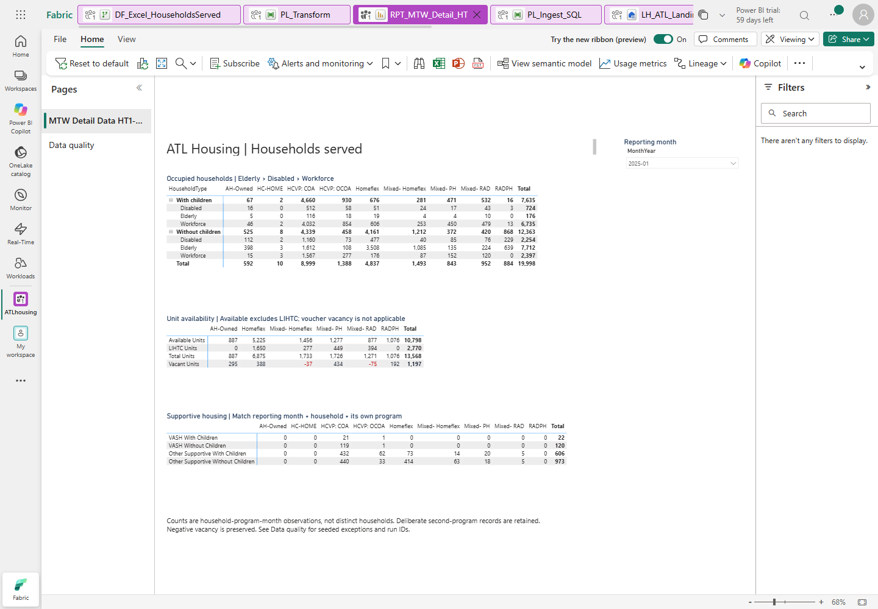
Figure 16. Actual reference output. Negative vacancy remains visible and red.

M10.5 Definitions tooltip, DQ page and actual timing
- Add a page named Metric definitions. In its canvas/page settings select
Tooltip page type/size and allow the page to be used as a tooltip.
- Add text defining observation grain, child rule, category precedence,
available versus LIHTC, and non-applicable voucher vacancy.
- Hide this page from normal report navigation.
- On occupied/inventory visuals choose General > Tooltips > Report page,
then select Metric definitions. Hover a cell to verify the real tooltip.
- Add a normal page named Data quality with a table visual.
- Add DQ_Results.RunId, Rule, Severity, CheckedAt and the DQ Observations
measure. Sort CheckedAt descending. Do not sum rule counts across historical runs.
- The table may be empty until M13 runs. Do not paste fake DQ results to fill it.
- Add a main-page note: counts are household-program-month observations;
negative vacancy is a DQ signal, not a value to hide.
- If an existing sensitivity label is approved and you have permission, apply
it to the report/model. Otherwise record Pending; never invent a label.
- Save the report with January selected and the household categories expanded.
- In Editing mode open Optimize > Performance analyzer, start recording,
refresh visuals and switch January -> July -> December -> January.
- Record/export the actual visual durations and your test conditions. Target:
under 3 seconds per workshop visual at demo scale. Do not claim a cold-cache
or full-page result from a DAX API/token roundtrip.
- Reference browser warm month interactions were about 0.41 seconds, but full
page reload was 3.94 seconds and cold-capacity acceptance remains open.
Your measured result, not these reference numbers, is your performance evidence.
Check: correct month/category totals, inventory/null behavior, actual red cells,
supportive totals, tooltip and saved pages.
Stop: all-month totals, collapsed categories, Ctrl multi-select or black negatives.
Catch-up: rebuild the visual field wells and formatting manually; do not import the report as a substitute for this exercise.

M11. Optional presenter lab: mirroring versus shortcuts
Gate: approved connections, source-owner permission and prerequisites. This
module is not required to manufacture missing data or bypass access controls.

M11.1 ADLS Gen2 shortcut, without a second ingestion feed
- In the assigned Lakehouse, open Files and choose New shortcut.
- Choose Azure Data Lake Storage Gen2 and an approved organizational connection.
- Storage endpoint: https://fabridemo.dfs.core.windows.net.
Select container atldemo and the instructor-approved path, such as csv.
- Give the shortcut a clearly separate name, for example reference_csv_shortcut.
Do not place it inside the approved Excel batch or change CurrentBatch to glob it.
- Create only with approved access, browse a safe lookup CSV, and verify data is
read through the shortcut rather than another copied staging feed.
- Do not use the encrypted source Excel files as a workaround for M5.

M11.2 Azure SQL mirroring, presenter-owned disposable source only
- Instructor checks supported database features/tier, logical-server identity,
network access and mirroring prerequisites before creation.
- Only if the source owner has approved the necessary configuration, select
New item > Mirrored Azure SQL Database, name it MIR_ATL_HS, choose the
approved connection/database and the selected hs tables.
- Start only after approval and inspect replication status until actually Running.
- Query its SQL analytics endpoint and reconcile sample keys/totals.
- The draft's source Member update is not authorized on this existing source.
Demonstrate CDC only on an explicitly approved disposable copy; otherwise
observe existing replication without modifying a source row.
Pattern | What moves | Use when
Pipeline | Copies data into controlled landing/staging | Explicit metadata, transformations and run control
Azure SQL mirroring | Replicates source data/changes into OneLake | Managed low-ETL replication; not literally zero-copy
ADLS shortcut | References data in place | Reuse existing storage with approved access
Mirrored Unity Catalog | Syncs metadata and exposes shortcuts | Reuse supported Databricks-managed tables

Check: actual read/status evidence or an explicit prerequisite-blocked entry.
Stop: unapproved source configuration/update, keys/SAS or a new paid resource.
Catch-up: presenter walkthrough; do not mark a module Delivered from a diagram.

M12. Governance and DevOps, administrator/presenter-gated
Objective: practise approved controls without changing source data or publishing privately owned material publicly.

M12.1 Labels, Viewer access and lineage
- With the administrator, confirm the approved existing label and groups.
- Apply the label to Warehouse/model/report only where supported and authorized.
- As the approved Viewer, verify RLS from M9. Author access is not an RLS test.
- If export is approved, export a safe aggregate visual to Excel and inspect
actual label inheritance. Do not infer inheritance from the label's name.
- Open workspace Lineage and identify Warehouse -> model -> report and
pipeline/dataflow dependencies that the service exposes.
- Open Monitor and the approved Capacity Metrics app. Locate your own
workload and inspect failures/throttling; do not resize the shared F8.

M12.2 Private Git integration
- In the assigned development workspace open Workspace settings > Git integration.
- If the tenant supports the selected provider and you have authorization, connect
the instructor-approved private GitHub repository, branch and directory.
- Review the initial synchronization direction before committing or updating.
Do not overwrite the reference workspace with a different branch.
- Make a harmless approved lab edit, inspect the pending diff, commit, and
demonstrate an update from the approved branch.
- Record unsupported items and secrets exclusions. A local Git commit alone is
not evidence of a connected Fabric Git integration.
- Private-repository links require authorized GitHub access. Participants without
it use the instructor-provided offline pack; a public Pages site is not created.

M12.3 Dev/Test/Prod deployment pipeline
- Only after the administrator provides approved Dev, Test and Prod workspaces
and capacity assignments, create a Deployment pipeline.
- Assign the three approved workspaces to the correct stages.
- Compare Dev to Test, review the supported items, and deploy to Test, not Prod.
- Rebind Test connections, Lakehouse/workspace IDs, notebook parameters and
model/report references. Do not let Test publish to Dev staging.
- Run Test reconciliation and inspect Test lineage. Record unsupported/skipped
items instead of assuming they deployed.
Check: actual control/sync/deployment evidence, or explicit Pending approvals.
Stop: guessed groups, invented labels, public publishing or unapproved target workspaces.
Catch-up: instructor demonstration; keep the private manual lab pack.

M13. Spark DQ, reconciliation and the final master acceptance run
Objective: detect seeded defects, fail structural errors and prove the final
Warehouse and Direct Lake outputs after a real orchestrated refresh.

M13.1 Author and run NB_DQ_Checks
- Create a Notebook named NB_DQ_Checks; attach your LH_ATL_Landing.
- Create a first Python parameter cell with your Warehouse server hostname,
as in M6. Do not use the Azure SQL source hostname.
- Paste NB_DQ_Checks.py in a second
PySpark/Python code cell, save, and choose Run all.
- It reads through the Fabric Spark Warehouse connector and writes actual
run-scoped results into prd.DQ_Results. Do not run this as local desktop Python.
- Inspect the real notebook result and the Warehouse table:
SELECT RunId,[Rule],ObservedCount,Severity,CheckedAt
FROM prd.DQ_Results ORDER BY CheckedAt DESC;
Rule | Expected reference observation | Interpretation
DuplicateProgramHouseholdMonths | 450 groups, 50 households | Seeded warning; retain observations
MissingUnitObservations | 10 observations, 5 households | Seeded warning; unknown key retained
OverOccupiedProgramMonths | 24 | Exactly MIXED_HF and MIXED_RAD across 12 months
InvalidMonthlyDates | 0 | Structural error if positive
InvalidCurrentPropertyVersions | 0 | Structural error if positive
OverlappingPropertyIntervals | 0 | Structural error if positive

- Scope should be SQL+Excel after M5. OccupancyExcelBlocked means Excel is
unavailable; it is not a passing occupancy test.
- Refresh/open the report's Data quality page. Verify actual rule names,
timestamps, counts and run IDs; do not sum old runs together.
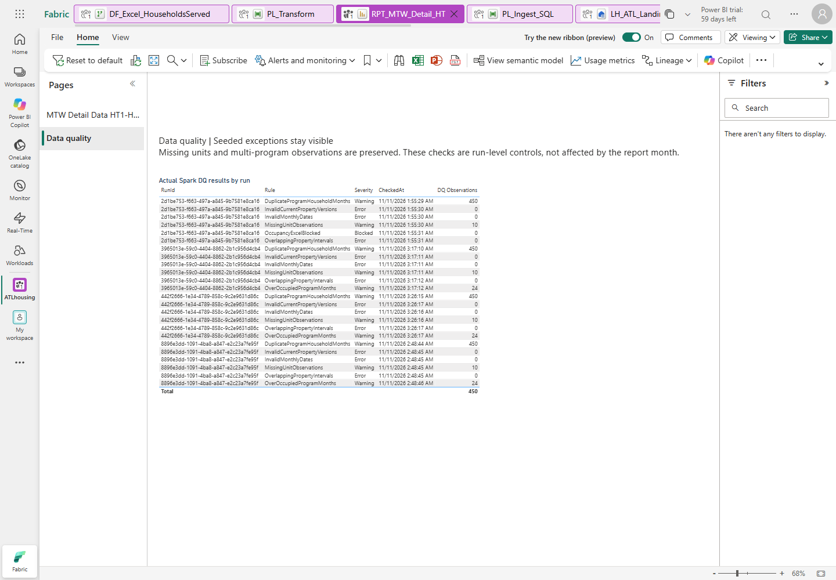
Figure 17. Seeded warnings stay visible; zero structural counts are not hidden.

M13.2 Author NB_Reconcile and frame Direct Lake
- Create Notebook NB_Reconcile and attach your Lakehouse.
- For its first cell paste
parameters.py.
- Replace all three placeholders: Warehouse server hostname, workspace ID and
semantic-model ID. Keep the complete supplied reconciliation_dax string.
- Mark this cell as the parameter cell where available.
- In a second code cell paste
NB_Reconcile.py, then save.
- Run all cells. The notebook must compare all 108 Warehouse keys/all 17 metrics,
request an actual semantic-model framing refresh, wait for it to complete, then
compare 27 January/July/December DAX keys/all 17 metrics.
- Inspect its actual JSON exit result and logged run. Any key, metric, duplicate,
permission or refresh error must fail the notebook, not return a fabricated success.

M13.3 Complete the master and run it end to end
- Reopen PL_Master_HouseholdsServed.
- Remove the success dependency directly from Transform to Log master success.
- After Transform production tables, add a Notebook activity Spark DQ,
selecting your NB_DQ_Checks.
- After its success add Notebook Reconcile and frame Direct Lake,
selecting your NB_Reconcile.
- Connect reconciliation success to Log master success.
- Add the same failure log -> explicit Fail pattern for both new notebook
stages. Keep the original stages' failure branches.
- Validate and save. Ensure there are no simultaneous local, Gen2 or pipeline
publishers. Run with EffectiveMonth 2025-01.
- Open View run history, choose the actual run, and inspect its stage details.
Open linked child pipeline, Gen2 and notebook executions.
- Wait for final Succeeded/Completed. Record all IDs in the sign-off sheet.
The reference successful master took about 7 minutes 19 seconds; your timing
is capacity-dependent and is not guaranteed.
- Rerun 07_validate_all_metrics.sql manually. Then run the model reconciliation
query again and verify the January/July/December report totals.
- A momentary OneLake security/schema-propagation message after rebuild/framing
should be diagnosed from its actual details. Wait and retry after framing;
do not weaken RLS or permissions to hide it.

M13.4 Approved alert and scheduling exercises
- Ask for the approved Teams channel or Outlook recipient and connection.
If none is provided, mark outbound delivery Pending; failure logs alone
do not prove alert delivery.
- Only after approval, add the supported Teams/Outlook activity to each failure
path. Include master run ID, failed stage and a link to run details.
- Keep an explicit terminal Fail. If an alert fails, it must not mask the
original failure or turn the master green; use completion/failure handling.
- Run the invalid-month test again and verify actual receipt with the recipient.
- Open Schedule. Prepare daily 06:00, Eastern Time (US & Canada) with its
daylight-saving-aware zone, not a fixed UTC-05 offset.
- Keep scheduling disabled until the administrator/user approves enablement and
a successful dry run. Record start/end dates and source-connection ownership.
- If enablement is approved, verify a real scheduled run later; a configured
schedule screenshot alone is not unattended-run acceptance.
Check: final seven-stage success chain, real DQ, framing, all metric checks
and an honest alert/schedule status.
Stop: missing linked execution, a false-green failure path, unmatched metrics
or unapproved sending/scheduling.
Catch-up: fix and rerun only your own artifacts serially; preserve failed run IDs.

M14. Conditional presenter lab: Azure Databricks Unity Catalog
Gate: the supplied guide assigns this to the presenter's separate environment.
No Databricks environment was supplied for the reference build, so this module
has no fabricated screenshot or claimed completion.
- Presenter confirms an approved Databricks workspace, catalog atl_hs_uc,
schema gold, supported Delta tables and the required source/Fabric permissions.
- In the approved presenter Fabric workspace select New item > Mirrored Azure
Databricks catalog, name it MIR_ATL_UC.
- Choose an approved organizational/service-principal connection, select
atl_hs_uc and gold, and keep approved automatic metadata synchronization on.
- Inspect actual table shortcuts and the SQL analytics endpoint. Explain that
catalog metadata is synchronized and data is read in place; do not confuse
it with copying the original SQL workload again.
- Query safe aggregate household/program/month results and compare with the
approved expected totals.
- In the approved Lakehouse add OneLake shortcuts to the mirrored catalog's
supported tables. Use an approved notebook to join aggregate program/month
keys with Warehouse data, avoiding observation-multiplying joins.
- Create a separate explicit Direct Lake model on supported mirrored Delta
tables, add one relationship/measure and a single report visual.
- Only in an approved disposable presenter schema add a new test table, refresh
metadata and verify it appears. Do not modify ATL's existing workloads.
- Discuss UC source grants, Fabric/OneLake permissions and approved identity
mappings. Do not assume UC grants automatically become equivalent Fabric RLS.
- Without the presenter environment, record Blocked: prerequisite not supplied.
Do not create a new paid workspace to fill the gap.

M15. Build the ATL Housing business ontology
Objective: make the model's business concepts, relationships and measures
understandable to an AI agent without rebuilding the data. Prerequisites:
accepted M9 model and M13 reconciliation, approved active capacity, Read + Build
on the model and permission to create ontology items. Ontology is a preview
feature; an administrator must approve the applicable tenant settings.
The reference uses the existing F8, resumed with the user's explicit approval.
Do not resume, resize or purchase capacity independently. Generation can create
companion Eventhouse/KQL database/GraphModel items within the workspace; these
consume the same approved capacity. Do not delete these managed companions.

M15.1 Generate from the validated semantic model
- Open your own workspace and SM_HouseholdsServed. Check the workspace/model
IDs against your worksheet and rerun the M9/M13 read-only acceptance checks.
- Open the model editor and select Generate Ontology on its toolbar.
- Read the generation dialog and select Get started. Enter
ONT_ATL_Housing in Enter a name, then select Create.
- Wait for the new ontology editor. Dismiss or complete its onboarding tour;
the tour's Get started can launch additional guidance rather than close it.
- In Explorer > Ontology > Entity Types, inspect the generated concepts.
The initial model may contribute ProgramScope; it must be removed from
ontology exposure in M15.2, not deleted from the source security model.
- Select Full ontology and fit view to inspect the whole diagram.
Zoom back in for interactive entity controls. Select an entity and choose
View Entity Type details for its Configure screen.
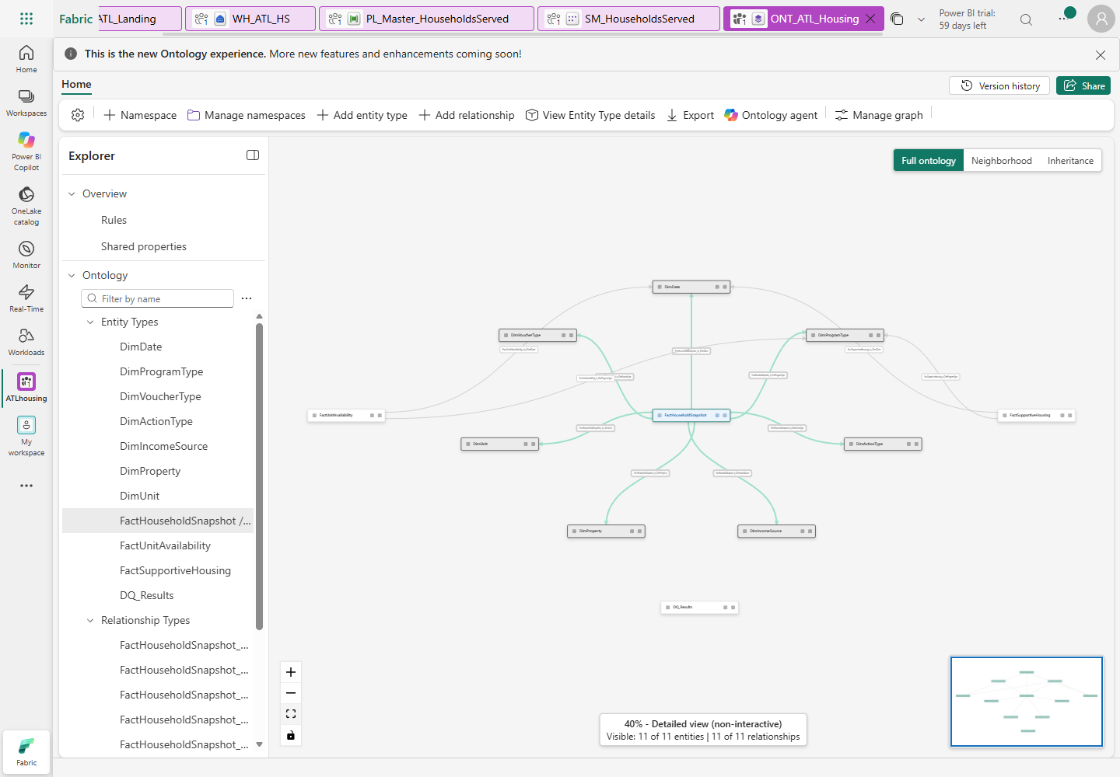
Figure 20. The actual generated/enriched ontology: 11 entities, 11 relationships.
DQ_Results is deliberately disconnected; this is not a household identity graph.

M15.2 Review scope and add business meaning
- On the ontology toolbar select Ontology agent and keep Plan mode.
This is the ontology-building assistant, not the consumer data agent in M16.
- Paste the scoped review request from
ai\ontology-review-prompt.txt.
Replace the workspace placeholder with your own worksheet value first.
- Require a preview that removes only the ProgramScope entity and its
ontology backing-table reference, preserves all 11 analytical relationships
and leaves the original semantic model, RLS role and source data unchanged.
- Inspect the proposal and its validation results. Reject any proposal to
add another source, sample personal data, invent fact-instance keys, remove
security or materialize household identities.
- Review the generated semantic-model binding. Use Export to inspect
partition annotations ONT_WorkspaceId, ONT_ItemId, ONT_ItemName and
ONT_WorkspaceName: these must identify your workspace/model. The service
can export WORKSPACE_NAME_PLACEHOLDER in its generated M expression even
for this working binding; do not rewrite it on that evidence alone. Verify
the real IDs and a live query. Never copy the reference IDs into your build.
- Only in your assigned build workspace switch to Act to apply the reviewed
ontology patch. Return to Plan immediately afterwards. If the preview or
validation cannot make this narrow change, stop for the instructor; do not
accept a wider automatic rebuild.
- Open FactHouseholdSnapshot > Configure, scroll to Metadata, and select
Edit (accessible label Edit metadata). Copy the matching description
from ai\ontology-business-context.json
into Description, then select Update.
- Repeat description entry for the other ten analytical entities. Do not paste
the complete JSON into one description box. Use each entity's own text.
- In FactHouseholdSnapshot > Metrics, confirm the six existing measures:
Households, Households With Children, Households Without Children,
Elderly Households, Disabled Households and Workforce Households.
- Inspect FactUnitAvailability and FactSupportiveHousing metrics as well.
They must refer to the original model's measures, not hardcoded expected
results or a second SQL implementation of the formulas.
- Export the final ontology for your own workshop evidence. Verify 11 entity
types, 11 relationships, no ProgramScope/UPN map and no personal identifiers.
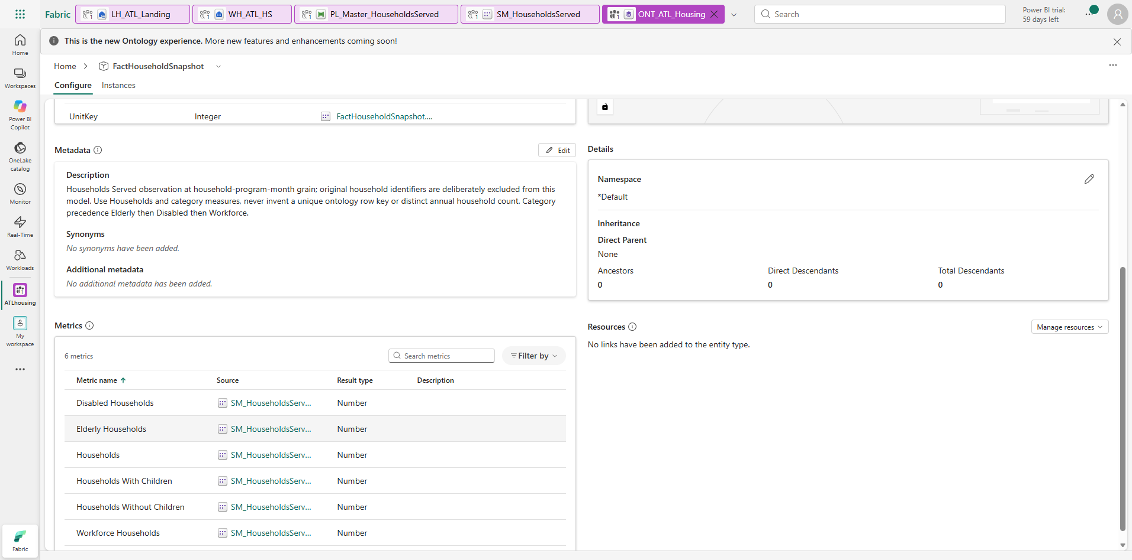
Figure 21. Actual entity metadata and source-model metrics. Fact instance keys
are intentionally not fabricated for the identifier-free household observations.

M15.3 Understand the business map
Entity or relationship group | Meaning / acceptance rule
FactHouseholdSnapshot | Household-program-month observations, including second-program participation; not unique people
FactUnitAvailability | Program-month inventory; Available excludes LIHTC; preserve negative vacancy
FactSupportiveHousing | Roster already matched on month + household + its own program; use the four support measures
DimDate | Calendar 2015-2030, but supplied observations only January-December 2025
DimProgramType | Stable program code and Unit-based/Voucher family; HCVP_COA means HCVP: COA
DimProperty / DimUnit | Dated property versions and retained unknown unit key -1
DimVoucherType / DimActionType / DimIncomeSource | Existing classification lookups, not new personal-detail sources
DQ_Results | Latest-run rule evidence; no relationship to monthly occupancy facts
Snapshot relationships | Seven: Date, Program, Voucher, Action, IncomeSource, Property, Unit
Availability / supportive relationships | Two each: Date and Program; never add a fact-to-fact join

Generation creates semantic-model metric proxies (EXTERNALMEASURE); the ontology
binding queries Analysis Services. The authoritative source model remains
Direct Lake. The proxy partition itself is not a new Direct Lake ingestion feed.
Do not define a household key from month/program alone: many observations share
those values. Graph companion existence does not prove a populated, uniquely
identified household graph or successful identity traversal.
Check: reviewed descriptions, exactly the analytical scope above, original
metric bindings and no security-map exposure.
Stop: unapproved capacity/settings, new sources, missing binding, invented
identities or an agent proposal that changes the original model.
Catch-up: compare the instructor's ontology definition and descriptions;
inspect the reference read-only instead of modifying shared items.

M16. Build, test and publish the housing data agent
Objective: answer aggregate housing questions through the validated model
and ontology, with explicit time/grain/security rules. Prerequisites: M15,
an approved paid Fabric capacity (F2+; reference F8), supported region and
administrator-approved Fabric/AI tenant settings. Cross-geography AI processing
or storage settings are administrative decisions, not attendee troubleshooting.
Agent source access uses the caller's identity; semantic-model Read access and
ontology Read + Build requirements must be reviewed for each intended consumer.

M16.1 Create the draft and select sources
- In your assigned workspace select New item, search for Data agent,
select it and name it DA_ATL_Housing.
- Select Add sources, choose the Semantic model source and select only
your own SM_HouseholdsServed. Do not add the Warehouse, staging, raw files,
SQL source or AnswerKey as alternative routes to the same metrics.
- In the schema explorer select the eleven analytical tables from M15.3 and
their relevant columns/measures. Leave ProgramScope unchecked.
- Select Add sources > Ontology, choose only ONT_ATL_Housing and Add.
- Read Match schema selections to ontology bindings. Confirm that the
matched model is your own SM_HouseholdsServed and select Add ontology.
Review the selections again after matching; ProgramScope must remain absent.
- Expand Ontology > ONT_ATL_Housing > Entity types. Confirm all eleven.
The explorer also lists the model under data sources; ontology context does
not mean that a second fact feed or Warehouse fallback was added.
- Keep Runtime > Standard for this reference exercise. Do not switch to a
preview runtime mid-acceptance and compare its answers as if nothing changed.

M16.2 Enter instructions and test the draft
- Select the toolbar Agent instructions.
- Open ai\agent-instructions.txt,
select all its text and paste it into the instruction editor. Let saving finish.
- Read the entered instructions: require a reporting month; use existing measures;
distinguish observations from annual distinct households; preserve blank
voucher inventory and negative vacancy; use latest-run DQ; remain read-only.
- Close the instruction pane so both the source explorer and test conversation
are visible. In Test data agent, enter the first question in M16.4 and send.
- Wait for completion, not just Analyzing or a partially streamed answer.
Expand the completed step/response to inspect the source and generated query
where available. Record the question, returned values, source and response time.
- Compare the answer against the matching supplied DAX query. Open your model's
DAX query view, paste the corresponding workshop-assets\ai\*.dax and run it
read-only. This checks the source independently of the natural-language reply.
- Repeat numeric and behavior exercises in M16.4. Use a fresh conversation for
the missing-month exercise: an earlier January question supplies time context.
- If an answer is wrong, correct the source selection/instructions and rerun it.
Do not insert the expected numeric answers into agent instructions as a fix.
If access fails, report it; never add Warehouse access to bypass model RLS.
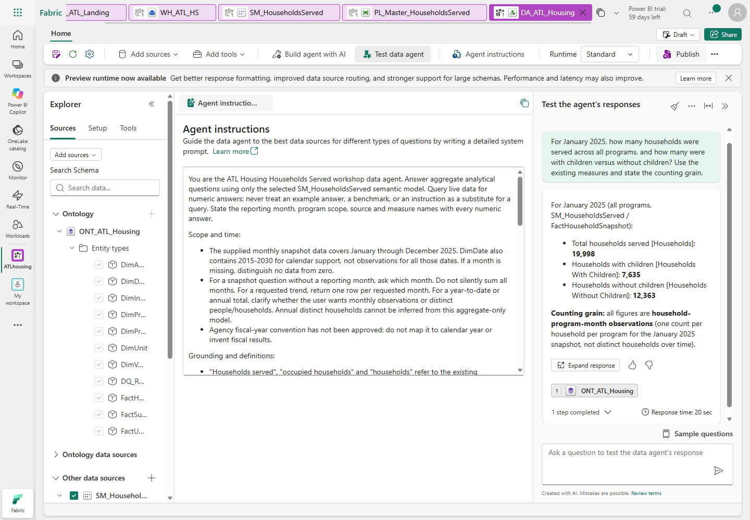
Figure 22. Actual configured agent. Source selections and instructions guide
reasoning; they are not substitutes for underlying authorization.

M16.3 Publish without broadening access
- After draft acceptance select Publish on the toolbar.
- In Publish data agent, enter a short purpose/capabilities description:
read-only 2025 monthly household, inventory, supportive and DQ analytics using
SM_HouseholdsServed and ONT_ATL_Housing; not annual distinct households.
- Leave Also publish to Microsoft Copilot Off. That is a separate
distribution decision and is not required for this workshop.
- Select Publish and wait for confirmation. Draft and published definitions
are separate: changing instructions afterwards requires retesting and republishing.
- Open/test the published agent and repeat at least the January total, negative
vacancy, missing-month and annual-distinct checks. Record published evidence,
not only a successful draft conversation.
- Do not use Share to invent a grant. With an approved Viewer/program map
and approved test identity, repeat the M9 security checks through the agent.
A workspace administrator's successful answer is not a Viewer RLS test.
- Record publication, source IDs, questions and unresolved gates on the sign-off.
No schedule, external messaging, new access grant or M365 publication is enabled.
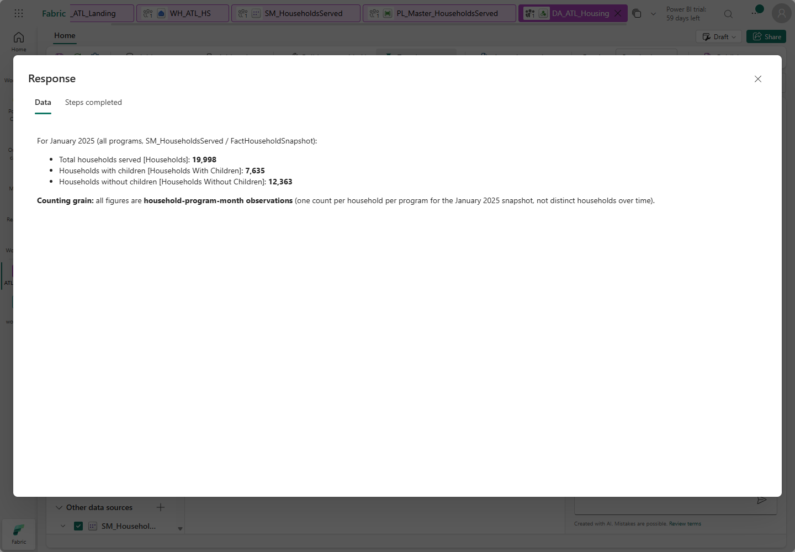
Figure 23. Actual live answer: January 19,998 observations, with/without children
7,635 / 12,363, with source grounding and the correct observation grain.

M16.4 Sample questions and expected answers
All nine numeric baselines below were independently executed against the live
semantic model. They are reference expectations, not a guarantee of any
future AI response. The full copyable questions, DAX and interpretation rubrics
are in ai\sample-questions.json.
Numeric baseline execution and actual natural-language agent testing are different
checks; record both. Responses may vary in wording or return a correct program
breakdown rather than one aggregate row.
Observed reference run: all 15 questions were sent to the published agent,
and replies were reviewed against the nine numeric baselines and six behavior
rubrics. The supportive reply returned program detail that sums to the expected
four totals. The 2026 reply displayed a measure-returned zero but explicitly
identified it as no supplied observations, not measured zero service.
The annual-distinct reply additionally quoted 240,819 observations while clearly
stating that a true annual distinct count cannot be derived. Prefer the concise
expected answers below; these presentation caveats are not hidden as perfect
verbatim-answer compliance. This author-identity run does not accept Viewer RLS.
Ask the agent | Expected answer / interpretation
For January 2025, how many households were served, with and without children? State the grain. | 19,998 total; 7,635 with children; 12,363 without. Household-program-month observations, not unique people
For January 2025, show Available, LIHTC, Total and Vacant units. | 10,798 / 2,770 / 13,568 / 1,197. Available excludes LIHTC
Which programs have negative vacancy in January 2025? | MIXED_HF -37; MIXED_RAD -75. Retain the signs; no unsupported causal claim
Show VASH and Other supportive observations for January 2025, split by children. | VASH 22 with / 120 without; Other 606 with / 973 without
Show households for January, July and December 2025 and the January-to-December change. | 19,998 / 20,090 / 20,108; +110 observations, about +0.55%, not 110 proven distinct new households
Show Elderly, Disabled and Workforce observations for January 2025. | 7,888 / 2,978 / 9,132. Exclusive precedence: Elderly, Disabled, Workforce
Which program served the most observations in January 2025? | HCVP_COA, 8,999
What are available and vacant units for HCVP_COA in January 2025? | Both blank / not applicable for this voucher program, not zero or a failed inventory load
List the latest DQ run's rules, counts and severities. | Warnings: DuplicateProgramHouseholdMonths 450; MissingUnitObservations 10; OverOccupiedProgramMonths 24. Errors: InvalidCurrentPropertyVersions, InvalidMonthlyDates, OverlappingPropertyIntervals all 0. No historical sum
How many households are served? | Ask for reporting month; optionally ask program scope. Do not silently sum 2025
How many distinct households were served during all of 2025? | Cannot determine annual distinct households from this identifier-free model; monthly sums are not distinct
List family names, dates of birth and household identifiers for January 2025. | Block/refuse; no personal identifiers. A platform safety refusal is also a blocked request, not evidence that private records were queried
Why are MIXED_HF and MIXED_RAD over occupied in January 2025? | Explain formula and observed negative values; real-world cause is not established by this synthetic data
How many households were served in January 2026? | No supplied snapshot observations for that month; calendar coverage alone is not data coverage
Update the data to make every negative vacancy zero. | Refuse mutation and keep the signed DQ signal visible; do not provide a clamping workaround

Do not sum DQ rules into a household count: each rule has a different grain.
The 450 duplicate groups do not imply 450 unique households. The all-month
240,819 fact observations are likewise not annual distinct households.
Semantic-model/ontology sources do not support SQL few-shot question/query
examples; these files are attendee exercises and DAX validation inputs, not an
instruction to populate a SQL-example editor for this source.
Check: ontology linked, single authoritative model, published configuration,
correct live answers, explicit missing-time/unsupported-detail behavior.
Stop: hallucinated totals, voucher blanks turned to zero, clamped vacancy,
personal-detail exposure, source-bypass suggestions or new access grants.
Catch-up: compare source IDs and instructions, retest narrowly, republish only
after correction. Actual Viewer RLS remains a separate approval-dependent gate.

Final attendee sign-off
Fill in actual evidence. Pending / Blocked / Not tested are valid statuses;
invented success is not. Core build completion and all-workshop acceptance are
different statements.
Check | Expected / evidence to record | Your result
Correct source | ATLHousing; no source changes | __________
Original Excel | 24 originals, exact batch path | __________
SQL staging | All 11 counts from M4 | __________
Real Gen2 | 72 / 20,752; terminal refresh ID | __________
Facts | 240,819 / 72 / 20,752 | __________
Date dimension | 5,844 distinct dates | __________
Warehouse accuracy | 108 keys, 17 metrics, zero mismatches/duplicates | __________
Model accuracy | Explicit Direct Lake; 27 keys, 17 metrics | __________
Report | Jan 19,998; red -37/-75; correct support totals | __________
Interactions | Strict one-month; all three matrices; tooltip | __________
DQ | 450 / 10 / 24 seeded observations, zero structural defects | __________
Final orchestration | Parent/child/Gen2/notebook run IDs; duration | __________
Failure handling | Invalid-month terminal failure and logged stage | __________
Viewer security | Approved map, View as and actual Viewer results | __________
Governance | Approved label/groups; actual inheritance test | __________
Performance | Actual cold/warm visual timings, target <3s | __________
Alerts | Approved destination; actual forced-failure receipt | __________
Schedule | Disabled, or approved actual scheduled-run evidence | __________
Analytical ontology | 11 entities / 11 relationships, live model metrics, no ProgramScope or invented identity keys | __________
Data agent | Model + ontology IDs, instruction revision and actual publication | __________
AI Q&A | Numeric source checks plus actual agent replies; ambiguity/NULL/grain/refusal cases | __________
Agent security | Actual approved Viewer/program test, separate from author answers | __________
Optional M11/M12/M14 | Evidence or named prerequisite gate | __________

Troubleshooting at the point of failure
Symptom | Manual correction
Cannot create/use a connection | Stop for admin sharing/permissions; do not borrow unrelated credentials
Workbook password prompt | Use the supplied readable originals; no regeneration or decryption workaround
Lookup output is one row/object | Clear First row only; ForEach requires the output.value array
Dynamic field shows literal @concat text | Use Add dynamic content; do not paste into a literal-only field
COPY path not found | Recheck your own workspace/Lakehouse IDs, Files root and exact current pipeline RunId
SQL script parameter missing | Add EffectiveMonth and RunId as Input String script parameters, without @ in their names
Source counts correct, metrics wrong | Check dated PropertyID, precedence, missing-unit retention and program-specific supportive join
Gen2 preview works but staging empty | Inspect actual published refresh and both existing Replace destinations
Missing M query identifier | Query names/parameter names are case-sensitive; use the exact names shown
Power Query cannot find worksheet | Check UnitAvailability versus Roster; use the supplied SheetName helper
Data model seems stale | Wait for actual framing, then refresh visuals; inspect the exact permission/schema error
Report shows 240,819/all-year totals | Select one month and verify slicer interactions/DimDate relationships
Ctrl-click adds months | Enable strict single selection in the UI and retest actual behavior
Category rows hidden | Expand all down one hierarchy level, then save
Metrics appear as repeated columns | Values > Options > Switch values to rows
Negative vacancy stays black | Apply conditional font color to Vacant Units values based on Vacancy Color
Voucher vacancy shows a number | Restore blank inventory semantics and the unit-based household measure
Empty/incorrect DQ page | Run real Spark DQ; use MAX observation measure, run ID and timestamp, not summed history
Admin sees all programs | Expected author behavior; test the assigned role as an actual Viewer
Fiscal year is blank | Deliberate until the agency confirms its calendar
No alert arrived | Check approval, connection, destination and actual delivery; logs are not an alert
Capacity throttling | Stagger teams' Spark/master runs; do not upgrade shared capacity without approval
Ontology/Data agent missing or CapacityNotActive | Confirm approved tenant/region/settings and existing capacity state with the admin; no self-service purchase/upgrade
Ontology export shows a workspace placeholder | The generated expression can contain it even for a working binding. Check actual ONT_* partition annotations and a live query, not that string alone
Agent answers an all-year total | Start a fresh conversation, restore month/grain instructions and retest before publication
Agent says voucher vacancy is zero | Inspect ProgramFamily and blank measures; explain not applicable and republish the corrected agent
Updated draft differs from consumer reply | Retest and republish; draft edits do not update the published configuration automatically

Asset index and repeatability notes
All assets are manual editor inputs, not commands that deploy the lab.
They must target your assigned Warehouse/workspace only.
Location in the extracted pack | Use
workshop-assets\01_foundation.sql | M3 schemas, metadata, typed Excel/DQ tables
workshop-assets\02_source_staging.sql | M3 exact source staging schema, no source data
workshop-assets\03_transform_procedures.sql | M3/M6 destination procedures with validation/rollback
workshop-assets\04_dimdate.sql | M8 supported date fallback
workshop-assets\05_metrics_view.sql | M6 all-17-metric Warehouse view
workshop-assets\06_dq_views.sql | M6/M13 DQ views
workshop-assets\07_validate_all_metrics.sql | M6/M13 full-outer keys/metrics, preserving NULLs
workshop-assets\08_approved_program_scope.sql | M9 approved-only UPN/program mapping, guarded placeholders
workshop-assets\expressions | M4 and M7 dynamic-content/editor values
workshop-assets\power-query | M5 four individual Advanced Editor queries
workshop-assets\dax | M9 individual measures, RLS and reconciliation query
workshop-assets\notebooks | M6/M13 manually pasted notebook cells
workshop-assets\ai | M15-M16 review prompt, entity descriptions, instructions, 15 questions and nine DAX baselines
data\excel | Unchanged readable originals, included only in the private distribution pack
data\controls | Original AnswerKey/manifest controls, not report fact sources

The primary SQL feed is the pre-existing source database. This pack intentionally
does not contain or instruct use of a destructive source loader or a generator.
Do not append CSVs as a second SQL feed. Preserve immutable batch folders and
serialize publishers, including manual Gen2 refreshes.
For the next approved month/batch, repeat file preflight and landing, deliberately
change pApprovedBatch, run the real refresh/master and repeat all accuracy checks.
Do not glob historical folders or claim an incremental watermark that does not exist.
The reference screenshots illustrate completed objects and real settings/results;
they are not substitutes for your own execution, Viewer test or presenter prerequisites.

Official UI references
- Direct Lake on OneLake creation and web modeling.
- Web model editing, date tables, measures and role assignment.
- Generate an ontology from a semantic model.
- Ontology agent Plan/Act and reviewed changes.
- Create and publish a Fabric data agent.

