KL ERP SYSTEM
A Practical Case Study in Adaptive Software Engineering
User Stories · Process Model · Technology Stack · Implementation · Evaluation
Name: M sathwik kumar goud
Roll Number: 2420090078
Section: 11

Table of Contents
1. Introduction and Choice of Case Study
2. User Stories
3. Software Development Process Model
4. Programming Language and Tech Stack
5. Overview of the System Architecture
6. Implementation, Step by Step
7. Evaluation Approach
8. Conclusion and Scope for Future Work

1. Introduction and Choice of Case Study
This document is a complete software engineering case study built around a KL ERP System, a campus Enterprise Resource Planning platform patterned on the operational needs of a university such as KL University. An ERP system was chosen in preference to an e-commerce one because it shows more clearly the core challenges stressed in this course: several interacting modules with different stakeholders, role-based workflows, transactional data integrity, and the need for incremental delivery in which each module can be built, tested and released on its own.
The KL ERP System modelled here brings four core administrative functions of a university together on a single platform:
- Student Module — registration records, department and year tracking, and fee status.
- HR / Faculty Module — employee and faculty records, designations and employment status.
- Finance Module — fee collections, salary disbursements and expense tracking, kept in a running ledger.
- Inventory Module — tracking of campus assets and equipment across departments.
Every module is handled as a semi-independent increment with its own data model, screens and user stories, and this is what motivates the process model discussed in Section 3.

2. User Stories
The user stories are written from the viewpoint of the main stakeholders of a real campus ERP: the System Administrator (who manages master data during rollout), the Registrar / Academic Office staff, the HR Officer, the Finance/Accounts Officer and the Facilities/Inventory Officer. They follow the standard “As a / I want to / So that” template and are grouped by module, so that each group corresponds to one release increment.

2.1 Authentication & Access
ID | As a... | I want to... | So that...
US-01 | system user | sign in with a username and password | student, financial and HR data can be reached only by authorised staff
US-02 | system user | be sent back to the login page when my session expires | the system remains secure while I am away from my desk
US-03 | administrator | have my role shown after I log in | I can check that I hold the right access level before making any changes

2.2 Student Module
ID | As a... | I want to... | So that...
US-04 | registrar | create a new student record containing the registration number, department and year | the student is formally enrolled in the system
US-05 | registrar | see all enrolled students in a single list | I can quickly gauge the strength of each department
US-06 | registrar | check every student's fee status (Paid / Pending / Overdue) | I can chase students who still owe fees
US-07 | academic office staff | filter students, conceptually, by department and year | I can produce department-wise reports (a future increment)

2.3 HR / Faculty Module
ID | As a... | I want to... | So that...
US-08 | HR officer | create a new faculty or staff record with the designation and department | new hires appear in the university's official records
US-09 | HR officer | see every employee together with their current status (Active / On Leave / Retired) | I can keep an accurate headcount for payroll planning
US-10 | department head | look up faculty contact details | I can contact staff to coordinate within the department

2.4 Finance Module
ID | As a... | I want to... | So that...
US-11 | finance officer | log a fee payment against a student's registration number | the university's revenue records remain accurate and auditable
US-12 | finance officer | log salary disbursements and campus expenses | the ledger captures every outgoing payment and not just incoming fees
US-13 | finance officer | view total revenue, total expenses and the net position on a single screen | I can report on the university's financial health without working through spreadsheets by hand
US-14 | finance officer | label a transaction as Completed, Pending or Overdue | the ledger separates settled transactions from those still being followed up

2.5 Inventory Module
ID | As a... | I want to... | So that...
US-15 | facilities officer | add a new campus asset with a unique asset code and a location | each item of equipment can be traced to a physical location
US-16 | facilities officer | see all assets along with their quantity and condition | I can plan budgets for replacement or maintenance
US-17 | lab in-charge | identify the assets flagged as “Needs Repair” | I can prioritise maintenance requests

2.6 Administration Dashboard
ID | As a... | I want to... | So that...
US-18 | administrator | view a consolidated dashboard showing the student count, staff count, revenue and pending fees | I get a quick summary without opening each module
US-19 | administrator | view the latest finance transactions on the dashboard | I can notice unusual activity quickly

3. Software Development Process Model

3.1 Chosen Model: Agile (Scrum) with Incremental Module Delivery
The KL ERP System follows an Agile process, specifically Scrum, with each module treated as a release increment. This follows naturally from what ERP systems are: loosely coupled functional modules (Student, HR, Finance, Inventory) that share a common platform but have separate stakeholders and acceptance criteria that can be tested independently, as the user-story groupings in Section 2 show.

3.2 Justification
- Modules as sprints: each functional module (Student, HR, Finance, Inventory) was scoped, built and demonstrated as a self-contained two-week sprint, mirroring how a real university would introduce ERP modules gradually instead of in one “big-bang” release.
- Stakeholder feedback loops: registrars, HR officers and finance staff have different priorities, and sprint reviews let each group validate its own module without holding up the others.
- Evolving requirements: fee-status categories, asset-condition labels and employee-status values are details that are realistically refined only after stakeholders see a working screen, and Agile absorbs such changes without an expensive re-specification phase.
- Early risk reduction: the riskiest integration point, a shared authentication and session layer used by every module, was built first in Sprint 0, so each later module sprint could rest on a proven foundation.

3.3 Why Waterfall and Spiral Were Not Used
Waterfall was considered and rejected because the requirements of an ERP are seldom fully known in advance; a registrar's exact reporting needs, for instance, tend to surface only once a working student list exists. Spiral, with its heavy risk analysis in every iteration, was judged to add more process overhead than this project needs. The risk profile here (independent CRUD modules integrated behind shared authentication) is handled well by the lighter sprint cadence of Scrum.

3.4 Sprint Plan Followed in This Implementation
Sprint | Scope | Key Deliverable
Sprint 0 | Project setup, session-based authentication, shared UI shell | Login page and sidebar layout (US-01, US-02, US-03)
Sprint 1 | Student Module | Student CRUD and fee-status badges (US-04 to US-07)
Sprint 2 | HR / Faculty Module | Employee CRUD and status tracking (US-08 to US-10)
Sprint 3 | Finance Module | Transaction ledger and revenue/expense summary (US-11 to US-14)
Sprint 4 | Inventory Module | Asset register and condition tracking (US-15 to US-17)
Sprint 5 | Admin Dashboard and Integration | KPI dashboard spanning all modules (US-18, US-19)

4. Programming Language and Tech Stack

4.1 Chosen Language: JavaScript (Node.js) with Server-Side EJS Rendering
JavaScript on Node.js was chosen as the main implementation language, together with Express.js as the web framework, EJS for server-rendered views and SQLite (through better-sqlite3) as the embedded relational database.

4.2 Justification
- One language throughout the stack: using JavaScript for both the server and the view templates removes context switching and keeps the codebase approachable for a small team, which fits the sprint-sized delivery model chosen in Section 3.
- Asynchronous I/O: the non-blocking model of Node.js suits an ERP system in which many staff members (registrar, HR, finance, facilities) send concurrent requests against shared data.
- Mature ecosystem: Express, EJS and better-sqlite3 are stable, widely used npm packages, which lowers implementation risk for a time-boxed academic project.
- Server-rendered pages instead of a client-side SPA framework: an ERP admin console is essentially a collection of CRUD forms and tables, so server rendering keeps each module small and avoids client-side state management and a separate API layer, which would be out of proportion for this scope.
- Relational integrity with little operational overhead: SQLite offers genuine relational storage, transactions and unique constraints (used for registration numbers, employee IDs and asset codes) without a separately hosted database server. That suits a prototype that can later be moved to PostgreSQL or MySQL with minimal code change, because the queries are written in standard SQL.

4.3 Technology Stack Summary
Layer | Technology | Purpose
Runtime | Node.js | JavaScript runtime environment on the server
Web Framework | Express.js | Routing, session handling and the request/response cycle
View Engine | EJS | Server-side HTML templates for every module
Database | SQLite (better-sqlite3) | Persistent relational storage for students, employees, finance and inventory
Auth | express-session | Server-side session cookies that hold the login state
Styling | Hand-written CSS (CSS variables) | A consistent navy/blue ERP look across all modules

5. Overview of the System Architecture
The system uses a classic three-tier architecture, which suits a server-rendered CRUD application:
- Presentation tier: EJS templates rendered for each module (login, dashboard, students, hr, finance, inventory), all sharing one sidebar/topbar layout partial for a uniform look.
- Application tier: Express route handlers provide one GET (list/view) and one POST (create) route per module, and a shared requireAuth middleware protects every module route using the session cookie set at login.
- Data tier: the SQLite tables users, students, employees, finance and inventory, each with a unique business key (username, reg_no, emp_id, asset_code) enforced by the database to prevent duplicate records.
This layout keeps the route, query and view of each module together and independently deployable within a sprint, which directly supports the incremental delivery model chosen in Section 3.

6. Implementation, Step by Step
The steps below walk through the working KL ERP application exactly as it was built and run for this case study. The screenshots were captured from the live application (SQLite-backed and session-authenticated) and are not static mockups.

Step 1 — Authentication
The entry point is a login screen backed by the users table. Credentials are checked against the database, and a server-side session is created when they are valid (US-01, US-02, US-03).

Figure 1. Login screen of the KL ERP.

Step 2 — Administration Dashboard
Once logged in, the administrator arrives at a consolidated dashboard that pulls live figures from all four modules: total students, active staff, fee revenue collected and accounts with pending fees. It also lists the five most recent finance transactions and a campus-wide snapshot (US-18, US-19). Every figure is computed live with SQL aggregate queries (COUNT, SUM) against the current database state and is not hard-coded.
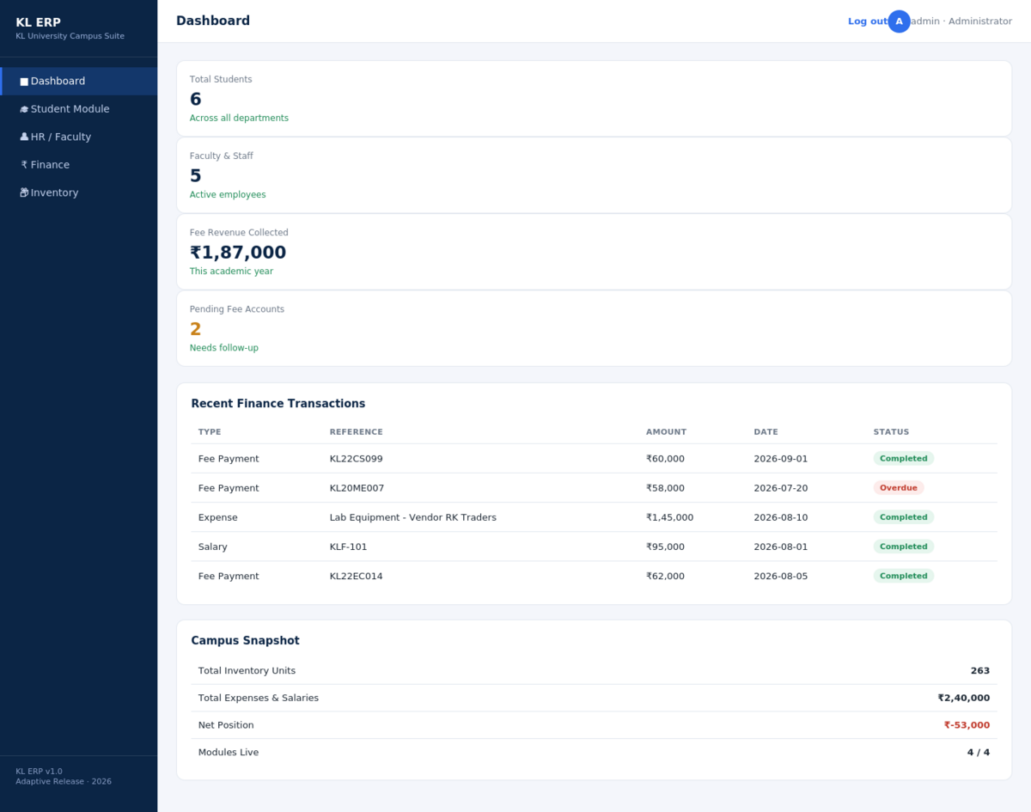
Figure 2. The consolidated administration dashboard.

Step 3 — Student Module
The Student module covers US-04 to US-07. An “Add New Student” form posts to the /students route, which runs a parameterized INSERT into the students table and then redirects to the list so that the new record shows up immediately. The screenshot below was taken after a new student record (KL22CS099) was submitted through the running application; the record sits at the top of the table, confirming that the create-then-list flow works end to end.
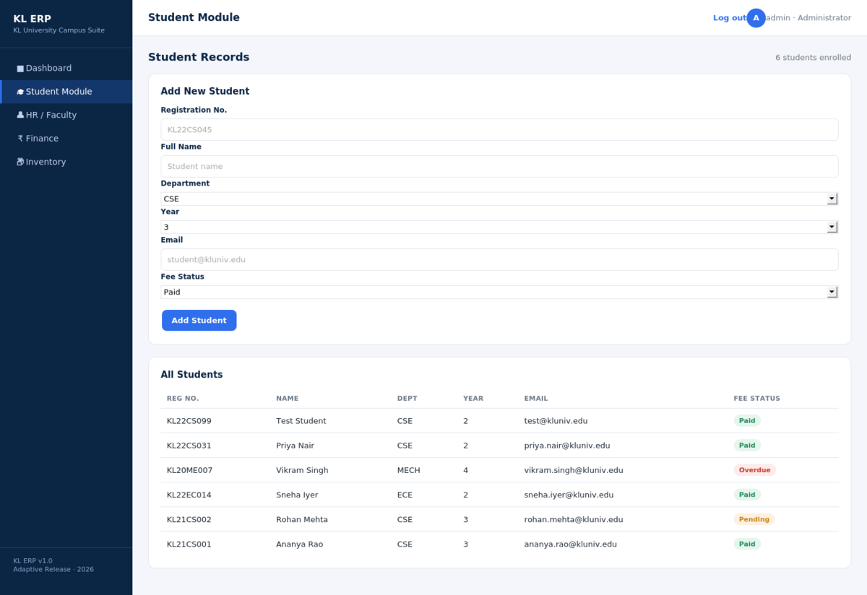
Figure 3. Student module: add form and live student list, including a record just created through the form.

Step 4 — HR / Faculty Module
The HR module (US-08 to US-10) follows the same structure as the Student module: an add-employee form and a live-queried employee table with a status badge (Active / On Leave / Retired). Reusing the same list-plus-form pattern across modules was a deliberate architectural decision that sped up every later sprint.
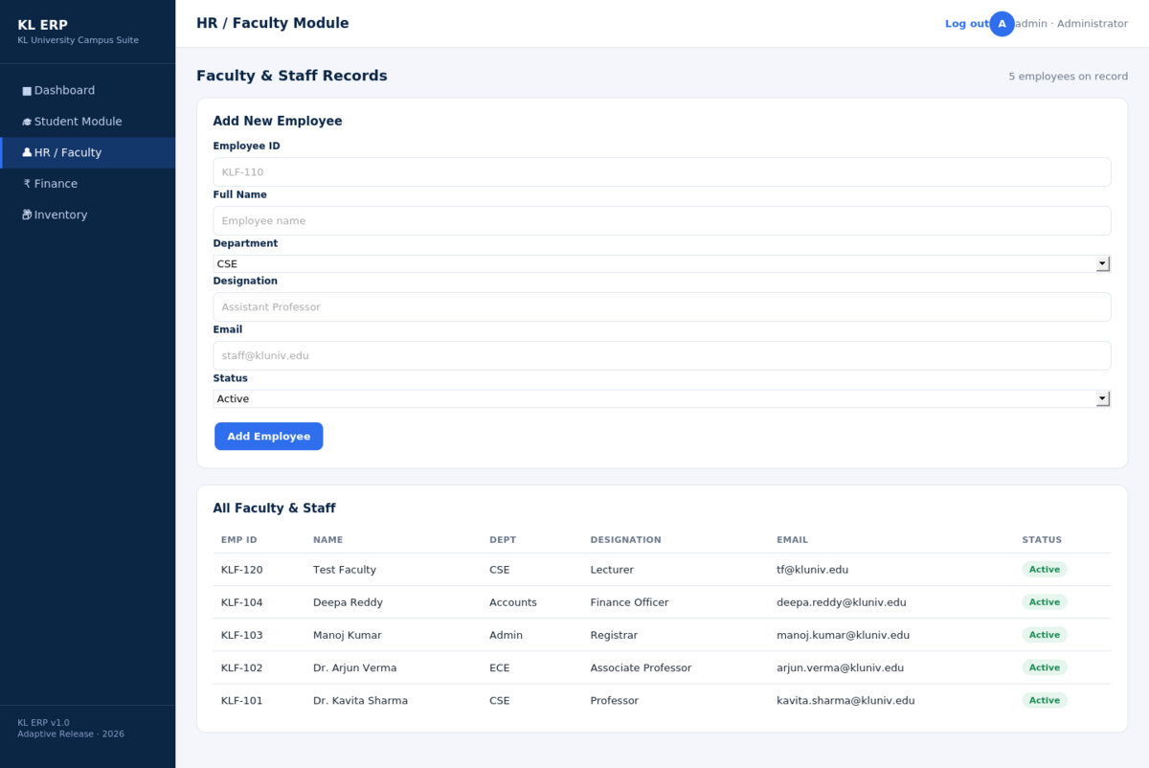
Figure 4. HR / Faculty module showing a newly added faculty record.

Step 5 — Finance Module
The Finance module (US-11 to US-14) is the most business-critical one. It keeps a single finance table that records fee payments, salaries and expenses as typed transactions. The revenue and expense totals at the top of the page come from conditional SQL aggregates (SUM ... WHERE txn_type IN (...)), and the net position is coloured green or red according to its sign.
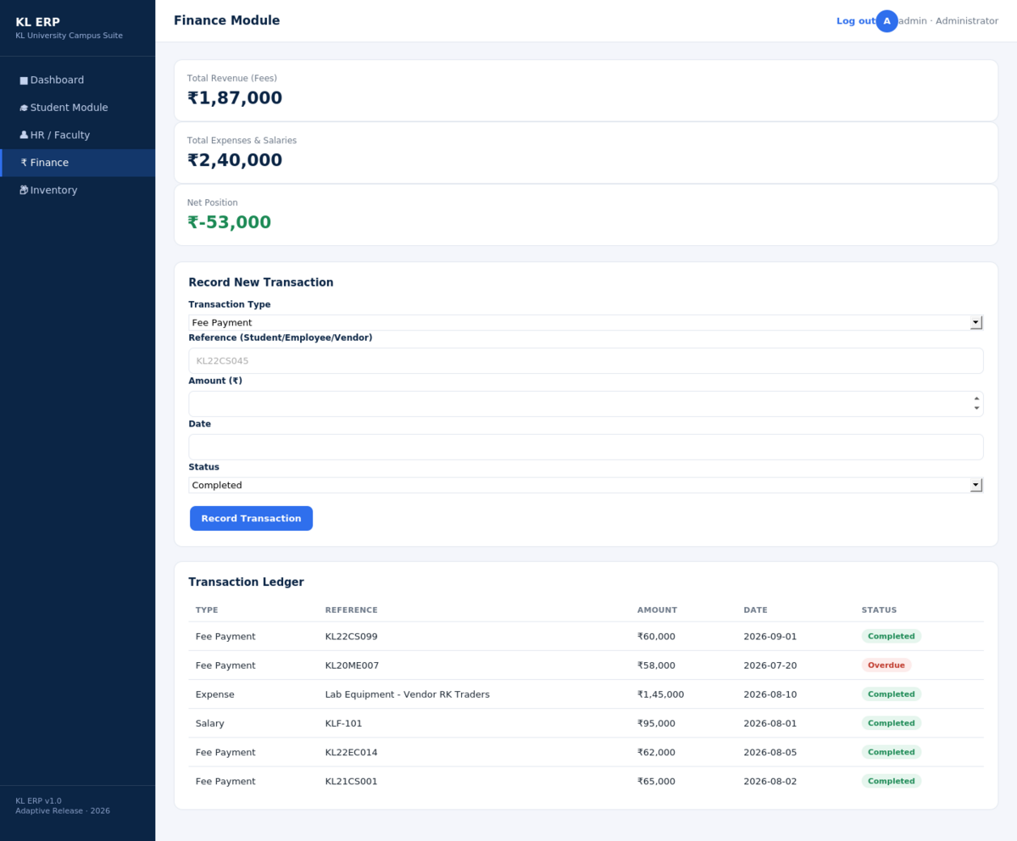
Figure 5. Finance module: revenue/expense summary and transaction ledger.

Step 6 — Inventory Module
The Inventory module (US-15 to US-17) tracks campus assets by category, quantity, location and condition. Condition is colour-coded (Good / Fair / Needs Repair), so facilities staff can triage maintenance priorities visually from the list, which satisfies US-17.
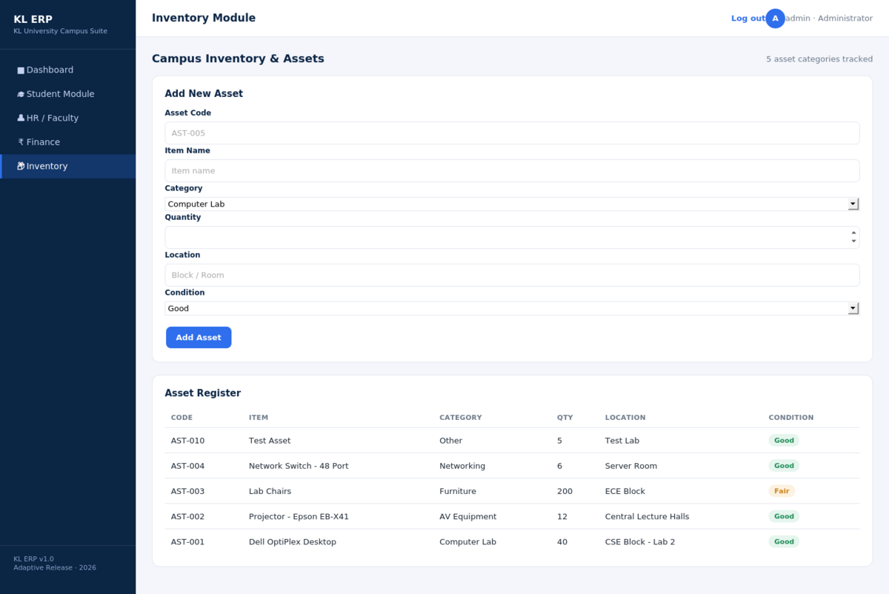
Figure 6. Inventory module: asset register with condition tracking.

Implementation Notes
- Every module uses the same GET (list) / POST (create) pair, protected by the same requireAuth middleware, which kept the implementation effort per module roughly constant across Sprints 1–4.
- The business keys (reg_no, emp_id, asset_code) are declared UNIQUE at the database layer, so duplicate records are rejected even when application-level validation is bypassed.
- All form inputs are bound through parameterized prepared statements (better-sqlite3's .prepare().run()), a deliberate defence against SQL injection from the first sprint rather than a later hardening pass.

7. Evaluation Approach

7.1 Functional Testing (Per User Story)
Each user story from Section 2 served directly as an acceptance-test script. For every module, the following cycle was run manually against the live application and can be repeated through the same HTTP routes:
- Submit the “Add” form with valid data and check that the new record appears in the matching list (verified for the Student, HR, Finance and Inventory modules in Section 6).
- Try to open a module route without an active session and check that the request is redirected to /login (validates US-02).
- Submit a duplicate business key (for example an existing reg_no) and check that the database's UNIQUE constraint rejects the insert.

7.2 Testing Levels Proposed for Further Development
Level | Approach | Tooling
Unit | Test individual SQL query builders and aggregate calculations (revenue, net position) separately | Jest
Integration | Exercise every Express route (GET/POST) against a temporary in-memory SQLite instance | Jest + Supertest
UAT | Take each stakeholder role (registrar, HR officer, finance officer, facilities officer) through the user stories of their module | Scripted manual walkthrough at each sprint review
Regression | Repeat the full user-story checklist after every sprint to confirm that earlier modules still work | Manual checklist, which can later be automated with Supertest

7.3 Non-Functional Evaluation
- Security: queries are parameterized throughout (guarding against SQL injection), and session cookies are held server-side and expire after 60 minutes of inactivity.
- Performance: each module route runs only a few indexed SQLite queries per request, so response times should stay in the low tens of milliseconds under typical campus-office load; this should be confirmed with a load-testing tool such as autocannon before production use.
- Usability: every module has the same sidebar/topbar layout and colour-coded status badges (fee status, employee status, transaction status, asset condition), so staff need to learn the interaction pattern only once.

7.4 Success Metrics
- Story completion rate per sprint (target: 100% of that sprint's user stories demonstrated and accepted).
- Defects found during UAT compared with defects found after release (target: most of them caught before release).
- Time a registrar needs to add a new student, used as a proxy for how easily the system would be adopted in practice.

8. Conclusion and Scope for Future Work
This case study carried the KL ERP System from stakeholder-driven user stories to a working, database-backed application covering the Student, HR, Finance and Inventory modules. It was delivered incrementally under Scrum and implemented on a Node.js/Express/EJS/SQLite stack chosen specifically for that incremental delivery model.
Further increments that were identified but fall outside this case study include department-wise and year-wise reporting (US-07), role-based access control that separates registrar, HR, finance and facilities logins instead of a single administrator account, audit logging of record changes, and migration from SQLite to a networked database (PostgreSQL/MySQL) for multi-instance deployment, a change that the parameterized-SQL design was deliberately kept compatible with.

