Name: M sathwik kumar goud
Roll Number: 2420090078

E-COMMERCE WEB APPLICATION
Case Study – Screenshots, Step by Step
Implementation Record

Step 1 – Launch the E-Commerce Home Page
Launch the application and confirm that the home page loads.
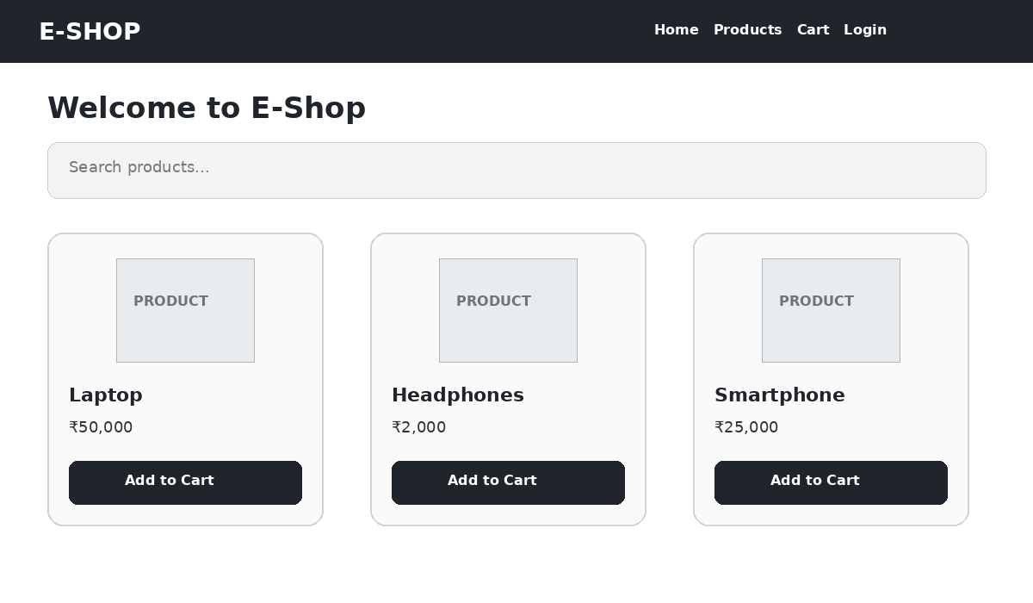
Figure 1: Launching the E-Commerce Home Page

Step 2 – Create a New User Account
Fill in the required user details and click Register.
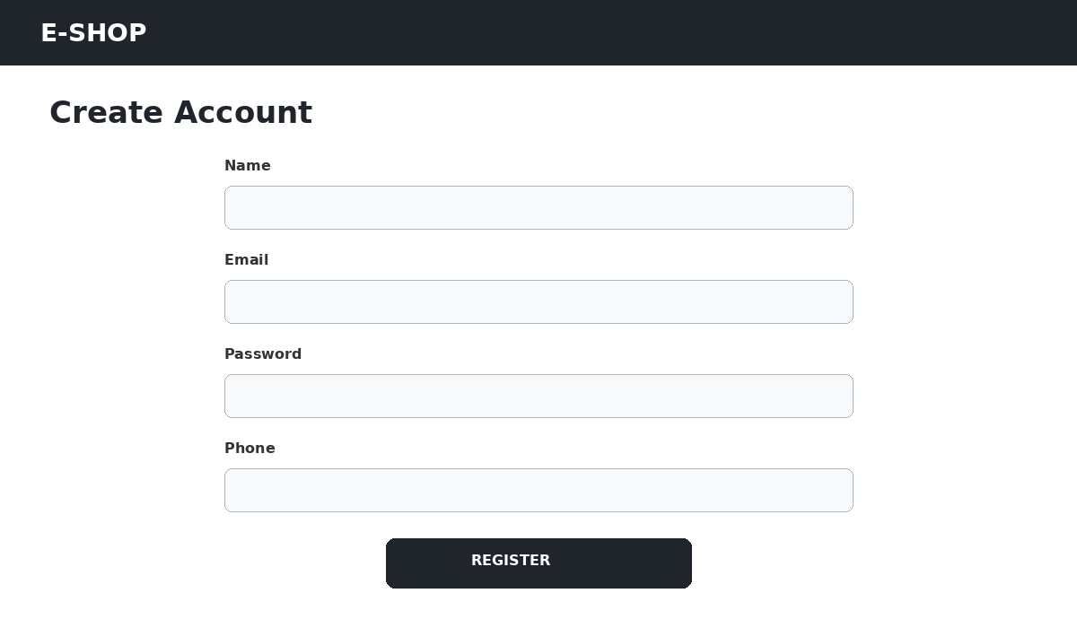
Figure 2: Creating a New User Account

Step 3 – Log In to the Application
Provide valid credentials and click Login.
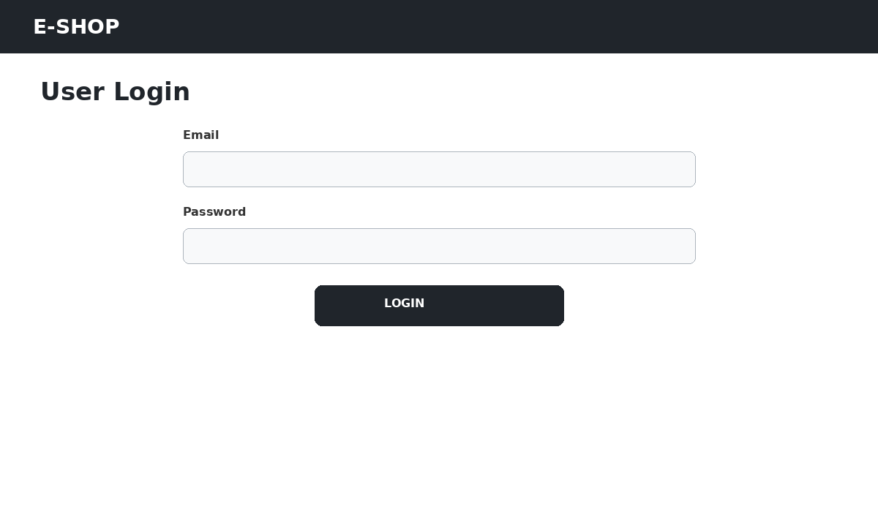
Figure 3: Logging In to the Application

Step 4 – Browse Available Products
Go to the Products section and check that the available products are listed.
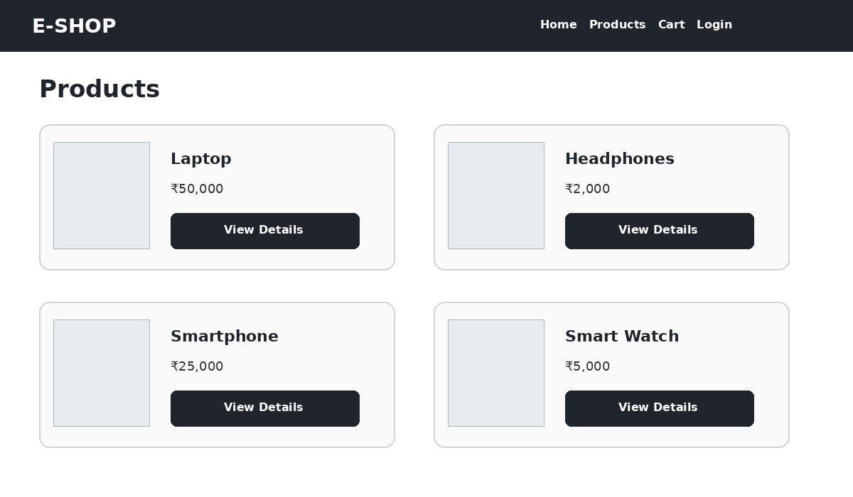
Figure 4: Browsing Available Products

Step 5 – Open Product Details
Pick a product to see its price, description and specifications.
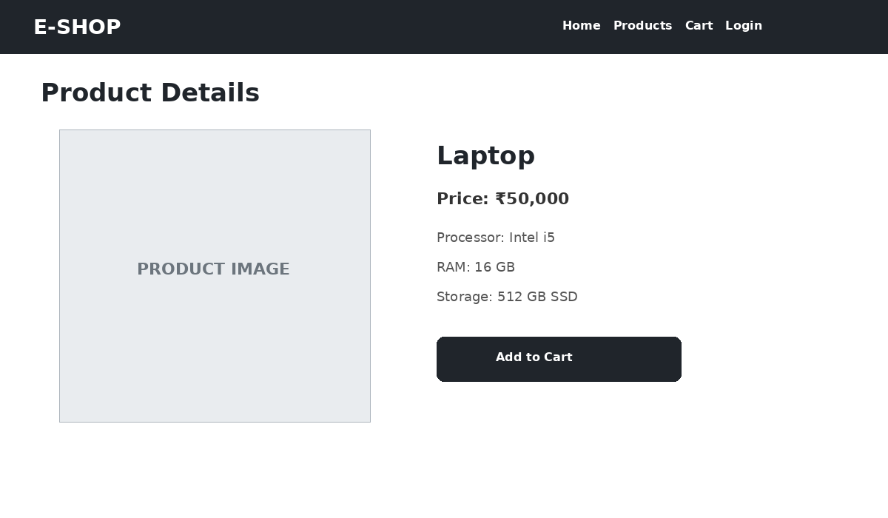
Figure 5: Viewing Product Details

Step 6 – Add a Product to the Cart
Click Add to Cart on the chosen product.
Figure 6: Adding a Product to the Cart

Step 7 – Review the Shopping Cart
Open the cart and check the selected products, their quantities and the total amount.
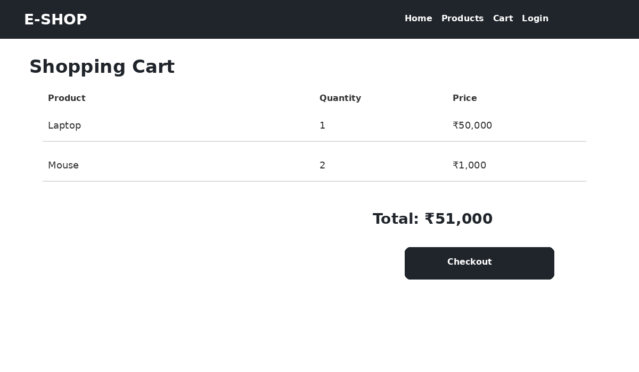
Figure 7: Reviewing the Shopping Cart

Step 8 – Proceed to Checkout
Provide the delivery details, choose a payment method and continue to place the order.
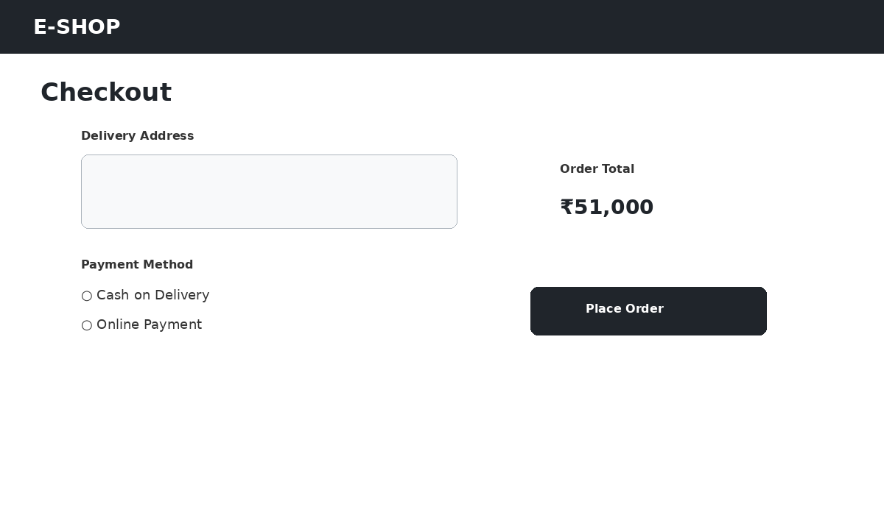
Figure 8: Proceeding to Checkout

Step 9 – Place the Order
Click Place Order and check that an order confirmation appears.
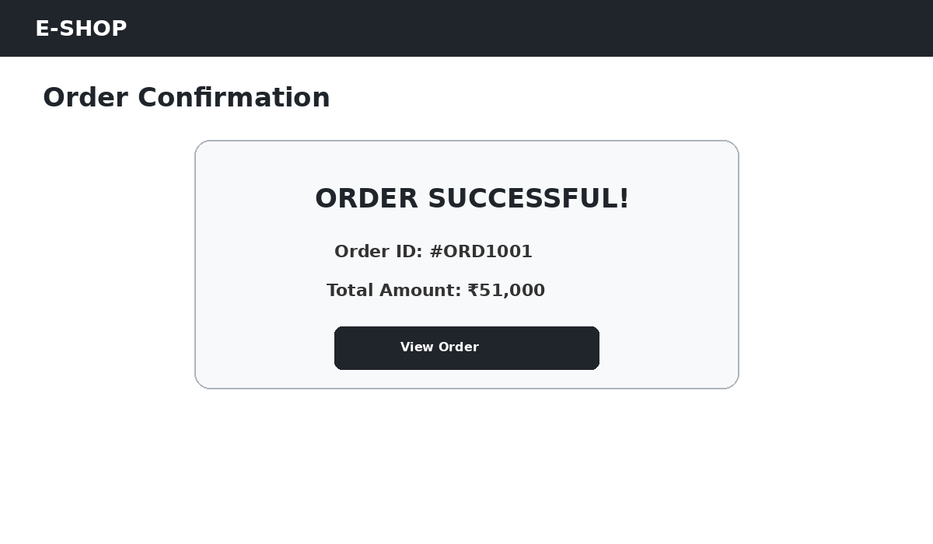
Figure 9: Placing the Order

Step 10 – Open the Administrator Dashboard
Sign in as the administrator and open the dashboard.
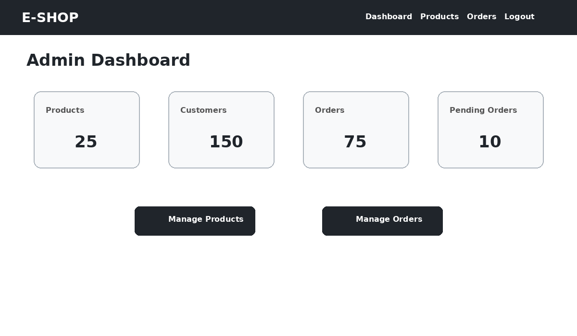
Figure 10: Viewing the Administrator Dashboard

Step 11 – Product Management
Use the admin product-management page to view, edit or delete products.
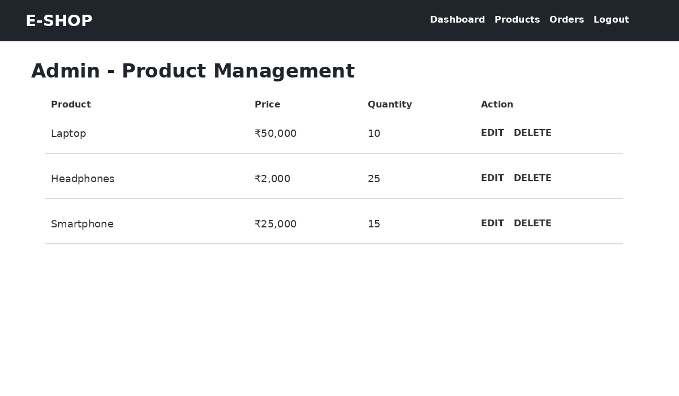
Figure 11: Managing Products

Evaluation
After implementation, check each of the main functions: registration, login, product browsing, product details, cart, checkout, order placement and administrator product management.

