Task 3: Setting Up a Jira Board with User Stories and Story Points
Aim: Set up a Scrum project in Jira, write five user stories and estimate them with story points, create a sprint, and run the work on a Scrum board.

Step 1: Sign Up for Jira
- Open https://www.atlassian.com/software/jira in your browser.
- Select Get it Free or Sign Up.
- Register an Atlassian account and confirm your email address (use a domain email ID only).
- Sign in to Jira.
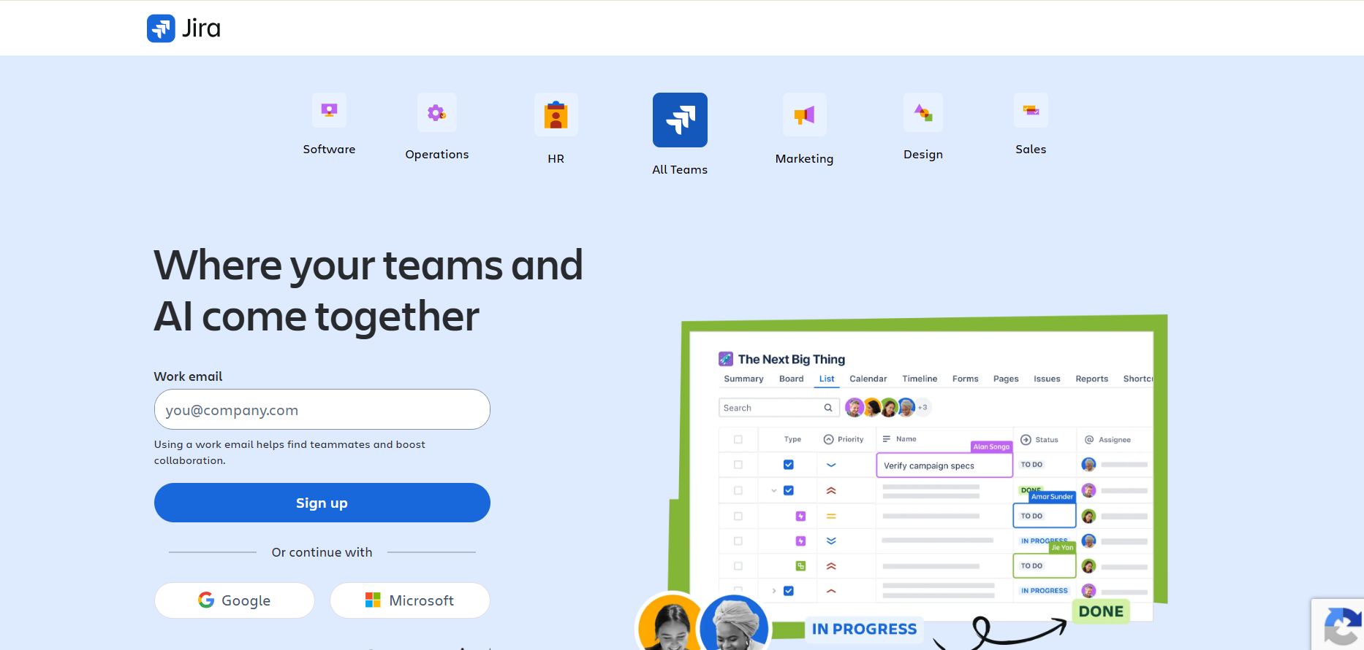

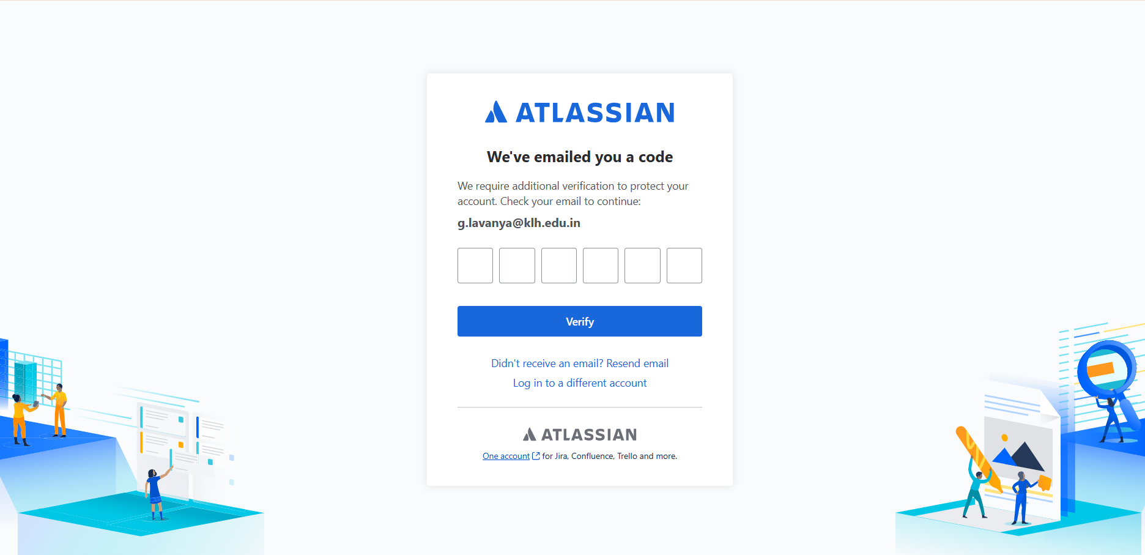
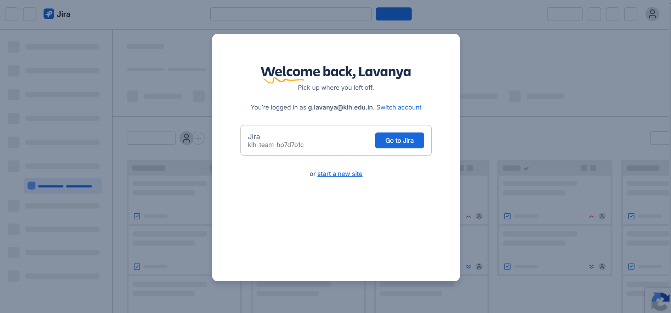
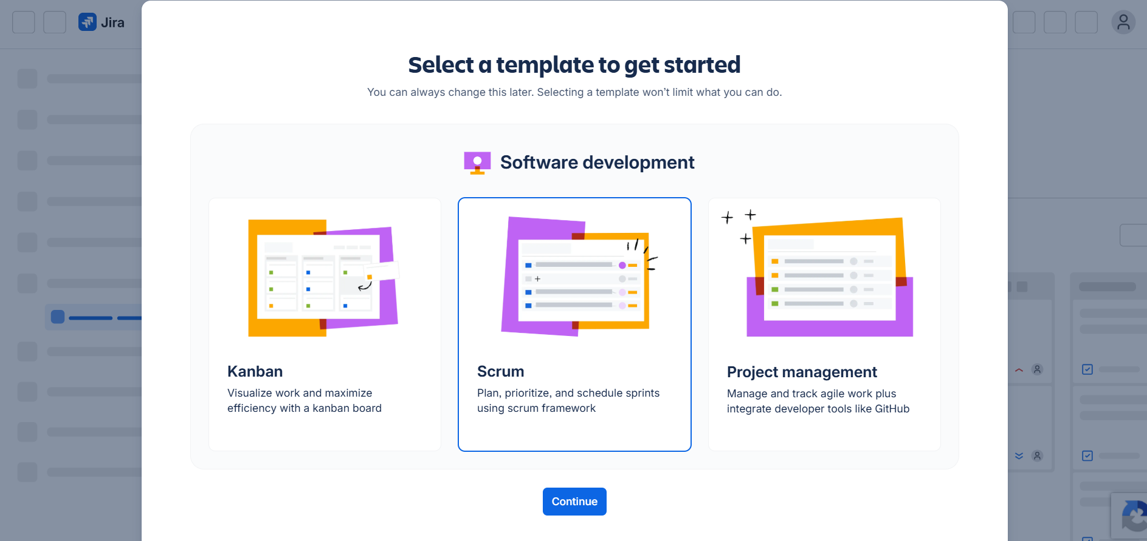

Step 2: Create a Scrum Project
Start a new Software project from the Scrum template and name it something like “My Software Team”.

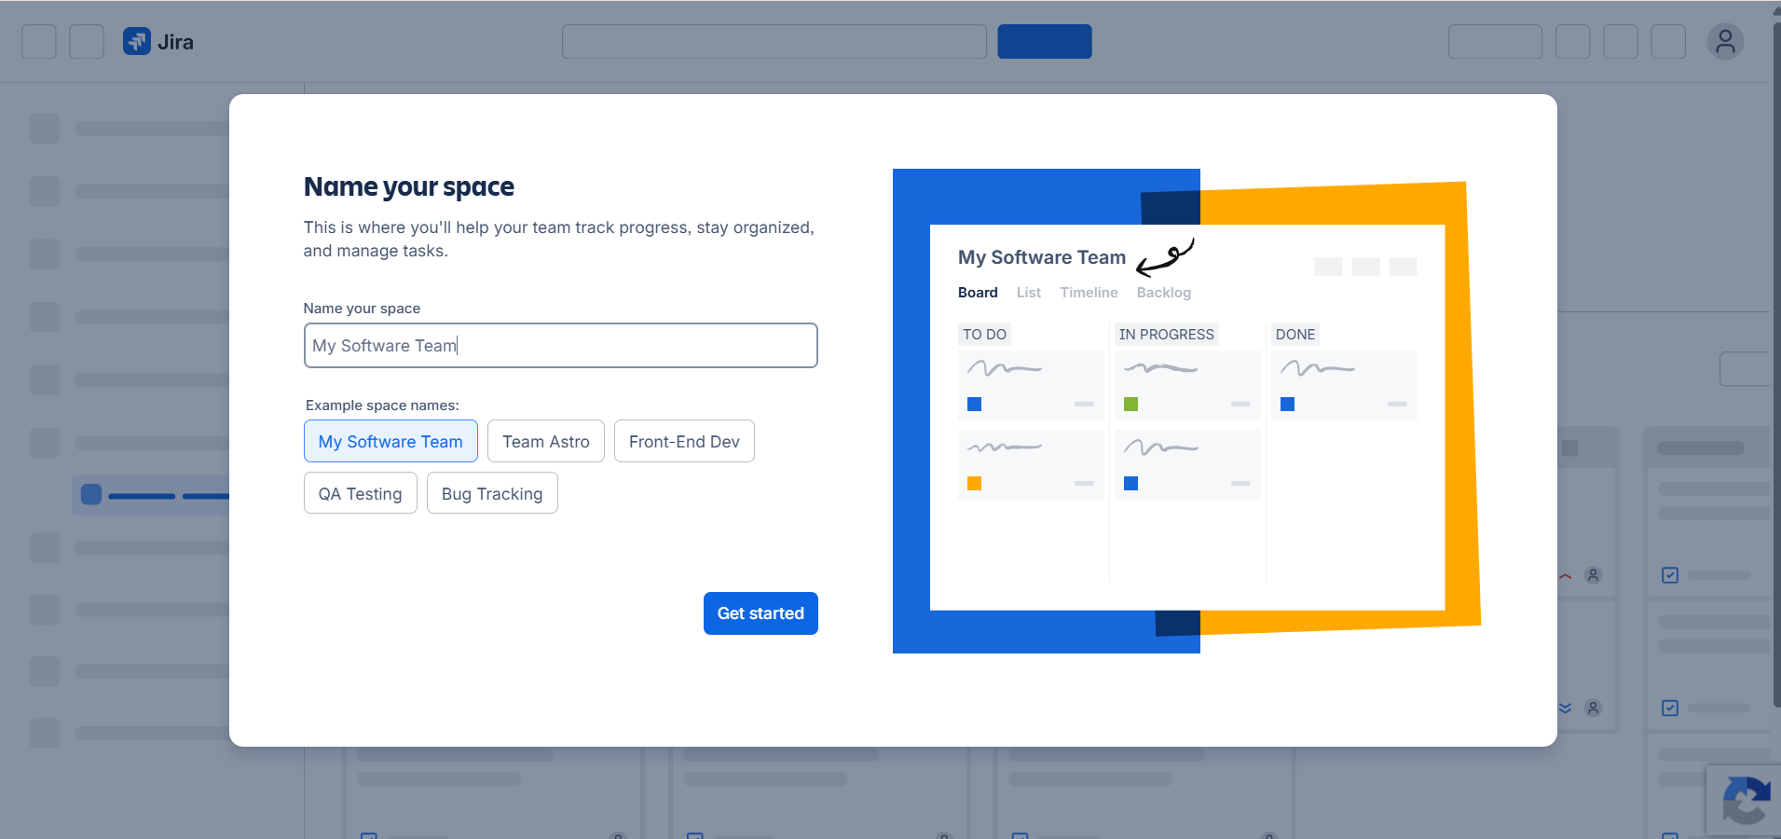

Step 3: Select Work Types
Choose Story and Task as the work types. Stories capture user requirements.

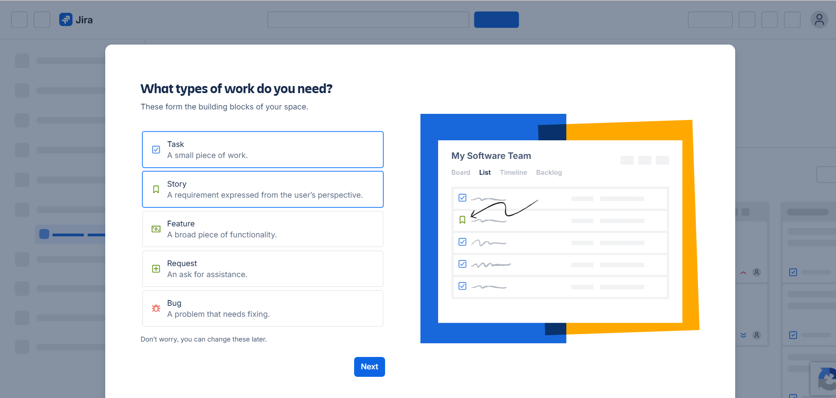

Step 4: Configure the Workflow
Leave the workflow at its default: To Do → In Progress → In Review → Done.
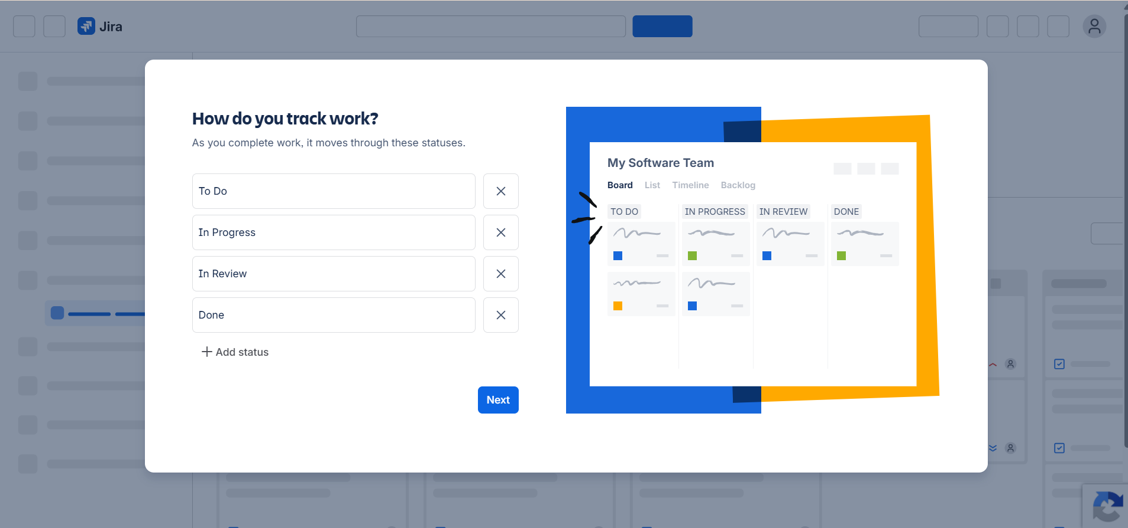

Step 5: Skip Inviting Teammates
Do not invite anyone for now; continue straight into Jira.
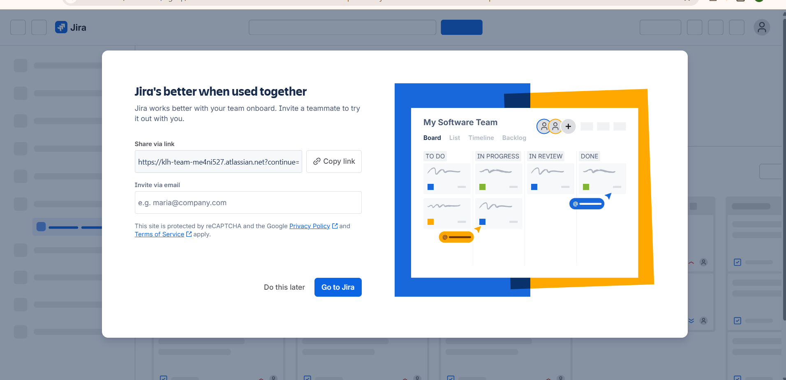

Step 6: Create User Stories
Create the following five stories:
• Student Login
• Course Registration
• View Attendance
• Faculty Enter Marks
• View Results
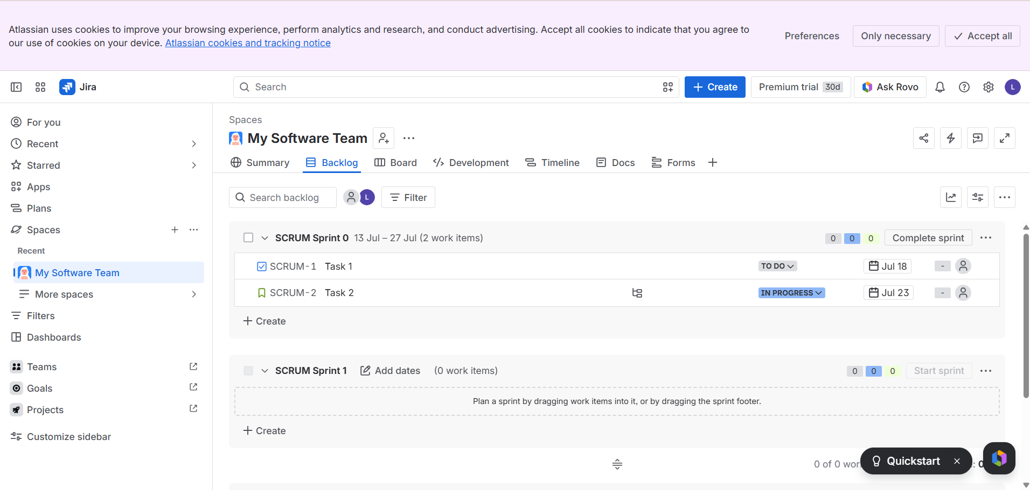

Step 7: Assign Story Points
Estimate each story in points on the Fibonacci scale:
Student Login – 3
Course Registration – 5
View Attendance – 2
Faculty Enter Marks – 5
View Results – 3

After You Click “Go to Jira”
Your project dashboard should now be visible.

Open the Backlog
In the left-hand navigation menu, choose Backlog.

Create the User Stories
Click Create, either in the top menu or within the backlog.

Story 1
Summary*
Student Login
Description
As a student,
I want to sign in securely,
So that I can get to my academic details.
Status
- To Do (keep as is)
Story Point Estimate
3
Priority
- Medium (keep the default)
Reporter
- Keep the default
Click Create.

Add the Remaining Four Stories

Story 2
Summary: Course Registration
Description:
As a student,
I want to sign up for courses,
So that I can enrol in my subjects.
Story Points: 5

Story 3
Summary: View Attendance
Description:
As a student,
I want to check my attendance,
So that I can keep track of my academic progress.
Story Points: 2

Story 4
Summary: Faculty Enter Marks
Description:
As a faculty member,
I want to record student marks,
So that students can see how they are performing academically.
Story Points: 5

Story 5
Summary: View Results
Description:
As a student,
I want to see my examination results,
So that I can assess my performance.
Story Points: 3
Click Create.
Repeat the process for the following stories:
Summary | Story Points
Student Login | 3
Course Registration | 5
View Attendance | 2
Faculty Enter Marks | 5
View Results | 3

Step 3: Assign Story Points
Open every story and enter its matching story-point value.

Step 4: Create Sprint
- Click Create Sprint.
- Drag all five stories into Sprint 1.
- Click Start Sprint.

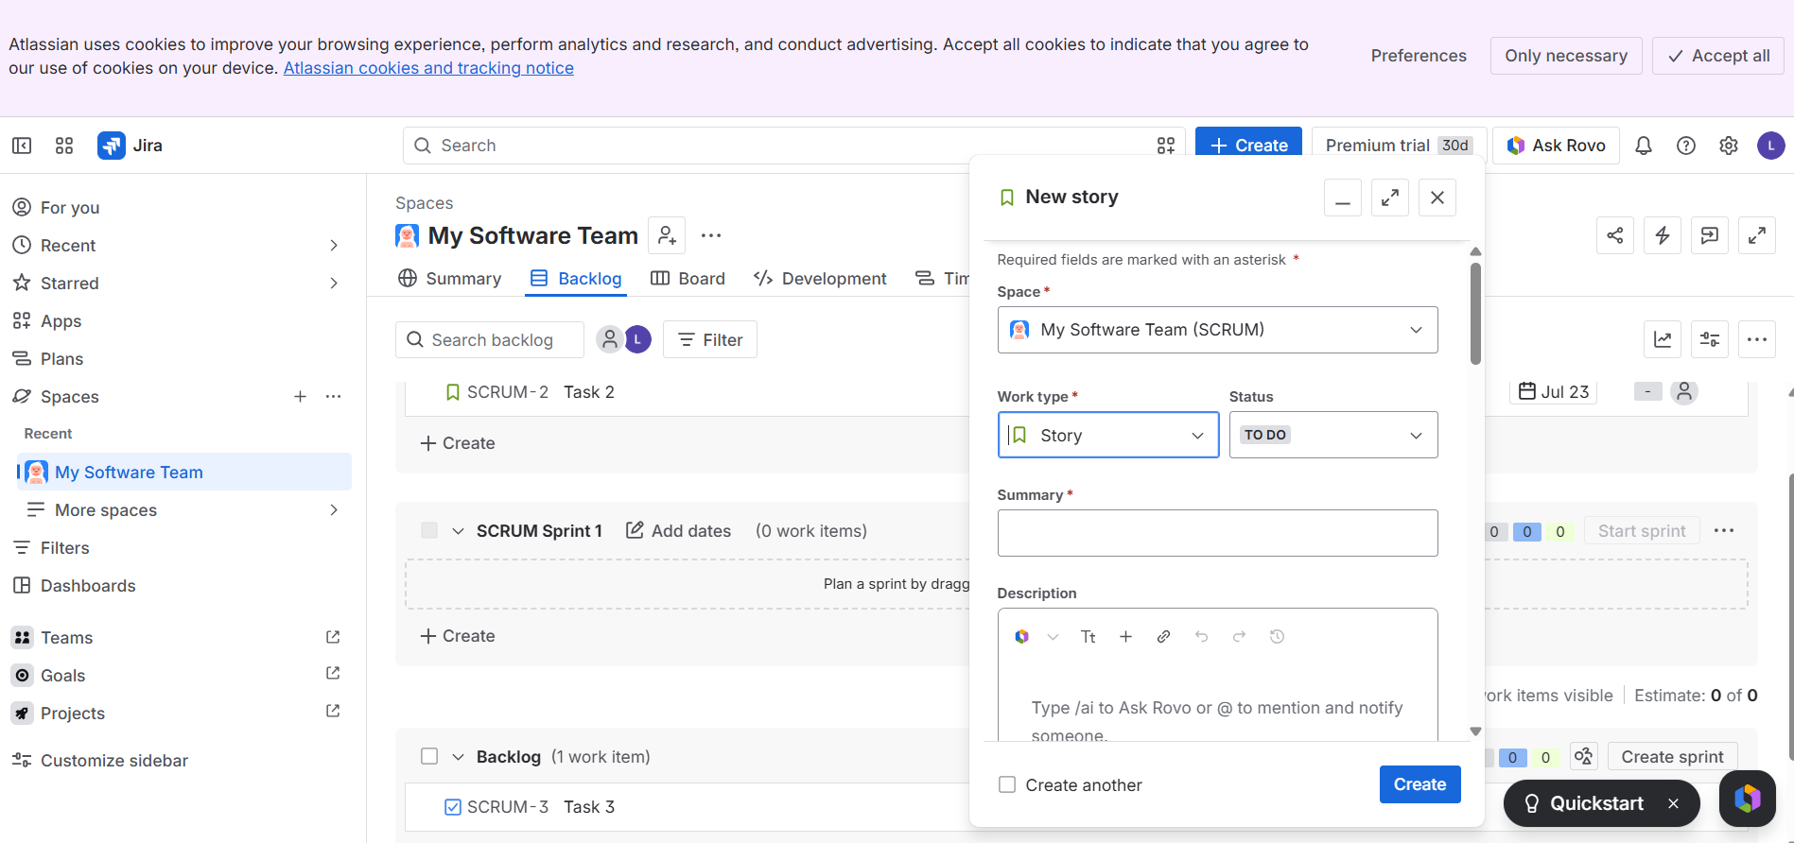
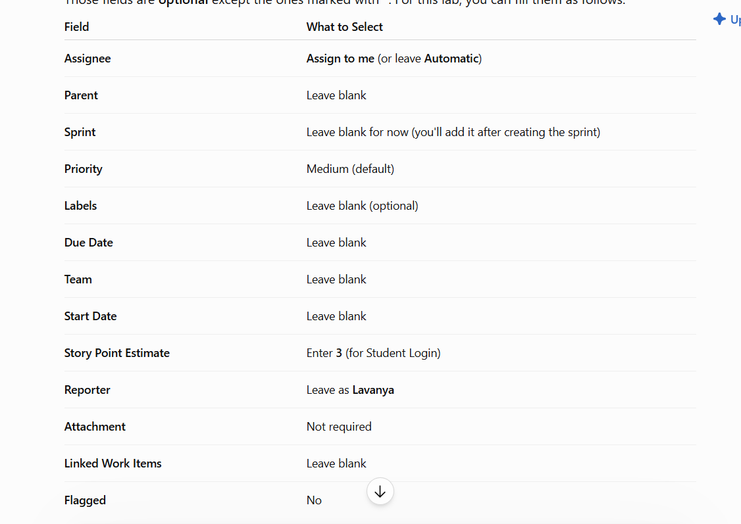

Step 8: Check the Product Backlog
Confirm that all five stories are listed in the backlog.

Step 9: Create the Sprint
Create Scrum Sprint 1 and move all of the stories into it.
Sprint Goal: Deliver student login, course registration, attendance viewing, faculty marks entry and result viewing.
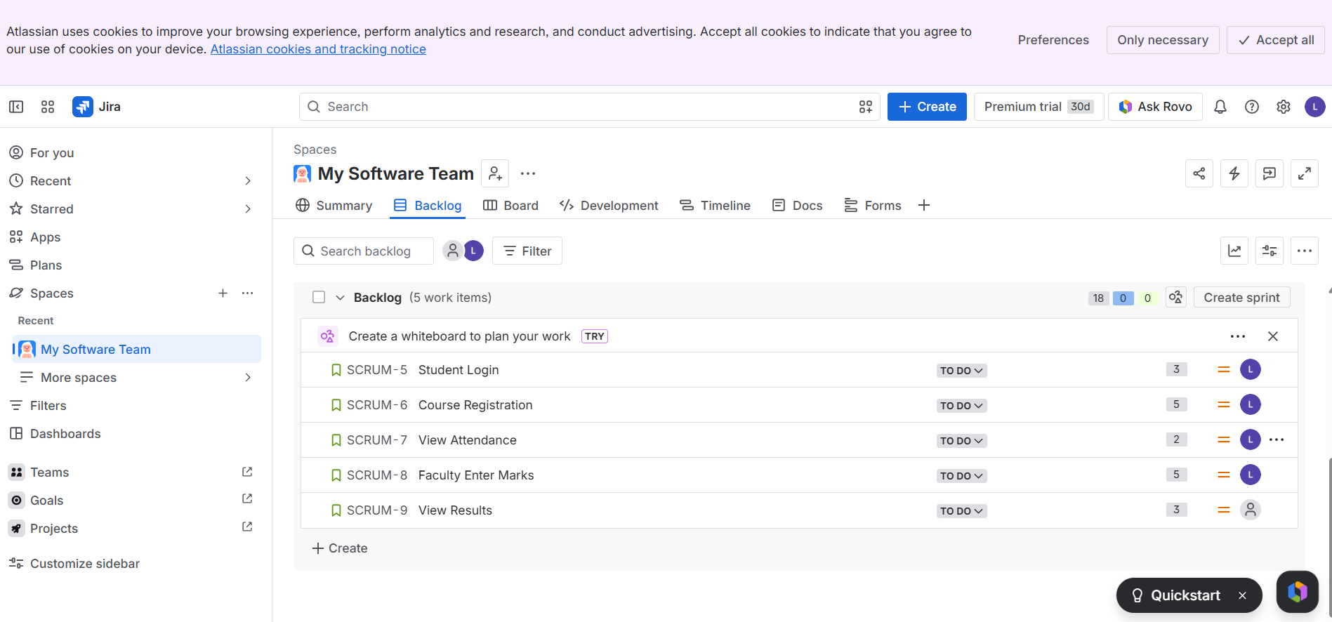

Step 10: Start the Sprint
Start Sprint 1 using the default duration.
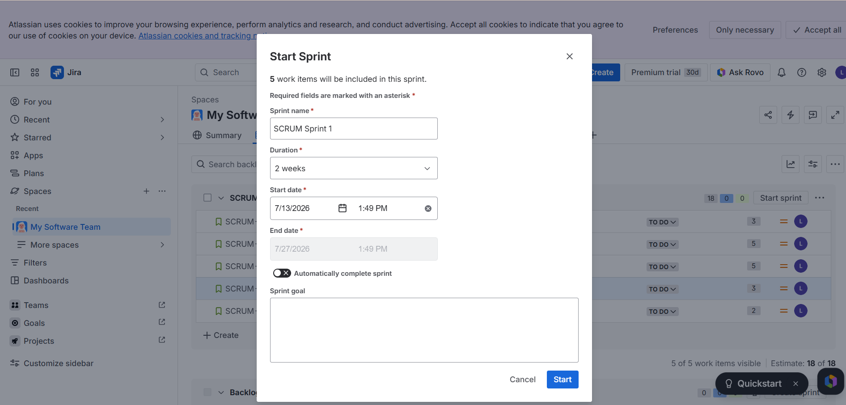

Step 11: Scrum Board
Check that the Scrum board shows all five stories in the To Do column.
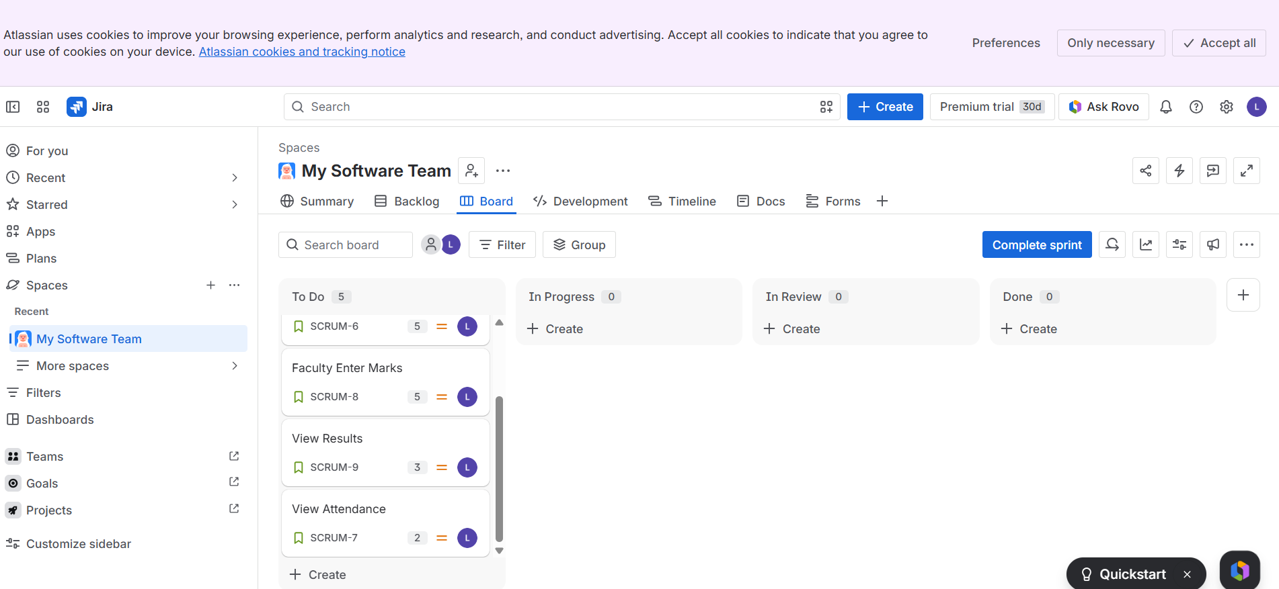

Result
A Jira Scrum project was created with five user stories, each given story points. Sprint 1 was set up, and the stories were managed on the Scrum board.

