Name: M sathwik kumar goud
Roll Number: 2420090078
Task: 4
Build a Trello board covering project boards, user stories, task assignments and sprint workflows, to demonstrate Agile project management and team collaboration.

Step 1: Visit the Trello Website
Official website: https://trello.com

Step 2: Sign Up for a Free Account
- Click Sign up.
- You may sign up with a Google account (the easiest option) or with an email address.
- Once you are signed in, Trello takes you to your Home page.

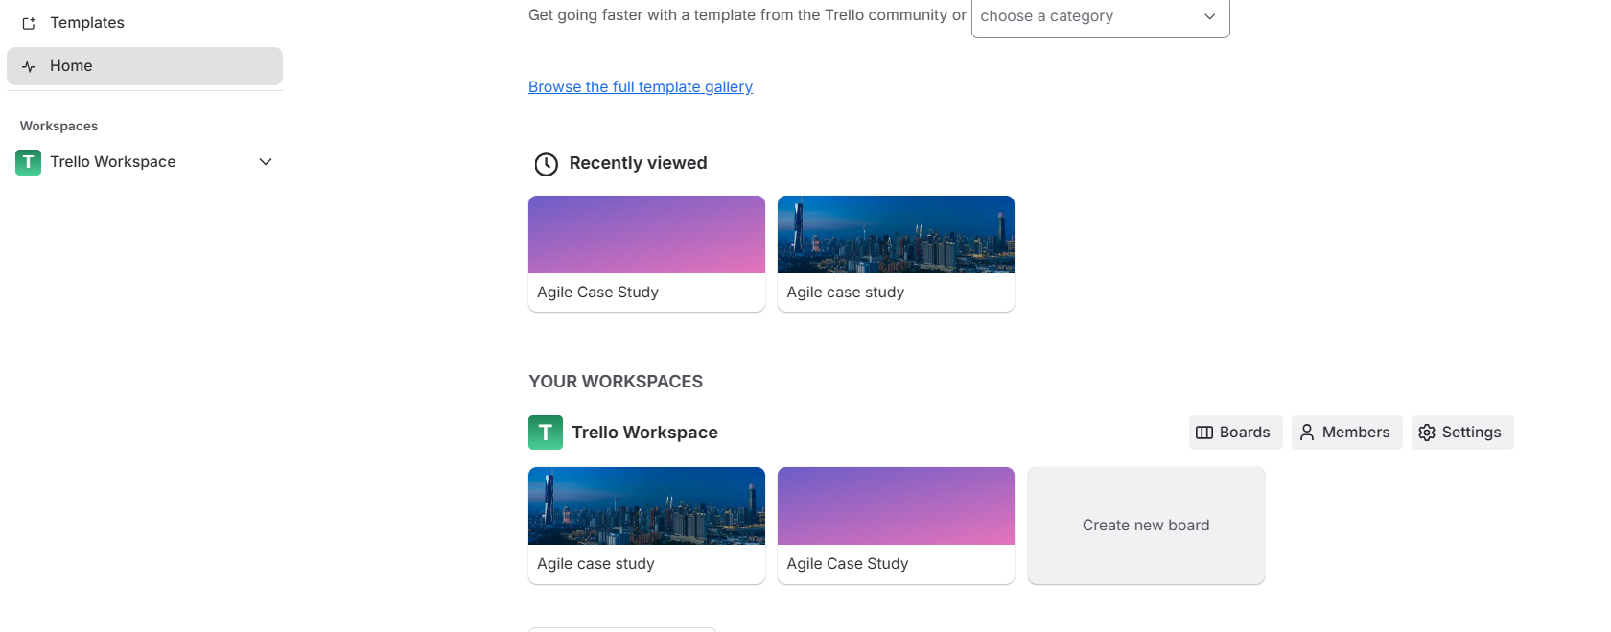

Step 3: Create Your First Workspace
A Workspace works like a folder that holds several boards.

Procedure
- Click Create at the top right.
- Choose Create Workspace.
- Enter the following:
  - Workspace name: Agile Case Study
  - Type: Education
- Click Continue.

Step 4: Set Up the Project Board
Next, create the board where all the Agile activities will take place.
- Board name: College Event Management System
- Workspace: Agile Case Study
- Visibility: Workspace
Click Create.
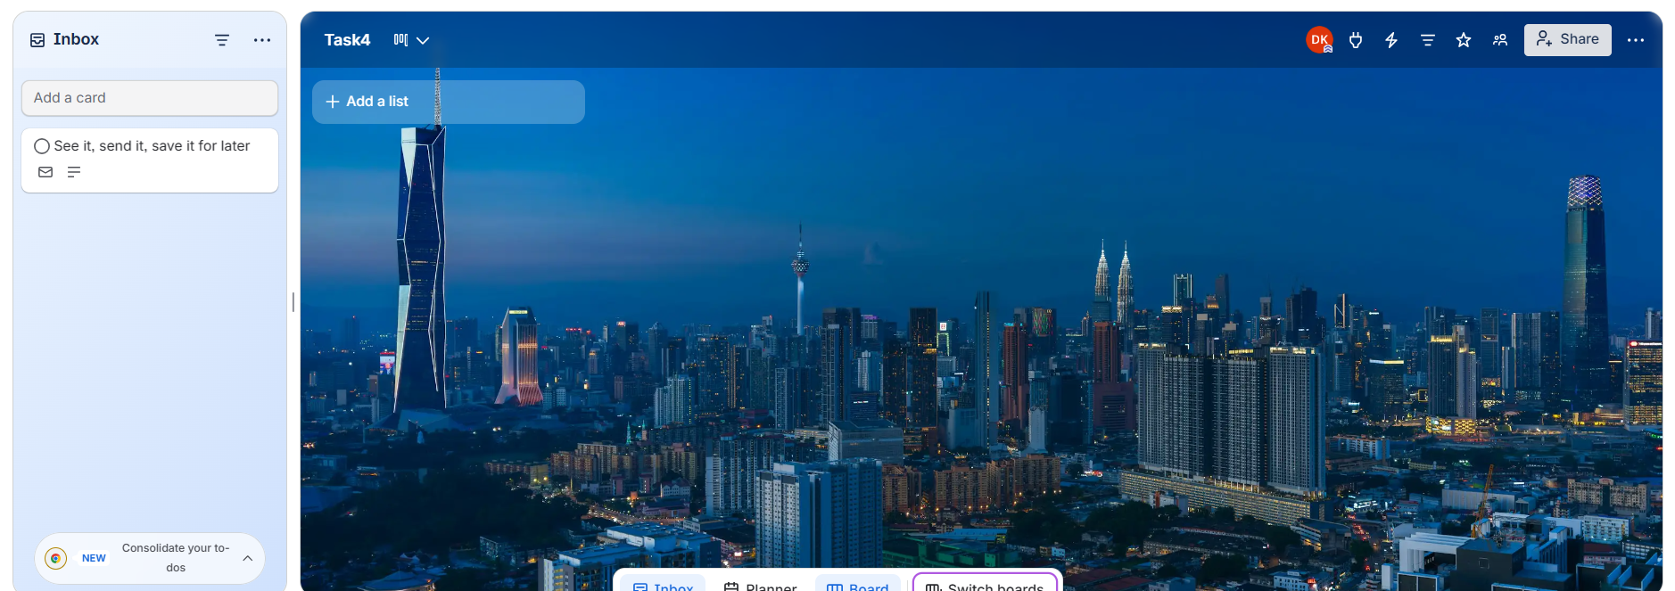

Step 5: Add the Agile Workflow Lists
Together, these lists represent the sprint workflow.

Create These Lists in the Following Order
- Product Backlog
- Sprint Backlog
- To Do
- In Progress
- Testing
- Done

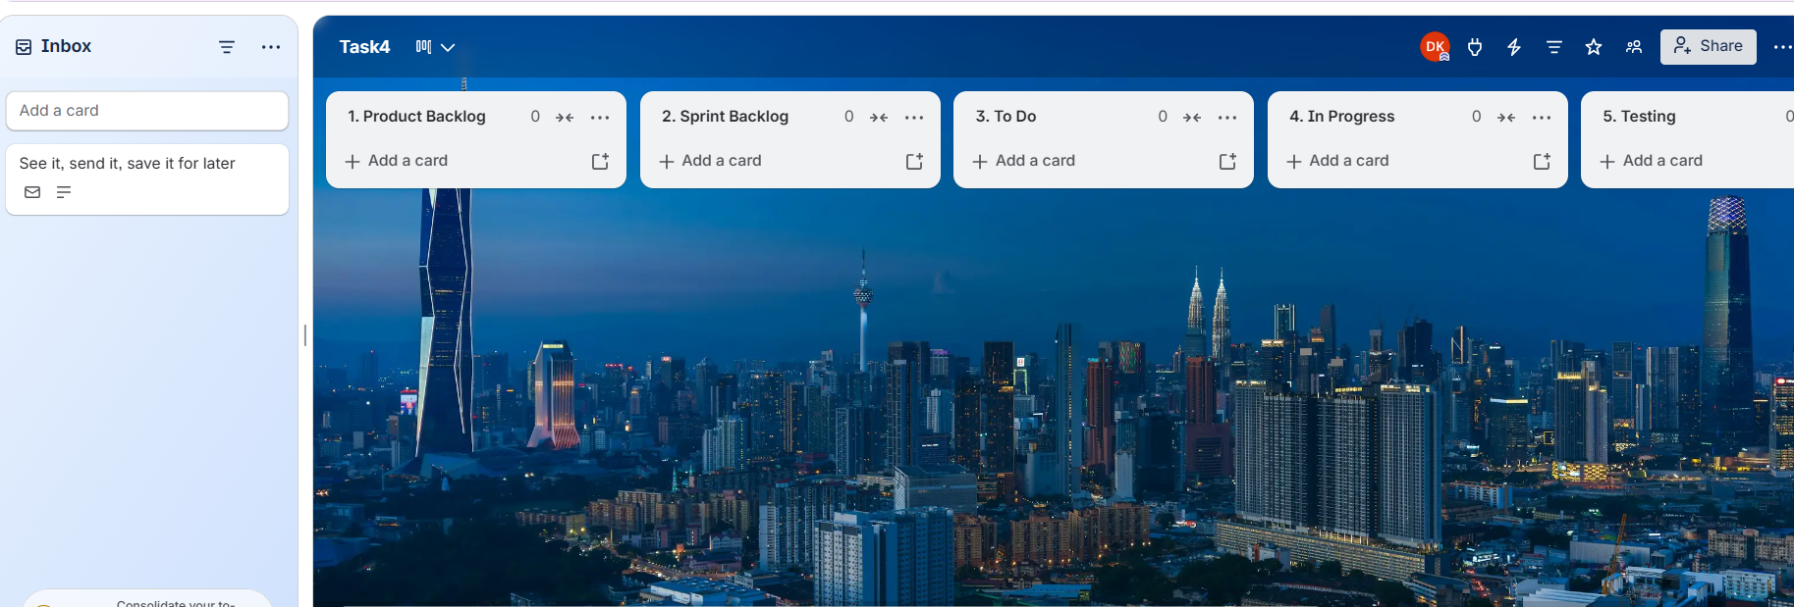

Step 6: Add the User Stories (important for the assignment)
Under Product Backlog, click Add a card and create the cards below.

User Stories
US-01: User Registration
As a student, I want to sign up for the event so that I can take part.
US-02: Event Schedule
As a participant, I want to check the event schedule so that I can be on time for the sessions.
US-03: Admin Login
As an admin, I want to log in securely so that I can run the event.
US-04: Email Notifications
As a participant, I want a confirmation email once I have registered.
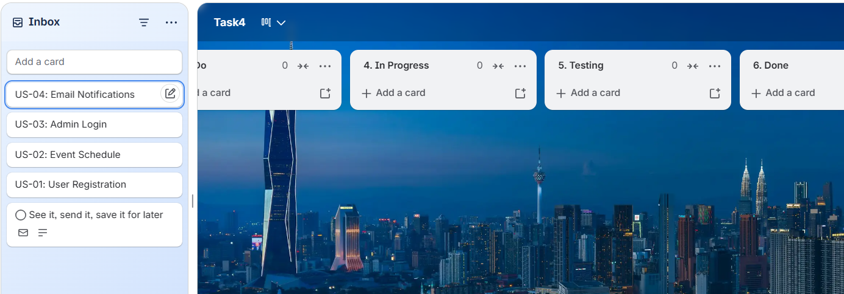
Drag each user-story card into the Product Backlog list.
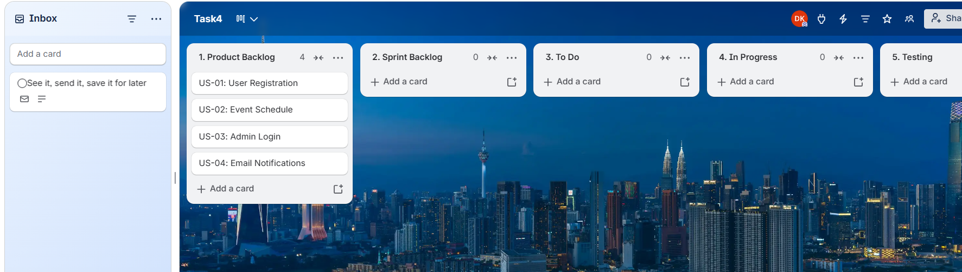

Step 7: Plan Sprint 1
Move these cards from Product Backlog to Sprint Backlog:
- US-01 User Registration
- US-02 Event Schedule
This marks these features as the ones chosen for Sprint 1.
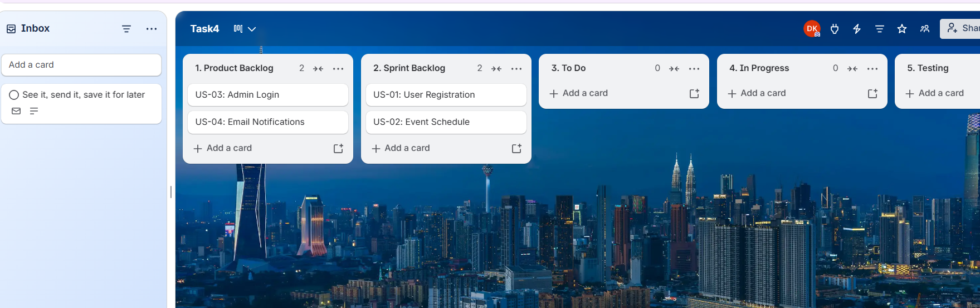

Step 8: Split a User Story into Tasks
Open the US-01 User Registration card and add a Checklist.

Checklist Items
Design the registration form
Create the database table
Validate the input fields
Save the user data
Display a success message
Add any further items that are needed.

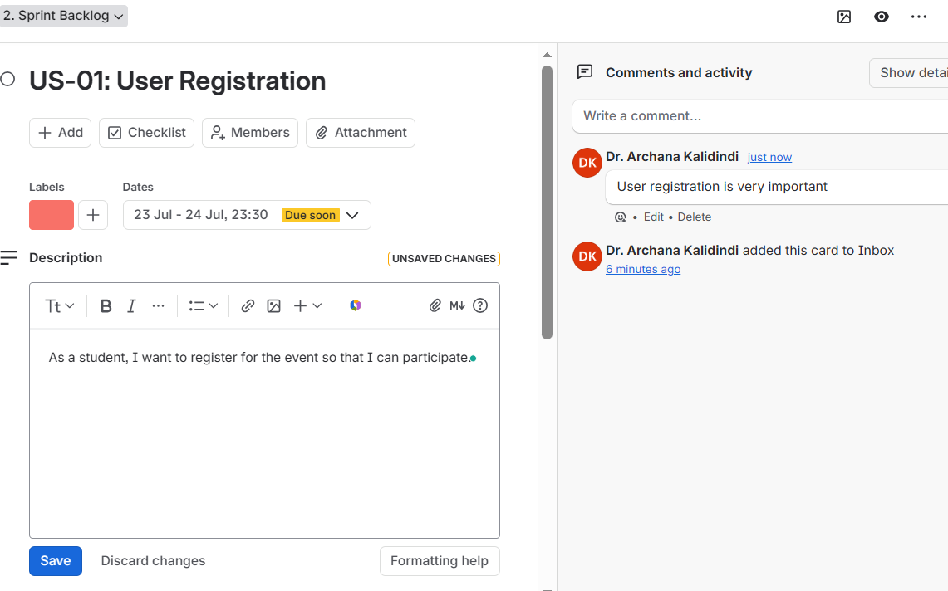

Do the same for the other Agile workflow lists.

Step 9: Assign Team Members
Within the card:
- Click Members.
- Add yourself.
- If you have classmates, invite them through Share → Invite.

Example
Task | Assigned To
Registration form | Archana
Database setup | Rahul
Validation | Sneha

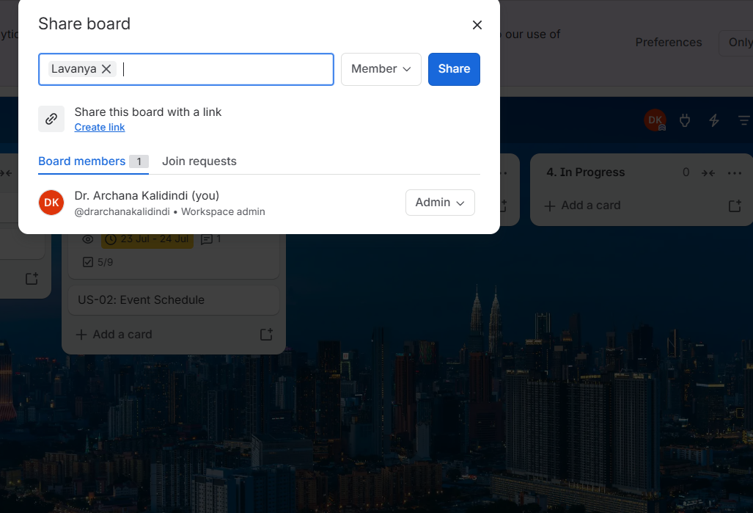

Step 10: Add Priority Labels
Create the labels shown below:
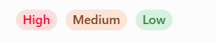

Step 11: Set Due Dates
Within the card:
- Click Dates.
- Choose a due date (for example, 20 July 2026).
- Turn on Reminder.

Step 12: Start the Sprint
Move the cards along the workflow as work progresses.
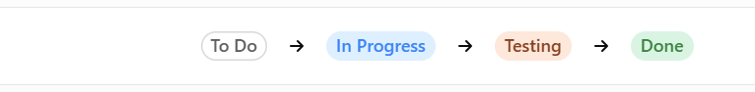
Output:
