Roll Number: 2420090078
Name: M sathwik kumar goud

Git and GitHub: Making Commits
- Install Git on your computer.
- Launch Command Prompt or Git Bash.
- Make a new project folder.

- Open that folder in the terminal.
- Run git init to initialise Git.

- Open that folder in the terminal.
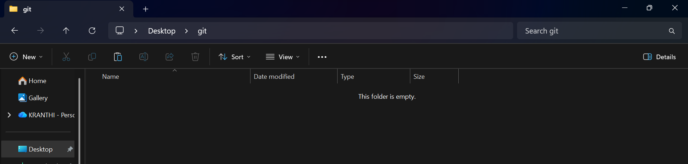
- Run git init to initialise Git.
- Create the project files or add existing ones.

- Inspect the files with git status.

- Stage the files with git add .
- Commit the staged files with git commit -m "Initial commit".
Create a repository on GitHub.
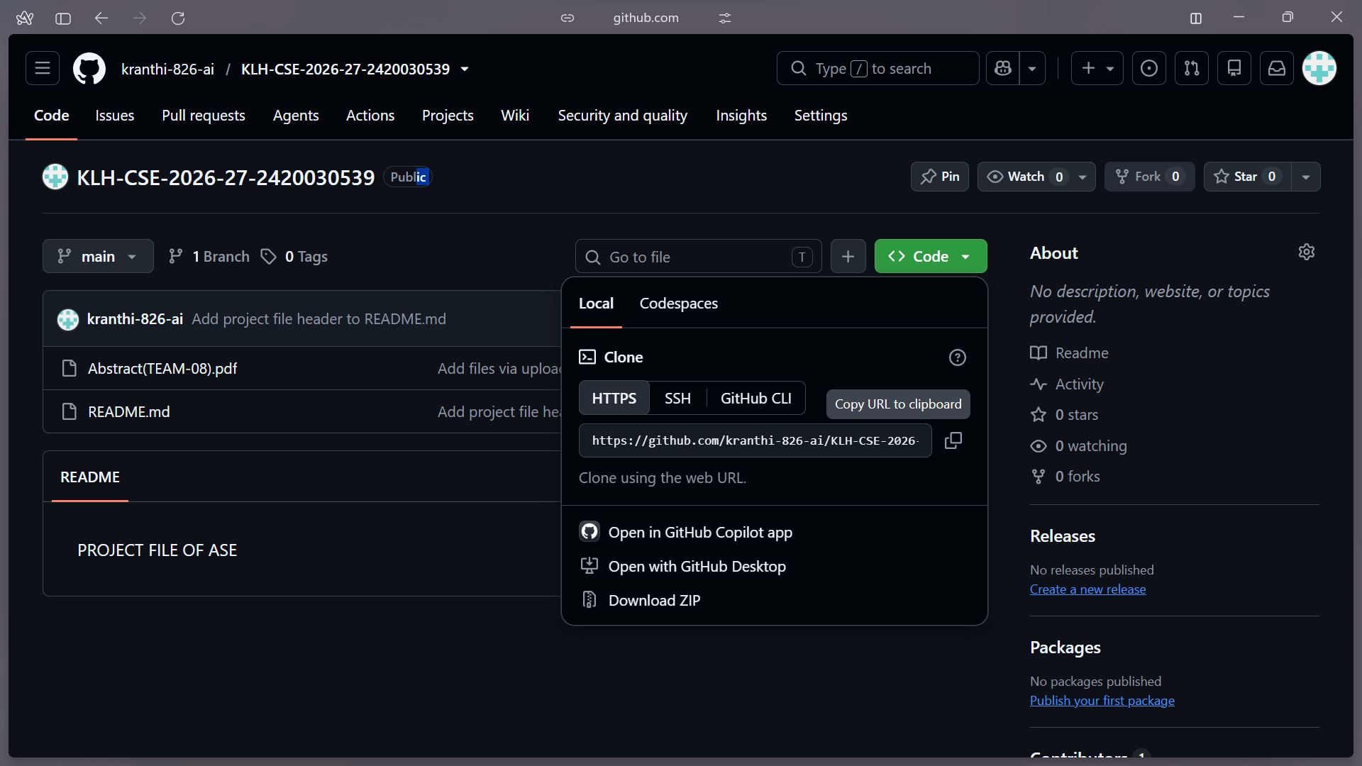
- Link the local repository to GitHub with git remote add origin.


- Upload the files with git push.

- Run git status.

- Upload the files with git push.

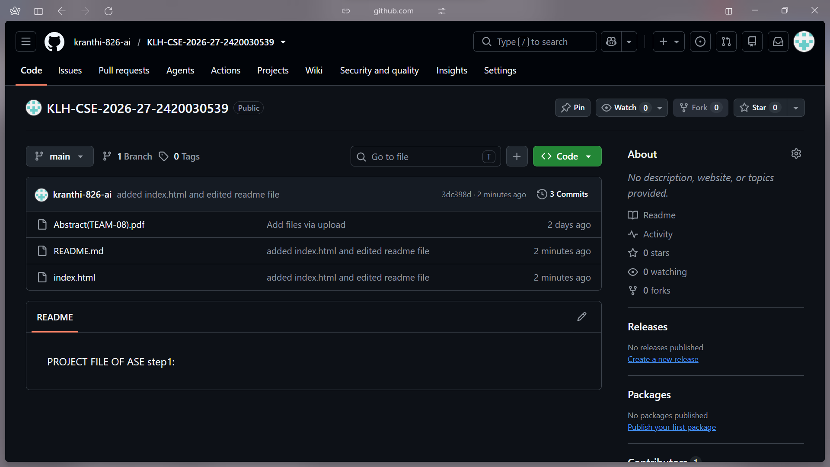
- Look at the commits on GitHub.
Outcome:
Learned how to make Git commits and upload a project to GitHub.

