Roll Number: 2420090078
Name: M sathwik kumar goud

Docker
- Install Docker Desktop.
- Launch Command Prompt.

- Enter docker to verify that Docker is working.
- Launch Docker Desktop.

- Go to Docker Hub and look for an image such as Hello World or Ubuntu.
- Pull the image you need using the appropriate Docker command.
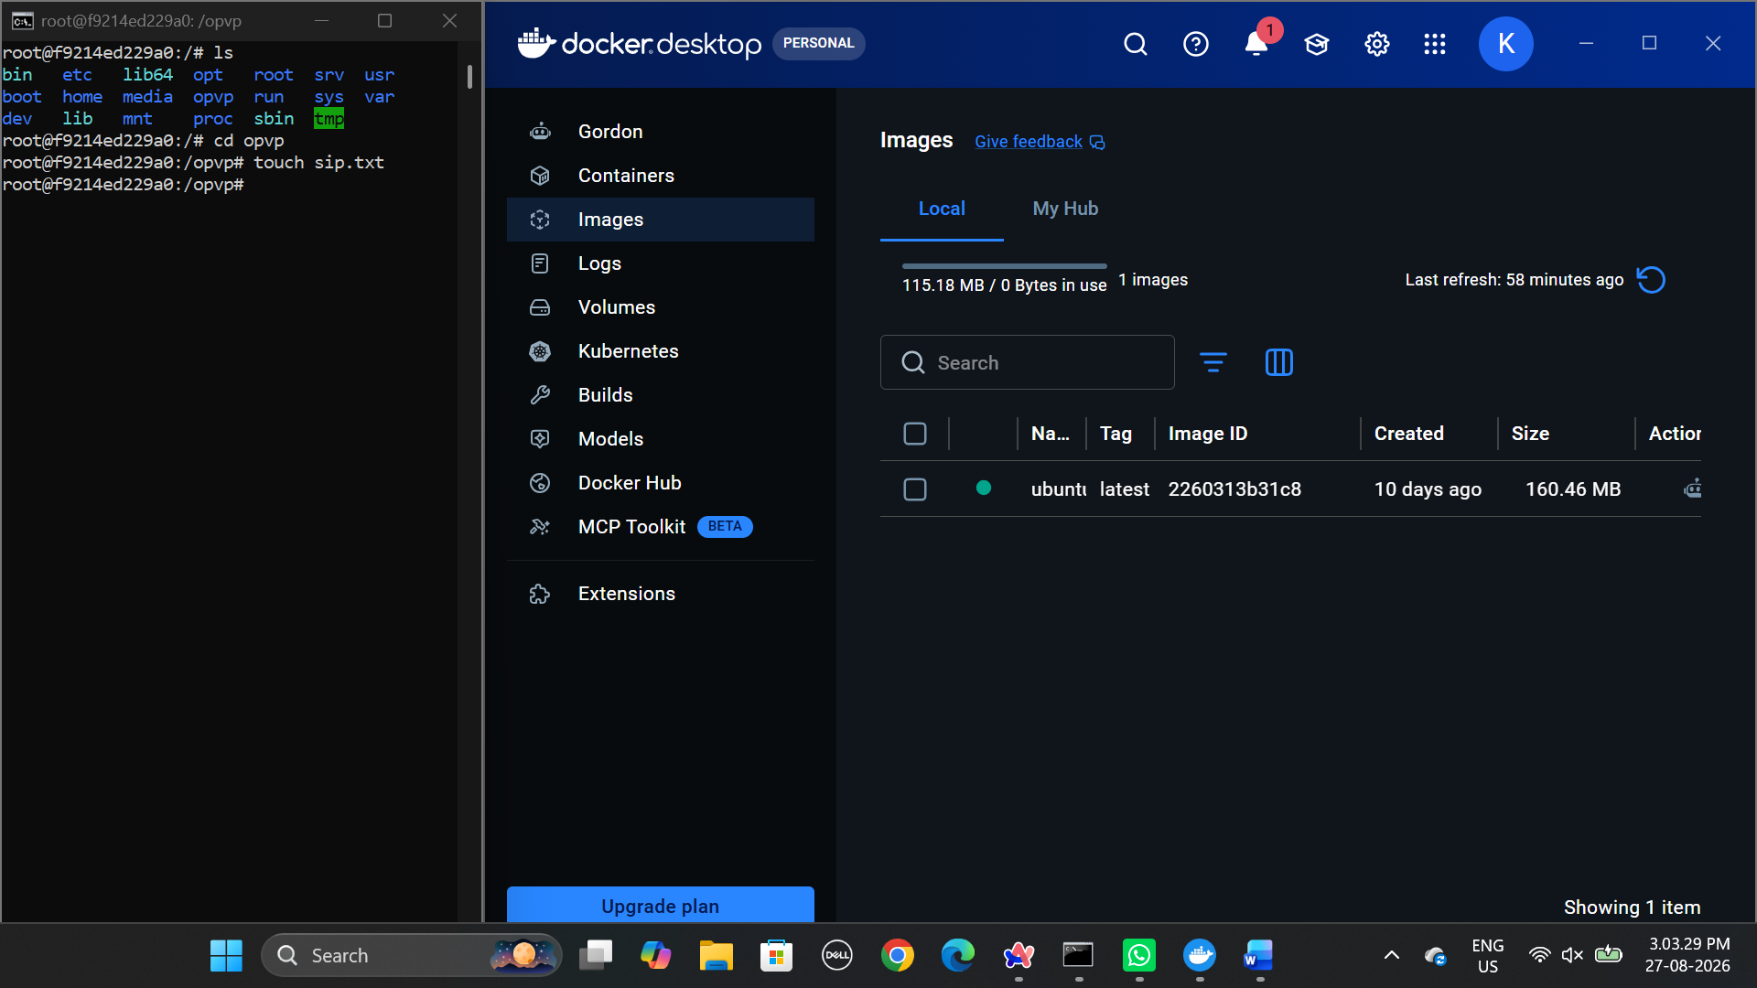
- Start the image with the docker run command.
- Stop the container with docker stop <container-id>.
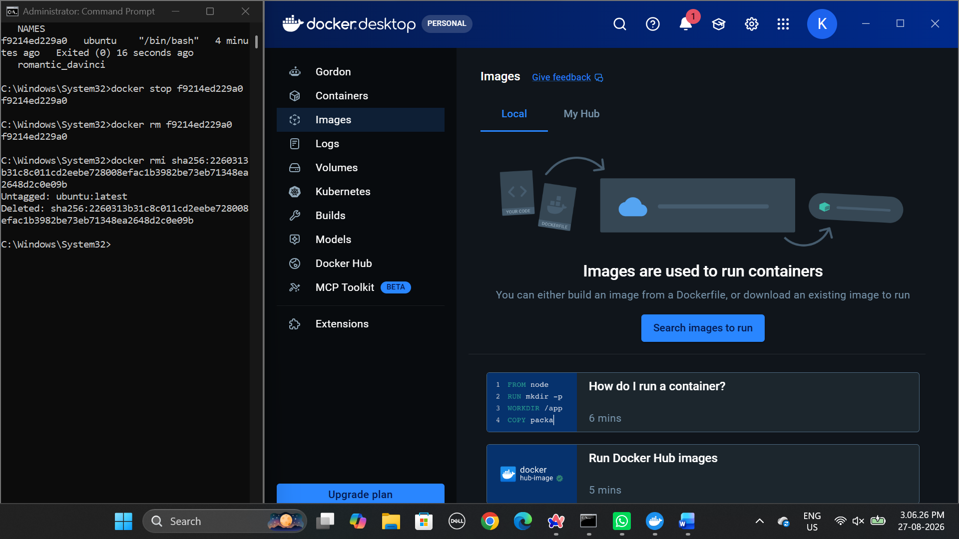
- Delete the container with docker rm <container-id>.
- To use Ubuntu interactively, run docker run -it ubuntu.
