Name: M sathwik kumar goud
Roll Number: 2420090078

Documentation for Experiment 8

Step 1: Install SonarQube
Open your browser and search for SonarQube installation.
https://www.sonarsource.com/products/sonarqube/downloads/
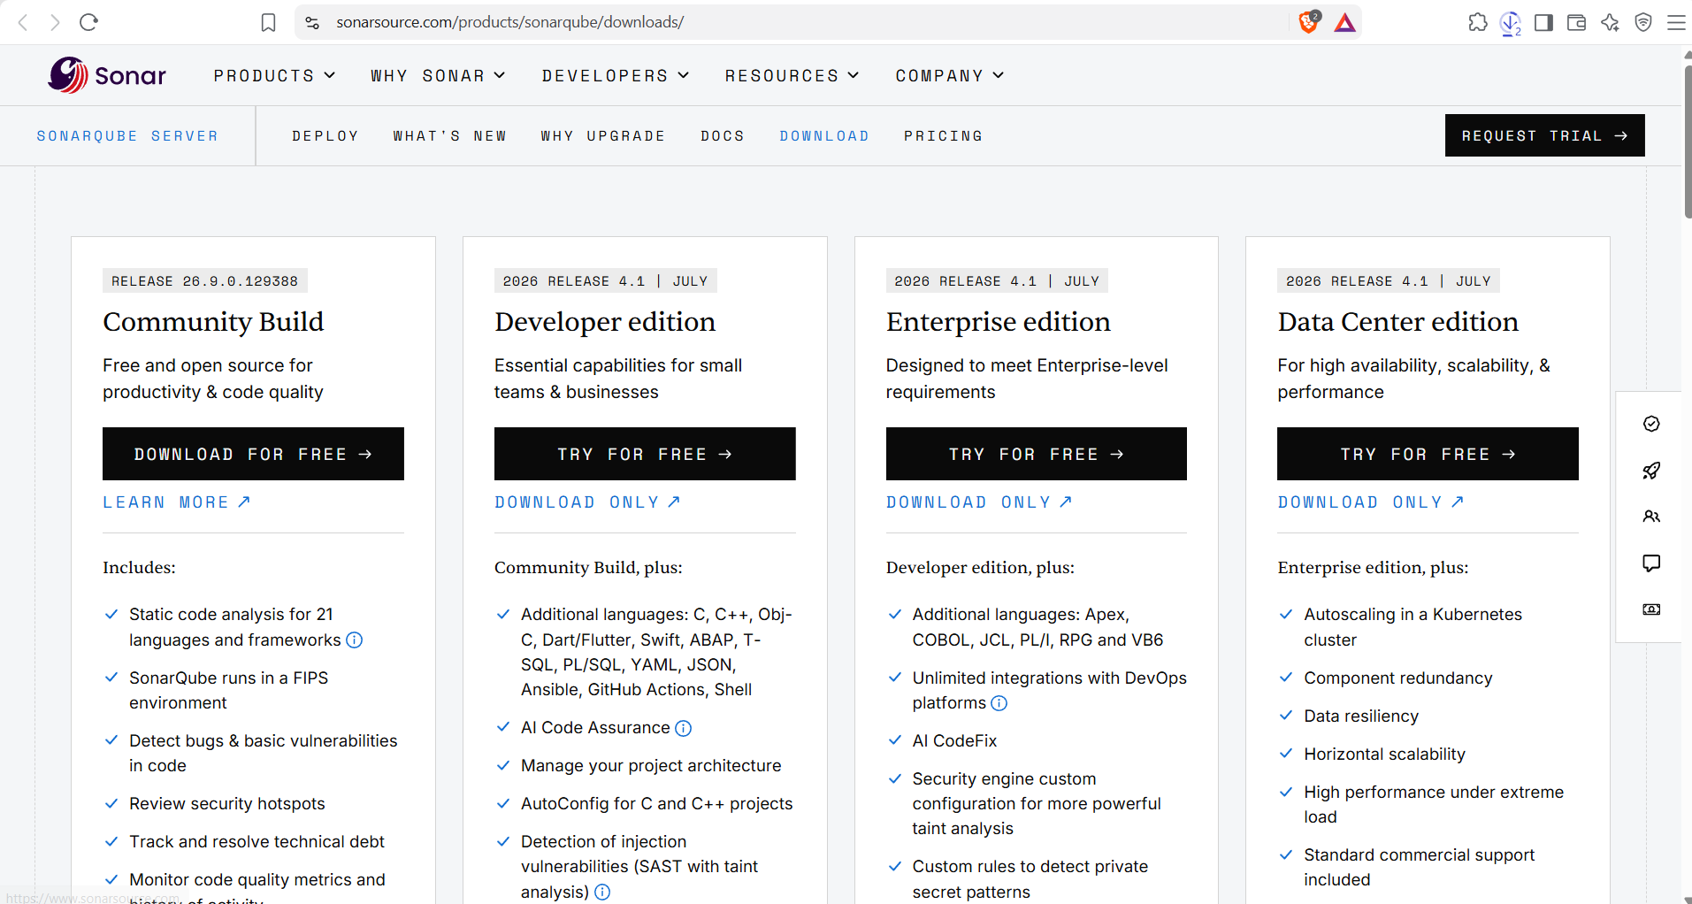
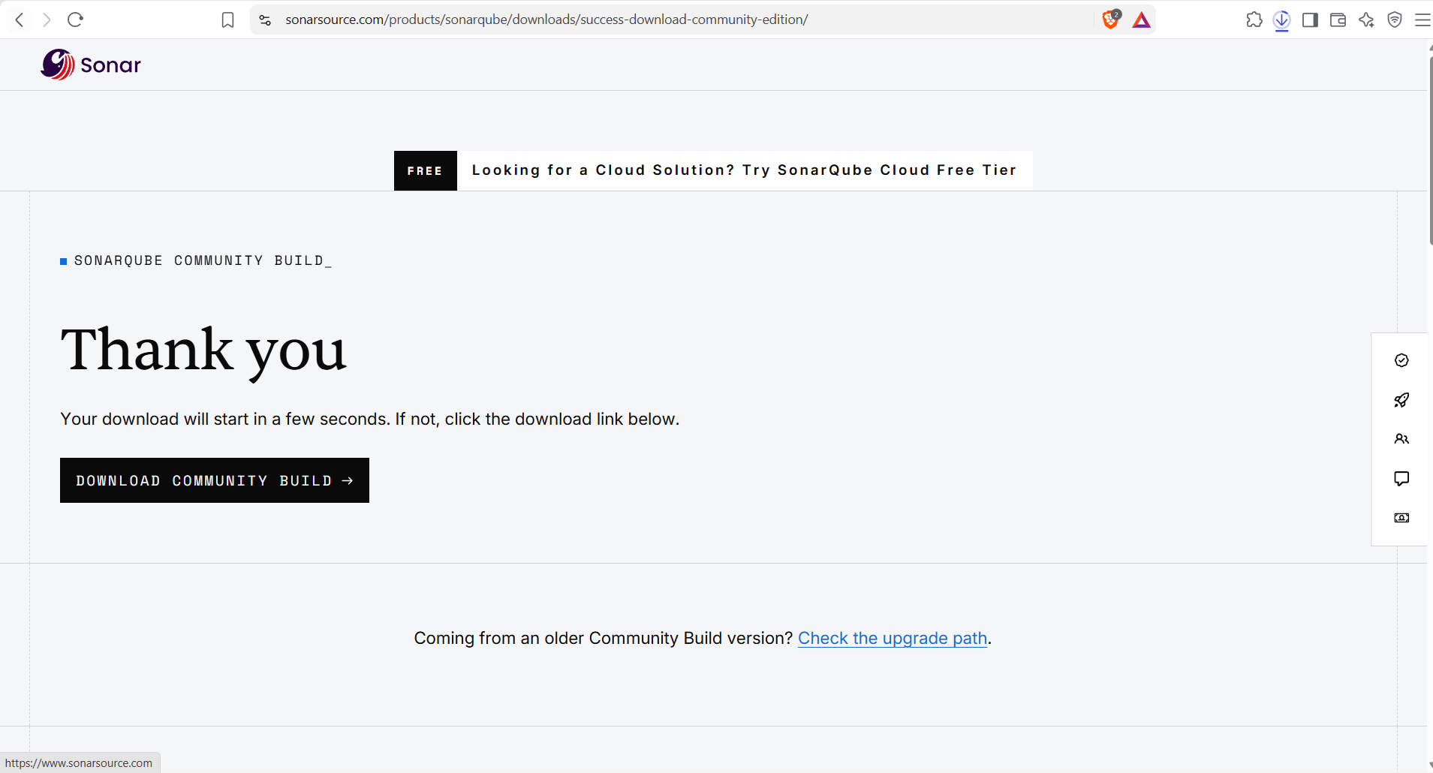

Step 2: Extract the Downloaded Zip into the C Drive
Screenshot:
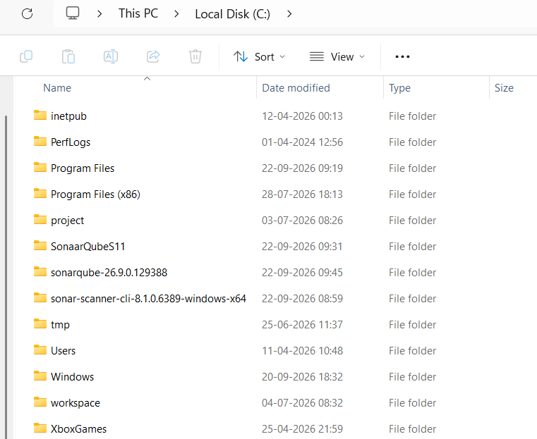
Go to the C drive → SonarQube folder → bin folder → windows → choose your operating system → open the Windows folder.
Copy the folder path from here.
Screenshot:
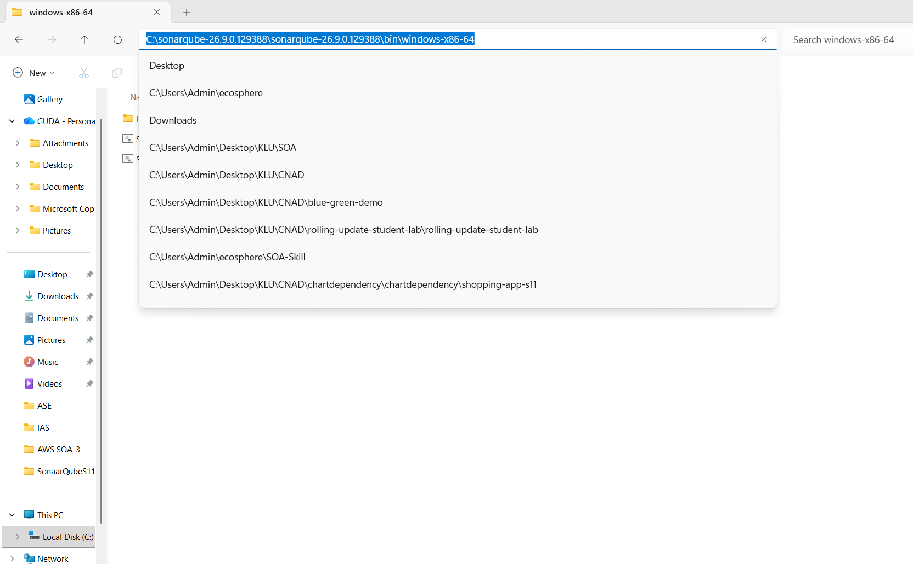
Open Edit the system environment variables.
From Windows, open Edit the system environment variables → select Path → Edit → New → paste the copied path → click OK three times to close each dialog.
Screenshot:
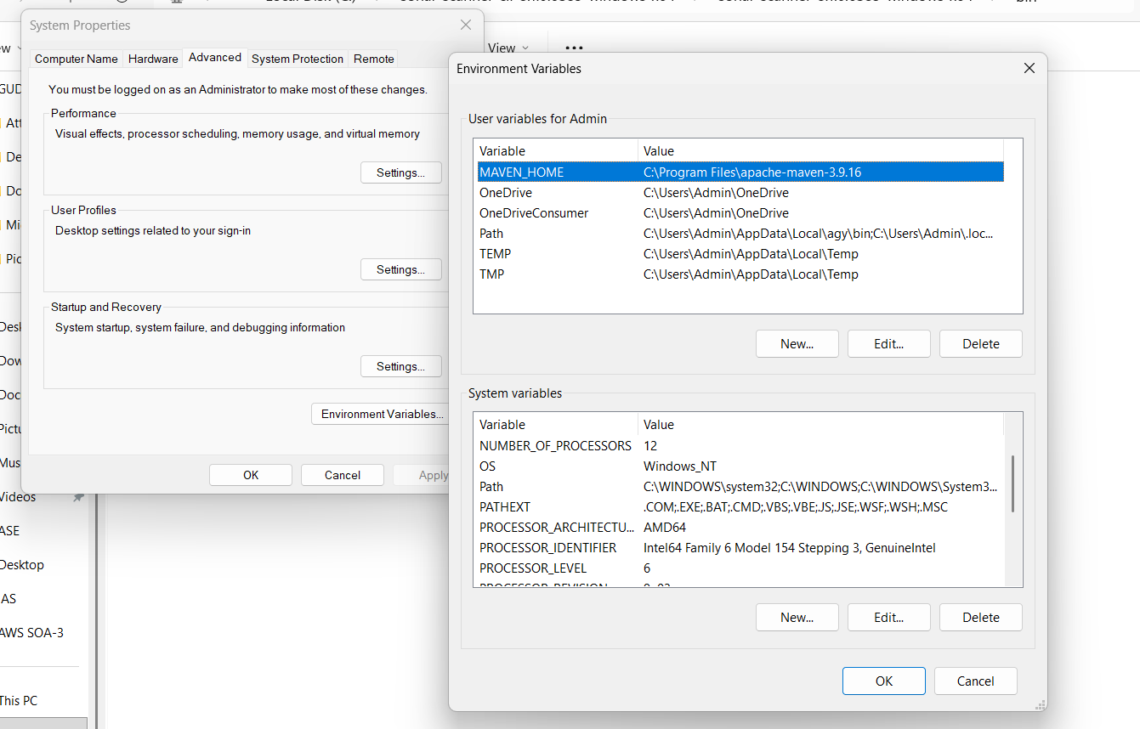
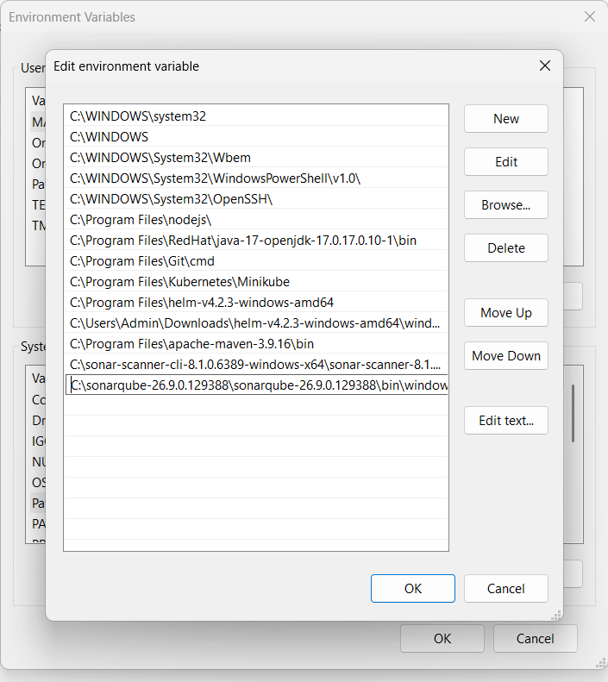

Step 3: Install SonarScanner
Open a web browser, search for “SonarScanner installation on Windows” and open the documentation.
https://docs.sonarsource.com/sonarqube-server/9.9/analyzing-source-code/scanners/sonarscanner
Select SonarScanner and choose your operating system; the zip file will be downloaded.

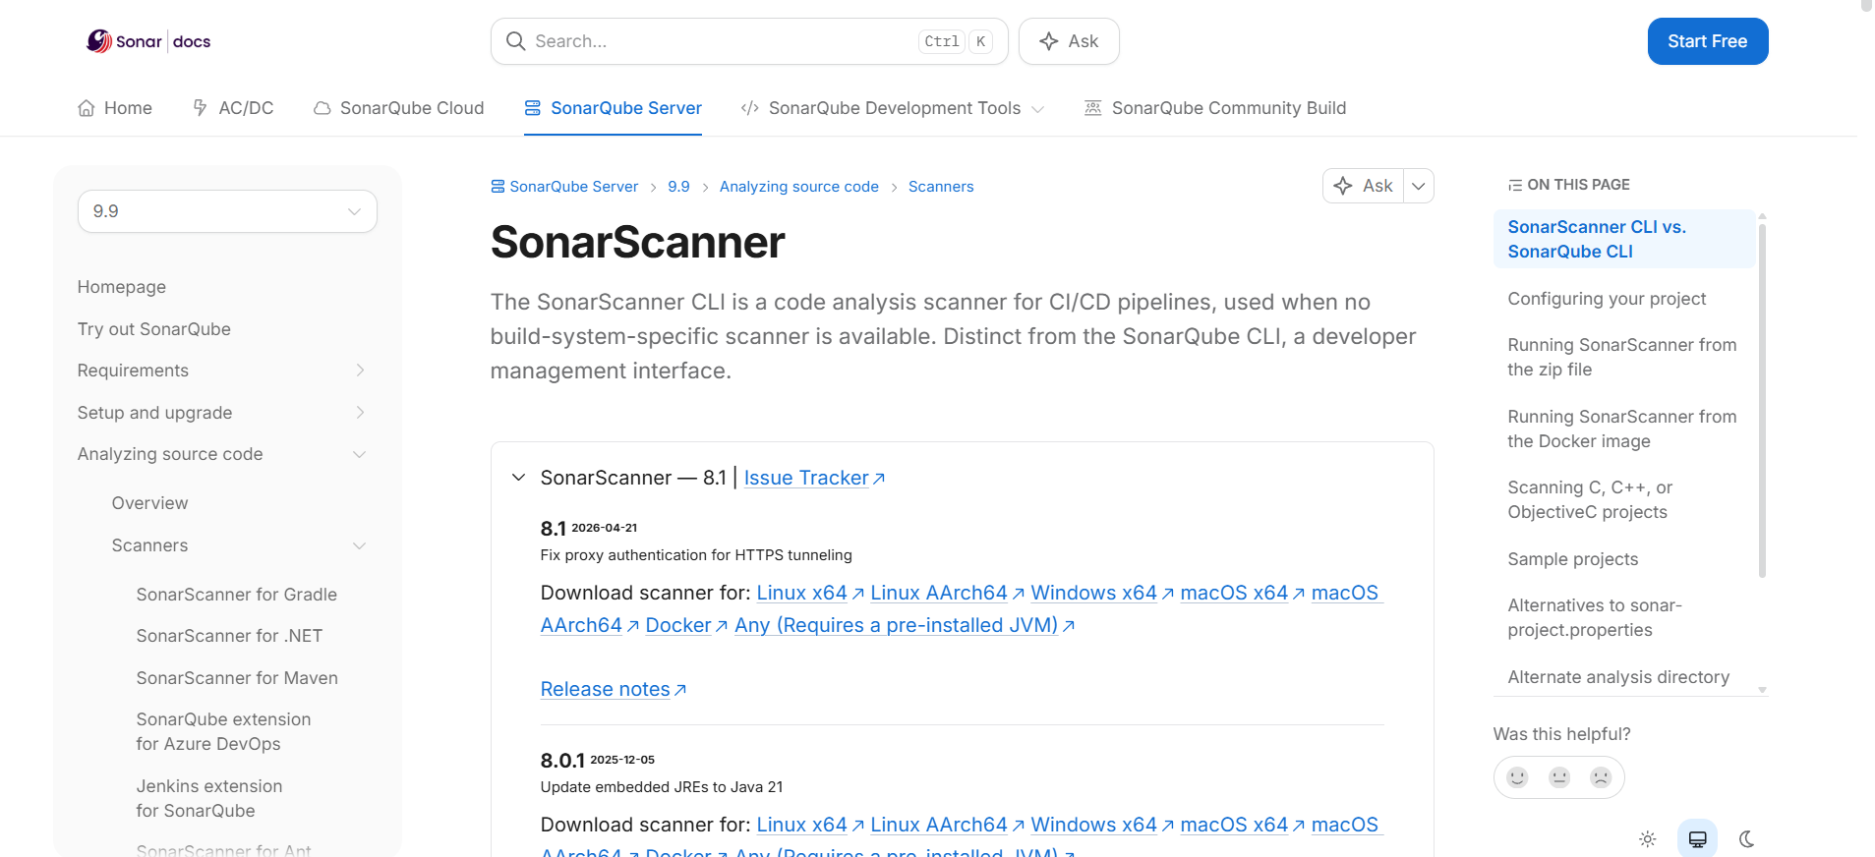

Step 3 (continued): Extract SonarScanner into the C Drive
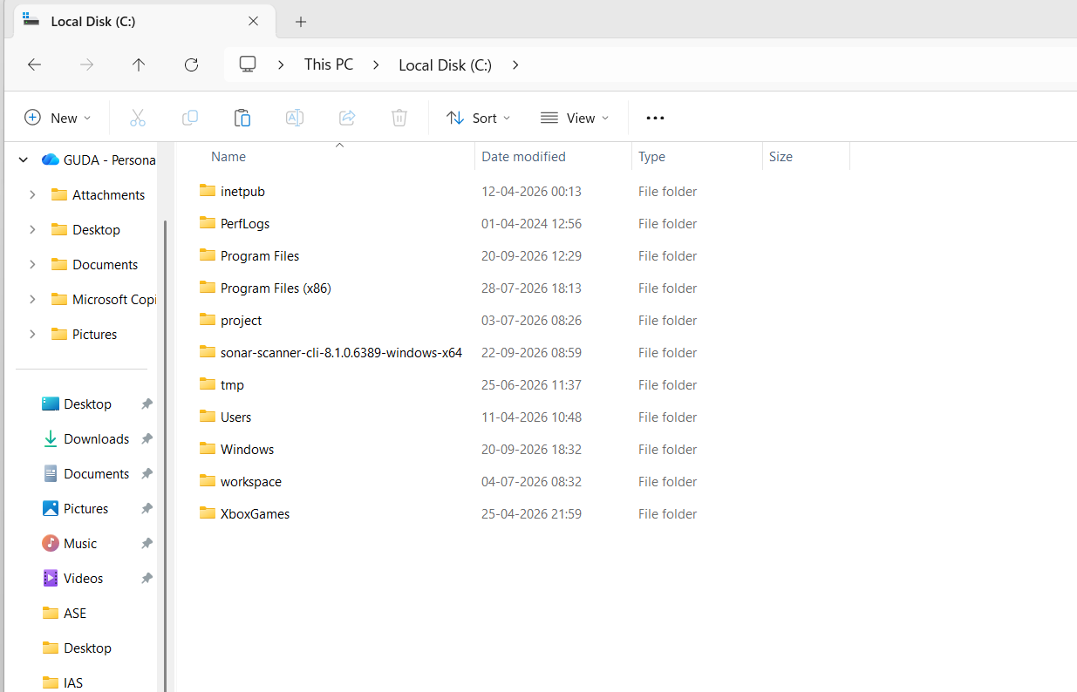
Go to the C drive → SonarScanner folder → bin folder, copy the path, and add it to the system environment variables.
Copy the folder path from here.
Screenshot:
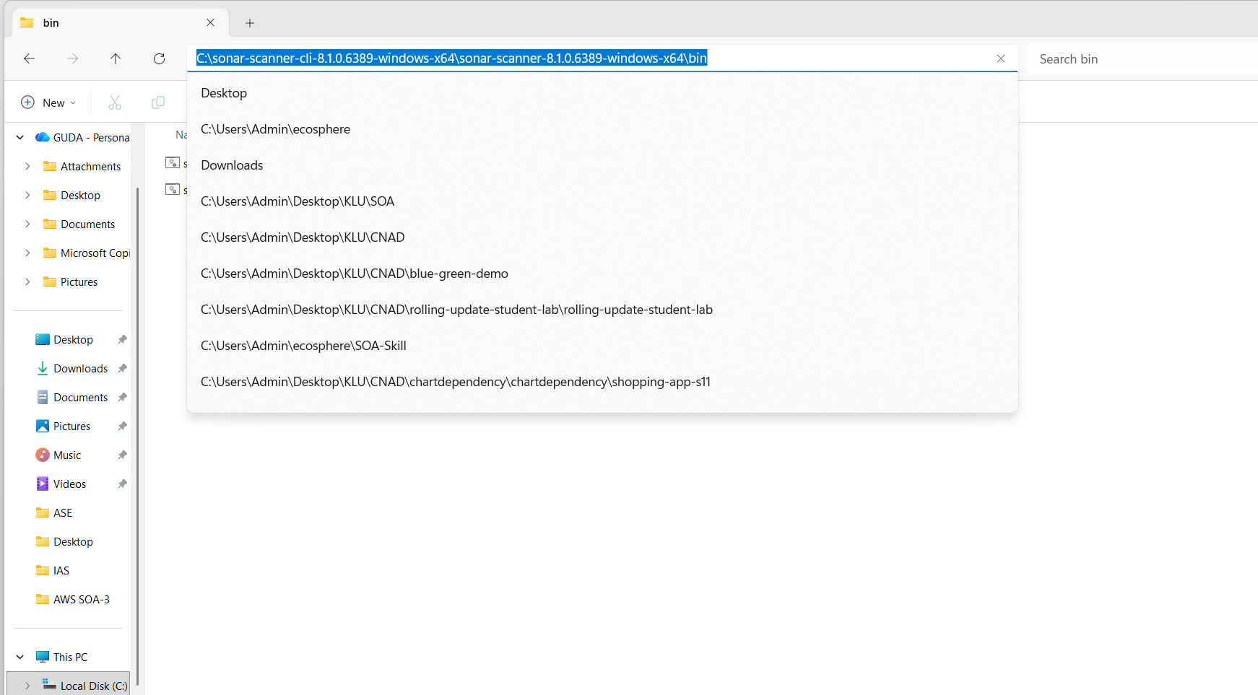
Open Edit the environment variables.
From Windows, open Edit the system environment variables → select Path → Edit → New → paste the copied path → click OK three times to close each dialog.
Screenshot:
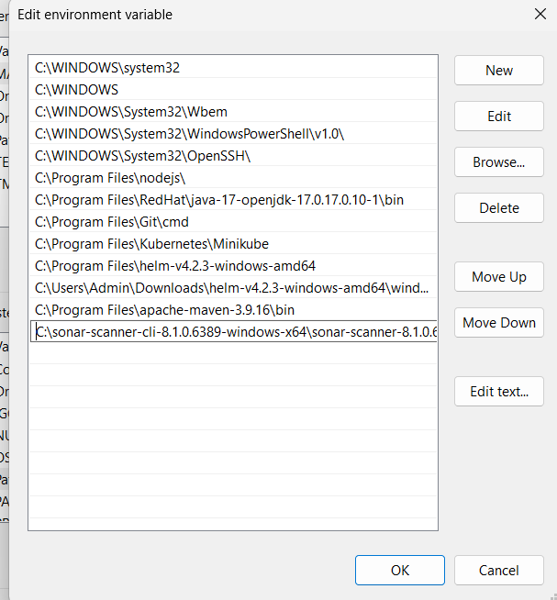

Step 4: Start the Server
Open Command Prompt, type StartSonar and press Enter.
Screenshot:
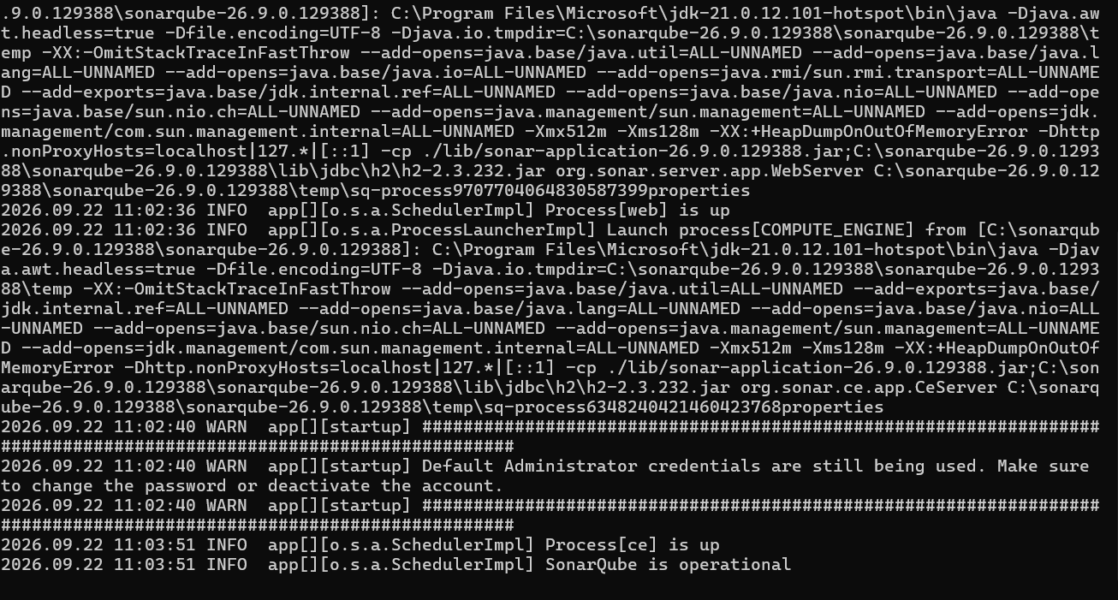

Wait for the message Process[ce] is up.
This means that SonarQube is up and running.
Note: do not close the SonarQube command prompt window; minimise it instead, because closing it shuts the server down.

Log In to the SonarQube Server
Open a browser, go to localhost:9000 and press Enter.
Log in with admin as both the username and the password.
Screenshot:
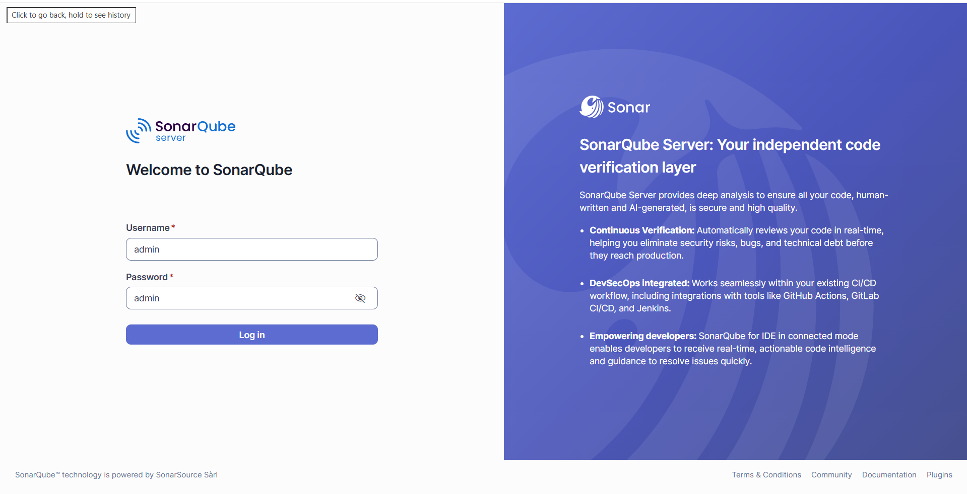

Step 5: Create a Local Project
Enter a project name and click Next.
Screenshot:
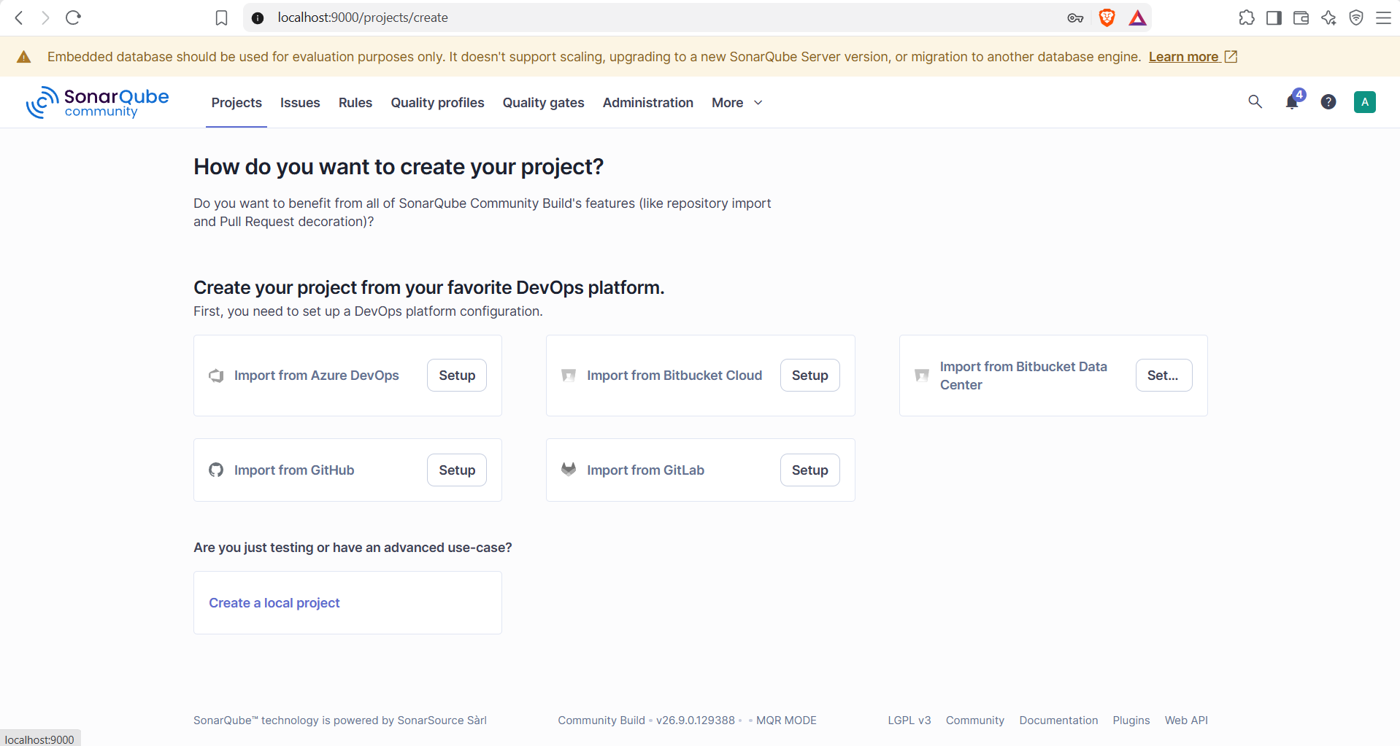
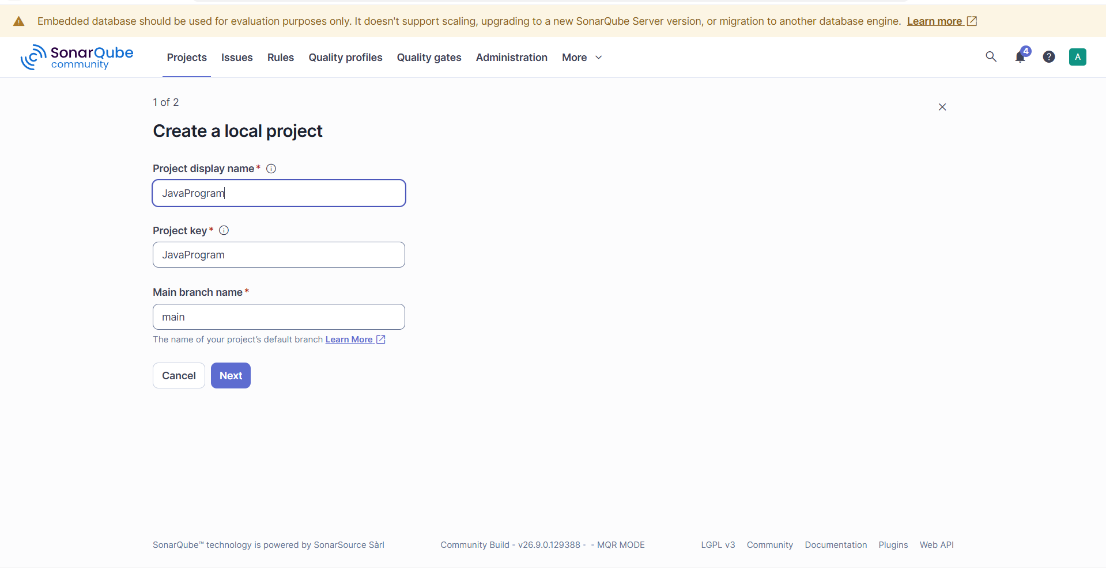
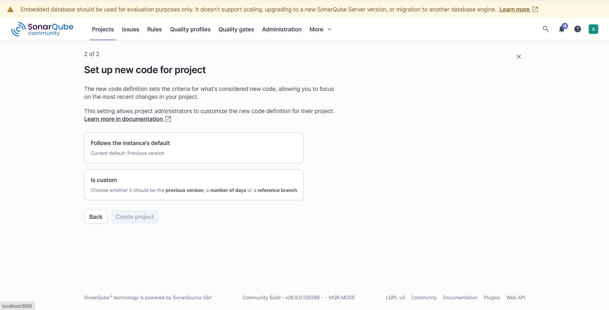

Select Follows the Instance’s Default, then click Create project.
Screenshot:
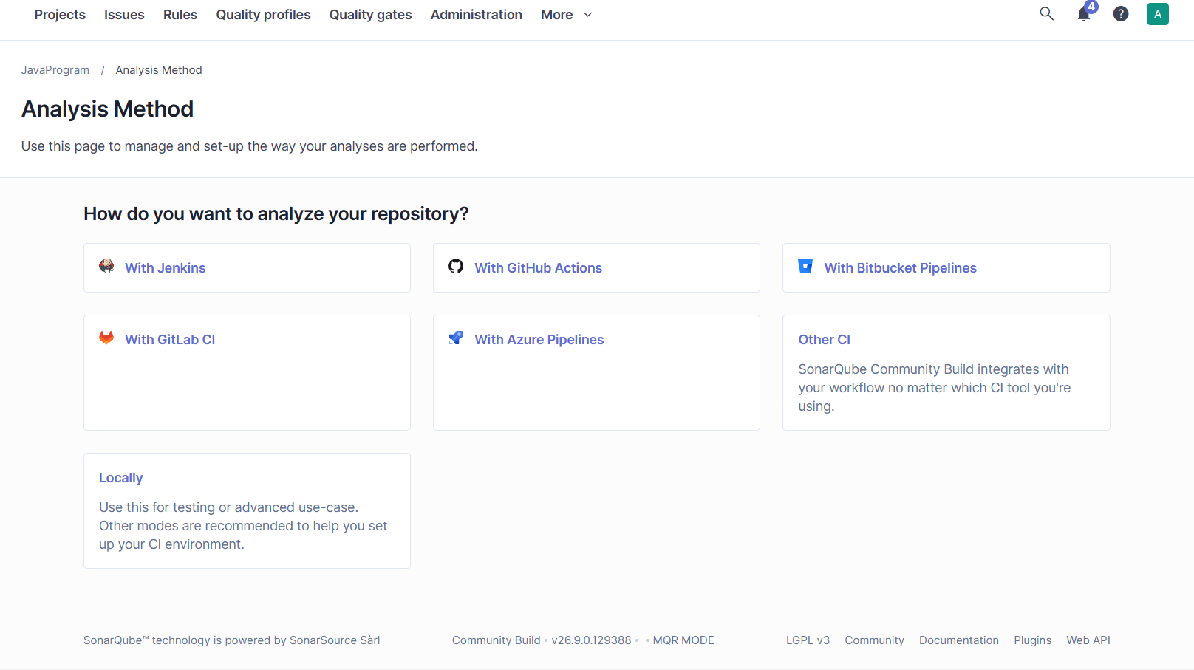
Choose Locally.
Click Generate.
Screenshot:
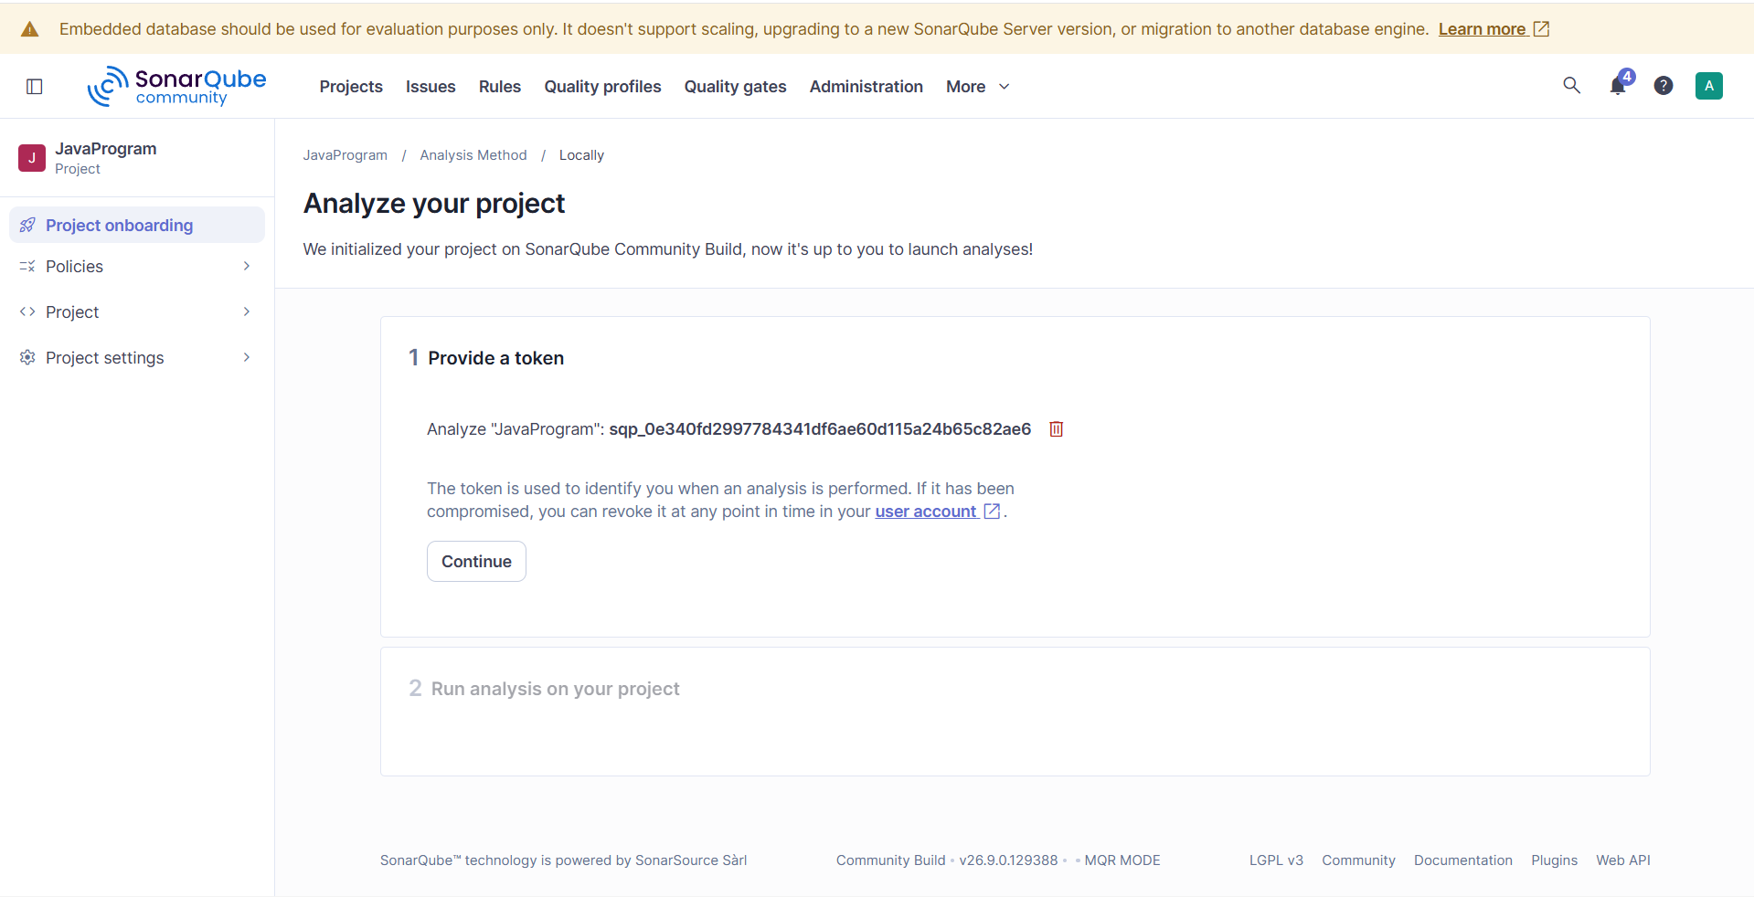
A token is generated. Copy it and keep it somewhere safe, because it is needed later, then click Continue.
Screenshot:
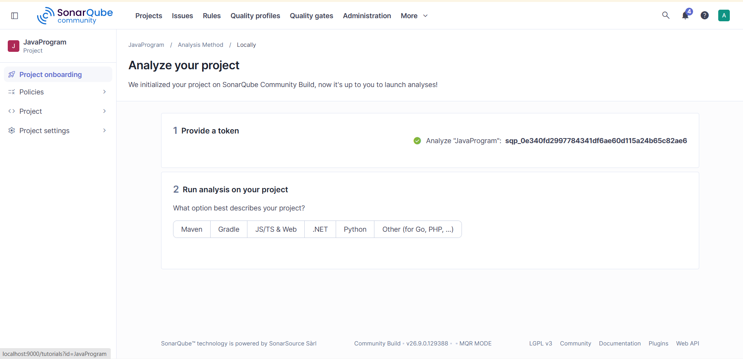
Token: sqp_0e340fd2997784341df6ae60d115a24b65c82ae6

Step 6: Verify the SonarScanner Installation
Open Command Prompt and run sonar-scanner -v.
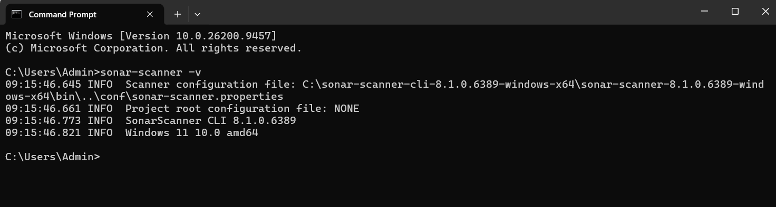

Step 7: Create the Project Folder and the Java Program
In the C drive, create a folder named SonarQubeS11, write a simple Java program and save it as Javaprogram.java.
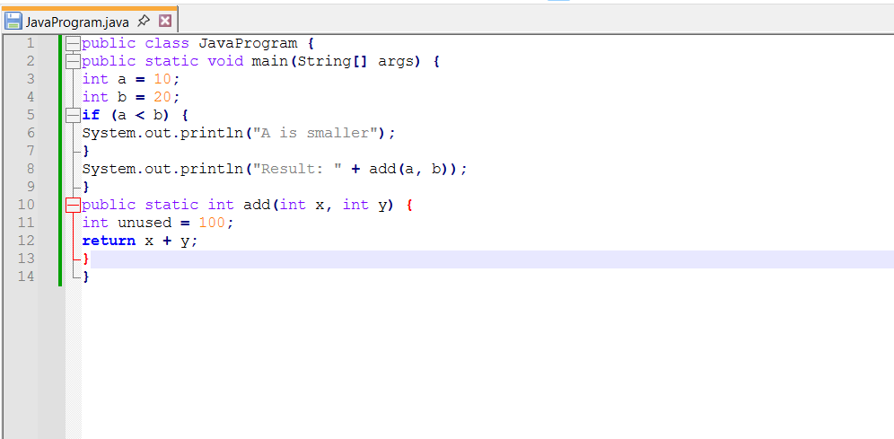

Save the configuration file with the name:
sonar-project.properties
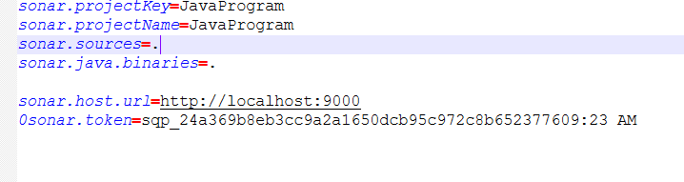
Save the file.
Compile the Java program to generate the class file.
Copy the location where the Java program is stored.
Change to the directory that contains the program.
In Command Prompt, switch to that path.
Screenshot:
Compile the program with this command:
C:\javac Javaprogram.java

Screenshot:
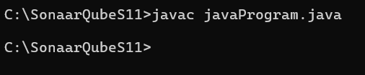

Step 8: Scan the Program
Run the command: c:\sonar-scanner
When the scan finishes, the output shows EXECUTION SUCCESS.
Screenshot:
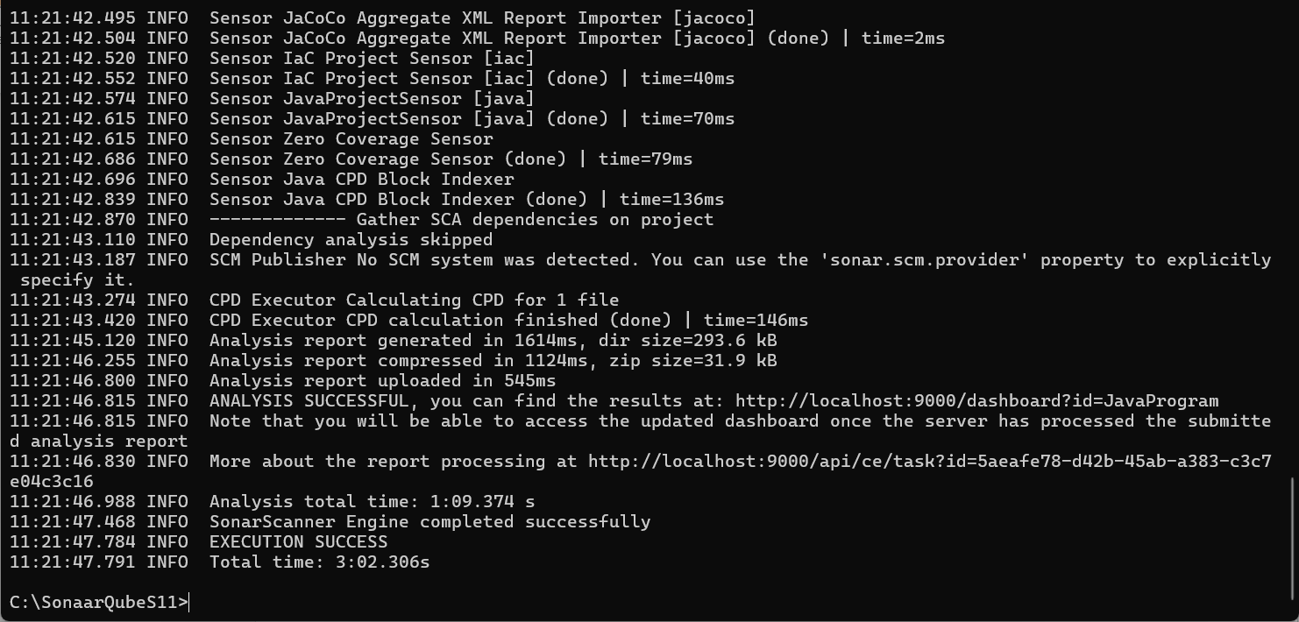
Now go back to the server.
Click Projects at the top and review the report.
Screenshot:
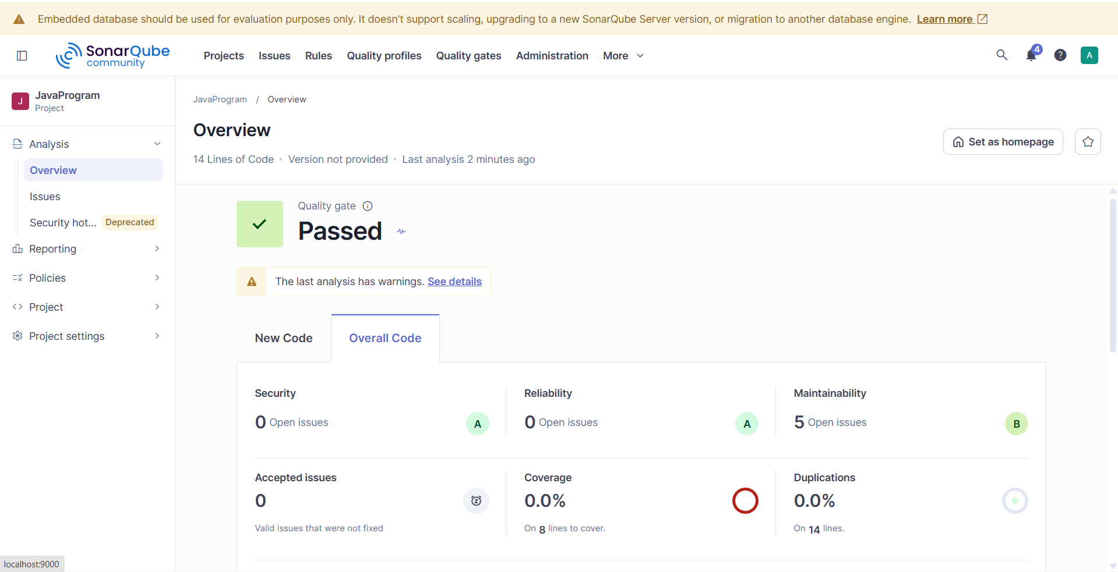

The report shows 5 maintainability issues; click Issues to see all of them.
Screenshot:
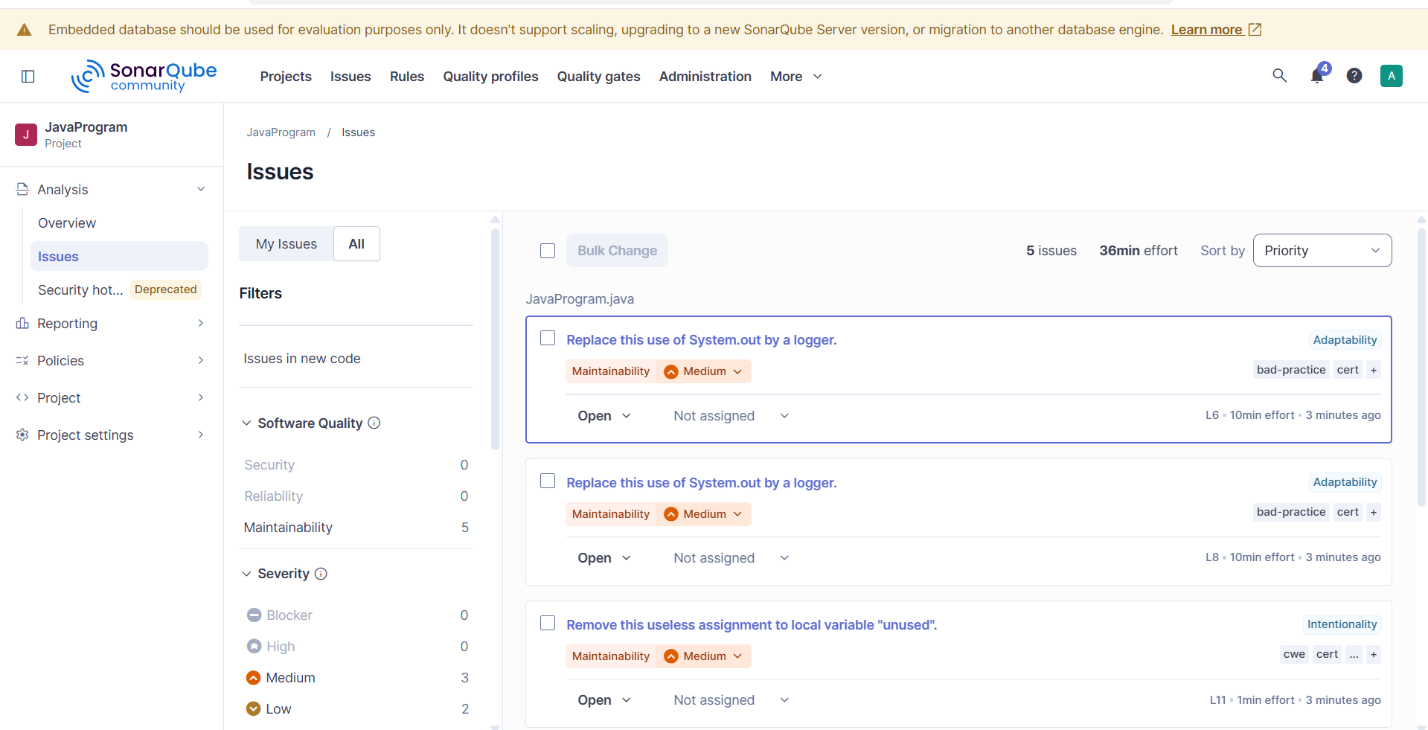
While the server is running, keep it up until the work is done, then stop it.
Switch to the command prompt in which the server is running.
Press Ctrl+C.
Screenshot:
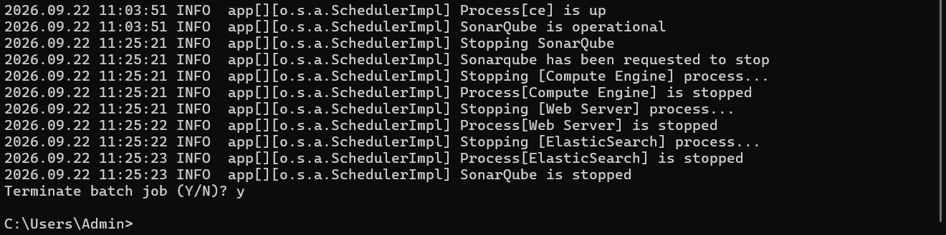

Type exit, then y.
Screenshot:
To confirm that the server has stopped, open SonarQube in the web browser and refresh the page.
Screenshot: the server has stopped successfully
