**Practical Activity 2 Based on Azure Cloud Disaster Recovery**

Assume that you are working as Azure cloud Information Security Officer in maintaining client’s data and servers running.

1. Deploy a windows server 2016 Gen 1 remotely on your machine from Azure cloud.

2. Install the windows feature- Web server management tools and confirm from your browser.

3. Create a Site Recovery Service Vault. Since your site will contain only one Windows Server just add the Windows server to Replicated Items in the Recovery Service Vault to be tracked.

4. Stop the Windows server from Azure to Assume it’s ‘breakdown’

5. Then perform a Test Failover for the windows server.

6. The test failover process should start.

7. You should see a replicated copy of the windows server and run it, copy the public IP address and test it from your browser.

8. Make a clear documentation of this with clear explanations and attach screenshots of each step.

Please use a word document for this and screenshots inserted as pictures.

As always save your work with your name and women techsters email.

All the best.

**Practical Activity 2**

*Below is a brief process I used to carry out a backup and test failover.*

**Step 1:**

Deploying a windows server 2016 Generation 1 and provision the machine in South Africa North. Then open port 80 to enable the setting up of a windows server and port 3389 for remote desktop.

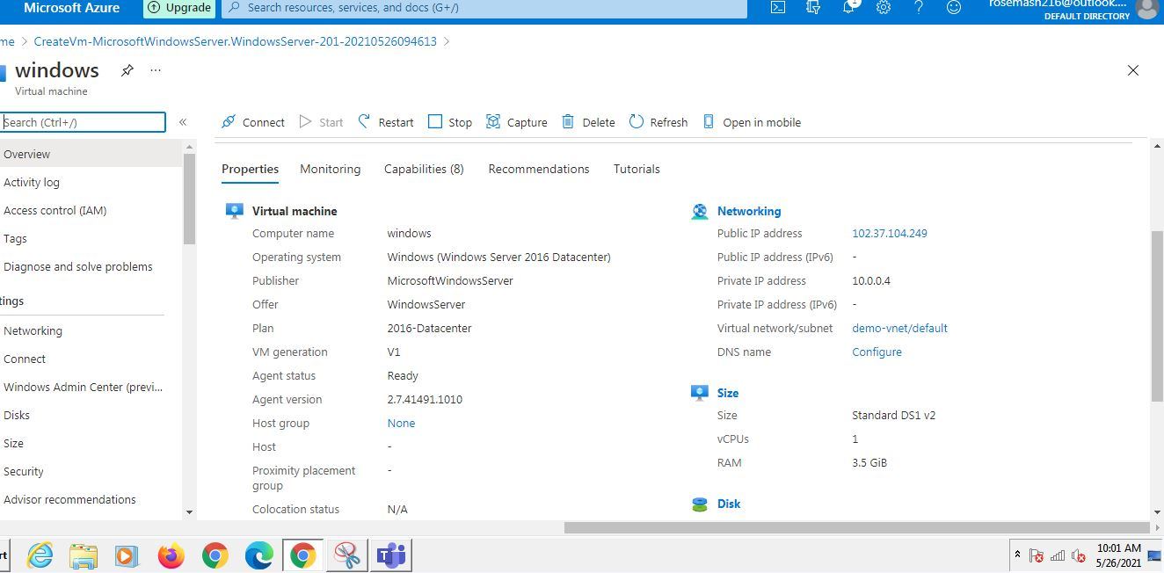

**Step 2:**

Installing the windows feature (IIS)

I installed the windows server with all its features with a rather longer method other than the PowerShell command.

In the azure portal copy the public, IP Address provided for the virtual machine and paste it on a web browser and since port 80 is open, I should be able to access the installed server.

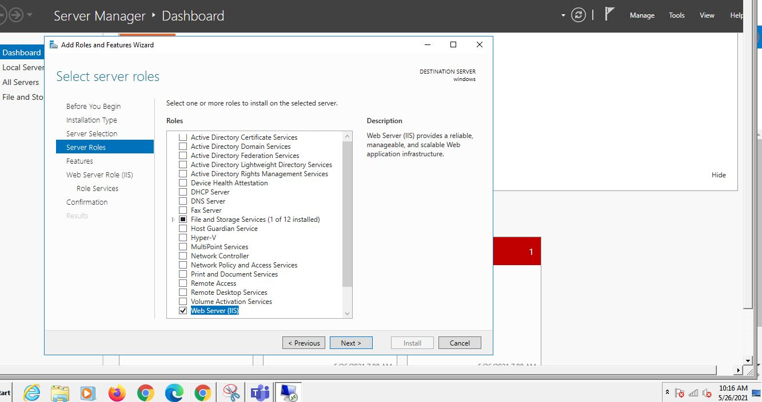

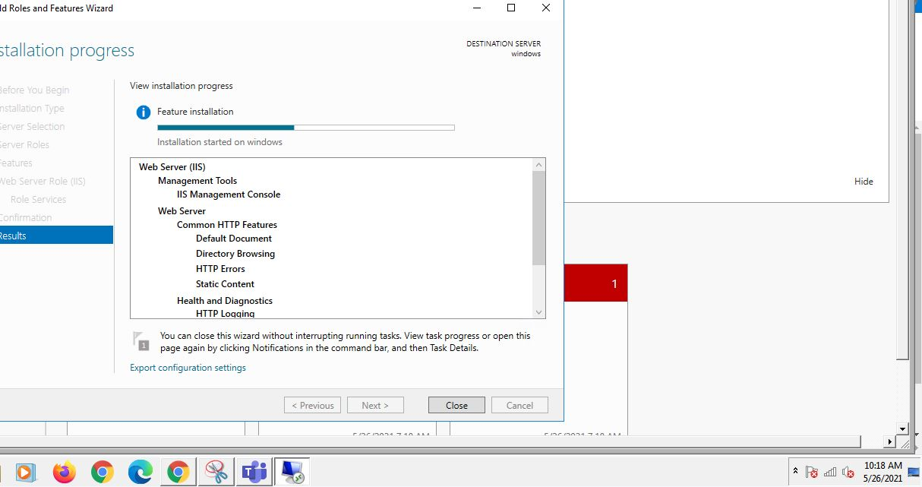

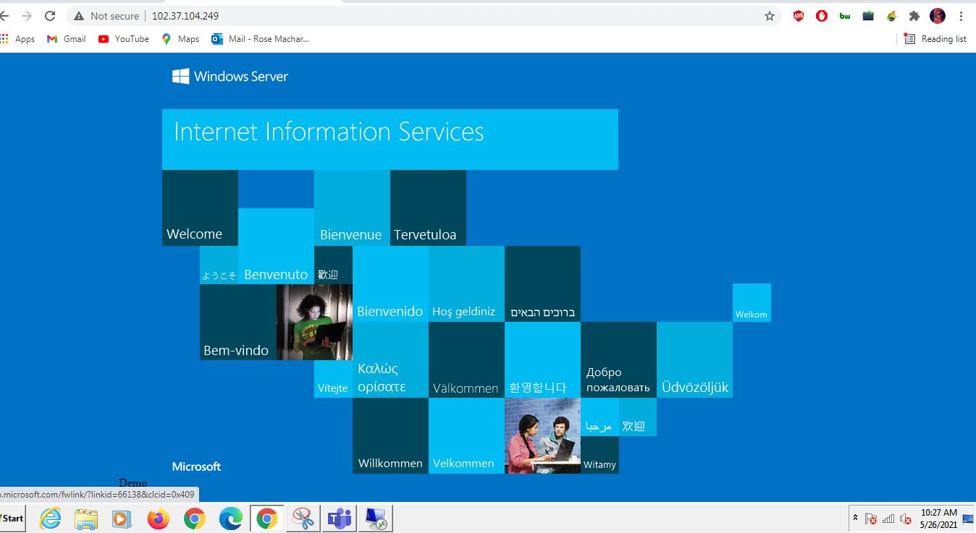

**Step 3:**

Creating a site recovery service vault and replicating items in the vault

In this step, I navigated to the disaster management tab to specify a target region to replicate the virtual machine in case of failure. I set my recovery region as North Europe, Resource group as ‘demo-asr’ and virtual network as’demo-vnet-asr. On replication setting, I assigned a backup service vault. Below is the replicated virtual machine in North Europe

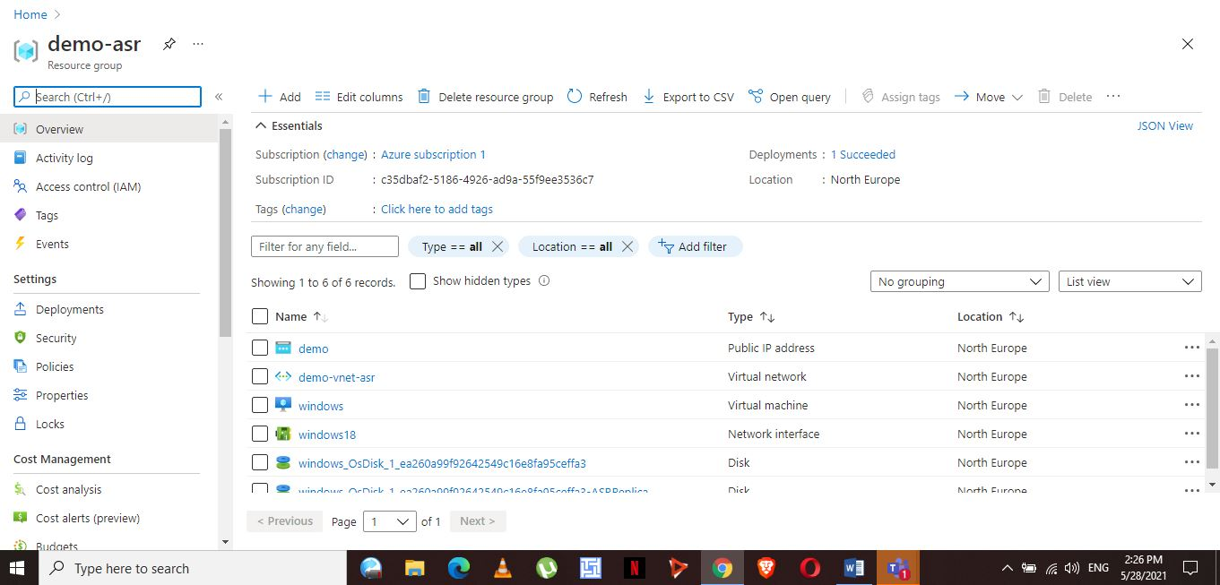

In the backup service vault, I navigated to the recovery vault to actually confirm completion of the replication.

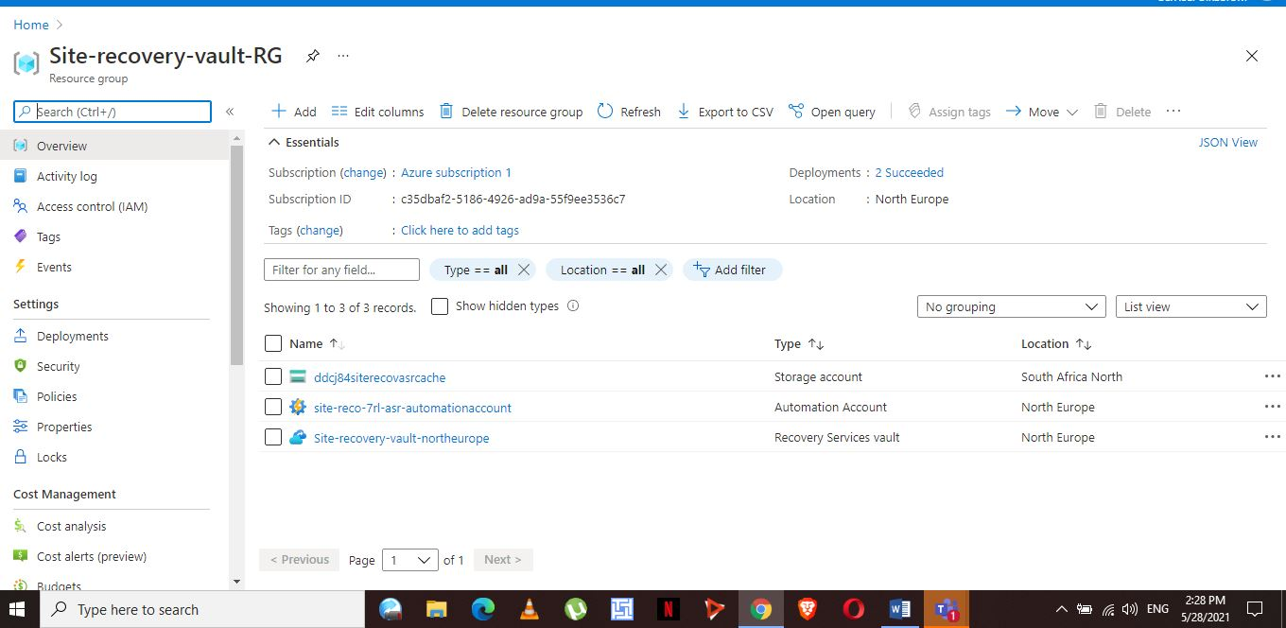

**Step 4:**

Stop the window server and carry out a test fail over for the server.

Before starting the test fail over, I left all options as default in the configuration. The test failover took some while but on completion, it was successful. On navigating to windows test there, public IP address is not assigned. For assigning of the IP, I navigated to the virtual network ‘demo-vnet-asr/default’ then to network interface lastly on menu IP Configurations. I enabled IP forwarding, on public IP address setting select associate then create a new IP address then save. Back to the overview to check if an IP has been assigned, then test if it working. IP address is 52.178.182.171

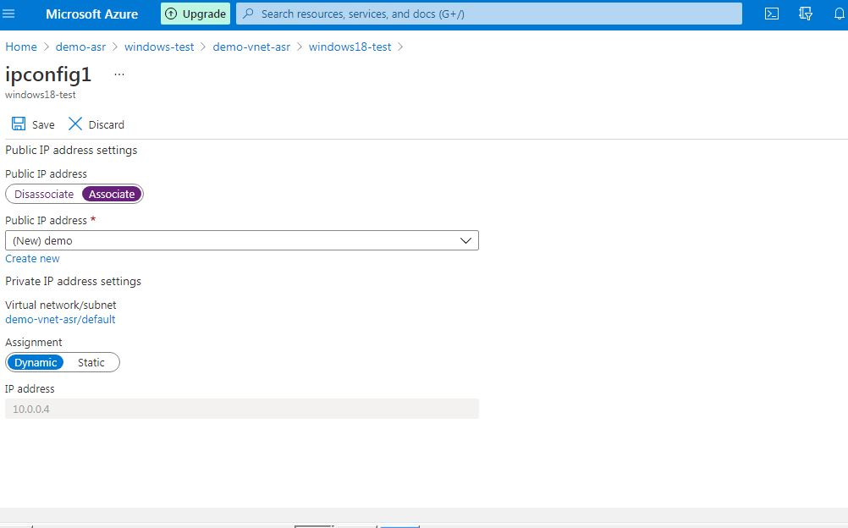

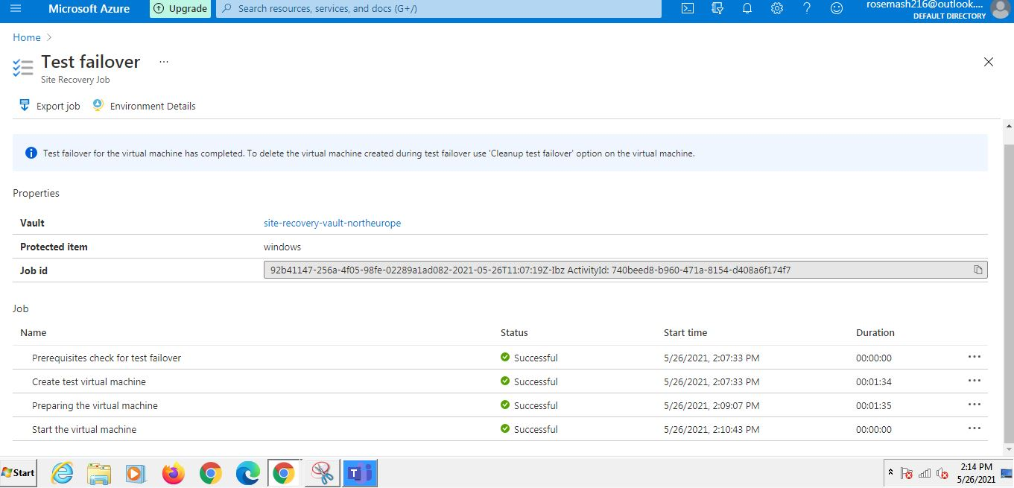

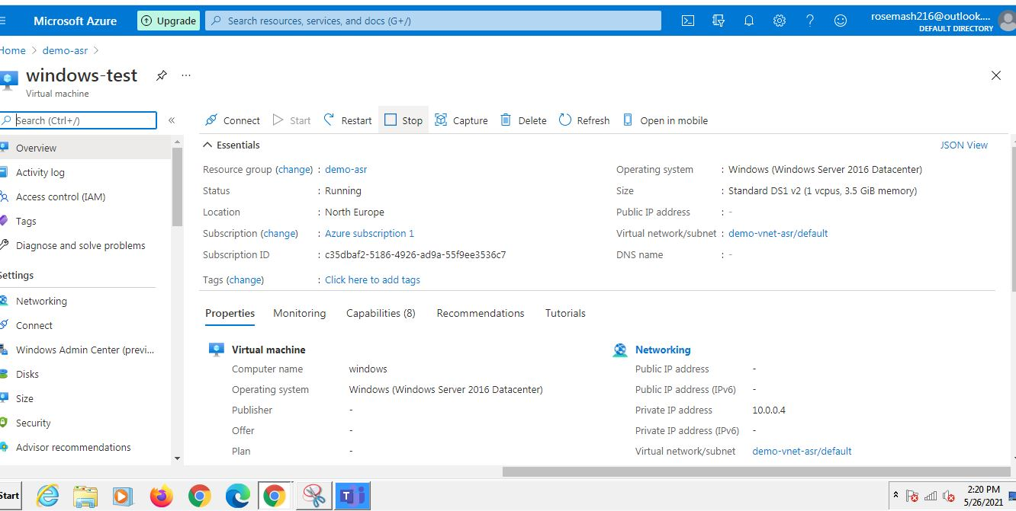

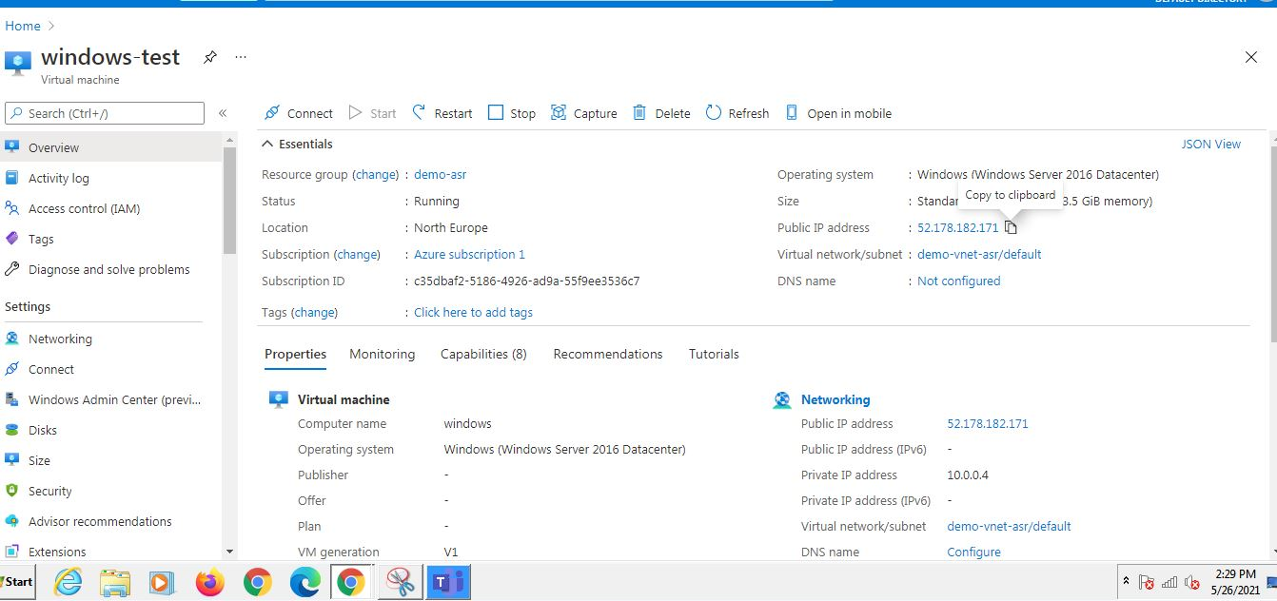

**Step 5:**

Check to see if replication occurred, then copy the new public address on the browser check if actually opens. 