**Practical Activity 4**

This week’s Practical Activity will be based on Bash script Programming. As a system Administrator in the near future, you will be expected to understand the structure of Bash Scripts and also you might encounter this type of questions in an interview scenario.

Write a shell script to validate password strength when a user enters. Here are a few assumptions for the password string.

• Length – minimum of 8 characters.

• Contain both alphabet and number.

• Include both the small and capital case letters.

If the password doesn’t comply with any of the above conditions, then the script should report it as a <Weak Password> if the password complies with the conditions, it should echo <Strong Password Secure User>

**Instructions:**

1. Write the code in a file created in your home directory and call it auntentic.sh

2. Just the same way we have created scripts execute it and use nano editor to add your code.

3. After words Screenshot, your Code Paste it in a word Document as part one of your Report.

4. Also test your script by typing different passwords and screen shot the output from your terminal and add to your report document.

NB: After successfully submitting this Practical Activity, you can push your code to git-hub and document it.

**Practical Activity 4**

This bash script code validates the strength of a given password

! /bin/bash

read -p "please enter password:" pass

count=`echo ${#pass}`

if [[ $count -gt 8 ]];then

echo "strong password secure user"

exit 1;

fi

echo $pass | grep "[A-Z]" | grep "[a-z]" | grep "[0-9]"

if [[ $? -ne 0 ]];then

echo "weak password"

exit 2;

fi

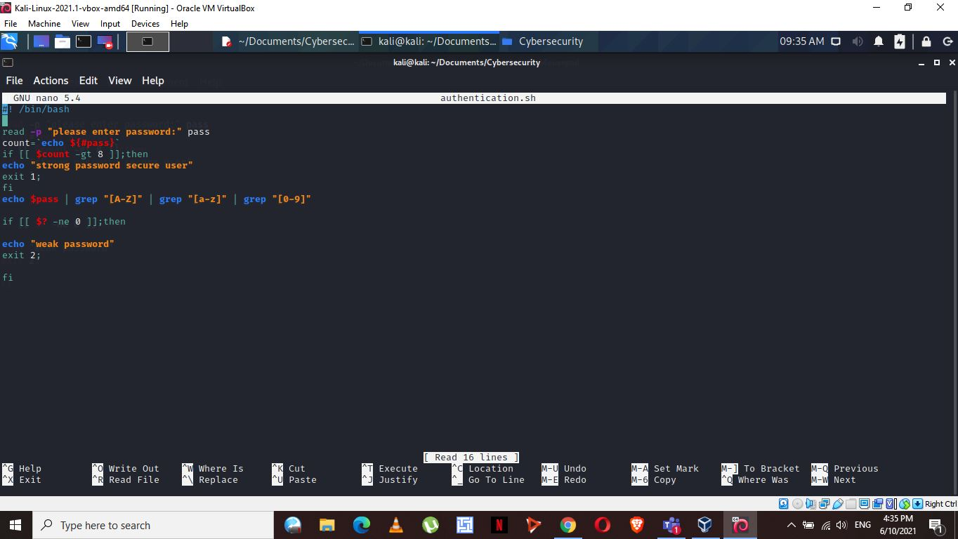

The script only accept a password with both small and capital letters, numbers and a length greater than 8. If a password does not meet the specified condition, it terms it as a weak password.

