**Practical Activity 5**

Assuming you are a system administrator in “CarMax” Car Dealership and you have been assigned with a task to add 1 Headquarters and 2 Sales Locations in a windows Server 2016 you configured.

1. With the help of Active Directory, Add the Headquarters and 2 Sales Locations.

Headquarters has:

➢ Administrative Dept

➢ Accounting Dept

➢ Hr

Each Sales Location has:

➢ Sales Staff

➢ Mechanic Staff

➢ Management

2. Under each Unit add dummy users.

3. Assuming a user in Sales Staff is promoted to Administrative Dept, give a description on how you will handle this and make sure the sales user is effectively transitioned to Administrative Unit. Please give a detailed description with accompanied screenshots.

4. Assuming “One dummy” user in Mechanic Staff has gone on leave for one month, give a detailed description of how you will ensure their user account is inactive and cannot be accessed by any other person during this one-month leave. This is to ensure unauthorized users to do not use that account to access the organization system.

5. In accounting Dept, we want to maintain high notes of security especially to the computers. Add a computer policy under Accounting Dept to ensure all computers are locked or disabled after 3 minutes of inactivity. The user has to login once again when back.

All these steps and procedures should be well documented with explanations and accompanied with screenshots.

**PRACTICAL ACTIVITY 5**

**QUESTION 1 & 2**

**The organization comprise of headquarter and 2 sales locations. In each locations, there is 3 departments, sales mechanical and management. In the headquarter there are 3 departments administrative accounting and hr. In each department I created some users**

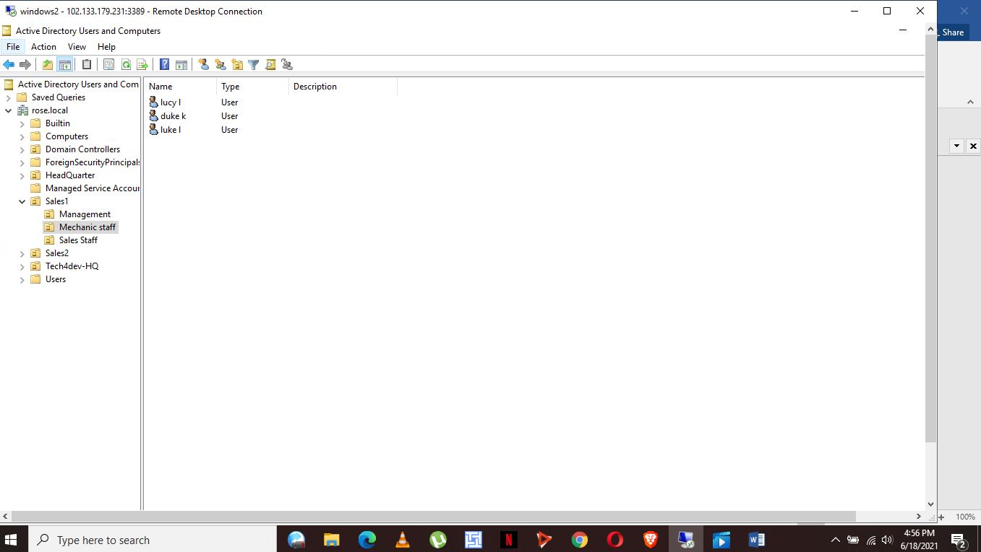

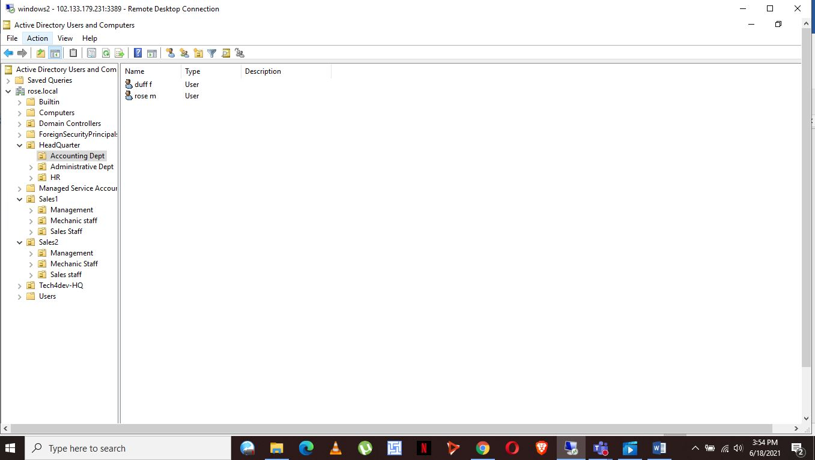

**QUESTION 4**

**In this, one of the mechanical staff leaves for a month. The users account has to be deactivated until the user can join back. I created a policy that will enable the users account stay locked until the administrator can unlock it. I navigated to the group policy on the tools tab, then to the mechanical staff group. The only user to be locked was lucy in my case so ensured the scope did not affect other users in the mechanical staff group. Edit the newly created policy; on windows, settings then security setting navigate to Account policies then to account lockout policy. In the account, lockout duration properties set the amount of time the account should stay locked**

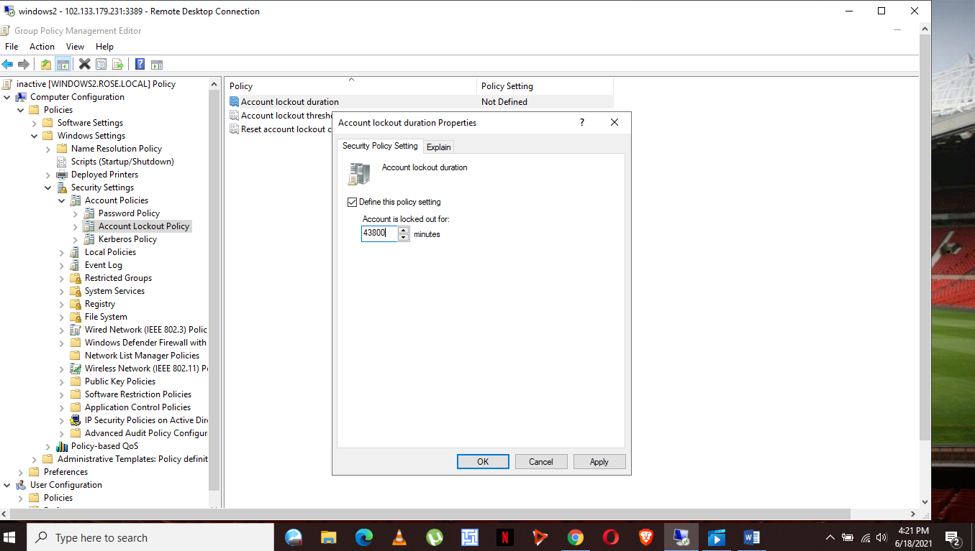

**QUESTION 5**

**First step to adding a policy**

**On the server manager navigate to tools then group policy management. Then click on the account unit and add a new group policy. Name the policy; edit the added policy via the management editor mode. Navigate to policies, windows settings, security setting, and local** **policies security options then navigate through the many undefined policies until interactive logout machine inactivity unit. Apply the necessary logout settings**

