------Total sales
select count(transactions_id) AS total_sales
from retail_sales_report
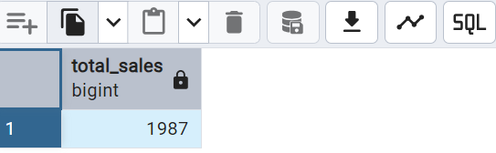

-----Total customers
select count(distinct customer_id) AS total_customers
from retail_sales_report
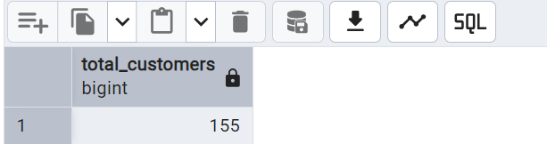

----Total categories
select count(distinct category) As total_category
from retail_sales_report
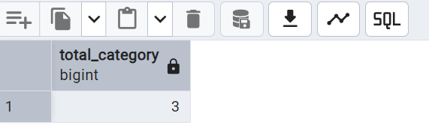

----Data Analysis
---1 Retrieve all columns for sales made on '2022-11-05
select *
from retail_sales_report
where sale_date='2022-11-05'

--2 Write a SQL query to retrieve all transactions where the category is 'Clothing' and the quantity sold is more than 4 in the month of Nov-2022
select *from retail_sales_report
where category='Clothing'
AND
sale_date BETWEEN '2022-11-01' AND '2022-11-30'
AND
quantity>=4

---3 calculate the total sales (total_sale) for each category.
select category,sum(total_sale) AS total_sales_per_category
from retail_sales_report
group by category
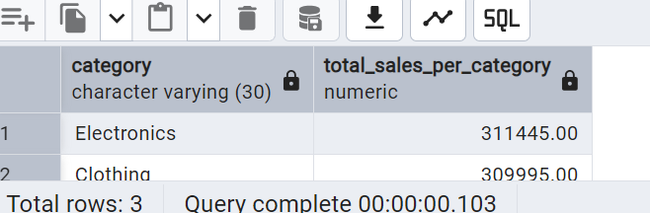

---4 Find the average age of customers who purchased items from the 'Beauty' category.
select round(avg(age),2)AS average_age from retail_sales_report
where category='Beauty'
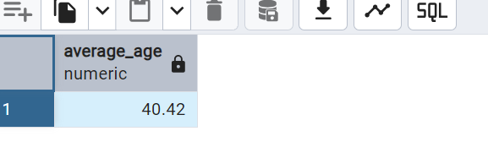

---- Find all transactions where the total_sale is greater than 1000.
select * from retail_sales_report
where total_sale>1000
order by total_sale asc

---Find the total number of transactions (transaction_id) made by each gender in each category.
select category, gender,count(*) AS total_transactions
from retail_sales_report
group by category,gender
order by category
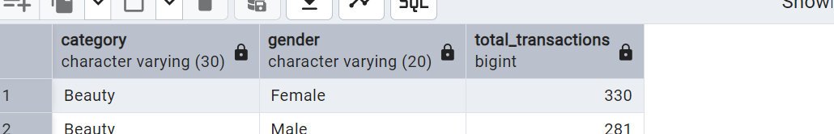

----calculate the average sale for each month. Find out best selling month in each year
select extract(Year from sale_date) AS Year,extract(month from sale_date)AS Month,
round(avg(total_sale),2)AS average_sale
from retail_sales_report
group by extract(Year from sale_date),extract(month from sale_date)
order by year,Month,average_sale desc

----Find the top 5 customers based on the highest total sales
select customer_id,sum(total_sale)AS total_sales_per_customer
from retail_sales_report
group by customer_id
order by total_sales_per_customer desc
limit 5
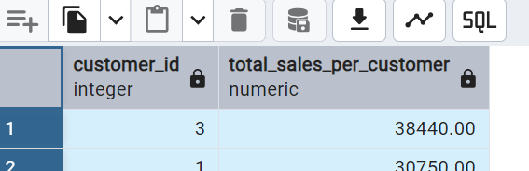

-----Find the number of unique customers who purchased items from each category.
select category, count(distinct customer_id)AS total_customers
from retail_sales_report
group by category
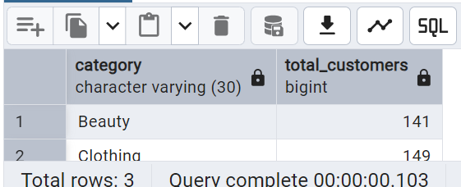

select
case
when EXTRACT(hour from sale_time)<=12 THEN 'Morning'

----Create each shift and number of orders (Example Morning <=12, Afternoon Between 12 & 17, Evening >17)
when EXTRACT(hour from sale_time)>12 AND EXTRACT(hour from sale_time)<=17 THEN 'Afternoon'
else 'Evening'
end AS shift,
count (distinct transactions_id)AS total_orders
from retail_sales_report
group by shift
