1. The vast majority of cities are in the northern hemisphere. The highest temperatures are observed in the northern hemisphere near the Tropic of Cancer because it is summer in the northern hemisphere. This is due to the tilt of the earth in relation to the sun.

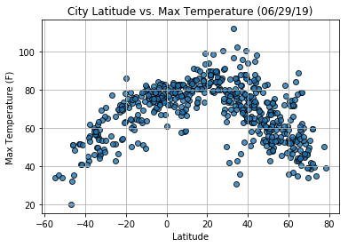

1. The humidity appears to be high overall with lower spikes appearing near the Tropic of Cancer. This is probably due to the extreme heat experienced there now because it is summer. 100% cloudiness seems to cluster at certain latitudes due to the presence of coastal cities at those latitudes. There is also a clustering of 0% humidity at certain latitudes probably due to the presence of deserts at those latitudes.

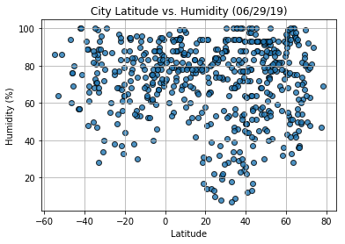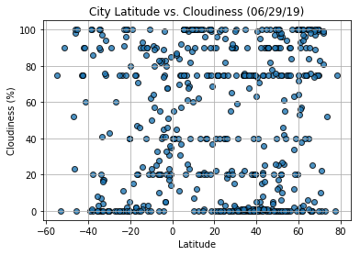

1. The more extreme wind speeds appear to be clustered in the southern hemisphere probably due to the currently colder temperatures there affecting seasonal weather/wind patterns.

