Introducrtion
Understanding of the acid-base balance needs a complex insight into the physiological processes in human body. We need to consider the distribution of water, protein, electrolytes and other solutes in the body fluids. For this reason, mathematical models were developed. We took a model of M. B. Wolf and E. C. DeLand from 2011 of blood-interstitial acid-base balance, which combines the knowledge of the traditional Siggaard-Andersen approach and more recent approach of Stewart and its application to blood and blood-interstitial fluid by Wooten. [1]
The model was implemented and verified using VisSim as the simulation tool. VisSim is block based language developed by Visual Solutions. Implementing more complex mathematical equations using block based language might be difficult to decipher for uninformed reader. [1, 6]
To make the model easier to understand and read, we reimplemented it in the Modelica language. Modelica is freely available, object-oriented modern language build on acausal modeling with mathematical equations. In Modelica we don’t have to construct equations using various blocks (e.g. constants, gains, etc.). The next advantage is the acausality of the language, which means we do not have to deduce the procedure of calculation. It is done by the compiler.

Theory of acids and bases
The first theory of acids and bases comes from late 19th century from Swedish chemist Savante Arrhenius cal after him Arrhenius theory. When dissolved in an aqueous solution, Arrheniuns acid cleaves a hydrogen cation (proton) and thus increases the H⁺ concentration. An Arrhenius base is a substance that while dissolved in the water cleaves a hydroxide anion and thus increases the OH⁻ concentration in a solution.
(1)
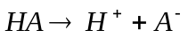
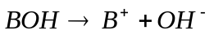
(2)
This theory is most general and has some limitations. There are some substances, which increases the OH⁻ concentration in water but do not contain any OH group they could cleave off. In an aqueous solution, the OH⁻ concentration increases but it happens thanks to the OH⁻ residue from water itself. [8, 10]
The limitation of the hydroxide group or the need for water as a solvent removes the Brønsted-Lowry theory, which defines an acid as a donor of hydrogen cantion while basis is an acceptor of hydrogen cation. While the acid dissociates in water, it increases the H⁺ concentration and base increases the OH⁻ concentration by taking protons from water. [8, 10]
(3)
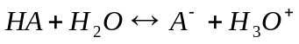
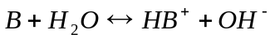
(4)
This way a conjugate pair of acid (HA or HB⁺) and base (A⁻ or B) is formed. The equilibrium between the conjugate pairs will be established. When the equilibrium is established depends on the strength of the acid or the base. The indicator of the strength of an acid or base is dissociation constant. The dissociation constant for an acid is
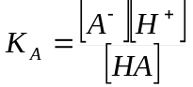
(5)
while for a base
(6)
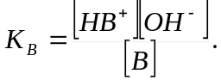
The dissociation constant can have values in vide range so we usually use the pK value which is a negative decadic logarithm of the dissociation constant:
(7)
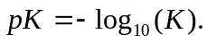
The stronger the acid (or the base) is, the more dissociates in the water. Hence strong acids (or bases) have higher dissociation constant a thus lower the pK value. Strong acid (or base) is usually labeled the acid (or base) that fully dissociates in the water solution (the concentration of the other part of conjugate pair is negligible). [8]
Similarly as the pK value is a negative decadic logarithm of the dissociation constant, the pH value is a negative decadic logarithm of the H⁺ ion concentration in a solution.
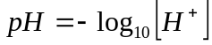
(8)
For the high concentration of substances (e.g. H⁺, OH⁻) in the solution, the effective concentration of the ions is somehow lower than the real concentration. This is caused by interaction between the ions of opposite charge. The associate into neutral pairs (e.g. H⁺Cl⁻). This effective concentration is called activity. We should be calculating the pH value using the activity instead of the concentration to be exact. In practice, we usually stick with the concentration of hydrogen ions instead of their activity, because the difference for the non-extreme pH values is negligible (the concentration of H⁺ for low pH or OH- for high pH is not high enough for the significant interaction between the ions). In the human body, the pH values are close to neutral pH (in extreme 6.5 – 8) hence we can use the concentration of hydrogen ions with sufficient accuracy of the results. [14]
While we are talking here about the H⁺ concentration in the water solution we should mention, that in reality the free hydrogen cations in the water does not exist. Even if the hydrogen cation has only single unit of positive charge, it is a bare nucleon (proton) and thus it has high charge density. Hence it is strongly attracted to any molecule with an excess of negative charge. The proton will be attracted by the lone electron pair of the H₂O molecule. The bond is created thanks to the sharing of electron between the oxygen and the proton. The result is the creation of hydronium ion H₃O⁺. [14]
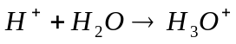
(9)

Acid base balance in human body
Acid-base homeostasis in human body is very important. The pH is maintained in a narrow range (7.4 ±0.04 for blood, cellular environment is more acidic ca. 7.0 – 7.2). To keep the pH values in this narrow range, number of mechanism is needed. Different systems works in different time scales. [5, 9]

Acute response
With the acute changes of the H⁺ concentration deal chemical buffer systems. The reaction is in the matter of milliseconds [5]. In different parts of the body we meet with different buffer systems. The most significant buffers for blood are the bicarbonate system and hemoglobin, for intracellular fluid it is the proteins and phosphates and for extracellular fluid the bicarbonate system. The chemical buffers are composed of the conjugate pairs of acids and basis. [5, 7]
For bicarbonate buffer it is weak carbonic acid and the bicarbonate anion as a base.
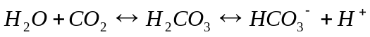
(10)
The bicarbonate buffer system is open. The body can actively change both of its parts. The amount of H₂CO₃ is bound with the P_{CO2} and thus with the respiration while the HCO₃⁻ can be controlled by the kidneys. [5, 7]
Proteins can thanks to its branched structure with a number of side chains bound or cleave off the hydrogen cations. The hemoglobin system is important for dealing with the CO₂ production of metabolism. The carbon dioxide diffuses to the erythrocytes where thanks to carbon anhydrase can quickly form the carbonic acid, which dissociates into hydrogen cation and bicarbonate anion. Most of the bicarbonates leave the erythrocytes thanks to chloride shift (Hamburger effect) while anion of bicarbonate is exchanged for chloride anion to maintain the electro neutrality. Deoxygenated hemoglobin can bind the H⁺ much more that the oxygenated one and thus helps with the buffering the products of metabolism. In lungs, the P_{CO2} is lower than in the body so the carbonic acid breaks into the water and carbon dioxide, which is breath out. The hydrogen cation is provided by the hemoglobin, where it was bound earlier. [5, 7]

Long-term response
The other systems need longer time to properly react on the acid-based disbalances. The second fastest system helping with the balance of is the shift of species between the buffer systems of blood and interstitium (tens of minutes). The intracellular buffers as well as the bone mass can response in few hours. The respiratory system can manipulate with the P_{CO2} and thus adjust the level of bicarbonates. Maximum efficiency occurs after 6 – 12 hours. The slowest system is the kidneys. They can adapt the excretion of acids (or bases) with maximum effect after 3 – 5 days. [5]

Importance in medicine
The narrow pH range is kept due to the importance of certain hydrogen cations concentrations in many biological processes. It is essential for a cell metabolism and transmembrane transport. Difference in pH might cause different protein conformations due to reaction with hydrogen ions. Proteins are essential part of many structures in the cells and their functionality depends on their certain conformation. Enzymes are pH sensitive as well. The disbalance in ion distribution caused by acid-base disbalnces might cause changes in bone density and muscle wasting. [5, 9]
Acid-base homeostasis influences transmission of oxygen as well. Not only by the respiratory regulation, but it influences the dissociation curves which are important for the mechanism of diffusion of oxygen from blood to the tissues. This effect is important especially for acute alkalosis, because it decreases the release of oxygen into the tissues. Even if the oxygen saturation of blood is high, tissues can suffer by the insufficiency of the oxygen. [5]

Approaches
There are two main approaches to the description of blood acid-base chemistry. The classical approach of Ole Siggaard-Andersen uses nomograms based on experimental data. Nomograms graphically describe the pH as a function of hemoglobin concentration, pressure of carbon dioxide and base excess (BE). Base excess is the amount of miliequivalents of strong acid (or base) that is needed to titrate one liter of blood to reach the normal pH (7.4). BE is derived from the Buffer Base (BB), which is the sum of bicarbonates and the non-bicarbonate buffers (Buf⁻).
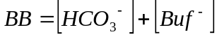
(11)
The problem with BB was the dependency on the concentration of hemobglobin (since it is one of the non-bicarbonate buffers), which makes it difficult to compare BB values for two different patients. To avoid the dependency on the hemoglobin concentration the BE was defined as a difference between the BB at the given pH value and the value of normal buffer base (NBB), which is the value at of BB at pH 7.4.
(12)

Since both the values (BB and NBB) are dependent on the hemoglobin, the dependency is eliminated. The weak point of this approach is the need of standard conditions to be accurate. It does not deal with different plasma protein concentrations or ion balance. [11, 12, 15]
The second widespread approach it Stewart’s. It deals with the limitation of need of the normal plasma proteins (or plasmatic buffers generally). He mathematically deduces, that pH is function of P_{CO2}, SID and concentration of total buffers. Total buffer is the sum of both conjugate pairs of the non-bicarbonate buffers. SID (Strong Ion Difference) is the difference of fully dissociated cations and anions:
.
(13)
The pressure of carbon dioxide is an indicator of the respiratory state while SID and Buf_{TOT} reflect the metabolic disorders. This approach offers better insight into the acid-base disturbances, but it considers only plasma and thus ignores the buffering capacity of hemoglobin (which is more significant than the capacity of plasmatic proteins). [11, 12, 15]
The two approaches are not in contradiction. Each is defined for different conditions (one for blood with the same plasma proteins ad the other for plasma only but more general). Despite its limitations both approaches are commonly used in clinical praxis. There are more precise models of the acid-based balances, but they are not received well by clinicians due to its complexity. [11, 12]

Regulation
Human body produces ca. 20 000 mmol of carbon dioxide, which with the connection with body fluids (water) creates weak carbonic acid and ca. 60 – 70 mmol of strong acids. The production of the acids in metabolism has to be in balance wit their elimination from the body. The elimination of carbon dioxide is a task for respiration system while the elimination of strong acids provides kidneys. In normal state, the intake and expenditure of the acids are in balance. [5]
The disorders in the balance of CO₂ lead to respiratory disturbances of acid-base balance – respiratory acidosis or respiratory alkalosis, while disbalance in the strong acids leads to the metabolic disturbances of acid-base balance – metabolic acidosis or metabolic alkalosis. [5]
The first to response to the acid-base disbalance are the buffer systems. The bicarbonate system provides connection between the CO₂ and H⁺ as shows figure 1. Thanks to this connection, kidneys can react on the disbalance of carbon dioxide and the respiratory system can compensate the strong acid disorders.
CO₂
H₂O
H₂CO₃
HCO₃⁻
H⁺
Figure 1: The relation between the hydrogen ions and carbon dioxide.

Besides the bicarbonate buffers, there are other non-bicarbonate buffers which we usually denote as Buf⁻ and their conjugate acid as HBuf. The relation between the Buf⁻ and HBuf shows figure 2.

H⁺
Buf⁻
HBuf
Figure 2: The relation between non-bicarbonate buffer and hydrogen cation.

Combining both types of buffer we receive an idea of the whole buffer system of the human body as shows figure 3. [5]
CO₂
H₂O
H₂CO₃
HCO₃⁻
H⁺
Buf⁻
HBuf
Figure 3: The representation of the buffer system of human body.

The buffer systems can help us with the fast response on the acute acid-base disorders but they can not fully compensate the disturbance and restore the physiological pH value. To fully compensate the acid-base disorder, we need to adjust the level of bicarbonates to restore the ideal level of H⁺ concentration. There are two ways of influencing the level of HCO₃⁻. Respiratory system can change the level of carbon dioxide and thus shift the balance of bicarbonate buffer (increase in the carbon dioxide pressure leads to increase of bicarbonates while decrease of P_{CO2} lowers the HCO₃⁻ see fig. 3). Kidneys can also manipulate with level of bicarbonates. For every ion of strong acid which is excluded by the kidneys, one ion of HCO₃⁻ is added to the body. Thus if we have problem with the respiration (disbalance in carbon dioxide), kidneys can compensate the disorder – metabolic compensation of respiration disorder; and if the disablance in strong acids occurs, respiratory system helps to compensate this disorder – respiratory response on metabolic disorder. [5, 9]

Metabolic acidosis
Metabolic acidosis is a disorder primary caused by increase of hydrogen ions. The acute redundancy of H⁺ is compensated by the buffer systems. This causes decrease in the BB (BE goes to negative values) and slight decrease in pH. At the beginning, the level of carbon dioxide does not change, but as the disorder persists, the ventilation starts to increase. This will lower the carbon dioxide in blood, which leads to the shift in the balance of bicarbonates (carbonic acid disintegrates into water and carbon dioxide, which leads to recombination of hydrogen ion and bicarbonate to carbonic acid and thus lowering the bicarbonates and increase of pH). Fully compensated metabolic acidosis is characteristic by low BB (negative BE – primary disorder) with low P_{CO2} value (caused by the regulation response) while the pH value is standard. [5]
CO₂
H₂O
H₂CO₃
HCO₃⁻
H⁺
Buf⁻
HBuf
Figure 4: Non-compensated metabolic acidosis. Increase of the hydrogen ions causes consumption of bicarbonate and non-bicarbonate buffers. The respiration keeps constant CO₂ level.

CO₂
H₂O
H₂CO₃
HCO₃⁻
H⁺
Buf⁻
HBuf
Figure 5: Fully compensated metabolic acidosis. The response of ventilation lowers the carbon dioxide level which shifts the balance of bicarbonates left and thus lowers the H⁺ back to standard level.

Metabolic alkalosis
Metabolic alkalosis is caused by negative balance of strong acids in the system. This causes the increased BB and BE values. The buffer systems react by releasing the hydrogen ions to balance the pH value. Respiration keeps constant carbon dioxide level, but with the persistent disturbance, the ventilation lowers. The increased pressure of carbon dioxide shifts the balance of bicarbonate buffer system increasing the hydrogen ion concentration back to normal. Result of the respiratory compensation of metabolic alkalosis is increased P_{CO2} and BE (which is primary problem). [5]
CO₂
H₂O
H₂CO₃
HCO₃⁻
H⁺
Buf⁻
HBuf
Figure 6: Non-compensated metabolic alkalosis. Decrease in the H⁺ leads to releasing it from the buffers and shifts the balance of bicarbonate buffer system right increasing the hydrogen ions and bicarbonates. The CO₂ is kept constant due to ventilation.

CO₂
H₂O
H₂CO₃
HCO₃⁻
H⁺
Buf⁻
HBuf
Figure 7: Fully compensated metabolic alkalosis. Increase in CO₂ shifts the bicarbonates balance further right increasing the hydrogen ion concentration. It bounds back to the non-bicarbonate buffers. The physiological pH is restored.

Respiratory acidosis
The cause of the respiratory acidosis is retention of carbon dioxide in blood. Acute hypercapnia leads to increased dissociation of carbonic acid and thus increased hydrogen ion concentration. They are bound to non-bicarbonate buffers. Some of the newly created bicarbonates shifts from plasma to interstitium which leads to slight decrease in BB and BE. If the disbalance persists, kidneys starts to excrete strong acids associated with equimolar intake of bicarbonates. The increase in bicarbonates shifts the bicarbonate buffer balance in advance of carbonic acid and thus lowers the H⁺. Result of fully compensated respiratory disturbance is high P_{CO2} and slightly increased BE with standard pH. [5]
CO₂
H₂O
H₂CO₃
HCO₃⁻
H⁺
Buf⁻
HBuf
Figure 8: Non-compensated respiratory acidosis. Retention of carbon dioxide increases the carbon acid concentration which dissociates to bicarbonate anion and hydrogen ion. Non-bicarbonate buffers bound the redundant H⁺ lowering the pH.

CO₂
H₂O
H₂CO₃
HCO₃⁻
H⁺
Buf⁻
HBuf
Figure 9: Fully compensated respiratory acidosis. Increased HCO₃⁻ consumes H⁺ lowering their concentration, which leads to releasing hydrogen ions from non-bicarbonate buffers and restoring physiological pH level.

Respiratory alkalosis
Respiratory alkalosis is caused by depletion of carbon dioxide (hypocapnia). Lowering the carbon dioxide shifts the balance of bicarbonate buffer system to the left creating more carbonic acid which is linked with decrease of bicarbonates and hydrogen ions. The hydrogen cation depletion is partially compensated by the non-bicarbonate buffers, which releases the H⁺. The persistent respiratory disorder is compensated by reduced excretion of strong acids by the kidneys, which leads to cumulation of hydrogen ions. The result of metabolic regulation of respiratory alkalosis is low P_{CO2}, and slight decrease in BB and BE while pH is normal. [5]
CO₂
H₂O
H₂CO₃
HCO₃⁻
H⁺
Buf⁻
HBuf
Figure 10: Non-compensated respiratory alkalosis. The decrease of carbon dioxide shifts the balance of bicarbonates in advance of carbonic acid lowering the hydrogen ions. The H⁺ deficit is partially compensated by the non-bicarbonate buffers.

CO₂
H₂O
H₂CO₃
HCO₃⁻
H⁺
Buf⁻
HBuf
Figure 11: Fully compensated respiratory alkalosis. Retention hydrogen ions causes decrease in bicarbonate anions and shifts the balance of non-bicarbonate buffers in advance of conjugate acids.

IPE model

Theoretical background
The main idea of the interstitial-plasma-erythrocyte (IPE) model is to compute concentrations of characteristic ions in each of those parts. This can be done using number of assumptions.
- Each of the three fluids is considered homogeneous.
- Each part attains to electro neutrality.
- In each compartment there is the same osmolarity.
The system is in equilibrium with the gas CO₂. It means it is open system to the carbon and carbonates are not conserved. The other species and water volumes are considered conserved. The electro neutrality and same osmolarity is reached by movements of mobile species and water across the membranes separating the compartments. [1]
The major permeant ion passing through erythrocyte membrane, separating erythrocytes and the plasma, is Cl⁻. Its distribution is in equilibrium described by Donnan ratio between erythrocytes concentration and plasma concentration. The permeant ions across the capillary membrane between interstitial fluid and plasma are Na⁺, K⁺, Ca²⁺, Mg²⁺, Cl⁻ and phosphates. Their equilibrium distribution is as well described by the Donnan ratio. The H⁺ cations can pass through all membranes. The concentration values of bicarbonates are intended by the P_{CO2} and the concentration of H⁺. The H⁺ concentration are connected with the pH value, hence the carbonates and bicarbonates are related to the pH. The partial pressure of carbon dioxide is considered to be the same for all compartments, but its solubility for each part is different. [1]
Besides the permeant ions, there are impermeant particles in each of the three compartments. In case of the erythrocytes there are charged macromolecules of hemoglobin, the metabolites DPG, ATP and GSH and small ions Na⁺ and K⁺. The impermeant molecules in plasma and interstitium are the serum albumin. Each of the three compartments also contains unidentified species. The mass and charge of these unidentified species are adjusted to reach the reference state of the model. The ions of weak acids and the macromolecules (metabolites, hemoglobin, albumin) can bind or release the H⁺ cations depending on their concentrations (pH). Therefore interaction with H⁺ changes the charge of the molecules hence we use the pH dependant charges for these species. [1]

Erythrocyte
Plasma
Interstitial fluid
CO₂
Cl⁻
Na⁺
K⁺
Cl⁻
Pi
Ca²⁺
Mg²⁺
Na⁺
K⁺
Cl⁻
Pi
Ca²⁺
Mg²⁺
Water
Water
Water
immobile
immobile
immobile
Figure 12: Diagram of the mobile species of the IPE model. The pressure of the carbon dioxide is same for all compartments but the solubility differs.

One of our assumptions is the equilibrium distribution of all mobile species across all the membranes. This means the IPE model can not simulate a system with arterial blood since it is not in equilibrium with the interstitial fluid. Hence we have will use the physiological values of venous blood and we have to keep in mind that in IPE model we work only with the venous blood.

Mathematical background
To be able to compose the model, we have to express the assumption we made earlier mathematically. For each issue, we construct a set of equations. Here we take a closer look at the equations of the IPE model.

Electro neutrality
Each ion in the solution has an electrical valence Z which describes its charge. We can get the total charge of one species using the relation
(14)
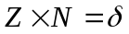
where Z is the valence of the ion, N is the molar amount of the ion and δ is the total charge of the species. If the sum of the total charges for each species is zero, the solution is electric neutral. The electro neutrality is solved for each solution (compartment) separately. This means all the ions are in the same volume of solvent V. Hence we can use their concentration C in the equation of electro neutrality instead of the molar amount as shows the following relations. [1]
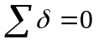
(15)
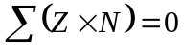
(16)
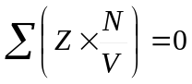
(17)
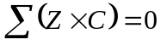
(18)
Using the formula (5), we can construct the equations of electro neutrality for each of the three compartments. Since the interstitium and plasma has the same composition of the species (the concentrations are not the same), the equations of electro neutrality has the same form
(19)
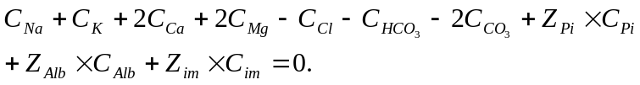
In the equation (6) the Pi is the combined form of the two forms of phosphate important in the physiological range of pH, Alb is the serum albumin and im is the impermeable species. In case of erythrocytes the equation has following form [1]
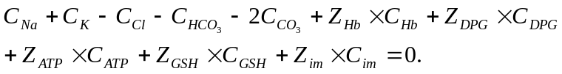
(20)

Osmotic equilibrium
The osmolarity O_{x} is the result of concentration C_{x} of the species multiplied by its osmotic coefficient ϕ_{x}.
(21)
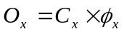
The total osmolarity O is the sum of osmolarities of each species O_{x} in the solution
(22)
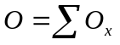
(23)
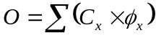
To reach the osmotic equilibrium, there has to be the same osmolarity on each side of the membrane and so the difference between the osmolarities has to be negligible.
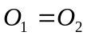
(24)
The values of osmotic coefficient ϕ_{x} are in most cases equal to one. For Na⁺, K⁺, Cl⁻ and phosphates the value ϕ_{x} = 0.93. The osmotic coefficient for hemoglobin are experimentally measured and the results matches the polynomial equation
(25)
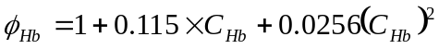.
Using the formula above, we can create equations for osmolarity in erythrocytes
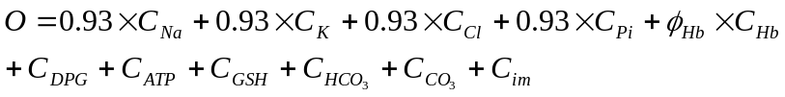
(26)
and for plasma and interstitium [1]
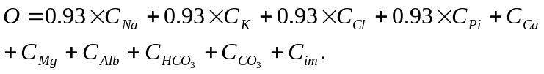
(27)

Transmembrane transport
To reach the equilibrium, the permeant ions move through the membranes dividing the compartments. This equilibrium is called the Donnan equilibrium distribution. For each permeant ion we can express the ratio r of its distribution on the membrane.
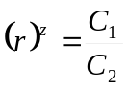
(28)
C₁ and C₂ are the concentrations of a permeant species on one and the second side of membrane. The power z of the ratio is the valence of the species (one for Na⁺, two for Ca²⁺ etc.). If the ratio for one polarity of ions (for example cations) is r the ratio for the opposite polarity (anions in this case) is inversed. [1]
(29)
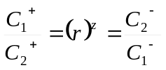

Carbonates concentration
The concentration of carbonates and bicarbonates in each compartment are determined using Henderson-Hasselbalch equation for bicarbonates:
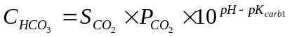
(30)
and for carbonates
(31)
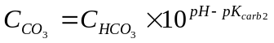
where S is the CO₂ solubility, P_{CO2} is the partial pressure of the carbon dioxide (which is the same for all compartments) and pK_{carb1} and pK_{carb2} are the first and second dissociation constants of carbonic acid. [1]

Charge of pH dependant species
Some species in the solution are not fully dissociated. The level of their dissociation depends on the acidity of solution. The charge of these species can be expressed using following equation
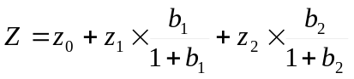
(32)
where
(33)
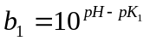
and
(34)
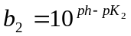.
The z₀, z₁ and z₂ are specific constants for the species. These equations are fitted to provide data similar to the experimental ones. The electrical charge of hemoglobin depends besides the pH on the O₂ saturation. The equation above solves the charge of fully saturated hemoglobin, but in the venous blood hemoglobin is lesser saturated. The charge can be expressed as
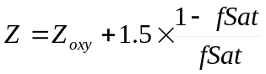
(35)
Where Z_{oxy} is the charge of fully saturated hemoglobin, fSat is the fractional O₂ saturation and Z is the desired charge of partially saturated hemoglobin. [1]

Solute | z₀ | z₁ | z₂
Hemoglobin | 15.6 | -23 | -4
Albumin | -10.7 | -16 | 0
DPG | -3 | -1 | -1
ATP | -3 | -1 | 0
GSH | -1 | -1 | -1
phosphates | -1 | -1 | 0
Table 1: Coefficients for pH dependant charges. [1]

Mass and volume conservation
Since the system is closed for all species except the carbon, we have to obey the principle of mass conservation. Hence all species except the carbonates and bicarbonates follows the equation
(36)
where VE is volume of water in erythrocytes, V^{P} volume of water in plasma and V^{I} volume of interstitial fluid. The concentrations C use the same superscript pattern and M is the total mass of the species. For the water we can simplify this equation only for volumes
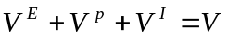
(37)
where V is the total volume of water in the system. [1]

Equation based implementation
First, we need to define a standard state. For this state we use values from the literature. The body should be in the standard state while there is nothing special happening. For this state the majority of the values are given, but there are the unidentified species in each compartment. We do not know their concentration and their charge. These values have to be determined experimentally. The concentration and charge influences the distribution of other species hence we must adjust the unidentified species to fit the known values to the standard state. We will set the volume of blood and interstitial fluid and the partial pressure of carbon dioxide in the model.

Solute [mmol/l] | Erythrocytes | Plasma | Interstitium
Hemoglobin | 5.3
Albumin |  | 0.65 | 0.19
DPG | 4.4
ATP | 1.8
GSH | 2.2
Na | 10 | 141 | 142
K | 99 | 4.2 | 4.14
Cl | 55.3 | 104 | 118
Ca |  | 2.3 | 2.2
Mg |  | 0.8 | 0.75
Phosphates | 0.67 | 1.16 | 1.2
Unidentified | 95 | 22.2 | 4.6
Table 2: Reference state concentrations of species in the model. [1] The concentrations of unidentified species are acquired experimentally.

Parameter | Erythrocytes | Plasma | Intertitium
P_{CO2} [torr] | 46 | 46 | 46
Water [l] | 1.606 | 2.632 | 10
Z_{im} [-] | -7.7 | -0.7 | -6.9
Table 3: Other parameters. [1] The charges of unidentified species are acquired experimentally.

For the future calculations we will have to get some more values, which can be derived from the values mentioned above. The blood volume is divided into the volume of erythrocytes and volume of plasma. Using the volume for each compartment, we can calculate the mass of all species and thus their total mass.
The model is implemented using the Modelica language. This allows us to solve the model as a system of equations. It means we must have as many equations as there are unknowns. The purpose of this model is to solve the equilibrium distribution of the mobile species across the compartments. Hence the concentrations of the mobile ions are the unknowns. Water can pass through all the membranes as well, so the volumes of water in each of the three compartments are the next unknowns. Since the system is open for the carbon dioxide, the concentration of bicarbonates in each compartment is unknown as well.
The Cl⁻ can pass through all membranes, hence we need to calculate its concentrations in all three compartments which gives us three unknowns. The rest of the mobile species (Na⁺, K⁺, Ca⁺, Mg⁺ and phosphates) moves only between the plasma and interstitial fluid. That gives us ten more unknowns. Water volumes of each compartment leave us three more unknowns and the HCO₃⁻ concentration in erythrocytes, plasma and interstitial fluid are the next three. It gives us total of nineteen unknowns.
To solve this system we need nineteen independent equations. We will use the mass conservation principle, the assumption of electro neutrality and osmotic equilibrium and the Donnan equilibrium distribution. All the six mobile ions mentioned above are conserved. It gives us six equations for their mass conservation. In the whole system, the total volume of water is constant, which gives use one more equation for volume conservation. The electro neutrality for all three compartments gives us three more equations and two more for the osmotic equilibrium between them. Last seven equations we need are for the Donnan equilibrium distribution of mobile species. There is one for the plasma-erythrocyte movement, since there are only two mobile species (Cl⁻ and HCO₃⁻ [2]) and six for the plasma-intersitium movement (besides the last mentioned two there are Na⁺, K⁺, Ca⁺, Mg⁺ and phosphates). This gives us total of nineteen equations needed to calculate our unknowns.
The rest of variables can be derived from the distribution of the ions in each compartment. The value of pH is derived using the HCO₃⁻ concentration and P_{CO2} value (which is constant for whole model), carbonates can be calculated using the pH and HCO₃⁻ concentration. The pH dependant charges are computed using pH and the change in concentrations of immobile species is calculated using the volumes of water in each compartment.

Model functionality
The IPE model a steady state model. Its goal is to solve the distribution of species in equilibrium under different circumstances. Modelica solves the steady state at the beginning of the simulation, hence we do not see any changes in results while all parameters are constant. Using other simulating tools (e.g. VisSim as for the original implementation) we can see changing variables during simulation when there are no changes in parameters. This does not mean the model is dynamic, it is only result of solving complex mathematical tasks like algebraic loops. Algebraic loop is a case when the output of operation affects its input. We can illustrate simple algebraic loop on figure 13. This loop has a simple solution but usually we use some mathematical algorithm. One of the possibilities is using the iteration while we use an initial estimate, compute the result, which we use for computing more precise result in next step etc. unit we have a result with sufficient accuracy. In the real human body, the equilibrium between blood and interstitial fluid occurs in tens of minutes[5].

u
y
+
-
Figure 13: Example of simple algebraic loop.

First we have to set all parameters to reach the reference state. This is done by manipulating with the concentration and charge of unidentified species in each compartment. We had to set the right concentrations to match the overall osmolarity of the system. Important was the amount of unidentified species in each compartment to balance the water distribution. Since the system is open only for the carbonates, we had to adjust the charge of unidentified species which helped us to reach the reference level of the carbonates thanks to the assumption of electro neutrality.
With the help of IPE model, we can simulate respiratory disturbances by changing the P_{CO2}. The P_{CO2} parameter is part of in the Henderson-Hasselbalch equation (17) where appears moreover the HCO₃ concentration and pH. Since the system is closed, the overall amount of ions is constant. We can not change the concentration of HCO₃ because of electro neutrality. This means only change in pH is possible. This cause the change of pH dependant charges so the carbonates concentration eventually changes along with the distribution of other mobile species. We might also want to know what the actual P_{CO2} level for certain pH is. For this case we can simply set the pH value. The result will be the same as if in the previous case. There is no difference between setting the P_{CO2} leaving the pH to compute or vice versa setting the pH and leaving the P_{CO2} variable.
We can also simulate the metabolic disorders by adding (or subtracting) certain species into the system. For this reason we have a X variables (XCl for Cl⁻ etc.). We might want to observe what happens when we add some acid into the system. We can use e.g. 200 mmol of HCl. It is strong acid thus it will fully dissociate. Most of the H⁺ cations will react with bicarbonates creating carbonic acid which will disassemble to water and carbon dioxide. While not compensated, the carbon dioxide will be breath out. The amount of water is negligible (ca. 3.6 ml). The result will be (besides increased chlorine) decreased level of bicarbonates and lowered pH value due to slightly increased level of H⁺ cations (ca. 32 nmol/l). The model is not conserved for the H⁺ cations. This means we do not have to add them along with the chlorine while adding the HCl. We simply add 200 mmol of Cl⁻. Adding the ions will change the balance of electrical charge. To keep the system in neutrality, we need to subtract other anions, which will be the bicarbonates, because the system is open for them. As the Henderson-Hasselbalch equation (17) states the decrease in bicarbonates (while the P_{CO2} level is fixed) leads to decrease in the pH. Knowing the pH value, we know also the H⁺ concentration.

Block based implementation
For modeling physiological processes in human body a special library called Physiolibrary was developed. It is a free open-source Modelica library containing basic physical laws governing human physiology. The Physiolibrary is divided into set of domains, each solving a certain issues (thermal, hydraulic etc.) Each domain contains components describing the laws of a single theme of physics. Hence we can use it for modeling cardiovascular circulation, thermoregulation, water distribution, electrochemical processes etc. [3]
For chemical and osmotic domains, the Physiolibrary recommends using another library called Chemical. This library is based on equilibrating the electrochemical potentials of the substances, following the modern theories of physical chemistry. It dynamically solves the chemical equilibration of homogenous chemical solution with fully thermodynamic states, supported also through thermal, mechanical, electrical and fluid components of Modelica Standard Library. [4]
Each of the three compartments of IPE model is considered homogenous solution. We need to create one solution for erythrocytes, plasma and interstitial fluid. In the Chemical library we use a component called Solution. This component represents chemical solution as homogenous mixture of the substances. We must fill this solution with the species it contains. For each chemical substance in the compartment, we have to create one component called Substance. There are common species contained in each of the three compartments. These are the dissolved carbon dioxide, water, bicarbonates and carbonates, phosphates, and the small ions of Na⁺, K⁺ and Cl⁻ as well as H⁺. There are also special species for each compartment: the metabolites and hemoglobin for erythrocytes and albumin and Ca²⁺ and Mg²⁺ ions for plasma and interstitial fluid. The mobile species can pass through the membrane dividing the neighbor compartments. These species moves through special canals in the membranes. For each species, we can simulate such canal using the Membrane component. The dissolved carbon dioxide and water reacts to form weak carbonic acid. This acid dissociates depending on the concentration of H⁺. In the first stage it creates H⁺ and HCO₃⁻. This reaction can be simulated by the Reaction component connecting the substrates on the one side and the products on the other side. Similarly we can write down dissociation of HCO3⁻ into H⁺ and CO₃²⁻ and balance between two main forms of phosphates in the physiological pH (H₂PO₄⁻ and HPO₄²⁻). For the rest species with pH dependant charge we will set the fix value for the standard pH.

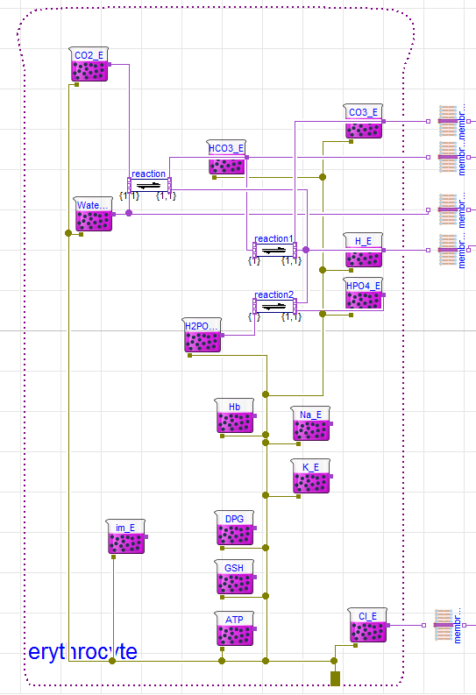
Figure 14: Construction of erythrocyte compartment using Chemical library. We can see all the substances contained in the solution. The mobile species are able to pass through the membrane.

Results

Equation based model
For the model validation, we used the same experiments as are discussed in the results part of [1]. The relation between the pH of blood plasma and the pH of erythrocytes seems to be almost linear. To validate this relation in our Modelica model, we set the plasma pH value in range 6.3 to 7.9 and observed how does the pH in the erythrocyte compartment changes. The result was almost linear with the pH in erythrocytes ringing slower than the pH in plasma as expected. The following figure (15) shows the results of our model in red in comparison with other experiments. In the physiological range, the results match with the others very closely with slight deviation in extreme pH values. This deviation could be caused by the changing BE in our experiment.

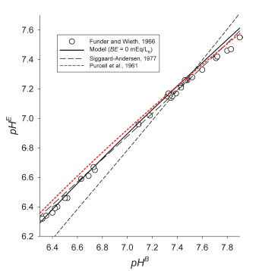
Figure 15: Dependency of the pH value in erythrocytes on the pH of plasma. The red curve shows result of experiment made in the Modelica model.

The next experiments show the Donnan equilibrium distribution in different values of pH in the model. Since all the mobile ions reach this state, we can illustrate the distribution using the Cl⁻. We will define the rCl as a ratio of Cl⁻ concentrations of erythrocytes relative to plasma. Figure 16 shows the results of our model in red with comparison with other experiments from [1]. We can observe similar trends. The values in physiological range are quite similar but our curve is little bit steeper for very low pH.

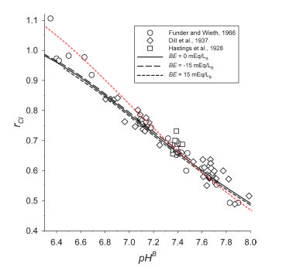
Figure 16: Donnan ratio for equilibrium distribution of Cl⁻ concentrations in erythrocytes water relative to plasma water for various pH values. Red curve shows results of our Modelica model.

As the figure 16 shows, the distribution of ions changes in various pH values. To balance these changes, the water shifts as well. We can illustrate this water shifts using the hematocrit. This is the ratio of erythrocytes volume in the blood. As the water shifts, this ratio changes as well. Figure 17 shows the change in hematorcit for various experiments. The red curve for our results is little steeper as suggests the results of previous experiment with the ions distributions.

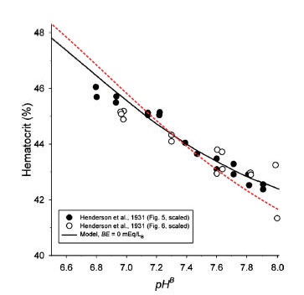
Figure 17: Changes in hematocrit in various pH values. The red curve shows results of the model implemented in Modelica.

With the changes of pH there has to be another change. Since our model is conserved for all species besides the carbonates, we have to adjust their concentrations by changing the pressure of carbon dioxide. In human body, the dependency is reversed. This means with the change of P_{CO2}, there is change of pH in the system. This way we can simulate uncompensated respiratory disturbances. Following figure (18) shows the change of P_{CO2} with the change of plasma pH. Results of our model are in red. In our experiment BE was not constant but changed with pH. We kept the model conserved so we could not compensate the BE change. The change of BE was almost linear starting at -8 for pH 6.8 reaching zero for pH 7.35 and increased to the 12 for pH 8.1. IF we take the BE change into account, the red curve closely follows the experimental data from [1]

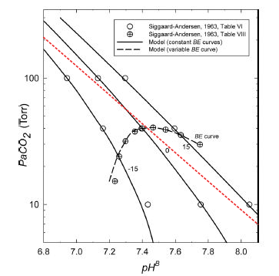
Figure 18: Changes in P_{CO2} for range of pH values. The red curve shows results of our Modelica model. In our case, the BE is not constant but changes with the pH in range of -8 to 12.

We performed further experiments with addition or subtraction of some species (Cl⁻, Na⁺, K⁺, Ca²⁺, Mg²⁺ and albumin). The results met the expectations. While adding Cl⁻ and albumins or subtracting the cations, the pH was below the standard level and conversely while adding the cations or subtracting the Cl⁻ and albumins, the pH was rising above the standard level. The results of adding Cl⁻ into the system can be observed on following figure.

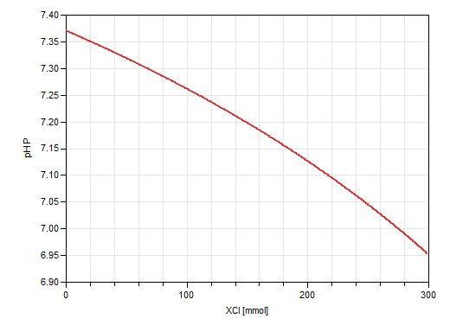
Figure 19: Change of pH value caused by adding acid (HCl) into the system.

Changing the volume of water in the system influences the pH value. Adding the water causes lower concentrations of the solutes and thus lowers the pH. The subtracting of water conversely increases the density of solution, hence increases the pH. This experiment illustrates figure 20.

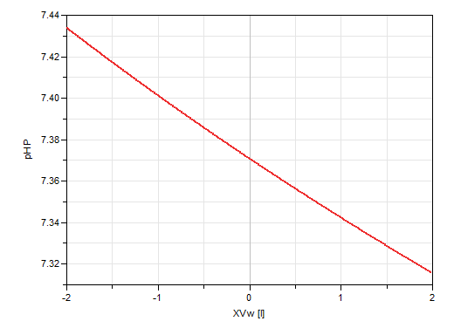
Figure 20: Effect of water changes on pH value. Loss of water causes alkalosis while increased water level causes acidosis.

As we mentioned above, using this model, we are not able to keep the BE value constant. In theory, respiratory disorders should not change the BE level, because there is no change in change in strong acids. This theory follows only in vitro experiments. In the organism while the acute respiratory insufficiency (increase of P_{CO2}) occurs, the BE value decreases slightly. This effect is caused by different distribution of bicarbonates between plasma and interstitium. [5] The change of BE in the IPE model is caused by the different concentration of species with pH dependant charge. The change of P_{CO2} causes change in pH and thus the change in overall charge of plasma is not same as of the interstitial fluid. To keep the BE value constant, we would have to allow change in the strong ions amount (e.g. Cl⁻).

Block based model
We implemented the model which comprises all principles from [1]. We had to make some adjustments to cover the way the Chemical library is constructed. We calculated the concentration of dissolved carbon dioxide instead of setting the pressure of its gaseous form. For the dissociation of the carbonates and phosphates we created a reaction with H⁺. The only way to observe pH is using the H⁺ concentration. For the rest of the species with the pH dependant we use the reference charge (charge they have in the standard state), because we are not able to make such simple dissociation reaction for them.
With this model we were not able to reach the equilibrium with physiological values for neither pH nor the concentration of some species. The H+ concentrations for each compartments shows figure 21.

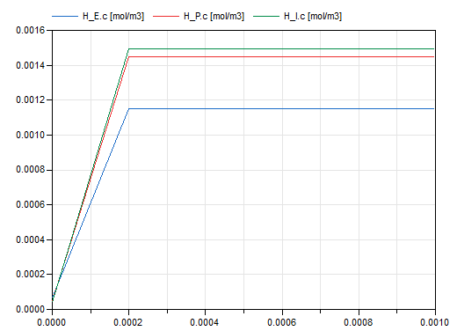
Figure 21: Concentration of H⁺ cations in block based model for the IPE compartments. These H⁺ concentrations correspond to ca. pH 3.

The assumption of electro neutrality in each compartment is violated. There is overall charge of each solution in thousands of coulombs. The assumption of Donnan ratio for all mobile species across a membrane is not satisfied either. We were not able to correct these issues like in the equation based model, because the charge or amount of unidentified species did not affect the ionic distribution. The change in charges of the pH dependant species did not affect the overall distribution of the mobile species either; it changes only the overall charge of the solution. We tried not to use the reactions in the solutions. We set the physiological values for each species instead. The results were similar except the H⁺ concentrations. The H⁺ cations were allowed only to pass from one compartment to another, but their concentrations were diminishing as shows following figure (22).

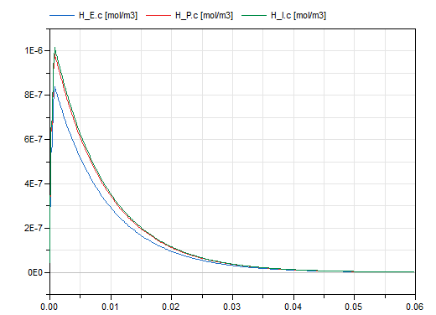
Figure 22: Concentration of H⁺ cations for IPE compartments with the reaction disabled. The cations are allowed only to switch between the compartments but their concentration diminishes in all compartments.

Discussion
The equation based IPE model works well. We can use it to simulate various situations in human body. We can change the concentration of the species in the system. This way we can observe what happens when there is low (or high) level of certain substance (e.g. chlorine, sodium etc.). We can set a combination of these irregularities. We have implemented parameters which changes the overall amount of some species (Cl⁻, Na⁺, K⁺, Ca⁺, Mg⁺ and water) in the model, so we can observe the effect of addition of certain amount of a substance to the system. This can help us to simulate metabolic disorders in human body. We can also make changes in the pressure of carbon dioxide which simulates the respiratory problems.
Since the Modelica langue is acausal, we can make the changes mentioned above and observe the changes of pH or we can make the pH parameter which we can manipulate with and one of the parameters mentioned above make a variable. This way we can see exactly how much of a substance is needed to get a certain value of pH.
In the block based IPE model, we were not able to reach the electroneutral state in the compartments. This violates one of the basic assumptions we made. We also could not use the changes of charge with the changes of pH. The only way to observe pH is via H⁺ concentration. We also could not reach the physiological value of the H⁺ concentration. This might be caused by the reactions we used for the dissociation of carbonates and phosphates. While we set all the reactions aside and observed the concentration (and amount) of the H⁺ concentrations, it was not conserved and was declining to zero. The concentration stabilized after removing the possibility of passing through the membrane. With the change of amount of a mobile species its equilibrium distribution changes as well, but we lack the physiological values of some species. The Chemical library seems to work with physical chemistry using strict laws of physics thermodynamics and chemical relations while the IPE model uses simplifications (pH dependant charge instead of reactions, simple osmotic equations etc.) and does not go in such deep as the Chemical library. We found the Chemical library is inappropriate for the implementation of the IPE model of M. B. Wolf and E. C. DeLand. Due to the unsuccessful implementation, we can not use the IPE model as a part of Physiomodel. The other issue with the incompatibility of Physiomodel and IPE model is their different comprehensiveness. The Physiomodel deals with much wider range of physiological processes and thus it is divided into many partial models for very specific area of interest. Physiomodel separately deals with the electrolytes, ventilation and gas exchange, proteins and water distribution, while the IPE model deals with all these issues in a single model neglecting the other interactions with the rest of the organism.
The equation based model simulates the physiological processes in human body as we expected and we can use it for various experiments. This can help us understand the basic acid-base balance of our system and use it for some predictions. The bock based model implemented using the Chemical library does not work so well. We are not able to obtain physiological values of some species in the system and its functionality is not as intuitive as the equation based model where we can plainly see cause and effect of each change we made.

CIPE model
We have also implemented the CIPE (cells – interstitial fluid – plasma – erythrocytes) model. This extends the IPE model adding the buffering cellular compartment which should compensate some of the previous IPE model limitations. [6]
The CIPE model follows the same assumptions as the IPE model with some changes. We added a cellular compartment which is homogenous like the other ones. For this cell compartment we use the data of skeletal muscle cells. These cells make the largest mass of human body and they are also often used for data gathering. The H⁺ and Na⁺ are not in equilibrium in the cell compartment like the other species. It is caused by the active pump so their distribution is adjusted using a coefficient which does not change for various conditions. We also use more explicit description of the forces leading to water distribution across the microvascular membrane separating plasma and interstitial fluid. We do not use the equality of osmotic pressure like for E-P and C-I membranes. The water distribution between interstitial fluid and plasma is based on the Starling osmotic-hydrostatic pressure-balance. [6]

Math
We use the same principles as in the IPE model with few additional equations for the P-I water balance and for the distribution of Na⁺ and H⁺ across the cell membrane.
The distribution of hydrogen and sodium are similar like other species, but the ratio is adjusted by a coefficient as following equations (25, 26) describes: [6]
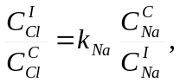
(38)
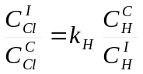
(39)
where kNa = 368 and kH = 10.
Pressure equilibrium across the microvasclar P-I membrane uses the starling principle as the equation (27) describes:
(40)
In the equation (27) Pr stands for a hydrostatic pressure, Π for the osmotic pressure and O is the osmolarity. The superscript B stands for blood while I and P are interstitial fluid and plasma, respectively. The σ_{lm} and σ_{sm} and are the osmotic reflection coefficients for large and small molecules, respectively. The constant 19.3 takes this value for temperature of 37°C. The hydrostatic pressure of blood shows the equation (41).
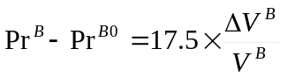
(41)
where difference in of hydrostatic blood pressure is proportional to the relative change in volume. For the hydrostatic pressure of interstitial fluid apply similar equations (42, 43).
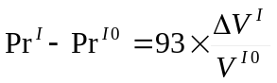 for 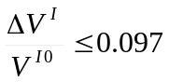
(42)
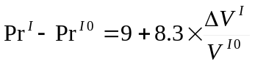 for 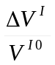 > 0.097
(43)
For standard state is the hydrostatic pressure between interstitial fluid and blood fixed as shows equation (44).
(44)
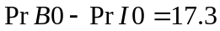
Plasma contains next to albumin some other proteins sot its osmotic pressure counts with albumins (Alb) and total plasma protein (Tpro)
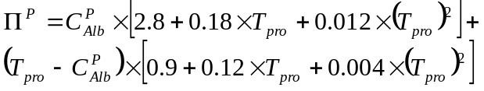
(45)
Since interstitial fluid contains only albumin, we can simplify the previous equation (32) to the form of (33) [6]
(46)

IPE model regulation
The acid-base disorders have two main reasons. One is the disturbance in the production and elimination of carbon dioxide, for which is the respiration responsible. The second reason is disturbance in the gains and losses of strong acids. To keep the balance, kidneys have to control the elimination of ions. While some problem occurs, the first is the response of the buffer system. This helps to keep pH in close range for acute problems. If the problem persists, the body tries to adapt the situation and next regulation systems come to play. If the respiratory disorder persists, it must be compensated by the shift of strong ions balance, hence we call it metabolic regulation. The prolonged disbalance in strong ions must be compensated by the weak carbonic acid and thus by the respiratory system. [5]
While we have two different ways of response depending on the nature of disorder, we have to make two models each for one kind of the disturbance. One model deals with the respiratory problems using metabolic regulation. The second model can simulate metabolic disbalances which are compensated via respiration.
Both these regulation systems react to prolonged disturbances. It means the systems need some time to reach its maximal efficiency. For the respiratory response it is six to twelve hours, while the metabolic response needs three to five days. [5] The IPE model is a steady state model so it does not deal with the time scale of a process. The results reflect only the steady state. Even if the simulation is dynamic due to the regulation, it does not reflect the dynamics of a real system. We can only compare the results after stabilization of the values.

Metabolic regulation
Metabolic regulation is a response to the respiratory disorders, and so the deviation of pressure of carbon dioxide from the standard state. We set the (pathological) value of P_{CO2} and a parameter for standard pH value (e.g. pH0 = 7.37). To balance the pH, we have to change the concentration of ions. We are balancing the pH of plasma. For the ion balance we use a variable X [mEq]. This variable substitute an amount of strong ions, which we would have to adjust, needed to compensate the respiratory disturbance. For the pH balance the adding of acid is equivalent to subtracting a base and vice versa. This means, if the X value is positive, the system needs more base (cations) or less acid (Cl⁻). The negative value of X is equivalent to gain of acids or loss of bases.
Since we use the universal variable, it does not influence the distribution of the mobile species, thus the result of this simulation is not really in steady state. The X is not mobile so it stays in plasma, while most of the plasma ions are mobile. We can manually set amount of other species (e.g. Cl⁻ or Na⁺) to substitute the universal species X. To simulate the steady state situation, we would have to choose one species, which compensates the shift of P_{CO2}.

Respiratory regulation
Human body compensates the long-term ionic disbalances thanks to the respiratory system. The strong acids are substituted by the weak carbonic acid, which amount depends on the amount of carbon dioxide in the solution and thus on the pressure of it in the lungs. Hyperventilation lowers the P_{CO2} in alveoli, while hypoventilation increases its value. We can add (or subtract) amount of ions to the system and observe how the respiration adapts.

Results
The results of the regulation of metabolic disorders shows following figure (23) in green. For the metabolic acidosis we added Cl⁻ (150 mmol and 250 mmol). The respiration system reacted by increasing the ventilation and thus lowering the P_{CO2}. Metabolic alkalosis caused by adding Na⁺ (150 mmol and 250 mmol) was compensated by hypoventilation to raise the P_{CO2}. The BE value (equivalent for H⁺ excess or deficit but with opposite sign) changes only slightly.
Respiratory problems was simulating by directly manipulating with the P_{CO2}. For respiratory acidosis we raised the pressure of carbon dioxide while to induce the respiratory alkalosis, we lowered the P_{CO2} value. To balance the pH, the model had to adjust the amount of acids or basis in the system, what is a cause of the significant BE (or H⁺ excess or deficit) changes for metabolic regulation.
The BE value (or H⁺ excess or deficit) was slightly different for our experiments. This is caused by using the venous blood while the compensating diagrams are usually made for arterial blood. The arterial blood is not in equilibrium with interstitial fluid so the distribution of mobile species is different. For the metabolic regulation we also use the universal variable which does not influence the distribution of other species like the specific ions would. This causes more inaccuracy.
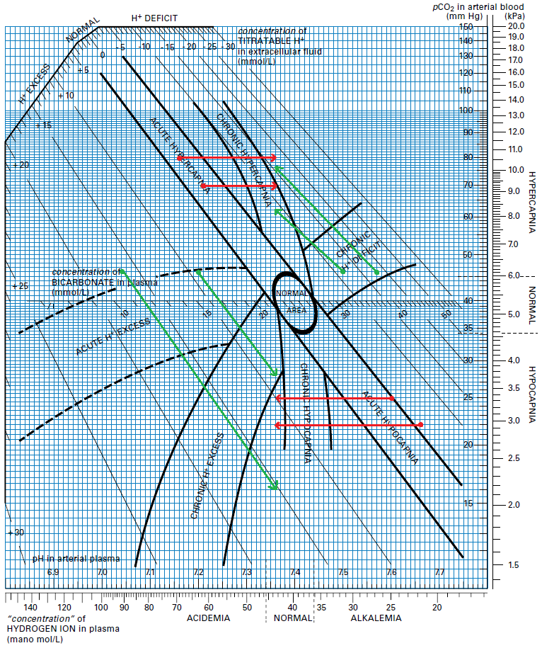
Figure 23: Compensating diagram of acid-base disturbances. The red curves shows regulation of respiratory disorders while the green shows regulation of metabolic disorders.

Interactive simulator
The IPE model offers us a great insight into the mechanisms of the acid-base balance of the human body. The mathematical apparatus is easy to understand and covers most of the physiological principles. These properties make it a suitable tool for educational purpose. We can simulate many acid-base disorders e.g. uncompensated metabolic or respiratory acidosis or alkalosis, compensated acid-base disorder, single or combined disorder etc. For every case, we have to choose the right model and modify adequate parameters. We can do this in one dose or we can continually modify the parameters in time. With this tool we can follow the process of the equilibration and observe the dependencies. This can help with understanding the whole acid-base balance and thus help with the predictions of acid-base disorders.
For each model, we would make a short introduction to help the viewer clarify the modifiable parameters. To the results we would add a commentary to explain the chain of processes that led to the certain result. We would enable display of most frequently observed quantities in the clinical praxis.
For more devoted users we would allow manipulating with more of the model’s parameters (e.g. changing directly concentration of any species in the model) and add the possibility of display all the variables of the model in the results. This could help with the acid-base predictions in clinical praxis. The downside of the IPE model is the lack of dynamics. We need to keep in mind we simulate only the steady state and thus the result of the process. The dynamics of the process in not involved. We also need to keep in mind the time scale of the processes which we simulate and adapt to it.
For the technical reasons we did not implement the interactive web simulator.

References
[1] Wolf, Matthew B., and Edward C. DeLand. ‘A Mathematical Model of Blood-Interstitial Acid-Base Balance: Application to Dilution Acidosis and Acid-Base Status’. Journal of Applied Physiology 110, no. 4 (1 April 2011): 988–1002. doi:10.1152/japplphysiol.00514.2010.

[2] Bergethon, Peter R. The Physical Basis of Biochemistry: The Foundations of Molecular Biophysics. Springer Science & Business Media, 2010.

[3] Mateják, Marek, Tomáš Kulhánek, Jan Šilar, Pavol Privitzer, Filip Ježek, and Jiří Kofránek. ‘Physiolibrary -Modelica Library for Physiology’. In ResearchGate, 2014. doi:10.3384/ecp14096499.

[4] Mateják, Marek. ‘Free Modelica Library of Chemical and Electrochemical Processes’. GitHub. Accessed 15 December 2016. https://github.com/MarekMatejak/Chemical/blob/master/Chemical/Resources/Documentation/Modelica2015-paper.pdf.

[5] Emanuel Nečas a spol.. Obecná Patologická Fyziologie. Praha: Nakladelství Karolinum, 2004. ISBN 80-246-0051-X.

[6] Wolf, Matthew B. ‘Whole Body Acid-Base and Fluid-Electrolyte Balance: A Mathematical Model’. American Journal of Physiology - Renal Physiology 305, no. 8 (15 October 2013): F1118–31. doi:10.1152/ajprenal.00195.2013.

[7] ‘7. Acidobazická Rovnováha • Funkce Buněk a Lidského Těla’. Accessed 23 December 2016. http://fblt.cz/skripta/vii-vylucovaci-soustava-a-acidobazicka-rovnovaha/7-acidobazicka-rovnovaha/.

[8] ‘Acid/Base Basics’. Chemistry LibreTexts, 2 October 2013. http://chem.libretexts.org/Core/Physical_and_Theoretical_Chemistry/Acids_and_Bases/Acid.

[9] Hamm, L. Lee, Nazih Nakhoul, and Kathleen S. Hering-Smith. ‘Acid-Base Homeostasis’. Clinical Journal of the American Society of Nephrology : CJASN 10, no. 12 (7 December 2015): 2232–42. doi:10.2215/CJN.07400715.

[10] ‘Acids and Bases | Chemistry’. Khan Academy. Accessed 21 December 2016. https://www.khanacademy.org/science/chemistry/acids-and-bases-topic.

[11] Kofranek, Jiri, Stanislav Matousek, and Michal Andrlik. ‘Border Flux Balance Approach towards Modelling Acid-Base Chemistry and Blood Gases Transport’. In In: Proceedings of the 6th EUROSIM Congress on Modelling and Simulation. Ljubljana: University of Ljubljana, 1–9. Citeseer, 2007. http://citeseerx.ist.psu.edu/viewdoc/download?doi=10.1.1.502.3332&rep=rep1&type=pdf.

[12] Ježek, Filip, and Jiří Kofránek. ‘Modern and Traditional Acid-Base Approaches Combined: Full Blood Model’. Google Docs. Accessed 23 December 2016. https://docs.google.com/document/d/1JZYU9Yp32cpi0SuiOYNGoNuIHQ5deL8kDu_W1KsiprA/edit?usp=embed_facebook.

[13] Mateják, Marek, and Jiří Kofránek. ‘Physiomodel-an Integrative Physiology in Modelica’. In 2015 37th Annual International Conference of the IEEE Engineering in Medicine and Biology Society (EMBC), 1464–1467. IEEE, 2015. http://ieeexplore.ieee.org/xpls/abs_all.jsp?arnumber=7318646.

[14] ‘The pH Scale’. Chemistry LibreTexts, 2 October 2013. http://chem.libretexts.org/Core/Physical_and_Theoretical_Chemistry/Acids_and_Bases/Aqueous_Solutions/The_pH_Scale.

[15] Morgan, T John. ‘The Stewart Approach – One Clinician’s Perspective’. The Clinical Biochemist Reviews 30, no. 2 (May 2009): 41–54.

