
PROJECT TITLE
Simple To-Do List Project Beginner-Friendly Python Program

PRESENTED BY: MACHHI DIMPAL
REGISTRATION NO.: 25BAI10718

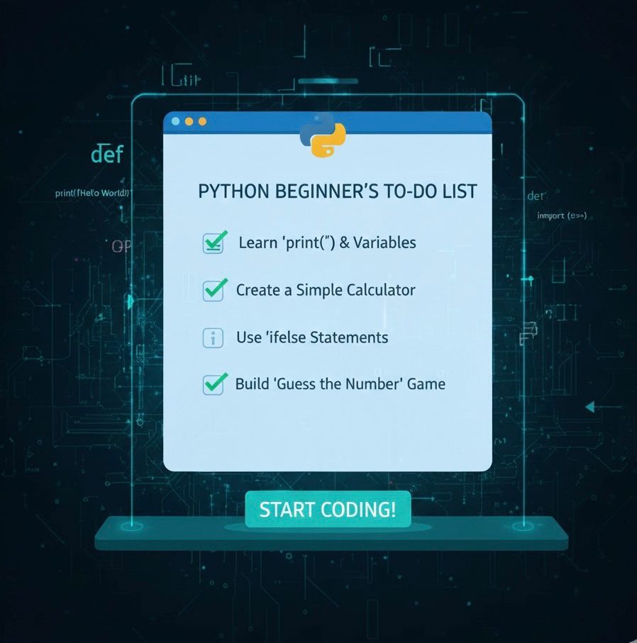

- Introduction:

• This project demonstrates how to create a basic To-Do List in Python.
• It helps beginners understand input/output, loops, and lists.

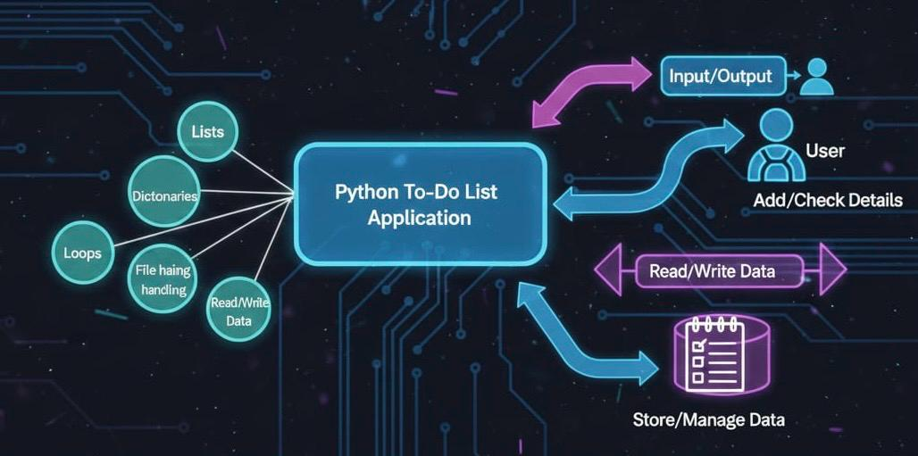

- Problem statement:

• Users need a simple way to store and view daily tasks.
• The system must be easy to use and text-based.
• Should allow adding and viewing tasks smoothly.

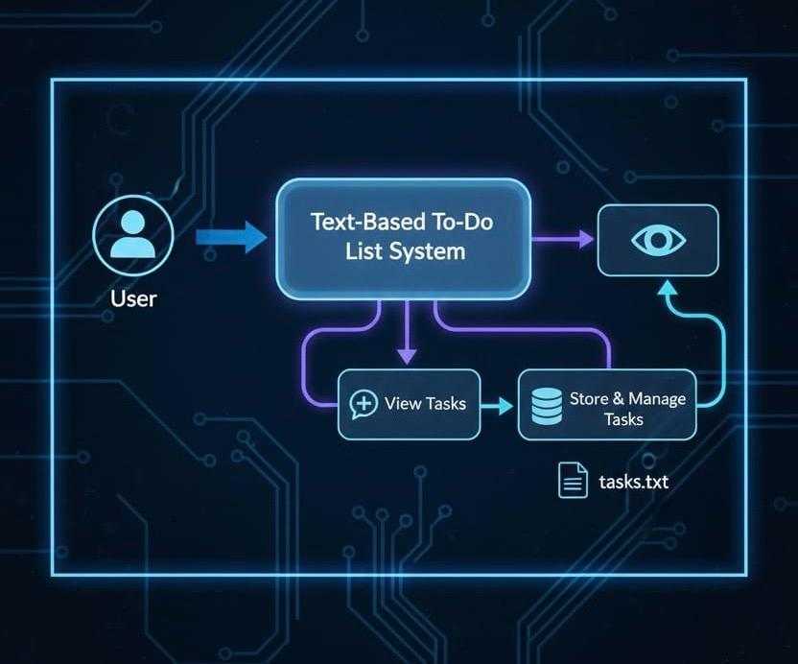

- Project Objectives

• Create a clean and simple menu system.
• Allow users to add tasks.
• Allow users to view stored tasks.
• Exit program safely.
• Understand core Python concepts.

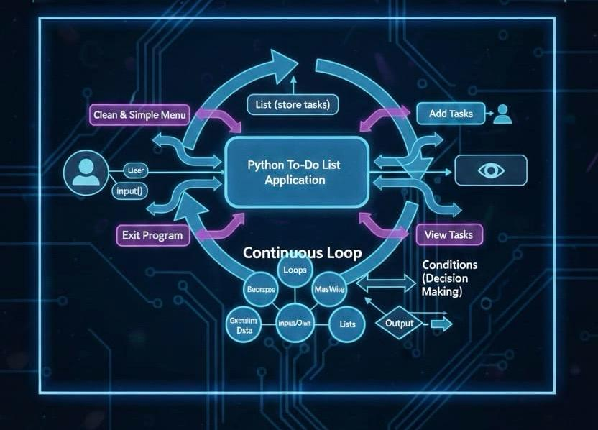

- Code:

tasks = [] # empty list to store tasks
print("SIMPLE TO-DO LIST:")
while True:
print("\n1. Add Task")
print("2. View Tasks")
print("3. Exit")
choice = input("Enter your choice: ")
if choice == "1":
task = input("Enter a task: ")
tasks.append(task) # add task to the list
print("Task added!")
elif choice == "2":
print("\nYour Tasks:")
if len(tasks) == 0:
print("No tasks yet.")
else:
for i in tasks:
print("- " + i)

elif choice == "3":
print("Goodbye!")
break

else:
print("Invalid choice, try again.")

- How the Program Works:
• Uses a Python list to store tasks.
• Takes user input using input().
• Uses loop to run continuously.
• Uses conditions to make decisions.

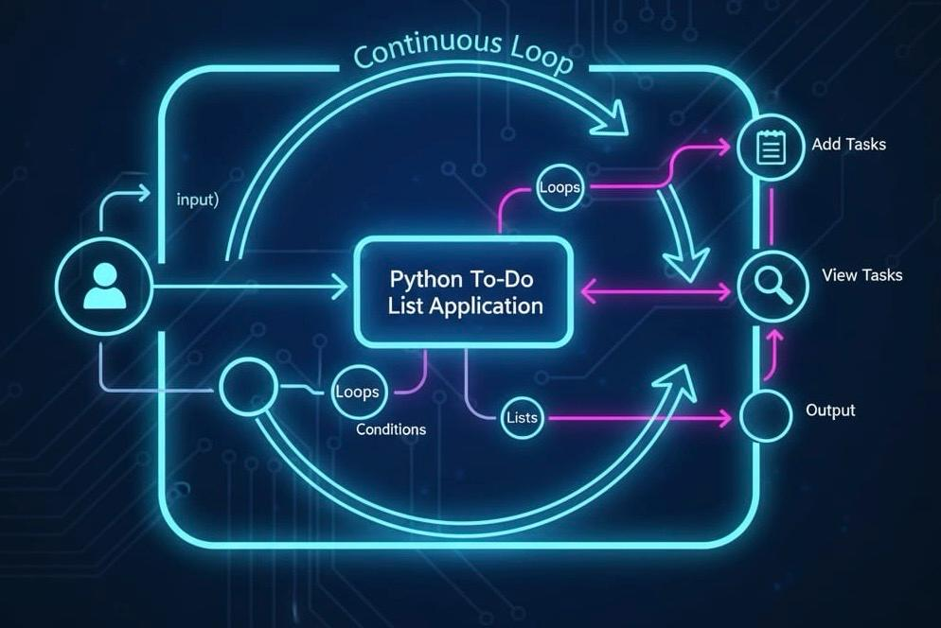

NOW ADDING FUNCTIONAL & NON-FUNCTIONAL REQUIREMENTS

⭐Functional Requirements:
Functional Requirements of To-Do List Project

- Add Task
• User must be able to input a new task.
• Task must be stored in a list.
• Program must confirm: “Task added!”

- View Tasks
• The system must display all stored tasks.
• If no tasks exist, show: “No tasks yet.”
• Tasks must appear in a clean list format.

- Exit Program
• The user must be able to exit using option 3.
• Program must print “Goodbye!” and stop.

- Display Menu & Workflow
• Menu must show options 1, 2, 3 clearly.
• Workflow:

Menu → User Choice → Perform Action → Return to Menu

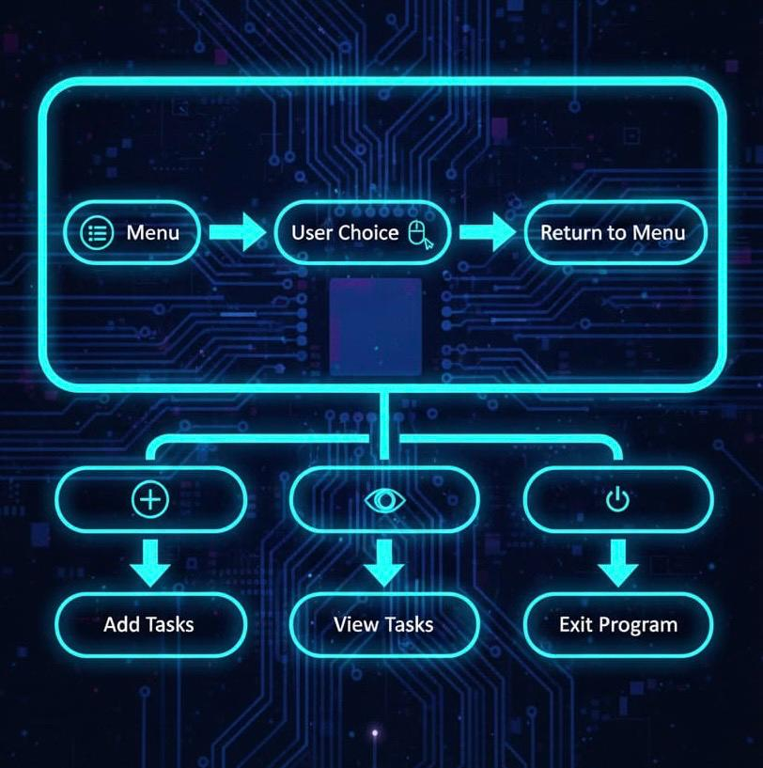

⭐ Non-Functional Requirements
Quality Attributes of the To-Do List Project

- Usability
• Interface must be simple and beginner-friendly.
• Options must be clearly visible.
• No complex instructions needed.

- Reliability
• Program must run without errors.
• Must handle repeated input smoothly.

- Performance
• Adding and viewing tasks should be fast.
• Should handle unlimited tasks.

- Maintainability
• Code must be easy to read and modify.
• Allows future features like delete or update tasks.

- Error Handling
• For invalid input, show: “Invalid choice, try again.”
• Program must not crash.

- Scalability
• The system should support adding many tasks without issues.

- FLOW CHART:

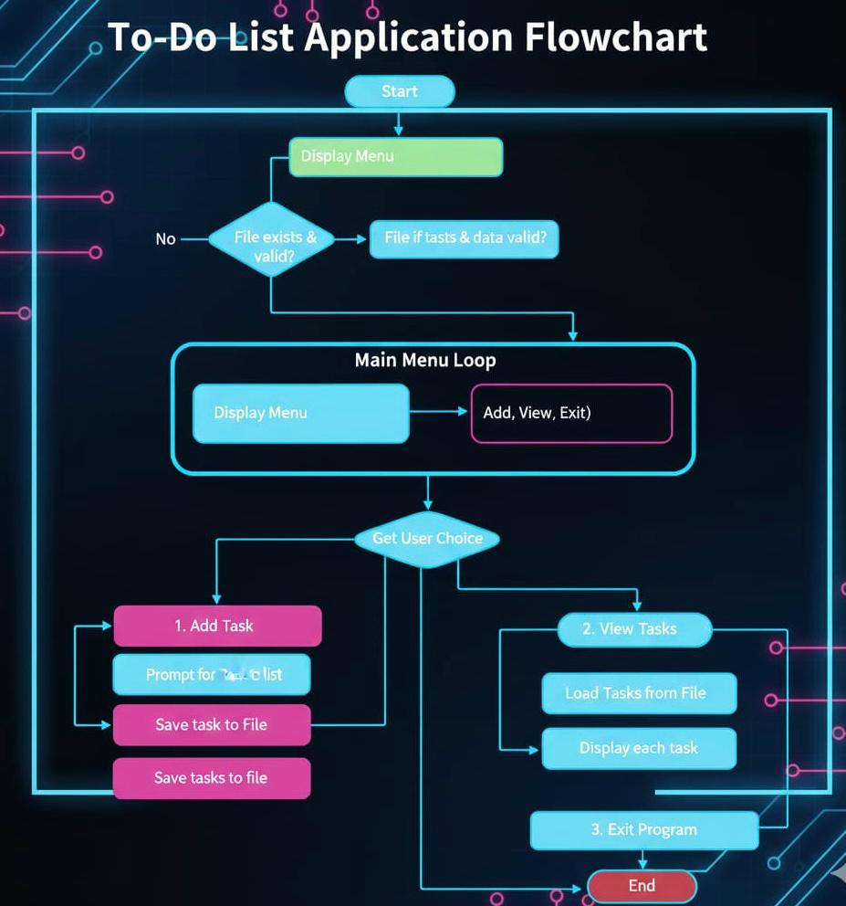

- CASE DIAGRAM:

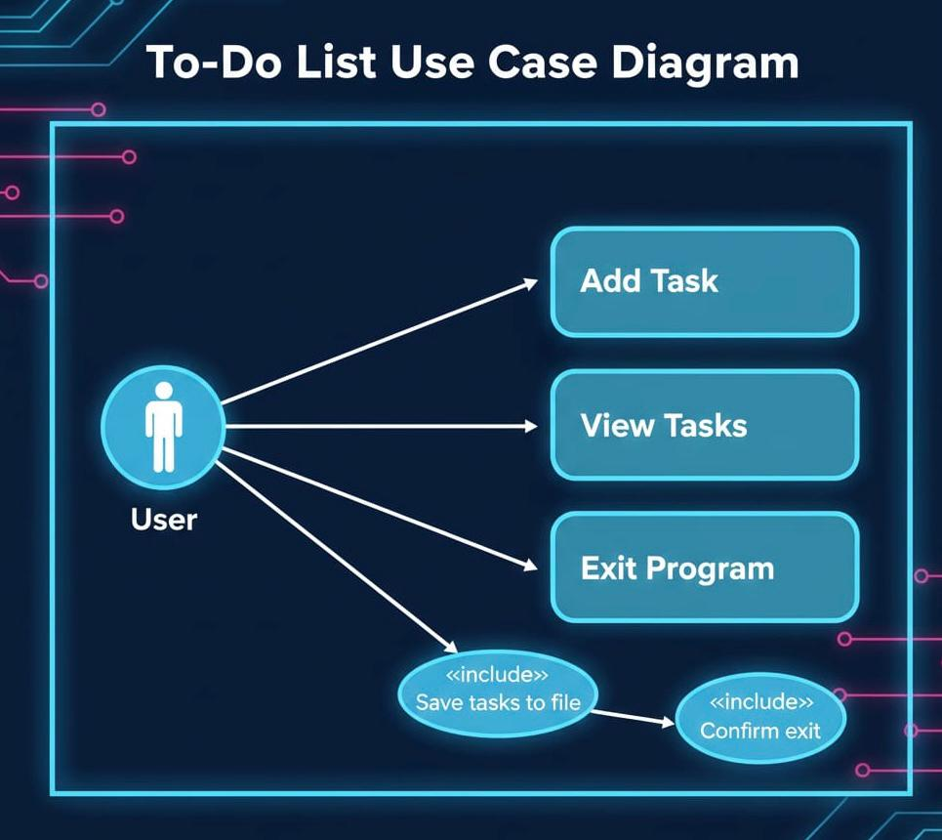

- Conclusion:
• The To-Do List project teaches loops, conditions, and lists.
• Easy to understand for beginners.
• Can be expanded with more features.

