1

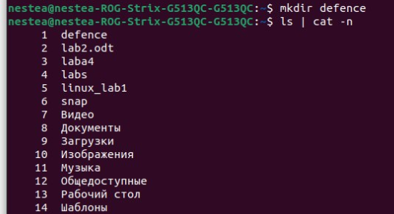

2



3



4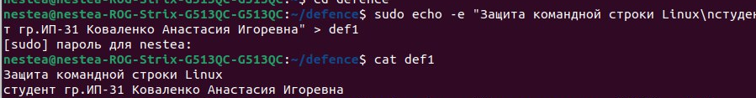





5

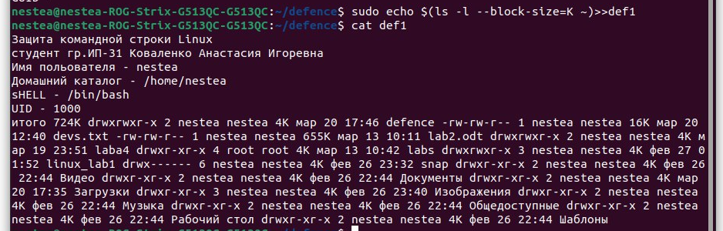

6

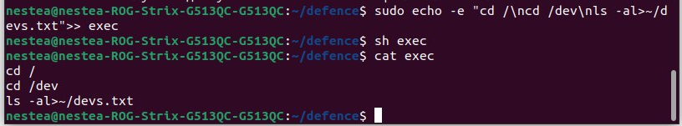

7

8

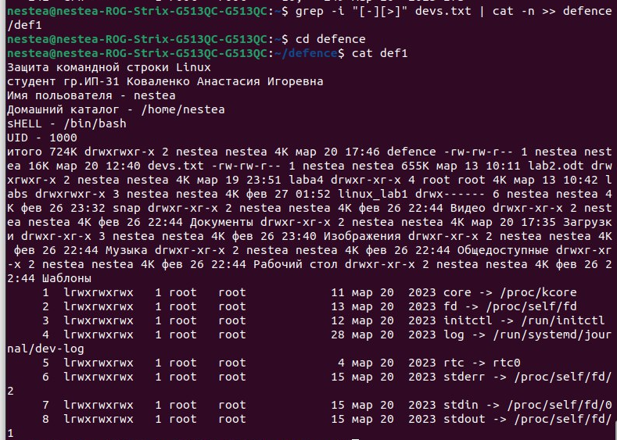

9



sudo groupadd -g 1500 Defencer

sudo useradd -g Defencer user