Evaluation

After defining the business problem in terms of machine learning and collecting the data, it is time to determine what defines success. There are various metrics for evaluating classification and regression problems. Which one we choose will depend on our objective.

Example: For this project to be successful, the model must have over 95% accuracy.

A model with 95% accuracy might be quite good for predicting insurance claims. But when it comes to predicting heart diseases, we will need better results.

This section shows:
- How to compare predicted labels to the truth labels,
- Evaluation metrics for different types of machine learning models.
The questions arise:
- How can we know if the model performed well?
- How can we measure the performance?
- How can we tune the model to perform better?

Evaluation Metrics

Aspect | Classification Metrics
Accuracy | Proportion of correct predictions
Precision | TP / (TP + FP) - Avoiding false positives
Recall | TP / (TP + FN) - Finding all true cases
F1 Score | Harmonic mean of precision and recall
Confusion Matrix | Summary of TP, TN, FP, FN

- True Positives (TP): Correctly predicted positive cases.
- True Negatives (TN): Correctly predicted negative cases.
- False Positives (FP): Incorrectly predicted positive cases (Type I error).
- False Negatives (FN): Incorrectly predicted negative cases (Type II error).
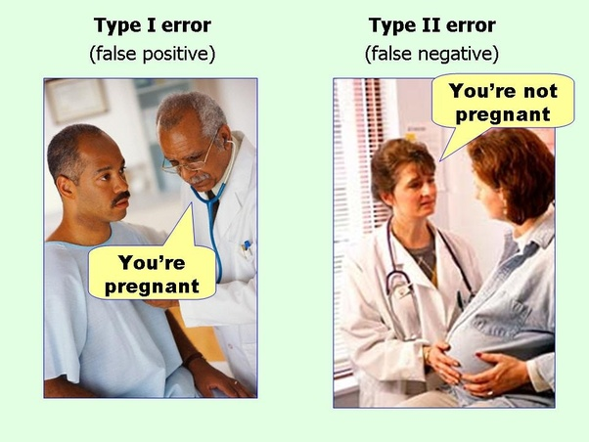

Aspect | Regression Metrics
Mean Absolute Error (MAE) | Average absolute difference between predicted and actual values
Mean Squared Error (MSE) | Average squared differences between predicted and actual values
R-squared (R²) | Proportion of variance in the dependent variable explained by the independent variables

