**Checking the Trend of Data**

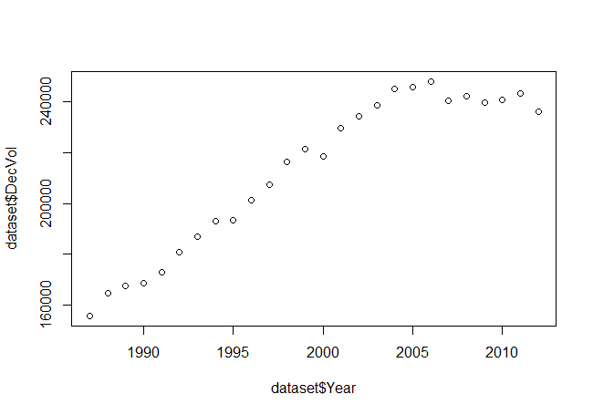

**Checking Missing Values**

Year DecVol

[1,] FALSE FALSE

[2,] FALSE FALSE

[3,] FALSE FALSE

[4,] FALSE FALSE

[5,] FALSE FALSE

[6,] FALSE FALSE

[7,] FALSE FALSE

[8,] FALSE FALSE

[9,] FALSE FALSE

[10,] FALSE FALSE

[11,] FALSE FALSE

[12,] FALSE FALSE

[13,] FALSE FALSE

[14,] FALSE FALSE

[15,] FALSE FALSE

[16,] FALSE FALSE

[17,] FALSE FALSE

[18,] FALSE FALSE

[19,] FALSE FALSE

[20,] FALSE FALSE

[21,] FALSE FALSE

[22,] FALSE FALSE

[23,] FALSE FALSE

[24,] FALSE FALSE

[25,] FALSE FALSE

[26,] FALSE FALSE

No Missing Values are there

**Regression model Summary**

Call:

lm(formula = DecVol ~ Year, data = training_set)

Residuals:

Min 1Q Median 3Q Max

-22053 -7718 -1557 10060 15581

Coefficients:

Estimate Std. Error t value Pr(>|t|)

(Intercept) -7002325.2 729902.6 -9.594 8.60e-08 ***

Year 3608.7 364.9 9.889 5.79e-08 ***

---

Signif. codes: 0 ‘***’ 0.001 ‘**’ 0.01 ‘*’ 0.05 ‘.’ 0.1 ‘ ’ 1

Residual standard error: 11010 on 15 degrees of freedom

Multiple R-squared: 0.867, Adjusted R-squared: 0.8581

F-statistic: 97.79 on 1 and 15 DF, p-value: 5.788e-08

**Predicting 2013 value**

2013-261926.2

