1. R2. What are the two most important network-layer functions in a datagram network? What are the three most important network-layer functions in a virtual circuit network?

The two most important network-layer functions in a datagram network are routing and forwarding. In a virtual circuit network, the three most important network-layer functions are the above – routing and forwarding – in addition to call setup.

1. R3. What is the difference between routing and forwarding?

The primary difference between routing and forwarding is the scale. In short, routing is inter-device and forwarding is intra-device. That is, where forwarding is the process of moving a packet from the input port of a router to the necessary output port of that same router, routing deals in larger scale connections between the source and final destination of a packet - often passing through multiple network devices including routers and switches.

1. R21. Compare and contrast link-state and distance-vector routing algorithms.

Distance-vector routing algorithms calculate the least-cost path in an iterative and distributed manner: any given node only knows to which neighboring node it should forward a packet to in order to reach the destination following that least-cost path. On the other hand, link-state algorithms compute this same least-cost path using a knowledge of the entire network the packet is passing through.

1. R27. Why are different inter-AS and intra-AS protocols used in the Internet?

Different AS protocols are used in the Internet for three reasons: policy, scale, and performance. In inter-AS, administrators want control over how its traffic is routed and who routes it through the network. Conversely, in intra-AS, there is only a single administrator and thus, no policy decisions are needed. With regards to scale, hierarchical routing saves table size, resulting in reduced update traffic. Finally, performance wise, while intra-AS can focus on performance, in an inter-AS, policy may dominate over performance.

1. P10. Consider a datagram network using 32-bit host addresses. Suppose a router has four links, numbered 0 through 3, and packets are to be forwarded to the link interfaces as follows:

|  |  |
| --- | --- |
| **Destination Address Range** | **Link Interface** |
| 11100000 00000000 00000000 00000000  through  11100000 00111111 11111111 11111111 | 0 |
| 11100000 01000000 00000000 00000000  through  11100000 01000000 11111111 11111111 | 1 |
| 11100000 01000001 00000000 00000000  through  11100001 01111111 11111111 11111111 | 2 |
| otherwise | 3 |

1. Provide a forwarding table that has five entries, uses longest prefix matching, and forwards packets to the correct link interfaces.

|  |  |
| --- | --- |
| **Prefix Match** | **Link Interface** |
| 11100000 00 | 0 |
| 11100000 01000000 | 1 |
| 1110000 | 2 |
| 11100001 1 | 3 |
| otherwise | 3 |

1. Describe how your forwarding table determines the appropriate link interface for datagrams with destination addresses:

11001000 10010001 01010001 01010101

11100001 01000000 11000011 00111100

11100001 10000000 00010001 01110111

The prefix match for the first address is the fifth entry in the table (link interface 3).

The prefix match for the second address is the third entry in the tale (link interface 2).

The prefix match for the third address is the fourth entry in the table (link interface 3).

1. P13. Consider a router that interconnects three subnets: Subnet 1, Subnet 2, and Subnet 3. Suppose all of the interfaces in each of these three subnets are required to have the prefix 223.1.17/24. Also suppose that Subnet 1 is required to support at least 60 interfaces, Subnet 2 is to support at least 90 interfaces, and Subnet 3 is to support at least 12 interfaces. Provide three network addresses (of the form a.b.c.d/x) that satisfy these constraints.

223.1.17.128/25

223.1.17.192/28

223.1.17.0/26

1. P16. Consider a subnet with prefix 128.119.40.128/26. Give an example of one IP address (of form xxx.xxx.xxx.xxx) that can be assigned to this network. Suppose an ISP owns the block of addresses of the form 128.119.40.64/26. Suppose it wants to create four subnets from this block, with each block having the same number of IP addresses. What are the prefixes (of form a.b.c.d/x) for the four subnets?

Any IP address in the range of 128.119.40.128 to 128.119.40.191 can be assigned to this network. In order to have equal size subnets, the prefixes would be 128.119.40.64/28, 128.119.40.80/28, 128.119.40.96/28, and 128.119.40.112/28.

1. 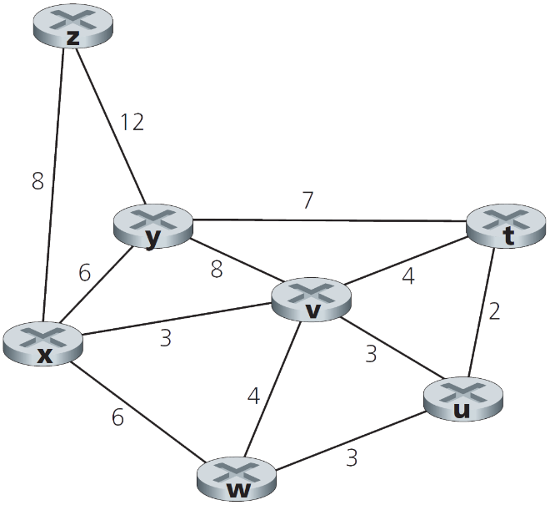P26. Consider the following network. With the indicated link costs, use Dijkstra’s shortest-path algorithm to compute the shortest path from *x* to all network nodes. Show how the algorithm works by computing a table similar to Table 4.3.

|  |  |  |  |  |  |  |  |
| --- | --- | --- | --- | --- | --- | --- | --- |
| Step | N’ | D(t), p(t) | D(u), p(u) | D(v), p(v) | D(w), p(w) | D(y), p(y) | D(z), p(z) |
| 0 | x | ∞ | ∞ | 3, x | 6, x | 6, x | 8, x |
| 1 | xv | 7, v | 6, v | 3, x | 6, x | 6, x | 8, x |
| 2 | xvu | 7, v | 6, v | 3, x | 6, x | 6, x | 8, x |
| 3 | xvuw | 7, v | 6, v | 3, x | 6, x | 6, x | 8, x |
| 4 | xvuwy | 7, v | 6, v | 3, x | 6, x | 6, x | 8, x |
| 5 | xvuwyt | 7, v | 6, v | 3, x | 6, x | 6, x | 8, x |
| 6 | xvuwytz | 7, v | 6, v | 3, x | 6, x | 6, x | 8, x |

1. P37. Consider the network shown below. Suppose AS3 and AS2 are running OSPF for their intra-AS routing protocol. Suppose AS1 and AS4 are running RIP for their intra-AS routing protocol. Suppose eBGP and iBGP are used for the inter-AS routing protocol. Initially suppose there is *no* physical link between AS2 and AS4.
2. Router 3c learns about prefix x from which routing protocol: OSPF, RIP, eBGP, or iBGP?

eBGP

1. Router 3a learns about x from which routing protocol?

iBGP

1. Router 1c learns about x from which routing protocol?

eBGP

1. Router 1d learns about x from which routing protocol?

iBGP

