1. R4. Describe why an application developer might run an application over UDP rather than TCP.

If an application developer wants to prioritize quantity or speed over quality or congestion control, then UDP is the right idea. TCP’s congestion control interferes with an application’s ability to send data as soon as possible. Additionally, TCPs reliable nature forces slow-downs on traffic.

1. R7. Suppose a process in Host C has a UDP socket with port number 6789. Suppose both Host A and Host B each send a UDP segment to Host C with destination port number 6789. Will both of these segments be directed to the same socket at Host C? If so, how will the process at Host C know that these two segments originated from two different hosts?

Yes, both of these UDP segments will be directed to the same socket at Host C. To determine that these segments came from different hosts, the process in Host C will be provided the IP addresses of each segment, enabling it to distinguish the two.

1. R14. True or false?
2. Host A is sending Host B a large file over a TCP connection. Assume Host B has no data to send Host A. Host B will not send acknowledgments to Host A because Host B cannot piggyback the acknowledgments on data.

FALSE

1. The size of the TCP rwnd never changes throughout the duration of the connection.

FALSE

1. Suppose Host A is sending Host B a large file over a TCP connection. The number of unacknowledged bytes that A sends cannot exceed the size of the receive buffer.

TRUE

1. Suppose Host A is sending a large file to Host B over a TCP connection. If the sequence number for a segment of this connection is *m*, then the sequence number for the subsequent segment will necessarily be *m* + 1.

FALSE

1. The TCP segment has a field in its header for rwnd.

TRUE

1. Suppose that the last SampleRTT in a TCP connection is equal to 1 sec. The current value of TimeoutInterval for the connection will necessarily be ≥ 1 sec.

FALSE

1. Suppose Host A sends one segment with sequence number 38 and 4 bytes of data over a TCP connection to Host B. In this same segment the acknowledgment number is necessarily 42.

FALSE

1. P15. Consider the cross-country example shown in Figure 3.17. How big would the window size have to be for the channel utilization to be greater than 98 percent? Suppose that the size of a packet is 1,500 bytes, including both header fields and data. Assume one-way cross country propagation delay of 15 msec.

$d_{trans}=\frac{L}{R}=\frac{1500 bytes×8 bits/byte}{{10}^{9} bits/sec}=0.00012 seconds or 0.012 milliseconds$

$t=RTT+d_{trans}=30 milliseconds+0.012 milliseconds=30.012 milliseconds$

$U=0.98=\frac{d_{trans}×n}{t}=\frac{0.012×n}{30.012}⟶n=2451 packets$

1. 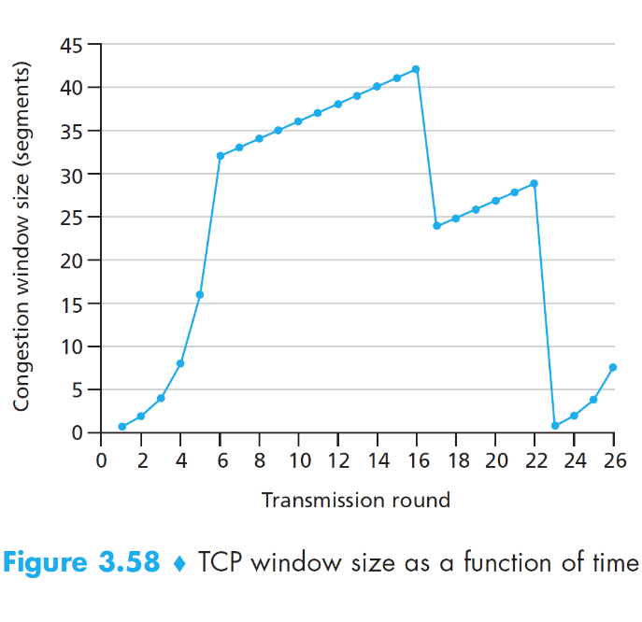P40. Consider Figure 3.58. Assuming TCP Reno is the protocol experiencing the behavior shown above, answer the following questions. In all cases, you should provide a short discussion justifying your answer.
   * + - 1. Identify the intervals of time when TCP slow start is operating.

From round **1 to 6** and round **23 to 26** (exponential growth in window size).

* + - * 1. Identify the intervals of time when TCP congestion avoidance is operating.

From round **6 to 16** and round **17 to 22** (linear growth in window size).

* + - * 1. After the 16th transmission round, is segment loss detected by a triple duplicate ACK or by a timeout?

**Triple duplicate ACK**. Had it been a timeout, the congestion window size would have fallen to just one segment.

* + - * 1. After the 22nd transmission round, is segment loss detected by a triple duplicate ACK or by a timeout?

**Timeout**. The congestion window size fell to just one segment.

* + - * 1. What is the initial value of ssthresh at the first transmission round?

The **initial value of ssthresh is 32**, as that is where the first TCP slow start ends and TCP congestion avoidance begins.

* + - * 1. What is the value of ssthresh at the 18th transmission round?

When packet loss has been detected, ssthresh is set to half the congestion window size. Since the congestion window size is approximately 42 or 43 during transmission round 16, **ssthresh is 21** (since $\left\lfloor 21.5\right\rfloor =21$) at the 18th transmission round.

* + - * 1. What is the value of ssthresh at the 24th transmission round?

When packet loss has been detected, ssthresh is set to half the congestion window size. Since the congestion windows size is approximately 28 or 29 during transmission round 22, **ssthresh is 14** (since $\left\lfloor 14.5\right\rfloor =14$) at the 24th transmission round.

|  |  |
| --- | --- |
| **Round** | **Packets Sent** |
| 1 | 1 |
| 2 | 2-3 |
| 3 | 4-7 |
| 4 | 8-15 |
| 5 | 16-31 |
| 6 | 32-63 |
| 7 | 64-96 |

* + - * 1. During what transmission round is the 70th segment sent?

The 70th segment is send during **transmission round 7** (see table).

* + - * 1. Assuming a packet loss is detected after the 26th round by the receipt of a triple duplicate ACK, what will be the values of the congestion window size and of ssthresh?

When a loss occurs, ssthresh is set to half the congestion window size and the congestion window size is set to the new ssthresh value + 3. Since the congestion window size is 8 at the 26th transmission round, **ssthresh is now 4**. Since the new ssthresh value is 4, the **congestion window size is now 7**.

* + - * 1. Suppose TCP Tahoe is used (instead of TCP Reno), and assume that triple duplicate ACKs are received at the 16th round. What are the ssthresh and the congestion window size at the 19th round?

In TCP Tahoe, when a packet loss has been detected, ssthresh is set to half the congestion window size and the congestion window size is set to 1. Since the congestion window size is approximately 42 or 43 during transmission round 16, **ssthresh is 21** (since $\left\lfloor 21.5\right\rfloor =21$) and the **congestion window size is now 1**.

* + - * 1. Again suppose TCP Tahoe is used, and there is a timeout event at 22nd round. How many packets have been sent out from 17th round till 22nd round, inclusive?

|  |  |
| --- | --- |
| **Round** | **Packets Sent** |
| 17 | 1 |
| 18 | 2 |
| 19 | 4 |
| 20 | 8 |
| 21 | 16 |
| 22 | 21 |

**52 packets** were sent from the 17th transmission round until the 22nd transmission round (see table).